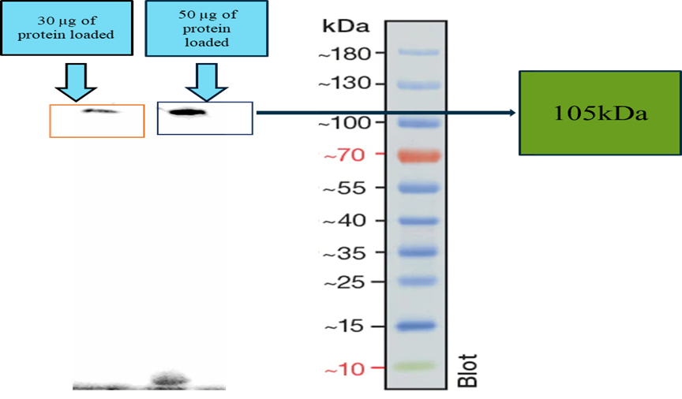

Figure S1 Western blot analysis showed the detection of gingipain.