SUPPLEMENTARY MATERIAL

SUPPLEMENTAL TABLES
Table S1. Characteristics at Entry Stratified by Sex
Variable | Women  (n=61) | Men  (n=263)
Age, mean (SD) | 52.1 (6.9) | 51.9 (7.4)
Non-Hispanic Black¹, % | 30 (49.2) | 63 (24.0)**
Hispanic¹, % | 15 (24.6) | 65 (24.7)
Efavirenz use, % | 25 (41.0) | 134 (51.0)
Nadir CD4+ T-cells/µl,  median (IQR) | 216 (42, 329) | 205 (78, 318)
HIV RNA <200 copies/ml, % | 56 (91.8) | 253 (96.9)
Anemia, % | 13 (22.0) | 21 (8.3)**
HCV seropositive, % | 1 (1.6) | 12 (4.6)
≥ 2 Comorbidities², % | 26 (42.6) | 92 (35.0)
Neurocognitively impaired, % | 20 (32.8) | 62 (24.0)

Abbreviations: SD, Standard Deviation; IQR, Interquartile Range; HCV, Hepatitis C Virus; µl, microliter
¹Self-reported race or ethnicity
²Clinically significant comorbidities, e.g., cancer, diabetes, cardiovascular disease, chronic kidney disease,
chronic HCV infection, bone fractures, prior transient ischemic attack, or stroke.
Note: No study participants reported active (current) substance use at entry or the time of neurocognitive assessment.
³Neurocognitive impairment status was missing for 5 individuals, due to incomplete test score information.
**p<0.01

Table S2. Fth-1 and Ftl Associations with Anemia in People with HIV at Entry
Biomarker | Beta Estimate (95% CI)
Fth-1 | All PWH: -0.836 (-1.088, -0.583)***  Women: -1.593 (-2.100, -1.086)***  Men: -0.372 (-0.663, -0.080)*
Ftl | All PWH: -0.160 (-0.436, 0.116)  Women: -0.456 (-0.980, 0.067)¹  Men: 0.032 (-0.307, -0.370)
Unadjusted associations of anemia with log-transformed serum biomarker levels at entry are shown.
Abbreviations: Fth-1, ferritin heavy-chain-1; Ftl, ferritin light-chain; 95% CI, 95% Confidence Interval; PWH,
people with HIV
*p=0.013
***p<0.001
¹p=0.086

SUPPLEMENTAL FIGURES

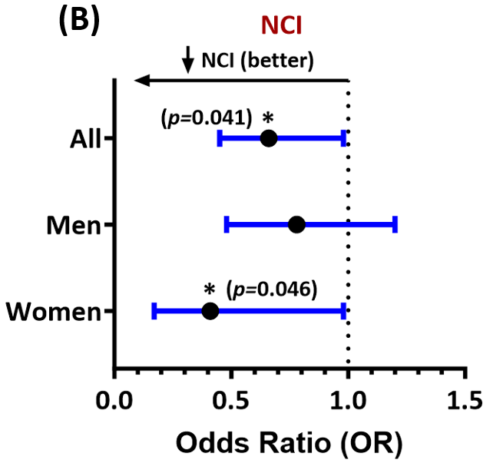
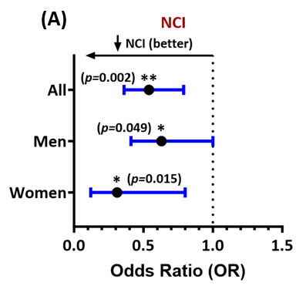

Figure S1. Forest plots of multivariable associations of (A) Ftl levels and (B) Fth-1 levels at entry with NCI in virally suppressed people with HIV (shown for all study participants and for men and women separately). Adjusted odds ratios (ORs) and their 95% confidence intervals are shown. Lower ORs (<1.0) indicate less likelihood of NCI. *p<0.05, **p<0.005. All p-values<0.05 are statistically significant.

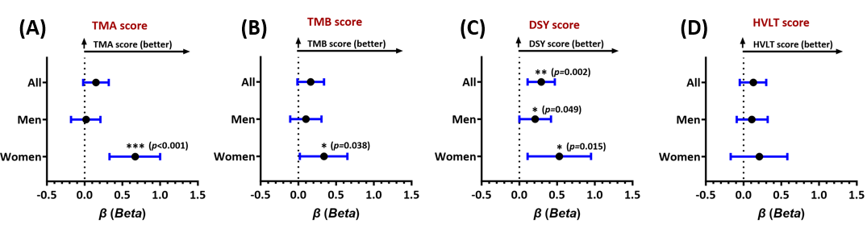

Figure S2. Forest plots of multivariable associations of Ftl levels at entry with scores on neurocognitive domain tests: (A) Trail-Making-A (TMA), (B) Trail-Making-B (TMB), (C) Digit Symbol (DSY), and (D) the Hopkins Verbal Learning Test (HVLT). Adjusted beta estimates and 95% confidence intervals are shown for all study participants, men, and women, with higher values (>0) indicating better performance. *p<0.05, **p<0.005, ***p<0.001. All p-values<0.05 are statistically significant.

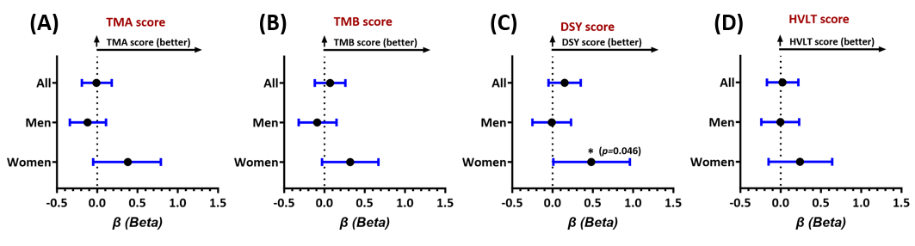

Figure S3. Forest plots of multivariable associations of Fth-1 levels at entry with scores on neurocognitive domain tests: (A) Trail-Making-A (TMA), (B) Trail-Making-B (TMB), (C) Digit Symbol (DSY), and (D) the Hopkins Verbal Learning Test (HVLT). Adjusted beta estimates and 95% confidence intervals are shown for all study participants, men, and women, with higher values indicating better performance. *p<0.05, **p<0.005, ***p<0.001. All p-values<0.05 are statistically significant.

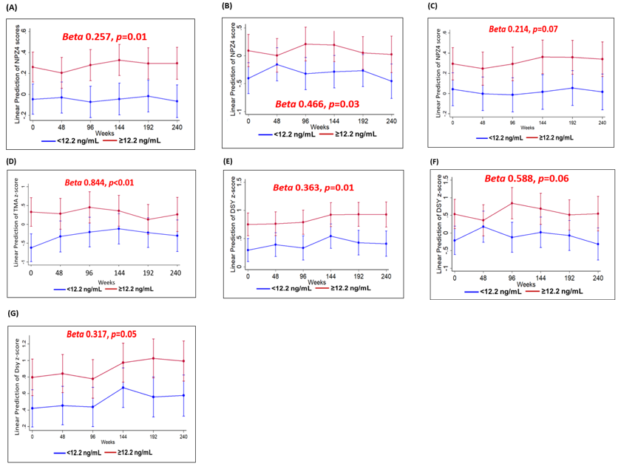

Figure S4. Longitudinal regression models of predicted adjusted changes over time in global and selected neurocognitive domain test scores in people with HIV for ferritin-light-chain (Ftl) levels above versus below the median at baseline (entry). Results are shown for the NPZ-4 score in all study participants (A), in women (B), and in men (C); TMA score in women (D); DSY score in all study participants (E), in women (F), and in men (G). Models included the following covariates at entry: age, nadir CD4<200/μl, inflammation (IL-6, sTNFR-II, sCD163), anemia (yes/no), education, race, ethnicity, comorbidity burden, and (in non-sex-stratified models), sex. All p-values<0.05 are statistically significant.

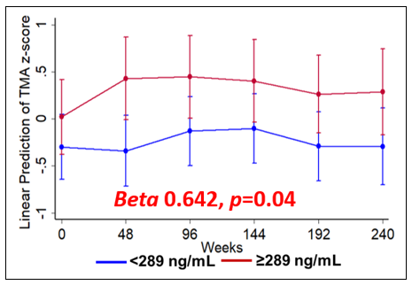
Figure S5. Longitudinal regression models of predicted adjusted changes over time in the TMA test score in women with HIV for serum Ferritin-heavy-chain-1 (Fth-1) levels above vs. below the median at entry. Models included the following covariates at entry: age, nadir CD4<200/μl, inflammation (IL-6, sTNFR-II, sCD163), anemia, education, race, ethnicity, and comorbidity burden.
A p-value <0.05 is statistically significant.

