Supplementary Material

Table 1



Table 2

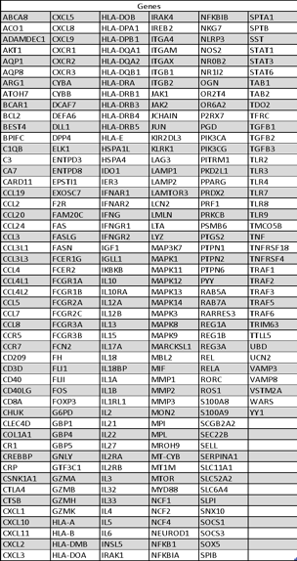

Table 3



Table 4



Table 5

|  |  |  |
| --- | --- | --- |
| Gene | Forward | Reverse |
| TNF | CTGCACTTTGGAGTGATCGG | TGAGGGTTTGCTACAACATGGG |
| IL1B | CACX3ATGCACCTGTACGATCA | GTTGCTCCATATCCTGTCCCT |
| IL1A | AGATGCCTGAGATACCCAAAACC | CCAAGCACACCCAGTAGTCT |
| IL6 | AGAGGCACTGGCAGAAAAC | TGCAGGAACTGGATCAGGAC |
| BIRC2 | AACTCTTGGCCTTTCATTCG | TGCTTTTGTTGTGATGGTGG |
| CASP8 | AGGCCAGATCTTCACTGTCC | GGTCACTTGAACCTTGGGAA |
| CAV1 | TCCCTTCTGGTTCTGCAATC | CGAGAAGCAAGTGTACGACG |
| EPOR | CAGGCCAGATCTTCTGCTTC | GACGCTCTCCCTCATCCTC |
| FOXO3 | AGTTCCCTCATTCTGGACCC | CTTCAAGGATAAGGGCGACA |
| GAB1 | TGCGTAACACGAACCATCTC | GTGGTGAAGTGGTCTGCTCC |
| IL4R | TGATTTCTTCCAGCTGTGTGT | CAGGGGTCCCCCACTTC |
| IL6ST | CAGCATGAATCCAGTCCAGA | CCCTCAGTACCTGGACCAAA |
| INSR | GTCGGGCTGAGAACAGTTG | GTCGAACGATGTTGGACTCA |
| LCP2 | GTTTGCGTGTGAAGATGCTC | GACATCCAGAAGTTCCCCAA |
| MAP3K14 | TTCTGGGTGAGGTCAATCCT | GGATGGAGGACAAGCAGACT |
| NCK2 | CTTGATGTCCAGCTCCTGGT | TCACCTCTCAACTGTGTGCC |
| NFKB2 | GGACTGGTAGGGGCTGTAGG | CACATGGGTGGAGGCTCT |
| RIPK2 | CTCTTCAAATGTTCTCAAAACTGG | AGAAAGTGGATGGGCACAAA |
| RPS6KA3 | TGGGTTAATCTCCTCCTCTCC | GTGGCAGAAGATGGCTGTG |
| SMAD7 | CCAGGCTCCAGAAGAAGTTG | CCAACTGCAGACTGTCCAGA |
| TANK | TTTATTGAGTTGCTCGCCAA | CAAAGGAAGACTTGTAACCTGGA |
| TGFBR1 | TTGTCTTTTGTACAGAGGTGGC | GCTGCTCCTCCTCGTGCT |
| TNFAJP3 | ACAGCTTTCCGCATATTGCT | TTGACCAGGACTTGGGACTT |
| TNFRSF10A | GGCTATGTTCCCATTGCTGT | AGACCTTCAAGTTTGTCGTCG |
| WAS | AGCCACTCAGTCATCCCATT | ATGCACGTGATGCAGAAGAG |
| XIAP | CCTTCAAAACTGTTAAAAGTCATCTTC | GGACCCTCCCCTTGGAC |
| 18srRNA | TCGGAACTGAGGCCATGATT | CTTTCGCTCTGGTCCGTCTT |
| GAPDH | ACCCACTCCTCCACCTTTGAC | TGTTGCTGTAGCCAAATTCGTT |
|  |  |  |

Supplemantary figure

