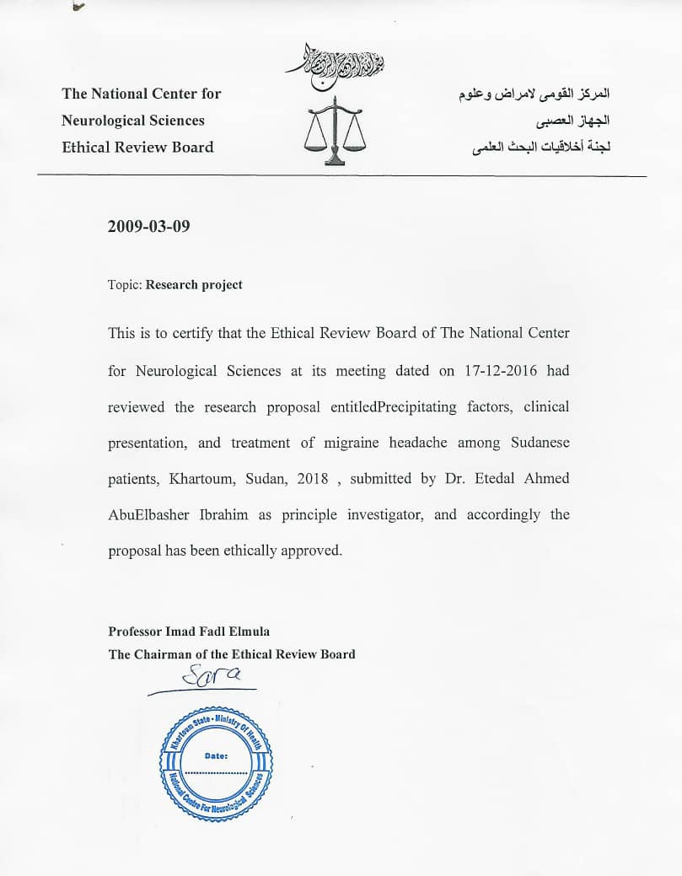

Date:…………………….

**The Full Title Of The Project:**

**Type of the project:**

Msc: ( ) MD ( ) PhD ( ) Postdoctoral ( )

others ( ) please specify:…………………………………………………………………….

**Title of the research**:…………………………………………………………………………………

………………………………………………………………………………………………………...

**Principle investigator:**

**Name:**………………………………………………………………………………………..

**Academic degree**:…………………………………………………………………………...

**Work address**:………………………………………………………………………………

**Tel**: …………………………………………. **Fax**:…………………………………………

**National investigators and/or Collaborators:**

**Name:**………………………………………………………………………………………...

**Academic degree**:……………………………………………………………………………

**Work address**:……………………………………………………………………………….

**Tel**: …………………………………………. **Fax**:………………………………………….

**Name:**…………………………………………………………………………………………

**Academic degree**:…………………………………………………………………………….

**Work address**:……………………………………………………………………………….

**Tel**: ………………………………………….. **Fax**:…………………………………………

**Name:**…………………………………………………………………………………………

**Academic degree**:…………………………………………………………………………….

**Work address**:………………………………………………………………………………..

**Tel**: …………………………………………... **Fax**:…………………………………………

**Name:**………………………………………………………………………………………….

**Academic degree**:……………………………………………………………………………..

**Work address**:………………………………………………………………………………...

**Tel**: …………………………………………… **Fax**:…………………………………………

**Role of each investigator:**

Investigator 1:……………………………………………………………………………..

Investigator 2:……………………………………………………………………………..

Investigator 3:…………………………………………………………………………….

Investigator 4:…………………………………………………………………………….

**Type of the research grant:**

National grant: ( ) International grant: ( ) Government: ( ) Private: ( )

**Details about the projects (please include the following points):**

* Rationale and Justification
* Objectives
* Summary of Methodology: (study design, Study area, Study population, Study duration, Types of samples and Frequency of sampling, Study variables, Inclusion and exclusion criteria)
* Work plan
* Expected risk or harm: No risk

**Please include the following:**

* CV of all investigators
* A copy of the consent form
* Funding issues related to patient and population care

**Prof. Imad Fadl Elmula**

**Chairman of the Ethical Board**