Supplementary files
- Testing protocol
In our study, we observed that not all teams commenced their pre-season program simultaneously. To ensure consistency, we scheduled the measurement day precisely two weeks after the initiation of the training session, which occurred in August 2018. This day was chosen to be the 14th training day, following a day of recovery, and took place between the hours of 17:00 and 18:30. Although the number of players varied among the teams, it is important to note that all players from each team were measured during this session. The study collected the anthropometric characteristics of the players, including age, stature, and body mass, and calculated their body mass index (BMI). The participants' preferred legs and medical history were additionally recorded. All players were assessed once, during the begging of the pre-season, and were followed for 30 weeks until the end of the season, including play-off matches.
The medical office of each soccer club was used for testing procedures. The set-up included a physiotherapy table, a tablet, and a portable HDD (KFORCE Muscle Controller, K-Invent, Biomecanique, Montpellier, France). The medical office of each soccer club was used for testing procedures. All Participants performed a warm-up consisting in 5-min of jogging in light intensity and an 8-min protocol of standardized static stretching exercises in leg and trunk muscles(Cejudo et al. 2015).
Two physiotherapists, a tester (A.K) and an assistant (T.B.) were present during the testing sessions. The tester, (A.K.) with extensive experience using the HHD, performed all the testing. The assistant (T.B.) registered all hip strength measurements and assisted in patient measurement fixations. The tester was blinded to the hip muscle strength of participants.
The tests were conducted in a predetermined sequence. To ensure correct action, the investigator's hand and the other hand were placed against HHD. The players were instructed to stabilize themselves by holding onto the sides of the table. Resistance was applied in a fixed position, and the participant exerted a 3-second isometric maximum voluntary contraction (MVC) against the dynamometer and the examiner. Each test was performed bilaterally, starting with the right limb, and administered 2 times with a 30-second resting period in between. The highest value of the 2 valid MVCs was used in the analysis. Participants were asked to resist the applied force (break test) (der Ploeg, G H Oosterhuis, and der Ploeg J G H Oosterhuis 1991). To avoid potential fatigue, a 2-minute rest period was implemented between each of the four tests (ref). The highest score achieved in each test was utilized for subsequent data analysis and treatment. The supine position was used for testing isometric hip adduction (ADD) strength (image 1). The hips were slightly abducted to fit the angle of the tester’s elbows as previously described (Nielsen et al. 2022). The isometric hip abduction (ABD) strength was tested in side-lying position as previously described (Thorborg et al. 2011), (2011), (image 2.) The isometric knee flexion (HMS) strength was tested in prone position with the knee to 15º as described by Reurink and colleagues(Reurink et al. 2016) (2016), (image 3). The supine position was applied for testing isometric hip flexion (HFL) strength as described by Thorborg and colleagues(Thorborg et al. 2010), (2010), (Image 4)
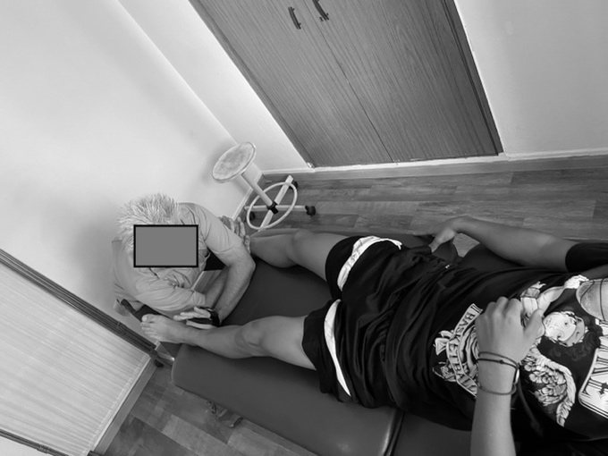
Image1. Isometric hip adduction strength test (Nielsen et al., 2022)

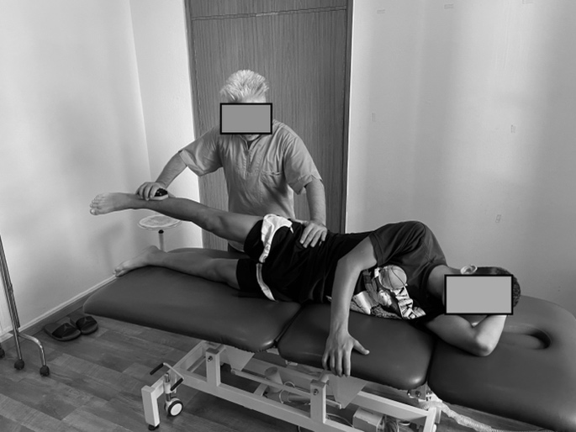

Image 2: isometric hip abduction (ABD) strength test (Thorborg et al., 2011)

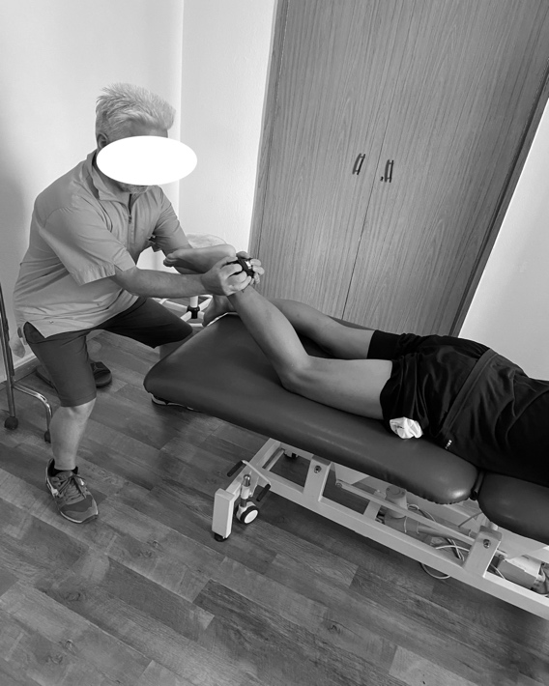

Image 3: Isometric knee flexors strength test in lengthening position (Reurink et al., 2016)
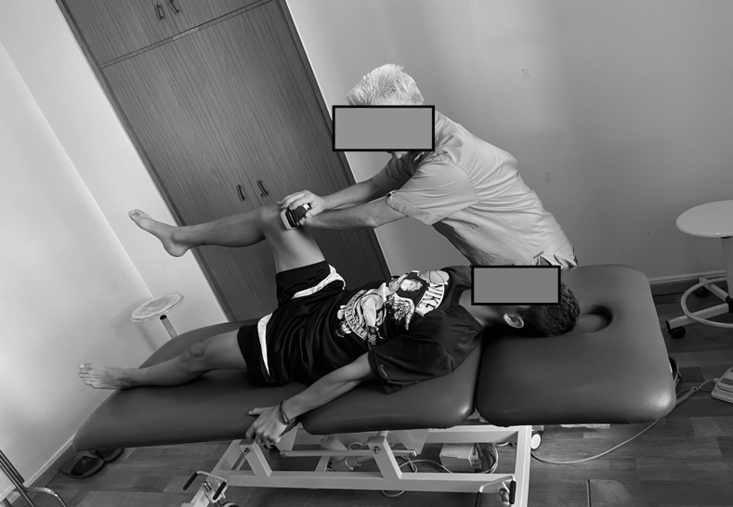

Image 4. Isometric hip flexors strength test (Thorborg et al., 2010)

2. Input data

1. | Previous hamstring Injury
2 | Age
3 | BMI
4 | Adductors dominant limb (ADD-D),
5 | Adductors non-dominant limb (ADD-ND),
6 | Abductors dominant limb (ABD-D),
7 | Abductors non-dominant limb (ABD-ND),
8 | Hamstrings dominant limb (HMS-D),
9 | Hamstrings non-dominant limb (HMS-ND),
10 | Hip flexors dominant limb (HFL-D),
11 | Hip flexors non-dominant limb (HFL-ND),
12 | Adductors dominant limb/ Adductors non-dominant limb (ADD-D/ADD-ND) ratio,
13 | Adductors dominant limb /abductors dominant limb ratio (ADD-D/ABD-D) ratio,
14 | Adductors non-dominant limb /Abductors non dominant limb (ADD-ND/ABD ND) ratio,
15 | Abductors dominant limb/ Abductors non-dominant limb (ABD-D/ABD ND) ratio,
16 | Hip Flexors dominant limb/ Hip Flexors non-dominant limb (HFL-D/HFL-ND) ratio,
17 | Hip Flexors dominant limb/ Hamstrings dominant limb (HFL-D/HMS-D) ratio,
18 | Hip Flexors dominant limb/ Hamstrings non-dominant limb (HFL-D/HMS-ND) ratio,
19 | Hip Flexors non-dominant limb/ Hamstrings non-dominant limb (HFL-ND/ HMS-ND) ratio,
20 | Hamstrings dominant limb/ Hamstrings non-dominant limb (HMS-D/HMS-ND) ratio,

Plar | Age | Position | Height | Weight | BMI* | Dominant | Previous Injury | Date of injury | injury | Mechanism of injury | Game or Training | Re-injury | RTP days | Use of imagine
player 1 | 32 | Defence winger | 1.68 | 62 | 22.0 | 0 | 1 | 14th sep 18 | 1st Grade injury R HIS | sprinting | T | NO | 5 | NO
player 2 | 30 | Defence winger | 1.76 | 83 | 26.8 | 0 | 1 | 9th sep 18 | 1st Grade injury L HIS | sprinting | T | NO | 7 | NO
player 2 | 30 | Defence winger | 1.76 | 83 | 26.8 | 0 | 1 | 20th Oct 18 | 1st Grade injury L HIS | Sprinting | G | yes | 14 | yen
player 1 | 32 | Defence winger | 1.68 | 62 | 22.0 | 0 | 1 | 20th Oct 18 | 1st Grade injury L HIS | sprinting | G | NO | 5 | NO
player 3 | 28 | Attacking Winger | 1.74 | 71 | 23.5 | 0 | 1 | 28th Oct 18 | 1st Grade injury R HIS | sprinting | G | NO | 8 | NO
player 1 | 32 | Defence winger | 1.68 | 62 | 22.0 | 0 | 1 | 15th Dec 18 | 1st Grade injury R HIS | Sprinting | T | yes | 11 | NO
player 4 | 20 | Defence winger | 1.76 | 83 | 26.8 | 0 | 1 | 16th Jan 19 | 1st Grade injury R HIS | Sprinting | T | NO | 6 | NO
player 1 | 32 | Defence winger | 1.68 | 62 | 22.0 | 0 | 1 | 24th Jan 19 | 1st Grade injury R HIS | kicking | T | yes | 17 | yes
player 5 | 28 | Defece Middle | 1.71 | 73 | 25.0 | 0 | 1 | 6th Feb 19 | 1st Grade injury L HIS | Sprinting | G | NO | 3 | NO
player 5 | 28 | Defece Middle | 1.71 | 73 | 25.0 | 0 | 1 | 17th Feb 19 | 1st Grade injury L HIS | sprinting | T | yes | 9 | NO
player 2 | 30 | Defence winger | 1.76 | 83 | 26.8 | 0 | 1 | 6th Mar 19 | 1st Grade injury L HIS | Sprinting | G | yes | 12 | NO
player 2 | 30 | Defence winger | 1.76 | 83 | 26.8 | 0 | 1 | 24th Apr 19 | 1st Grade injury R HSI | Sprinting | G | NO | 6 | NO
player 6 | 15 | forward | 1.84 | 76 | 22.4 | 0 | 1 | 14th Oct 18 | 1st Grade injury L HIS | sprinting | G | NO | 8 | NO
player 6 | 15 | forward | 1.84 | 76 | 22.4 | 0 | 1 | 4th Nov 18 | 1st Grade injury R HSI | sprinting | G | NO | 12 | NO
player 6 | 15 | forward | 1.84 | 76 | 22.4 | 0 | 1 | 17th Mar 19 | 1st Grade injury R HSI | sprinting | G | yes | 19 | yes
player 7 | 17 | Attacking Winger | 1.76 | 65 | 21.0 | 0 | 0 | 3rd Sep 18 | 1st Grade injury L HIS | sprinting | T | NO | 8 | NO
player 8 | 21 | Attacking Winger | 1.80 | 70 | 21.6 | 0 | 1 | 14th Oct 18 | 1st Grade injury L HIS | sprinting | G | NO | 6 | NO
player 8 | 21 | Attacking Winger | 1.80 | 70 | 21.6 | 0 | 1 | 10th Feb 19 | 1st Grade injury L HIS | sprinting | G | yes | 9 | NO
player 9 | 33 | Attacking Winger | 1.72 | 77 | 26.0 | 0 | 1 | 13th Feb 19 | 1st Grade injury L HIS | sprinting | T | NO | 10 | NO
player 10 | 40 | Central defender | 1.80 | 85 | 26.2 | 0 | 1 | 2nd Oct 18 | 1st Grade injury L HIS | sprinting | T | NO | 7 | NO
player 11 | 37 | Attacking Midfielder | 1.70 | 60 | 20.8 | 0 | 1 | 5th Oct 18 | 1st Grade injury R HIS | sprinting | T | NO | 6 | NO
player 12 | 33 | Center Middfielder | 1.80 | 78 | 24.1 | 0 | 1 | 17th Oct 18 | 1st Grade injury L HIS | sprinting | G | NO | 8 | NO
player 13 | 26 | Attacking Middle center | 1.72 | 80 | 27.0 | 0 | 1 | 13th Nov 18 | 1st Grade injury R HIS | sprinting | G | yes | 11 | NO
player 13 | 26 | Attacking Middle center | 1.72 | 80 | 27.0 | 0 | 1 | 15th Jan 19 | 1st Grade injury R HIS | Acceleration | T | yes | 9 | NO
player 14 | 16 | Defencive Midfielder | 1.75 | 70 | 22.9 | 0 | 1 | 10th Mar 19 | 1st Grade injury R HIS | sprinting | T | NO | 7 | NO
player 15 | 28 | Goalkeaper | 1.85 | 85 | 24.8 | 0 | 1 | 20th Nov 18 | 1st Grade injury L HIS | Acceleration | T | NO | 9 | NO
player 16 | 15 | Attacking Winger | 1.80 | 65 | 20.1 | 0 | 0 | 13st Oct 18 | 1st Grade injury R HSI | deceleration | G | NO | 7 | NO
player 17 | 22 | Center Middfielder | 1.68 | 65 | 23.0 | 0 | 1 | 10th Nov 18 | 2nd Grade R BFLh | sprinting | G | NO | 32 | yes
player 18 | 15 | Defence winger | 1.72 | 78 | 26.4 | 0 | 0 | 24th Jan 19 | 1st Grade injury R HIS | over stretching | G | NO | 11 | NO
player 19 | 15 | Center Middfielder | 1.76 | 58 | 18.7 | 0 | 1 | 4th Feb 19 | 1st Grade injury R HIS | Acceleration | T | NO | 7 | NO
player 20 | 31 | Attacking Winger | 1.76 | 64 | 20.7 | 0 | 1 | 18th Nov 18 | 1st Grade injury L HIS | deceleration | G | NO | 6 | NO
player 21 | 36 | Central Middfielder | 1.82 | 85 | 25.7 | 0 | 1 | 22th Nov 18 | 1st Grade injury L HIS | sprinting | T | NO | 5 | NO

Dominant limb: 0= Right, 1=Left
Previous injury: 0=No previous, 1= Previous
Game or Training : T= Training, G=Game
Use of imagine : Yes = MRI and/or MSK US

Injury data registration
A hamstring injury was described as "an injury to the posterior thigh resulting from playing football that caused a player to be unable to fully participate in future training or match play"¹⁷. Hamstring injuries reported as spasm/cramping by the player (in the absence of tissue damage), were included as injuries. Injury data were collected every week, verified by the first author (A.K.), and subsequently collected. During the competitive season, all injuries were diagnosed and recorded by the medical staff of the football team or the medical staff of the local hospital following the recommendations adopted by FIFA¹⁷. The time devoted to training and match play was individually obtained by the team staff to calculate the time of exposure.

