Table S1 Genes and primers used in qRT-PCR.
Gene ID | Forword Primers | Reverse Primers | Description
BnaC01g19330D | ACAGGACGGTTGTGGAAGTC | CAGACTGCATTGCCTGCTTG | Lipid transfer protein
BnaC03g08840D | CCAATGCCTCCGTCTACAGG | CCTAAATGGACCGGCTTGGT | Lipid transfer protein
BnaA01g17200D | AGCCGGCCCATTTAGGATTC | ACTGCATTGCTTGCTTGTGG | Lipid transfer protein
BnaA03g06940D | ACAGGACGGTTGTGGAAGTC | GCTTGTGGAGCCATTGTTGG | Lipid transfer protein
BnaA05g15470D | TTTCAATGGGAAGTGCCGGA | TCTAGGTGCAGCTTCAACGG | Protein AINTEGUMENTA-LIKE 4
BnaA06g16330D | CTCTCCTGTGCCAACGTTCT | TGGTGACGAGGAGGAAGACA | SWEET sugar transporter
BnaC08g20440D | AAGTTACCGGAGGTGACCCT | ACGAACGGCTGTGATTGTCT | Chlorophyll A-B binding protein
BnaA03g36810D | CACCATCGGAGATCTGAGCC | CCTTGAAAAGGGGCACAAGC | Chlorophyll A-B binding protein

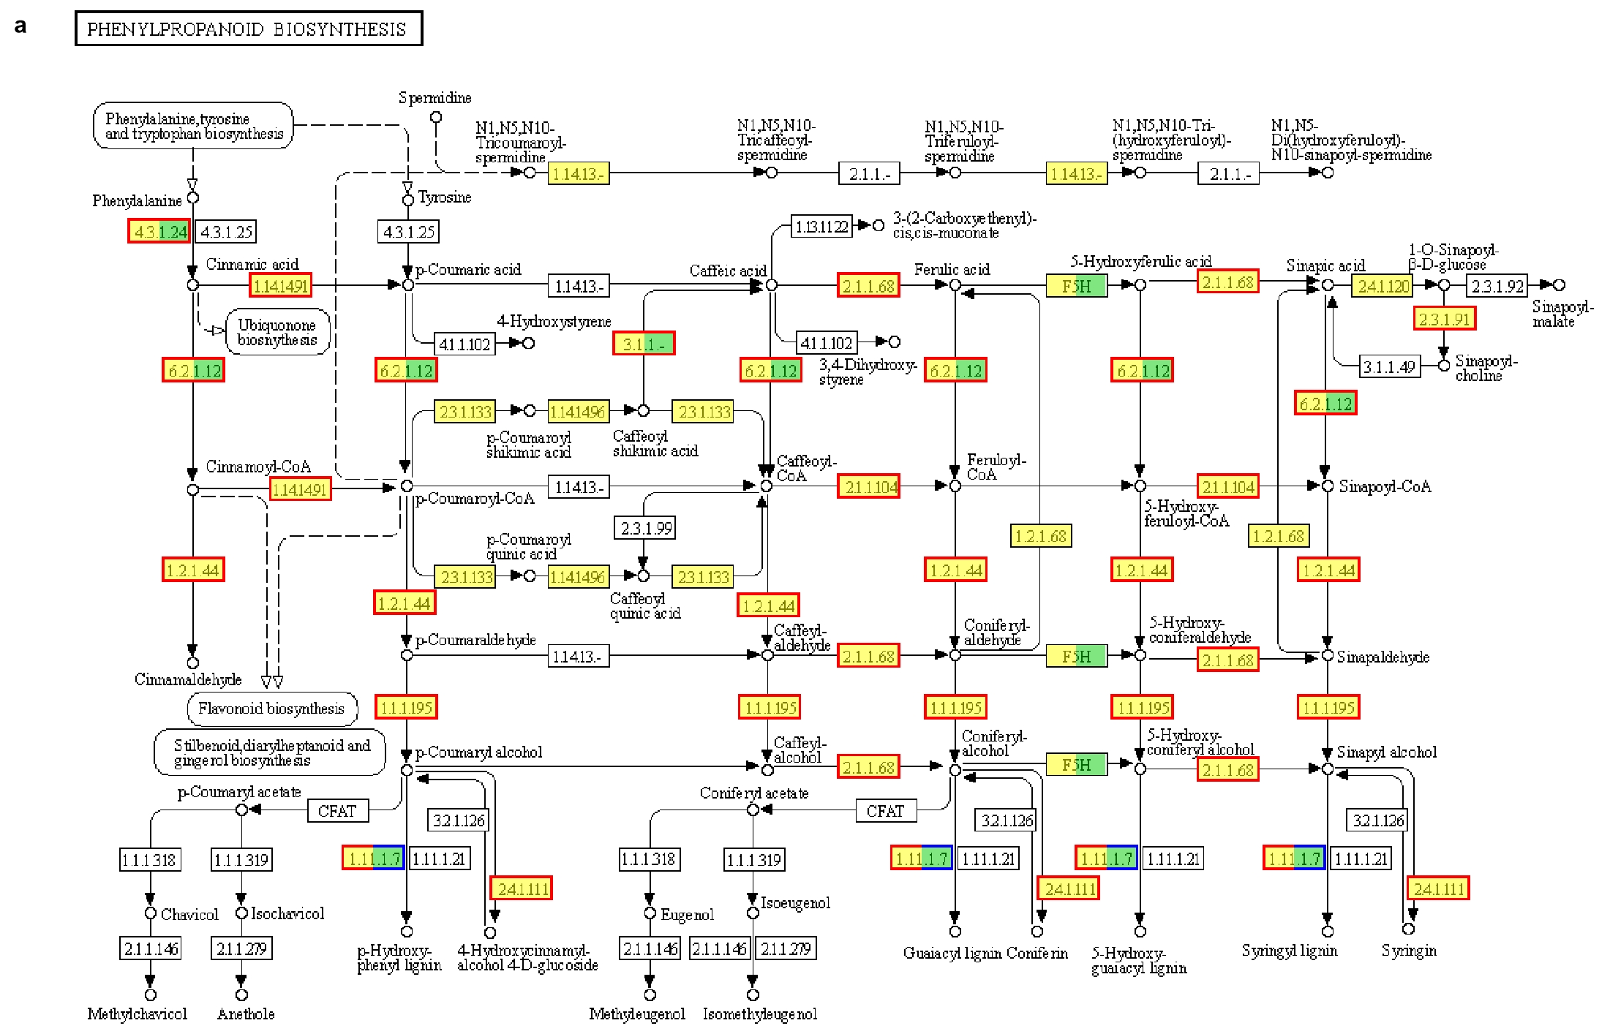
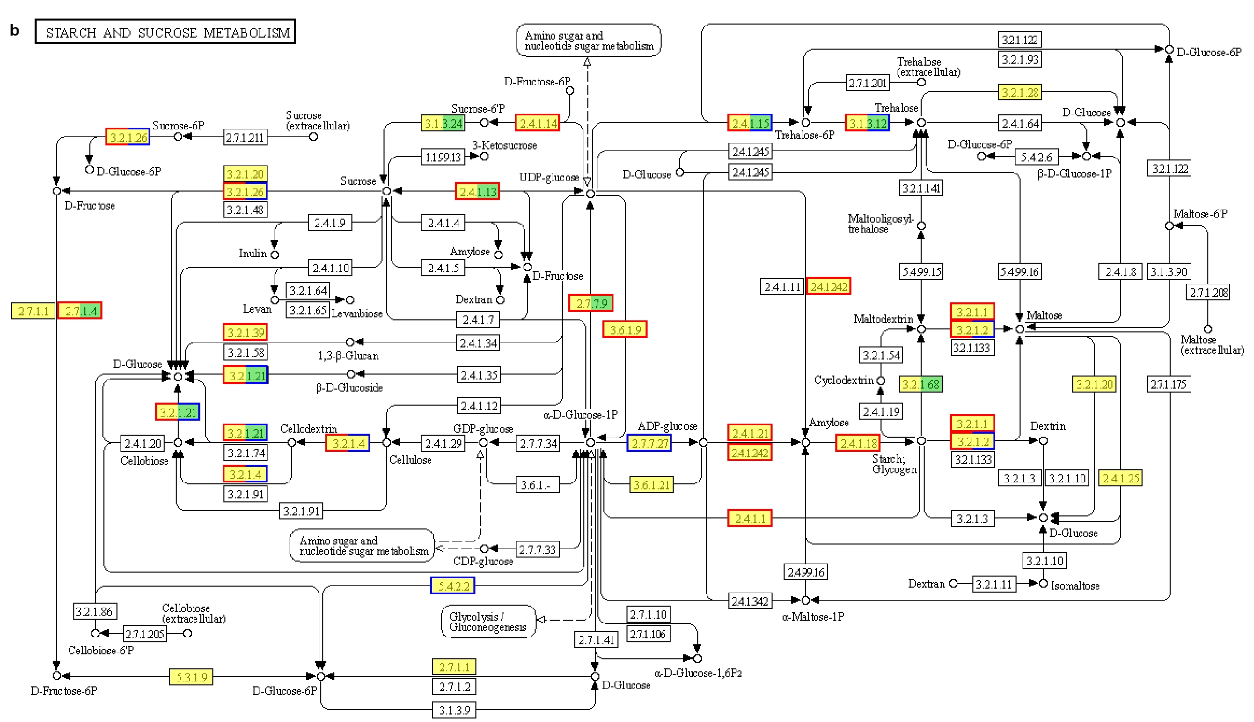
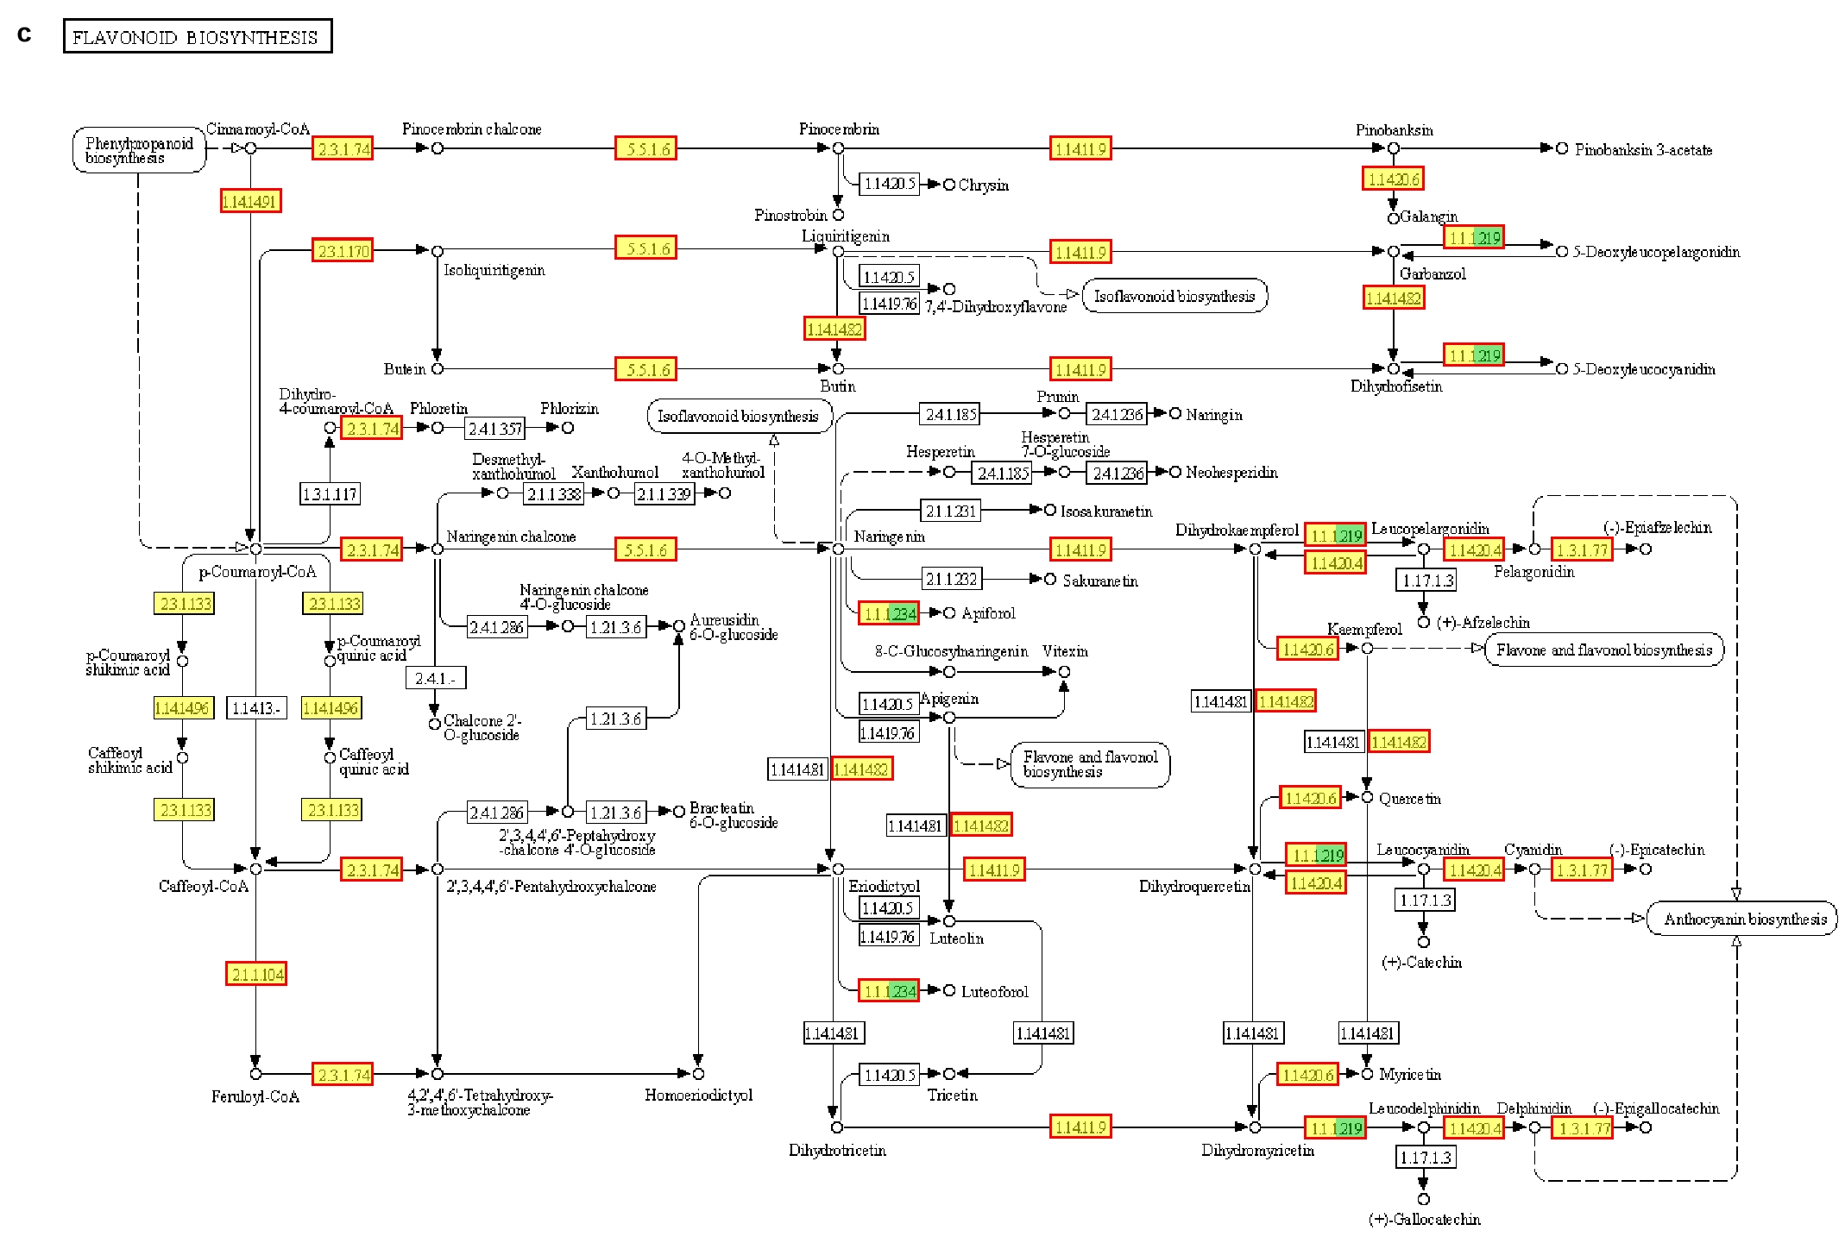

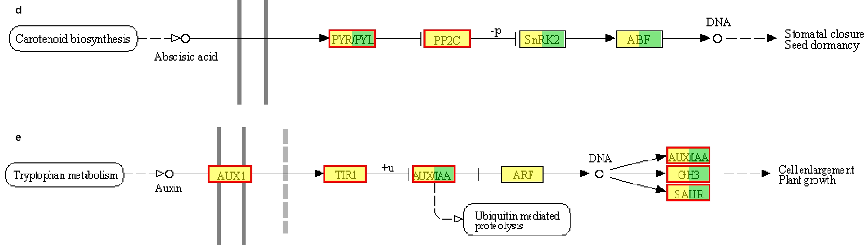
Supplementary Figure 1 Expression profile of pathway. (a) Phenylpropanoid biosynthesis; (b) Stach and sucrose metablism; (c) Flavonoid biosynthesis; (d) Indole-3-acetic acid (IAA) signaling pathway; (e) abscisic acid (ABA) signaling pathway. Solid lines and arrows indicate the signal transduction process and direction. Red frame means up-regulation, Blue frame means down-regulation, Yellow means known genes, Green means new genes.

