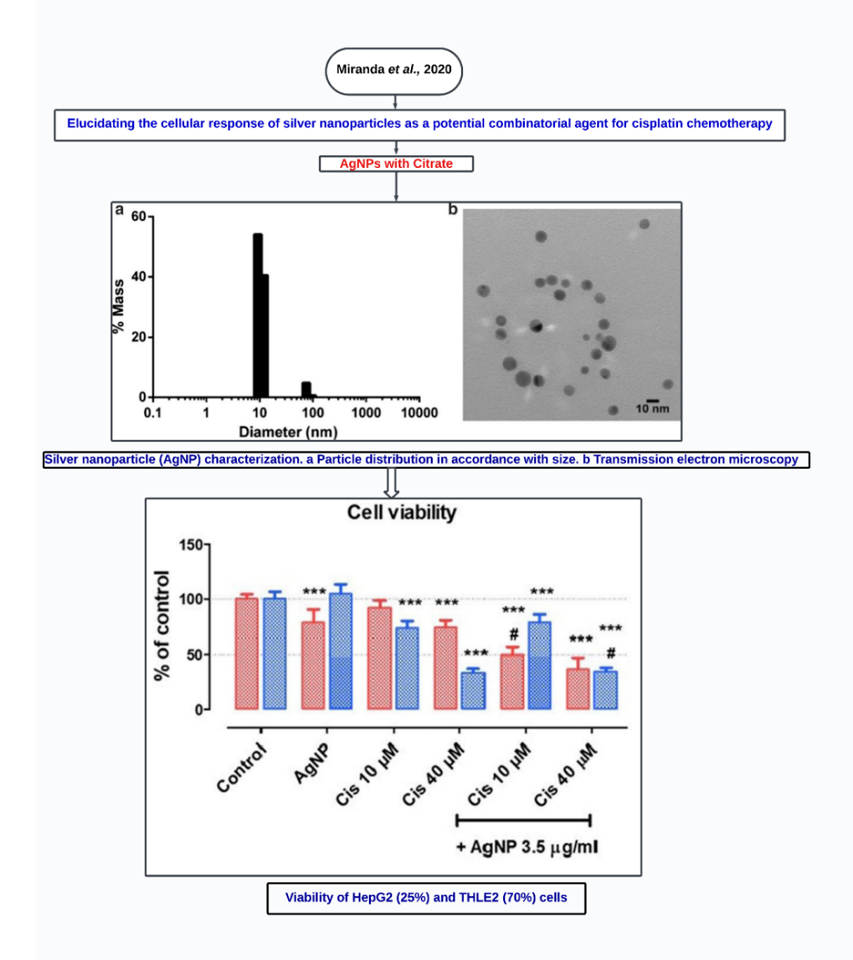
a

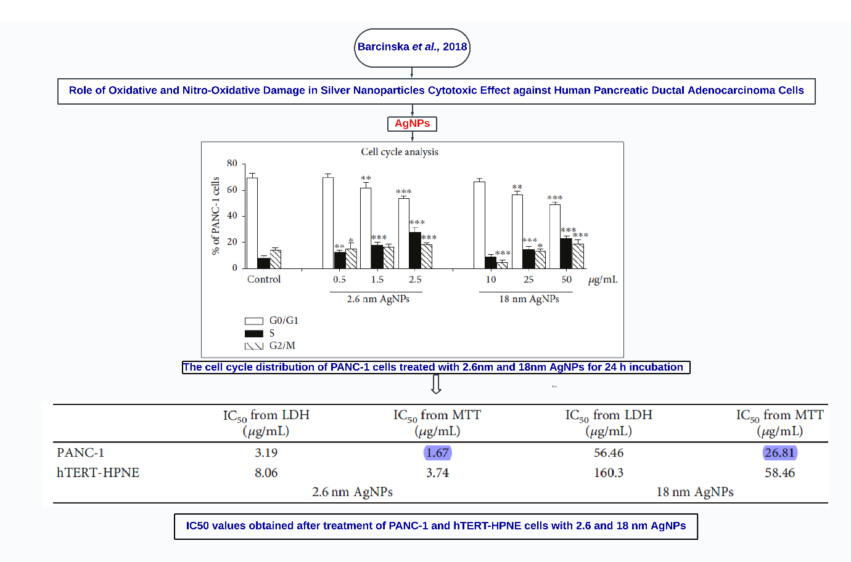
b

Figure S1. Articles summary for a. Miranda et al., 2020 [10] and b. Barcinska et al., 2018 [11]

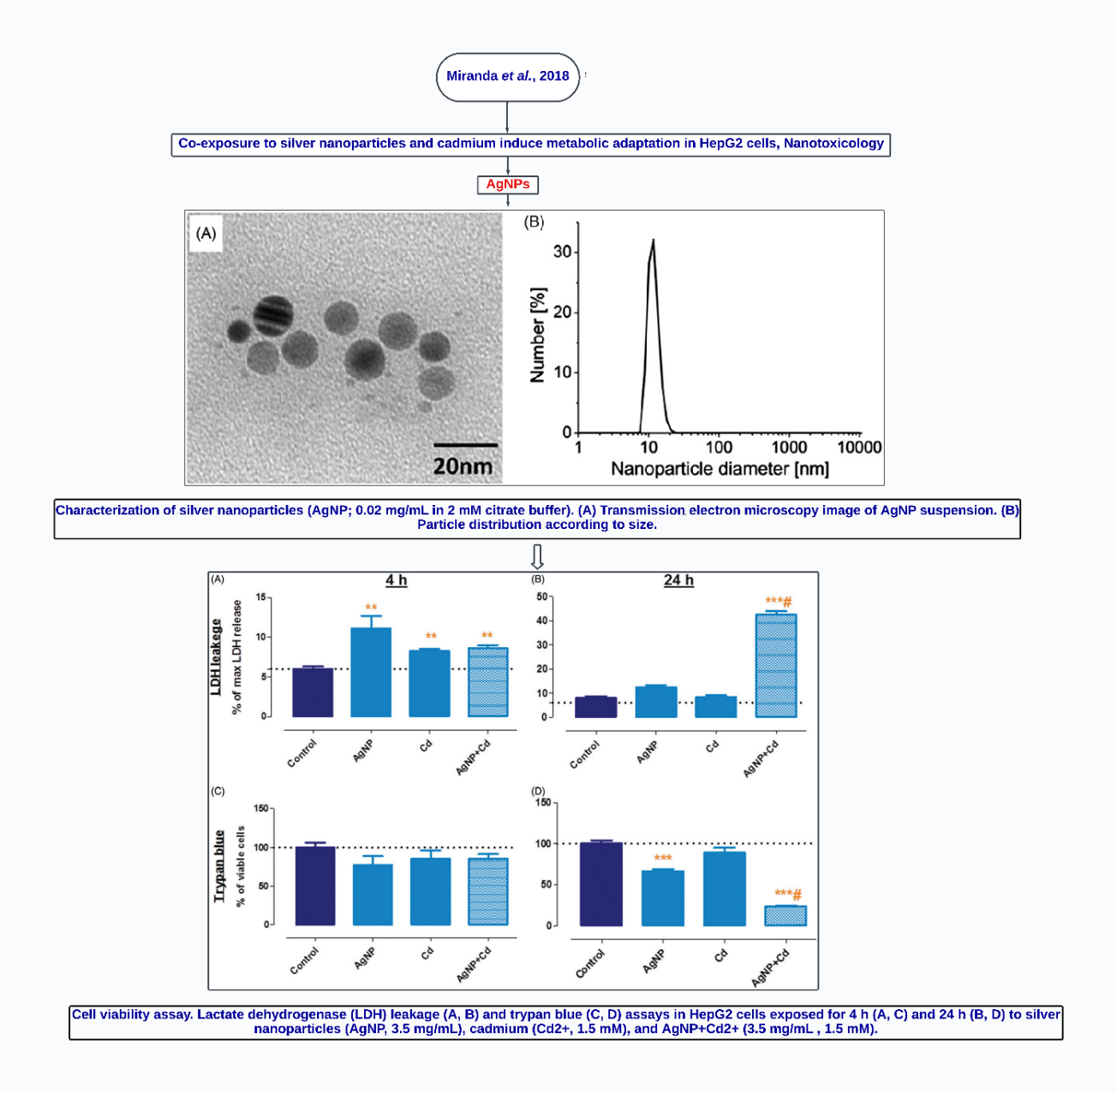
a

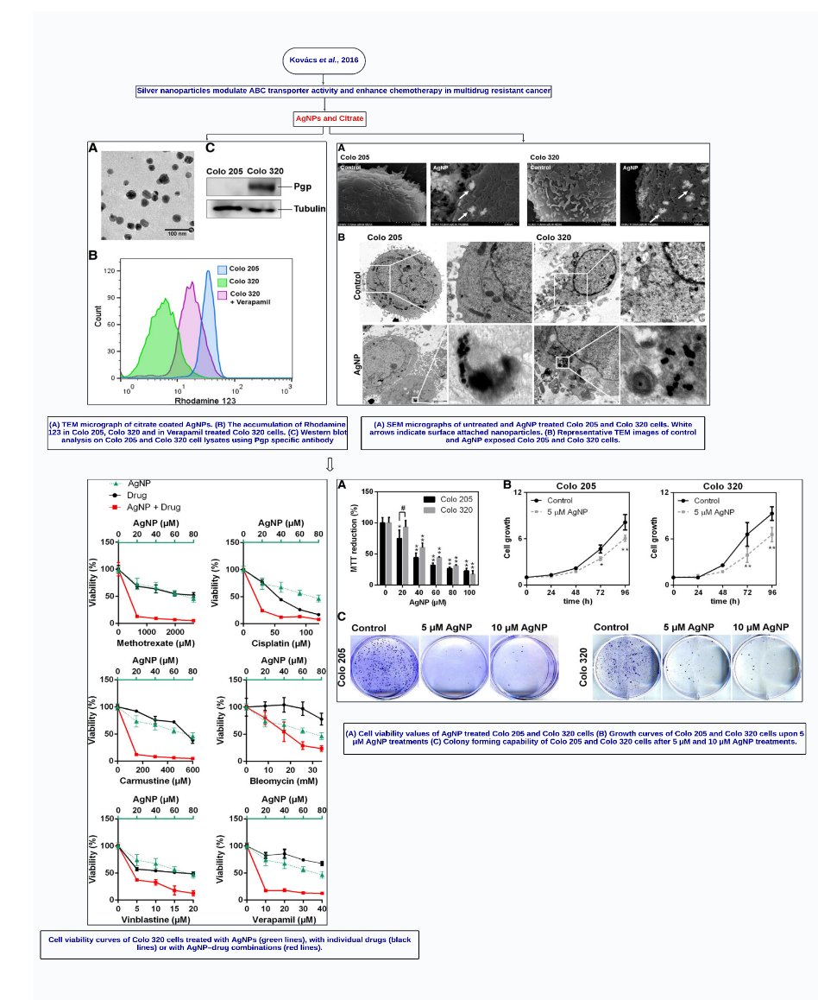
b

Figure S2. articles summary for a. Miranda et al., 2018 [12] and b. Kovács et al. 2016 [13]

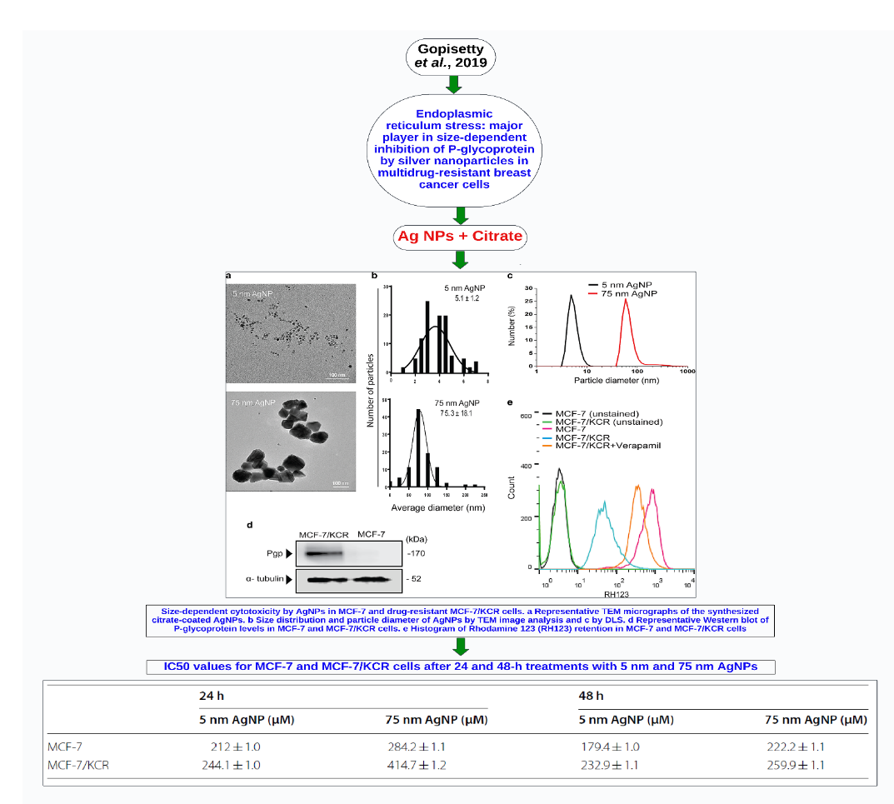
a

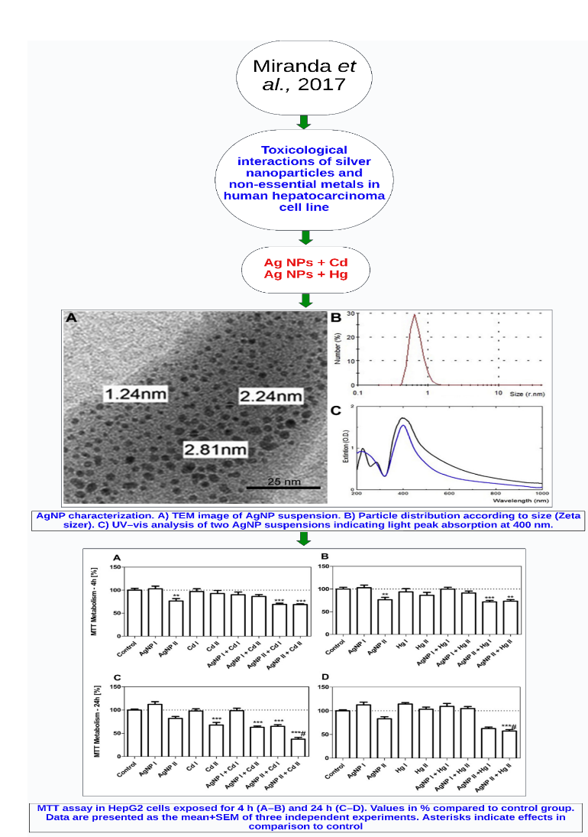
b

Figure S3. articles summary for a. Gopisetty et al., 2019 [14] and b. Miranda et al., 2017 [15]
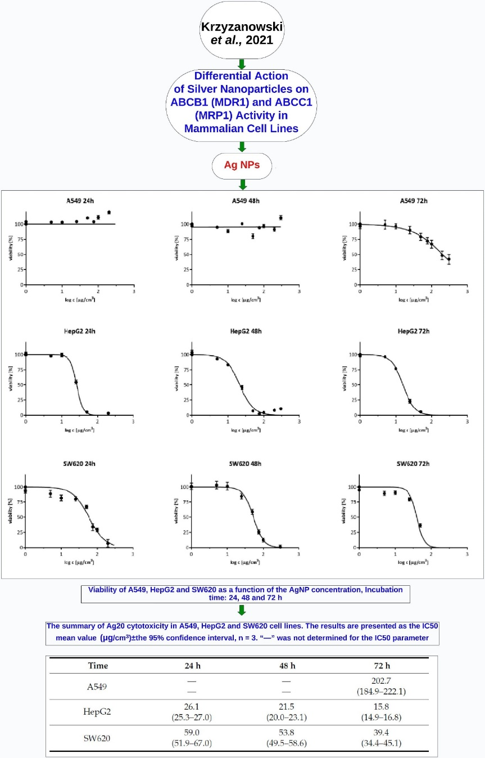
a

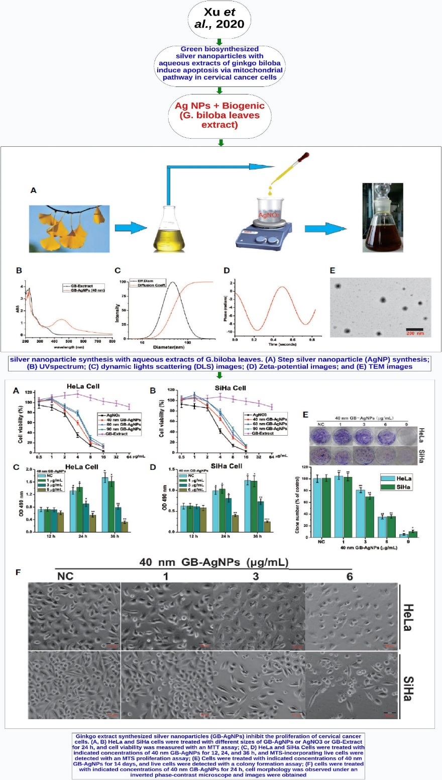
b

Figure S4. Articles summary for a. Krzyzanowski et al. 2021 [16] and b. Xu et al., 2020 [17]
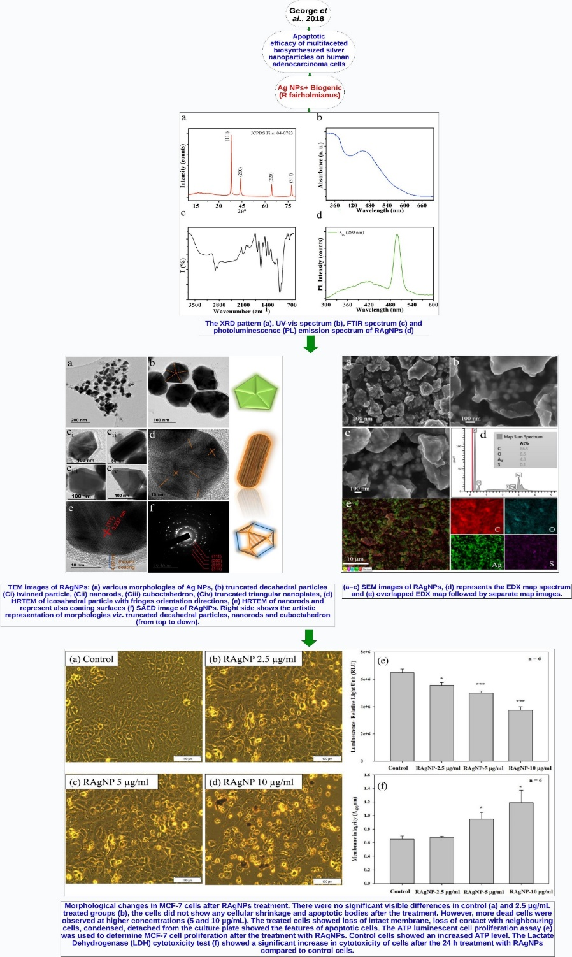
a

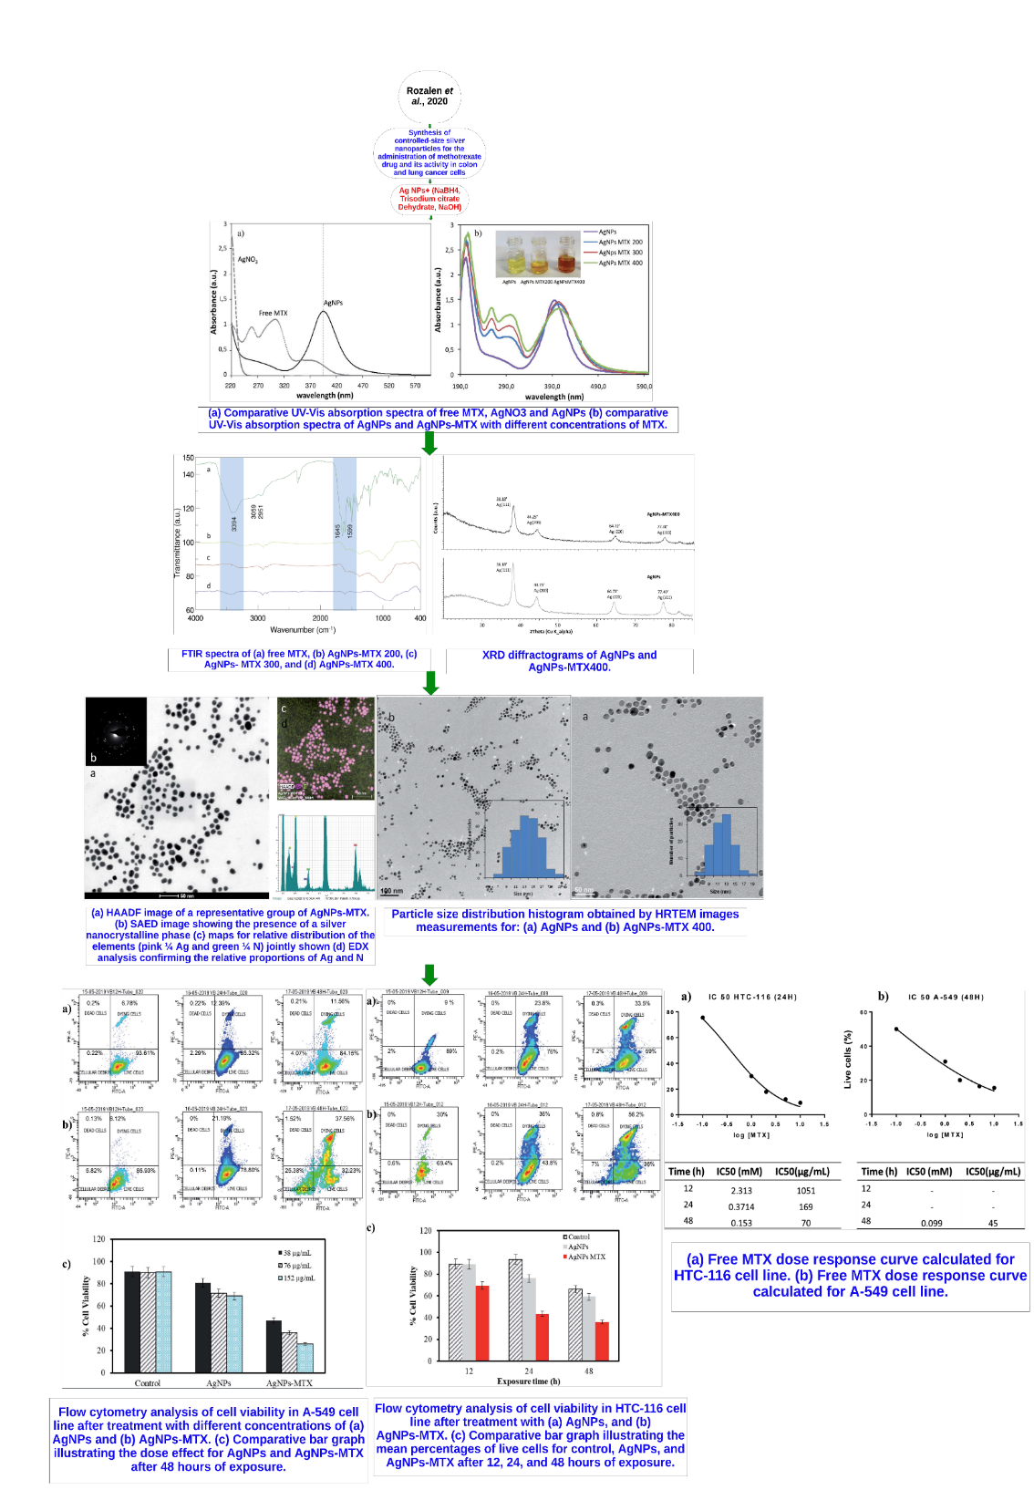
b

Figure S5. articles summary for a. George et al., 2018 [18] and b. Rozalen et al., 2020 [19]
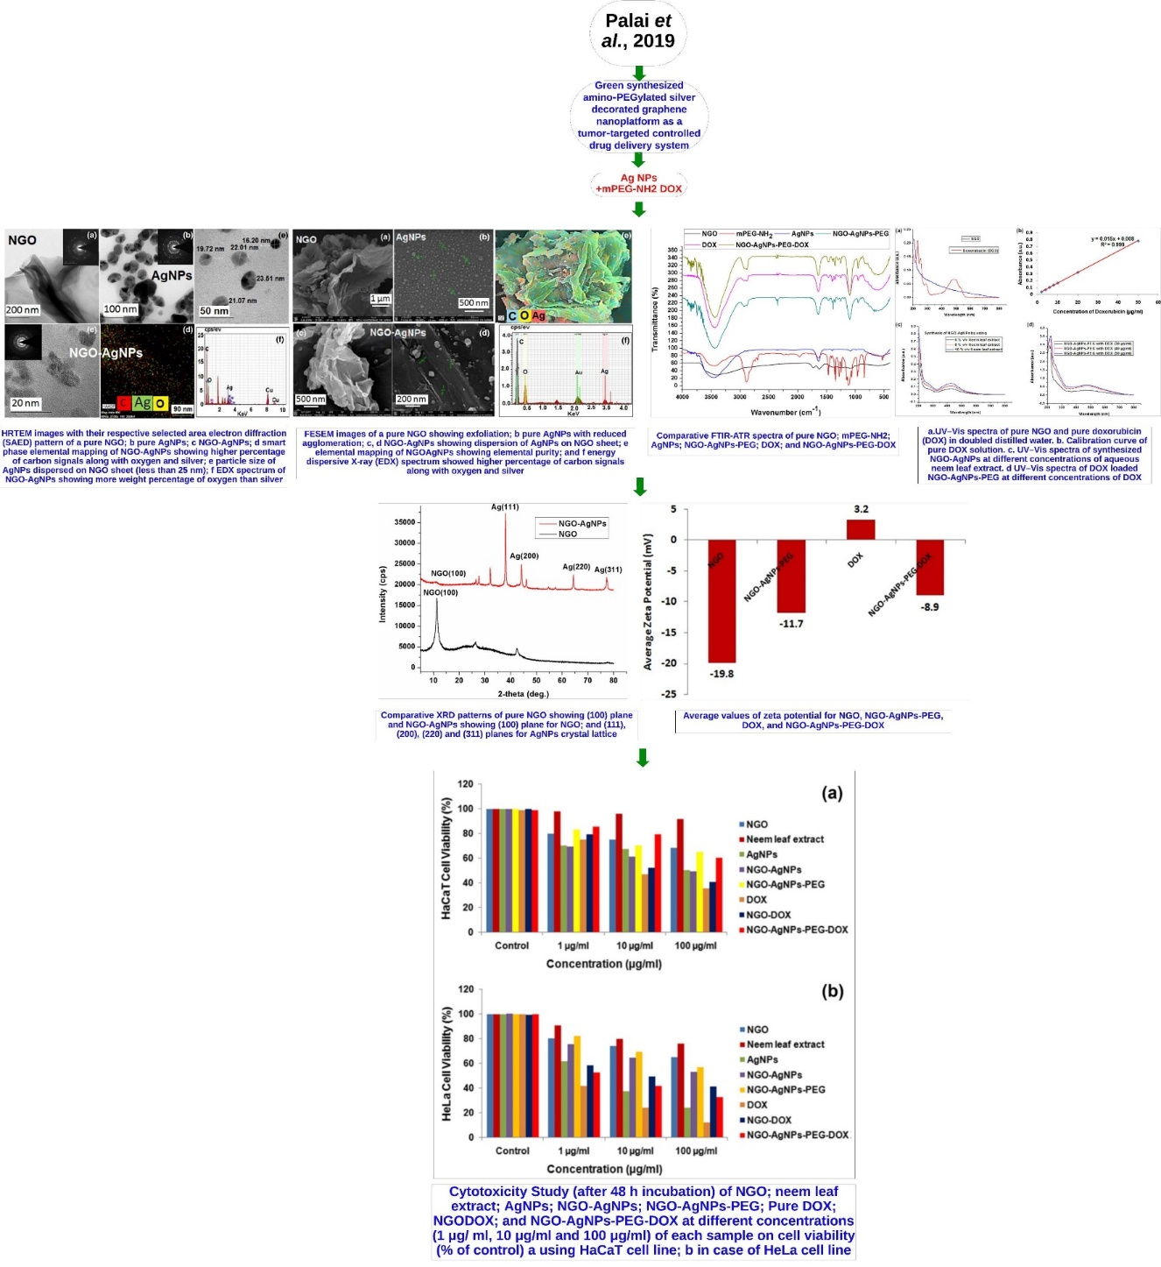
a

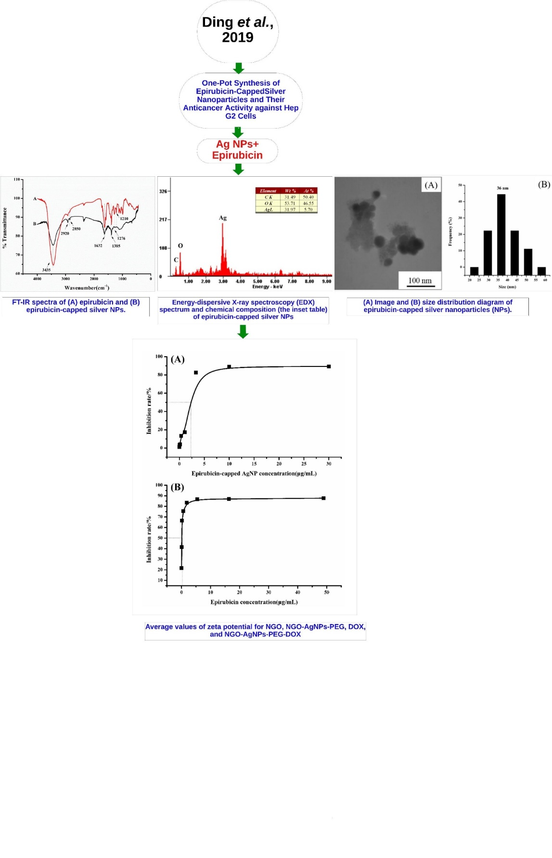
b

Figure S6. articles summary for a. Palai et al., 2019 [20] and b. Ding et al., 2019 [21]

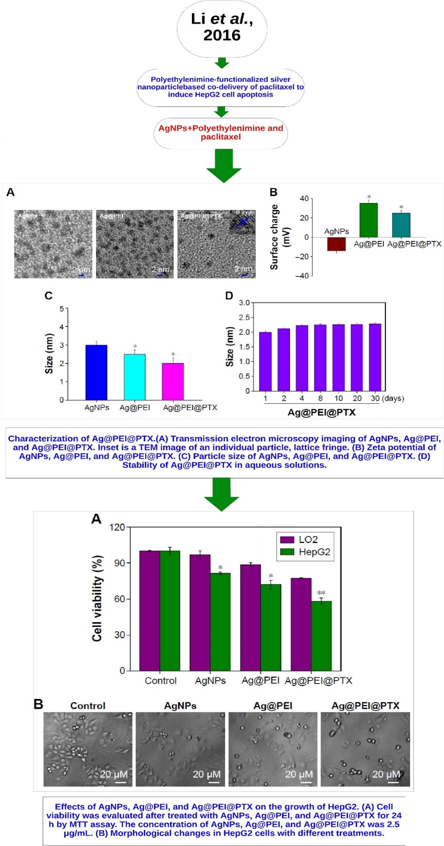
a

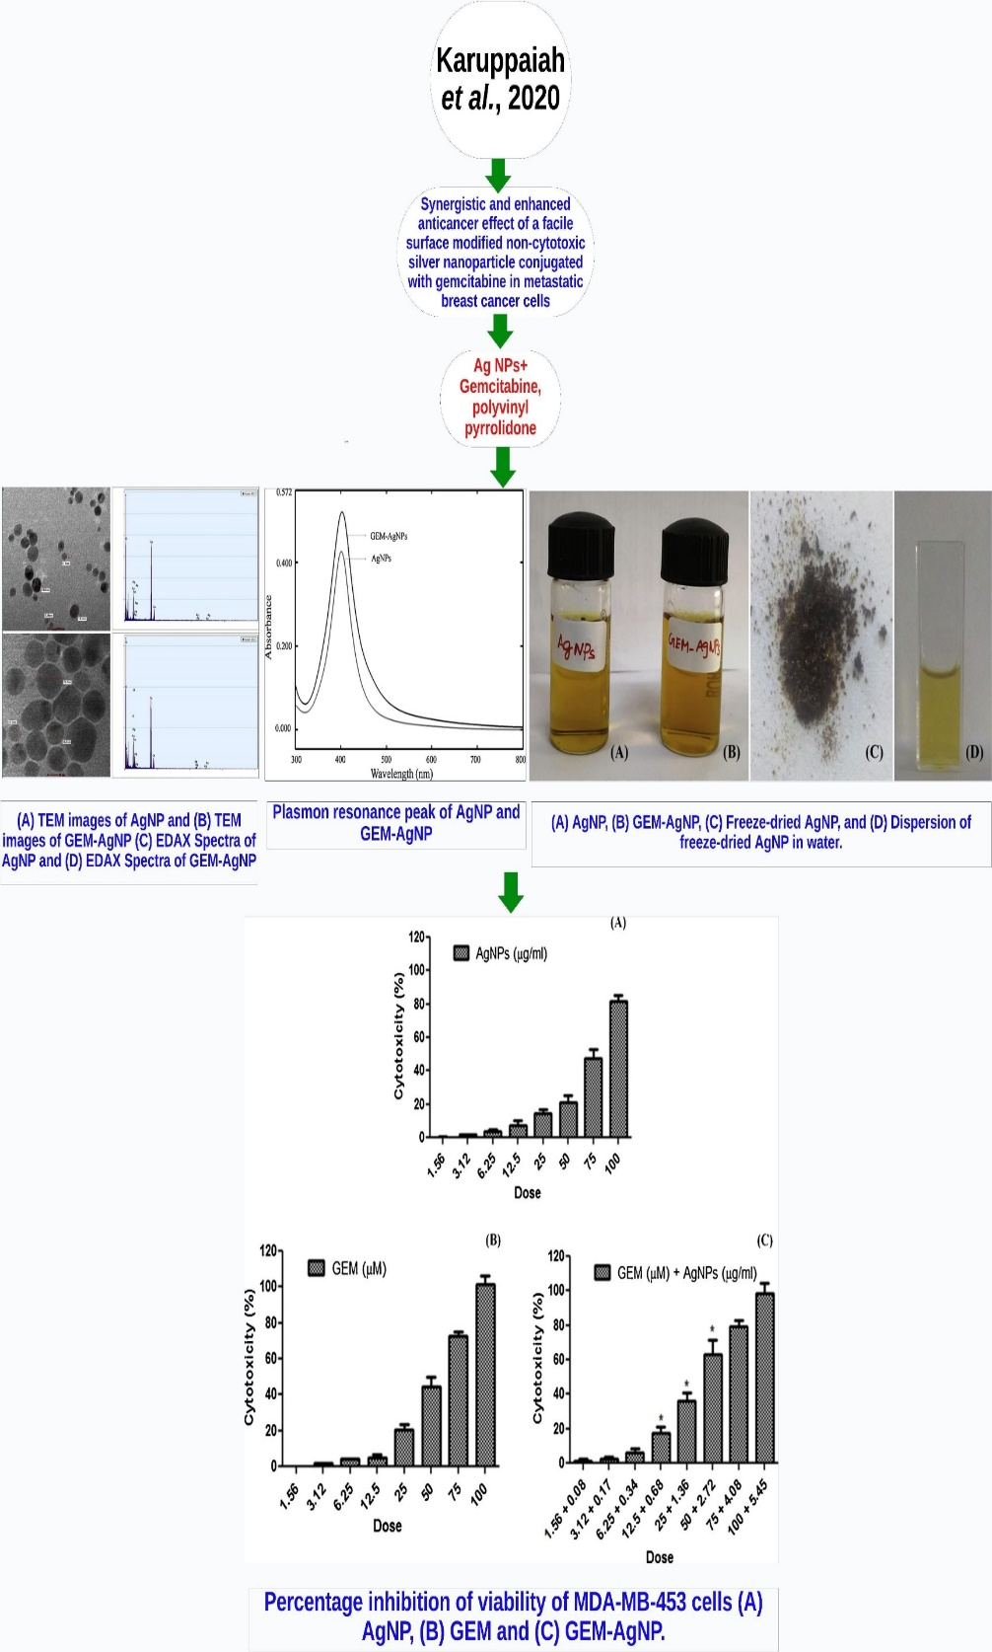
b

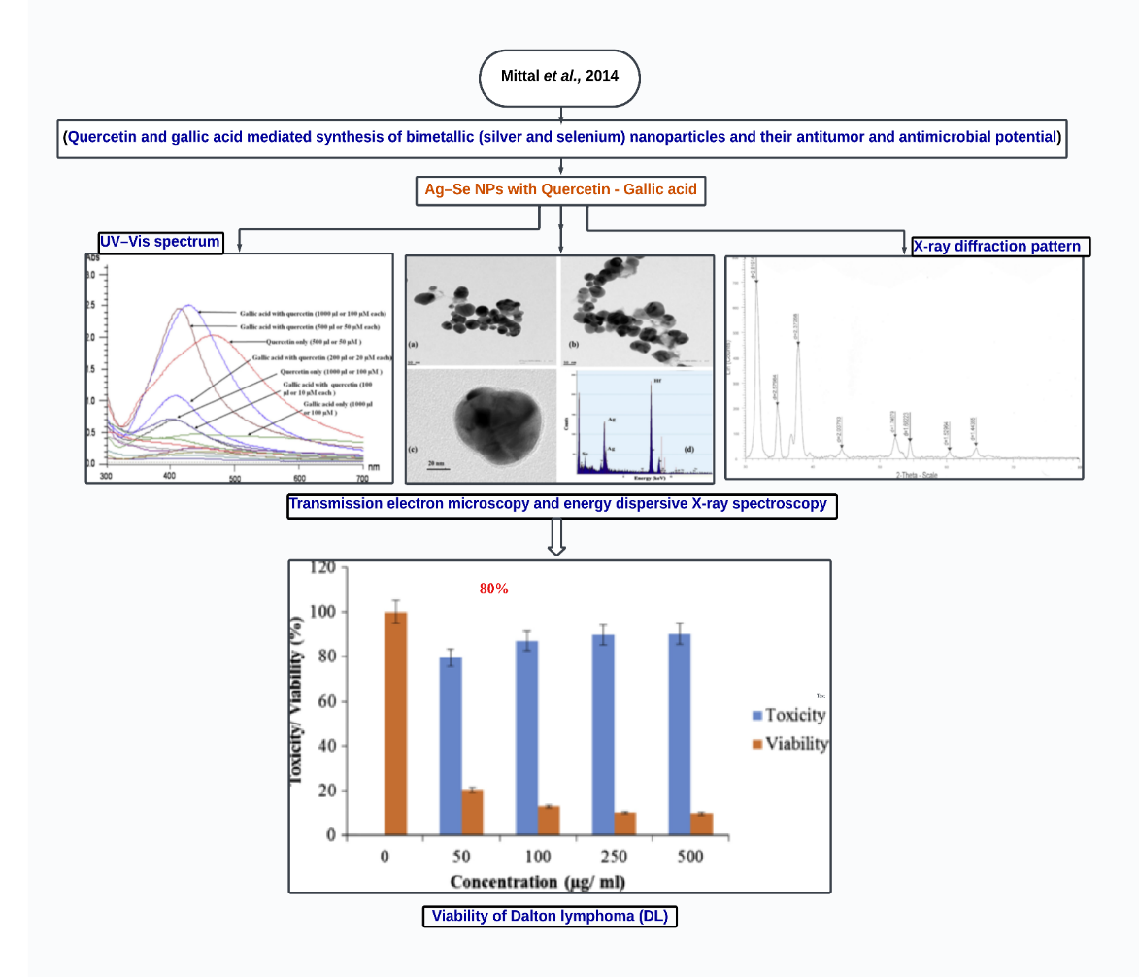
c

Figure S7. articles summary for a. Li et al., 2016 [22], b. Karuppaiah et al. 2020 [23], and Mittal et al., 2014 [24]
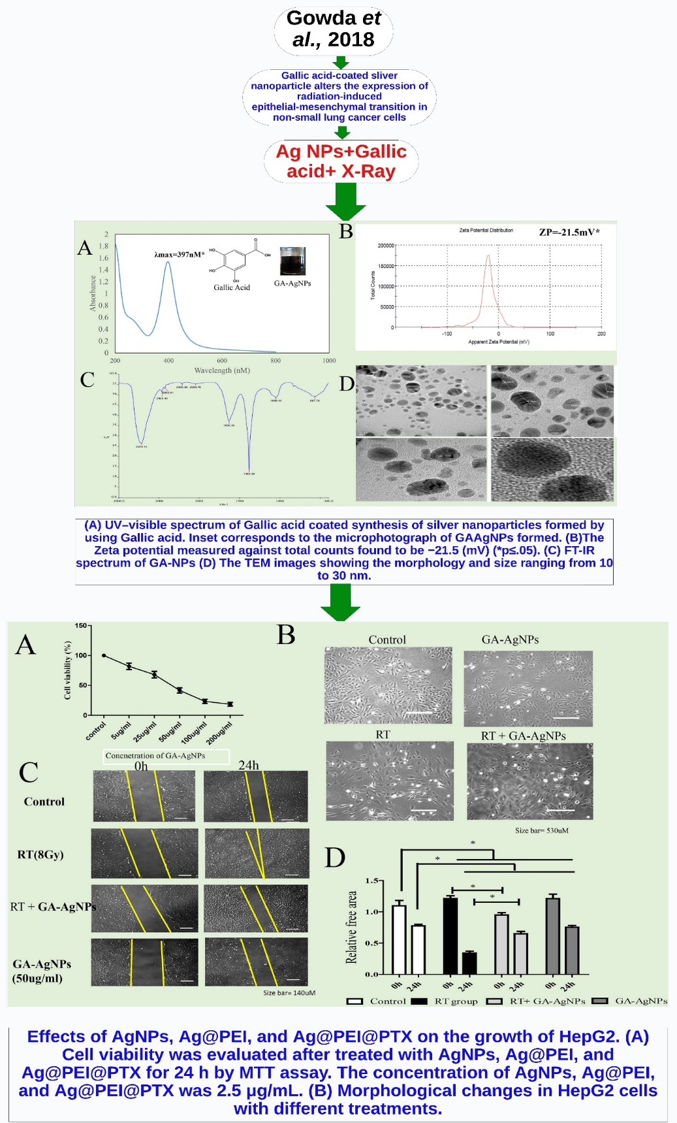
a

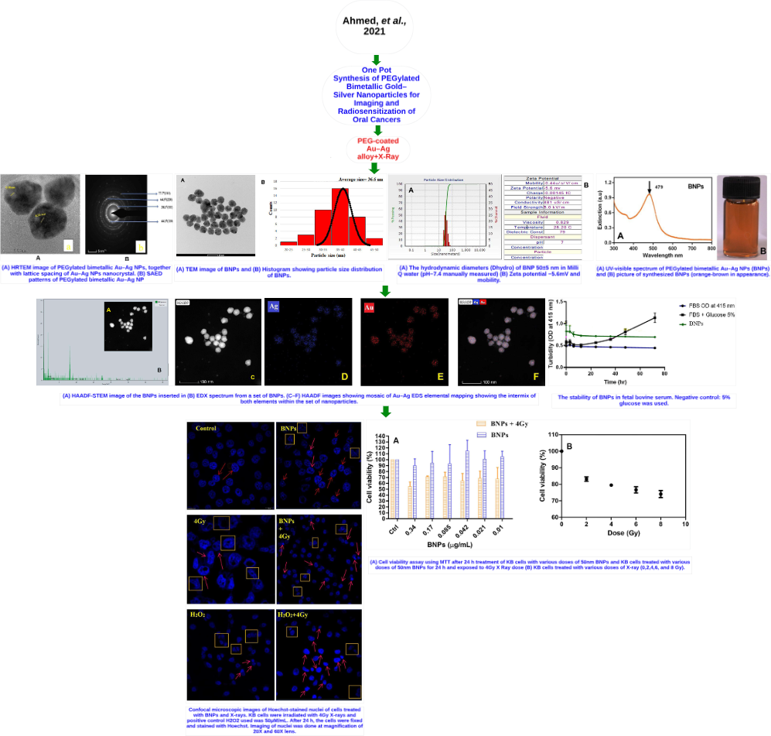
b

Figure S8. articles summary for a. Gowda et al., 2018 [37], and b. Ahmed et al., 2021 [38]
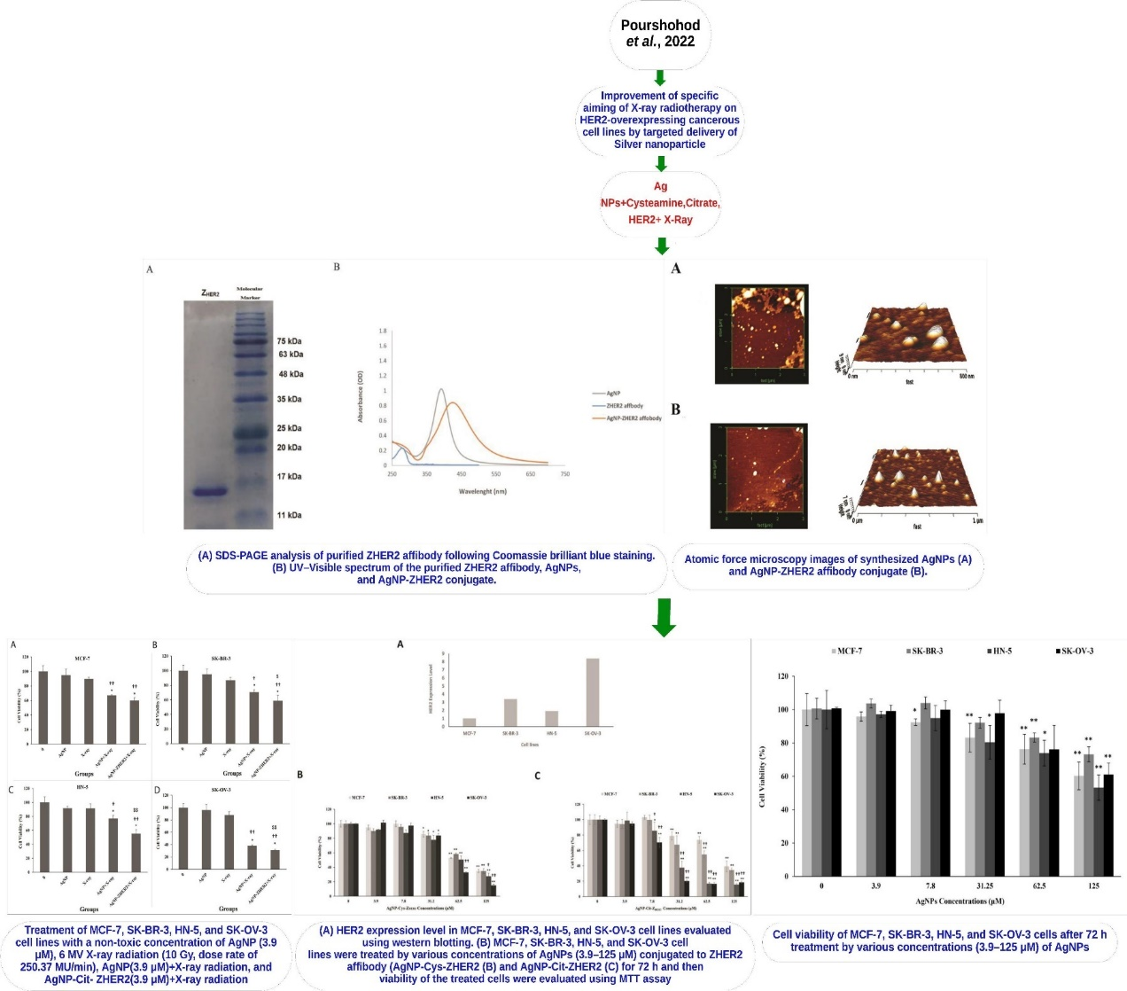
a

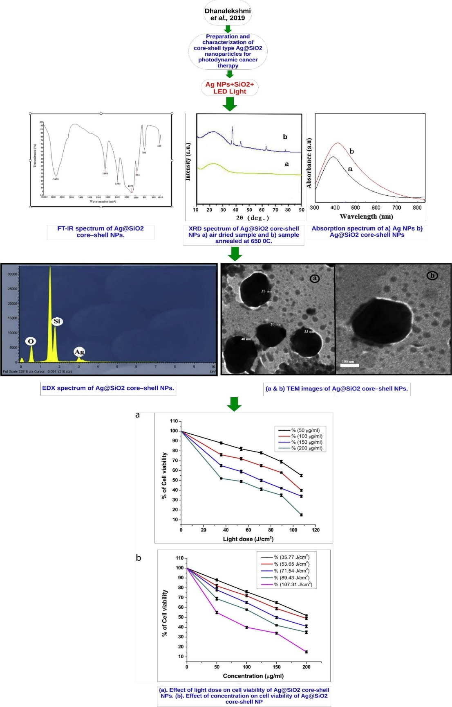
b

Figure S9. articles summary for a. Pourshohod et al., 2022 [39], and b. Dhanalekshmi et al., 2019 [40]

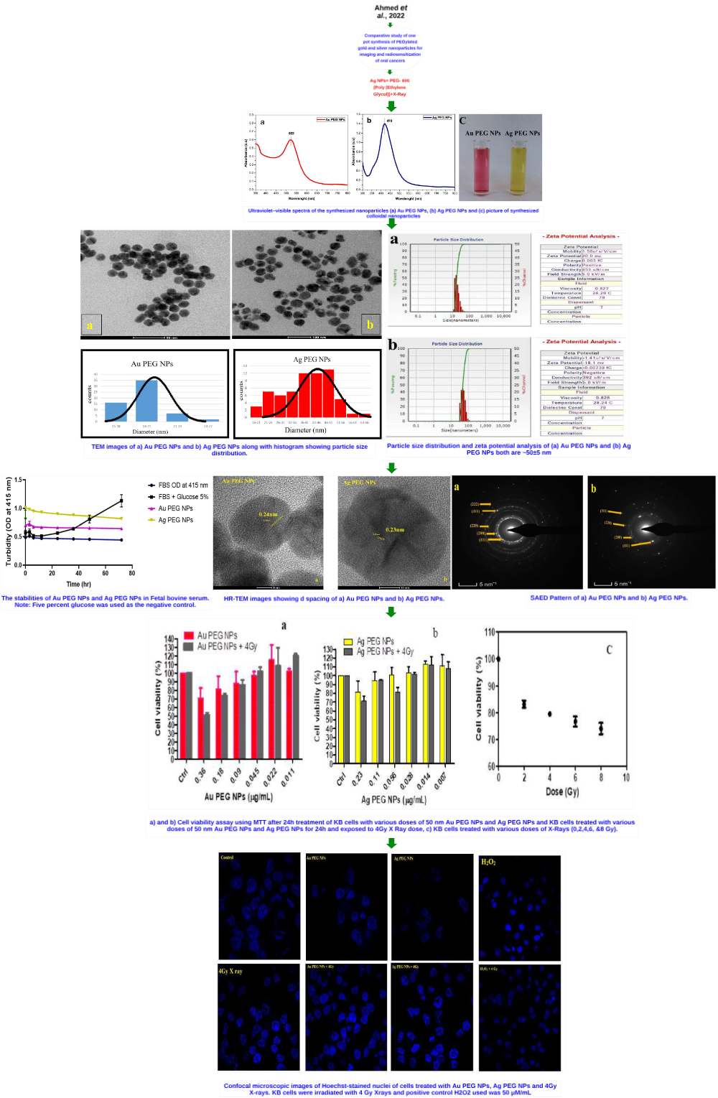
Figure S10. articles summary for Ahmed et al., 2022 [41]

