**Supplementary Materials**

**Imaging the Raf–MEK–ERK signaling cascade in living cells**

Young-Chul Shin1,2, Minkyung Cho1, Jung Me Hwang3, Kyungjae Myung3,4,

Hee-Seok Kweon5, Hyun-A Seong1,*, Zee-Won Lee2,*, and Kyung-Bok Lee5,*

1Department of Biochemistry, School of Life Science, Chungbuk National University, Cheongju 28644, Korea; [cubio072@daum.net](mailto:cubio072@daum.net)(Y.-C.S.); [tin1400@gamil.com](mailto:tin1400@gamil.com) (M.C.)

2bHLBIO, Cheongju 28119, Korea

3Center for Genomic Integrity, Institute for Basic Science (IBS), Ulsan 44919, Korea; hjm072@ibs.re.kr

4Department of Biomedical Engineering, Ulsan National Institute of Science and Technology (UNIST), Ulsan 44919, Korea; kjmyung@unist.ac.kr

5Center for Bio-imaging & Translational Research, Korea Basic Science Institute (KBSI), Cheongju 28119, Korea; [hskweon@kbsi.re.kr](mailto:hskweon@kbsi.re.kr)

*Correspondence; [haseung@chungbuk.ac.kr](mailto:haseung@chungbuk.ac.kr); Tel.: +82-43-261-2308 (H.-A.S.);

[ezone@bhlbio.com](mailto:ezone@bhlbio.com); Tel.: +82-43-240-5369 (Z.-W.L.);

[kblee@kbsi.re.kr](mailto:kblee@kbsi.re.kr); Tel.: +82-43-240-5442 (K.-B.L.)

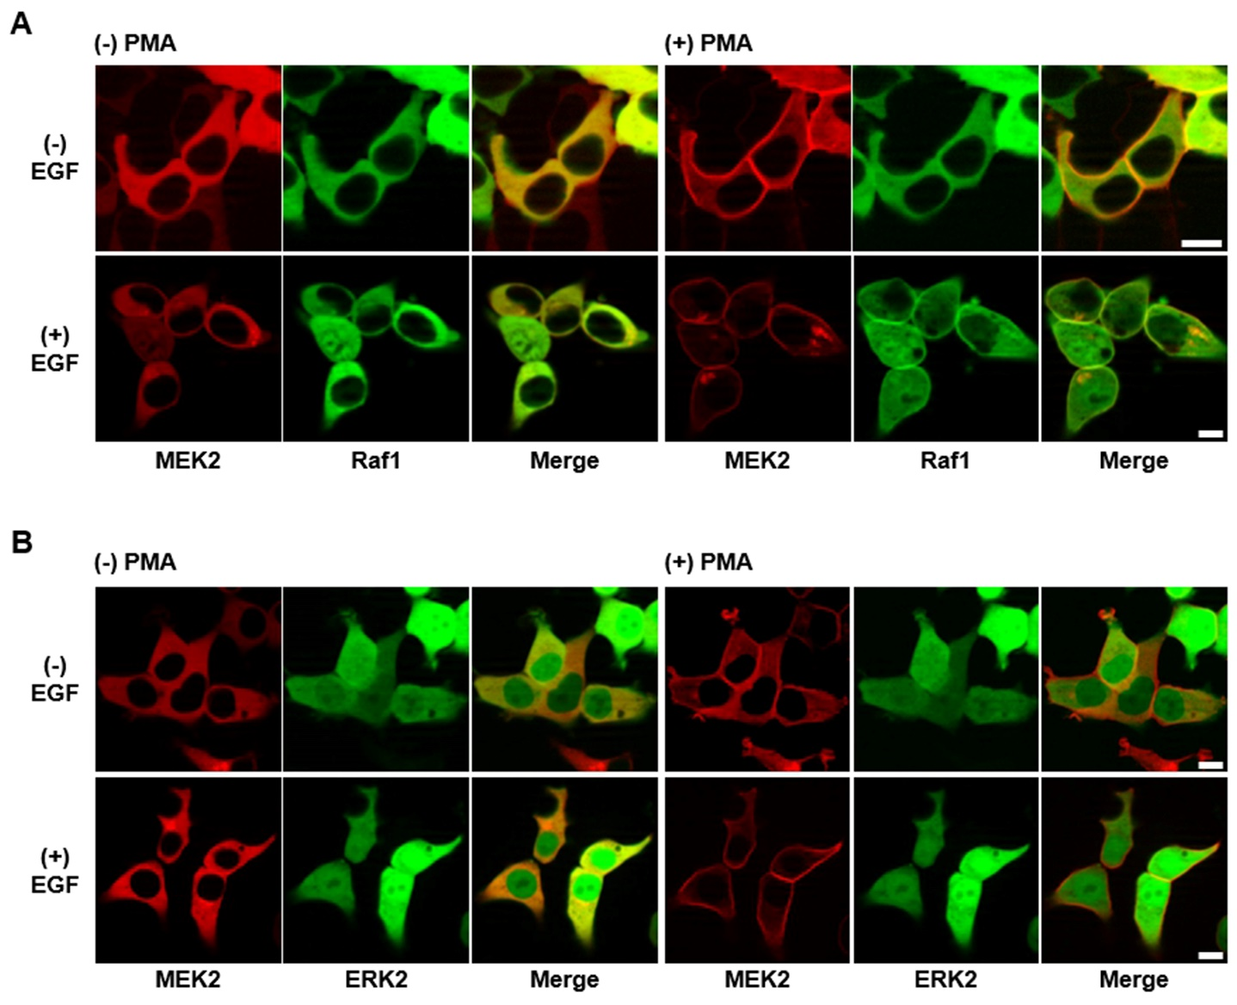

**Figure S1.** Confocal images of the RAF–MEK–ERK signaling cascade in living cells without exogenous expression of scaffold proteins. HEK-293T cells were co-transfected with PKC–mRFP–MEK2 (bait) and each of eGFP–Raf1 and eGFP–ERK2 (prey). Transiently co-transfected cells were serum starved for 16 – 18 h in serum-free DMEM before stimulation with EGF. After induction with 100 ng/mL of EGF for 5 min, cells were treated with PMA (final concentration 1 mM) in serum-free DMEM. (A) Without serum stimulation, only MEK protein was translocated to the plasma membrane (top row); with EGF stimulation, Raf1 and MEK2 were co-translocated to the plasma membrane (bottom row). (B) Interaction between MEK2 and ERK2 was not observed under either condition. The scale bar is 10 m.

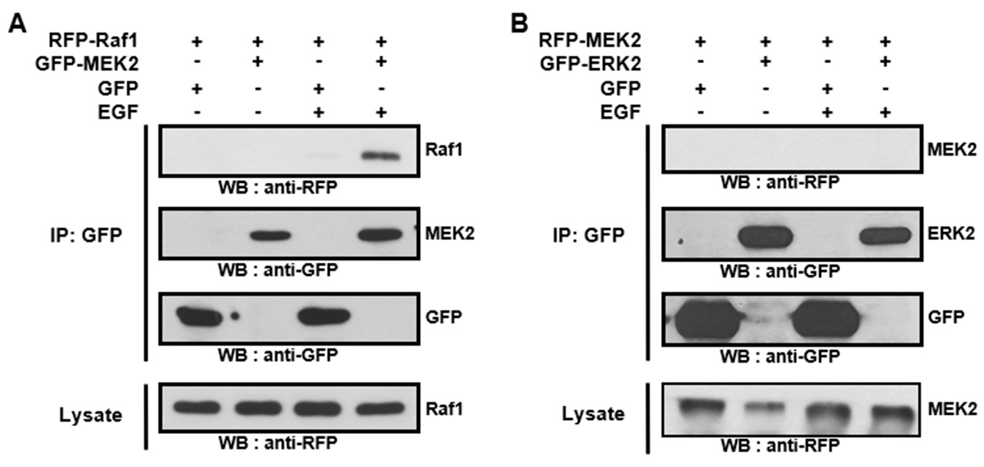

**Figure S2.** HEK-293T cells were transiently co-transfected with either mRFP–Raf1/eGFP–MEK2 (A) or mRFP–MEK2/eGFP–ERK2 (B). Transiently co-transfected cells were serum starved overnight in serum-free DMEM and then stimulated with EGF. Co-immunoprecipitation assay showed an interaction between Raf1 and MEK2 (A) but not between MEK2 and ERK2 (B).

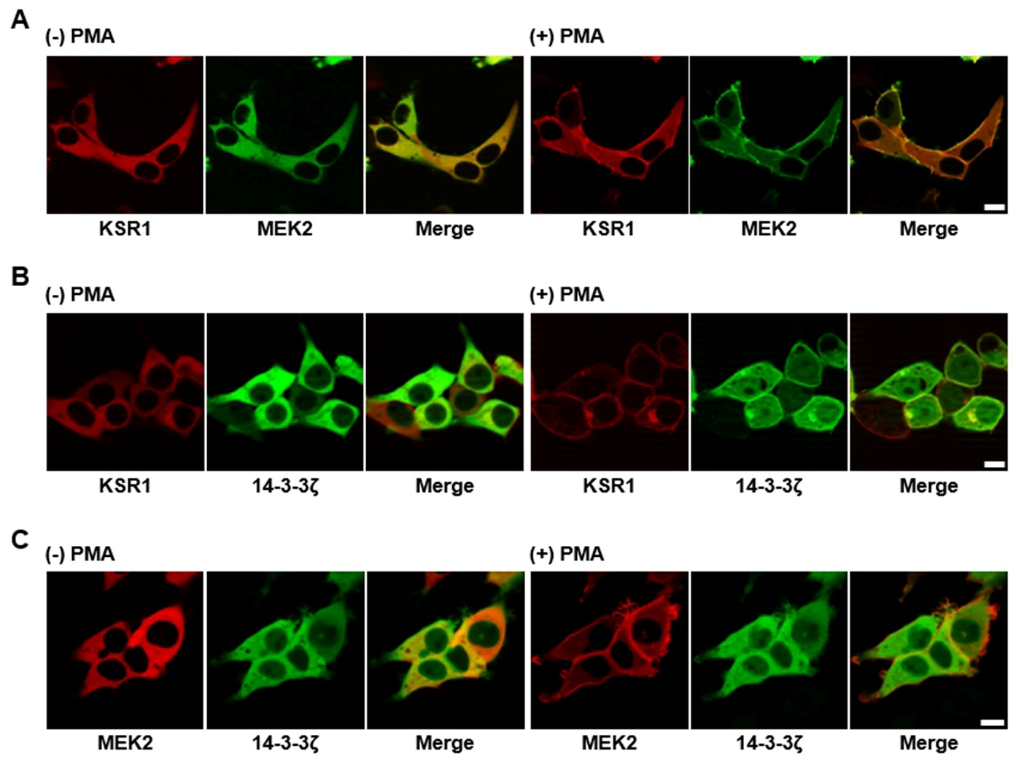

**Figure S3.** HEK-293T cells were transiently co-transfected with the following protein pairs: PKC–mRFP–KSR1/eGFP–MEK2 (A), PKC–mRFP–KSR1/eGFP–14-3-3ζ (B), and PKC–mRFP–MEK2/eGFP–14-3-3ζ (C). After PMA treatment, (A) KSR1 and MEK2 were co-translocated to the plasma membrane, exhibiting a constitutive interaction, (B) KSR1 and 14-3-3ζ were co-translocated to the plasma membrane with an interaction between them, and (C) No interaction was observed between MEK2 and 14-3-3ζ. The scale bar is 10 m.

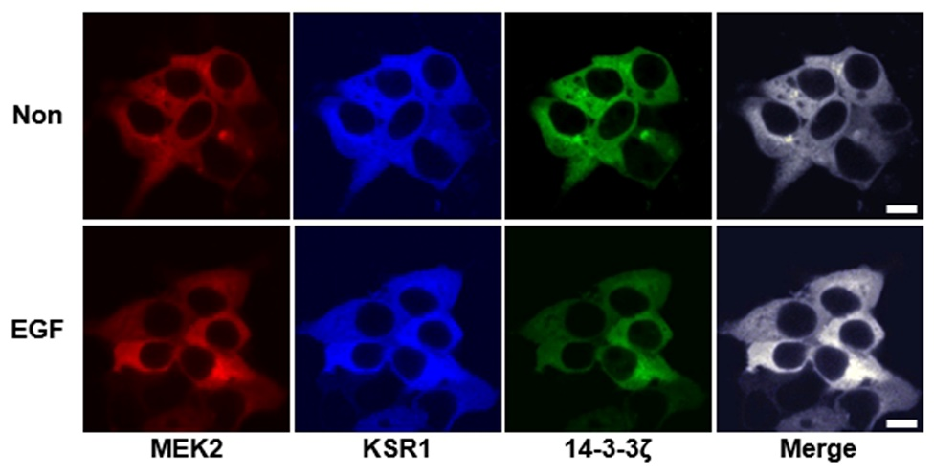

**Figure S4.** HEK-293T cells were transiently co-transfected with PKC–mRFP–MEK2/TagBFP–KSR1/eGFP–14-3-3ζ. Cells overexpressing MEK/KSR/14-3-3 were imaged without (top row) or with EGF stimulation (bottom row). The scale bar is 10 m.

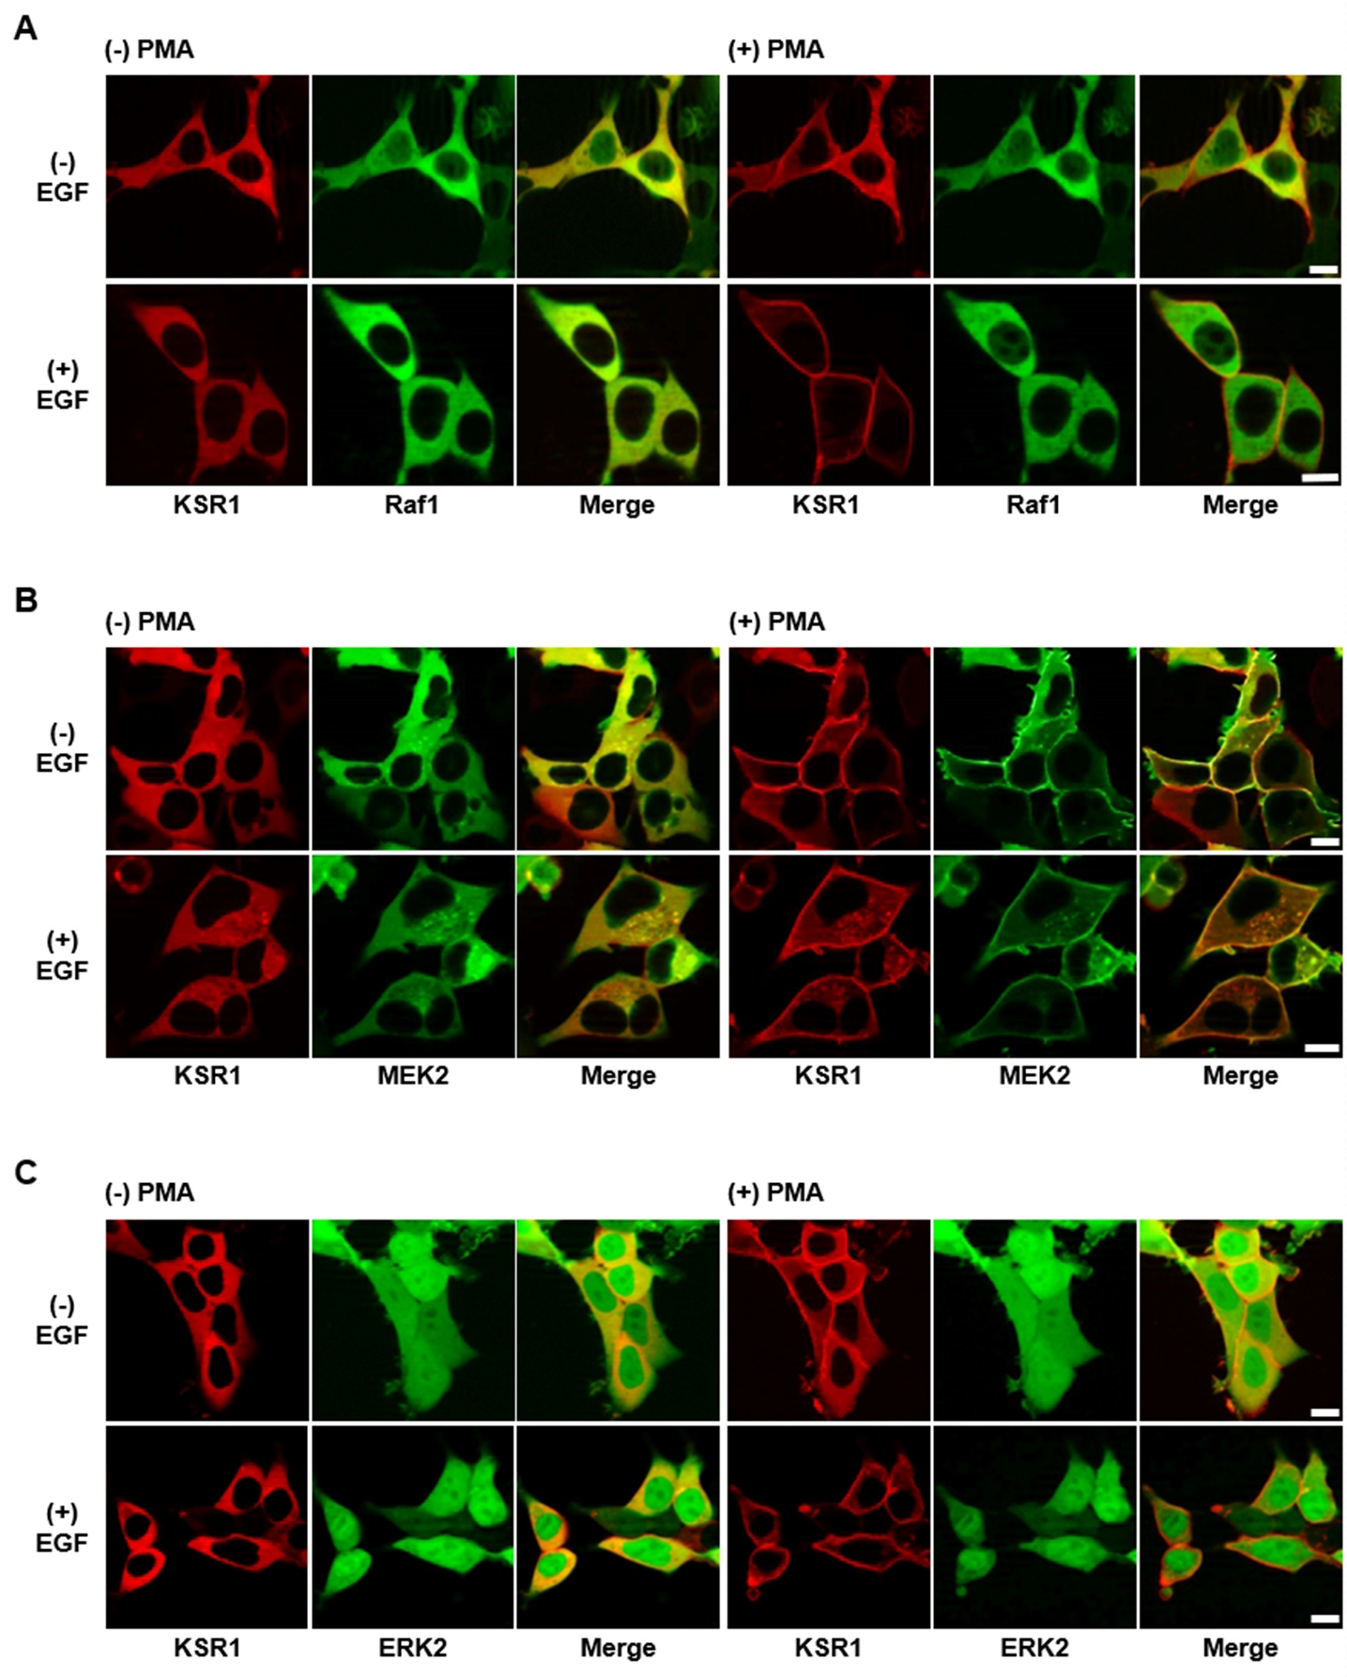

**Figure S5.** HEK-293T cells were transiently co-transfected with PKC–mRFP–KSR1 and each of eGFP–Raf1, eGFP–MEK2, and eGFP–ERK2. The cells were then serum starved, stimulated with EGF, and treated with PMA. KSR1 translocation to the plasma membrane was observed with or without serum stimulation (A, B, and C), only the MEK protein was bound to KSR1 under either condition (B). The scale bar is 10 m.

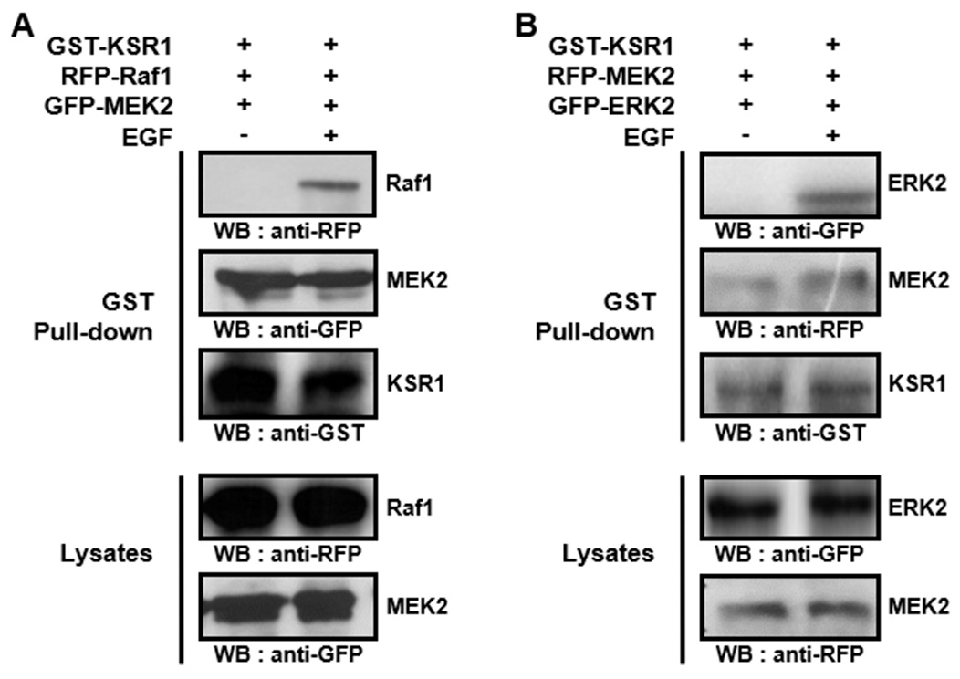

**Figure S6.** HEK-293T cells were transiently co-transfected with either GST–KSR1/mRFP–Raf1/eGFP–MEK2 (A) or GST–KSR1/mRFP–MEK2/eGFP–ERK2 (B). Transiently co-transfected cells were serum starved overnight in serum-free DMEM and then stimulated with EGF. GST pull-down assays showed that KSR1 interacted with both Raf1 and MEK2 (A), and with both MEK2 and ERK2 (B).

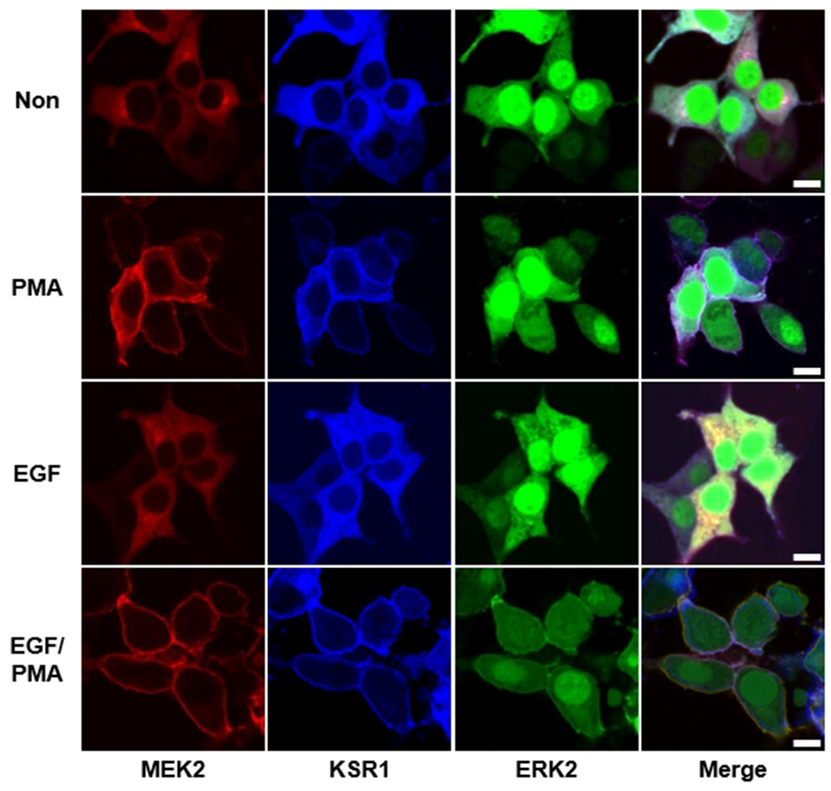

**Figure S7.** HEK-293T cells were transiently co-transfected with PKC–mRFP–MEK2, TagBFP–KSR1, and eGFP–ERK2. Cells overexpressing MEK/KSR/ERK were imaged without (second row) or with EGF stimulation (bottom row). In the absence of serum stimuli, only the KSR/MEK protein complex was co-translocated to the plasma membrane (second row). The ternary protein complex, MEK2/KSR1/ERK2, was co-translocated to the plasma membrane in the presence of serum stimuli (bottom row). The scale bar is 10 m.