**Supporting Information**

**Seasonal variations of sediment fungal community of a shallow lake in north China**

**The file includes:**

**6 pages**

**Table S1 to S4**

**Figure S1 to S2**

**Table S1**. Pearson relationships of the environmental factors of Baiyangdian Lake sediments

|  |  |  |  |  |  |  |  |  |  |  |  |  |  |  |  |  |  |  |  |  |  |  |
| --- | --- | --- | --- | --- | --- | --- | --- | --- | --- | --- | --- | --- | --- | --- | --- | --- | --- | --- | --- | --- | --- | --- |
|  | T | TP | Res-P | HCl-P | NaOH-P | BD-P | NH4Cl-P | TN | NO3- | NH4+ | pH | TOC | As | Cd | Cr | Cu | Pb | Zn | Co | Mn | Ni | Fe |
| T | 1 |  |  |  |  |  |  |  |  |  |  |  |  |  |  |  |  |  |  |  |  |  |
| TP | 0.10 | 1 |  |  |  |  |  |  |  |  |  |  |  |  |  |  |  |  |  |  |  |  |
| Res-P | -0.13 | **0.80\*\*** | 1 |  |  |  |  |  |  |  |  |  |  |  |  |  |  |  |  |  |  |  |
| HCl-P | 0.13 | **0.98\*\*** | 0.67* | 1 |  |  |  |  |  |  |  |  |  |  |  |  |  |  |  |  |  |  |
| NaOH-P | 0.41** | 0.76** | 0.60* | 0.70** | 1 |  |  |  |  |  |  |  |  |  |  |  |  |  |  |  |  |  |
| BD-P | 0.07 | 0.36** | -0.15 | 0.49** | 0.06 | 1 |  |  |  |  |  |  |  |  |  |  |  |  |  |  |  |  |
| NH4Cl-P | 0.23* | 0.03 | -0.28* | 0.13 | -0.15 | 0.48** | 1 |  |  |  |  |  |  |  |  |  |  |  |  |  |  |  |
| TN | -0.16 | -0.10 | -0.24* | -0.04 | -0.24* | 0.42** | 0.02 | 1 |  |  |  |  |  |  |  |  |  |  |  |  |  |  |
| NO3 | -0.41** | 0.07 | 0.14 | 0.05 | 0.01 | -0.11 | 0.11 | -0.30** | 1 |  |  |  |  |  |  |  |  |  |  |  |  |  |
| NH4 | 0.66** | -0.06 | -0.28* | -0.04 | 0.35** | 0.18 | 0.18 | 0.05 | -0.32** | 1 |  |  |  |  |  |  |  |  |  |  |  |  |
| pH | -0.59** | -0.36** | 0.02 | -0.44** | -0.40** | -0.54** | -0.12 | -0.38** | 0.38** | -0.49 | 1 |  |  |  |  |  |  |  |  |  |  |  |
| TOC | -0.15 | -0.05 | -0.21 | 0.01 | -0.13 | 0.41** | -0.05 | **0.96\*\*** | -0.25 | 0.07 | -0.39* | 1 |  |  |  |  |  |  |  |  |  |  |
| As | -0.20 | -0.11 | -0.05 | -0.13 | -0.05 | 0.03 | -0.19 | 0.18 | 0.10 | 0.01 | 0.02 | 0.27 | 1 |  |  |  |  |  |  |  |  |  |
| Cd | -0.07 | 0.18 | 0.12 | 0.17 | 0.30* | 0.02 | -0.09 | 0.22* | 0.18 | 0.04 | -0.13 | 0.37** | 0.58 | 1 |  |  |  |  |  |  |  |  |
| Cr | -0.21 | 0.37** | 0.22* | 0.39** | 0.07 | 0.46** | -0.05 | 0.17 | -0.03 | -0.17 | -0.27* | 0.20 | 0.19 | 0.06 | 1 |  |  |  |  |  |  |  |
| Cu | 0.23* | 0.35** | 0.17 | 0.33** | 0.51** | 0.37** | -0.13 | 0.28* | -0.07 | 0.45** | -0.56** | 0.37** | 0.36** | 0.43** | 0.40** | 1 |  |  |  |  |  |  |
| Pb | -0.15 | 0.22 | 0.27* | 0.15 | 0.34** | -0.06 | 0.14 | -0.05 | 0.40** | 0.03 | 0.09 | 0.03 | 0.49** | 0.69** | -0.05 | 0.34** | 1 |  |  |  |  |  |
| Zn | 0.06 | 0.69** | 0.49** | 0.68** | 0.61** | 0.38** | 0.03 | 0.05 | 0.11 | 0.07 | -0.49** | 0.11 | 0.21 | 0.38** | 0.46** | 0.64** | 0.43** | 1 |  |  |  |  |
| Co | -0.10 | 0.14 | 0.18 | 0.09 | 0.16 | 0.05 | 0.24* | -0.08 | 0.44** | -0.02 | 0.10 | -0.12 | 0.07 | 0.13 | -0.05 | 0.25* | 0.62** | 0.30** | 1 |  |  |  |
| Mn | 0.09 | -0.14 | -0.09 | -0.17 | 0.04 | 0.07 | -0.15 | 0.13 | -0.01 | 0.23 | -0.13 | 0.19 | 0.45** | 0.12 | 0.23* | 0.54** | 0.19 | 0.11 | 0.27* | 1 |  |  |
| Ni | 0.15 | 0.10 | -0.05 | 0.11 | 0.19 | 0.41** | -0.15 | 0.39** | -0.18 | 0.35** | -0.43** | 0.44** | 0.30** | 0.17 | 0.53** | 0.83** | -0.01 | 0.29** | 0.05 | 0.63* | 1 |  |
| Fe | 0.17 | 0.12 | 0.06 | 0.11 | 0.16 | 0.10 | 0.33** | -0.07 | 0.23* | 0.15 | -0.06 | -0.14 | -0.04 | 0.11 | -0.15 | 0.17 | 0.48** | 0.22* | **0.88\*\*** | 0.19 | -0.05 | 1 |

Note: * represents p < 0.05; and ** p < 0.01

**Table S2**. Secequance numbers of fungi at phylum level in BYD Lake sediments

|  |  |  |  |  |  |  |  |  |  |
| --- | --- | --- | --- | --- | --- | --- | --- | --- | --- |
| **Sites**  **Taxa** | S1 | S2 | S3 | S4 | S5 | S6 | S7 | S8 | S9/S9* |
| **Fungi** | 187665 | 205375 | 147879 | 105726 | 119495 | 234553 | 163728 | 196941 | 197542 |
| Ascomycota | 82235 | 65671 | 30534 | 42168 | 29411 | 96212 | 41567 | 68696 | 121616 |
| Basidiomycota | 11541 | 5379 | 8308 | 8070 | 3964 | 12139 | 8179 | 10033 | 11041 |
| Blastocladiomycota | 1497 | 3856 | 2259 | 2052 | 3316 | 3475 | 3447 | 5335 | 453 |
| Chytridiomycota | 34713 | 68082 | 56137 | 31569 | 43536 | 60155 | 46171 | 59507 | 31059 |
| Cryptomycota | 17640 | 9438 | 8614 | 3986 | 10925 | 13584 | 12829 | 10223 | 3893 |
| Glomeromycota | 7 | 0 | 0 | 188 | 0 | 7 | 0 | 69 | 0 |
| Zygomycota | 445 | 1227 | 104 | 892 | 501 | 557 | 505 | 640 | 452 |
| norank Fungi | 12158 | 15168 | 8375 | 1579 | 2171 | 6864 | 6603 | 4827 | 2248 |
| unclassified Fungi | 27429 | 36554 | 33548 | 15222 | 25671 | 41560 | 44427 | 37611 | 26780 |
| **Protozoa** | 101978 | 92829 | 115550 | 173268 | 157048 | 60497 | 118559 | 109573 | 93944 |
| Choanozoa | 26703 | 41080 | 39345 | 74804 | 52268 | 32690 | 30756 | 27873 | 12783 |
| Ichthyosporea | 1514 | 3147 | 1472 | 50251 | 26331 | 2487 | 2159 | 1464 | 1449 |
| Ciliophora | 59669 | 37326 | 64227 | 81340 | 87554 | 17238 | 81582 | 66266 | 20686 |
| other protozoa | 15606 | 14423 | 11978 | 17124 | 17226 | 10569 | 6221 | 15434 | 60475 |
| **Algae** | 17700 | 18877 | 58256 | 14964 | 22516 | 2374 | 3746 | 10355 | 8716 |
| Cryptista | 15261 | 18091 | 57368 | 10894 | 20279 | 1812 | 3214 | 9140 | 8228 |
| other algae | 2439 | 786 | 888 | 4070 | 2237 | 562 | 532 | 1215 | 488 |
| **other Eukaryotes** | 46082 | 32967 | 19890 | 26681 | 26384 | 23484 | 19178 | 16634 | 19741 |
| **Total** | 353425 | 350048 | 341575 | 320639 | 325443 | 320908 | 305211 | 333503 | 319943 |

**Table S3**. Background value of the concentrations of heavy metals in soil of Hebei Province

The values derived from the summary of China Environmental Monitoring Center (1990).

|  |  |
| --- | --- |
| Heavy Metals | Average Concentrations of background soil ± Standard Deviation(mg/kg) |
| As | 13.6 ± 5.11 |
| Cd | 0.094 ± 0.0792 |
| Cr | 68.3 ± 22.35 |
| Cu | 21.8 ± 6.22 |
| Pb | 21.5 ± 6.88 |
| Zn | 78.4 ± 38.19 |
| Co | 12.4 ± 3.91 |
| Mn | 608 ± 137.2 |
| Ni | 30.8 ± 11.18 |
| Fe | 2820 ± 690 |

**Table S4**. Key genera contributing to similarity of fungal composition between lotus ponds and duck farms

|  |  |
| --- | --- |
| Genus | Contribution percentage |
| *unclassified_genus_Fungi* | 15.02% |
| *norank_genus_Chytridiomycota* | 12.05% |
| *unclassified_genus_Trichocomaceae* | 9.74% |
| *norank_genus_Cryptomycota* | 9.58% |
| *Pseudallescheria* | 4.39% |
| *norank_genus_Sordariomycetes* | 4.16% |
| *unclassified_genus_Dothideomycetes* | 4.00% |
| *Talaromyces* | 3.67% |
| *Cladosporium* | 3.36% |
| *norank_genus_Sordariales* | 3.35% |

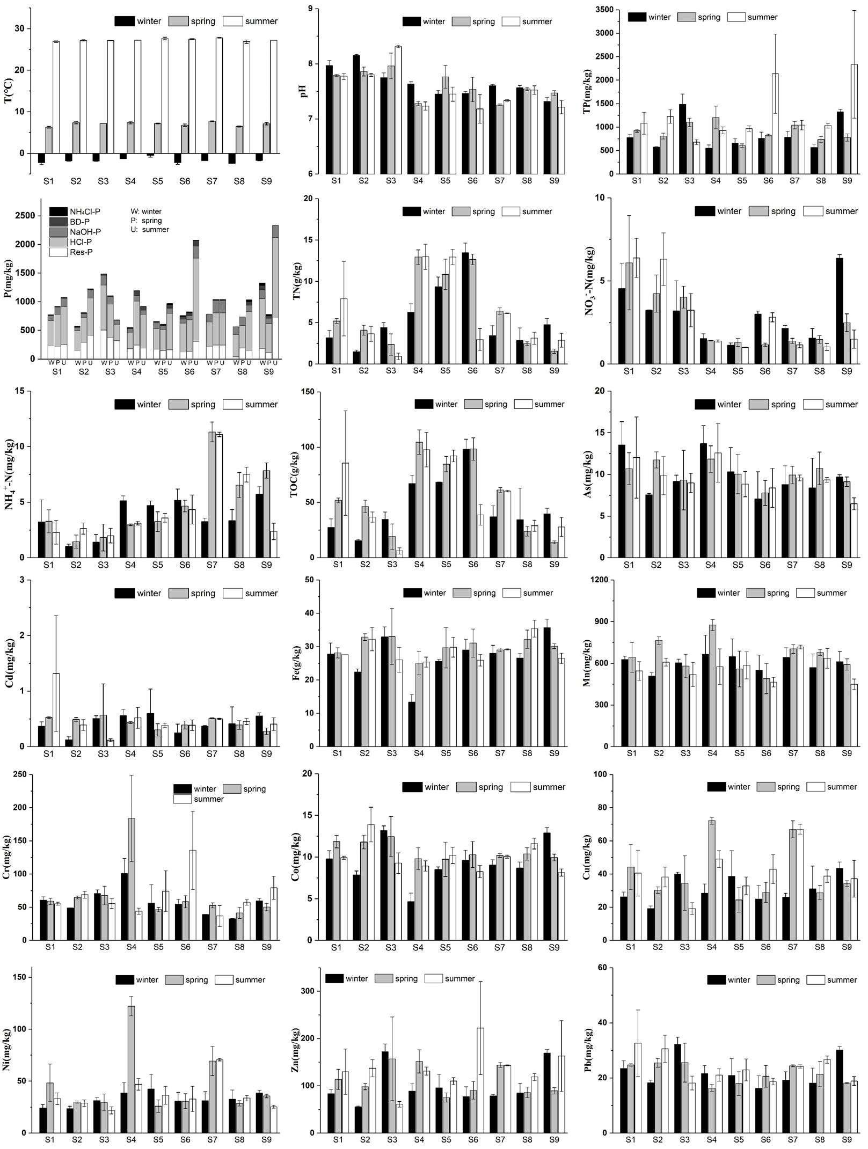

**Figure S1**. Contents of sediment physical and chemical properties among all habitats in three seasons. Error bars represented the standard deviations.

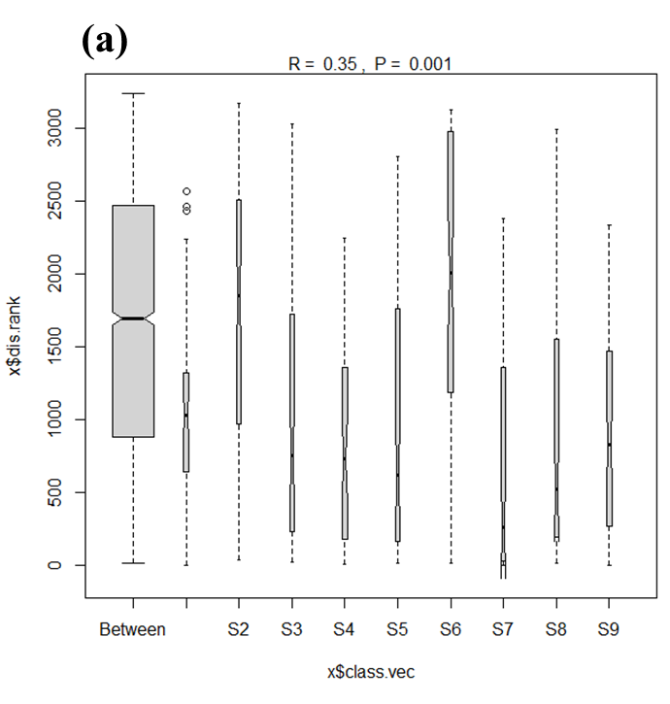 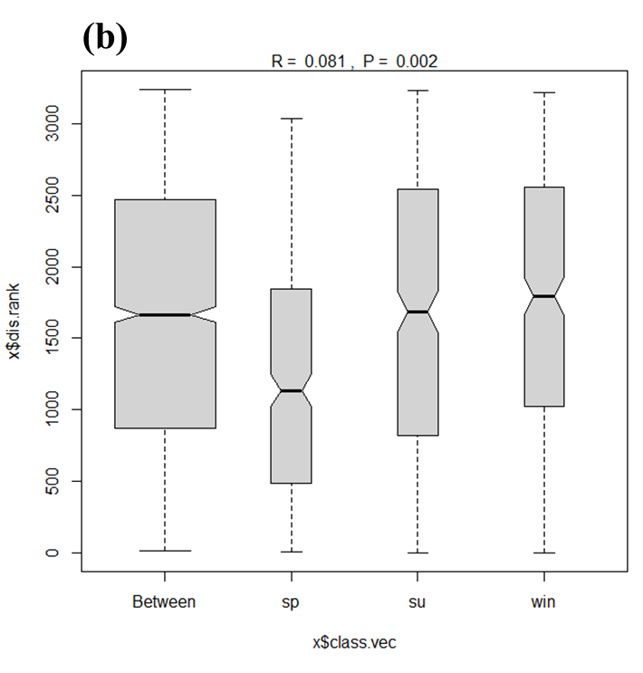

**Figure S2**. ANOSIM results of fungal communities in different sites and seasons. (a) sites; (b) seasons

**References**

China Environmental Monitoring Center, 1990. Background value of soil elements in China. China Environmental Science Press.