Supplementary Material

Supplementary Tables 2

Supplementary Table S1: Previous MR Studies of Micronutrient Exposures in Depression 2

Supplementary Table S2: Characteristics of the PGC MDD GWAS 5

Supplementary Table S3: Studies contributing data for micronutrient GWASs with PGC MDD sample overlap 6

Supplementary Table S4: Micronutrient instruments used in analyses 12

Supplementary Table S5: Heterogeneity Statistics for MR analyses 19

Supplementary Table S6: Table containing SEIVW/SEcIVW ratios for relevant micronutrients. 21

Supplementary Table S7: Heterogeneity analyses for reverse MR analyses 22

Supplementary Material 23

Supplementary Material S1: Supplementary Methods 23

Supplementary Material S2: Individual Micronutrient MR plots 24

Supplementary Material S3: List of PGC MDD collaborators 54

References 66

## Supplementary Tables

### Supplementary Table S1: Previous MR Studies of Micronutrient Exposures in Depression

|  |  |  |  |  |  |  |  |
| --- | --- | --- | --- | --- | --- | --- | --- |
| Exposure | Study | Outcome Sample | Exposure Sample Size | Outcome Sample Size | MR Method | SNPs | Results (OR or beta; (95% confidence intervals)[1] |
| Vitamin D | Michaelsson 20181 | Psychiatric Genomics Consortium (PGC) | 79,366 | 173,005 | Two-sample | 6 | 0.98 (0.93, 1.03) p=0.44[2] |
| Milaneschi 20192 | Netherlands Study of Depression and Anxiety (NESDA) | 2,013 | 2,047 | One-sample | 6 | 0.94 (0.84, 1.06) p=0.34 |
| PGC | 79,366 | 480,359 | Two -sample | 6 | 0.97 (0.88, 1.07)[3] p=0.50 |
| Mulugeta 20203 | PGC | 79,366 | 331,677 | Two sample | 6 | 0.97 per 50% increase in vit D (0.91, 1.04) |
| UK Biobank (UKBB) | 79,366 | 251,962 | Two sample | 6 | 0.97 per 50% increase (0.90, 1.05) |
| Libuda 20194 | UKBB Depressive Symptoms | 79,366 | 161,460 | Two sample | 6 | 0.025 (-0.05, 0.10) p=0.52 |
| UKBB Depression | 79,366 | 322,580 | Two-sample | 6 | 0.98 (0.96, 1.00) p=0.10 |
| Revez 20205 | PGC | 417,580 | 807,553 | Two-sample | 240 | 0.98 (0.96, 1.00) p=0.03b |
| B12 | Mollehave 2017 6 | Health 2006 & Inter 99 | 4,126 | 4,126 | One-sample | 12 | 0.96 (0.52, 1.79) p=0.91 |
| Folate | Health 2006 & Inter 99 | 3,942 | 3,942 | One-sample | 2 | 1.18 (0.18, 7.66) p=0.86 |
| Homocysteine | Yu 2022 | PGC | 44,147 | 42,455 | Two-sample | 13 | 0.95 (0.88, 1.00) p=0.12 |
|  |  |  |  |  |  |  |  |
| Calcium | Cheng 20197 | Chinese Women through CONVERGE consortium | 39,400 | 10,640 | Two-sample | 6 | 0.92 (0.67, 1.28) p=0.63 |
| Magnesium | 15,366 | 3 | 1.19 (0.22, 6.61) p=0.84 |
| Iron | 48,972 | 9 | 0.98 (0.91, 1.05) p=0.60 |
| Zinc | 2,603 | 2 | 0.99 (0.95, 1.03) p=0.66 |

### Supplementary Table S2: Characteristics of the PGC MDD GWAS

Summary statistics from thePsychiatric Genomics Consortium MDD GWAS published in 20198 were used as the primary outcome sample. This GWAS is a meta-analysis of the three largest independent GWASs of MDD to date, including 246,363 cases and 561,190 controls. 23andMe Participants provided informed consent and participated in the research online, under a protocol approved by the external AAHRPP-accredited IRB, Ethical & Independent Review Services (E&I Review). For full details of the methods used for genotyping in each cohort, please refer to the original publications.

|  |  |  |  |
| --- | --- | --- | --- |
| **Author** | **Sample** | **N** | **MDD categorisation** |
| Hyde et al9 | 23andMe discovery cohort/307k | 75,607 cases  231,747 controls | Self-report clinical diagnosis |
| Howard et al8 | UK Biobank | 127,552 cases  233,763 controls | Self-reported help seeking for problems with nerves, anxiety, tension, or depression |
| Wray et al10 | Total sample (five cohorts) | 43,204 cases  95,680 controls | See below for details. Individual cohort numbers below are prior to exclusion of 23andMe_307k and prior release of UK Biobank data (N=4,381) |
| PGC 29 | 16,823 cases  25,632 controls | Structured diagnostic interviews from 29 samples as described in Wray et al.10 |
| deCODE | 1,980 cases  9,536 controls | National inpatient electronic records |
| GenScotland | 997 cases  6,358 controls | Structured diagnostic interview |
| GERA | 7,162 cases  38,307 controls | Kaiser Permanenta Northern California Electronic Medical records (1995-2013) |
| iPSYCH | 18,629 cases  17,841 controls | National inpatient electronic records |

### Supplementary Table S3: Studies contributing data for micronutrient GWASs with PGC MDD sample overlap

|  |  |  |  |  |  |  |  |
| --- | --- | --- | --- | --- | --- | --- | --- |
| **Group** | **Exposure** | **Measure** | **Author** | **Population** | **Study** | **Cohort contributes data to PGC** | **N** |
| Water soluble Vitamins | Vitamin B6 | Serum B6 | Tanaka11 | Italy | InCHIANTI | No | 1178 |
|  |  |  |  | Italy | Progetto Nutrizione | No | 686 |
|  |  |  |  |  |  |  |  |
|  | Vitamin B9 | Serum Folate | Grarup12 | Iceland | Icelandic | No | 20,717 |
|  |  |  |  | Denmark | Inter-99 | No | 5,624 |
|  |  |  |  | Denmark | Health 2006 | No | 2,804 |
|  |  |  |  |  |  |  |  |
|  |  | Serum Homocysteine | Van Meurs13 | Italy | InCHIANTI | No | 1,208 |
|  |  |  |  | USA | Baltimore Longitudinal Study of Aging | No | 638 |
|  |  |  |  | USA/ UK | Nurse’s Health Study | No | 1,658 |
|  |  |  |  | USA | Women’s Genome Health Study |  | 13,974 |
|  |  |  |  | Netherlands | Rotterdam Study I | Yes | 3,414 |
|  |  |  |  | Netherlands | Rotterdam Study II | Yes | 1,868 |
|  |  |  |  | UK | TwinsUK cohort | No | 1,172 |
|  |  |  |  | Switzerland | CoLaus cohort | Yes | 5,434 |
|  |  |  |  | USA | Cardiovascular Health Study | No | 3,980 |
|  |  |  |  | USA | Framingham Heart Study | No | 10,251* |
|  |  |  |  | Netherlands | Nijemen Medical Study | No | 550 |
|  |  |  |  |  |  |  |  |
|  | Vitamin B12 | Serum B12 | Grarup12 | Icelandic | Icelandic | No | 25,960 |
|  |  |  |  | Danish | Inter-99 | No | 5,481 |
|  |  |  |  | Danish | Health 2006 | No | 2,812 |
|  |  |  |  |  |  |  |  |
|  | Vitamin C | Plasma Vitamin C | Zheng 2021 | UK | Fenland | No | 10,771 |
|  |  |  |  | UK | EPIC-Norfolk | No | 16,756 |
|  |  |  |  | France, Italy, Spain, UK, Netherlands, Germany, Sweden, Denmark | EPIC-InterAct | No | 16,841 |
|  |  |  |  | As above | EPIC-CVD | No | 7,650 |
|  |  |  |  |  |  |  |  |
|  |  |  |  |  |  |  |  |
| Fat soluble Vitamins | Vitamin A | Serum Retinol | Mondul14 | Finland | Alpha-Tocopherol, Beta Carotene Cancer Prevention (ATBC) Study | No | 4,014 |
|  |  |  |  | USA | Prostate, Lung, Colorectal and Ovarian Cancer Screening trial | No | 992 |
|  |  |  |  | UK | Nurses Health Study (NHS) | No | 2772 |
|  |  |  |  | Italy | InCHIANTI | No | 1,124 |
|  |  |  |  |  |  |  |  |
|  |  | Beta Carotene | Ferrucci15 | Italy | InCHIANTI | No | 1,191 |
|  |  |  |  | USA | Women’s Health and Aging Study | No | 615 |
|  |  |  |  | USA | ATBC Study | No | 2,136 |
|  |  |  |  |  |  |  |  |
|  | Vitamin D | Serum 25(OH)D | Jiang16 | UK | 1958 British Birth Cohort | No | 4,985 |
|  |  |  |  | USA | The Cardiovascular Health Study | No | 1,791 |
|  |  |  |  | USA | The Framingham Heart Study | No | 5,654 |
|  |  |  |  | Sweden | The Gothenburg Osteoporosis and Obesity Determinants Study | No | 921 |
|  |  |  |  | USA | The Health, Aging, Body Composition Study | No | 1,558 |
|  |  |  |  | USA | The Indiana Women cohort | No | 567 |
|  |  |  |  | Finland | The North Finland Birth Cohort 1966 | No | 4,604 |
|  |  |  |  | USA | The Old Order Amish Study | No | 330 |
|  |  |  |  | Netherlands | The Rotterdam Study | Yes | 1,237 |
|  |  |  |  | UK | Twins UK | No | 5,135 |
|  |  |  |  | Finland | ATBC | No | 1,372 |
|  |  |  |  | USA | PLCO | No | 1,315 |
|  |  |  |  | USA | Atherosclerosis Risk in Communities (ARIC) | No | 8,124 |
|  |  |  |  | Germany | AtheroGene | No | 1,062 |
|  |  |  |  | Netherlands | B-vitamins for the Prevention of Osteoporotic Fractures (BPROOF) | No | 2,525 |
|  |  |  |  | USA | Epidemiology of Diabetes Interventions and Complications (EDIC) | No | 1,094 |
|  |  |  |  | Finland | Case- Control Study for  Metabolic Syndrome  (GENMETS) | No | 1,641 |
|  |  |  |  | Finland | The Helsinki Birth Cohort Study (HBCS) | No | 917 |
|  |  |  |  | USA | Coronary Heart Disease Case - Control Study nested within NHS and HPFS (HPFS_CHD) | No | 1,245 |
|  |  |  |  | Italy | The Invecchiare in Chianti Study (InChianti) | No | 1,094 |
|  |  |  |  | Germany | Cooperative Health Research in the Region Augsburg (KORA) | Yes (controls) | 1,805 |
|  |  |  |  | Netherlands | Leiden Longevity Study (LLS) | No | 2,265 |
|  |  |  |  | Germany | Ludwigshafen Risk and Cardiovascular Health Study (LURIC) | No | 2,846 |
|  |  |  |  | USA | Multi -Ethnic Study of Atherosclerosis (MESA) | No | 2,240 |
|  |  |  |  | Netherlands | Nijmegen Biomedische Studie | No | 2,610 |
|  |  |  |  | UK/ USA | Breast Cancer Case-Control Study nestled in NHS | No | 870 |
|  |  |  |  | UK/ USA | Type II diabetes Case-Control Study nested within NHS | No | 724 |
|  |  |  |  | Scotland | The Orkney Complex Disease Study (ORCADES) | No | 847 |
|  |  |  |  | Scotland, Ireland and the Netherlands | Prospective Study of Pravastatin in the Elderly at Risk (PROSPER) | No | 4,871 |
|  |  |  |  | Netherlands | Rotterdam Study I& II | Yes | 8,313 |
|  |  |  |  | Germany | The Study of Health in Pomerania (SHIP) | Yes | 1,655 |
|  | 2 |  |  | UK | The Scottish Colorectal Cancer Study | No | 1,165 |
|  |  |  |  | Finland | Cardiovascular risk in Young Finns Study | No | 1,984 |
|  |  |  |  | Sweden | Prospective Investigation of the Vasculature in Uppsala Seniors (PIVUS) | No | 989 |
|  |  |  |  | Sweden | Uppsala Longitudinal Study of Adult Men (ULSAM) | No | 1,124 |
|  |  |  |  |  |  |  |  |
|  |  |  |  |  |  |  |  |
| Macrominerals | Calcium | Serum Calcium | O'Seaghadha17 | Iceland | Age Gene/Environment Susceptibility (AGES) | No | 1949 |
|  |  |  |  | USA | ARIC | No | 9049 |
|  |  |  |  | USA | Baltimore Study of Aging (BLSA) | No | 719 |
|  |  |  |  | USA | CHS | No | 1802 |
|  |  |  |  | Switzerland | CoLaus | Yes | 5411 |
|  |  |  |  | Croatia | CROATIA-Korcula | No | 880 |
|  |  |  |  | Croatia | CROATIA-Split | No | 488 |
|  |  |  |  | Croatia | CROATIA-Vis | No | 910 |
|  |  |  |  | USA | FHS | No | 2853 |
|  |  |  |  |  | HABC | No | 1554 |
|  |  |  |  | Italy | InCHIANTI | No | 1204 |
|  |  |  |  | UK | LBC1936 | No | 993 |
|  |  |  |  | UK | LOLIPOP EW A | No | 589 |
|  |  |  |  | UK | LOLIPOP EW P | No | 652 |
|  |  |  |  | UK | LOLIPOP EW610 | No | 927 |
|  |  |  |  | Sardinia | OGP Talana | No | 1039 |
|  |  |  |  | UK | ORCADES | No | 877 |
|  |  |  |  | Netherlands | Rotterdam Study | No | 3436 |
|  |  |  |  | Germany | SHIP | Yes | 4068 |
|  |  |  |  | UK | British Genetics of Hypertension Study (BRIGHT) | No | 1855 |
|  |  |  |  | Switzerland | Bus Santé | No | 4670 |
|  |  |  |  | Italy | INGI-Carlantino | No | 499 |
|  |  |  |  | Italy | INGI-FVG | No | 1432 |
|  |  |  |  | Italy | INGI-CILENTO | No | 1147 |
|  |  |  |  | Germany | Cooperative Health Research in the Region of Augsburg (KORA) F3 | Yes (controls) | 1640 |
|  |  |  |  | Germany | KORA F4 | Yes (controls) | 1809 |
|  |  |  |  | Germany | LURIC Study | No | 2927 |
|  |  |  |  | Sweden | the Prospective Investigation of the Vasculature in Uppsala Seniors (PIVUS) | No | 945 |
|  |  |  |  | Germany | SHIP-Trend | Yes | 986 |
|  |  |  |  | UK | TwinsUK |  | 3965 |
|  |  |  |  |  |  |  |  |
|  | Magnesium | Serum Magnesium | Meyer18 | USA | ARIC | No | 8,122 |
|  |  |  |  | USA | FHS | No | 2,866 |
|  |  |  |  | Netherlands | RS | Yes | 4,378 |
|  |  |  |  |  |  |  |  |
|  | Phosphate | Serum Phosphorus | Kestenbaum19 | USA | CHS | No | 2,337 |
|  |  |  |  | USA | ARIC | No | 8,122 |
|  |  |  |  | USA | FHS | No | 2,865 |
|  |  |  |  | Netherlands | RS | Yes | 3,516 |
|  |  |  |  |  |  |  |  |
|  |  |  |  |  |  |  |  |
| Microminerals | Iron | Serum Iron & Ferritin | Benyamin20 | Australia | Queensland Institute of medical research (QIMR) | Yes | 11,692 |
|  |  |  |  | Estonia | Estonian Genome Project | No | 893 |
|  |  |  |  | Italy | Val Borbera Study | No | 1,659 |
|  |  |  |  | Netherlands | Nijmegen Biomedical Study | No | 1,791 |
|  |  |  |  | UK | UK Blood Services Common Controls Panel | Yes (controls) | 2,419 |
|  |  |  |  | Italy | Micros/ Eurac | No | 1,218 |
|  |  |  |  | Netherlands | ERF/ Rotterdam | Yes | 871 |
|  |  |  |  | Germany | Kora F3/ F4 | Yes (controls) | 3,443 |
|  |  |  |  | Australia | Busselton Health Study | No | 877 |
|  |  |  |  | Estonia | Estonian Genome Project | No | 1,017 |
|  |  |  |  | Italy | InCHIANTI | No | 1,206 |
|  |  |  |  | Sardinia | SardiNIA study of Aging | No | 4,694 |
|  |  |  |  | Switzerland | CoLaus | Yes | 5,419 |
|  |  |  |  | Netherlands | Prevention of Renal and Vascular Endstage Disease (PREVEND) | No | 3,644 |
|  |  |  |  | UK | Fenland | No | 1,402 |
|  |  |  |  | France, Italy, Spain, UK, Netherlands, Germany, Sweden, Denmark | INTERACT | No | 9,294 |
|  |  |  |  |  |  |  |  |
|  | Copper | Erythrocyte Copper | Evans21 | Australia | QIMR | Yes | 2,603 |
|  |  |  |  |  |  |  |  |
|  | Manganese | Serum Manganese | Ng22 | Sweden | PIVUS | No | 949 |
|  | Selenium | Serum Selenium | Evans21 | Australia | QIMR | Yes | 2,603 |
|  |  |  |  | UK | Avon Longitudinal Study of Parents and Children (ALSPAC) | No | 2,874 |
|  | Zinc | Erythrocyte Zinc | Evans21 | Australia | QIMR | Yes | 2,603 |
|  |  |  |  |  |  |  |  |

### Supplementary Table S4: Micronutrient instruments used in analyses

SNP lists used in primary analyses are listed for each micronutrient; N = sample size; Chr = Chromosome P = p value for association; SNPs were mapped to genes using the GWAS catalog metadata or derived from original publications. Details of gene function were obtained from the National Library of Medicine (NLM) Gene database (<https://www.ncbi.nlm.nih.gov/gene/>). Genes encoding proteins directly related to the metabolism of each micronutrient (defined as processes related to micronutrient uptake, synthesis, transport, or degradation) were included in ‘functional’ sensitivity analyses and postfixed with an asterix* in the gene column. Where the description given on the NLM Gene database did not clearly specify a physiological function with direct relevance to the metabolism of the specified micronutrient, biological pathways for the gene were cross-checked with the Kyoto Encyclopedia of Genes and Genomes (KEGG) pathway resource (<https://www.kegg.jp/kegg/>).23 Additional SNPs included in cIVW methods available on request from authors, or through the IEU Open GWAS <https://gwas.mrcieu.ac.uk>; GWAS id from the IEU Open GWAS is given in brackets: Vitamin D (*ebi-a-GCST005367*), copper (*ieu-a-1073*), selenium (*ieu-a-1077*) and zinc (*ieu-a-1079*).

|  |  |  |  |  |  |  |  |  |
| --- | --- | --- | --- | --- | --- | --- | --- | --- |
| Micronutrient | GWAS | N | SNP | P | Chr | gene |  | Function of gene with respect to micronutrient |
| Vitamin A (serum retinol) | Mondul 2011 | 9302 | rs10882272 | 6.51E-15 | 10 | RBP4* | Retinol binding protein 4 | Encodes retinol binding protein, which delivers retinol from the liver stores to the peripheral tissues |
|  | 9302 | rs1667255 | 6.35E-14 | 18 | TTR* | Transthyretin | Encodes transthyretin, which transports thyroid hormones in the plasma and cerebrospinal fluid. It is also involved in the transport of retinol (vitamin A) in the plasma by associating with retinol-binding protein. |
| Vitamin A (beta carotene) | Ferrucci 2009 | 3881 | rs6564851 | 1.6E-24 | 16 | BCO1* | Beta-carotene oxygenase 1 | The protein encoded by this gene is a key enzyme in beta-carotene metabolism to vitamin A. It catalyzes the oxidative cleavage of beta,beta-carotene into two retinal molecules |
| Vitamin B6 | Tanaka 2009 | 1,864 | rs4654748 | 8.30E-18 | 1 | ALPL | Alkaline Phophatase | This gene encodes a member of the alkaline phosphatase family of proteins. The product of this gene is a membrane bound glycosylated enzyme that is not expressed in any particular tissue and is, therefore, referred to as the tissue-nonspecific form of the enzyme |
| Folate | Grarup 2013 | 37,465 | rs652197 | 1.40E-12 | 11 | FOLR3* | Folate receptor gamma | Encodes a member of the folate receptor family of proteins, which mediate the delivery of 5-methylhydroolate to interior of cells |
|  |  | 37,337 | rs1801133 | 9.50E-53 | 1 | MTHFR* | Methylenetetrahydrofolate reductase | Encodes a protein that catalyses the conversion of 5,10,methylenetetrahydrofolate to 5-methyltetrahydrofolate |
| Homocysteine | Van Meurs 2013 | 44,147 | rs1801133 | 4.34E-104 | 1 | MTHFR | Methylenetetrahydrofolate reductase | Catalyzes the conversion of 5,10-methylenetetrahydrofolate to 5-methyltetrahydrofolate, a co-substrate for homocysteine remethylation to methionine |
|  |  |  | rs2275565 | 1.96E-10 | 1 | MTR | 5-methyltetrahydrofolate-homocysteine methyltransferase | Catalyzes the remethylation of homocysteine to methionine |
|  |  |  | rs9369898 | 2.17E-10 | 6 | MMUT | Methylmalonyl-CoA mutase | A vitamin B12-dependent enzyme which catalyzes the isomerization of methylmalonyl-CoA to succinyl-CoA |
|  |  |  | rs7130284 | 1.88E-20 | 11 | NOX4 | NADPH oxidase 4 | An oxygen sensor that catalyzes the reduction of molecular oxygen to various reactive oxygen species. |
|  |  |  | rs154657 | 1.74E-43 | 16 | DPEP1 | Dipeptidase 1 | Kidney membrane enzyme that hydrolyzes a variety of dipeptides and is implicated in renal metabolism of glutathione and its conjugates |
|  |  |  | rs234709 | 3.90E-24 | 21 | CBS | Cystathione beta-synthase | Catalyzes the conversion of homocysteine to cystathionine, the first step in the trans-sulfuration pathway |
|  |  |  | rs548987 | 1.12E-08 | 6 | SLC17A3 | Solute carrier family 17, member 3 | The protein encoded by this gene is a voltage-driven transporter that excretes intracellular urate and organic anions from the blood into renal tubule cells. |
|  |  |  | rs42648 | 1.97E-08 | 7 | GTBP10 | GTP binding protein 1 | Small G proteins, such as GTPBP10, act as molecular switches that play crucial roles in the regulation of fundamental cellular processes such as protein synthesis, nuclear transport, membrane trafficking, and signal transduction |
|  |  |  | rs1801222 | 8.43E-10 | 10 | CUBN | Cubilin | A receptor for intrinsic factor-vitamin B12 complexes |
|  |  |  | rs2251468 | 1.28E-12 | 12 | HNF1A | HNF homeobox A | A transcription factor required for the expression of several liver-specific genes |
|  |  |  | rs838133 | 7.48E-09 | 19 | FUT2 | Fucosyltransferase 2 | This gene is one of two encoding the galactoside 2-L-fucosyltransferase enzyme. The encoded protein is important for the final step in the soluble ABO blood group antigen synthesis pathway. It is also involved in cell-cell interaction, cell surface expression, and cell proliferation. |
|  |  |  | rs12780845 | 7.80E-10 | 10 | CUBN | Cubilin | A receptor for intrinsic factor-vitamin B12 complexes |
| Vitamin B12 | Grarup 2013 | 45,575 | rs2336573 | 8.40E-59 | 19 | CD320* | CD320 molecule | This gene encodes the transcobalamin receptor that is expressed at the cell surface. It mediates the cellular uptake of transcobalamin bound cobalamin (vitamin B12). |
|  | 45,575 | rs1131603 | 4.90E-49 | 22 | TCN2* | Transcobalamin 2 | This gene encodes a member of the vitamin B12-binding protein family. This plasma protein binds cobalamin and mediates the transport of cobalamin into cells. |
|  | 45,571 | rs3742801 | 1.70E-13 | 14 | ABCD4* | ATP binding cassette subfamily D member 4 | The protein encoded by this gene is a member of the superfamily of ATP-binding cassette (ABC) transporters. Lysosomal membrane protein that transports cobalamin (Vitamin B12) from the lysosomal lumen to the cytosol in an ATP-dependent manner |
|  | 45,576 | rs2270655 | 2.20E-13 | 4 | MMAA* | Metabolism of cobalamin associated A | Involved in translocation of vitamin B-12 into the mitochondria |
|  | 45,576 | rs34324219 | 1.10E-111 | 11 | TCN1* | Transcobalamin 1 | This gene encodes a member of the vitamin B12-binding protein family, which facilitates the transport of cobalamin into cells. |
|  | 45,575 | rs7788053 | 1.70E-10 | 19 | FUT6 | Fucosyltransferase 6 | The protein encoded by this gene is a Golgi stack membrane protein |
|  | 45,568 | rs602662 | 2.40E-139 | 19 | FUT2 | Fucosyltransferase 2 | As above |
|  | 45,576 | rs1801222 | 3.30E-75 | 10 | CUBN* | Cubilin | Cubilin (CUBN) acts as a receptor for intrinsic factor-vitamin B12 complexes. Cubulin is located within the epithelium of intestine and kidney. |
|  | 45,576 | rs41281112 | 8.90E-35 | 13 | CLYBL* | Citramalyl-CoA lyase | Enables (S)-citramalyl-CoA lyase activity; magnesium ion binding activity; and malate synthase activity. Involved in protein homotrimerization and regulation of cobalamin metabolic process. |
|  | 45,574 | rs1141321 | 3.60E-26 | 6 | MMUT | Methylmalonyl-CoA mutase | Vitamin B-12 dependent enzyme |
| Vitamin C | Zheng 2021 | 52,018 | rs6693447 | 6.25E-10 | 1 | RER1 | Rhodopsin enhancer region | A conserved regulatory region upstream of the rhodopsin (RHO) gene, thought to bind retina-specific transcription factors |
|  |  |  | rs13028225 | 2.38E-30 | 2 | SLC23A3 | Solute carrier family 23 member 3 | Predicted to enable transmembrane transporter activity. |
|  |  |  | rs33972313 | 4.61E-90 | 5 | SLC23A1* | Solute carrier family 23 member 1 | Encodes one of the two sodium-dependent vitamin C transporters used to transport vitamin C into the body and its distribution to organs |
|  |  |  | rs10051765 | 3.64E-09 | 5 | RGS14 | Regulator of G protein signalling | Encodes a member of the regulator of G-protein signaling family |
|  |  |  | rs7740812 | 1.88E-09 | 6 | GSTA5 | Glutathione S-transferase alpha 5 | Encodes glutathione S-transferase (GST)-α5, which catalyzes the conjugation of reduced glutathiones and a variety of electrophiles |
|  |  |  | rs174547 | 3.84E-08 | 11 | FADS1 | Fatty acid Desaturase 1 | Encodes fatty acid desaturase enzyme. |
|  |  |  | rs117885456 | 1.70E-11 | 12 | SNRPF | small nuclear ribonucleoprotein polypeptide F | Unclear relevance to vitamin C metabolism |
|  |  |  | rs2559850 | 6.30E-20 | 12 | CHPT1 | Choline phosphotransferase 1 | Enables diacylglycerol cholinephosphotransferase activity. |
|  |  |  | rs10136000 | 1.33E-08 | 14 | AKT1 | AKT serine/threonine kinase 1 | Encodes AKT serine-thronine protein kinase family. |
|  |  |  | rs56738967 | 7.62E-10 | 16 | MAF | MAF bZIP transcription factor | The protein encoded by this gene is a DNA-binding, leucine zipper-containing transcription factor |
| Vitamin D | Jiang 2018 | 42,274 | rs3755967 | 4.74e-343 | 4 | GC* | GC vitamin binding protein | The protein encoded by this gene binds to vitamin D and its plasma metabolites and transports them to target tissues. |
|  |  |  | rs10741657 | 2.05E-46 | 11 | CYP2R1* | Cytochrome P450 family 2 subfamily R member 1 | Encodes and enzyme that catalyzes vitamin D into the active form |
|  |  |  | rs12785878 | 3.8E-62 | 11 | NADSYN1/DHCR7* | Cytochrome P450 family 2 subfamily R member 1 | This enzyme is a microsomal vitamin D hydroxylase that converts vitamin D into the active ligand for the vitamin D receptor. |
|  |  |  | rs10745742 | 1.88E-14 | 12 | AMDHD1 | amidohydrolase domain containing 1 | Predicted to enable imidazolonepropionase activity. Predicted to be involved in histidine catabolic process. |
|  |  |  | rs8018720 | 4.72E-09 | 14 | SEC23A | SEC23 homolog A | Encodes a protein found in the ribosome-free transitional face of the endoplasmic reticulum (ER) and associated vesicles. |
|  |  |  | rs17216707 | 8.14E-23 | 20 | CYP24A1* | Cytochrome p450 family 24 subfamily A member 1 | Mitochondrial protein that initiates the degradation of the physiologically active form (hormonal form) of vitamin D, playing a role in calcium and vitamin D homeostasis |
| Calcium | O'Seaghada 2013 | 61,054 | rs1801725 | 8.90E-86 | 3 | CASR* | Calcium sensing receptor | Encodes a membrane G coupled calcium sensing receptor that senses small changes in calcium and maintains homeostasis through intracellular signalling pathways and parathyroid hormone secretion |
|  |  | 60,958 | rs780094 | 1.30E-10 | 2 | GCKR | Glucokinase regulator | Encodes glucokinase regulator, which plays a role in glucose homeostasis, but has multiple metabolic roles including of liver enzymes, amino acids and serum albumin |
|  |  | 60,040 | rs10491003 | 4.80E-09 | 10 | GATA3 | GATA binding protein 3 | GATA3 encodes a transcription factor involved in parathyroid gland development, therefore calcium homeostasis |
|  |  | 61,011 | rs7481584 | 1.20E-10 | 11 | CARS1 | Cysteinyl-tRNA synthetase | Encodes a cysteinyl-tRNA synthetase. Variants in this region lead to Beckwith-Wiedmann syndrome, associated with hypocalcemia and hypercalciuria |
|  |  | 60,928 | rs7336933 | 9.10E-10 | 13 | DGKH/KIAA0564 | Diacylglycerol kinase eta | Encodes diacylglycerol kinase eta, which is involved in regulating intracellular diacylglycerol and phophatidic acid. Variants in this gene have been associated with bipolar disorder |
|  |  | 60,966 | rs1570669 | 9.10E-12 | 20 | CYP24A1 | Cytochrome p450 family 24 subfamily A member 1 | Mitochondrial protein that initiates the degradation of the physiologically active form (hormonal form) of vitamin D, playing a role in calcium and vitamin D homeostasis |
|  |  |  |  |  |  |  |  |  |
| Copper | Evans 2013 | 2,603 | rs1175550 | 5.03E-10 | 1 | SMIM1 | small integral membrane protein 1 | Encodes a protein involved in red blood cell formation |
|  |  |  | rs2769264 | 2.63E-20 | 1 | SELENBP1 | selenium binding protein 1 | Encodes selenium binding protein. Uncertain role in copper metabolism |
| Ferritin | Benyamin 2014 | 48,972 | rs1800562 | 1.54E-38 | 6 | HFE | Homeostatic iron regulator | Encodes a protein that regulates iron absorption. Hereditary haemochromatosis is a recessive disorder resulting from defects in this gene |
|  |  |  | rs855791 | 1.38E-14 | 22 | TMPRSS6 | Transmembrane serine protease 6 | The protein encoded by this gene is a type II transmembrane serine proteinase that is found attached to the cell surface. |
|  |  |  | rs744653 | 8.37E-19 | 2 | SLC40A1 | Solute carrier family 40 member 1 | SLC40A1 is a cell membrane protein involved in iron export from duodenal epithelial cells. Defects in SLC40A1 are a cause of hemochromatosis type 4 |
|  |  |  | rs651007 | 1.31E-08 | 9 | ABO | alpha 1-3-galactosyltransferase | Encodes proteins related to ABO blood system |
|  |  |  | rs411988 | 1.59E-10 | 17 | TEX14 | Testis expressed 14, intracellular bridge forming factor | Encodes protein necessary for intercellular bridges in germ cells, which are required for spermatogenesis. Unclear relevance for iron homeostasis. |
| Iron | Benyamin 2014 | 48,972 | rs1800562 | 2.72E-97 | 6 | HFE* | Homeostatic iron regulator | As above |
|  |  |  | rs1799945 | 1.10E-81 | 6 | HFE* | Homeostatic iron regulator | As above |
|  |  |  | rs855791 | 1.32E-139 | 22 | TMPRSS6 | Transmembrane serine protease 6 | As above |
|  |  |  | rs8177240 | 6.65E-20 | 3 | TF* | Transferrin | As above |
|  |  |  | rs7385804 | 1.36E-18 | 7 | TFR2* | Transferrin receptor 2 | As above |
| Magnesium | Meyer 2010 | 15,366 | rs4072037 | 2.01E-36 | 1 | MUC1 | Mucin 1, cell surface associated | Unclear relevance for magnesium homeostasis. Involved in forming protective mucous barriers on epithelial surfaces, and have a role in intracellular signaling |
|  |  |  | rs13146355 | 6.27E-13 | 4 | SHROOM3 | Shroom family member 3 | Encodes protein that may regulate cell types in certain tissues. Involved in neural tube closure |
|  |  |  | rs11144134 | 8.21E-15 | 9 | TRPM6* | Transient receptor potential cation channel subfamily M member 6 | Encodes a TRP ion channel subunit which mediates magnesium reuptake in kidneys |
|  |  |  | rs3925584 | 5.20E-16 | 11 | DCDC5 | doublecortin domain containing 5 | Unclear relevance for magnesium physiology |
|  |  |  | rs448378 | 1.25E-08 | 3 | MDS1 | Myelodysplasia syndrome 1 | Unclear relevance for magnesium physiology |
| Manganese | Ng 2015 | 949 | rs1776029 | 2.17E-14 | 1 | SLC30A10* | Solute carrier family 30 member 10 | This gene plays a critical role in manganese transport and is induced by manganese in the liver |
|  |  |  | rs13107325 | 5.08E-11 | 4 | SLC39A8* | Solute carrier family 39 member 8 | Encodes a protein found in plasma membrane and mitochondria involved in the cellular transport of zinc and manganese |
| Phosphorus | Kestenbaum 2010 | 21,726 | rs1697421 | 3.47E-16 | 1 | ALPL* | Alkaline Phosphatase | Encodes a membrane bound enzyme that hydrolyses pyrophosphate into phosphate in cells. Rare mutations in this gene linked to hypophophatasia with failure to mineralize teeth and bone |
|  |  |  | rs17265703 | 6.26E-08 | 3 | CSTA | Cystatin A | Unclear relevance |
|  |  |  | rs9469578 | 5.15E-10 | 6 | IHPK3 | Inositol hexakisphosphate kinase 3 | Encodes a protein that belongs to the inositol phosphokinase (IPK) family. This protein is likely responsible for the conversion of inositol hexakisphosphate (InsP6) to diphosphoinositol pentakisphosphate (InsP7/PP-InsP5). |
|  |  |  | rs947583 | 2.19E-09 | 6 | PDE7B | Phosphodiesterase 7B | Hydrolyzes cAMP, which regulates many important physiological processes. May be involved in the control of cAMP-mediated neural activity and cAMP metabolism in the brain. Gene variants appear associated with Dyslexia |
|  |  |  | rs2970818 | 4.04E-08 | 12 | FGF6 | Fibroblast growth factor 6 | Plays an important role in the regulation of cell proliferation, cell differentiation, angiogenesis and myogenesis, and is required for normal muscle regeneration |
| Selenium | Evans 2013 | 2,603 | rs921943 | 9.40E-28 | 5 | DMGDH/ BHMT2 | Dimethylglycine dehydrogenase/ betaine-homocysteine S-methyltransferase 2 | Exact relevance to selenium status unclear. DMGDH encodes enzymes involved in choline catabolism. BHMT2 is one of two methyl transferases that can catalyze the transfer of the methyl group from betaine to homocysteine. |
|  |  |  |  |  |  |  |  |  |
| Zinc | Evans 2013 | 2603 | rs1532423 | 6.40E-12 | 8 | CA1 | Carbonic anhydrase 1 | Carbonic Anhydrases are a large family of zinc containing enzymes that catalyse the reversible hydration of carbon dioxide |
|  |  |  | rs2120019 | 1.55E-18 | 15 | PPCDC | Phosphopantothenoylcysteine decarboxylase | Protein coding gene involved in biosynthesis of coenzyme A (CoA) from vitamin B5, involved in multiple metabolic processes. |

### Supplementary Table S5: Heterogeneity Statistics for MR analyses

Heterogeneity statistics for each MR analysis is given below: number of SNPs in analysis (nSNPs); percentage of variance explained in exposure for primary analyses (R2), mean F statistic (mFc); I2 statistic (I2), Cochran’s Q, Rucker’s Q and Egger intercept, with p values in brackets.

clumping threshold (r2, either 0.001 for traditional analyses, and 0.2 for correlated analyses). As none of the analyses had SNPs removed after Steiger filtering, the results are equivalent.

|  |  |  |  |  |  |  |  |  |  |  |  |  |  |  |
| --- | --- | --- | --- | --- | --- | --- | --- | --- | --- | --- | --- | --- | --- | --- |
|  |  |  |  |  |  |  |  | **MAJOR DEPRESSIVE DISORDER** | | |  | **RECURRENT DEPRESSION** | | |
|  |  | **nSNPs** | **R2** | **r2** | **mFc** | **I2** |  | **Cochrans Q (p)** | **Ruckers Q (p)** | **Egger Int (p)** |  | **Cochrans.Q.p.** | **Ruckers.Q.p.** | **Egger.Intercept..p.** |
|  |  |  |  |  |  |  |  |  |  |  |  |  |  |  |
| Water Soluble Vitamins | **Vitamin B6** | 1 | 1.5% | NA | 27 | NaN |  | NA (NA) | NA (NA) | NA (NA) |  | NA (NA) | NA (NA) | NA (NA) |
| **Vitamin B9** |  |  |  |  |  |  |  |  |  |  |  |  |  |
| *Folate* | 2 | 0.6% | 0.001 | 620 | 0.94 |  | NA (NA) | NA (NA) | NA (NA) |  | NA (NA) | NA (NA) | NA (NA) |
| *Homocysteine* | 12 | 2.8% | 0.001 | 101 | 0.99 |  | 29 (0.003) | 28 (0.002) | -0.002 (0.70) |  | 13 (0.32) | 12 (0.26) | -0.004 (0.81) |
|  |  |  |  |  |  |  |  |  |  |  |  |  |  |
| **Vitamin B12** | 9 | 5.4% | 0.001 | 192 | 0.98 |  | 17 (0.03) | 17 (0.02) | 0.0028 (0.73) |  | 10 (0.25) | 7 (0.47) | 0.03 (0.1) |
| *Functional* | *7* | 3.7% | 0.001 | 159 | 0.98 |  | 16 (0.01) | 16 (0.01) | 0.005 (0.69) |  | 7 (0.28) | 3 (0.76) | 0.04 (0.08) |
|  |  |  |  |  |  |  |  |  |  |  |  |  |  |
| **VitaminC** | 11 | 1.8% | 0.001 | 85 | 0.97 |  | 21 (0.02) | 14 (0.12) | 0.008 (0.06) |  | 20 (0.026) | 20 (0.016) | 1.3e-05 (1) |
| *Functional* | *1* | 0.8% | NA | 400 | NaN |  | NA (NA) | NA (NA) | NA (NA) |  | NA (NA) | NA (NA) | NA (NA) |
|  |  |  |  |  |  |  |  |  |  |  |  |  |  |
| Fat soluble vitamins | ***Vitamin A*** |  |  |  |  |  |  |  |  |  |  |  |  |  |
| *Retinol* | 2 | 0.1% | 0.001 | 56 | 0.99 |  | NA (NA) | NA (NA) | NA (NA) |  | NA (NA) | NA (NA) | NA (NA) |
| *Beta carotene* | 1 | 1.1% | 0.001 | 99 | NaN |  | NA (NA) | NA (NA) | NA (NA) |  | NA (NA) | NA (NA) | NA (NA) |
|  |  |  |  |  |  |  |  |  |  |  |  |  |  |
| **Vitamin D** | 6 | 3.6% | 0.001 | 169 | 0.98 |  | 2 (0.8) | 2 (0.68) | -0.0003 (0.95) |  | 2 (0.79) | 2 (0.68) | 0.004 (0.79) |
| *Functional* | *4* | 3.4% | 0.001 | 234 | 0.99 |  | 2 (0.54) | 2 (0.38) | -0.003 (0.69) |  | 1 (0.69) | 1 (0.5) | -0.006 (0.8) |
| *Correlated* | *29* |  | 0.2 | 296 |  |  | 44 (0.03) | 31 (0.27) | 1.01 (<0.001) |  | 35 (0.16) | 35 (0.14) | 1 (0.47) |
|  |  |  |  |  |  |  |  |  |  |  |  |  |  |

|  |  |  |  |  |  |  |  |  |  |  |  |  |  |  |  |
| --- | --- | --- | --- | --- | --- | --- | --- | --- | --- | --- | --- | --- | --- | --- | --- |
| Macrominerals | **Serum Calcium** | 7 | 0.2% | 0.001 |  | 74 | 0.96 |  | 23 (0.001) | 18 (0.003) | -0.01 (0.27) |  | 9 (0.17) | 8 (0.14) | 0.01 (0.52) |
| *Functional* | *1* | 0.1% | 0.001 |  | 315 | NaN |  | NA (NA) | NA (NA) | NA (NA) |  | NA (NA) | NA (NA) | NA (NA) |
|  |  |  |  |  |  |  |  |  |  |  |  |  |  |  |
| **Magnesium** | 5 | 2.2% | 0.001 |  | 60 | 0.9 |  | 9 (0.07) | 5 (0.14) | -0.01 (0.27) |  | 7 (0.15) | 4 (0.24) | -0.04 (0.27) |
| *Functional* | *1* | 0.4% | NA |  | 121 | NaN |  | NA (NA) | NA (NA) | NA (NA) |  | NA (NA) | NA (NA) | NA (NA) |
| *Correlated* | *7* |  | 0.2 |  | 48 |  |  | 10 (0.15) | 9 (0.11) | 0.99 (0.56) |  | 7 (0.31) | 5 (0.42) | 0.96 (0.14) |
|  |  |  |  |  |  |  |  |  |  |  |  |  |  |  |
| **Phosphate** | 5 | 1.2% | 0.001 |  | 40 | 0.98 |  | 4 (0.44) | 4 (0.29) | -0.003 (0.87) |  | 4 (0.45) | 4 (0.32) | -0.02 (0.75) |
| *Functional* | *1* | 0.4% | 0.2 |  | 67 | NaN |  | NA (NA) | NA (NA) | NA (NA) |  | NA (NA) | NA (NA) | NA (NA) |
|  |  |  |  |  |  |  |  |  |  |  |  |  |  |  |
| Microminerals | **Copper** | 2 | 5.3% | 0.001 |  | 62 | 0.99 |  | NA (NA) | NA (NA) | NA (NA) |  | NA (NA) | NA (NA) | NA (NA) |
|  |  |  | 0.2 |  | 378 |  |  | 4 (0.66) | 4 (0.54) | 1 (0.98) |  | 4 (0.64) | 4 (0.59) | 0.98 (0.46) |
|  |  |  |  |  |  |  |  |  |  |  |  |  |  |  |
| **Ferritin** | 6 | 1.2% | 0.001 |  | 69 | 0.98 |  | 5 (0.41) | 2 (0.67) | 0.01 (0.18) |  | 4 (0.57) | 4 (0.42) | 0.001 (0.94) |
| *Correlated* | *6* |  | 0.2 |  | 41 |  |  | 5 (0.37) | 4 (0.47) | 1.01 (0.18) |  | 4 (0.51) | 4 (0.37) | 1 (0.81) |
|  |  |  |  |  |  |  |  |  |  |  |  |  |  |  |
| **Iron** | 4 | 3.3% | 0.001 |  | 315 | 1 |  | 4 (0.22) | 4 (0.13) | -0.003 (0.70) |  | 1 (0.72) | 0 (0.79) | -0.02 (0.45) |
| *Functional* | *4* | 2.6% | 0.001 |  | 237 | 1 |  | 4 (0.28) | 3 (0.18) | -0.003 (0.67) |  | 1 (0.82) | 1 (0.77) | -0.01 (0.60) |
| *Correlated* | *31* |  | 0.2 |  | 140 |  |  | 101 (<0.001) | 101 (7.5e-10) | 1 (0.79) |  | 34 (0.29) | 34 (0.25) | 1 (0.72) |
|  |  |  |  |  |  |  |  |  |  |  |  |  |  |  |
| **Manganese** | 2 | 11.0% | 0.001 |  | 50 | 0.81 |  | NA (NA) | NA (NA) | NA (NA) |  | NA (NA) | NA (NA) | NA (NA) |
|  |  |  |  |  |  |  |  |  |  |  |  |  |  |  |
| **Selenium** | 1 | 2.5% | NA |  | 119 | NaN |  | NA (NA) | NA (NA) | NA (NA) |  | NA (NA) | NA (NA) | NA (NA) |
| *Correlated* | *7* |  | 0.2 |  | 109 |  |  | 4 (0.55) | 1 (0.85) | 1.02 (0.10) |  | 3 (0.63) | 3 (0.55) | 1.03 (0.54) |
|  |  |  |  |  |  |  |  |  |  |  |  |  |  |  |
| **Zinc** | 2 | 4.2% | 0.001 |  | 61 | 0.99 |  | NA (NA) | NA (NA) | NA (NA) |  | NA (NA) | NA (NA) | NA (NA) |
| *Correlated* | *7* |  | 0.2 |  | 225 |  |  | 16 (0.01) | 15 (0.01) | 1 (0.59) |  | 7 (0.32) | 5 (0.43) | 0.98 (0.14) |

### Supplementary Table S6: Table containing SEIVW/SEcIVW ratios for relevant micronutrients.

|  |  |  |  |
| --- | --- | --- | --- |
|  |  | Major Depressive Disorder  (n=430,775)  SEIVW  /SEcIVW | Recurrent Depression  (n= 80,933)  SEIVW  /SEcIVW |
|  |  |  |  |
| Vitamin D |  | 1.59 | 2.36 |
| Iron |  | 1.58 | 2.03 |
| Ferritin |  | 1.31 | 0.96 |
| Magnesium |  | 1.13 | 1.44 |
| Copper |  | 2.63 | 3.06 |
| Selenium |  | 2.32 | 2.63 |
| Zinc |  | 1.16 | 3.38 |
|  |  |  |  |

The table below provides ratios of standard errors for each micronutrient/ outcome set. MR estimates derived using correlated MR methods should not be ‘strikingly more precise’ than the estimates derived using uncorrelated variants.24 Correlated MR estimates with standard errors 2-3 times smaller than the estimate using non-correlated instruments should be checked carefully. In particular, as estimates are highly dependent on the LD matrix, this must reflect the population ancestry of the exposure/ outcome GWAS samples.24 The harmonized exposure/ outcome alleles also need to be aligned with the alleles in the LD matrix as this can also bias results. Although the precision for several of the analyses was much higher than for the uncorrelated analyses, the consistency between effect estimates between traditional and correlated MR is reassuring.

### Supplementary Table S7: Heterogeneity analyses for reverse MR analyses

Heterogeneity statistics for reverse MR analyses, in which MDD is treated as the exposure, and the micronutrient as the outcome. Results on the left are prior to Steiger filtering, with the results on the right after Steiger filtering. The clumping threshold for traditional analyses (r2) is 0.001, but for cIVW this is relaxed to 0.2. The columns include number of SNPs in analysis (nSNPs); mean F statistic (mFc); percentage of variance explained in exposure (R2), I2 statistic (I2), Cochran’s Q, Rucker’s Q and Egger intercept, with p values in brackets. For cEgger analyses, obly intercept p values are given in the R readout, and hence the intercept value is not included.

|  |  |  |  |  |  |  |  |  |  |  |  |  |  |  |  |  |  |  |  |  |  |  |  |  |  |
| --- | --- | --- | --- | --- | --- | --- | --- | --- | --- | --- | --- | --- | --- | --- | --- | --- | --- | --- | --- | --- | --- | --- | --- | --- | --- |
|  |  |  | **Unfiltered** | | |  | |  | |  | |  | |  | |  | | **Steiger** | | **Filtered** | |  | |  | |
| **Outcome** | **r2** | **nSNPs** | **mFc** | **R2** | **I2** | | **Cochrans Q(p)** | | **Ruckers Q(p)** | | **Int (p)** | | **nSNPs** | | **mFc** | | **R2** | | **I2** | | **Cochrans Q(p)** | | **Ruckers Q(p)** | | **Int (p)** | |
|  |  |  |  |  |  | |  | |  | |  | |  | |  | |  | |  | |  | |  | |  | |
| **Vitamin D** | <0.001 | 66 | 45 | *1.8%* | 0.98 | | 156 (0.002) | | 156 (0.002) | | -6E-04 (0.77) | | 53 | | 47 | | *1.5%* | | 0.98 | | 37(0.94) | | 37(0.93) | | 0.001 (0.55) | |
|  | <0.2 | 110 | 43 | *2.9%* | 0.98 | | 189 (3E-6) | | 188 (3E-6) | | (0.41) | | 91 | | 44 | | *2.4%* | | 0.98 | | 103 (0.17) | | 102 (0.2) | | (0.47) | |
|  |  |  |  |  |  | |  | |  | |  | |  | |  | |  | |  | |  | |  | |  | |
| **Magnesium** | <0.001 | 42 | 45 | *1.20%* | 0.98 | | 41(0.47) | | 40(0.47) | | -0.01(0.32) | | 26 | | 44 | | 0.70% | | 0.98 | | 5(1) | | 5(1) | | 0.01 (0.65) | |
|  | <0.2 | 60 | 43 | 1.60% | 0.98 | | 73 (0.1) | | 72 (0.1) | | (0.31) | | 36 | | 43 | | 0.9 | | 0.98 | | 8 (1) | | 8 (1) | | (0.91) | |
|  |  |  |  |  |  | |  | |  | |  | |  | |  | |  | |  | |  | |  | |  | |
| **Copper** | <0.001 | 66 | 45 | 1.8% | 0.98 | | 50(0.92) | | 50(0.91) | | -0.003 (0.90) | | 15 | | 43 | | 0.4% | | 0.98 | | 0(1) | | 0(1) | | -0.02 (0.78) | |
|  | <0.2 | 110 | 43 | 2.90% | 0.98 | | 143 (0.02) | | 141 (0.02) | | (0.02) | | 27 | | 41 | | 0.70% | | 0.98 | | 1(1) | | 1(1) | | (0.79) | |
|  |  |  |  |  |  | |  | |  | |  | |  | |  | |  | |  | |  | |  | |  | |
| **Iron** | <0.001 | 64 | 46 | 1.8% | 0.98 | | 57(0.65) | | 57(0.67) | | -0.01 (0.21) | | 46 | | 45 | | 1.3% | | 0.98 | | 17(1) | | 17(1) | | 0.004 (0.74) | |
|  | <0.2 | 107 | 43 | 2.8% | 0.98 | | 165 (2E-4) | | 163 (3E-4) | | (0.15) | | 71 | | 43 | | 1.9% | | 0.98 | | 29 (1) | | 29 (1) | | (0.75) | |
|  |  |  |  |  |  | |  | |  | |  | |  | |  | |  | |  | |  | |  | |  | |
| **Ferritin** | <0.001 | 64 | 46 | 1.8% | 0.98 | | 56(0.71) | | 52(0.81) | | -0.02 (0.04) | | 48 | | 45 | | 1.3% | | 0.98 | | 11(1) | | 11(1) | | -0.004 (0.67) | |
|  | <0.2 | 104 | 43 | 2.70% | 0.98 | | 157 (5E-4) | | 145 (0.004) | | (0.001) | | 67 | | 43 | | 1.80% | | 0.98 | | 19(1) | | 19(1) | | (0.87) | |
|  |  |  |  |  |  | |  | |  | |  | |  | |  | |  | |  | |  | |  | |  | |
| **Selenium** | <0.001 | 66 | 45 | *1.8%* | 0.98 | | 66 (0.45) | | 65 (0.44) | | -0.023 (0.34) | | 18 | | 45 | | 0.5% | | 0.98 | | 1 (1) | | 1 (1) | | -0.01 (0.85) | |
|  | <0.2 | 110 | 43 | 2.9% | 0.98 | | 172 (1E-4) | | 170 (4E-4) | | (0.18) | | 29 | | 44 | | 0.8% | | 0.98 | | 1 (1) | | 1 (1) | | (0.98) | |

**Supplementary Material**

### Supplementary Material S1: Supplementary Methods

#### 

#### Calculating variance (r2)

Variance explained in the exposure was calculated for each SNP using the formula:

2 x beta2x EAF x (1-EAF) / (2 x beta2 x EAF x (1-EAF) + SE2 x 2 x N x EAF x (1-EAF))

Where beta is the effect size of the SNP on the exposure, and SE is the corresponding standard error, EAF is the effect allele frequency and N is the sample size of the exposure GWAS. The variance for each SNP in the instrument was summed to provide the total variance overall for that instrument set.

For analyses using depression as an exposure (ie reverse MR), we used the TwoSampleMR package to approximate the R-squared statistic using the “get_r_from_lor” function, with prevalence set at 10%. This result was squared to get the approximate r2.

#### 

#### Calculating F Statistics

F-statistics for each exposure were calculated using the formula:

F= (Σ r2/nSNP)/ ((1-Σ r2)/(N-nSNP-1))

Where Σ r2 is the sum of the variance explained in the exposure for each SNP, nSNP is the number of SNPs and N is the sample size of the exposure GWAS

### Supplementary Material S2: Individual Micronutrient MR plots

For each exposure, the following plots are shown:

i) Scatter plot showing how MR estimates compare between MR methods.

ii) Funnel plot depicting instrumental variable precision. The log(odds ratios) of each IV is plotted on the x-axis (βIV) against instrument strength on the y axis (1/ SEIV). Asymmetry may suggest directional pleiotropy.

iii) Forest plot showing individual SNP ratio estimates (SNP-outcome estimate / SNP-exposure estimate), and

iv) Leave one out plot showing inverse variance weighted (IVW) estimates after omitting each SNP

#### Water Soluble Vitamins

##### Serum Folate and Major Depressive Disorder (N=430,775)

##### Serum Folate and Recurrent Depression (N= 80,933)

##### Serum homocysteine and Major Depressive Disorder (N=430,775)

##### Serum Homocysteine and Recurrent Depression (N= 80,933)

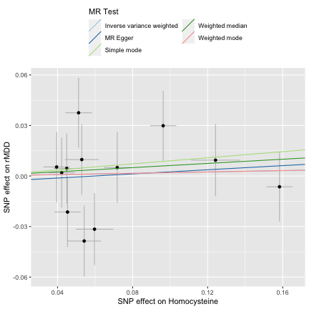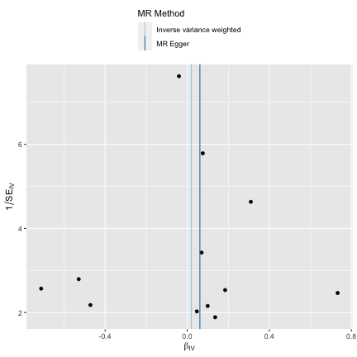

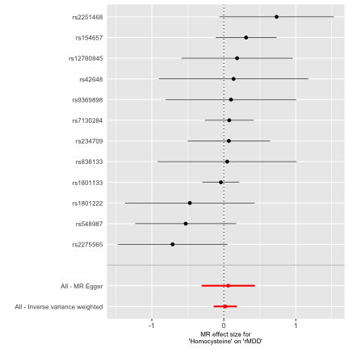

##### Serum B12 and Major Depressive Disorder (N=430,775)

##### Serum B12 and Recurrent Depression (N= 80,933)

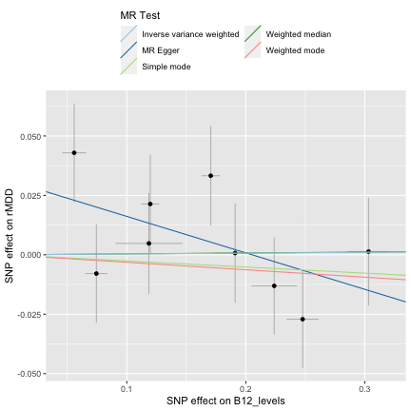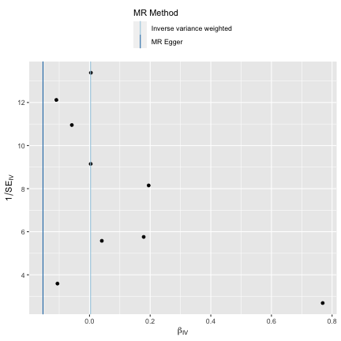

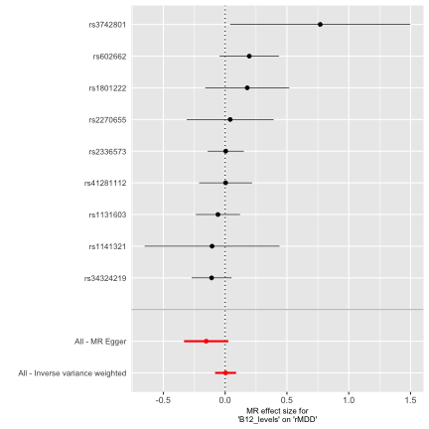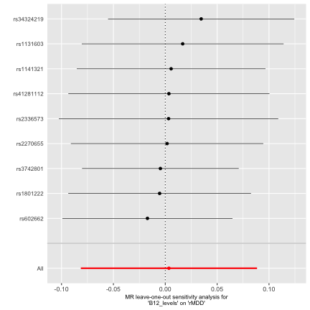

##### Vitamin C and Major Depressive Disorder (N=430,775)

##### Vitamin C and Recurrent Depression (N= 80,933)

#### Fat Soluble Vitamins

##### Serum Retinol and Major Depressive Disorder (N=430,775)

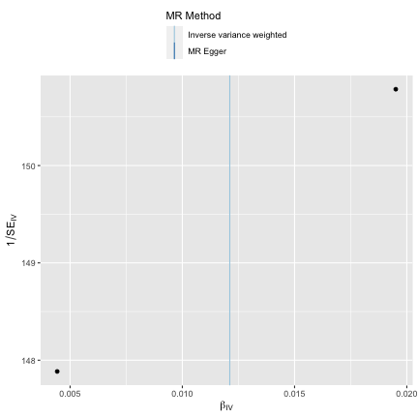

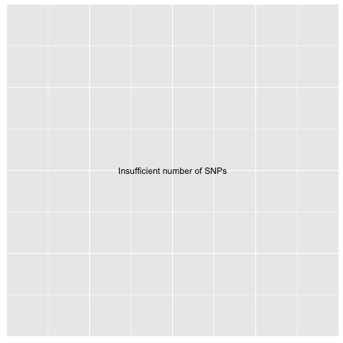

##### Serum Retinol and Recurrent Depression (N= 80,933)

##### Serum 25 (OH) Vitamin D and Major Depressive Disorder (N=430,775)

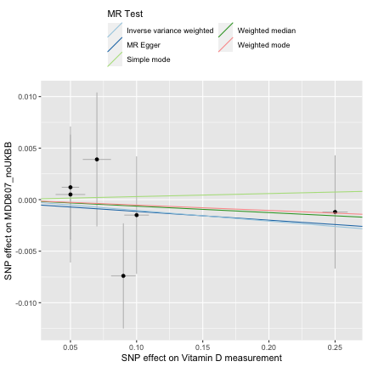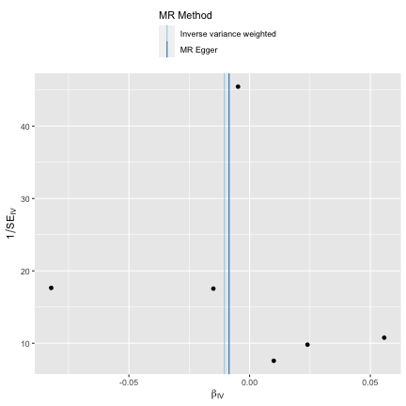

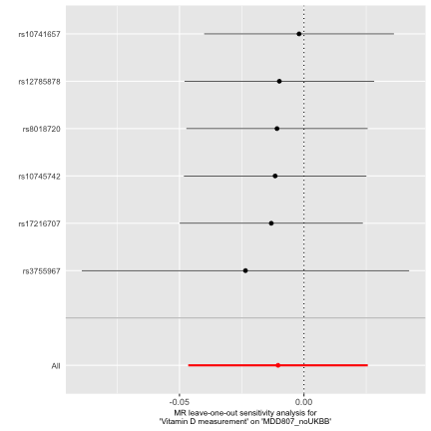

#### Macrominerals

##### Calcium and Major Depressive Disorder (N=430,775)

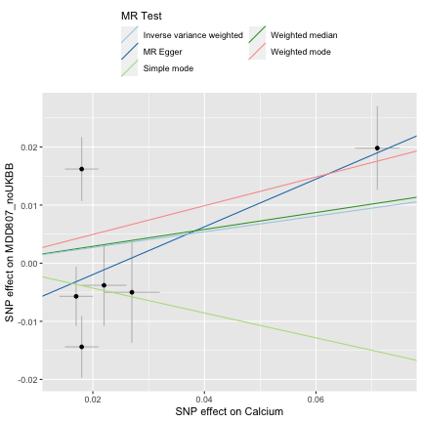

##### Calcium and Recurrent Depression (N= 80,933)

##### Serum Magnesium and Major Depressive Disorder (N=430,775)

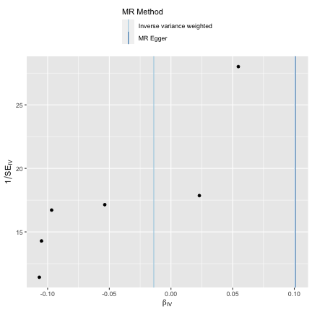

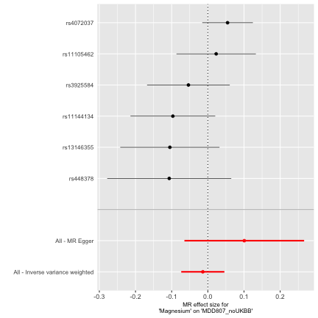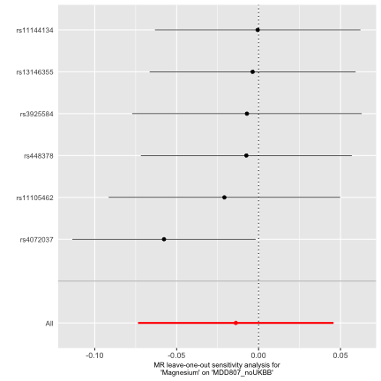

##### Serum Magnesium and Recurrent Depression (N= 80,933)

##### Phosphate and Major Depressive Disorder (N=430,775)

##### Phosphate and Recurrent Depression (N= 80,933)

#### Microminerals

##### Serum Iron and Major Depressive Disorder (N=430,775)

##### Serum Iron and Recurrent Depression (N= 80,933)

##### Serum Ferritin and Major Depressive Disorder (N=430,775)

##### Serum Ferritin and Recurrent Depression (N= 80,933)

##### Erythrocyte Copper and Major Depressive Disorder (N=430,775)

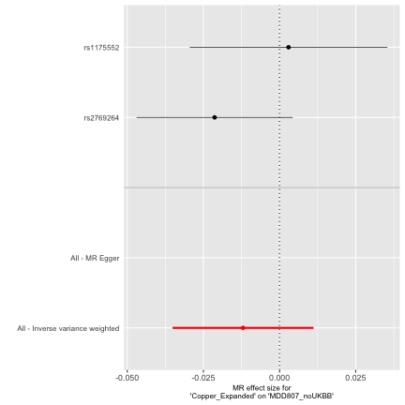

##### Erythrocyte Copper and Recurrent Depression (N= 80,933)

##### Serum Manganese and Major Depressive Disorder (N=430,775)

##### Serum Magnanese and Recurrent Depression (N= 80,933)

##### Serum Selenium and Major Depressive Disorder (N=430,775)

##### Serum Selenium and Recurrent Depression (N= 80,933)

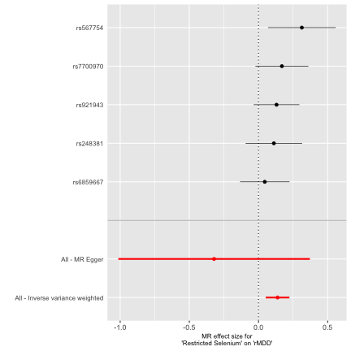

##### Erythrocyte Zinc and Major Depressive Disorder (N=430,775)

##### Erythrocyte Zinc and Recurrent Depression (N= 80,933)

### Supplementary Material S3: List of PGC MDD collaborators

Mark J Adams 1

Fabian Streit 2

Swapnil Awasthi 3

Brett N Adey 4

Karmel W Choi 5, 6

V Kartik Chundru 7

Jonathan RI Coleman 4, 8

Jerome C Foo 2

Olga Giannakopoulou 9

Alisha S M Hall 2, 10

Jens Hjerling-Leffler 11

David M Howard 4

Christopher Hübel 4, 12, 13

Alex S F Kwong 1, 14

Bochao Danae Lin 15

Xiangrui Meng 9

Guiyan Ni 16

Oliver Pain 17

Gita A Pathak 18, 19

Eva C Schulte 20, 21, 22, 23

Jackson G Thorp 24

Alicia Walker 16

Shuyang Yao 25

Jian Zeng 16

Johan Zvrskovec 4, 8

Dag Aarsland 26

Ky'Era V Actkins 27

Mazda Adli 3, 28

Esben Agerbo 12, 29, 30

Mareike Aichholzer 31

Tracy M Air 32

Allison Aiello 33

Thomas D Als 30, 34, 35

Evelyn Andersson 36

Till F M Andlauer 37, 38

Volker Arolt 39

Helga Ask 40, 41

Sunita Badola 42

Clive Ballard 43

Karina Banasik 44

Nicholas J Bass 9

Aartjan T F Beekman 45

Sintia Belangero 46

Elisabeth B Binder 38, 47

Ottar Bjerkeset 48, 49

Gyda Bjornsdottir 50

Julia Boberg 36

Sigrid Børte 51, 52, 53

Emma Bränn 54

Alice Braun 55

Thorsten Brodersen 56

Søren Brunak 44

Mie T Bruun 57

Pichit Buspavanich 58, 59

Jonas Bybjerg-Grauholm 60,61

Enda M Byrne 62

Archie Campbell 63, 64

Megan L. Campbell 65

Enrique Castelao 66

Jorge Cervilla 67, 68

Boris Chaumette 69

Chia-Yen Chen 70

Zhengming Chen 71, 72

Sven Cichon 73, 74, 75, 76

Lucía Colodro-Conde 24

Anne Corbett 43

Elizabeth C Corfield 40, 77

Baptiste Couvy-Duchesne 78

Nick Craddock 79, 80

Udo Dannlowski 39

Gail Davies 81

EJC de Geus 82

Ian J Deary 81

Franziska Degenhardt 76, 83

Abbas Dehghan 84, 85

J Raymond DePaulo 86

Michael Deuschle 87

Maria Didriksen 88

Khoa Manh Dinh 89

Nese Direk 90

Srdjan Djurovic 91, 92

Anna R Docherty 93, 94, 95

Katharina Domschke 96

Joseph Dowsett 88

Ole Kristian Drange 49, 97,98, 99

Erin C Dunn 6, 100

Gudmundur Einarsson 50

Thalia C Eley 4

Samar S M Elsheikh 101

Jan Engelmann 102

Michael E Benros 60, 103,104

Christian Erikstrup 89

Valentina Escott-Price 80

Chiara Fabbri 4, 105

Yu Fang 106

Sarah Finer 107

Josef Frank 2

Robert C Free 108

He Gao 109

Michael Gill 110

Maria Gilles 87

Fernando S Goes 86

Scott Douglas Gordon 24

Jakob Grove 30, 34, 35, 111

Daniel F Gudbjartsson 50,112

Blanca Gutierrez 67, 68

Tim Hahn 39

Lynsey S Hall 80

Thomas F Hansen 44, 60,113

Magnus Haraldsson 114

Catherina A Hartman 115

Alexandra Havdahl 40

Caroline Hayward 116

Stefanie Heilmann-

Heimbach 76

Stefan Herms 74, 76

Ian B Hickie 117

Henrik Hjalgrim 118

Per Hoffmann 74, 76

Georg Homuth 119

Carsten Horn 120

Jouke-Jan Hottenga 82

David M Hougaard 60, 61

Iiris Hovatta 121

Qin Qin Huang 7

Floris Huider 82

Karen A Hunt 122

Marcus Ising 123

Erkki Isometsä 124

Rick Jansen 45

Yunxuan Jiang 125

Ian Jones 80

Lisa A Jones 126

Lina Jonsson 127

Robert Karlsson 25

Siegfried Kasper 128

Kenneth S Kendler 129

Ronald C Kessler 130

Stefan Kloiber 101, 123, 131,132

James A Knowles 133

Nastassja Koen 65-22-

Julia Kraft 55

Henry R Kranzler 134, 135

Kristi Krebs 136

Theodora Kunovac Kallak137

Zoltán Kutalik 138, 139, 140

Elisa Lahtela 141

Margit Hørup Larsen 88

Eric J Lenze 142

Daniel F Levey 143, 144

Melissa Lewins 1

Glyn Lewis 9

Liming Li 145, 146

Kuang Lin 71

Penelope A Lind 24

Donald J MacIntyre 1, 147,148

Dean F MacKinnon 86

Hermine HM Maes 149, 150

Wolfgang Maier 151

Victoria S Marshe 101, 152

Hamdi Mbarek 82

Peter McGuffin 4

Sarah E Medland 24

Susanne Meinert 39, 153

Susan Mikkelsen 89

Christina Mikkelsen 88, 154

Yuri Milaneschi 45

Iona Y Millwood 71, 72

Brittany L Mitchell 24

Esther Molina 67, 155

Francis M Mondimore 86

Preben Bo Mortensen 12,29, 30

Benoit H Mulsant 101, 131

Joonas Naamanka 121

Jake M Najman 156

Matthias Nauck 157, 158

Igor Nenadić 159

Kasper R Nielsen 160

Ilja M Nolte 161

Merete Nordentoft 60, 103,104

Markus M Nöthen 76

Mette Nyegaard 30, 162,163, 164

Michael C O'Donovan 80

Asmundur Oddsson 50

Catherine M Olsen 165, 166

Hogni Oskarsson 167

Sisse Rye Ostrowski 88, 168

Vanessa K Ota 46

Michael J Owen 80

Richard Packer 169

Teemu Palviainen 141

Pedro M Pan 170

Carlos N Pato 171

Michele T Pato 171

Nancy L Pedersen 25

Ole Birger Pedersen 172

Roseann E Peterson 129,173

Wouter J Peyrot 45

James B Potash 86

Martin Preisig 66

Jorge A Quiroz 174

Charles F Reynolds III 175

John P Rice 142

Giovanni A Salum 176

Robert A Schoevers 177, 178

Andrew Schork 30, 179, 180

Thomas G Schulze 2, 21, 86,181, 182

Tabea S Send 87

Jianxin Shi 183

Engilbert Sigurdsson 114

Kritika Singh 27

Grant C B Sinnamon 184

Lea Sirignano 2

Olav B Smeland 185, 186

Daniel J Smith 187

Erik Sørensen 88

Sundararajan Srinivasan 188

Hreinn Stefansson 50

Kari Stefansson 50, 189

Dan J. Stein 190

Frederike Stein 191

André Tadic 102, 192

Henning Teismann 193

Alexander Teumer 194

Anita Thapar 80, 195

Pippa A Thomson 64

Lise Wegner Thørner 88

Apostolia Topaloudi 196

Ioanna Tzoulaki 84, 85, 197

Monica Uddin 198

André G Uitterlinden 199

Henrik Ullum 88, 200, 201

Daniel Umbricht 202

Robert J Ursano 203

Sandra Van der Auwera 204

David A van Heel 122

Albert M van Hemert 205

Abirami Veluchamy 188

Alexander Viktorin 25

Henry Völzke 194

Agaz Wani 198

G Bragi Walters 50

Robin G Walters 71, 72

Sylvia Wassertheil-Smoller206

Myrna M Weissman 207,208

Jürgen Wellmann 193

David C Whiteman 165

Derek Wildman 198

Gonneke Willemsen 82

Alexander T Williams 169

Bendik S Winsvold 51, 52,209

Stephanie H Witt 2

Ying Xiong 25

Lea Zillich 2

John-Anker Zwart 51, 52, 53

23andMe Research Team125

Estonian Biobank Research

Team 136

HUNT All-In Psychiatry 210

China Kadoorie Biobank

Collaborative Group 211

Genes & Health Research

Team 212

Ole A Andreassen 185, 186,213

Bernhard T Baune 214, 215,216

Klaus Berger 193

Dorret I Boomsma 82

Anders D Børglum 30, 34, 35

Gerome Breen 4, 8

Na Cai 217, 218, 219

Hilary Coon 94

William E Copeland 220

Byron Creese 43

Lea K Davis 27

Eske M Derks 24

Enrico Domenici 221

Paul Elliott 84, 85, 197, 222

Andreas J Forstner 73, 76

Micha Gawlik 223

Joel Gelernter 19, 143, 224

Hans J Grabe 204-23-

Steven P Hamilton 225

Kristian Hveem 226, 227,228

Catherine John 169, 229

Jaakko Kaprio 141

Tilo Kircher 159

Marie-Odile Krebs 230

Karoline Kuchenbaecker 9,71

Mikael Landén 25, 127

Kelli Lehto 136

Douglas F Levinson 231

Qingqin S Li 232

Klaus Lieb 102

Yi Lu 25

Susanne Lucae 123

Jurjen J Luykx 15, 233

Patrik K Magnusson 25

Nicholas G Martin 24

Hilary C Martin 7

Andrew McQuillin 9

Christel M Middeldorp 62,234

Lili Milani 136

Ole Mors 30, 235

Daniel J Müller 101, 131,132, 236

Bertram Müller-Myhsok 38,237, 238

Albertine J Oldehinkel 115

Sara A Paciga 239

Colin NA Palmer 188

Peristera Paschou 196

Brenda WJH Penninx 45

Roy H Perlis 5, 6, 240

Giorgio Pistis 66

Renato Polimanti 18, 19

David J Porteous 64

Danielle Posthuma 241, 242

Ted Reichborn-Kjennerud40

Andreas Reif 31

Frances Rice 80, 243

Roland Ricken 3

Marcella Rietschel 2

Margarita Rivera 67, 244

Christian Rück 245

Catherine Schaefer 246

Srijan Sen 106, 247

Alessandro Serretti 105

Alkistis Skalkidou 137

Jordan W Smoller 5, 248,249

Frederike Stein 191

Murray B Stein 250, 251, 25

Patrick F Sullivan 25, 253

Martin Tesli 40

Thorgeir E Thorgeirsson 50

Henning Tiemeier 254, 255

Nicholas J Timpson 14

Rudolf Uher 256

Jens R Wendland 42

Thomas Werge 60, 179, 201,257, 258

Naomi R Wray 16, 259

Stephan Ripke 3, 248

Cathryn M Lewis 4, 260

Andrew M McIntosh 1, 261

**PGC MDD Affiliations**

1, Division of Psychiatry, University of Edinburgh, Edinburgh, UK

2, Department of Genetic Epidemiology in Psychiatry, Central Institute of Mental Health, Medical Faculty Mannheim, Heidelberg University, Mannheim, BW, DE

3, Department of Psychiatry and Psychotherapy, Charité – Universitätsmedizin Berlin, Berlin, BE, DE

4, Social, Genetic and Developmental Psychiatry Centre, King's College London, London, UK

5, Department of Psychiatry, Massachusetts General Hospital, Boston, MA, US

6, Department of Psychiatry, Harvard Medical School, Boston, MA, US

7, Human Genetics, Wellcome Sanger Institute, Hinxton, UK

8, NIHR Maudsley Biomedical Research Centre, King's College London, London, UK

9, Division of Psychiatry, University College London, London, UK

10, Department of Clinical Medicine, Aarhus University, Aarhus, DK

11, Department of Medical Biochemistry and Biophysics, Karolinska Institutet, Stockholm, SE

12, National Centre for Register-based Research, Aarhus University, Aarhus, DK

13, Department of Pediatric Neurology, Charité – Universitätsmedizin Berlin, Berlin, BE, DE

14, MRC Integrative Epidemiology Unit, University of Bristol, Bristol, UK

15, Department of Psychiatry and Neuropsychology, School for Mental Health and Neuroscience, Maastricht University Medical Centre, Maastricht, NL

16, Institute for Molecular Bioscience, University of Queensland, Brisbane, QLD, AU

17, Maurice Wohl Clinical Neuroscience Institute, Department of Basic and Clinical Neuroscience, King's College London, London, UK

18, Veterans Affairs Connecticut Healthcare System, West Haven, CT, US

19, Department of Psychiatry, Yale University School of Medicine, New Haven, CT, US

20, Department of Psychiatry, University of Munich, Munich, BY, DE

21, Institute of Psychiatric Phenomics and Genomics, University of Munich, Munich, BY, DE

22, Department of Psychiatry and Psychotherapy, University Hospital Bonn, Medical Faculty, University of Bonn, Bonn, DE

23, Institute of Human Genetics, University Hospital Bonn, Medical Faculty, University of Bonn, Bonn, DE

24, Mental Health and Neuroscience, QIMR Berghofer Medical Research Institute, Brisbane, QLD, AU

25, Department of Medical Epidemiology and Biostatistics, Karolinska Institutet, Stockholm, SE

26, Old Age Psychiatry, King's College London, London, UK

27, Department of Medicine, Division of Genetic Medicine, Vanderbilt University Medical Center, Nashville, TN, US

28, Department of Psychiatry and Psychotherapy, Fliedner Klinik Berlin, Berlin, BE, DE

29, Centre for Integrated Register-based Research, Aarhus University, Aarhus, DK

30, iPSYCH, The Lundbeck Foundation Initiative for Integrative Psychiatric Research, Aarhus, DK

31, Department of Psychiatry, Psychosomatic Medicine and Psychotherapy, Goethe University Frankfurt - University Hospital, Frankfurt am Main, DE

32, Discipline of Psychiatry, University of Adelaide, Adelaide, SA, AU

33, Department of Epidemiology, Columbia University Mailman School of Public Health, New York, NY, US

34, Department of Biomedicine and Centre for Integrative Sequencing, iSEQ, Aarhus University, Aarhus, DK

35, Center for Genomics and Personalized Medicine, Aarhus University, Aarhus, DK

36, Department of Clinical Neuroscience, Karolinska Institutet,, SE

37, Department of Neurology, Klinikum rechts der Isar, Technical University of Munich, Munich, BY,DE

38, Department of Translational Research in Psychiatry, Max Planck Institute of Psychiatry, Munich,BY, DE

39, Institute for Translational Psychiatry, University of Münster, Münster, NRW, DE-25-

40, Department of Mental Disorders, Norwegian Institute of Public Health, Oslo, NO

41, PROMENTA Research Center, Department of Psychology, University of Oslo, Oslo, NO

42, Research and Development, Takeda Pharmaceutical Company Limited, Cambridge, MA, US

43, Faculty of Health and Life Sciences, University of Exeter, Exeter, UK

44, Novo Nordisk Center for Protein Research, Department of Health Sciences, University of Copenhagen, Copenhagen, DK

45, Department of Psychiatry, Amsterdam Public Health and Amsterdam Neuroscience, Amsterdam UMC, Vrije Universiteit Amsterdam, Amsterdam, NL

46, Morphology and Genetics, Universidade Federal de Sao Paulo, Sao Paulo, SP, BR

47, Department of Psychiatry and Behavioral Sciences, Emory University School of Medicine, Atlanta, GA, US

48, Faculty of Nursing and Health Sciences, NORD University, Levanger, NO

49, Department of Mental Health, Faculty of Medicine and Health Sciences, Norwegian University of Science and Technology (NTNU), Trondheim, TRD, NO

50, deCODE Genetics / Amgen, Reykjavik, IS

51, K. G. Jebsen Center for Genetic Epidemiology, Department of Public Health and Nursing, Faculty of Medicine and Health Sciences, Norwegian University of Science and Technology (NTNU), Trondheim, TRD, NO

52, Department of Research and Innovation, Division of Clinical Neuroscience, Oslo University Hospital, Oslo, NO

53, Institute of Clinical Medicine, Faculty of Medicine, University of Oslo, Oslo, NO

54, Institute of Environmental Medicine, Unit of Integrative Epidemiology, Karolinska Institutet, Stockholm, SE

55, Department of Psychiatry and Psychotherapy, Charité – Universitätsmedizin Berlin, Berlin, DE

56, Department of Clinical Immunology, Roskilde University/Næstved Hospital, Roskilde, DK

57, Department of Clinical Immunology, Odense University Hospital, Odense, DK

58, Department of Psychiatry, Psychotherapy and Psychosomatics, Brandenburg Medical School Theodor Fontane, Neuruppin, BB, DE

59, Department of Psychiatry and Psychotherapy, Gender Research in Medicine, Institute of Sexology and Sexual Medicine, Charité – Universitätsmedizin Berlin, Berlin, BE, DE

60, iPSYCH, The Lundbeck Foundation Initiative for Integrative Psychiatric Research, Copenhagen, DK

61, Center for Neonatal Screening, Department for Congenital Disorders, Statens Serum Institut, Copenhagen, DK

62, Child Health Research Centre, University of Queensland, Brisbane, QLD, AU

63, Centre for Medical Informatics, Usher Institute, University of Edinburgh, Edinburgh, UK

64, Centre for Genomic & Experimental Medicine, Institute for Genetics and Cancer, University of Edinburgh, Edinburgh, UK

65, Department of Psychiatry and Mental Health, University of Cape Town, Cape Town, SA

66, Department of Psychiatry, Lausanne University Hospital and University of Lausanne, Prilly, VD, CH

67, Instituto de Investigación Biosanitaria ibs.GRANADA, Granada, ES

68, Department of Psychiatry, Faculty of Medicine and Institute of Neurosciences, Biomedical Research Centre (CIBM), University of Granada, Granada, ES

69, Université de Paris Cité, INSERM U1266, Institute of Psychiatry and Neuroscience of Paris, GHU Paris Psychiatry and Neuroscience, Paris, FR

70, Translational Biology, Biogen, Cambridge, MA, US

71, Nuffield Department of Population Health, University of Oxford, Oxford, UK

72, MRC Population Health Research Unit, University of Oxford, Oxford, UK

73, Institute of Neuroscience and Medicine (INM-1), Research Center Juelich, Juelich, DE

74, Human Genomics Research Group, Department of Biomedicine, University of Basel, Basel, CH

75, Institute of Medical Genetics and Pathology, University Hospital Basel, University of Basel, Basel,

CH-26-

76, Institute of Human Genetics, University of Bonn, School of Medicine & University Hospital Bonn, Bonn, DE

77, Nic Waals Institute, Lovisenberg Diakonale Hospital, Oslo, NO

78, Centre for Advanced Imaging, University of Queensland, Saint Lucia, QLD, AU

79, Psychological Medicine, Cardiff University, Cardiff, WLS, UK

80, Centre for Neuropsychiatric Genetics and Genomics, Cardiff University, Cardiff, WLS, UK

81, The Lothian Birth Cohorts, University of Edinburgh, Edinburgh, UK

82, Department of Biological Psychology & Amsterdam Public Health Research Institute, Vrije Universiteit Amsterdam, Amsterdam, NL

83, Department of Child and Adolescent Psychiatry, Psychosomatics and Psychotherapy, University Hospital Essen, Unversity of Duisburg-Essen, Duisburg, DE

84, MRC Centre for Environment and Health, School of Public Health, Imperial College London, London, UK

85, Imperial College Dementia Research Institute, Imperial College London, London, UK

86, Department of Psychiatry and Behavioral Sciences, Johns Hopkins University School of Medicine,

Baltimore, MD, US

87, Department of Psychiatry and Psychotherapy, Research Group Stress Related Disorders, Central Institute of Mental Health, Medical Faculty Mannheim, Heidelberg University, Mannheim, BW, DE

88, Department of Clinical Immunology, Copenhagen University Hospital, Rigshospitalet, Copenhagen, CPH, DK

89, Department of Clinical Immunology, Aarhus University Hospital, Aarhus, DK

90, Department of Psychiatry, Istanbul University, Istanbul, TR

91, Department of Medical Genetics, Oslo University Hospital, Oslo, OSL, NO

92, NORMENT, Department of Clinical Science, University of Bergen, Bergen, NO

93, Virginia Institute for Psychiatric & Behavioral Genetics, Virginia Commonwealth University, Richmond, VA, US

94, Psychiatry Department / Huntsman Mental Health Institute, University of Utah School of Medicine, Salt Lake City, UT, US

95, Center for Genomic Research, University of Utah School of Medicine, Salt Lake City, UT, US

96, Department of Psychiatry and Psychotherapy, Medical Center, University of Freiburg, Faculty of Medicine, University of Freiburg, Freiburg,DE

97, Division of Mental Health Care, St. Olavs Hospital, Trondheim University Hospital, Trondheim, TRD,NO

98, Department of Psychiatry, Sørlandet Hospital, Kristiansand, AG, NO

99, University of Oslo, NORMENT Centre, Institute of Clinical Medicine, Oslo, OSL, NO

100, Center for Genomic Medicine, Massachusetts General Hospital, Boston, MA, US

101, Centre for Addiction and Mental Health, Toronto, ON, CA

102, Department of Psychiatry and Psychotherapy, University Medical Center of the Johannes Gutenberg University Mainz, Mainz, DE

103, Mental Health Center Copenhagen, Mental Health Services Capital Region of Denmark, Copenhagen, DK

104, Faculty of Health Science, Department of Clinical Medicine, University of Copenhagen, Copenhagen, DK

105, Department of Biomedical and Neuromotor Sciences, University of Bologna, Bologna, IT

106, Michigan Neuroscience Institute, University of Michigan, Ann Arbor, MI, US

107, Wolfson Institute of Population Health, Queen Mary University of London, London, UK

108, School of Computing and Mathematical Sciences, University of Leicester, Leicester, UK

109, Department of Epidemiology and Biostatistics, Imperial College London, London, UK

110, Discipline of Psychiatry, School of Medicine, Trinity College Dublin, Dublin, IE

111, Bioinformatics Research Centre, Aarhus University, Aarhus, DK

112, School of Engineering, University of Iceland, Reykjavik, IS-27-

113, Danish Headache Centre, Department of Neurology, Rigshospitalet, Glostrup, DK

114, Faculty of Medicine, Department of Psychiatry, University of Iceland, Reykjavik, IS

115, Department of Psychiatry, University of Groningen, University Medical Center Groningen, Groningen, NL

116, MRC Human Genetics Unit, Institute for Genetics and Cancer, University of Edinburgh, Edinburgh, UK

117, Brain and Mind Centre, University of Sydney, Sydney, NSW, AU

118, Department of Epidemiology Research, Statens Serum Institut, Copenhagen, DK

119, Interfaculty Institute for Genetics and Functional Genomics, Department of Functional Genomics, University Medicine Greifswald, Greifswald, MV, DE

120, Roche Pharmaceutical Research and Early Development, Pharmaceutical Sciences, Roche Innovation Center Basel, F. Hoffmann-La Roche Ltd, Basel, CH

121, SleepWell Research Program and Department of Psychology and Logopedics, University of Helsinki, Helsinki, FI

122, Blizard Institute, Barts and the London School of Medicine and Dentistry, Queen Mary University of London, London, UK

123, Max Planck Institute of Psychiatry, Munich, BY, DE

124, Department of Psychiatry, University of Helsinki, Helsinki, FI

125, 23andMe Research Team, 23andMe, Inc., Sunnyvale, CA, US

126, Department of Psychological Medicine, University of Worcester, Worcester, UK

127, Institution of Neuroscience and Physiology, University of Gothenburg, Gothenburg, SE

128, Department of Psychiatry and Psychotherapy, Medical University of Vienna, Vienna, AT

129, Department of Psychiatry, Virginia Commonwealth University, Richmond, VA, US

130, Health Care Policy, Harvard Medical School, Boston, MA, US

131, Department of Psychiatry, University of Toronto, Toronto, ON, CA

132, Department of Pharmacology & Toxicology, University of Toronto, Toronto, ON, CA

133, Department of Genetics, Rutgers University, Piscataway, NJ, US

134, Department of Psychiatry, Perelman School of Medicine, University of Pennsylvania, Philadelphia, PA, US

135, Mental Illness Research, Education and Clinical Center, Crescenz VA Medical Center, Philadelphia, PA, US

136, Estonian Genome Centre, Institute of Genomics, University of Tartu, Tartu, EE

137, Department of Women's and Children's Health, Uppsala University, Uppsala, SE

138, Department of Epidemiology and Health Systems, Center for Primary Care and Public Health, Lausanne, VD, CH

139, Swiss Institute of Bioinformatics, Lausanne, VD, CH

140, Department of Computational Biology, University of Lausanne, Lausanne, VD, CH

141, Institute for Molecular Medicine Finland - FIMM, University of Helsinki, Helsinki, FI

142, Department of Psychiatry, Washington University School of Medicine in St. Louis, St. Louis, MO, US

143, Psychiatry, Veterans Affairs Connecticut Healthcare System, West Haven, CT, US

144, Department of Psychiatry, Yale University, New Haven, CT, US

145, Department of Epidemiology and Biostatistics, School of Public Health, Peking University, Beijing, CN

146, Peking University Center for Public Health and Epidemic Preparedness & Response, Peking University, Beijing, CN

147, Mental Health, NHS 24, Glasgow, UK

148, Royal Edinburgh Hospital, NHS Lothian, Edinburgh, UK

149, Department of Human and Molecular Genetics, Virginia Commonwealth University, Richmond, VA, USA-28-

150, Virginia Institute for Psychiatric and Behavioral Genetics, Virginia Commonwealth University, Richmond, VA, USA

151, Department of Psychiatry and Psychotherapy, University of Bonn, Bonn, DE

152, Center for Translational and Computational Neuroimmunology, Columbia University Medical Center, New York, NY, US

153, Institute for Translational Neuroscience, University of Münster, Münster, NRW, DE

154, Novo Nordisk Foundation Center for Basic Metabolic Research, Faculty of Health Science, Copenhagen University, Copenhagen, DK

155, Department of Nursing, Faculty of Health Sciences and Institute of Neurosciences, Biomedical Research Centre (CIBM), University of Granada, Granada, ES

156, School of Public Health, University of Queensland, Brisbane, QLD, AU

157, DZHK (German Centre for Cardiovascular Research), Partner Site Greifswald, Greifswald, MV, DE

158, Institute of Clinical Chemistry and Laboratory Medicine, University Medicine Greifswald, Greifswald, MV, DE

159, Department of Psychiatry, University of Marburg, Marburg, DE

160, Department of Clinical Immunology, Aalborg University Hospital, Aalborg, DK

161, Department of Epidemiology, University of Groningen, University Medical Center Groningen, Groningen, NL

162, Department of Health, Science and Technology, Aalborg University, Aalborg, DK

163, Centre for Integrative Sequencing, iSEQ, Aarhus University, Aarhus, DK

164, Department of Biomedicine-Human Genetics, Aarhus University, Aarhus, DK

165, Population Health, QIMR Berghofer Medical Research Institute, Brisbane, QLD, AU

166, The Fraser Institute, Faculty of Medicine, University of Queensland, Brisbane, QLD, AU

167, Humus, Reykjavik, IS

168, Department of Clinical Medicine, University of Copenhagen, Copenhagen, CPH, DK

169, Department of Population Health Sciences, University of Leicester, Leicester, UK

170, Department of Psychiatry, Universidade Federal de Sao Paulo, Sao Paulo, SP, BR

171, Department of Psychiatry, Rutgers University, Piscataway, NJ, US

172, Department of Clinical Immunology, Zealand University Hospital, Køge, DK

173, Department of Psychiatry and Behavioral Sciences, SUNY Downstate Health Sciences University, Brooklyn, NY, US

174, NMD Pharma, Lexington, MA, US

175, Psychiatry, University of Pittsburgh Medical Centre, Pittsburgh, PA, US

176, Psychiatry, Universidade Federal do Rio Grande do Sul, Porto Alegre, BR

177, Department of Psychiatry, University Medical Center Groningen, Groningen, NL

178, Research School of Behavioural and Cognitive Neurosciences (BCN), University of Groningen, Groningen, NL

179, Institute of Biological Psychiatry, Mental Health Center Sct. Hans, Mental Health Services Capital Region of Denmark, Copenhagen, DK

180, Neurogenomics Division, The Translational Genomics Research Institute (TGEN), Phoenix, AZ, US

181, Human Genetics Branch, NIMH Division of Intramural Research Programs, Bethesda, MD, US

182, Department of Psychiatry and Psychotherapy, University Medical Center Göttingen, Goettingen, NI, DE

183, Division of Cancer Epidemiology and Genetics, National Cancer Institute, Bethesda, MD, US

184, School of Medicine and Dentistry, James Cook University, Townsville, QLD, AU

185, Division of Mental Health and Addiction, Oslo University Hospital, Oslo, OSL, NO

186, NORMENT, Institute of Clinical Medicine, University of Oslo, Oslo, OSL, NO

187, Institute of Health and Wellbeing, University of Glasgow, Glasgow, UK

188, Division of Population Health and Genomics, Ninewells Hospital and School of Medicine, University of Dundee, Dundee, UK

189, Faculty of Medicine, University of Iceland, Reykjavik, IS-29-

190, SAMRC Unit on Risk & Resilience in Mental Disorders, Department of Psychiatry and Mental Health, University of Cape Town, Cape Town,SA

191, Department of Psychiatry and Psychotherapy, University of Marburg, Marburg, HE, DE

192, Department of Psychiatry, Psychotherapy and Psychosomatics, Dr. Fontheim Mentale Gesundheit, Liebenburg, DE

193, Institute of Epidemiology and Social Medicine, University of Münster, Münster, NRW, DE

194, Institute for Community Medicine, University Medicine Greifswald, Greifswald, MV, DE

195, Wolfson Centre for Young People's Mental Health, Division of Psychological Medicine and Clinical Neurosciences, Cardiff University, Cardiff, WLS, UK

196, Department of Biological Sciences, Purdue University, West Lafayette, IN, US

197, Imperial College BHF Centre for Research Excellence, Imperial College London, London, UK

198, Genomics Program, University of South Florida College of Public Health, Tampa, FL, US

199, Department of Internal Medicine, Erasmus University Medical Center Rotterdam, Rotterdam, NL

200, Management Section, Statens Serum Institut, Copenhagen, DK

201, Department of Clinical Medicine, University of Copenhagen, Copenhagen, DK

202, Xperimed LLC, Basel, CH

203, Psychiatry, USUHS, Bethesda, US

204, Department of Psychiatry and Psychotherapy, University Medicine Greifswald, Greifswald, MV, DE

205, Department of Psychiatry, Leiden University Medical Center, Leiden, NL

206, Department of Epidemiology and Population Health, Albert Einstein College of Medicine, Bronx, NY, US

207, Department of Psychiatry, Columbia University College of Physicians and Surgeons, New York, NY, US

208, Division of Epidemiology, New York State Psychiatric Institute, New York, NY, US

209, Department of Neurology, Oslo University Hospital, Oslo, NO

210, HUNT All-In Psychiatry

211, China Kadoorie Biobank Collaborative Group

212, Genes & Health Research Team

213, KG Jebsen Centre for Neurodevelopmental Research, University of Oslo, Oslo, OSL, NO

214, Department of Psychiatry, University of Melbourne, Melbourne, VIC, AU

215, Florey Institute of Neuroscience and Mental Health, University of Melbourne, Melbourne, VIC, AU

216, Department of Psychiatry, University of Münster, Münster, NRW, DE

217, Computational Health Centre, Helmholtz Zentrum München, Neuherberg, DE

218, School of Medicine, Technical University of Munich, Munich, BY, DE

219, Helmholtz Pioneer Campus, Helmholtz Zentrum München, Neuherberg, DE

220, Department of Psychiatry, University of Vermont, Burlington, VT, US

221, Department of Cellular, Computational and Integrative Biology, Università degli Studi di Trento, Trento, IT

222, Imperial College Biomedical Research Centre, Imperial College London, London, UK

223, Department of Psychiatry, Psychosomatics and Psychotherapy, Julius-Maximilians-Universität Würzburg, Würzburg, DE

224, Department of Genetics, Department of Neuroscience, Yale University School of Medicine, New Haven, CT, US

225, Psychiatry, Kaiser Permanente Northern California, San Francisco, CA, US

226, K. G. Jebsen Center for Genetic Epidemiology, Department of Public Health and Nursing, Faculty of Medicine and Health Sciences, Norwegian University of Science and Technology (NTNU), Trondheim, NO

227, HUNT Research Center, Department of Public Health and Nursing, Faculty of Medicine and Health Sciences, Norwegian University of Science and Technology (NTNU), Trondheim, NO-30-

228, Department of Research, Innovation and Education, St. Olavs Hospital, Trondheim University Hospital, Trondheim, NO

229, NIHR Leicester Biomedical Research Centre, Glenfield Hospital, Leicester, UK

230, Pathophysiology of Psychiatric Diseases, INSERM, Univ Paris Cité, GHU Paris, Paris, FR

231, Department of Psychiatry & Behavioral Sciences, Stanford University, Stanford, CA, US

232, Neuroscience Therapeutic Area, Janssen Research and Development, LLC, Titusville, NJ, US

233, Second Opinion Outpatient Clinic, GGNet Mental Health, Warnsveld, NL

234, Child and Youth Mental Health Service, Children's Health Queensland Hospital and Health Service, Brisbane, QLD, AU

235, Psychosis Research Unit, Aarhus University Hospital-Psychiatry, Aarhus, DK

236, Department of Psychiatry, Psychosomatics and Psychotherapy, University Hospital of Würzburg, Würzburg, DE

237, Munich Cluster for Systems Neurology (SyNergy), Munich, BY, DE

238, University of Liverpool, Liverpool, UK

239, Human Genetics and Computational Biomedicine, Pfizer Global Research and Development, Groton, CT, US

240, Centre for Quantitative Health, Massachusetts General Hospital, Boston, MA, US

241, Child and Adolescent Psychiatry, Amsterdam UMC, Vrije Universiteit Amsterdam, Amsterdam, NL

242, Complex Trait Genetics, Vrije Universiteit Amsterdam, Amsterdam, NL

243, Wolfson Centre for Young People's Mental Health, Division of Psychological Medicine and Clinical Neurosciences, Cardiff University, Cardiff, UK

244, Department of Biochemistry and Molecular Biology II, Faculty of Pharmacy and Institute of Neurosciences, Biomedical Research Centre (CIBM), University of Granada, Granada, ES

245, Department of Clinical Neuroscience, Karolinska Institutet, Stockholm, SE

246, Division of Research, Kaiser Permanente Northern California, Oakland, CA, US

247, Department of Psychiatry, University of Michigan, Ann Arbor, MI, US

248, Stanley Center for Psychiatric Research, Broad Institute of MIT and Harvard, Cambridge, MA, US

249, Psychiatric and Neurodevelopmental Genetics Unit, Massachusetts General Hospital, Boston, MA, US

250, Psychiatry, UCSD School of Medicine, La Jolla, CA, US

251, Public Health, UCSD School of Public Health, La Jolla, CA, US

252, Psychiatry, Veterans Affairs San Diego Healthcare System, San Diego, CA, US

253, Departments of Genetics and Psychiatry, University of North Carolina at Chapel Hill, Chapel Hill, NC, US

254, Child and Adolescent Psychiatry, Erasmus University Medical Center Rotterdam, Rotterdam, NL

255, Social and Behavioral Science, Harvard T.H. Chan School of Public Health, Boston, MA, US

256, Psychiatry, Dalhousie University, Halifax, NS, CA

257, Institute of Biological Psychiatry, Mental Health Center Sct. Hans, Copenhagen University Hospital, Mental Health Services, Copenhagen, DK

258, GLOBE Institute, Lundbeck Foundation Centre for Geogenetics, University of Copenhagen, Copenhagen, DK

259, Queensland Brain Institute, University of Queensland, Brisbane, QLD, AU

260, Department of Medical & Molecular Genetics, King's College London, London, UK

261, Institute for Genomics and Cancer, University of Edinburgh, Edinburgh, UK-31-S1: Previous MR evidence for micronutrients in major depression

## References

1. Michaelsson K, Melhus H, Larsson SC. Serum 25-Hydroxyvitamin D Concentrations and Major Depression: A Mendelian Randomization Study. Nutrients. 2018;10(12).

2. Milaneschi Y, Peyrot WJ, Nivard MG, Mbarek H, Boomsma DI, Penninx BWJH. A role for vitamin D and omega-3 fatty acids in major depression? An exploration using genomics. Transl Psychiat. 2019;9.

3. Mulugeta A, Lumsden A, Hypponen E. Relationship between Serum 25(OH)D and Depression: Causal Evidence from a Bi-Directional Mendelian Randomization Study. Nutrients. 2020;13(1).

4. Libuda L, Laabs BH, Ludwig C, Buhlmeier J, Antel J, Hinney A, et al. Vitamin D and the Risk of Depression: A Causal Relationship? Findings from a Mendelian Randomization Study. Nutrients. 2019;11(5).

5. Revez JA, Lin T, Qiao Z, Xue A, Holtz Y, Zhu Z, et al. Genome-wide association study identifies 143 loci associated with 25 hydroxyvitamin D concentration. Nat Commun. 2020;11(1):1647.

6. Mollehave LT, Skaaby T, Simonsen KS, Thuesen BH, Mortensen EL, Sandholt CH, et al. Association studies of genetic scores of serum vitamin B12 and folate levels with symptoms of depression and anxiety in two danish population studies. Eur J Clin Nutr. 2017;71(9):1054-60.

7. Cheng WW, Zhu Q, Zhang HY. Mineral Nutrition and the Risk of Chronic Diseases: A Mendelian Randomization Study. Nutrients. 2019;11(2):12.

8. Howard DM, Adams MJ, Clarke TK, Hafferty JD, Gibson J, Shirali M, et al. Genome-wide meta-analysis of depression identifies 102 independent variants and highlights the importance of the prefrontal brain regions. Nat Neurosci. 2019;22(3):343-52.

9. Hyde CL, Nagle MW, Tian C, Chen X, Paciga SA, Wendland JR, et al. Identification of 15 genetic loci associated with risk of major depression in individuals of European descent. Nat Genet. 2016;48(9):1031-6.

10. Wray NR, Ripke S, Mattheisen M, Trzaskowski M, Byrne EM, Abdellaoui A, et al. Genome-wide association analyses identify 44 risk variants and refine the genetic architecture of major depression. Nat Genet. 2018;50(5):668-81.

11. Tanaka T, Scheet P, Giusti B, Bandinelli S, Piras MG, Usala G, et al. Genome-wide association study of vitamin B6, vitamin B12, folate, and homocysteine blood concentrations. Am J Hum Genet. 2009;84(4):477-82.

12. Grarup N, Sulem P, Sandholt CH, Thorleifsson G, Ahluwalia TS, Steinthorsdottir V, et al. Genetic architecture of vitamin B12 and folate levels uncovered applying deeply sequenced large datasets. Plos Genet. 2013;9(6):e1003530.

13. van Meurs JBJ, Pare G, Schwartz SM, Hazra A, Tanaka T, Vermeulen SH, et al. Common genetic loci influencing plasma homocysteine concentrations and their effect on risk of coronary artery disease. Am J Clin Nutr. 2013;98(3):668-76.

14. Mondul AM, Yu K, Wheeler W, Zhang H, Weinstein SJ, Major JM, et al. Genome-wide association study of circulating retinol levels. Hum Mol Genet. 2011;20(23):4724-31.

15. Ferrucci L, Perry JR, Matteini A, Perola M, Tanaka T, Silander K, et al. Common variation in the beta-carotene 15,15'-monooxygenase 1 gene affects circulating levels of carotenoids: a genome-wide association study. Am J Hum Genet. 2009;84(2):123-33.

16. Jiang X, O'Reilly PF, Aschard H, Hsu YH, Richards JB, Dupuis J, et al. Genome-wide association study in 79,366 European-ancestry individuals informs the genetic architecture of 25-hydroxyvitamin D levels. Nat Commun. 2018;9(1):260.

17. O'Seaghdha CM, Wu H, Yang Q, Kapur K, Guessous I, Zuber AM, et al. Meta-analysis of genome-wide association studies identifies six new Loci for serum calcium concentrations. Plos Genet. 2013;9(9):e1003796.

18. Meyer TE, Verwoert GC, Hwang SJ, Glazer NL, Smith AV, van Rooij FJA, et al. Genome-Wide Association Studies of Serum Magnesium, Potassium, and Sodium Concentrations Identify Six Loci Influencing Serum Magnesium Levels. Plos Genet. 2010;6(8).

19. Kestenbaum B, Glazer NL, Kottgen A, Felix JF, Hwang SJ, Liu YM, et al. Common Genetic Variants Associate with Serum Phosphorus Concentration. J Am Soc Nephrol. 2010;21(7):1223-32.

20. Benyamin B, Esko T, Ried JS, Radhakrishnan A, Vermeulen SH, Traglia M, et al. Novel loci affecting iron homeostasis and their effects in individuals at risk for hemochromatosis. Nature Communications. 2014;5.

21. Evans DM, Zhu G, Dy V, Heath AC, Madden PAF, Kemp JP, et al. Genome-wide association study identifies loci affecting blood copper, selenium and zinc. Human Molecular Genetics. 2013;22(19):3998-4006.

22. Ng E, Lind PM, Lindgren C, Ingelsson E, Mahajan A, Morris A, et al. Genome-wide association study of toxic metals and trace elements reveals novel associations. Hum Mol Genet. 2015;24(16):4739-45.

23. Arakawa K, Kono N, Yamada Y, Mori H, Tomita M. KEGG-based pathway visualization tool for complex omics data. In Silico Biol. 2005;5(4):419-23.

24. Patel A, Ye T, Xue H, Lin Z, Xu S, Woolf B, et al. MendelianRandomization v0.9.0: updates to an R package for performing Mendelian randomization analyses using summarized data. Wellcome Open Res. 2023;8:449.

1. Results are given per SD change in exposure unless otherwise stated. p-values are included where in original publication
2. Original paper gives OR in terms of decrease in vitamin D levels, i.e., OR: 1.02 per SD decrease in vitamin D levels (95% confidence intervals: 0.97, 1.08)
3. Original paper gives OR in log odds ratio. OR converted from publication data: -0.02 (SE: 0.011) p=0.029