**Supplementary Material**

**Ein Bild, das Dunkelheit, Screenshot, Schwarz, Nacht enthält.
**

**Figure S1**. Absolute cell counts of different B cell subsets and BCMA expression on total B cells and antibody secreting sells. Comparison between 30 healthy controls (HC) and 86 SLE patients undergoing standard of care immunosuppression (SLE SOC) using Mann-Whitney U test. **(A)** comparison between HC and SLE SOC patients of absolute numbers of different B cell subsets in trucount measurements. **(B)** comparison between HC and SLE SOC patients of BCMA expression on total B cells and antibody secreting cells. Black lines represent the interquartile range with median values. B cell subsets include naive B cells (NB), activated naive B cells (aNB), double-negative memory B cells (DN), non-switched memory B cells (NSM), switched memory B cells (SM), plasmablasts (PB), and plasma cells (PC). * p < 0.05; ** p < 0.01; *** p < 0.001; **** p < 0.0001; MFI: median fluorescence intensity.

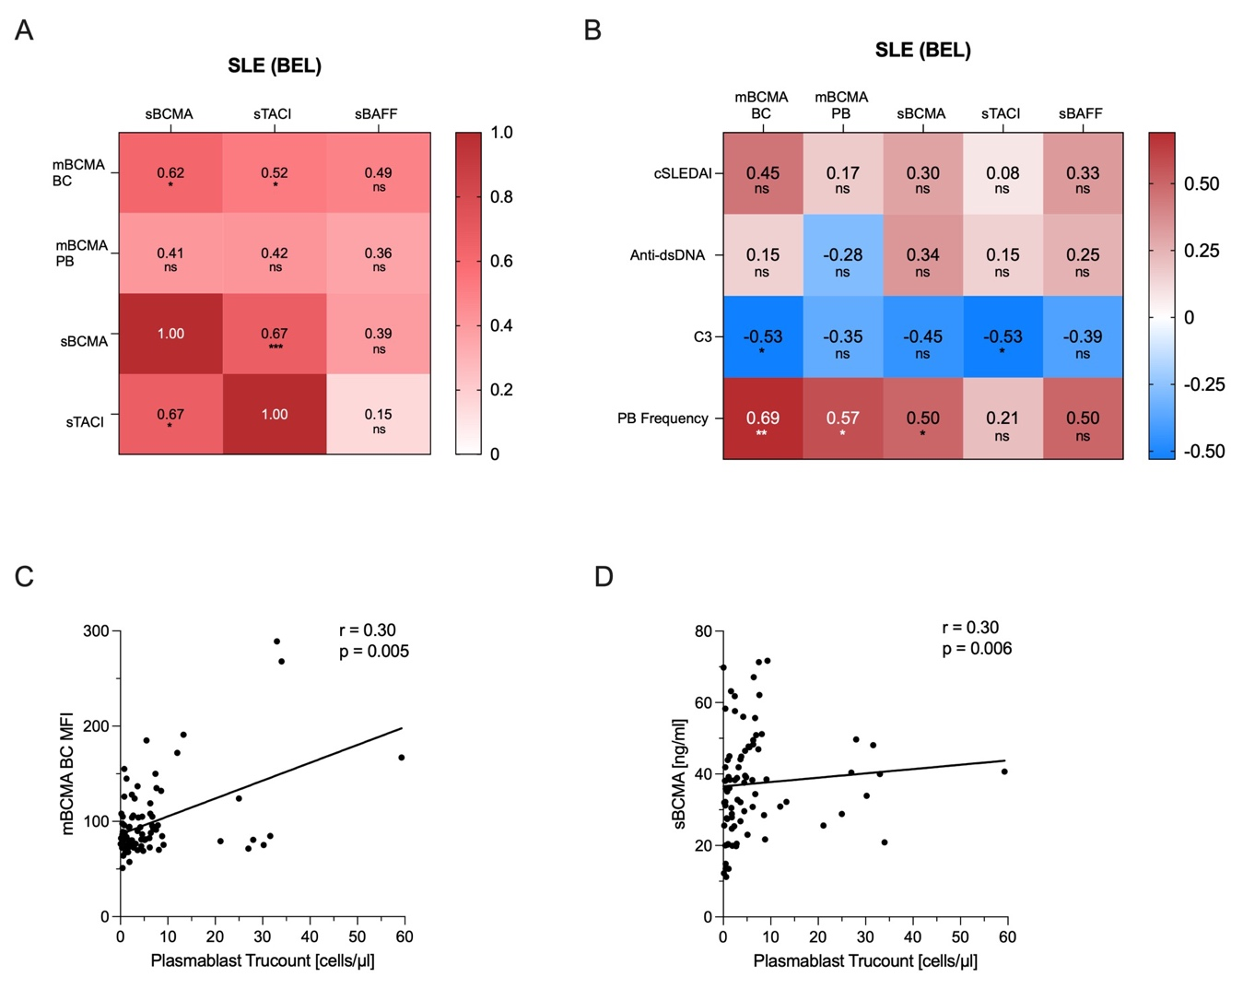

**Figure S2.** Plasma levels of soluble BCMA (sBCMA), soluble TACI (sTACI), soluble BAFF (sBAFF) and BCMA expression (mBCMA) on total B cells (BC) and plasmablasts (PB). Correlation analyses for 14 SLE patients undergoing belimumab treatment (BEL) (Figure S2A-B) and 86 SLE patients undergoing standard of care immunosuppressive treatment (SOC) (Figure S2C-D) with Spearman ranked test and calculation of Spearman‘s rank correlation coefficient (*r*) and p-values (*p*). **(A)** correlation matrix heat map from SLE BEL patients representing r-values and levels of significance for sBCMA, sTACI, sBAFF, BCMA expression on total B cells (mBCMA BC) and BCMA expression on plasmablasts (mBCMA PB). **(B)** correlation matrix heat map from SLE BEL patients representing r-values and levels of significance for BCMA expression on total B cells (mBCMA BC), BCMA expression on plasmablasts (mBCMA PB), sBCMA, sTACI and sBAFF, correlated with clinical markers clinical SLEDAI-2K (cSLEDAI), levels of anti-dsDNA-antibodies (anti-dsDNA), complement 3 (C3) levels, and plasmablast (PB) frequency. **(C)** correlation of plasmablast trucount with soluble BCMA in SLE SOC patients. **(D)** correlation of plasmablast trucount with BCMA expression on total B cells in SLE SOC patients. * *p* < 0.05; ** *p* < 0.01; *** *p* < 0.001; **** *p* < 0.0001.

**Ein Bild, das Text, Diagramm, Reihe, parallel enthält.
**

**Figure S3.** Intraindividual Effects of Belimumab Treatment and Effects of Belimumab Treatment on the Distribution of B Cell Subsets. Comparison between 86 SLE patients undergoing standard-of-care immunosuppression (SOC), and 14 on belimumab treatment (BEL), using Mann-Whitney-U-test. Black lines represent the interquartile range with median values. Comparison of values from before and during belimumab treatment (BEL) in 9 SLE patients, at a median of 8 months after initiating BEL, using Wilcoxon signed-rank test. Frequencies of displayed B cell subsets include naive B cells (NB), activated naive B cells (aNB), double-negative memory B cells (DN), non-switched memory B cells (NSM), switched memory B cells (SM), plasmablasts (PB) and plasma cells (PC). p-values (*p*). **(A)** distribution of different B cell subsets among total B cells between SLE patients under SOC and under BEL treatment. **(B)** plasmablast frequency. Black lines represent the interquartile range with median values. B cell subsets include naive B cells (NB), activated naive B cells (aNB), double-negative memory B cells (DN), non-switched memory B cells (NSM), switched memory B cells (SM), plasmablasts (PB), and plasma cells (PC). * p < 0.05; ** p < 0.01; *** p < 0.001; **** p < 0.0001.

**Table S1.** Comparison of Patients with Standard of Care Immunosuppression versus Patients Receiving Belimumab Treatment.

|  |  |  |  |
| --- | --- | --- | --- |
| **Characteristics** | **Standard of care (n=86)** | **Belimumab**  **(n=14)** | **P-Value** |
| Age, median (range) | 37.0 (19–80) | 41.3 (24–63) | 0.26 |
| Gender, n (%)  Female | 78 (91) | 12 (86) | 0.56 |
| Ethnicity, n (%)  Caucasian  Asian  African  Latin American | 80 (93)  0 (0)  4 (5)  2 (2) | 10 (72)  1 (7)  2 (14)  1 (7) | 0.01  0.01  0.09  0.33 |
| Disease duration, median years (range) | 6.5 (0–40) | 8.6 (1–27) | 0.66 |
| SLEDAI-2K, median (range)  Clinically active, n (%)  DORIS remission, n (%) | 4 (0–26)  37 (43)  23 (27) | 7 (0–10)  9 (64)  3 (21) | 0.13 |
| Clinical manifestations at time of presentation, n (%)  Musculoskeletal  Mucocutaneous  Polyserositis  Nephritis  CNS  Cytopenia | 27 (31)  14 (16)  2 (2)  5 (6)  2 (2)  39 (45) | 6 (43)  4 (29)  1 (7)  0 (0)  0 (0)  4 (29) |  |
| Serology  Anti-dsDNA positive, n (%)  C3-deficiency, n (%) | 60 (70)  60 (70) | 11 (79)  11 (79) |  |
| Medication, n (%)  Prednisolone  Prednisolone dosage (mg/d),  median  Prednisolone ≥ 7.5 mg/d  Hydroxychloroquine  Methotrexate  Azathioprine  Mycophenolate mofetil  Calcineurin inhibitors  Belimumab, median treatment  duration in months (range) | 61 (71)  5.0  23 (27)  71 (83)  8 (9)  28 (33)  14 (16)  4 (5)  n.a. | 14 (100)  7.25  7 (50)  7 (50)  3 (21)  6 (43)  0 (0)  1 (7)  9.0 (5–39) | 0.03 |

Abbreviations: SLEDAI-2K, Systemic Lupus Erythematosus Disease Activity-Index 2000. Statistical analysis of age differences was conducted using the Mann-Whitney test, and sex differences were analyzed with the chi-square test.

**Table S2.** Belimumab-Treated Patients Included in Intraindividual Analyses.

|  |  |
| --- | --- |
| **Characteristics** | **n=9** |
| Age, median (range) | 41.6 (24–63) |
|  |  |
| Gender, n (%)  Female | 8 (89) |
| Ethnicity, n (%)  Caucasian  Asian  African  Latin American | 5 (56)  1 (11)  2 (22)  1 (11) |
| Disease duration [years], mean (range) | 3.4 (1-27) |
| SLEDAI-2K, median (range)  Clinically active, n (%)  DORIS remission, n (%) | 8 (4-10)  7 (78)  2 (22) |
| Clinical manifestations at time of presentation, n (%)  Musculoskeletal  Mucocutaneous  Polyserositis  Nephritis  CNS  Cytopenia | 6 (67)  7 (78)  0 (0)  0 (0)  0 (0)  7 (78) |
| *Serology*  Anti-dsDNA positive, n (%)  C3-deficiency, n (%) | 7 (78)  7 (78) |
| Medication, n (%)  Prednisolone  Prednisolone dosage (mg/d), median  Prednisolone ≥ 7.5 mg/d  Hydroxychloroquine  Methotrexate  Azathioprine  Mycophenolate mofetil  Calcineurin inhibitors  Belimumab, median treatment duration in months (range) | 9 (100)  10.0  7 (78)  5 (56)  1 (11)  5 (56)  0 (0)  1 (11)  8.0 (5-26) |

Abbreviations: SLEDAI-2K, Systemic Lupus Erythematosus Disease Activity-Index 2000.

**Table S3.** FACS Panels and Applied Fluorescent Dyes.

|  |  |
| --- | --- |
| **Panel 1: Antigens and dyes (concentration) (clone and manufacturer)** | **Panel 2: Antigens and dyes (concentration) (clone and manufacturer)** |
| IgD FITC (1:20) (Clone IA 6-2,  BioLegend, USA) | IgD FITC (1:20) (Clone IA 6-2,  BioLegend, USA) |
| CD269/BCMA PE (1:20) (Clone 19F2, BioLegend, USA) | Isotype control PE (1:20) (Clone QA16A12, BioLegend, USA) |
| CD24 PerCP (1:20) (Clone ML5,  BioLegend, USA) | CD24 PerCP (1:20) (Clone ML5, BioLegend, USA) |
| CD19 PE/Cy7 (1:20) (Clone SJ25c1, BioLegend, USA) | CD19 PE/Cy7 (1:20) (Clone SJ25c1, BioLegend, USA) |
| Mito Tracker Deep Red (1:1000000) (Thermo Fisher, USA) |  |
| CD27 APC/Cy7 (1:20) (Clone O323, BioLegend, USA) | CD27 APC/Cy7 (1:20) (Clone O323, BioLegend, USA) |
| HLA-DR Brilliant Violet 510 (1:20) (Clone L243, BioLegend, USA) | HLA-DR Brilliant Violet 510 (1:20) (Clone L243, BioLegend, USA) |
| CD3 Pacific Blue (1:20) (Clone UCHT1,  BD Biosciences, USA) | CD3 Pacific Blue (1:20) (Clone UCHT1, BD Biosciences, USA) |
| CD14 Pacific Blue (1:20) (Clone MϕP9,  BD Biosciences, USA) | CD14 Pacific Blue (1:20) (Clone MϕP9, BD Biosciences, USA) |
| CD16 Pacific Blue (1:20)  (Clone MOPC-21, BioLegend, USA) | CD16 Pacific Blue (1:20) (Clone MOPC-21, BioLegend, USA) |
| DAPI Pacific Blue (1:20) | DAPI Pacific Blue (1:20) |