Rapid PM2.5-Induced Health Impact Assessment: A Novel Approach Using Conditional U-Net CMAQ Surrogate Model
Supplementary materials
Yohan Lee¹, Junghyun Park¹, Jinseok Kim^{2,3}, Jung-Hun Woo³, and Jong-Hyeon Lee¹
¹ EH Research & Consulting Co., Ltd., E TechHive, 410 Jeongseojin-ro, Seo-gu, 22689, Incheon, Republic of Korea
² Civil and Environmental Engineering, College of Engineering, Konkuk University, 120 Neungdong-ro, Gwangjin-gu, 05029, Seoul, Republic of Korea
³ Environmental Planning Institute, Seoul National University, Rm 303, Bldg 82, 1, Gwanak-ro, Gwanak-gu, 08826, Seoul, Republic of Korea

Index
S1. Visualization 2D PM2.5 annual concentration

S2. Relation between domestic activities and boundary conditions

S3. Contribution analysis of input variables with various SHAP value analyses

S4. Total premature mortality

S5. Health Benefits Equation

S6. PM2.5 concentration reduction compared to 2019

S7. 5-year precursor emission reduction

S1. Visualization 2D PM2.5 annual concentration
Figure 1 illustrates the performance of our Conditional U-Net emulation model compared to CMAQ simulations for annual PM2.5 concentrations over South Korea. The figure shows results for three randomly selected scenarios (#12, #24, and #62) from the test dataset, providing a representative sample of the model's capabilities. Each row corresponds to a different scenario, with columns showing CMAQ simulation results (left), Conditional U-Net emulation predictions (middle), and the relative error between simulation and emulation as a percentage (right).
The emulated results closely replicate the spatial patterns of PM2.5 concentrations from the CMAQ simulations in all scenarios. The model accurately captures the variation in concentration levels, including higher concentrations in urban and industrial areas and lower concentrations in rural and coastal areas. Both simulated and emulated PM2.5 concentrations typically range from about 10 to 50 $μg/m^{3}$, with slight variations between scenarios. The model effectively reproduces the overall concentration gradients across the country, demonstrating its ability to handle diverse emission and boundary condition inputs.
The relative error maps demonstrate the high accuracy of the emulation model. Most areas show errors below 5%, with some coastal and border regions showing slightly higher errors (up to 7.5%). These higher error areas can be attributed to complex terrain effects or sensitivity to boundary conditions. The performance of the emulator remains consistent across the different scenarios, indicating its robustness. This visualization confirms the ability of the Conditional U-Net model to accurately emulate CMAQ simulations for annual PM2.5 concentrations under various scenarios and underscores its reliability as a computationally efficient alternative to full CMAQ simulations. The model's performance makes it valuable for rapid air quality assessments and policy scenario evaluations, enabling faster and more flexible analysis of PM2.5 concentrations across South Korea.

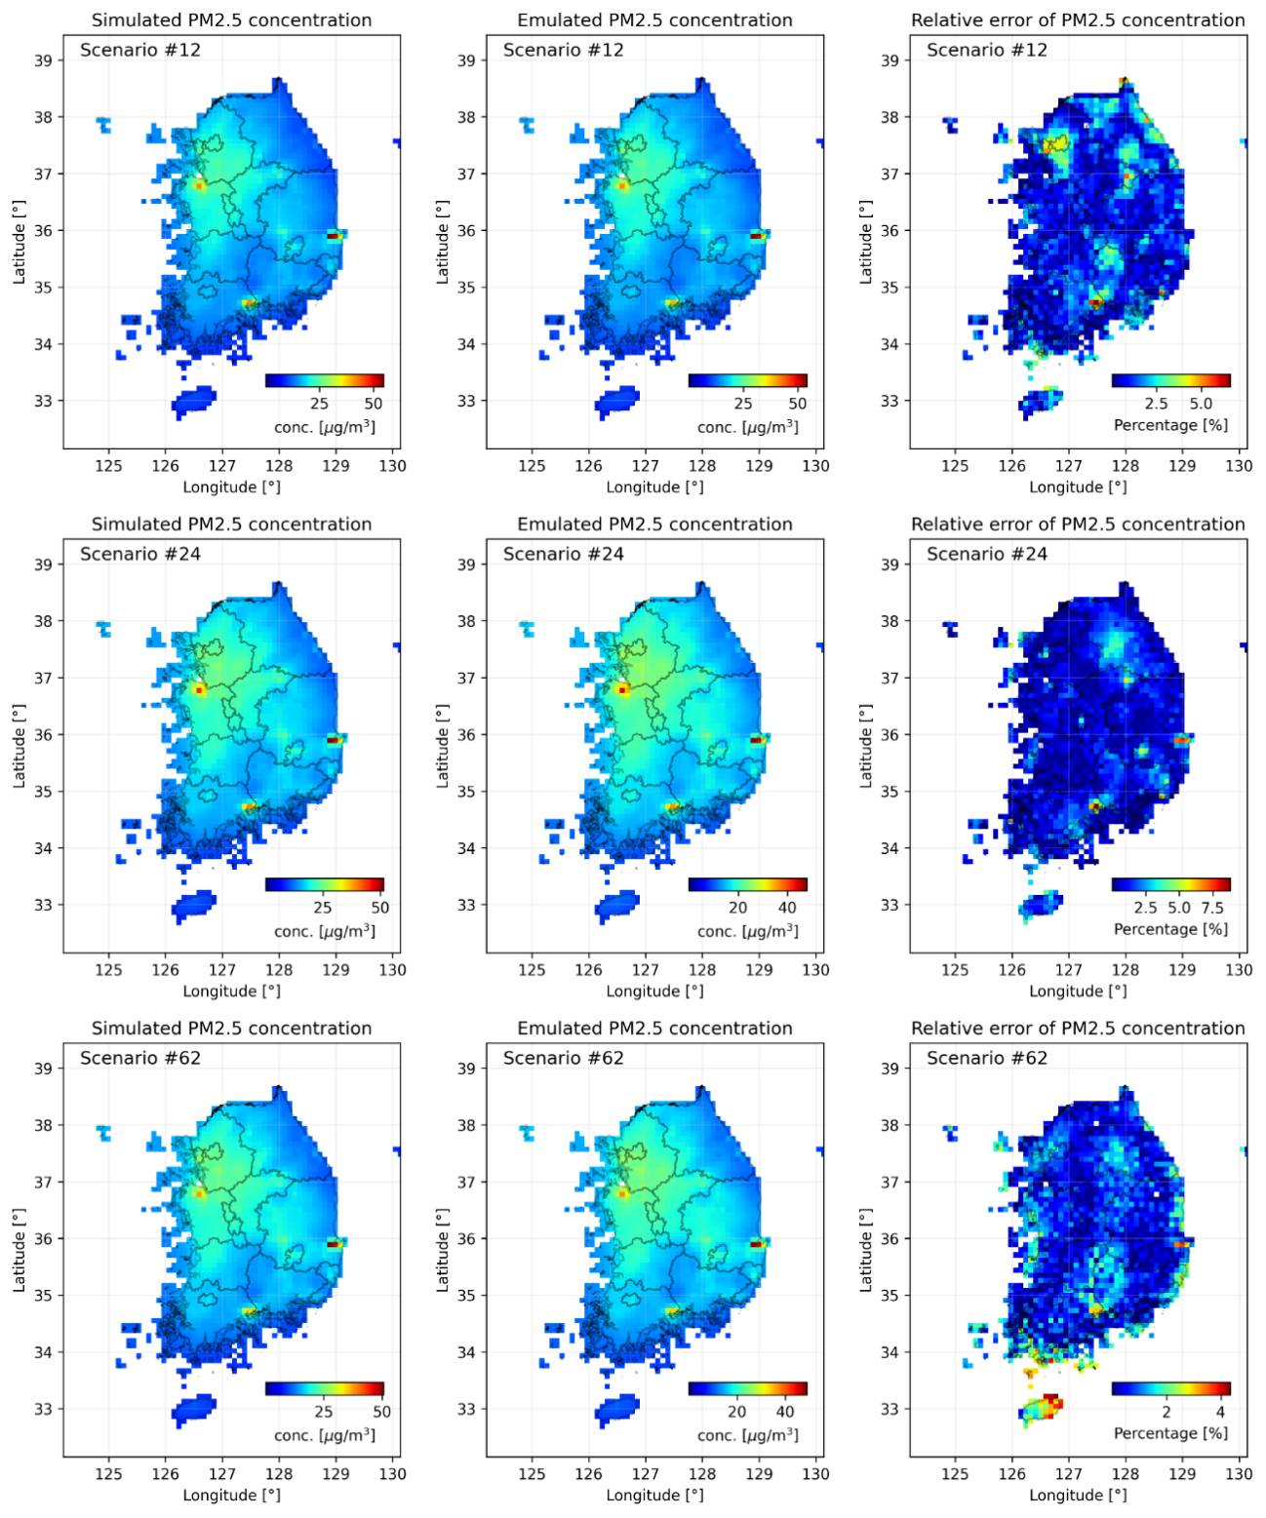
Figure 1. The result of using the emulation model to visualize the predictions for the test input data on a map of South Korea. Each scenario was randomized within the total test scenarios. The leftmost figure shows the simulation results from CMAQ, the middle figure shows the predictions from the emulator, and the rightmost figure shows the relative error between simulation and emulation as a percentage.

S2. Relation between domestic activities and boundary conditions
Figure 2 illustrates the relationship between domestic emission activities, boundary conditions, and their effects on annual PM2.5 concentrations in South Korea and five major cities. The x-axis represents the boundary condition activity ratio (0.4-1.8), which serves as a proxy for transboundary pollution. The y-axis shows the total domestic emission activity ratio (0.4-1.8), representing collective domestic emissions. Key observations of the figure are,
- National trend: PM2.5 concentrations increase with both higher domestic emissions and increased boundary conditions, with domestic emissions having a more pronounced effect.
- Regional variations:
  - Seoul and Daejeon have the highest PM2.5 concentrations (10-28 $μg/m^{3}$ and 10-26 $μg/m^{3}$, respectively).
  - Gwangju shows moderate levels (7-24 $μg/m^{3}$) with a balanced influence of both factors.
  - Ulsan shows lower concentrations (6-20 $μg/m^{3}$) with a stronger influence of domestic emissions.
  - Jeju Island has significantly lower concentrations (3-10 $μg/m^{3}$) with higher sensitivity to boundary conditions.
- Non-linear responses: All regions show non-linear relationships between emission activities, boundary conditions, and PM2.5 concentrations.
- Relative importance: For most mainland cities, domestic emissions appear to have a stronger influence than boundary conditions.
These results highlight the complex interplay between local emissions and transboundary pollution in determining PM2.5 concentrations. They underscore the need for region-specific air quality management strategies that consider both domestic emission reductions and international cooperation to address transboundary pollution. This analysis demonstrates the ability of our Conditional U-Net model to capture and visualize these complex relationships, providing valuable insights for targeted air quality improvement strategies.
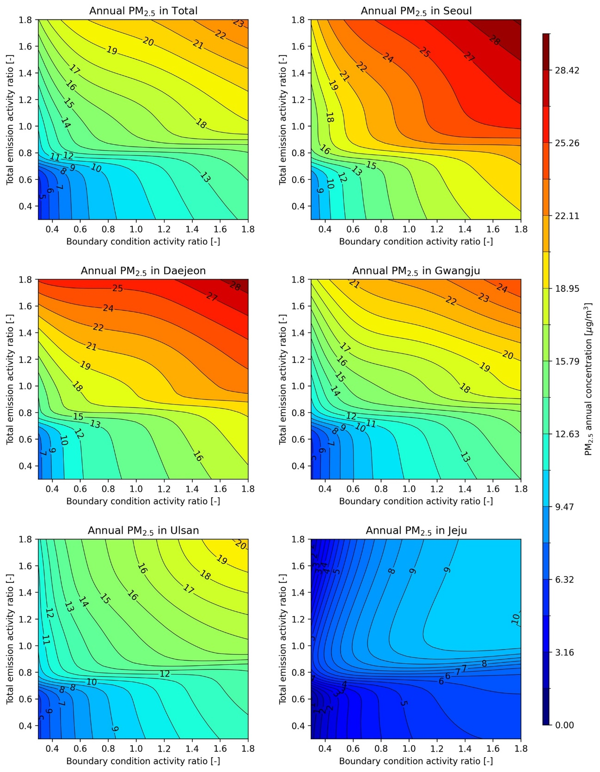
Figure 2. Contour map visualizing the response of domestic and international (boundary) effects on PM2.5 concentrations, showing that the response is generally sensitive to the change in emissions of foreign precursors. From left to right at the top, the response of PM2.5 concentrations for the whole country, Seoul, Daejeon, Gwangju, Ulsan, and Jeju Island.
S3. Contribution analysis of input variables with various SHAP value analyses
To gain deeper insights into the factors influencing PM2.5 concentrations across South Korea, we conducted a comprehensive contribution analysis using SHAP values. This analysis helps quantify the impact of various input variables on the model's predictions, providing valuable information for policy makers and researchers. Figures 3 and figure 4 show the results of this analysis for the whole country and five major cities: Seoul, Daejeon, Gwangju, Ulsan, and Jeju Island.
Figure 3 shows the contribution of input variables to the change in PM2.5 concentrations in each region using SHAP values. There are 86 input variables in total, but only the eight with the largest contributions are shown here. When the effect of the boundary is included for all regions, it can be seen that the contribution of the boundary is larger than the contribution of the other input variables. Figure 4 shows the contributions of 85 input variables without the effect of the boundary, showing only the eight with the largest contributions. This exclusion allows a clearer comparison of the contributions of domestic emissions between regions.
The relative importance of different precursors and emission sources varies considerably between regions, reflecting local characteristics and emission patterns. PM2.5 and NH3 emissions often appear as significant contributors in several regions, suggesting their critical role in secondary particle formation. Interestingly, in many cases, emissions from neighboring provinces contribute significantly to a region's PM2.5 levels, underscoring the importance of interregional cooperation in air quality management.
As shown in the analysis in the main text, Jeju Island shows a different pattern compared to mainland regions, with a higher relative importance of local emissions, probably due to its geographical isolation. These detailed SHAP analyses provide a nuanced understanding of the complex interactions between different emission sources and their impact on PM2.5 concentrations. Such insights are invaluable for the development of targeted and effective air quality improvement strategies tailored to the specific characteristics and challenges of each region, enabling policymakers to prioritize the most impactful interventions for PM2.5 reduction.
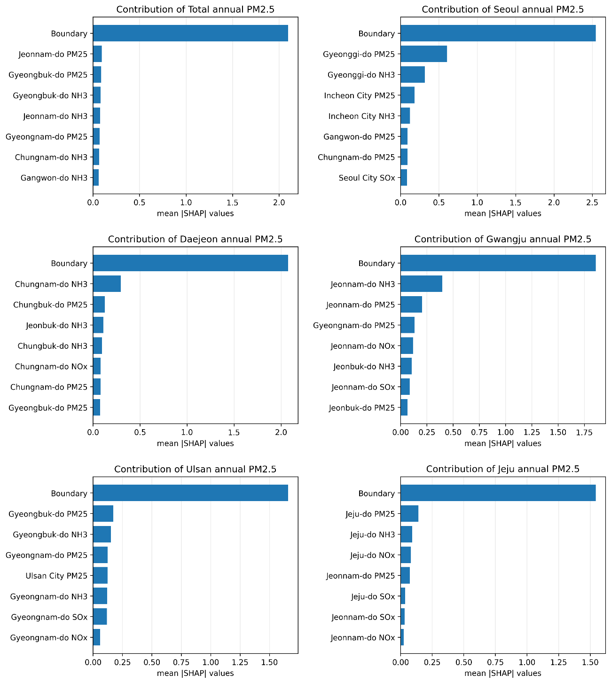
Figure 3. Figure showing the contribution of input variables to changes in PM2.5 concentration in each region using SHAP values. There are 86 input variables in total, but only the eight that contribute the most are shown here. It can be seen that the contribution of the boundary is greater than the contribution of the other inputs when the effect of the boundary is included for all regions. From left to right at the top, the analysis results are shown for the nation as a whole, Seoul, Daejeon, Gwangju, Ulsan, and Jeju Island.

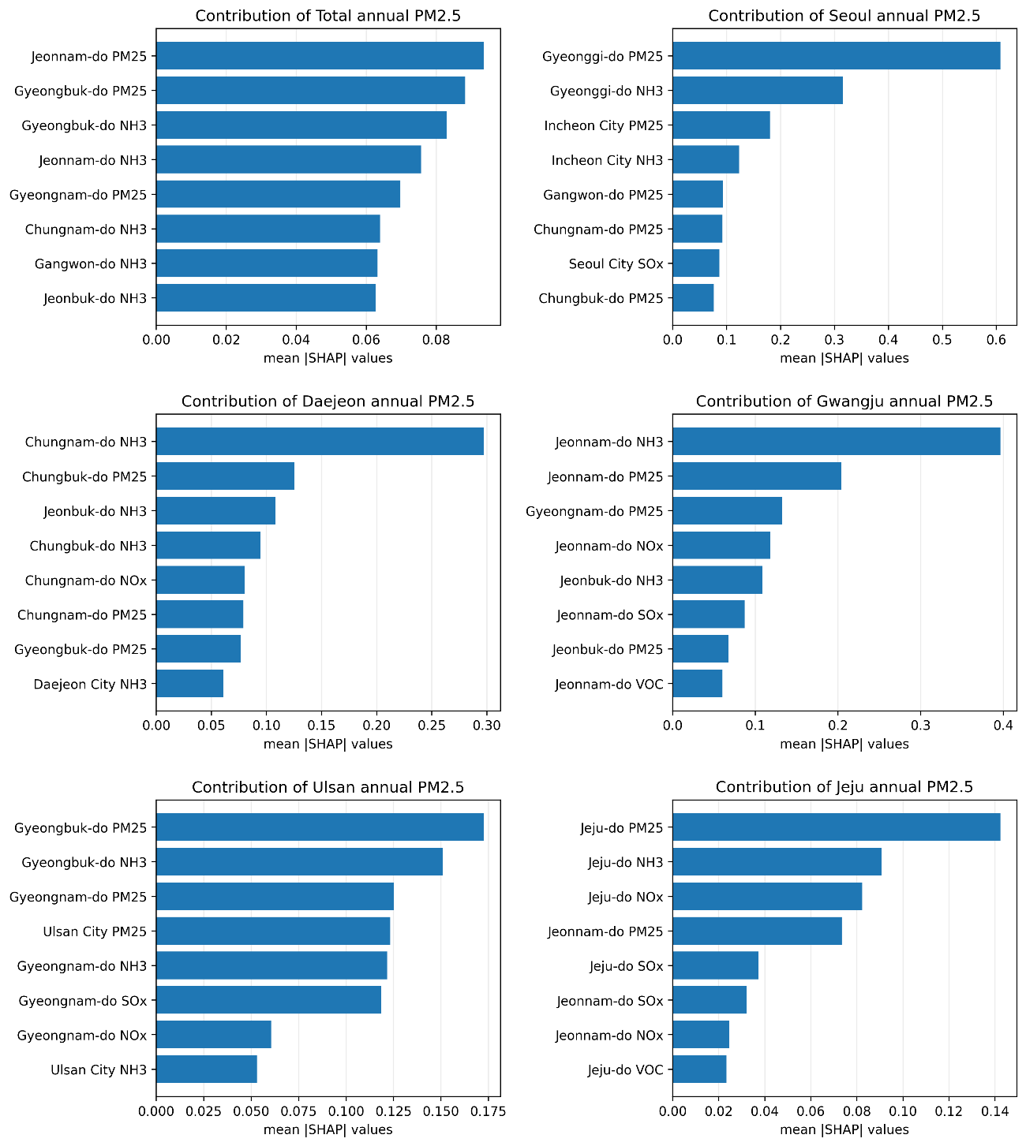
Figure 4. Figure showing the contribution of input variables to the change in PM2.5 concentrations in each region using SHAP values, excluding the effects of boundaries. Excluding the effect of boundaries, there are a total of 85 input variables, but only the eight with the largest contribution are shown in the figure. From left to right at the top are the results for the whole country, Seoul, Daejeon, Gwangju, Ulsan, and Jeju Island.

S4. Total premature mortality
Table 1. Boundary condition 100% premature mortality
cause | year | Premature Mortality (95% CI: lower – upper)
 |  | 100% | 90% | 75% | 50% | 25% | 10%
CVD | 2019 | 10,220 (8,579-12,530) | 10,016 (8,405-12,286) | 9,688 (8,125-11,894) | 8,802 (7,370-10,829) | 6,385 (5,326-7,901) | 2,445 (2,027-3,052)
 | 2020 | 10,768 (9,039-13,201) | 10,553 (8,855-12,945) | 10,208 (8,561-12,532) | 9,273 (7,765-11,409) | 6,727 (5,611-8,324) | 2,575 (2,135-3,214)
 | 2021 | 11,265 (9,456-13,810) | 11,040 (9,264-13,542) | 10,679 (8,956-13,110) | 9,701 (8,123-11,935) | 7,037 (5,869-8,707) | 2,693 (2,233-3,361)
 | 2022 | 11,833 (9,933-14,507) | 11,598 (9,732-14,226) | 11,218 (9,408-13,771) | 10,190 (8,533-12,537) | 7,392 (6,165-9,146) | 2,829 (2,346-3,532)
 | 2023 | 12,404 (10,413-15,207) | 12,157 (10,201-14,912) | 11,759 (9,861-14,435) | 10,681 (8,944-13,141) | 7,749 (6,463-9,588) | 2,967 (2,460-3,703)
 | 2024 | 12,894 (10,824-15,807) | 12,637 (10,604-15,500) | 12,223 (10,250-15,004) | 11,102 (9,297-13,659) | 8,055 (6,718-9,966) | 3,085 (2,558-3,851)
 | 2025 | 13,424 (11,269-16,456) | 13,156 (11,040-16,136) | 12,725 (10,672-15,620) | 11,558 (9,678-14,219) | 8,385 (6,994-10,375) | 3,212 (2,663-4,009)
 | 2026 | 13,802 (11,586-16,919) | 13,527 (11,351-16,590) | 13,083 (10,972-16,059) | 11,883 (9,950-14,618) | 8,621 (7,190-10,666) | 3,303 (2,738-4,122)
 | 2027 | 14,447 (12,127-17,709) | 14,158 (11,881-17,365) | 13,693 (11,484-16,809) | 12,437 (10,415-15,300) | 9,023 (7,526-11,164) | 3,457 (2,866-4,315)
 | 2028 | 15,087 (12,665-18,495) | 14,786 (12,408-18,135) | 14,300 (11,994-17,554) | 12,988 (10,876-15,978) | 9,423 (7,860-11,659) | 3,611 (2,994-4,507)
 | 2029 | 15,695 (13,176-19,240) | 15,382 (12,908-18,865) | 14,877 (12,477-18,261) | 13,511 (11,314-16,621) | 9,803 (8,177-12,129) | 3,757 (3,115-4,690)
 | 2030 | 16,397 (13,765-20,100) | 16,070 (13,486-19,709) | 15,542 (13,035-19,077) | 14,115 (11,820-17,364) | 10,241 (8,543-12,671) | 3,926 (3,255-4,900)
 | 2031 | 16,971 (14,247-20,803) | 16,632 (13,957-20,398) | 16,085 (13,491-19,744) | 14,608 (12,233-17,971) | 10,599 (8,841-13,114) | 4,063 (3,369-5,072)
 | 2032 | 17,704 (14,862-21,701) | 17,350 (14,560-21,279) | 16,780 (14,074-20,597) | 15,239 (12,762-18,747) | 11,058 (9,223-13,681) | 4,240 (3,515-5,292)
 | 2033 | 18,446 (15,485-22,611) | 18,078 (15,171-22,171) | 17,484 (14,664-21,460) | 15,878 (13,297-19,532) | 11,521 (9,610-14,255) | 4,419 (3,663-5,515)
 | 2034 | 19,185 (16,106-23,517) | 18,802 (15,779-23,059) | 18,184 (15,251-22,320) | 16,514 (13,830-20,315) | 11,983 (9,995-14,826) | 4,597 (3,811-5,738)
 | 2035 | 20,203 (16,960-24,764) | 19,799 (16,616-24,282) | 19,149 (16,060-23,504) | 17,390 (14,563-21,392) | 12,619 (10,525-15,612) | 4,841 (4,014-6,043)
 | 2036 | 21,162 (17,766-25,940) | 20,740 (17,405-25,435) | 20,059 (16,824-24,620) | 18,216 (15,255-22,409) | 13,218 (11,025-16,354) | 5,072 (4,205-6,331)
 | 2037 | 22,087 (18,543-27,073) | 21,647 (18,166-26,547) | 20,936 (17,559-25,697) | 19,013 (15,922-23,388) | 13,796 (11,507-17,069) | 5,295 (4,390-6,609)
 | 2038 | 23,091 (19,386-28,304) | 22,631 (18,992-27,754) | 21,888 (18,358-26,866) | 19,878 (16,647-24,452) | 14,423 (12,031-17,844) | 5,537 (4,590-6,911)
 | 2039 | 24,080 (20,215-29,515) | 23,600 (19,805-28,942) | 22,825 (19,144-28,016) | 20,729 (17,360-25,499) | 15,040 (12,545-18,608) | 5,775 (4,788-7,208)
 | 2040 | 25,208 (21,163-30,899) | 24,706 (20,734-30,299) | 23,896 (20,042-29,330) | 21,702 (18,174-26,695) | 15,745 (13,133-19,480) | 6,047 (5,013-7,547)
 | 2041 | 26,377 (22,144-32,331) | 25,852 (21,695-31,704) | 25,004 (20,972-30,690) | 22,709 (19,018-27,934) | 16,475 (13,742-20,383) | 6,328 (5,247-7,898)
 | 2042 | 27,230 (22,860-33,376) | 26,688 (22,397-32,729) | 25,814 (21,651-31,683) | 23,444 (19,633-28,838) | 17,008 (14,187-21,042) | 6,534 (5,417-8,156)
 | 2043 | 28,174 (23,653-34,533) | 27,614 (23,174-33,864) | 26,709 (22,402-32,782) | 24,257 (20,315-29,838) | 17,597 (14,678-21,771) | 6,762 (5,607-8,440)
 | 2044 | 28,867 (24,235-35,383) | 28,293 (23,745-34,697) | 27,367 (22,954-33,589) | 24,854 (20,815-30,573) | 18,030 (15,039-22,306) | 6,931 (5,746-8,651)
 | 2045 | 29,628 (24,874-36,315) | 29,040 (24,371-35,612) | 28,089 (23,560-34,475) | 25,510 (21,364-31,379) | 18,505 (15,436-22,894) | 7,116 (5,900-8,882)
 | 2046 | 30,321 (25,456-37,164) | 29,719 (24,941-36,445) | 28,747 (24,112-35,282) | 26,108 (21,865-32,114) | 18,937 (15,796-23,429) | 7,283 (6,039-9,091)
 | 2047 | 30,920 (25,959-37,898) | 30,306 (25,434-37,165) | 29,315 (24,588-35,979) | 26,624 (22,297-32,749) | 19,311 (16,108-23,891) | 7,429 (6,159-9,272)
 | 2048 | 31,510 (26,454-38,620) | 30,884 (25,919-37,873) | 29,874 (25,058-36,666) | 27,132 (22,723-33,373) | 19,679 (16,415-24,346) | 7,572 (6,278-9,451)
 | 2049 | 32,214 (27,045-39,483) | 31,574 (26,499-38,719) | 30,543 (25,618-37,485) | 27,739 (23,231-34,119) | 20,118 (16,781-24,889) | 7,743 (6,419-9,664)
 | 2050 | 32,749 (27,495-40,138) | 32,099 (26,939-39,362) | 31,050 (26,044-38,108) | 28,200 (23,617-34,686) | 20,451 (17,060-25,302) | 7,872 (6,527-9,826)
RD | 2019 | 5,714 (1,881-9,325) | 5,601 (1,841-9,152) | 5,420 (1,778-8,876) | 4,925 (1,607-8,110) | 3,561 (1,145-5,953) | 1,369 (431-2,341)
 | 2020 | 6,048 (1,991-9,869) | 5,928 (1,949-9,687) | 5,737 (1,882-9,394) | 5,213 (1,701-8,584) | 3,769 (1,212-6,300) | 1,448 (456-2,477)
 | 2021 | 6,351 (2,091-10,364) | 6,226 (2,047-10,172) | 6,024 (1,977-9,864) | 5,474 (1,786-9,014) | 3,958 (1,273-6,615) | 1,521 (479-2,601)
 | 2022 | 6,705 (2,208-10,941) | 6,572 (2,161-10,738) | 6,360 (2,087-10,413) | 5,779 (1,886-9,515) | 4,178 (1,344-6,984) | 1,606 (505-2,747)
 | 2023 | 7,056 (2,323-11,513) | 6,916 (2,274-11,300) | 6,692 (2,196-10,957) | 6,080 (1,984-10,011) | 4,397 (1,414-7,349) | 1,691 (532-2,892)
 | 2024 | 7,348 (2,419-11,988) | 7,202 (2,368-11,766) | 6,969 (2,287-11,409) | 6,331 (2,066-10,424) | 4,579 (1,473-7,653) | 1,762 (554-3,013)
 | 2025 | 7,668 (2,525-12,510) | 7,516 (2,472-12,278) | 7,272 (2,387-11,905) | 6,607 (2,156-10,877) | 4,778 (1,537-7,986) | 1,839 (579-3,144)
 | 2026 | 7,887 (2,597-12,867) | 7,731 (2,542-12,628) | 7,480 (2,455-12,245) | 6,795 (2,218-11,186) | 4,914 (1,581-8,213) | 1,892 (595-3,235)
 | 2027 | 8,290 (2,730-13,523) | 8,126 (2,672-13,272) | 7,862 (2,580-12,869) | 7,142 (2,331-11,756) | 5,165 (1,661-8,632) | 1,989 (626-3,401)
 | 2028 | 8,689 (2,862-14,173) | 8,516 (2,801-13,910) | 8,240 (2,704-13,487) | 7,485 (2,443-12,320) | 5,414 (1,741-9,046) | 2,085 (656-3,565)
 | 2029 | 9,067 (2,986-14,790) | 8,887 (2,923-14,515) | 8,598 (2,822-14,073) | 7,810 (2,549-12,856) | 5,649 (1,817-9,440) | 2,177 (685-3,722)
 | 2030 | 9,508 (3,131-15,507) | 9,319 (3,065-15,219) | 9,016 (2,959-14,756) | 8,189 (2,673-13,479) | 5,924 (1,906-9,898) | 2,283 (718-3,904)
 | 2031 | 9,861 (3,248-16,083) | 9,665 (3,179-15,785) | 9,351 (3,069-15,304) | 8,493 (2,772-13,979) | 6,144 (1,976-10,266) | 2,368 (745-4,049)
 | 2032 | 10,328 (3,402-16,844) | 10,122 (3,330-16,532) | 9,793 (3,215-16,028) | 8,895 (2,904-14,641) | 6,435 (2,070-10,752) | 2,481 (781-4,242)
 | 2033 | 10,800 (3,557-17,614) | 10,585 (3,482-17,287) | 10,241 (3,362-16,761) | 9,302 (3,036-15,310) | 6,729 (2,165-11,244) | 2,595 (817-4,438)
 | 2034 | 11,273 (3,713-18,385) | 11,049 (3,635-18,044) | 10,690 (3,509-17,494) | 9,709 (3,169-15,980) | 7,024 (2,260-11,737) | 2,710 (853-4,633)
 | 2035 | 11,939 (3,933-19,471) | 11,702 (3,850-19,109) | 11,321 (3,717-18,527) | 10,282 (3,357-16,923) | 7,439 (2,393-12,429) | 2,870 (903-4,908)
 | 2036 | 12,565 (4,139-20,491) | 12,315 (4,052-20,111) | 11,915 (3,912-19,498) | 10,821 (3,533-17,810) | 7,829 (2,519-13,081) | 3,021 (951-5,166)
 | 2037 | 13,174 (4,340-21,483) | 12,912 (4,248-21,084) | 12,492 (4,101-20,442) | 11,345 (3,704-18,672) | 8,208 (2,641-13,714) | 3,168 (997-5,417)
 | 2038 | 13,839 (4,559-22,567) | 13,564 (4,462-22,149) | 13,123 (4,308-21,474) | 11,918 (3,891-19,614) | 8,622 (2,774-14,406) | 3,328 (1,047-5,691)
 | 2039 | 14,500 (4,777-23,644) | 14,212 (4,676-23,206) | 13,750 (4,514-22,499) | 12,487 (4,077-20,551) | 9,033 (2,906-15,093) | 3,488 (1,098-5,964)
 | 2040 | 15,260 (5,027-24,884) | 14,957 (4,921-24,422) | 14,471 (4,751-23,679) | 13,142 (4,291-21,628) | 9,507 (3,059-15,884) | 3,671 (1,155-6,277)
 | 2041 | 16,051 (5,288-26,173) | 15,732 (5,176-25,688) | 15,221 (4,997-24,907) | 13,824 (4,513-22,749) | 9,999 (3,217-16,706) | 3,862 (1,215-6,603)
 | 2042 | 16,624 (5,477-27,108) | 16,295 (5,361-26,606) | 15,765 (5,176-25,797) | 14,318 (4,675-23,562) | 10,356 (3,332-17,303) | 4,001 (1,259-6,840)
 | 2043 | 17,264 (5,688-28,150) | 16,921 (5,567-27,629) | 16,372 (5,375-26,789) | 14,869 (4,855-24,468) | 10,754 (3,460-17,967) | 4,155 (1,308-7,104)
 | 2044 | 17,729 (5,841-28,908) | 17,378 (5,718-28,373) | 16,814 (5,521-27,511) | 15,270 (4,986-25,128) | 11,044 (3,553-18,451) | 4,268 (1,343-7,297)
 | 2045 | 18,246 (6,012-29,751) | 17,885 (5,885-29,200) | 17,304 (5,682-28,313) | 15,715 (5,131-25,860) | 11,365 (3,657-18,988) | 4,393 (1,383-7,512)
 | 2046 | 18,717 (6,167-30,518) | 18,346 (6,037-29,953) | 17,751 (5,828-29,044) | 16,121 (5,264-26,527) | 11,658 (3,751-19,477) | 4,507 (1,418-7,706)
 | 2047 | 19,126 (6,301-31,183) | 18,747 (6,168-30,607) | 18,139 (5,956-29,677) | 16,473 (5,379-27,106) | 11,912 (3,833-19,901) | 4,605 (1,449-7,874)
 | 2048 | 19,531 (6,435-31,844) | 19,144 (6,299-31,255) | 18,524 (6,082-30,307) | 16,822 (5,493-27,681) | 12,164 (3,914-20,322) | 4,704 (1,480-8,042)
 | 2049 | 20,021 (6,597-32,643) | 19,625 (6,458-32,040) | 18,989 (6,235-31,067) | 17,245 (5,631-28,376) | 12,469 (4,012-20,831) | 4,822 (1,518-8,245)
 | 2050 | 20,397 (6,721-33,254) | 19,993 (6,579-32,640) | 19,345 (6,352-31,649) | 17,568 (5,737-28,907) | 12,702 (4,087-21,220) | 4,913 (1,546-8,400)

Table 2. Boundary condition 50% premature mortality
cause | year | Premature Mortality (95% CI: lower – upper)
 |  | 100% | 90% | 75% | 50% | 25% | 10%
CVD | 2019 | 10,220 (8,579-12,530) | 10,016 (8,405-12,286) | 9,688 (8,125-11,894) | 8,802 (7,370-10,829) | 6,385 (5,326-7,901) | 2,445 (2,027-3,052)
 | 2020 | 10,768 (9,039-13,201) | 10,553 (8,855-12,945) | 10,208 (8,561-12,532) | 9,273 (7,765-11,409) | 6,727 (5,611-8,324) | 2,575 (2,135-3,214)
 | 2021 | 11,265 (9,456-13,810) | 11,040 (9,264-13,542) | 10,679 (8,956-13,110) | 9,701 (8,123-11,935) | 7,037 (5,869-8,707) | 2,693 (2,233-3,361)
 | 2022 | 11,833 (9,933-14,507) | 11,598 (9,732-14,226) | 11,218 (9,408-13,771) | 10,190 (8,533-12,537) | 7,392 (6,165-9,146) | 2,829 (2,346-3,532)
 | 2023 | 12,404 (10,413-15,207) | 12,157 (10,201-14,912) | 11,759 (9,861-14,435) | 10,681 (8,944-13,141) | 7,749 (6,463-9,588) | 2,967 (2,460-3,703)
 | 2024 | 12,894 (10,824-15,807) | 12,637 (10,604-15,500) | 12,223 (10,250-15,004) | 11,102 (9,297-13,659) | 8,055 (6,718-9,966) | 3,085 (2,558-3,851)
 | 2025 | 13,424 (11,269-16,456) | 13,156 (11,040-16,136) | 12,725 (10,672-15,620) | 11,558 (9,678-14,219) | 8,385 (6,994-10,375) | 3,212 (2,663-4,009)
 | 2026 | 13,802 (11,586-16,919) | 13,527 (11,351-16,590) | 13,083 (10,972-16,059) | 11,883 (9,950-14,618) | 8,621 (7,190-10,666) | 3,303 (2,738-4,122)
 | 2027 | 14,447 (12,127-17,709) | 14,158 (11,881-17,365) | 13,693 (11,484-16,809) | 12,437 (10,415-15,300) | 9,023 (7,526-11,164) | 3,457 (2,866-4,315)
 | 2028 | 15,087 (12,665-18,495) | 14,786 (12,408-18,135) | 14,300 (11,994-17,554) | 12,988 (10,876-15,978) | 9,423 (7,860-11,659) | 3,611 (2,994-4,507)
 | 2029 | 15,695 (13,176-19,240) | 15,382 (12,908-18,865) | 14,877 (12,477-18,261) | 13,511 (11,314-16,621) | 9,803 (8,177-12,129) | 3,757 (3,115-4,690)
 | 2030 | 16,397 (13,765-20,100) | 16,070 (13,486-19,709) | 15,542 (13,035-19,077) | 14,115 (11,820-17,364) | 10,241 (8,543-12,671) | 3,926 (3,255-4,900)
 | 2031 | 16,971 (14,247-20,803) | 16,632 (13,957-20,398) | 16,085 (13,491-19,744) | 14,608 (12,233-17,971) | 10,599 (8,841-13,114) | 4,063 (3,369-5,072)
 | 2032 | 17,704 (14,862-21,701) | 17,350 (14,560-21,279) | 16,780 (14,074-20,597) | 15,239 (12,762-18,747) | 11,058 (9,223-13,681) | 4,240 (3,515-5,292)
 | 2033 | 18,446 (15,485-22,611) | 18,078 (15,171-22,171) | 17,484 (14,664-21,460) | 15,878 (13,297-19,532) | 11,521 (9,610-14,255) | 4,419 (3,663-5,515)
 | 2034 | 19,185 (16,106-23,517) | 18,802 (15,779-23,059) | 18,184 (15,251-22,320) | 16,514 (13,830-20,315) | 11,983 (9,995-14,826) | 4,597 (3,811-5,738)
 | 2035 | 20,203 (16,960-24,764) | 19,799 (16,616-24,282) | 19,149 (16,060-23,504) | 17,390 (14,563-21,392) | 12,619 (10,525-15,612) | 4,841 (4,014-6,043)
 | 2036 | 21,162 (17,766-25,940) | 20,740 (17,405-25,435) | 20,059 (16,824-24,620) | 18,216 (15,255-22,409) | 13,218 (11,025-16,354) | 5,072 (4,205-6,331)
 | 2037 | 22,087 (18,543-27,073) | 21,647 (18,166-26,547) | 20,936 (17,559-25,697) | 19,013 (15,922-23,388) | 13,796 (11,507-17,069) | 5,295 (4,390-6,609)
 | 2038 | 23,091 (19,386-28,304) | 22,631 (18,992-27,754) | 21,888 (18,358-26,866) | 19,878 (16,647-24,452) | 14,423 (12,031-17,844) | 5,537 (4,590-6,911)
 | 2039 | 24,080 (20,215-29,515) | 23,600 (19,805-28,942) | 22,825 (19,144-28,016) | 20,729 (17,360-25,499) | 15,040 (12,545-18,608) | 5,775 (4,788-7,208)
 | 2040 | 25,208 (21,163-30,899) | 24,706 (20,734-30,299) | 23,896 (20,042-29,330) | 21,702 (18,174-26,695) | 15,745 (13,133-19,480) | 6,047 (5,013-7,547)
 | 2041 | 26,377 (22,144-32,331) | 25,852 (21,695-31,704) | 25,004 (20,972-30,690) | 22,709 (19,018-27,934) | 16,475 (13,742-20,383) | 6,328 (5,247-7,898)
 | 2042 | 27,230 (22,860-33,376) | 26,688 (22,397-32,729) | 25,814 (21,651-31,683) | 23,444 (19,633-28,838) | 17,008 (14,187-21,042) | 6,534 (5,417-8,156)
 | 2043 | 28,174 (23,653-34,533) | 27,614 (23,174-33,864) | 26,709 (22,402-32,782) | 24,257 (20,315-29,838) | 17,597 (14,678-21,771) | 6,762 (5,607-8,440)
 | 2044 | 28,867 (24,235-35,383) | 28,293 (23,745-34,697) | 27,367 (22,954-33,589) | 24,854 (20,815-30,573) | 18,030 (15,039-22,306) | 6,931 (5,746-8,651)
 | 2045 | 29,628 (24,874-36,315) | 29,040 (24,371-35,612) | 28,089 (23,560-34,475) | 25,510 (21,364-31,379) | 18,505 (15,436-22,894) | 7,116 (5,900-8,882)
 | 2046 | 30,321 (25,456-37,164) | 29,719 (24,941-36,445) | 28,747 (24,112-35,282) | 26,108 (21,865-32,114) | 18,937 (15,796-23,429) | 7,283 (6,039-9,091)
 | 2047 | 30,920 (25,959-37,898) | 30,306 (25,434-37,165) | 29,315 (24,588-35,979) | 26,624 (22,297-32,749) | 19,311 (16,108-23,891) | 7,429 (6,159-9,272)
 | 2048 | 31,510 (26,454-38,620) | 30,884 (25,919-37,873) | 29,874 (25,058-36,666) | 27,132 (22,723-33,373) | 19,679 (16,415-24,346) | 7,572 (6,278-9,451)
 | 2049 | 32,214 (27,045-39,483) | 31,574 (26,499-38,719) | 30,543 (25,618-37,485) | 27,739 (23,231-34,119) | 20,118 (16,781-24,889) | 7,743 (6,419-9,664)
 | 2050 | 32,749 (27,495-40,138) | 32,099 (26,939-39,362) | 31,050 (26,044-38,108) | 28,200 (23,617-34,686) | 20,451 (17,060-25,302) | 7,872 (6,527-9,826)
RD | 2019 | 5,714 (1,881-9,325) | 5,601 (1,841-9,152) | 5,420 (1,778-8,876) | 4,925 (1,607-8,110) | 3,561 (1,145-5,953) | 1,369 (431-2,341)
 | 2020 | 6,048 (1,991-9,869) | 5,928 (1,949-9,687) | 5,737 (1,882-9,394) | 5,213 (1,701-8,584) | 3,769 (1,212-6,300) | 1,448 (456-2,477)
 | 2021 | 6,351 (2,091-10,364) | 6,226 (2,047-10,172) | 6,024 (1,977-9,864) | 5,474 (1,786-9,014) | 3,958 (1,273-6,615) | 1,521 (479-2,601)
 | 2022 | 6,705 (2,208-10,941) | 6,572 (2,161-10,738) | 6,360 (2,087-10,413) | 5,779 (1,886-9,515) | 4,178 (1,344-6,984) | 1,606 (505-2,747)
 | 2023 | 7,056 (2,323-11,513) | 6,916 (2,274-11,300) | 6,692 (2,196-10,957) | 6,080 (1,984-10,011) | 4,397 (1,414-7,349) | 1,691 (532-2,892)
 | 2024 | 7,348 (2,419-11,988) | 7,202 (2,368-11,766) | 6,969 (2,287-11,409) | 6,331 (2,066-10,424) | 4,579 (1,473-7,653) | 1,762 (554-3,013)
 | 2025 | 7,668 (2,525-12,510) | 7,516 (2,472-12,278) | 7,272 (2,387-11,905) | 6,607 (2,156-10,877) | 4,778 (1,537-7,986) | 1,839 (579-3,144)
 | 2026 | 7,887 (2,597-12,867) | 7,731 (2,542-12,628) | 7,480 (2,455-12,245) | 6,795 (2,218-11,186) | 4,914 (1,581-8,213) | 1,892 (595-3,235)
 | 2027 | 8,290 (2,730-13,523) | 8,126 (2,672-13,272) | 7,862 (2,580-12,869) | 7,142 (2,331-11,756) | 5,165 (1,661-8,632) | 1,989 (626-3,401)
 | 2028 | 8,689 (2,862-14,173) | 8,516 (2,801-13,910) | 8,240 (2,704-13,487) | 7,485 (2,443-12,320) | 5,414 (1,741-9,046) | 2,085 (656-3,565)
 | 2029 | 9,067 (2,986-14,790) | 8,887 (2,923-14,515) | 8,598 (2,822-14,073) | 7,810 (2,549-12,856) | 5,649 (1,817-9,440) | 2,177 (685-3,722)
 | 2030 | 9,508 (3,131-15,507) | 9,319 (3,065-15,219) | 9,016 (2,959-14,756) | 8,189 (2,673-13,479) | 5,924 (1,906-9,898) | 2,283 (718-3,904)
 | 2031 | 9,861 (3,248-16,083) | 9,665 (3,179-15,785) | 9,351 (3,069-15,304) | 8,493 (2,772-13,979) | 6,144 (1,976-10,266) | 2,368 (745-4,049)
 | 2032 | 10,328 (3,402-16,844) | 10,122 (3,330-16,532) | 9,793 (3,215-16,028) | 8,895 (2,904-14,641) | 6,435 (2,070-10,752) | 2,481 (781-4,242)
 | 2033 | 10,800 (3,557-17,614) | 10,585 (3,482-17,287) | 10,241 (3,362-16,761) | 9,302 (3,036-15,310) | 6,729 (2,165-11,244) | 2,595 (817-4,438)
 | 2034 | 11,273 (3,713-18,385) | 11,049 (3,635-18,044) | 10,690 (3,509-17,494) | 9,709 (3,169-15,980) | 7,024 (2,260-11,737) | 2,710 (853-4,633)
 | 2035 | 11,939 (3,933-19,471) | 11,702 (3,850-19,109) | 11,321 (3,717-18,527) | 10,282 (3,357-16,923) | 7,439 (2,393-12,429) | 2,870 (903-4,908)
 | 2036 | 12,565 (4,139-20,491) | 12,315 (4,052-20,111) | 11,915 (3,912-19,498) | 10,821 (3,533-17,810) | 7,829 (2,519-13,081) | 3,021 (951-5,166)
 | 2037 | 13,174 (4,340-21,483) | 12,912 (4,248-21,084) | 12,492 (4,101-20,442) | 11,345 (3,704-18,672) | 8,208 (2,641-13,714) | 3,168 (997-5,417)
 | 2038 | 13,839 (4,559-22,567) | 13,564 (4,462-22,149) | 13,123 (4,308-21,474) | 11,918 (3,891-19,614) | 8,622 (2,774-14,406) | 3,328 (1,047-5,691)
 | 2039 | 14,500 (4,777-23,644) | 14,212 (4,676-23,206) | 13,750 (4,514-22,499) | 12,487 (4,077-20,551) | 9,033 (2,906-15,093) | 3,488 (1,098-5,964)
 | 2040 | 15,260 (5,027-24,884) | 14,957 (4,921-24,422) | 14,471 (4,751-23,679) | 13,142 (4,291-21,628) | 9,507 (3,059-15,884) | 3,671 (1,155-6,277)
 | 2041 | 16,051 (5,288-26,173) | 15,732 (5,176-25,688) | 15,221 (4,997-24,907) | 13,824 (4,513-22,749) | 9,999 (3,217-16,706) | 3,862 (1,215-6,603)
 | 2042 | 16,624 (5,477-27,108) | 16,295 (5,361-26,606) | 15,765 (5,176-25,797) | 14,318 (4,675-23,562) | 10,356 (3,332-17,303) | 4,001 (1,259-6,840)
 | 2043 | 17,264 (5,688-28,150) | 16,921 (5,567-27,629) | 16,372 (5,375-26,789) | 14,869 (4,855-24,468) | 10,754 (3,460-17,967) | 4,155 (1,308-7,104)
 | 2044 | 17,729 (5,841-28,908) | 17,378 (5,718-28,373) | 16,814 (5,521-27,511) | 15,270 (4,986-25,128) | 11,044 (3,553-18,451) | 4,268 (1,343-7,297)
 | 2045 | 18,246 (6,012-29,751) | 17,885 (5,885-29,200) | 17,304 (5,682-28,313) | 15,715 (5,131-25,860) | 11,365 (3,657-18,988) | 4,393 (1,383-7,512)
 | 2046 | 18,717 (6,167-30,518) | 18,346 (6,037-29,953) | 17,751 (5,828-29,044) | 16,121 (5,264-26,527) | 11,658 (3,751-19,477) | 4,507 (1,418-7,706)
 | 2047 | 19,126 (6,301-31,183) | 18,747 (6,168-30,607) | 18,139 (5,956-29,677) | 16,473 (5,379-27,106) | 11,912 (3,833-19,901) | 4,605 (1,449-7,874)
 | 2048 | 19,531 (6,435-31,844) | 19,144 (6,299-31,255) | 18,524 (6,082-30,307) | 16,822 (5,493-27,681) | 12,164 (3,914-20,322) | 4,704 (1,480-8,042)
 | 2049 | 20,021 (6,597-32,643) | 19,625 (6,458-32,040) | 18,989 (6,235-31,067) | 17,245 (5,631-28,376) | 12,469 (4,012-20,831) | 4,822 (1,518-8,245)
 | 2050 | 20,397 (6,721-33,254) | 19,993 (6,579-32,640) | 19,345 (6,352-31,649) | 17,568 (5,737-28,907) | 12,702 (4,087-21,220) | 4,913 (1,546-8,400)

S5. Health Benefits Equation
Given the equation for health benefit:
$$\text{Health Benefit}=Y_{0}⋅\text{Population}⋅\left(1-e^{-β⋅ΔC}\right)$$
where:
- $\text{Health Benefit}$ is the estimated health benefit due to changes in pollution, calculated separately for different provinces and age groups.
- $Y_{0}$ is the baseline rate of health outcomes (e.g., mortality) per unit of population, specific to each province and age group.
- $\text{Population}$ is the total population size, specific to each province and age group.
- $β$ is the coefficient that quantifies the sensitivity of the health outcome to changes in pollution concentration.
- $ΔC$ is the change in pollution concentration, specific to each province.

To solve for $ΔC$, follow these steps:
- Divide both sides by ($Y_{0}$⋅ $\text{Population}$):
$$\frac{\text{Health Benefit}}{Y_{0}⋅\text{Population}}=1-e^{-β⋅ΔC}$$
- Isolate the exponential term:
$$\frac{\text{Health Benefit}}{Y_{0}⋅\text{Population}}-1=-e^{-β⋅ΔC}$$
- Multiply both sides by -1:
$$1-\frac{\text{Health Benefit}}{Y_{0}⋅\text{Population}}=e^{-β⋅ΔC}$$
- Take the natural logarithm of both sides:
$$\ln\left(1-\frac{\text{Health Benefit}}{Y_{0}⋅\text{Population}}\right)=-β⋅ΔC$$
- Solve for $ΔC$:
$$ΔC=-\frac{1}{β}\ln\left(1-\frac{\text{Health Benefit}}{Y_{0}⋅\text{Population}}\right)$$
This derivation helps to determine the change in pollution concentration $ΔC$ required to achieve a specific health benefit, based on the beta coefficient β and the baseline health rate $Y_{0}$ adjusted for the total population size.

S6. PM2.5 concentration reduction compared to 2019
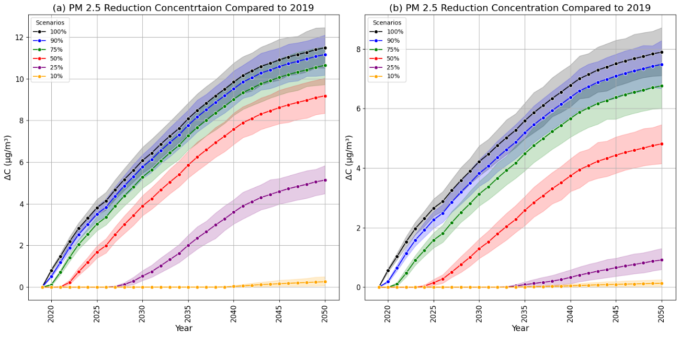
Figure 5. Required PM2.5 concentration reductions under different emission scenarios to avoid exceeding the premature mortality associated with the 2019 100% precursor emission scenario. (a) shows the PM2.5 concentration differences under the 100% boundary condition, and (b) under the 50% boundary condition.

S7. 5-year precursor emission reduction
Table 3. The five-year precursor emission reduction targets percentage relative to the baseline (%)
Province | The five-year precursor emission reduction targets (%) relative to the baseline
 | 2019 - 2025 | 2025 - 2030 | 2030 - 2035 | 2035 - 2040 | 2040 - 2045 | 2045 - 2050
Busan | 35 | 23 | 22 | 20 | 10 | 4
Chungcheongbuk-do | 26 | 18 | 24 | 28 | 20 | 12
Chungcheongnam-do | 23 | 18 | 22 | 26 | 20 | 13
Daegu | 33 | 22 | 23 | 23 | 15 | 8
Daejeon | 32 | 23 | 25 | 26 | 18 | 11
Gangwon-do | 29 | 17 | 22 | 26 | 18 | 10
Gwangju | 33 | 23 | 22 | 25 | 18 | 12
Gyeonggi-do | 40 | 28 | 29 | 31 | 22 | 14
Gyeongsangbuk-do | 23 | 16 | 21 | 23 | 16 | 9
Gyeongsangnam-do | 28 | 21 | 24 | 26 | 17 | 10
Incheon | 38 | 28 | 29 | 30 | 21 | 12
Jeju-do | 28 | 21 | 23 | 26 | 21 | 15
Jeollabuk-do | 23 | 16 | 16 | 20 | 15 | 9
Jeollanam-do | 21 | 12 | 14 | 20 | 16 | 10
Sejong | 43 | 35 | 38 | 40 | 32 | 25
Seoul | 35 | 24 | 22 | 22 | 15 | 9
Ulsan | 40 | 32 | 34 | 32 | 21 | 10
All | 31 | 22 | 24 | 26 | 19 | 11

