**Composite Dynamic Double Network Hydrogels with Rapid Self-healing, Stretchable, Moldable and Antibacterial Properties based on PVA / ε-Poly-L-lysine / Hyaluronic Acid**

Na Sun 2, a, Xiangnan Liu1, a, Wenqi Lv1, a, Chunlin Xu1, Ailing Zhang3,*and Panpan Sun1,*

1．School of Bioscience and Technology, Shandong Second Medical University, Weifang 261053, China; 1576277215@qq.com; 2776584978@qq.com; 2020466794@qq.com

2．College of Pharmacy, Shandong Second Medical University, Weifang 261053, China sunna@sdsmu.edu.cn

3．College of Chemical Engineering and Environmental Chemistry, Weifang University, Weifang 261061, China

* Correspondence: zhangal89@163.com; sunpanpan@sdsmu.edu.cn

a These authors contributed equally to this work.

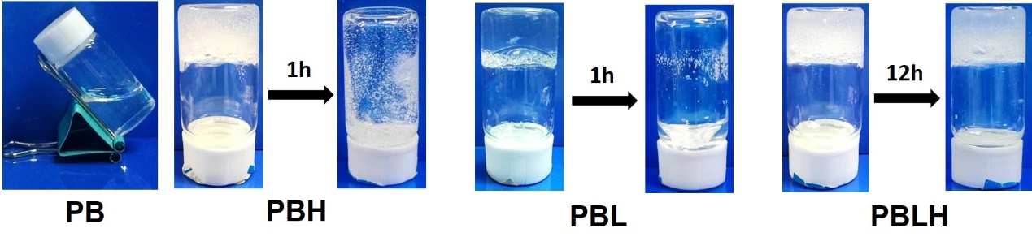

**Figure S1**. The photographs of the states of the PB, PBH, PBL, PBLH hydrogels at initial and after certain hours.

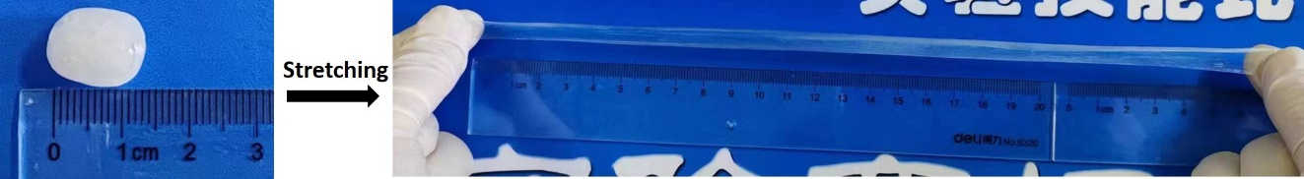

**Figure S2**. The photographs of the stretchable states of the PBLH composite hydrogels.