**Supplementary Material**

**Table S1:** Gene symbol, functions and primers assay ID used for microfluidic expression analyses (Biomark HD System - Fluidigm).

|  |  |  |  |
| --- | --- | --- | --- |
| Gene Symbol   |  | | --- | |  | | **Function** | **Assay ID\*** |
| GAPDH | Reference gene | Bt03210912_g1 |
| ACTB | Reference gene | PA5-16914 |
| CD40 | Apoptosis | Bt03817804_g1 |
| BID | Apoptosis | Bt03241255_m1 |
| BAX | Apoptosis | Bt03211777_g1 |
| CASP3 | Apoptosis | Bt03250954_g1 |
| NPPA | Cell development | Bt03223175_g1 |
| NPPB | Cell development | Bt04301375_g1 |
| NPR1 | Cell development | Bt04297034_g1 |
| IMPDH1 | Cell development | Bt00995384_m1 |
| NLRP5 | Cell development | Bt03218031_m1 |
| BMP15 | Cell development | Bt03286494_u1 |
| NANOG | Cell development | Bt03220541_m1 |
| SOX2 | Cell development | Bt03278318_s1 |
| NRP1 | Cell development | Bt04284287_m1 |
| NRP2 | Cell development | Bt04284287_m1 |
| BDNF | Cell development | Bt04316732_m1 |
| FSHR | Cell development | Bt03212674_m1 |
| IGFBP4 | Cell development | Bt03259500_m1 |
| ADCY6 | Cell development | Bt03816767_m1 |
| ADCY9 | Cell development | Bt04287024_m1 |
| EGFR | Cell development | AJT96D7 |
| HSPA1A | Cell development | Bt03292670_g1 |
| NPPC | Cell development | Bt03212844_m1 |
| NPR2 | Cell development | Bt04316732_m1 |
| POU5F1 | Cell development | Bt03223846_g1 |
| ELF5 | Cell development | Bt03220307_m1 |
| HSPA5 | Oxidative stress | Bt03244880_m1 |
| GFPT2 | Oxidative stress | Bt03250351_m1 |
| GLRX2 | Oxidative stress | Bt03229700_m1 |
| SOD1 | Oxidative stress | Bt03215423_g1 |
| GPX1 | Oxidative stress | Bt03259217_g1 |
| FDX1 | Oxidative stress | Bt03217449_m1 |
| CAT | Oxidative stress | Bt03228713_m1 |
| FADS2 | Lipid metabolism | Bt03256255_g1 |
| SCD | Lipid metabolism | Bt04307476_m1 |
| ACSL1 | Lipid metabolism | Bt03248469_m1 |
| ACAT1 | Lipid metabolism | Bt03238649_g1 |
| PNPLA2 | Lipid metabolism | Bt03234129_g1 |
| PLIN2 | Lipid metabolism | Bt03212182_m1 |
| PLIN3 | Lipid metabolism | Bt03230537_m1 |
| AGPAT9 | Lipid metabolism | Bt04292093_m1 |
| AGPAT1 | Lipid metabolism | Bt03224587_g1 |
| SREBF1 | Lipid metabolism | Bt03276370_m1 |
| ACACA | Lipid metabolism | Bt03213389_m1 |
| ACSL3 | Lipid metabolism | Bt04282138_m1 |
| ACSL6 | Lipid metabolism | Bt03231692_m1 |
| ELOVL1 | Lipid metabolism | Bt03286627_s1 |
| ELOVL2 | Lipid metabolism | Bt03256849_m1 |
| ELOVL4 | Lipid metabolism | Bt03270721_m1 |
| ELOVL5 | Lipid metabolism | Bt03235956_m1 |
| ELOVL6 | Lipid metabolism | Bt00907566_m1 |

* ThermoFischer Scientific

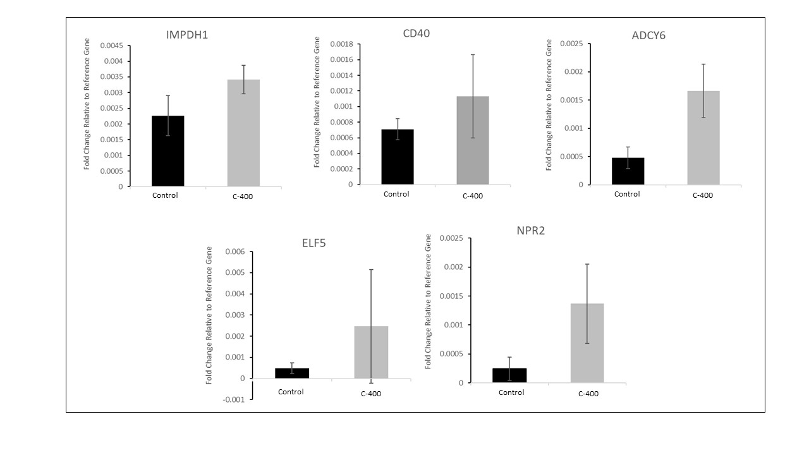

**Figure S1-** Upregulated transcription observed in bovine morulas after treatment with CNP. The relative abundance of transcripts was selected by the Fold change analysis (with magnitude greater than 1.5 times, that is, with the threshold > 1.5). Control (no treatment) and C-400 (400 nM of CNP).

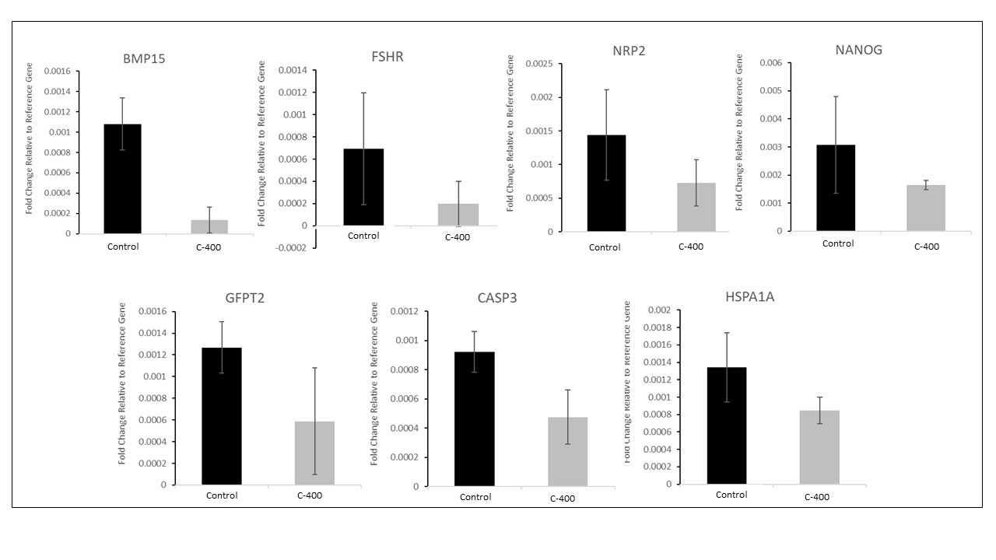

**Figure S2-** Downregulated transcription observed in bovine morulas after treatment with CNP. The relative abundance of transcripts was selected by the Fold change analysis (with magnitude greater than 1.5 times, that is, with the threshold > 1.5). Control (no treatment) and C-400 (400 nM of CNP).

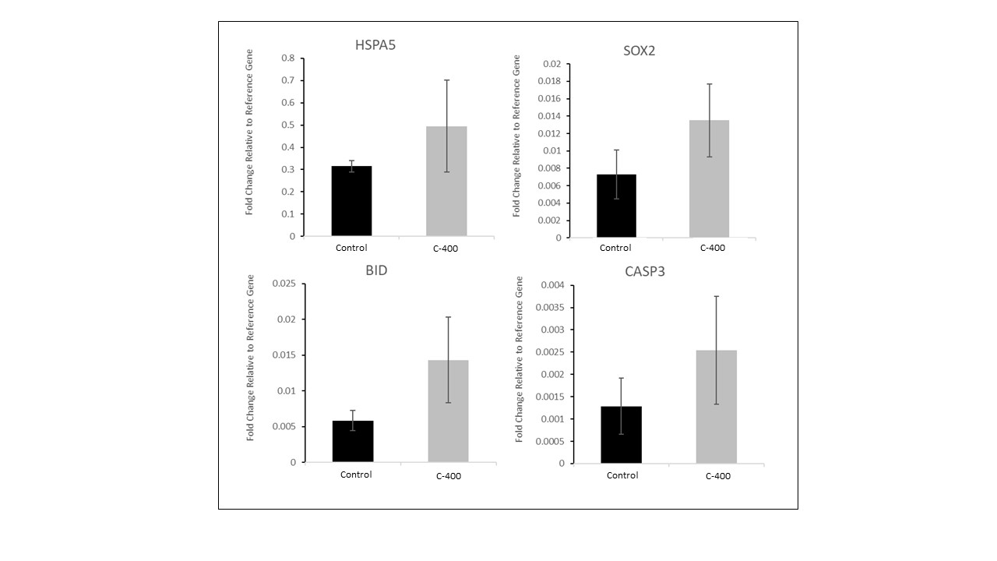

**Figure S3-** Upregulated transcription observed in bovine blastocytes after inclusion of CNP in *in vitro* culture. The relative abundance of transcripts was selected by the Fold change analysis (with magnitude greater than 1.5 times, that is, with the threshold > 1.5). Control (no treatment) and C-400 (400 nM of CNP).

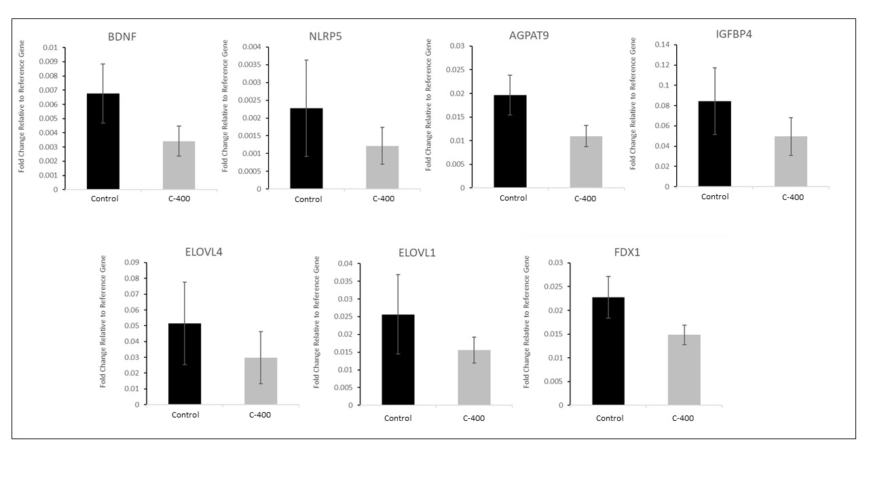

**Figure S4-** Downregulated transcription observed in bovine blastocytes after inclusion of CNP in *in vitro* culture. The relative abundance of transcripts was selected by the Fold change analysis (with magnitude greater than 1.5 times, that is, with the threshold > 1.5). Control (no treatment) and C-400 (400 nM of CNP).

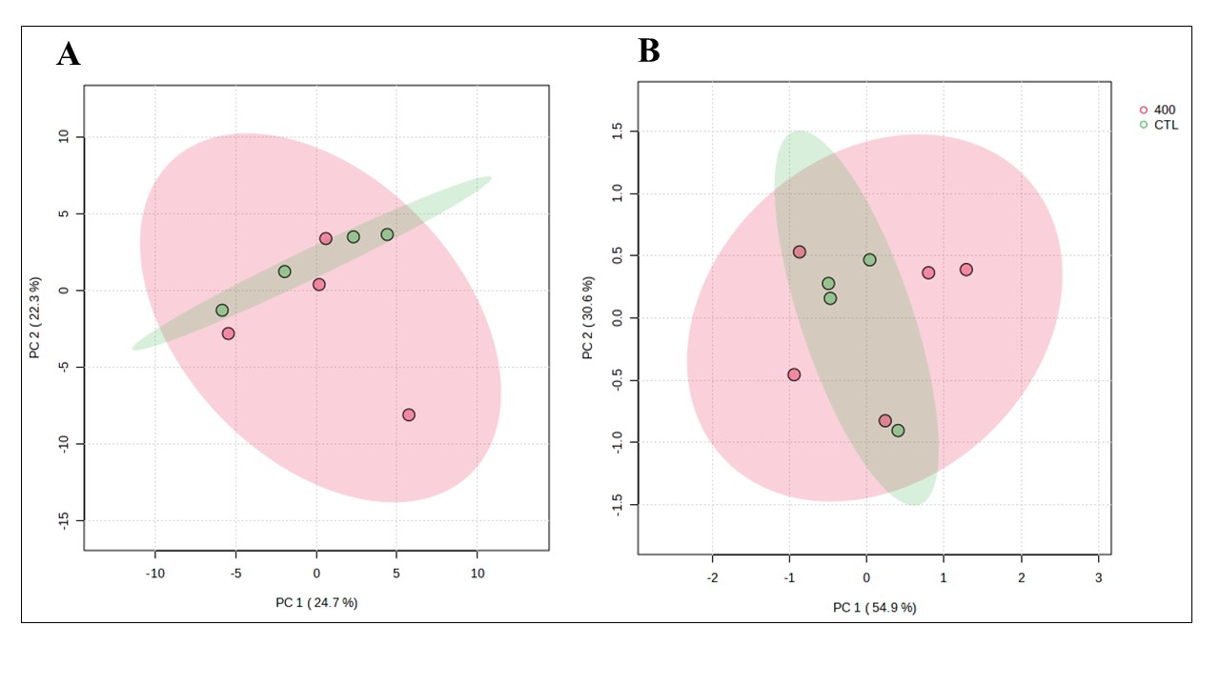**Figure S5**- Multivariate analysis plots of the abundance of transcripts derived from untreated (control) and CNP-treated morula. **(A)** PCA plot of morula from control and treated groups; **(B)** PCA plot of blastocyst treated with CNP and control group (n = 4 / group). Control (no treatment) and C-400 (400 nM of CNP).