Supplementary material
Table S1. Expert´s scores, content validity index and Aiken’s V coefficient in each item and global for MatCODE and MatER questionaries. CVI-i: Content validity index item; SEM: standard error of mean. Aiken's V coefficient was calculated considering the language clarity, relevance, and coherence domains.
MatCODE | Expert 1 | Expert 2 | Expert 3 | Expert 4 | Expert 5 | CVI-i | Aiken's V
Item 1 | 7 | 13 | 15 | 15 | 15 | 0.87 | 0.83
Item 2 | 11 | 14 | 11 | 13 | 14 | 0.84 | 0.80
Item 3 | 14 | 15 | 15 | 15 | 15 | 0.99 | 0.98
Item 4 | 15 | 15 | 15 | 15 | 15 | 1.00 | 1.00
Item 5 | 15 | 14 | 15 | 15 | 15 | 0.99 | 0.98
Item 6 | 9 | 15 | 15 | 15 | 14 | 0.91 | 0.88
Item 7 | 15 | 15 | 15 | 15 | 15 | 1.00 | 1.00
Item 8 | 15 | 15 | 15 | 15 | 14 | 0.99 | 0.98
Item 9 | 15 | 15 | 15 | 15 | 15 | 1.00 | 1.00
Item 10 | 15 | 15 | 7 | 15 | 14 | 0.88 | 1.00
Item 11 | 14 | 15 | 7 | 15 | 15 | 0.88 | 1.00
Mean±SEM | 13.2±0.86 | 14.6±0.20 | 13.2±0.99 | 14.8±0.18 | 14.6±0.15 | 0.94±0.02 | 0.96±0.02
MatER | Expert 1 | Expert 2 | Expert 3 | Expert 4 | Expert 5 | CVI-i | Aiken's V
Item 1 | 15 | 15 | 15 | 15 | 15 | 1.00 | 1.00
Item 2 | 14 | 15 | 15 | 15 | 15 | 0.99 | 0.98
Item 3 | 12 | 15 | 15 | 15 | 15 | 0.96 | 1.00
Item 4 | 14 | 15 | 15 | 15 | 15 | 0.99 | 0.98
Item 5 | 14 | 15 | 15 | 13 | 15 | 0.96 | 0.95
Item 6 | 15 | 15 | 15 | 15 | 15 | 1.00 | 1.00
Item 7 | 15 | 15 | 15 | 15 | 15 | 1.00 | 1.00
Item 8 | 15 | 15 | 15 | 15 | 15 | 1.00 | 1.00
Item 9 | 15 | 15 | 15 | 15 | 15 | 1.00 | 1.00
Mean±SEM | 14.3±0.33 | 15.0±0.00 | 15.0±0.00 | 14.8±0.22 | 15.0±0.00 | 0.99±0.01 | 0.99±0.01

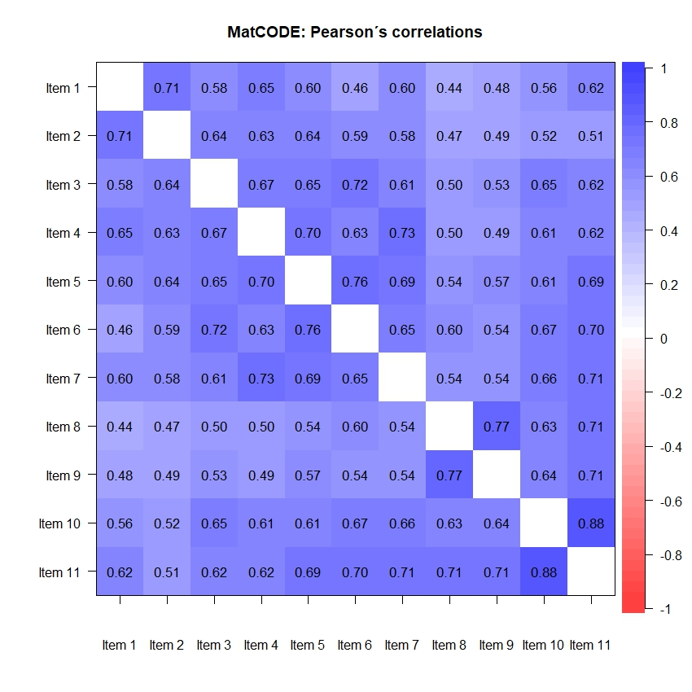
Figure S1. Pearson´s correlation coefficients of the items from the questionnaires focus on women's knowledge of obstetric healthcare rights (MatCODE) and perception of resource scarcity (MatER) during pregnancy, labor and early postpartum.

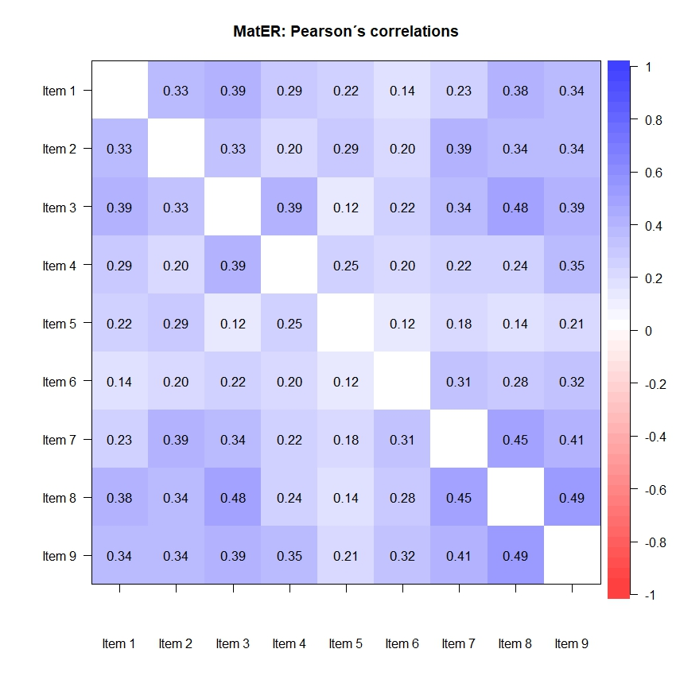

Table S2. The divergent analysis removing item 5 from MatER. Pearson´s correlation coefficient regarding to MatER scores with validated psychometric tests. RS-14: the Resilience scale; PANAS+: the Positive and Negative Affect Schedule positive score; PANAS-: the Positive and Negative Affect Schedule negative score; MBS-life: the Maternity Beliefs Scale maternity as a sense of life domain; MBS-social: the Maternity Beliefs Scale as a social duty domain. A p-Value (P)<0.05 was considered statistically significant.
 | MatER
RS-14 | -0.34 [-0.48; -0.19]  P<0.001
PANAS+ | -0.46 [-0.58; -0.31]  P<0.001
PANAS- | 0.49 [0.36; 0.61]  P<0.001
MBS-life | 0.01 [-0.16; 0.17]  P=0.940
MBS-social | 0.03 [-0.13; 0.20]  P=0.685

Table S3. The known-groups validation removing item 5 from MatER. Data shown Mean±standard error of mean (SEM). Statistically significant was established as p-value (P)≤0.05 by Mann–Whitney U-test.
 |  |  | Mean±SEM | P |  |  |  | Mean±SEM |  | P
Parity | Primiparous | 10.13±0.69 |  | 0.322 | Last labor | C-section | 10.10±0.75 |  | 0.372
 | Multiparous | 9.17±0.75 |  |  |  | Vaginal | 9.38±0.69
Civil status | Single/unmarried | 11.12±1.61 |  | 0.543 | Pregnancy complications | Yes | 10.93±0.96 |  | 0.109
 | In relationship | 9.37±0.51 |  |  |  | No | 9.11±0.96
Work situation | Unemployed | 10.52±0.80 |  | 0.130 | Labor complications | Yes | 11.11±1.23 |  | 0.123
 | Active working | 8.97±0.64 |  |  |  | No | 9.35±0.56
Planned pregnancy | Yes | 8.41±0.61 |  | 0.022 | Postpartum complications | Yes | 13.23±1.26 |  | 0.003
 | No | 11.13±0.81 |  |  |  | No | 9.04±0.54
Desired pregnancy | Yes | 9.06±0.51 |  | 0.009
 | No | 13.79±1.69

