Suppl. Fig. 1. Phylogenetic analysis of HA segment of H3N3 avian influenza viruses obtained from seal (marked in red) and wild bird population. The nucleotide sequences of HA segment were aligned using MUSCLE software and GTR nucleotide substitution model, with among-site rate variation model using a discrete gamma distribution. Bootstrap support values were generated using 500 rapid bootstrap replicates.
Suppl. Fig. 2. Phylogenetic analysis of NA segment of H3N3 avian influenza viruses obtained from seal (red dot) and wild bird population. The nucleotide sequences of NA segment were aligned using MUSCLE software and GTR nucleotide substitution model, with among-site rate variation model using a discrete gamma distribution. Bootstrap support values were generated using 500 rapid bootstrap replicates.
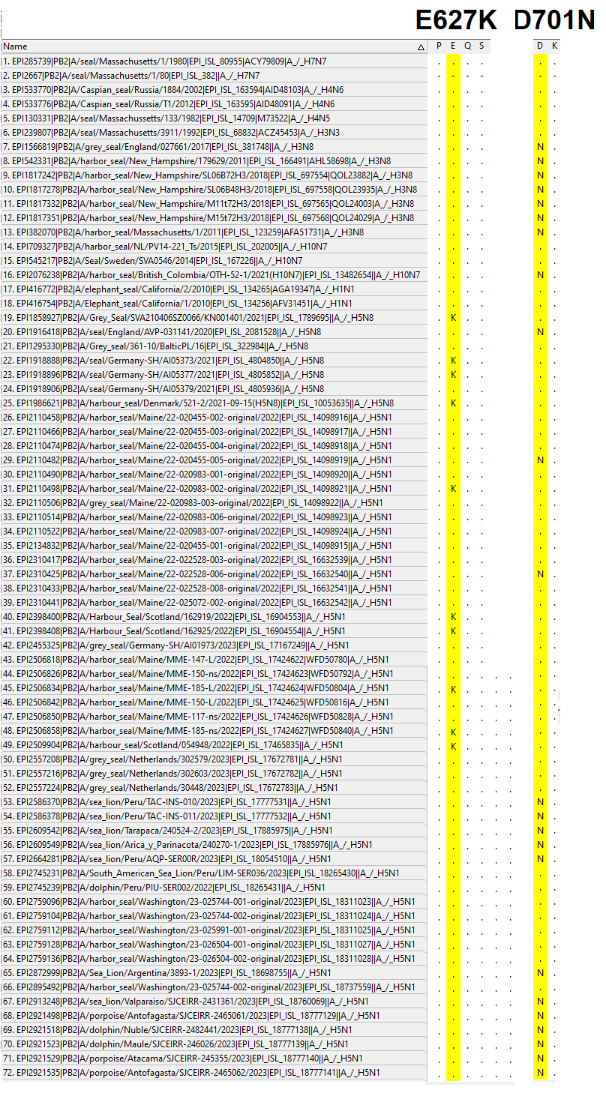
Suppl. Fig. 3. Avian influenza virus PB2 protein alignment of all available strains obtained from marine mammals in the last 45 years. The PB2 amino acid position at 627 and 701 is highlighted in yellow. The substitution E627K and D701N in PB2 segment is frequently observed in AIVs isolated from mammals.
Suppl. Fig. 4. Phylogenetic analysis of NP segment of avian influenza viruses found in seal population over the last 45 years. The analysis includes seal isolates of different avian influenza subtype isolated between 1980-2023 along with current H5N1 clade 2.3.4.4b viruses from 8 sea lions, 3 dolphins and 3 porpoise available in GSAID (as of March 2024). The nucleotide sequences of NP segment were aligned using MUSCLE software and GTR nucleotide substitution model, with among-site rate variation model using a discrete gamma distribution. Bootstrap support values were generated using 500 rapid bootstrap replicates.
Suppl. Fig. 5. Phylogenetic analysis of HA segment of avian influenza viruses found in seal population over the last 45 years. The analysis includes seal isolates of different avian influenza subtype isolated between 1980-2023 along with current H5N1 clade 2.3.4.4b viruses from 8 sea lions, 3 dolphins and 3 porpoise available in GSAID (as of March 2024). The nucleotide sequences of HA segment were aligned using MUSCLE software and GTR nucleotide substitution model, with among-site rate variation model using a discrete gamma distribution. Bootstrap support values were generated using 500 rapid bootstrap replicates.
Suppl. Fig. 6. Phylogenetic analysis of NA segment of avian influenza viruses found in seal population over the last 45 years. The analysis includes seal isolates of different avian influenza subtype isolated between 1980-2023 along with current H5N1 clade 2.3.4.4b viruses from 8 sea lions, 3 dolphins and 3 porpoise available in GSAID (as of March 2024). The nucleotide sequences of NA segment were aligned using MUSCLE software and GTR nucleotide substitution model, with among-site rate variation model using a discrete gamma distribution. Bootstrap support values were generated using 500 rapid bootstrap replicates.
Suppl. Fig. 7. Phylogenetic analysis of NS segment of avian influenza viruses found in seal population over the last 45 years. The analysis includes seal isolates of different avian influenza subtype isolated between 1980-2023 along with current H5N1 clade 2.3.4.4b viruses from 8 sea lions, 3 dolphins and 3 porpoise available in GSAID (as of March 2024). The nucleotide sequences of NS segment were aligned using MUSCLE software and GTR nucleotide substitution model, with among-site rate variation model using a discrete gamma distribution. Bootstrap support values were generated using 500 rapid bootstrap replicates.

