Supplementary materials to paper

**A Reaction-based Approach to Colorimetric Detection of Organic Analytes in Water Using a Chlorine-containing Carbocyanine Dye and Hypochlorite**

Anna V. Shik1,*, Evgenii V. Skorobogatov1, Ramil M. Akhmetov1, Irina A. Doroshenko1, Tatyana A. Podrugina1, Gleb K. Sugakov2, Mikhail K. Beklemishev1

1 Department of Chemistry, Lomonosov Moscow State University, 119991 Moscow, Russia;

2 Institute for African Studies of the Russian Academy of Sciences, 30/1 Spiridonovka str., 123001 Moscow, Russia

**Spectral data for dye I** (2-((E)-2-((E)-2-Chloro-3-(2-((E)-1-(5-ethoxy-5-oxopentyl)-3,3-dimethylindolin-2-ylidene)ethylidene)cyclohex-1-en-1-yl)vinyl)-1-(5-ethoxy-5-oxopentyl)-3,3-dimethyl-3H-indol-1-ium iodide)

* **Absorption spectrum**: λmax = 780 nm; ε = 2.4×105 L/mol cm.
* **1H NMR** (400 MHz, CD3OD, δ, ppm, J/Hz): 1.21 (t, 6H*,* 3*J*HH = 7.12, 2 OCH2CH3), 1.74 (s, 12H, 2C(CH3)2), 1.75 - 1.81 (m, 4H, 2CH2), 1.83 - 1.91 (m, 4H, 2CH2) 1.95 - 1.99 (m, 2H, CH2), 2.43 (t, 4H*,* 3*J*HH = 7.00, 2CH2COOEt), 2.76 (t, 4H*,* 3*J*HH = 6.11, 2CH2), 4.10 (q, 4H*,* 3*J*HH = 7.13, OCH2CH3) 4.22 (t, 4H*,* 3*J*HH = 7.21, CH2N+), 6.32 (d, 2H, 3*J*HH =14.18, =CH), 7.27 - 7.33 (m, 2H, Ar), 7.33 - 7.38 (m, 2H, Ar), 7.40 - 7.47 (m, 2H, Ar), 7.54 (d, 2H, 3*J*HH =7.46, Ar), 8.45 (d, 2H, 3*J*HH =14.18, =CH).
* **13C NMR** (100 MHz, CD3OD δ, ppm, J/Hz): 14.11 (s, 2COOCH2CH3), 20.57 (s, CH2), 22.16 (s, 2CH2), 26.64 (s, 4CH2), 28.05 (s, 2C(CH3)2), 33.47 (s, 2CH2), 44.65 (s, 2C(CH3)2), 49.23 (s, 2CH2N+), 60.35 (s, 2COOCH2CH3), 93.32 (s, 2CH), 101.30 (s, Ar), 110.85 (s, С=С(Cl)-C), 116.55 (s, Ar), 122.16 (s, Ar), 125.25 (s, Ar), 127.46 (s, 2CH), 128.74 (s, Ar), 140.87 (s, Ar), 142.01 (s, Ar), 144.27 (s, Ar), 150.44 (s, CCl), 172.96 (s, 2COOCH2CH3), 176.57 (s, 2С=N). IR, ν/cm–1: 714.01 (C-Cl), 1368,25 (N sec.), 1550.01 - 1512.40 (Ar), 1728.87 (C=O).
* **HRMS-ESI**: found m/z: 711.3929, [M+] C44H56ClN2O4+, calculated M: 711.3923.

**Table S1.** Composition of natural water samples (mg/L)

|  |  |  |  |  |  |  |  |  |  |  |
| --- | --- | --- | --- | --- | --- | --- | --- | --- | --- | --- |
| Sample | Color degree | Turbidity* | pH | Hardness (dH) | MnO4– index** | F– | Cl– | NO3– | SO42– | Dry re­sidue*** |
| Bor-8 | 5.8 | 1 | 7.4 | 3.9 | 2.7 | 0.3 | 32 | 4.8 | 22 | 340 |
| Well-4 | 5.0 | 1 | 6.3 | 2.9 | 3.0 | 0.3 | 0.5 | 0.5 | 0.5 | 380 |
| Spr-6 | 2.3 | 1 | 6.4 | 8.4 | 1.2 | 0.03 | 120 | 2.3 | 62 | 470 |

* Formazine turbidity units. ** mg oxygen/L. *** mg/L.

Table S2. Inorganic components of natural water samples according to total reflectance X-ray fluorescence (TXRF)* (mg/L)

|  |  |  |  |  |  |  |  |  |  |  |  |
| --- | --- | --- | --- | --- | --- | --- | --- | --- | --- | --- | --- |
| Sample | Mg | K | Ca | Ti | Mn | Fe | Ni | Cu | Zn | Br | Sr |
| Bor-8 | 10 | 1.7 | 36 | 0 | 0.011 | 0.022 | 0 | 0 | 0.026 | 0.0096 | 0.11 |
| Well-4 | 0 | 0.8 | 29 | 0 | 0 | 0.012 | 0.004 | 0.014 | 0.14 | 0.049 | 0.08 |
| Spr-6 | 9.9 | 1.2 | 63 | 0 | 0 | 0.011 | 0 | 0 | 0.021 | 0.036 | 0.11 |

* TXRF spectra of samples were measured on Picofox S2 spectrometer (Bruker Nano GmbH, Germany). A 5 μL aliquot of the water sample was pipetted on a quartz reflector and dried. Mo K-L3 line was used for excitation of X-ray fluorescence, the spectrum acquisition time was 250 s. The concentrations were calculated by internal calibration. The reflectors were treated with 10% nitric acid, water and acetone before use.

**Table S3.** Effect of pH on the color of the reaction system *dye I – NaOCl*.

*Carbonate buffer (pH 5.6); Glyc: glycinate buffer; NIR: near-IR images. Concentrations: NaOCl 2.5×10-4 M, Dye 0.01 g/L.

|  |  |
| --- | --- |
| *Time* | *Images of the reaction mixture at various pH values* |

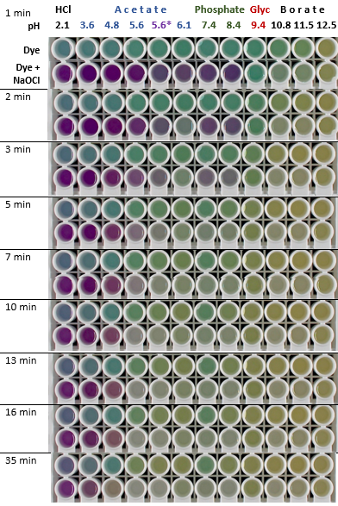

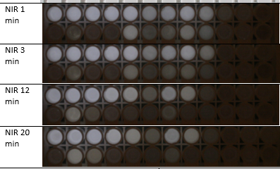

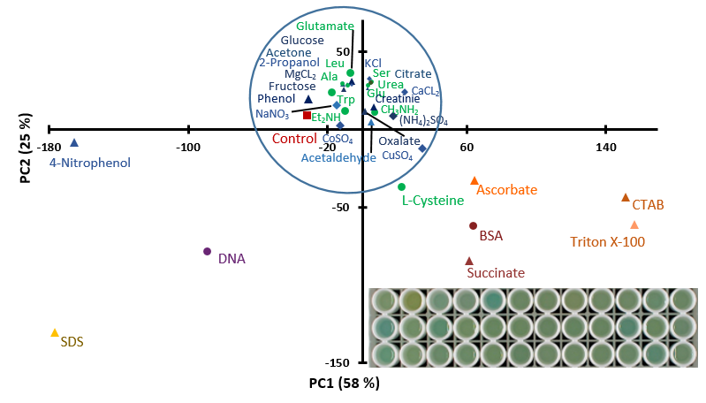

**Figure S1.** Principal component analysis (PCA) score plot constructed using the images of mixtures of dye I with model analytes (shown in the plot) **without NaOCl.** The signal was observedduring 30 min in acetate buffer solution (pH 5.6). ***Inset***: image of the plate at 8 min after mixing the reactants. Model compounds: 1st row: control, 4-nitrophenol, Triton X-100, CTAB, SDS, fructose, glucose, phenol, isopropanol, acetone, acetaldehyde, control; 2nd row: succinate, oxalate, ascorbate, citrate, serine, glutamate, leucine, glutamine, alanine, cysteine, ​​tryptophan, BSA; 3rd row: DNA, diethylamine, methylamine, creatinine, urea, CaCl2, NaNO3, KCl, MgCl2, (NH4)2SO4, CuSO4, CoSO4. Concentrations of organic analytes in the well were 0.5 mM, inorganic compounds 1 mM, Cu and Co 0.1 mM, BSA 0.3 g/L, DNA 0.025 g/L.

**Figure S2.** Fluorescence spectra of dye I (no NaOCl) and its reaction products with NaOCl at various reaction times. Excitation at 300 nm.

**Table** **4.** Images of the wells for selected reaction times. Each concentration was run in 6 replicate runs (6 wells of the plate in a row). The concentrations refer to the reaction mixture in the well.

***a*** – varying concentration of tryptophan and urea (separately)**:**

|  |  |  |
| --- | --- | --- |
| Time, min / concentration, M | Tryptophan | U r e a |
| 1  0  5·10–7  5·10–6  5·10–5  5·10–4 |  | |
| 2  0  5·10–7  5·10–6  5·10–5  5·10–4 |  | |
| 5  0  5·10–7  5·10–6  5·10–5  5·10–4 |  | |

***b*** – varying concentration of tryptophan in a mixture with a constant concentration of urea (5·10–5 M):

|  |  |
| --- | --- |
| Time, min / composition of mixture | Tryptophan + urea mixture |
| 1 | 0  5·10–7 M trp + 5·10–5 M urea  5·10–6 M trp + 5·10–5 M urea  5·10–5 M trp + 5·10–5 M urea  5·10–4 M trp + 5·10–5 M urea |
| 2  0  5·10–7 M trp + 5·10–5 M urea  5·10–6 M trp + 5·10–5 M urea  5·10–5 M trp + 5·10–5 M urea  5·10–4 M trp + 5·10–5 M urea |  |
| 5 | 0  5·10–7 M trp + 5·10–5 M urea  5·10–6 M trp + 5·10–5 M urea  5·10–5 M trp + 5·10–5 M urea  5·10–4 M trp + 5·10–5 M urea |

**Table S5.** Images of the wells with four model analytes in reaction *dye I – NaOCl* started different time after adding NaOCl (0, 1, and 24 h). In the left column, time after the reaction start (min) is given. All experiments were conducted in 6 replicates (6 wells in a row). The final concentrations of model analytes were: diethylamine 1 mM, DNA 0.025 g/L, proteins 0.1 g/L.

**Diethylamine**

**DNA**

**Lysozyme**

**BSA**

|  |  |  |  |  |
| --- | --- | --- | --- | --- |
| Reaction time, min /  Model analyte  **Diethylamine**  **DNA**  **Lysozyme**  **BSA** | Time between adding NaOCl and the dye, h | | | |
| **0** | **1** | **24** |
| **1** |  |  |  |
| **3**  **Diethylamine**  **DNA**  **Lysozyme**  **BSA** |  |  |  |
| **15** |  |  |  |
| **30**  **Diethylamine**  **DNA**  **Lysozyme**  **BSA** |  |  |  |

**Table S6**. Concentration of nitrogen species and chemical oxygen demand in water samples used in this study

|  |  |  |  |  |  |  |
| --- | --- | --- | --- | --- | --- | --- |
| *Sample code* | *Water type* | *Ammonia, mg/L* | *NO3**–,* *mg/L* | *NO2–, mg/L* | *Total N, mg/L* | *MnO4– index, mg oxygen/L* |
| WW-7 | Sewage | 4.4±0.6 | 0.34±0.05 | 0.06±0.01 | 40±5 | 10±2 |
| WW-4 | Sewage | <0.1 | 11±1 | >1.0 | 30±3 | 28±3 |
| WW-1 | Sewage | 0.79±0.16 | 9.2±0.9 | 0.094±0.016 | 30±3 | 62±4 |
| Bor-8 | Borehole | – | 5.0±0.5 | <0.01 | 21±3 | 2.7±0.3 |
| Well-4 | Well | 0.26±0.05 | <0.1 | <0.01 | 16±2 | 3.0±0.4 |
| Spr-6 | Spring | 0.23±0.05 | <0.1 | 0.015±0.005 | 18±2 | 1.2±0.1 |