**Text S1.** **Soil physicochemical properties**

The soil type is a reddish paddy soil with the following physicochemical properties: pH 5.68; total organic carbon, 16.5 g∙kg-1; total nitrogen (N), 1.58 g∙kg-1; total phosphorus (P), 0.68 g∙kg-1; total potassium (K), 2.33 g∙kg-1;available N, 138.2 mg∙kg-1;available P, 10.4 mg∙kg-1;andavailable K, 75.2 mg∙kg-1.

**Text S2. FT-ICR MS measurements**

The molecular characteristics of organic amendment-DOM and soil DOM were analyzed using a Bruker Apex Ultra Fourier transform ion cyclotron resonance (FT-ICR-MS) equipped with a 9.4 T superconducting magnet (Bruker, Billerica, MA, USA). Blank analyses of solvent and SPE extraction were also performed to check for possible contaminants and remnants. Peaks abundant in blank samples were removed from the results of DOM samples. Deuterated stearic acid (C18D35H1O2, Sigma-Aldrich) was added as an internal standard to compare the relative intensities of spectral peaks across various samples. Peaks with a signal-to-noise ratio (S/N) greater than 6 were considered, and those with a mass accuracy within 1 ppm were exported into a spreadsheet based on the criteria of elemental compositions: up to 100 12C, 200 1H, 4 14N, 30 16O, and 2 32S. Simultaneously, C peaks were removed from the data set. Mass peaks detected in more than two of the triplicates for each treatment were retained for further data analysis. Here, C, H, and N represent the number of carbon, hydrogen, and nitrogen atoms in the formulas. The molecular properties of DOM were described using the O/C ratio, H/C ratio, MW, double bond equivalence (DBE), and modified aromaticity index (AImod). All detected compounds were classified into several major biochemical classes based on the O/C ratio and H/C ratio, following the classification described by Zhang, Lv, He, Cao, He, Zhao, Wang and Jiang 1 (Table S1). Based on the AImod, H/C value and their relationship with bacteria, lignins, tannins and condensed hydrocarbons were classified as recalcitrant components, while unsaturated hydrocarbons, lipids, proteins, and carbohydrates were classified as labile components 2, 3.

According to previous studies, double bond equivalence (DBE) was used to measure the number of double bonds and rings in a molecule (Eq. (1)); the modified aromaticity index (AImod) were calculated to estimate the fraction of aromatic structures (Eq. (2)) (Koch and Dittmar, 2006; Riedel et al, 2012). The magnitude-averaged O/Cw, H/Cw, DBEw, MWw and AImodw values determined by Eq. (3) were used to estimate the averaged molecular characteristics of DOM, where the value of the peak intensity was the average of all the test results 1, 4.

(1)

$AImod = (1+C-O/2-H/2)/(C-O/2-N)$ (2)

${\left(M\right)}_{w}=[\sum_{i}{(I_{i}×M_{i})]/\sum_{i}{I_{i}}}$ (3)

where C, H, O and N represent the number of carbon, hydrogen, oxygen and nitrogen atoms per molecular formula, respectively; M represents parameters of O/C, H/C, DBE, m/z and AImod, respectively; w signifies a magnitude-weighted calculation, and Ii and Mi are the peak intensity and M value of peak i, respectively.

**Table S1. Classification of Van Krevelen diagram**

|  |  |  |
| --- | --- | --- |
| Category | O/C or AImod | H/C |
| Lipid | 0.3 ≥ O/C > 0 | 2 ≥ H/C > 1.5 |
| Protein | 0.67 ≥ O/C > 0.3 | 2.2 ≥ H/C > 1.5 |
| Carbonhydrates | 1.2 ≥ O/C > 0.67 | 2.2 ≥ H/C > 1.5 |
| Unsaturated hydrocarbons | 0.1 ≥ O/C > 0 | 1.5 ≥ H/C > 0.7 |
| Lignin | 0.67 ≥ O/C > 0.1 | 1.5 ≥ H/C > 0.7 |
| Tannins | 1.2 ≥ O/C > 0.67 | 1.5 ≥ H/C > 0 |
| Condensed aromatics | 0.67 ≥ O/C > 0 | 0.7 ≥ H/C > 0.2 |
| Aliphatic compounds (Ali) | / | 2.0 ≥ H/C ≥ 1.5 |
| Highly unsaturated and phenolic compounds (HUP) | AImod ≤ 0.50 | H/C < 1.5 |
| Vascular plant-dervied polyphenols (VP) | 0.66 ≥ AImod > 0.50 | / |
| Combustion-derived polycyclic aromatics (PA) | AImod > 0.66 | / |

**Table S2. The α-diversity (Chao 1) of soil microbial community.** **Different letters represent significant differences at P < 0.05 (Tukey’s test).**

|  |  |  |  |  |  |
| --- | --- | --- | --- | --- | --- |
|  | 3 day | 10 day | 30 day | 60 day | 100 day |
| CK | 1050.8a | 1020.8a | 1014.8c | 1268.3a | 1569.8ab |
| OM | 899.8ab | 1045.5a | 1257.8a | 1467.3a | 1271.3b |
| CS | 779.3b | 771.5b | 1238.5ab | 1478.8a | 1298.5b |
| OB | 558.5c | 817.0b | 1293.8a | 1597.0a | 1387.3ab |
| CB | 589.5c | 786.0b | 1241.5ab | 1589.8a | 1672.5a |

**Table S3. The *rrn* copy number of soil microbial communities. Different letters represent significant differences at P < 0.05 (Tukey’s test).**

|  |  |  |  |  |  |
| --- | --- | --- | --- | --- | --- |
|  | 3 day | 10 day | 30 day | 60 day | 100 day |
| CK | 2.56c | 2.47d | 2.46a | 2.55a | 2.34a |
| OM | 2.63c | 2.46d | 2.50a | 2.56a | 2.41a |
| CS | 3.17b | 2.78c | 2.61a | 2.59a | 2.39a |
| OB | 4.04a | 3.16b | 2.61a | 2.46a | 2.40a |
| CB | 4.14a | 3.38a | 2.66a | 2.45a | 2.37a |

**Table S4. Properties of DOM that contribute significantly to FeRB, Methanotroph, r-strategies and K-strategies. Different letters represent significant differences at P < 0.05 (Tukey’s test).**

|  |  |  |  |  |
| --- | --- | --- | --- | --- |
|  | O/C | H/C | DBE | AImod |
| FeRB | 0.45a | 0.97b | 9.79a | 0.51a |
| Methanotroph | 0.51a | 1.32a | 8.21b | 0.21b |
| r-strategies | 0.45a | 0.94b | 9.65a | 0.54a |
| K-strategies | 0.47a | 1.39a | 7.55b | 0.18b |

**Figures**

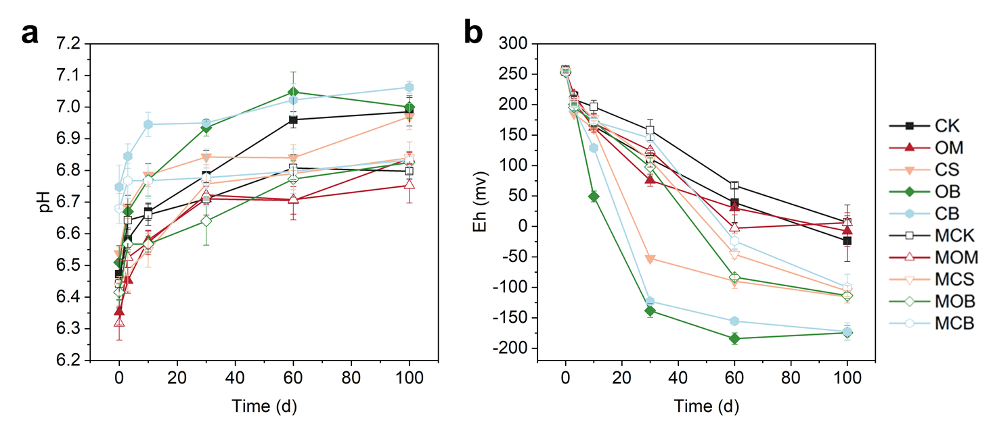

**Fig. S1.** Soil pH (a) and Eh (b) changes during the 100day incubation after addition of DOM. Values represent the means of the four replicates and the error bars represent the standard error of the means. OM, CS, OB and CB represent living soils with addition of the DOM derived from organic manure, crop straw, manure-biochar, and straw-biochar, respectively; MOM, MCS, MOB and MCB represent sterilized soils with addition of the DOM derived from organic manure, crop straw, manure-biochar, and straw-biochar, respectively.

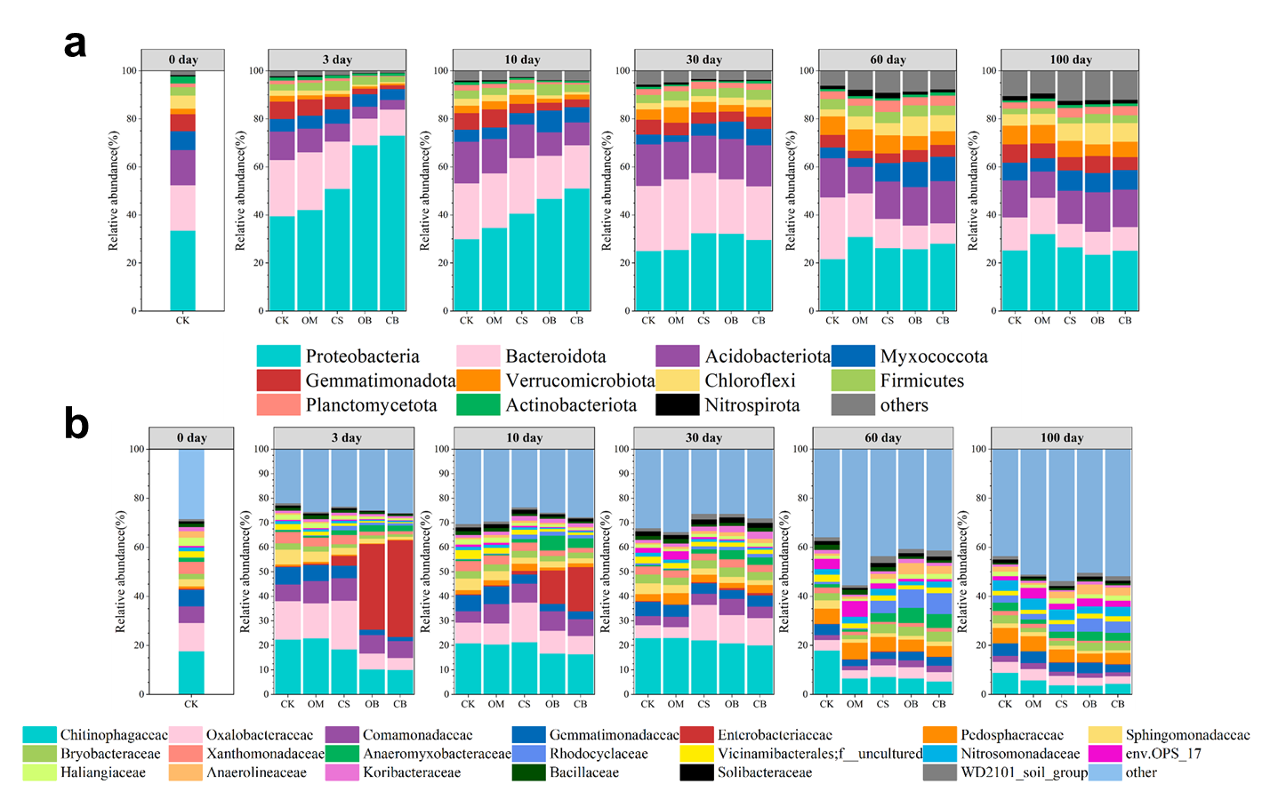

**Fig. S2.** Shifts in the soil microbial community at phylum (a) and family levels (b). The top 11 phyla (abundance > 1%) and 20 family (abundance > 1%) were presented, and the other taxa were lumped into “Others”. The abbreviations of the treatments are shown in Fig. S1.

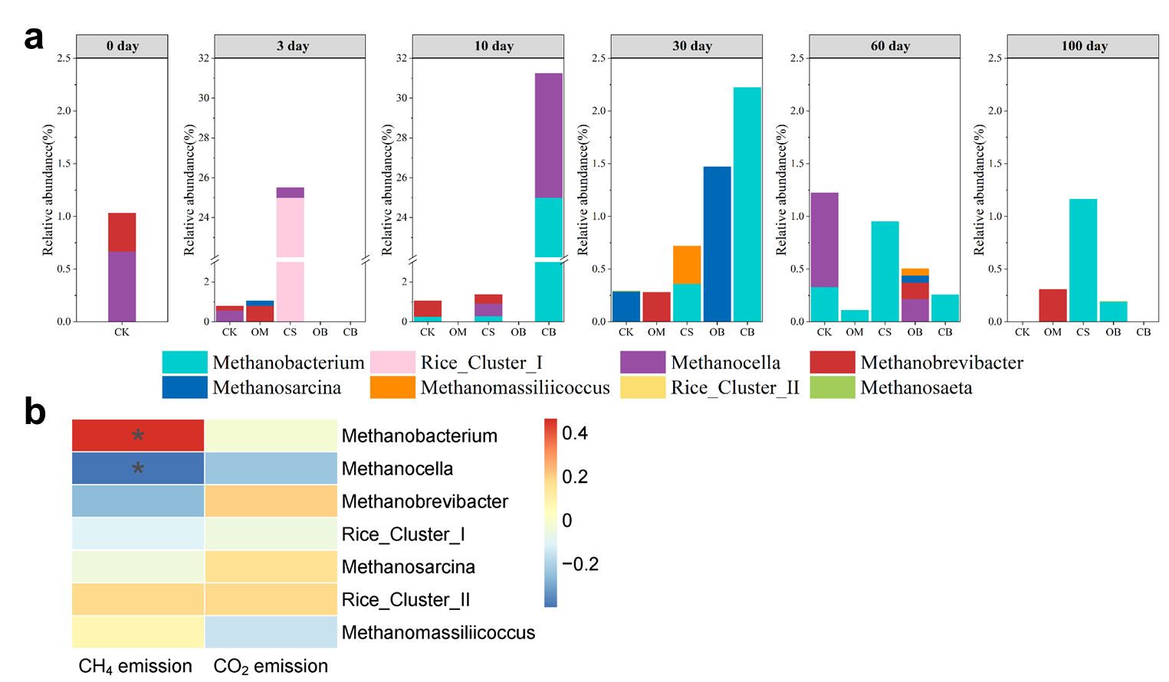

**Fig. S3.** Relative abundance of methanogens at the genus level in paddy soils (a), and the correlations between the carbon emission and the abundance of methanogens (b) during the incubation. The abbreviations of the treatments are shown in Fig. S1.

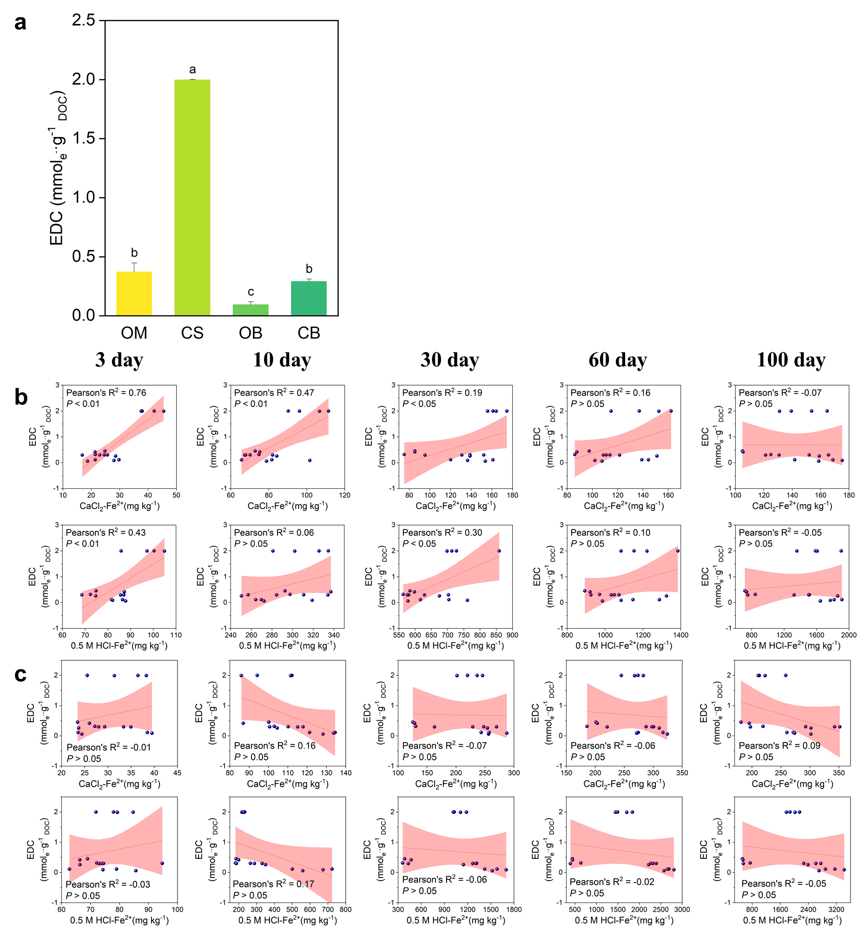

**Fig. S4.** Electron-donating capacities (EDC) of DOM derived from organic amendments (a). The Pearson correlation between EDC and CaCl2-Fe2+, 0.5 M HCl-Fe2+ under sterilization conditions (b) and non-sterilization conditions (c). The abbreviations of the treatments are shown in Fig. S1.

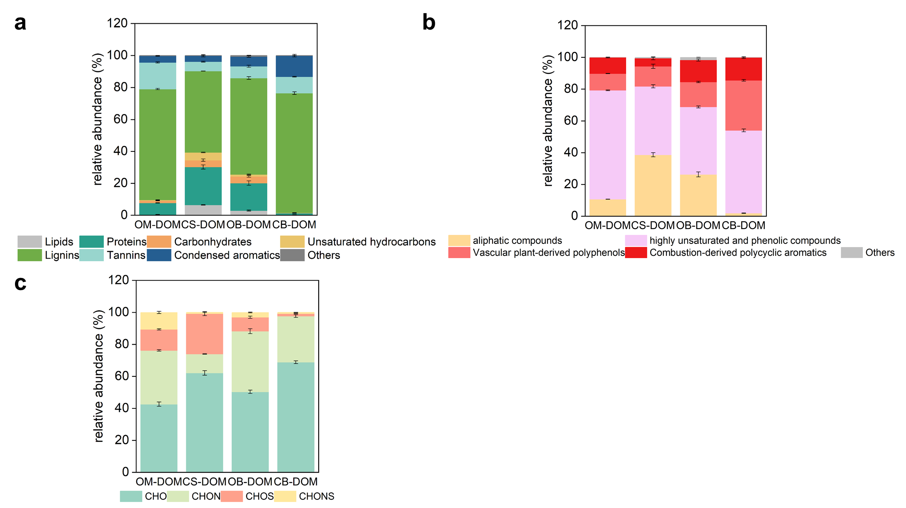

**Fig. S5.** Relative abundance (%) of van Krevelen diagram-derived classification classes (a, b) and elemental composition formulae (b) from the FT-ICR MS analysis of the DOM derived from organic amendments.

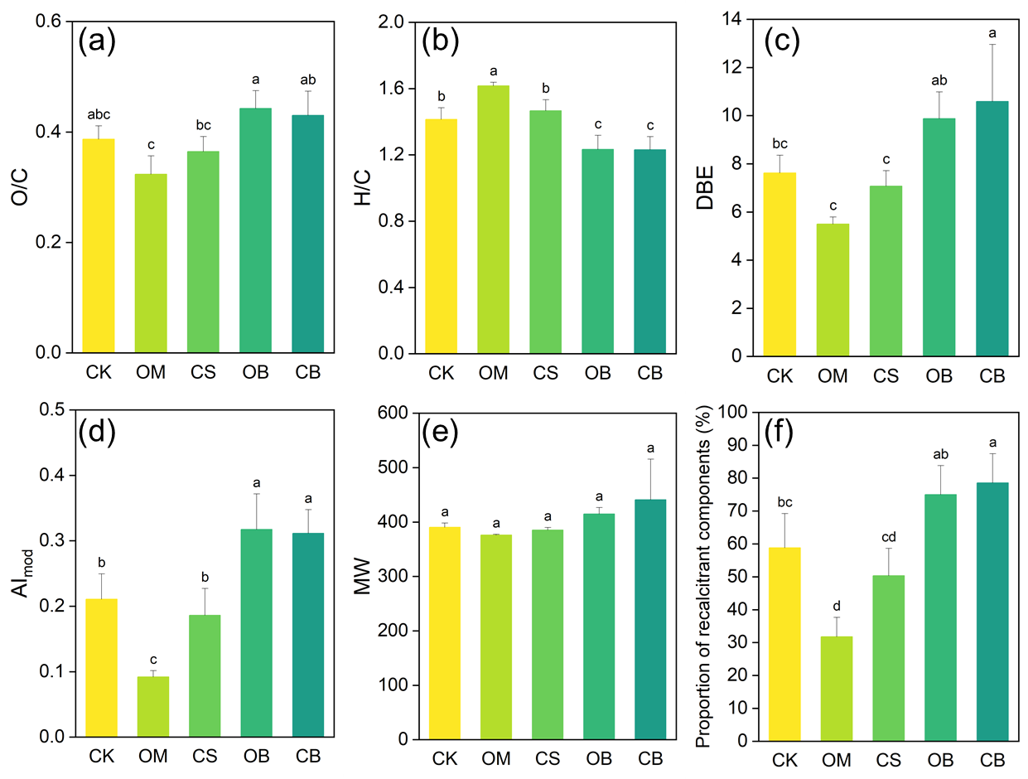

**Fig. S6.** The intensity-weighted molecular parameters of soil DOM, including O/C (a), H/C (b), DBE (c), AImod (d), MW (e) and proportion of recalcitrant components (f) of soil DOM. The abbreviations of the treatments are shown in Fig. S1.

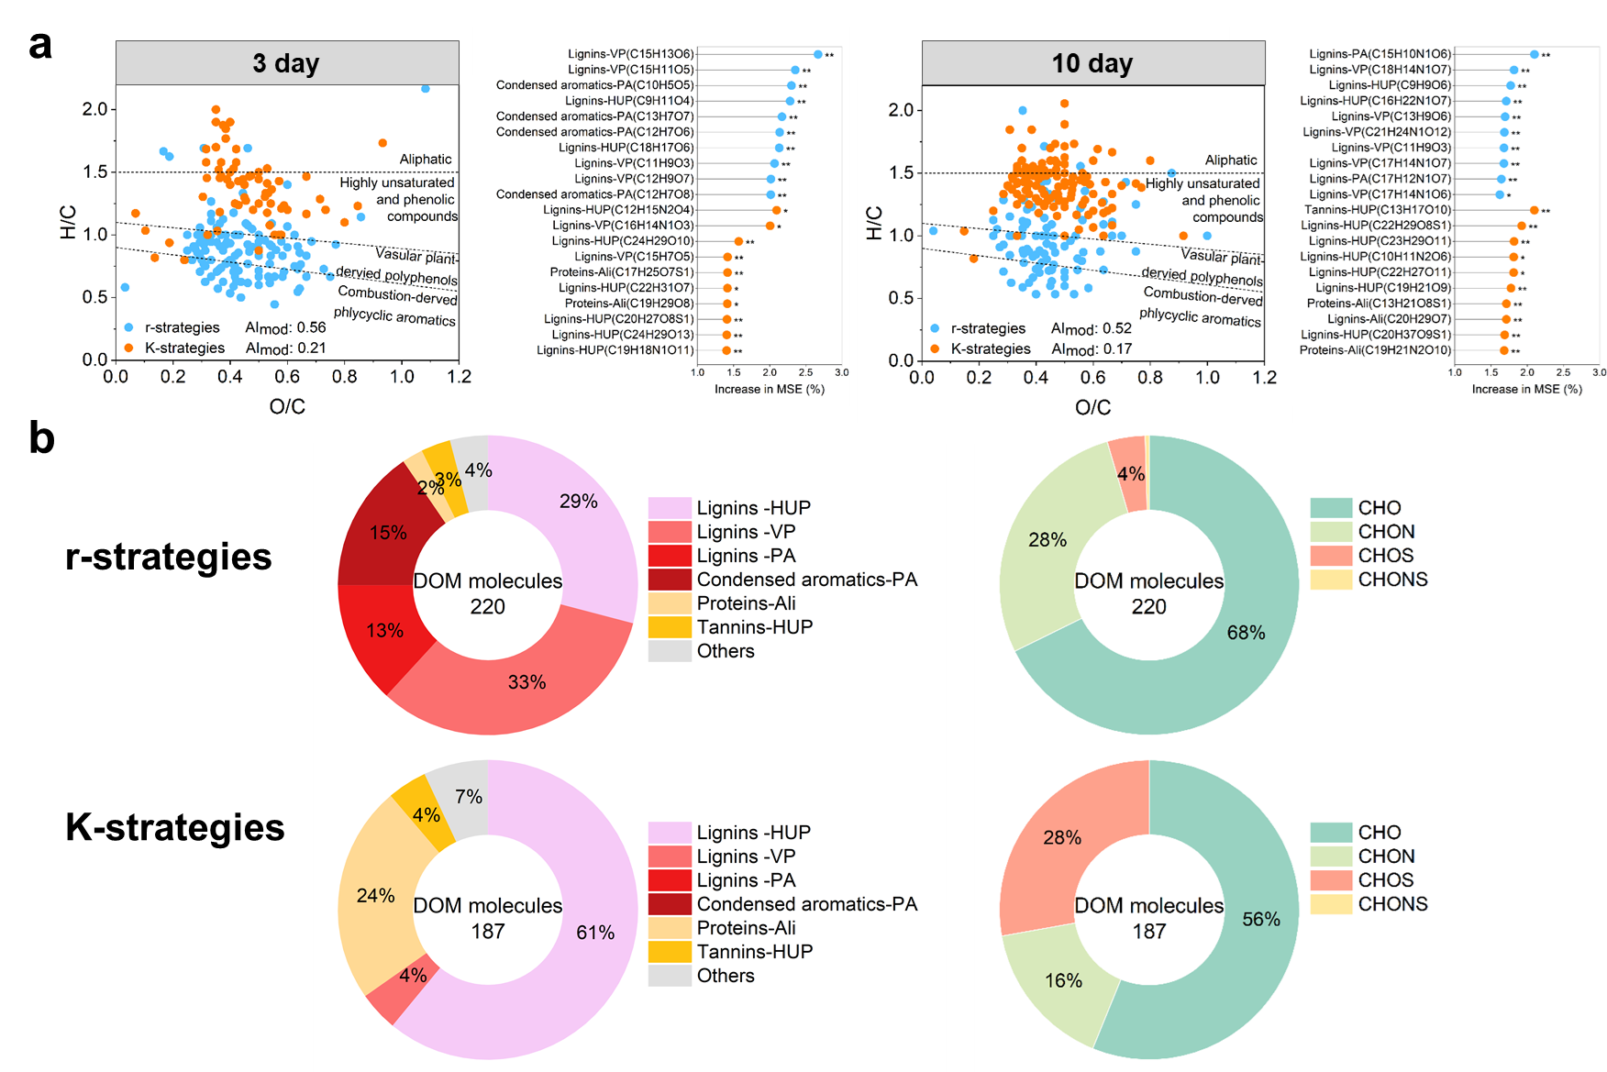

**Fig. S7.** The exogenous DOM molecules significantly correlated with r-strategies and K-strategies. (a) The van Krevelen diagrams showing the organic amendment-derived DOM molecules contributing to the r-strategies (significantly positively correlated with rrn copy number) and K-strategies (significantly negatively correlated with rrn copy number) as identified by random forest analysis. (b) Circle plots represent relative abundance of van krevelen diagram-derived classification classes and elemental composition formulae of DOMs that contribute to the r-strategies and K-strategies. Ali, aliphatic compounds; HUP, highly unsaturated and phenolic compounds; VP, vascular plant-derived polyphenols; PA, combustion-derived polycyclic aromatics.

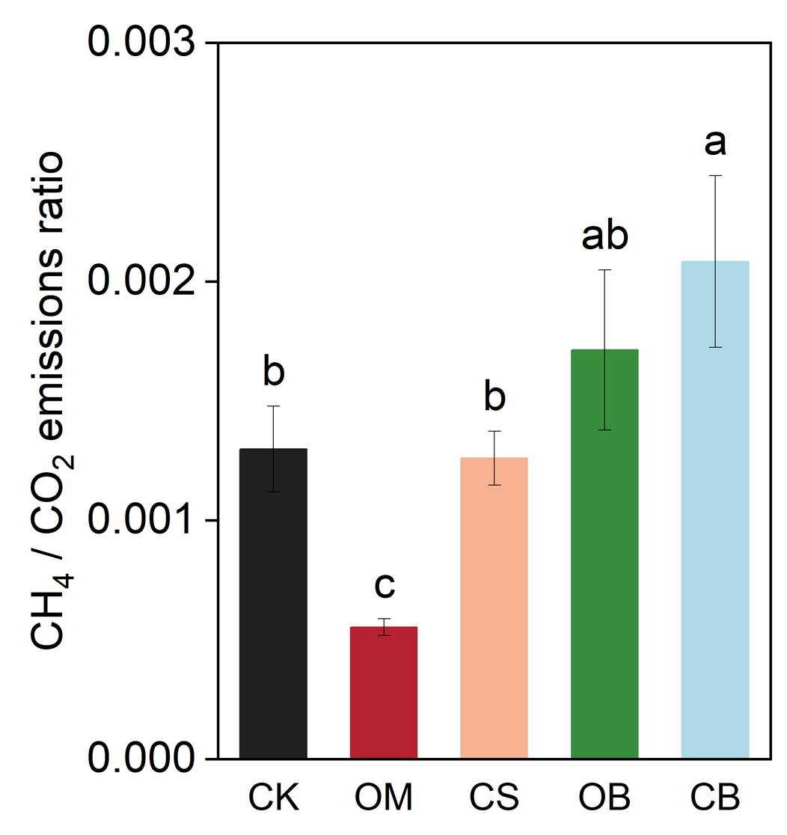

**Fig. S8.** The CH4 / CO2 emissions ratio in the paddy soil after adding DOM. The abbreviations of the treatments are shown in Fig. S1.

**References**

(1) Zhang, Q.; Lv, J.; He, A.; Cao, D.; He, X.; Zhao, L.; Wang, Y.; Jiang, G. Investigation with ESI FT-ICR MS on sorbent selectivity and comprehensive molecular composition of landfill leachate dissolved organic matter. *Water Research* **2023**, *243*. DOI: 10.1016/j.watres.2023.120359.

(2) Ling, L.; Luo, Y.; Jiang, B.; Lv, J.; Meng, C.; Liao, Y.; Reid, B. J.; Ding, F.; Lu, Z.; Kuzyakov, Y.; et al. Biochar induces mineralization of soil recalcitrant components by activation of biochar responsive bacteria groups. *Soil Biology and Biochemistry* **2022**, *172*. DOI: 10.1016/j.soilbio.2022.108778.

(3) Li, X. M.; Sun, G. X.; Chen, S. C.; Fang, Z.; Yuan, H. Y.; Shi, Q.; Zhu, Y. G. Molecular Chemodiversity of Dissolved Organic Matter in Paddy Soils. *Environ Sci Technol* **2018**, *52* (3), 963-971. DOI: 10.1021/acs.est.7b00377.

(4) Lv, J.; Miao, Y.; Huang, Z.; Han, R.; Zhang, S. Facet-Mediated Adsorption and Molecular Fractionation of Humic Substances on Hematite Surfaces. *Environmental Science & Technology* **2018**. DOI: 10.1021/acs.est.8b03940.