**Supplementary Materials**

A1: Shapely value summary plots

We have categorized the parameters into the four models and the SHAP value summary plots were drawn taking only the parameters in the relevant categories. For instance, yield parameters and parameters related to juice only depend on viticulture related data. Parameters related to wine composition depends on the parameters related to berry juice. The quality of the wine product is completely depend on the wine composition.

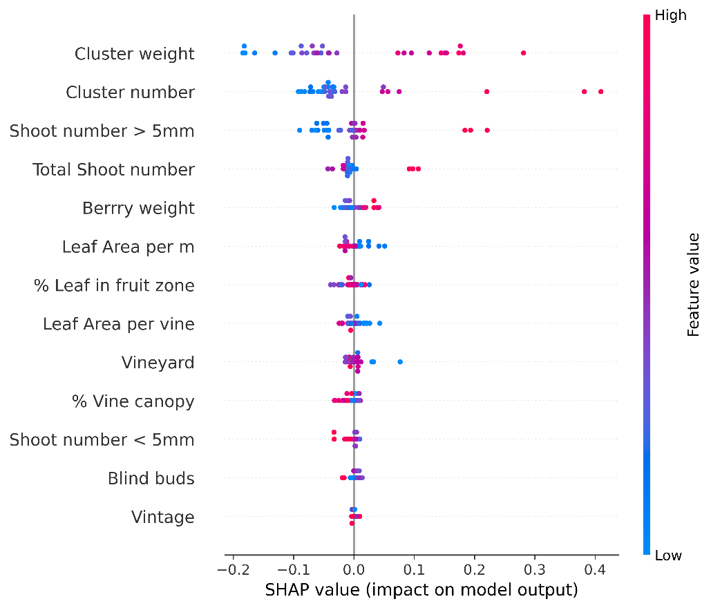

Figure 1: SHAP value summary plot for Yield per square meter

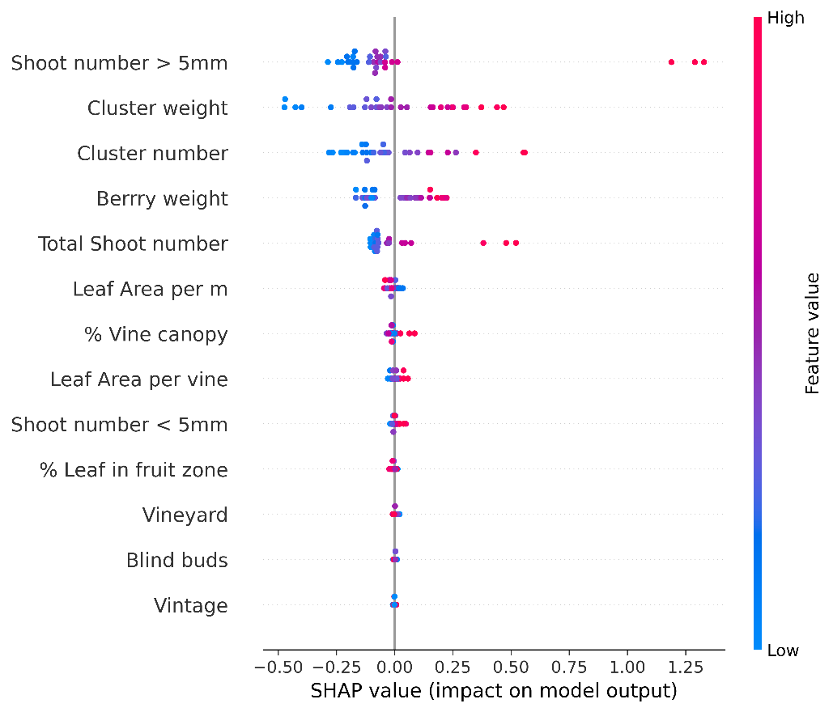

Figure 2: SHAP value summary plot for Yield per meter

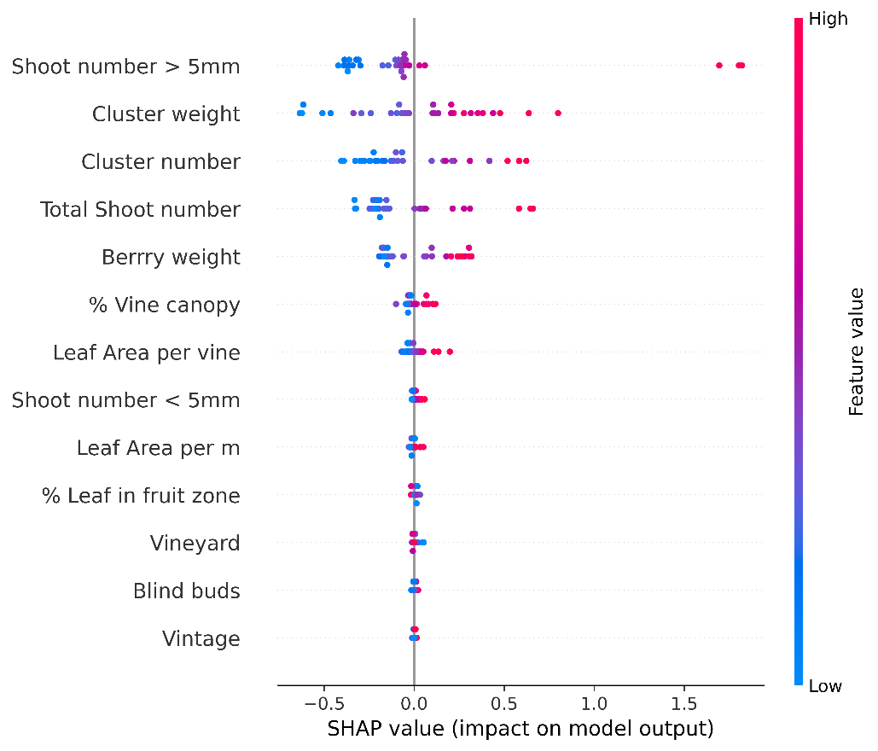

Figure 3: SHAP value summary plot for Yield per vine

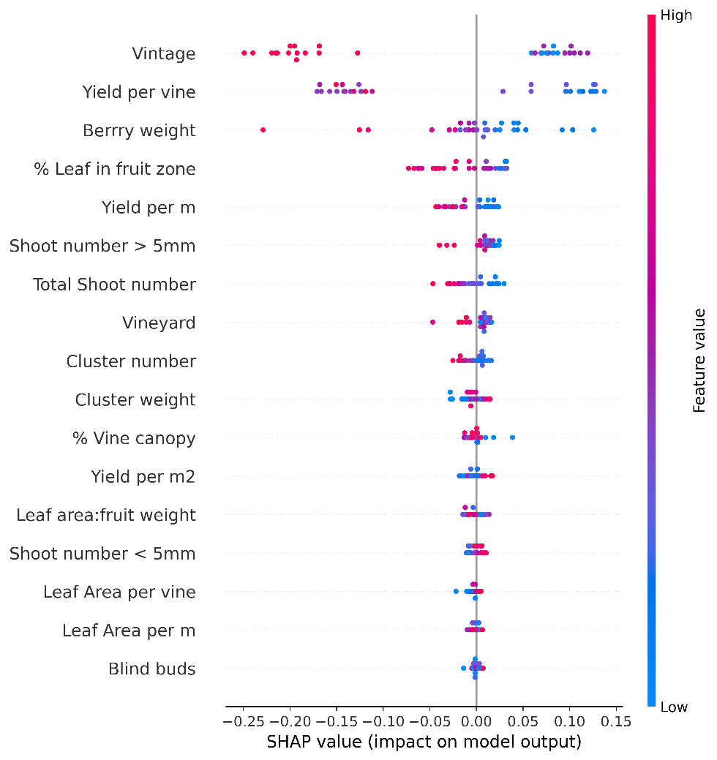

Figure 4:SHAP value summary plot for ODE280

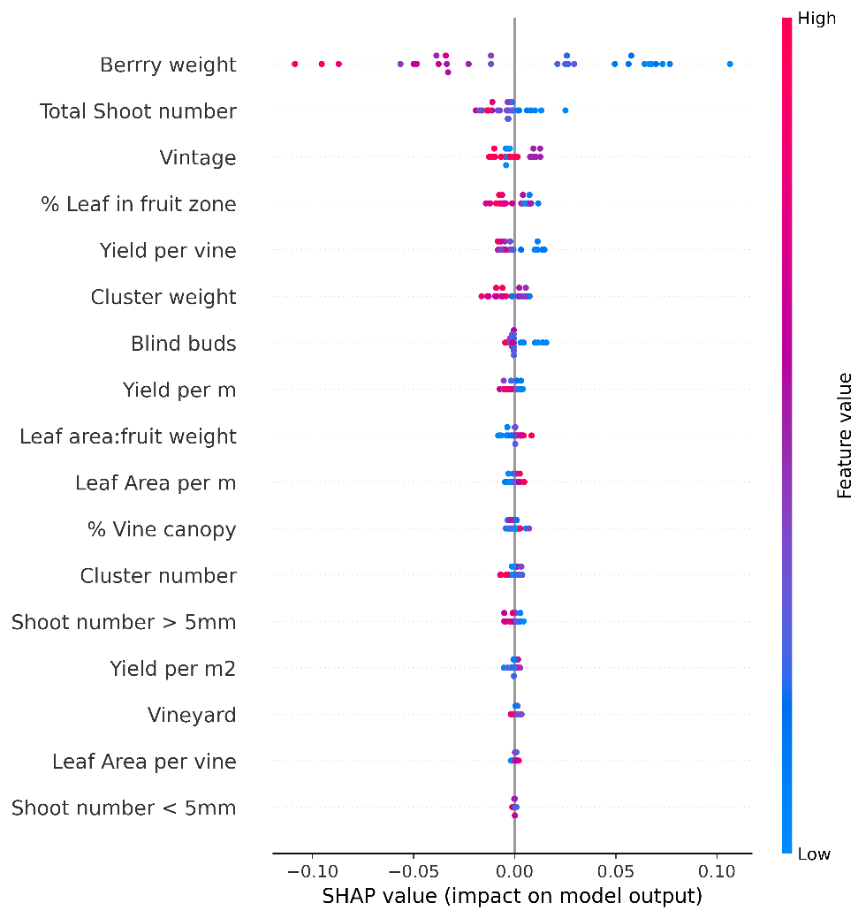

Figure 5: SHAP value summary plot for ODE320

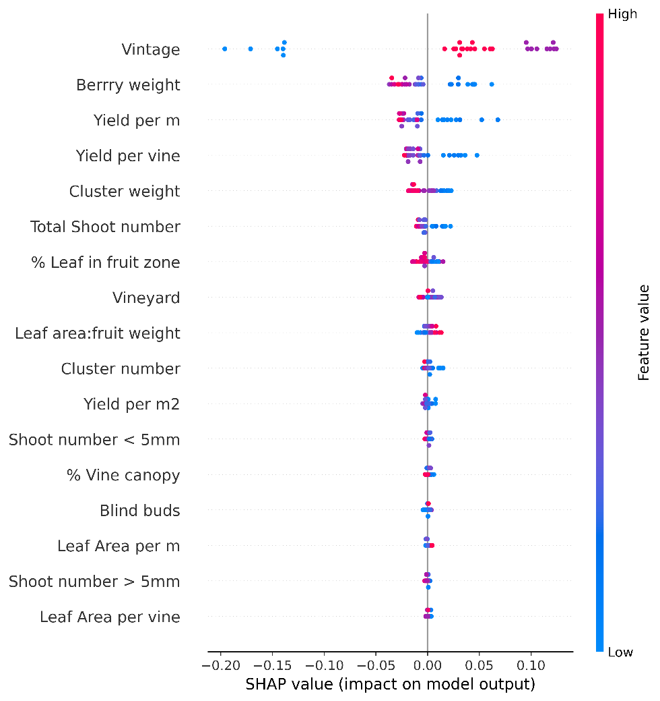

Figure 6: SHAP value summary plot for ODE520

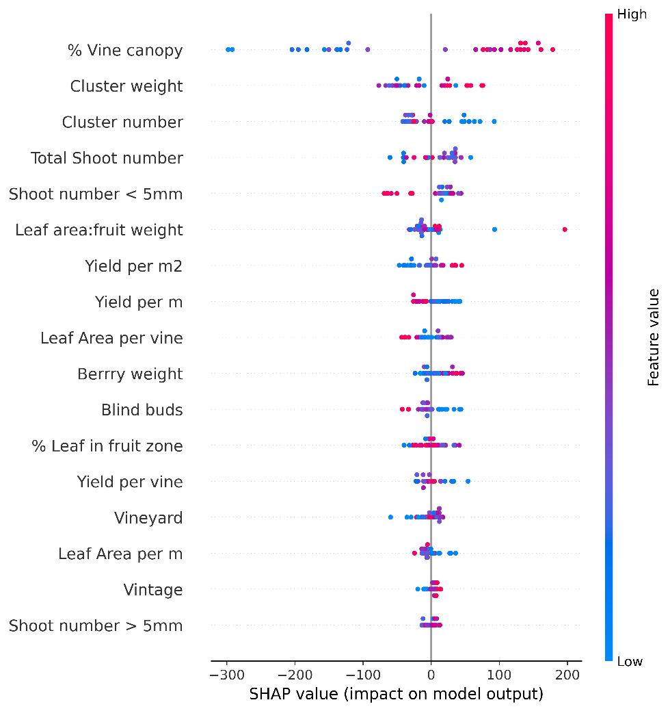

Figure 7: SHAP value summary plot for alanine level in berry juice

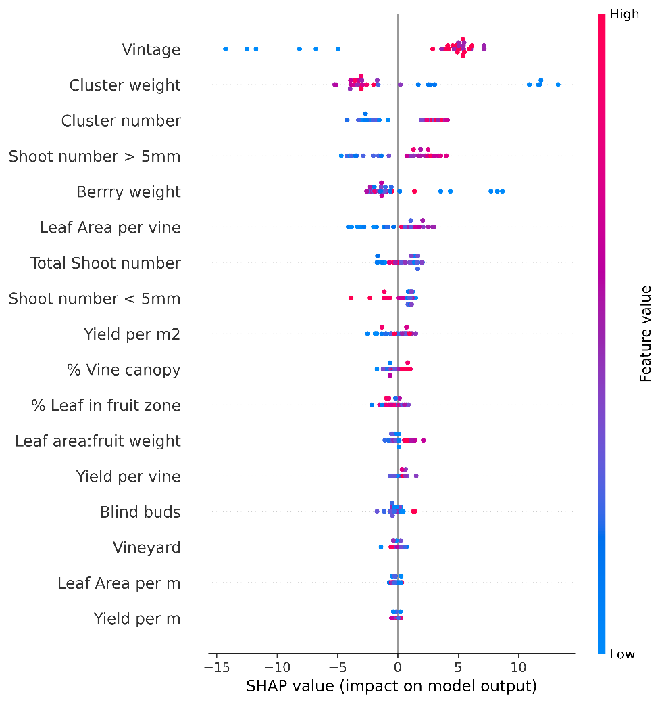

Figure 8: SHAP value summary plot for ammonium level in berry juice

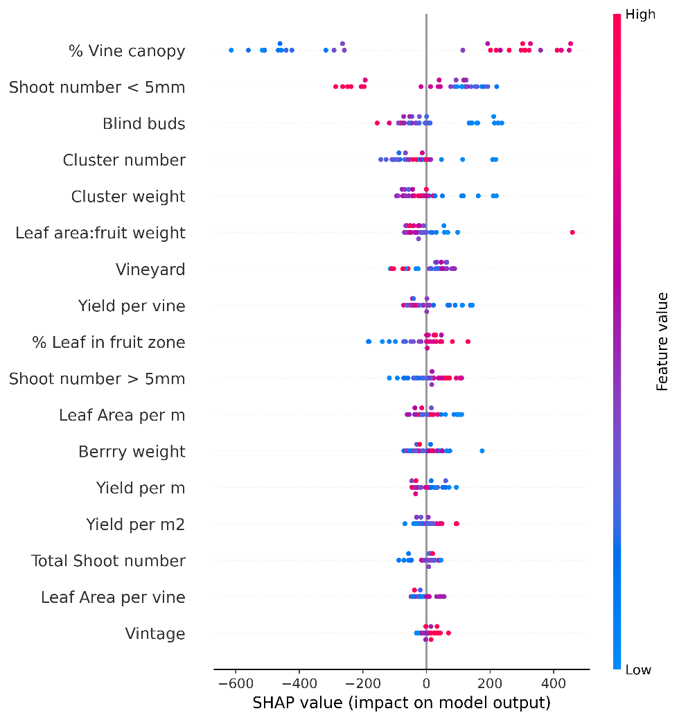

Figure 9: SHAP value summary plot for arginine level in berry juice

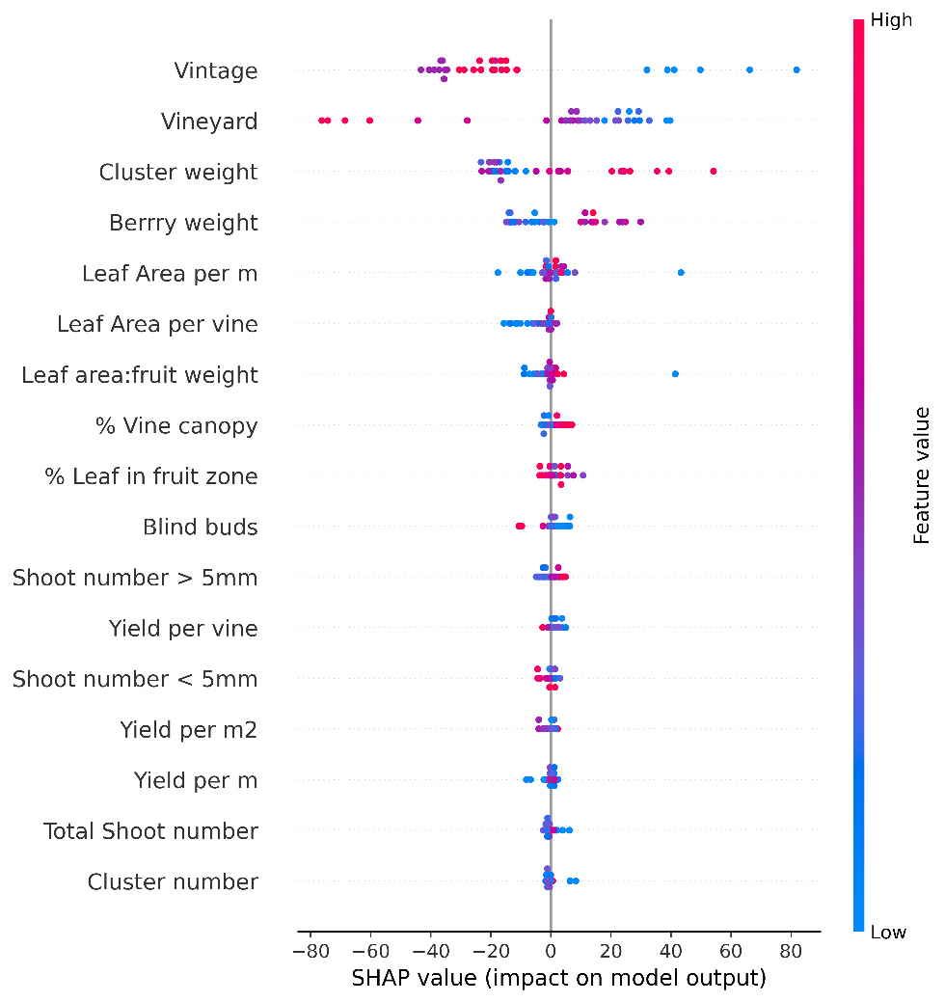

Figure 10: SHAP value summary plot for aspartic acid level in berry juice

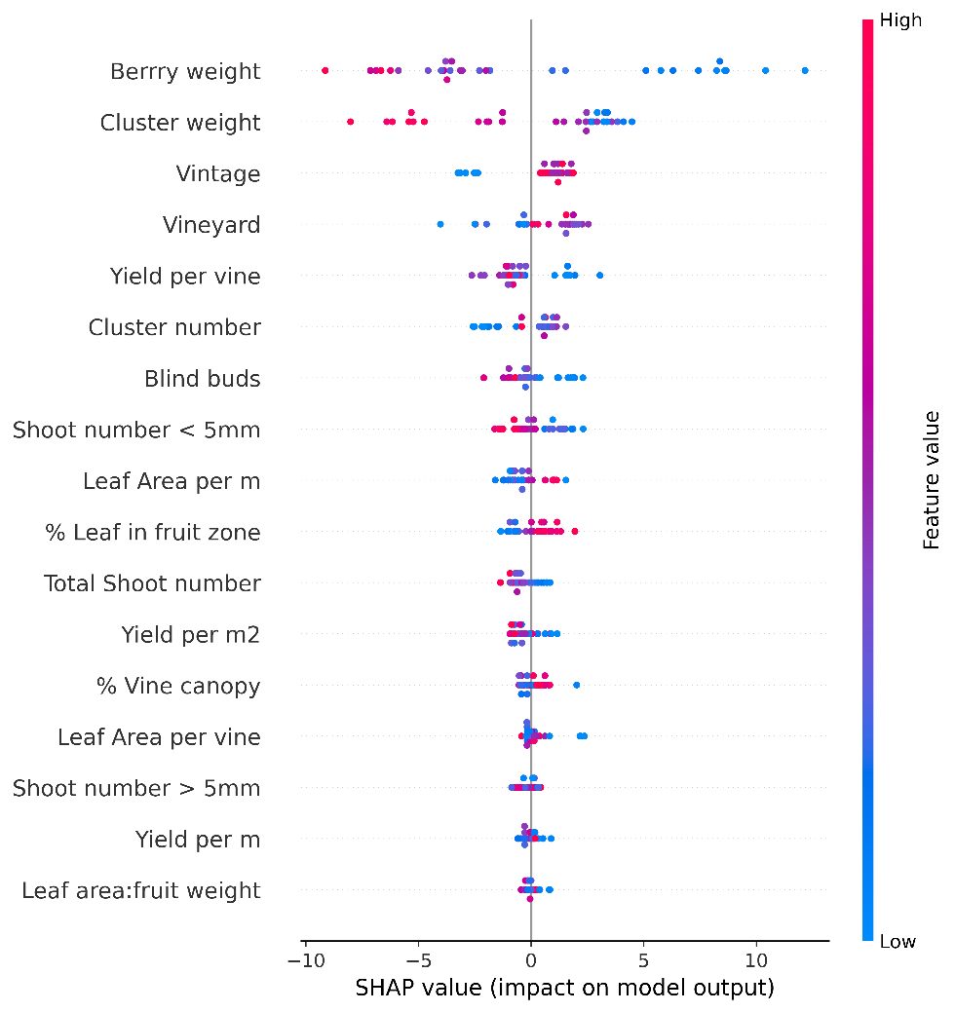

Figure 11: SHAP value summary plot for Calcium level in berry juice

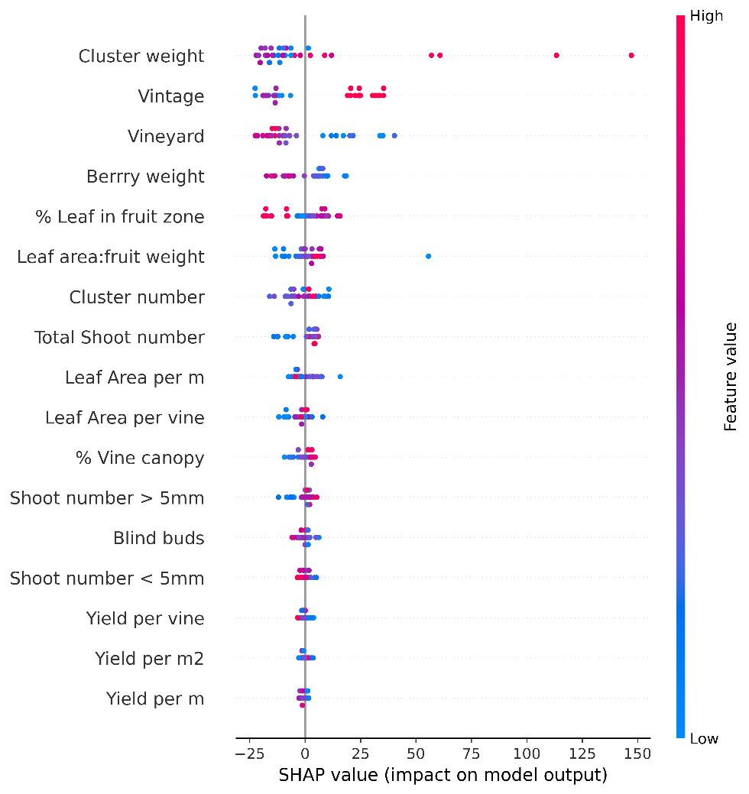

Figure 12: SHAP value summary plot for glutamic acid level in berry juice

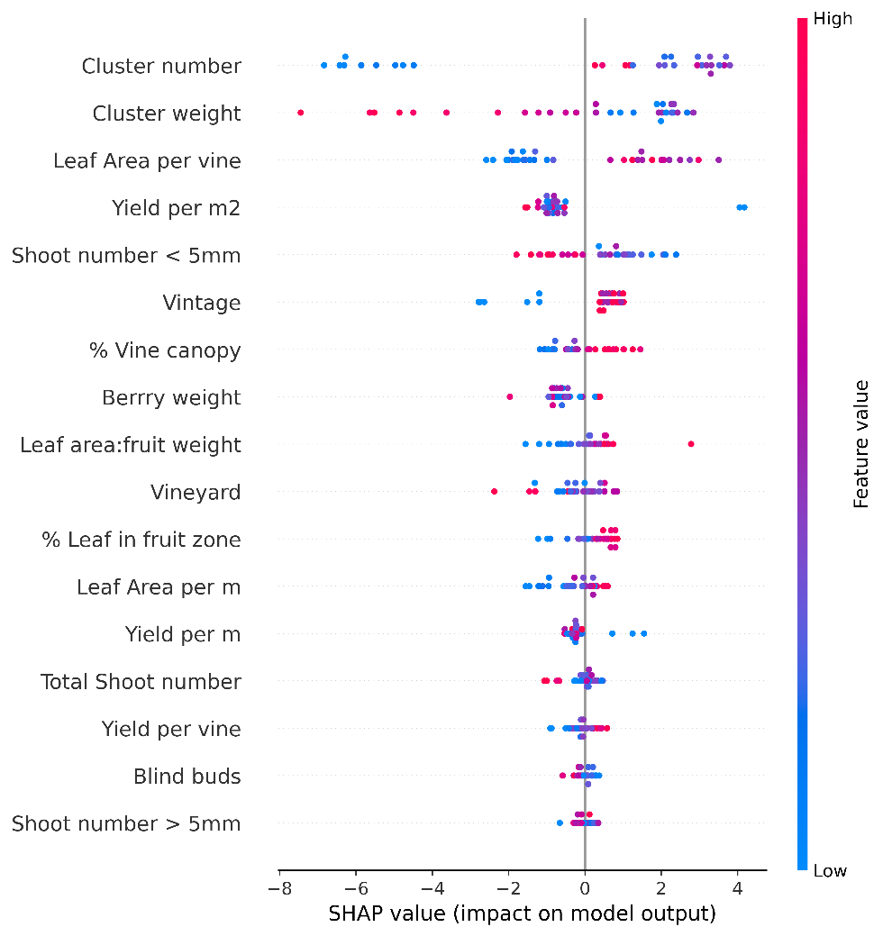

Figure 13: SHAP value summary plot for magnesium level in berry juice

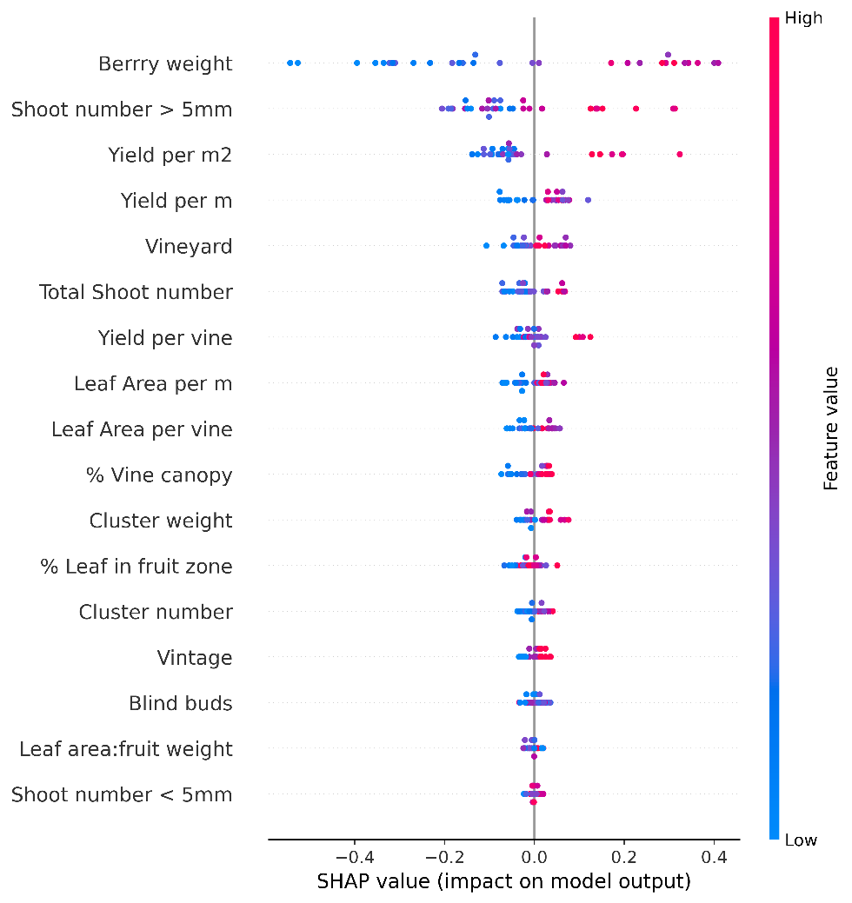

Figure 14: SHAP value summary plot for malic acid level in berry juice

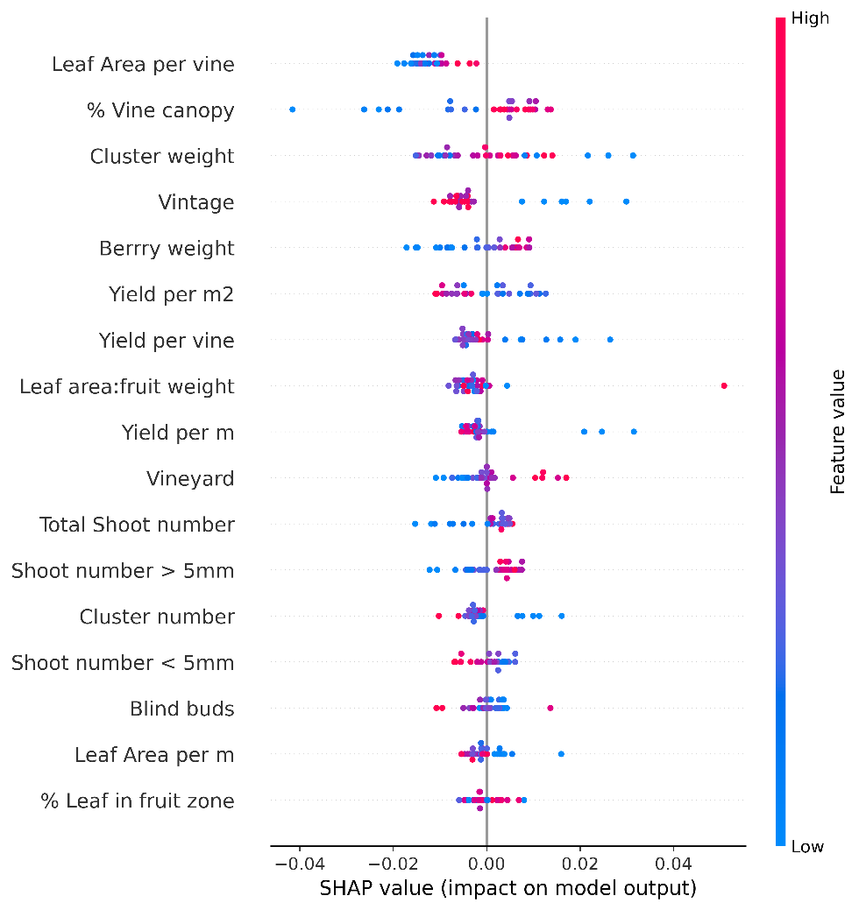

Figure 15: SHAP value summary plot for pH level in berry juice

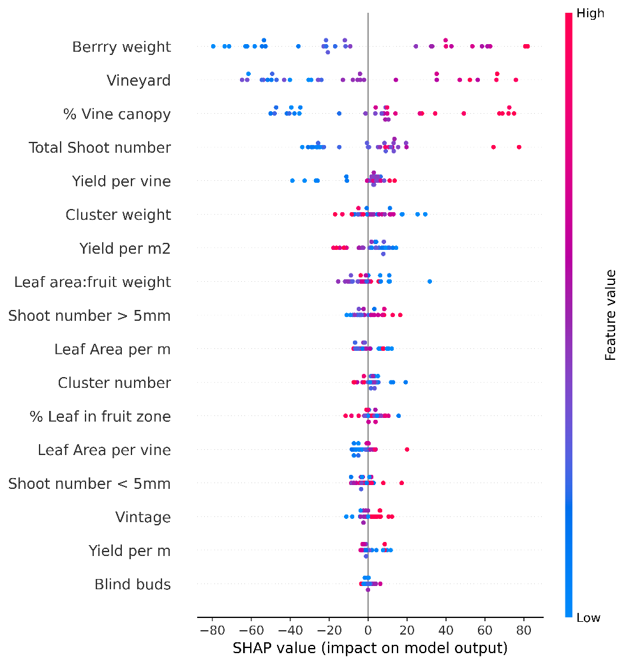

Figure 16: SHAP value summary plot for potassium level in berry juice

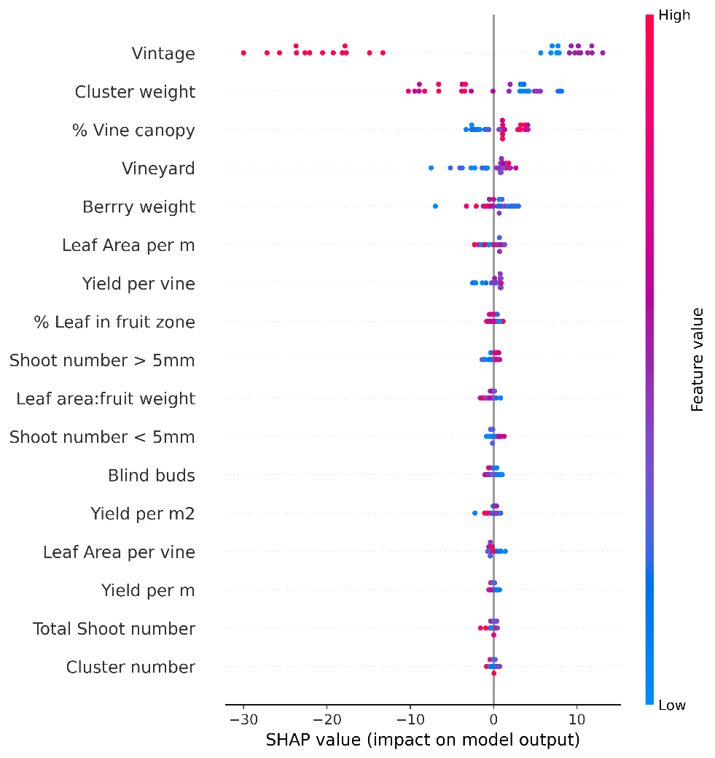

Figure 17: SHAP value summary plot for primary amino acids level in berry juice

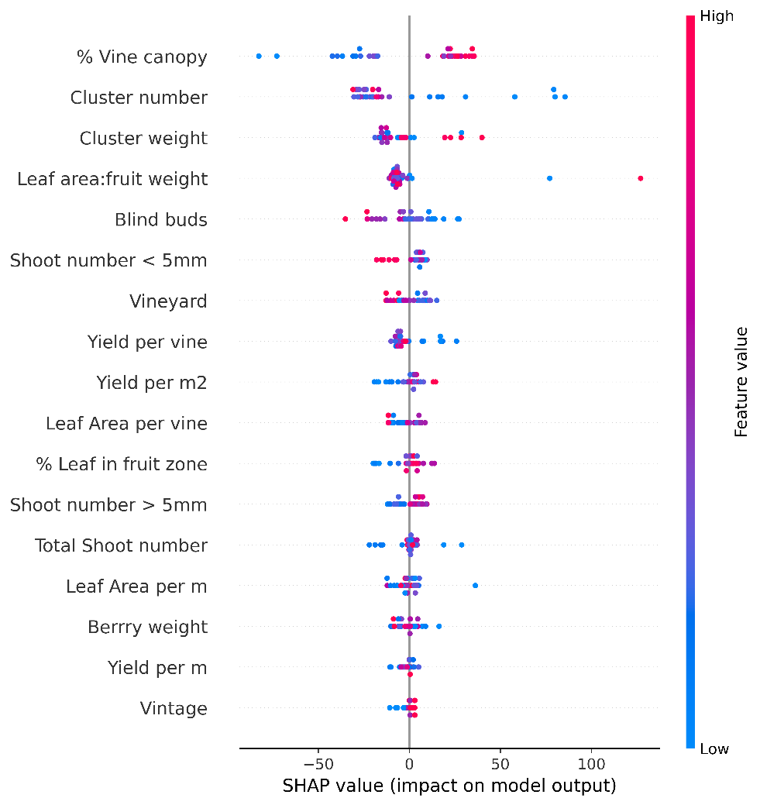

Figure 18: SHAP value summary plot for serine level in berry juice

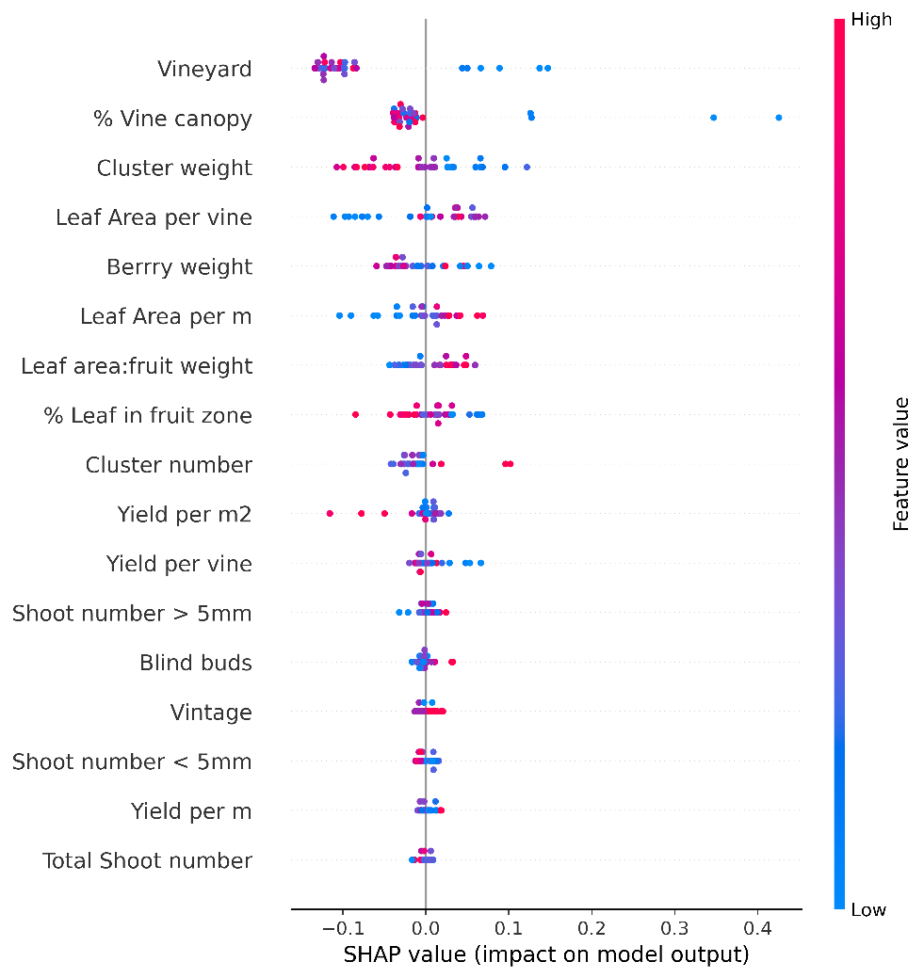

Figure 19: SHAP value summary plot for tartaric acid level in berry juice

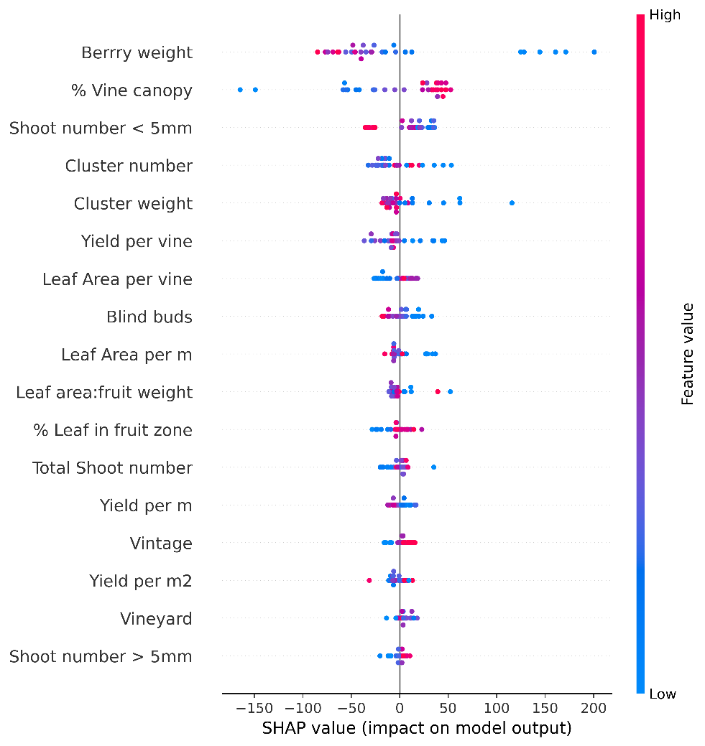

Figure 20: SHAP value summary plot for threonine level in berry juice

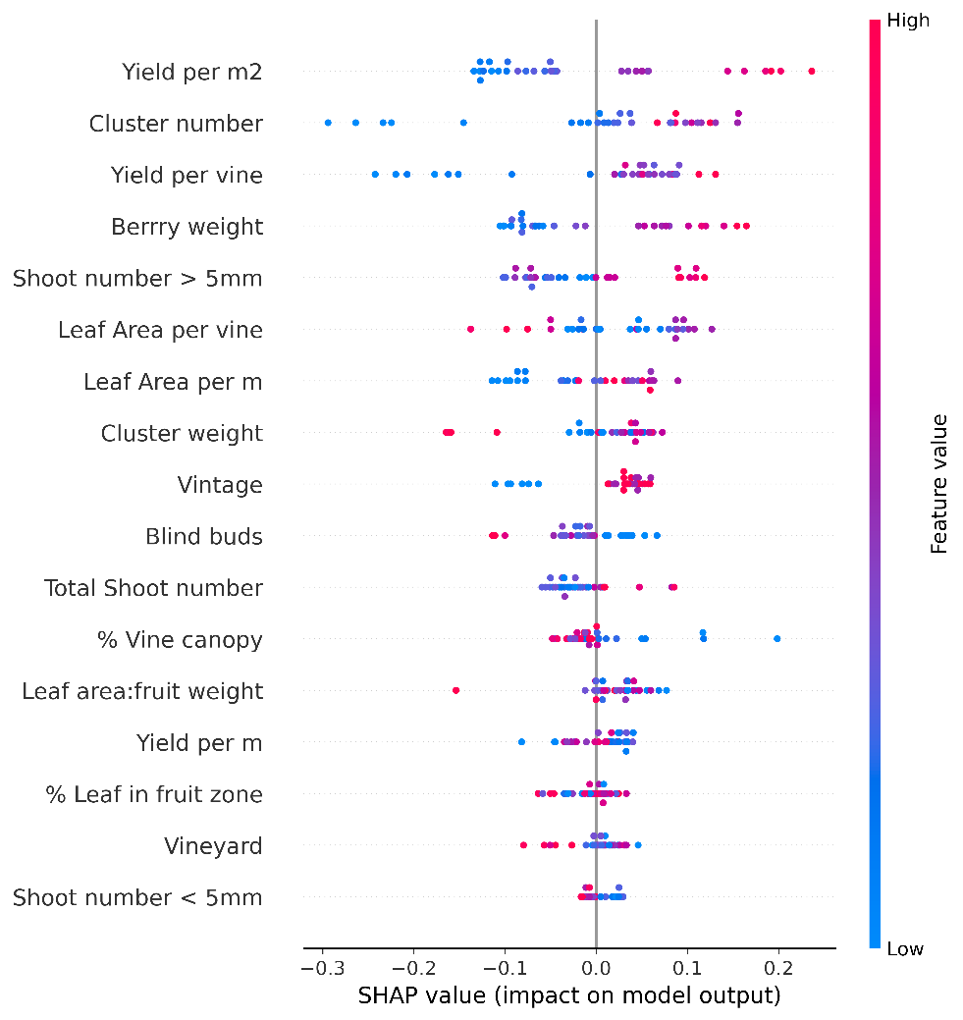

Figure 21: SHAP value summary plot for titratable acidity level in berry juice

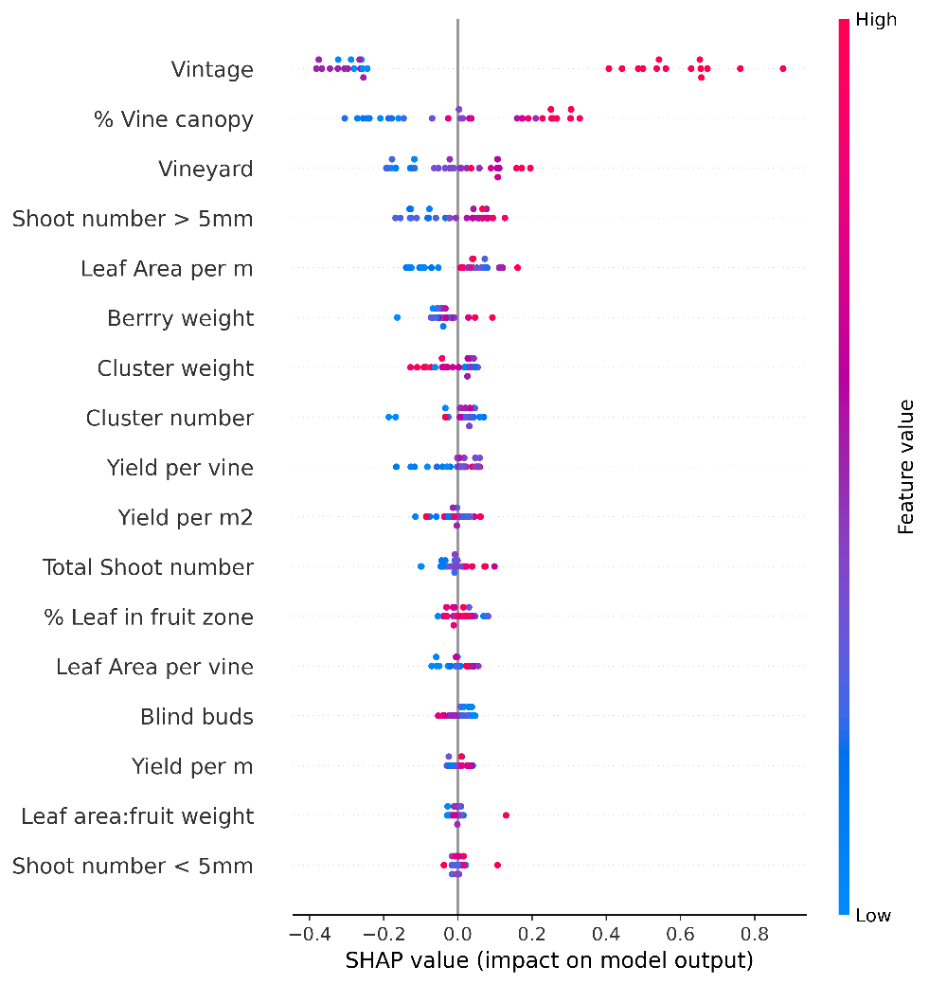

Figure 22: SHAP value summary plot for total soluble solids in berry juice

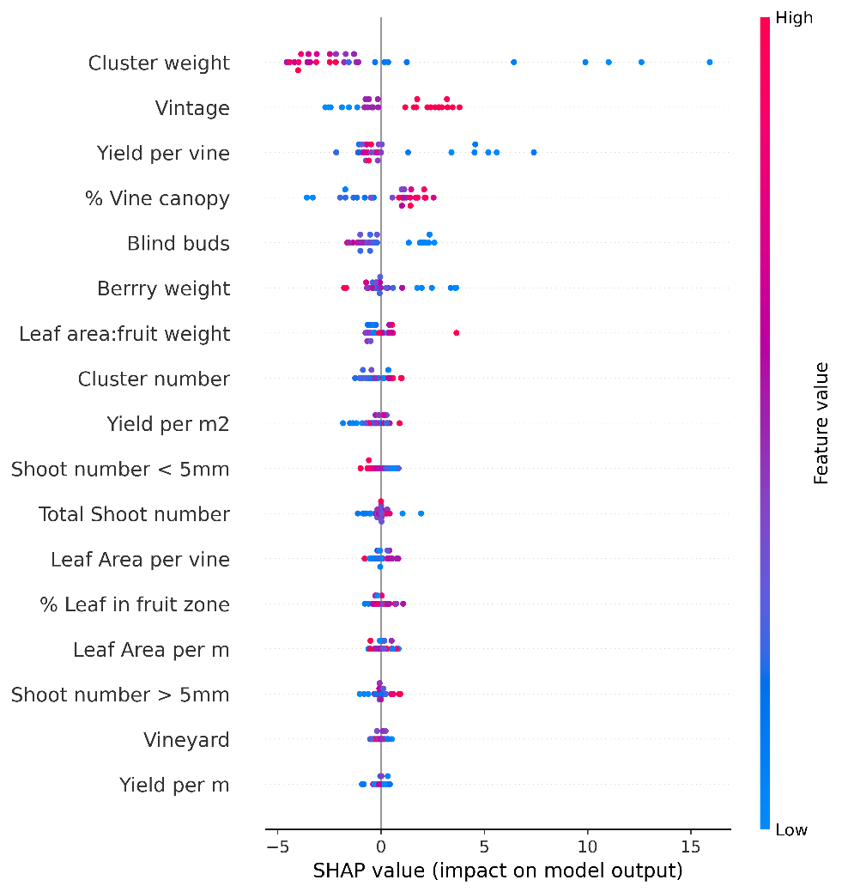

Figure 23: SHAP value summary plot for tyrosine level in berry juice

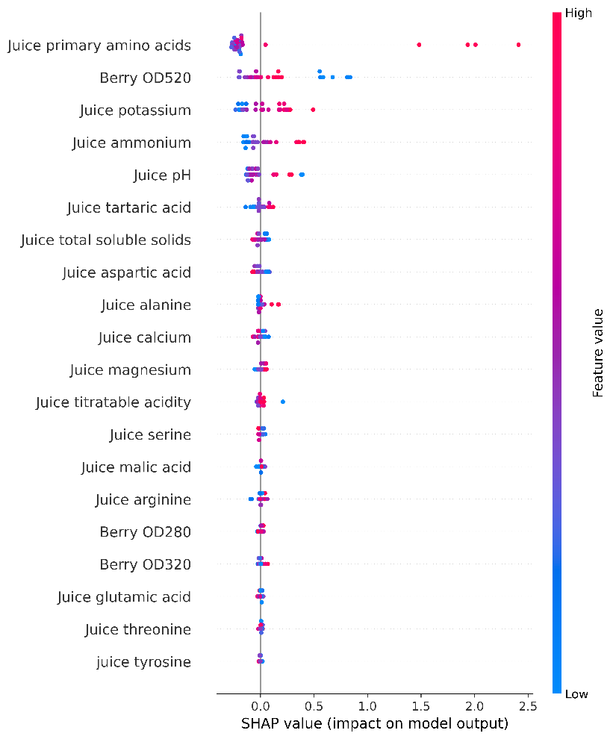

Figure 24: SHAP value summary plot for caffeic acid levels in wine

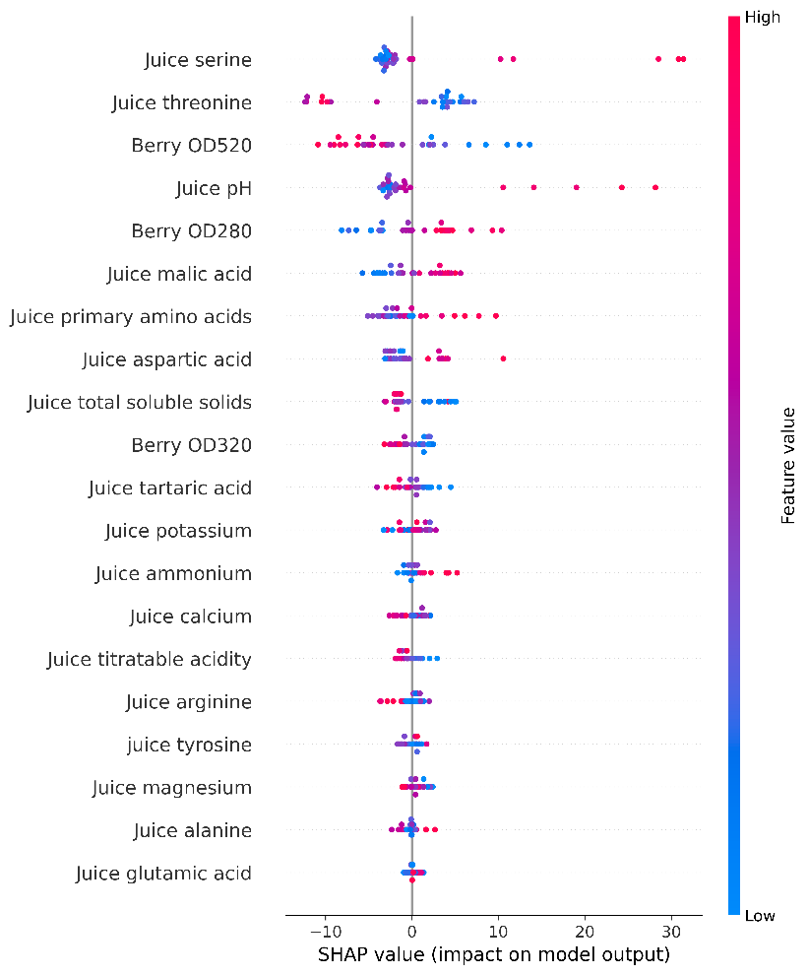

Figure 25: SHAP value summary plot for catechin levels in wine

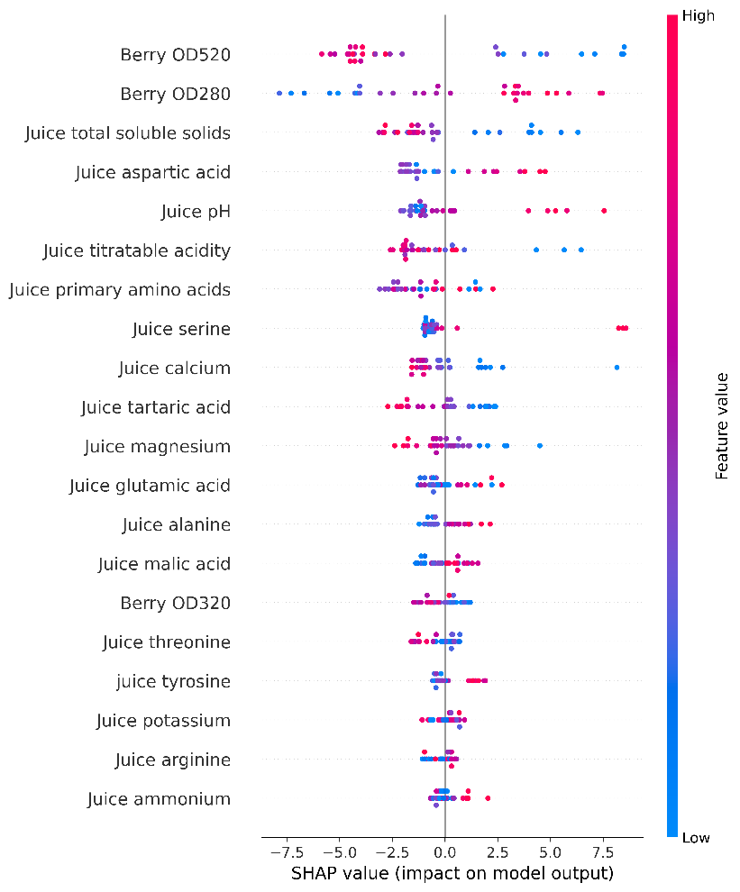

Figure 26: SHAP value summary plot for epicatechin levels in wine

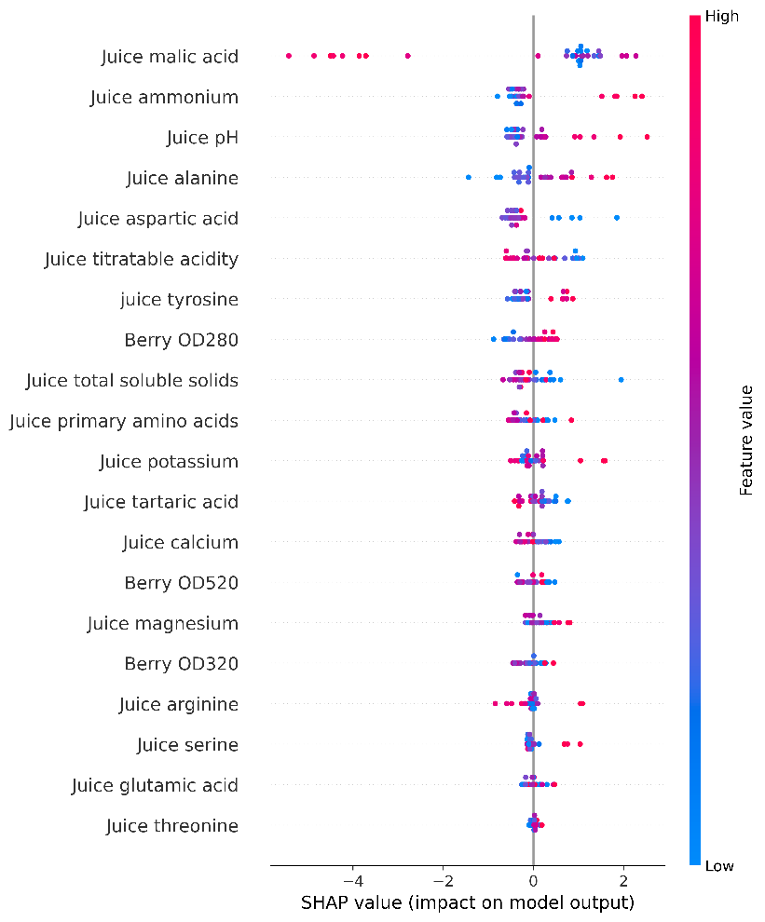

Figure 27: SHAP value summary plot for gallic acid levels in wine

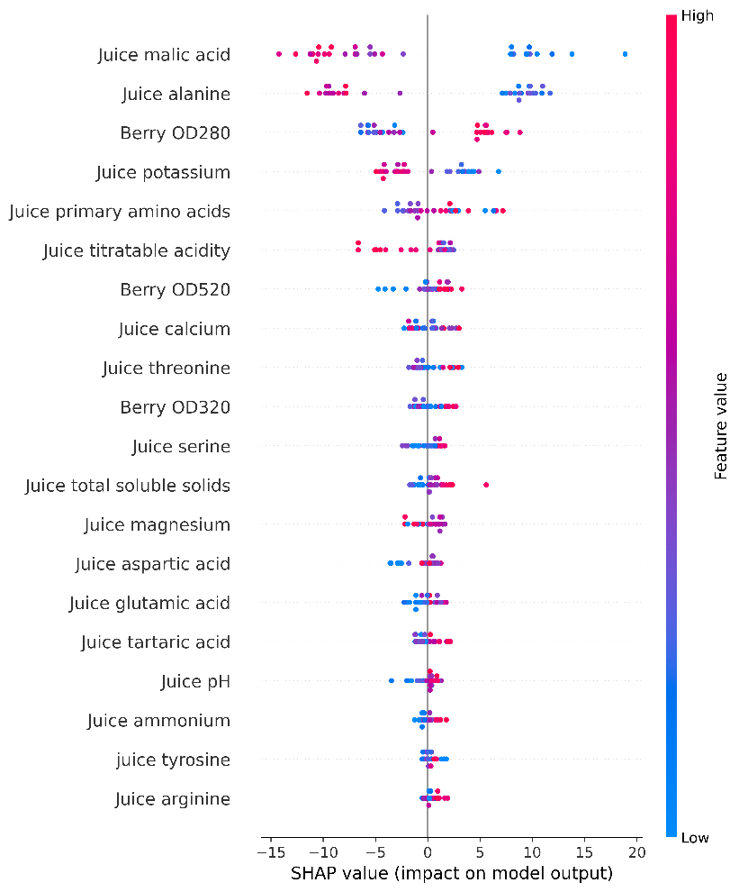

Figure 28: SHAP value summary plot for Malvidin 3-glucoside levels in wine

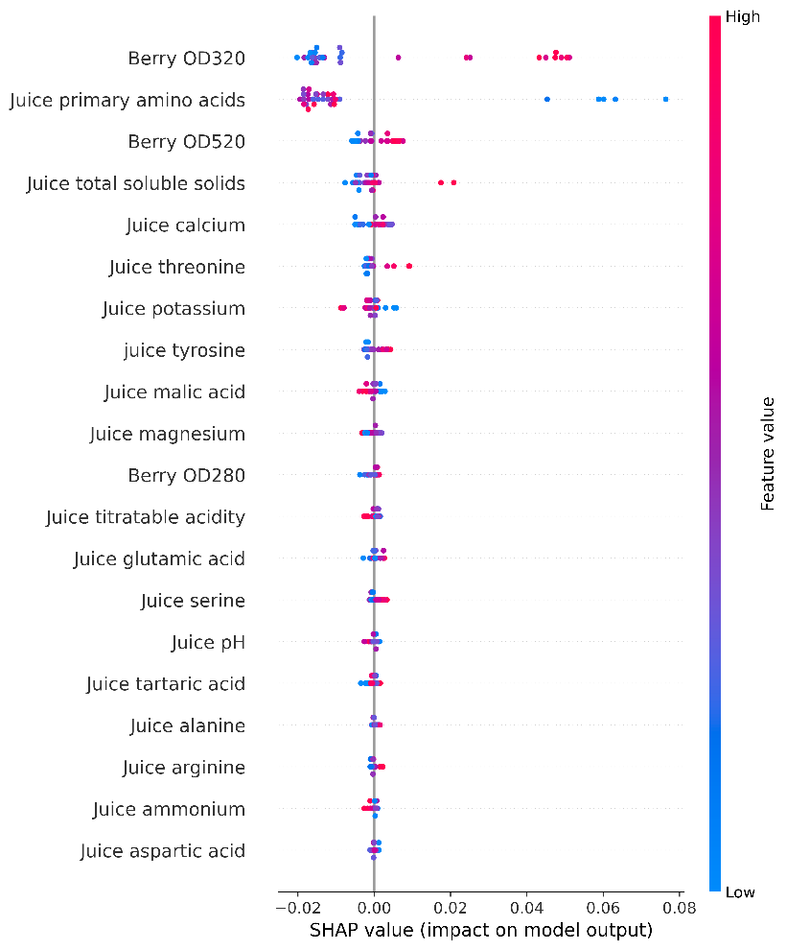

Figure 29: SHAP value summary plot for Mark to wine ratio in wine

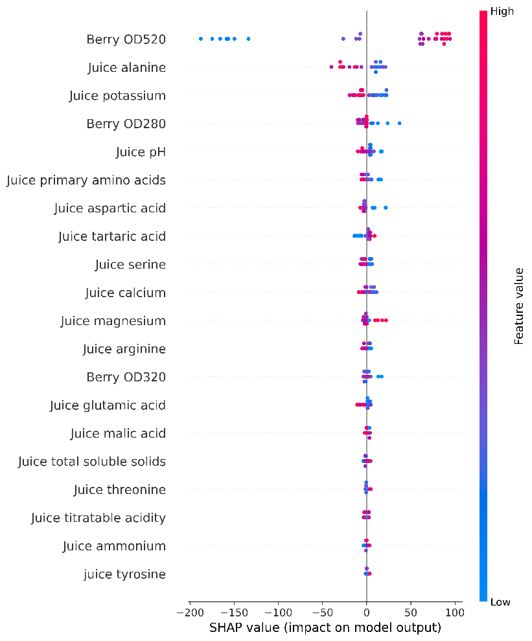

Figure 30: SHAP value summary plot for polymeric anthocyanin levels in wine

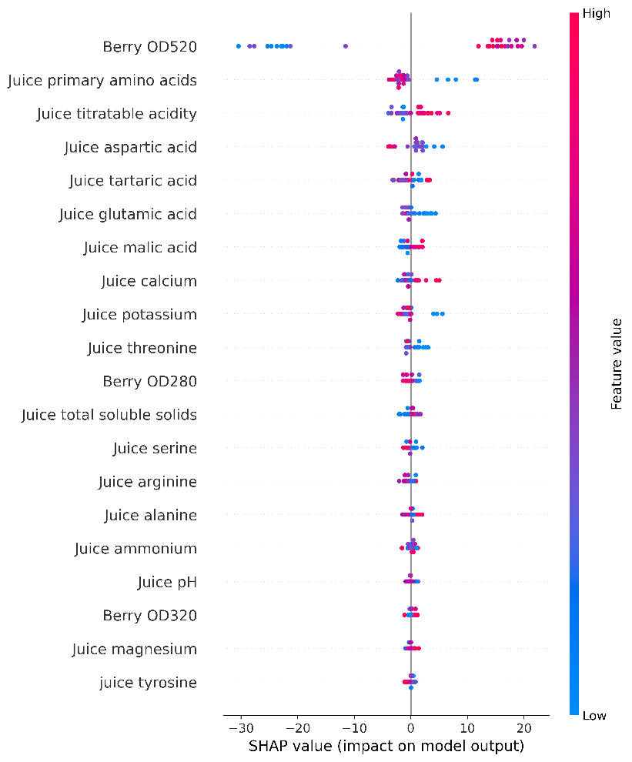

Figure 31: SHAP value summary plot for quercentin-G levels in wine

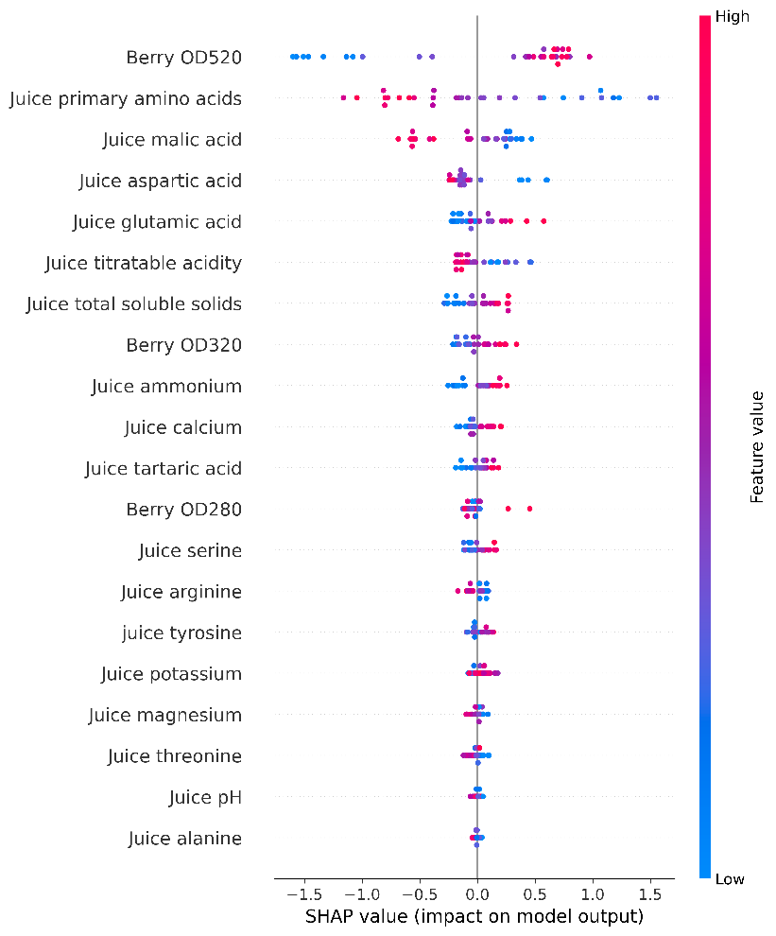

Figure 32: SHAP value summary plot for resveratrol levels in wine

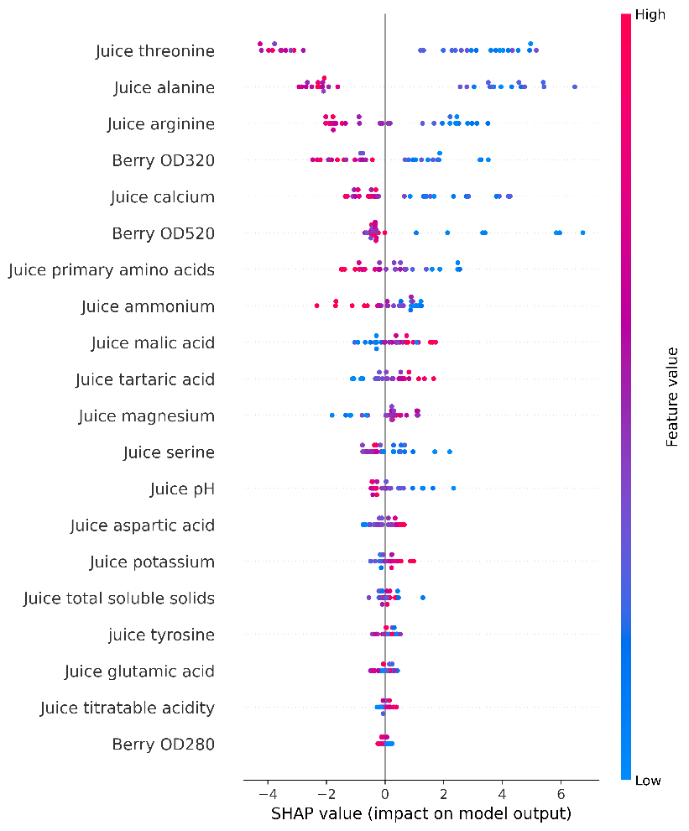

Figure 33: SHAP value summary plot for trans caftaric acid levels in wine

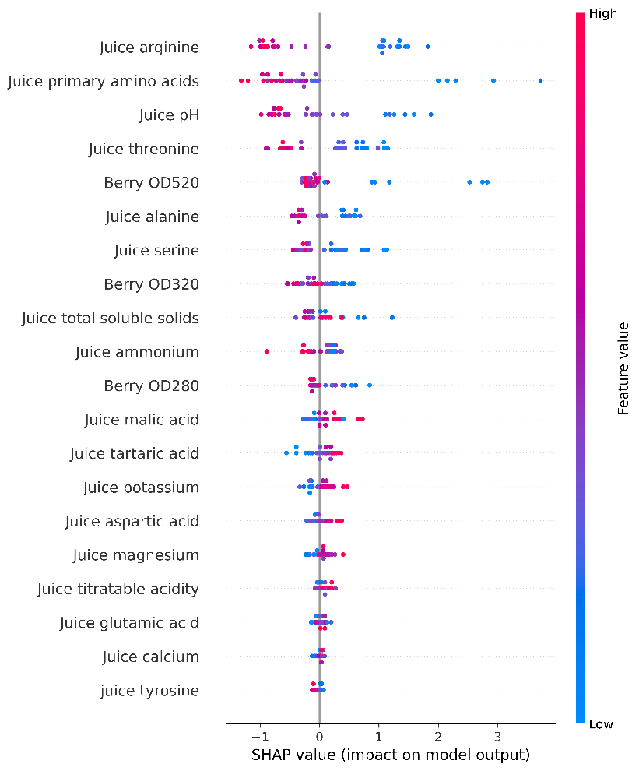

Figure 34: SHAP value summary plot for Trans-coutaric acid levels in wine

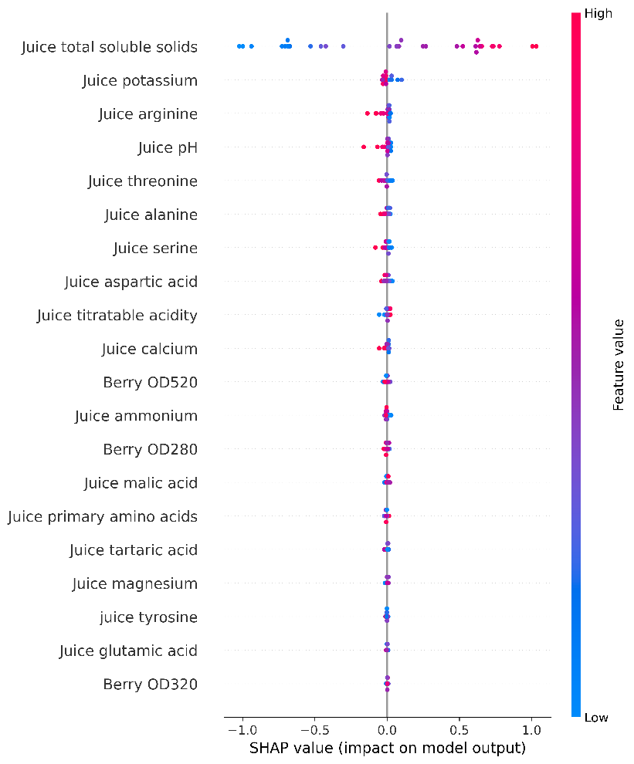

Figure 35: SHAP value summary plot for alcohol levels in wine

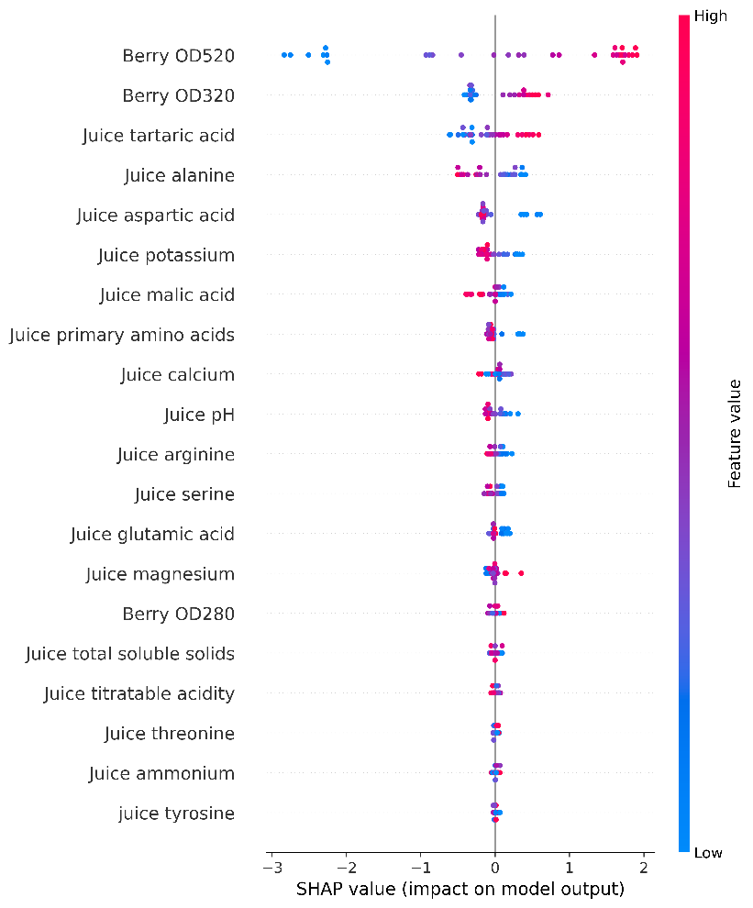

Figure 36: SHAP value summary plot for color density levels in wine

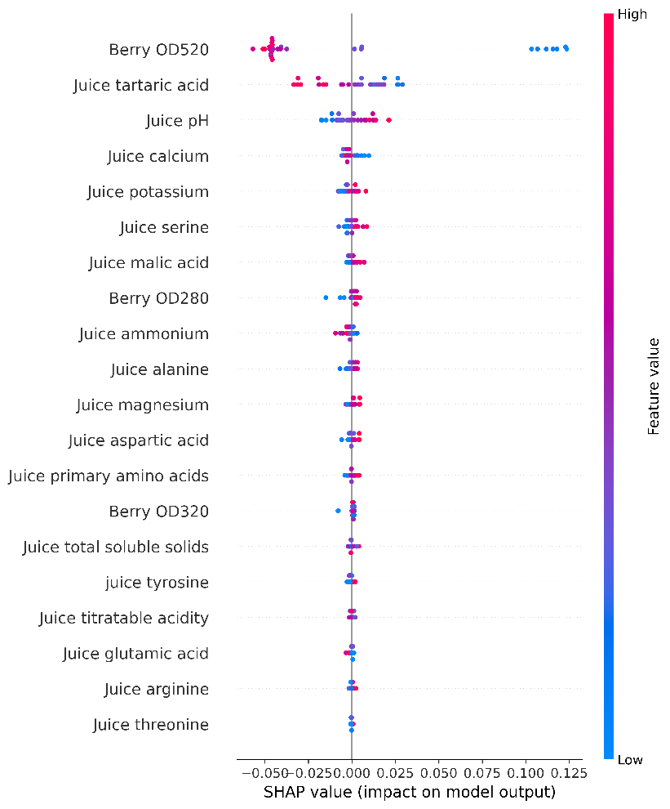

Figure 37: SHAP value summary plot for hue of wine

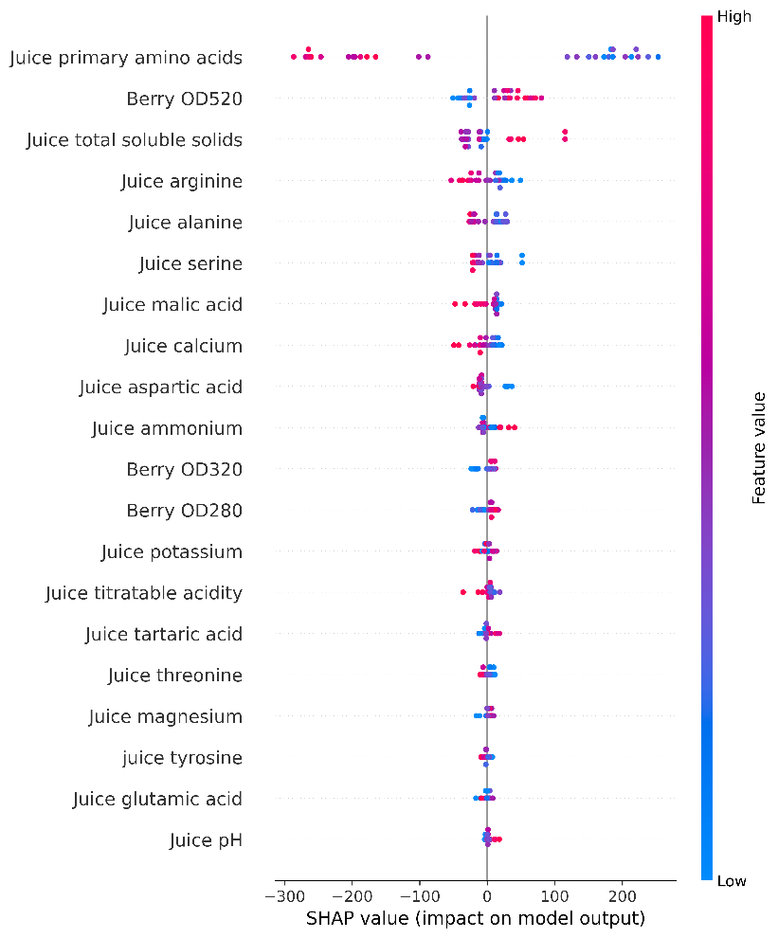

Figure 38: SHAP value summary plot for methyl cellulose precipitable tannins levels in wine

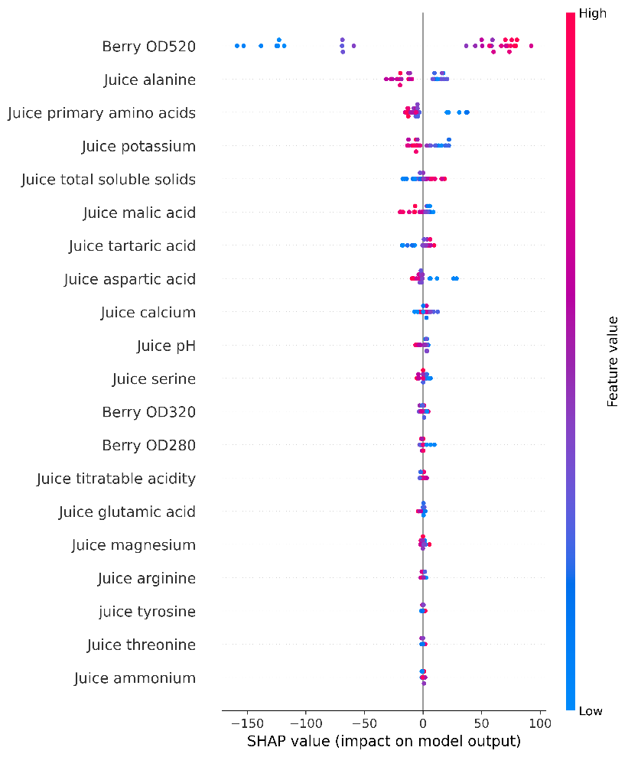

Figure 39: SHAP value summary plot for monomeric anthocyanin levels in wine

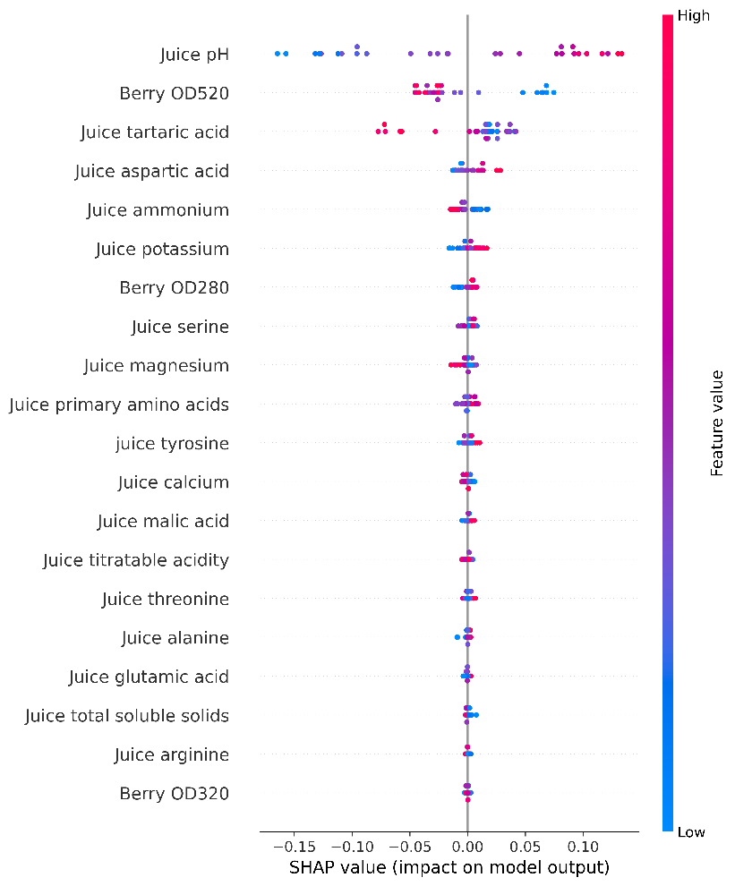

Figure 40: SHAP value summary plot for pH value in wine

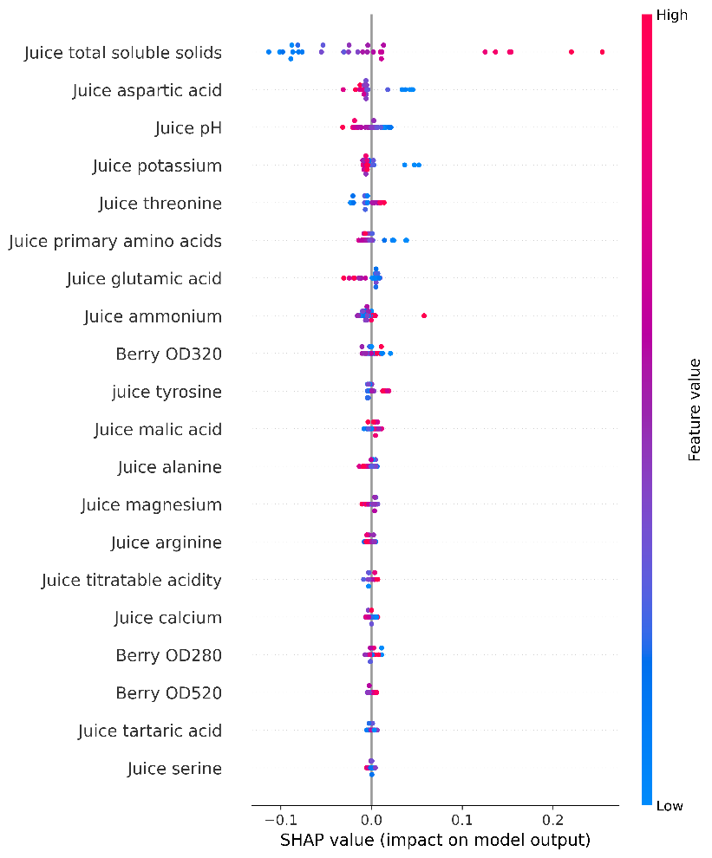

Figure 41: SHAP value summary plot for residual sugar levels in wine

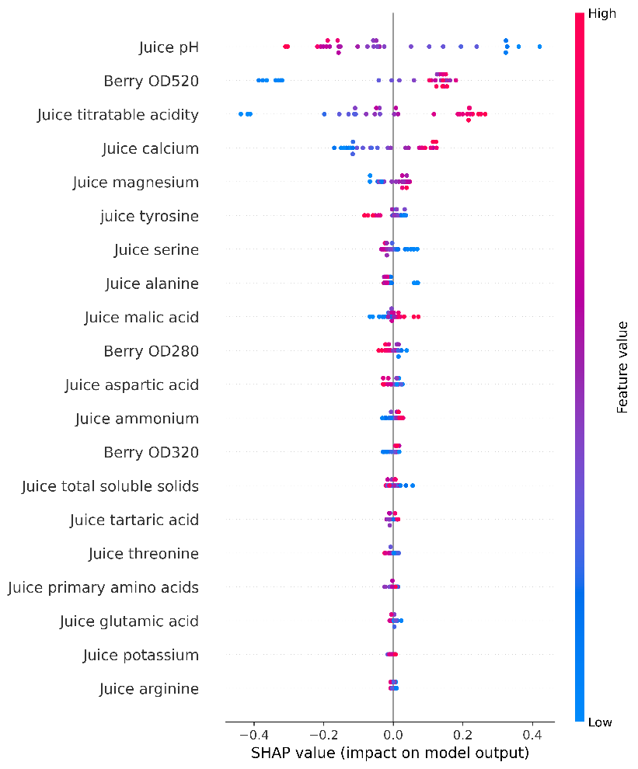

Figure 42: SHAP value summary plot for titratable acidity levels in wine

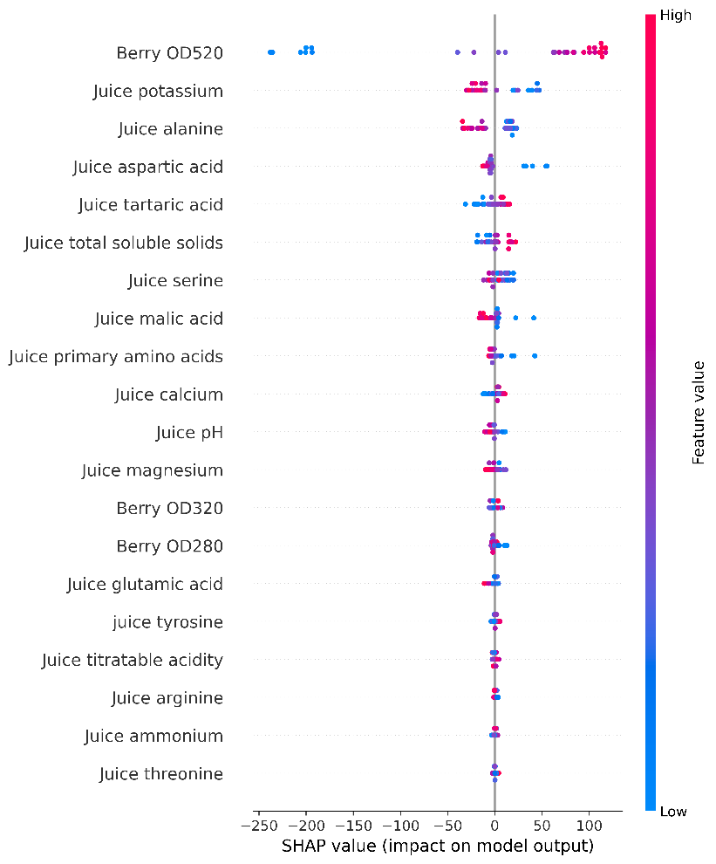

Figure 43: SHAP value summary plot for total anthocyanin levels in wine

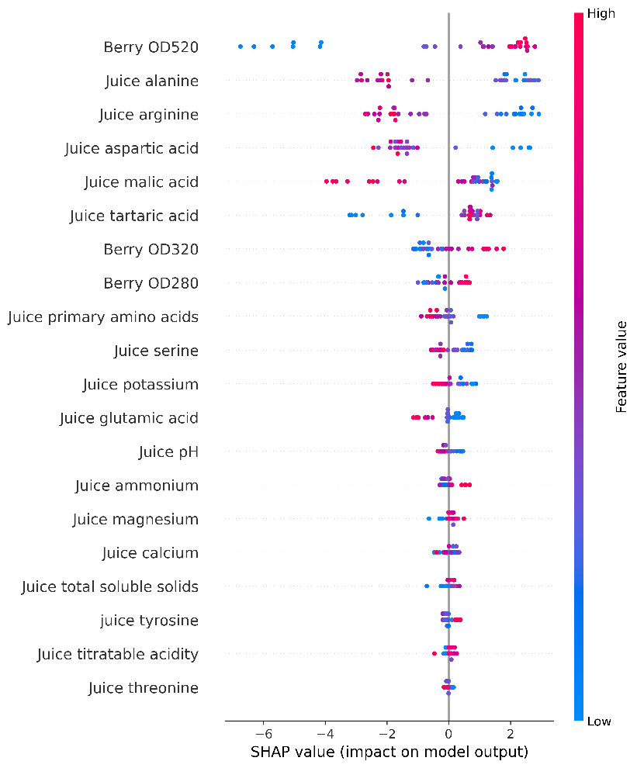

Figure 44: SHAP value summary plot for total phenolic levels in wine

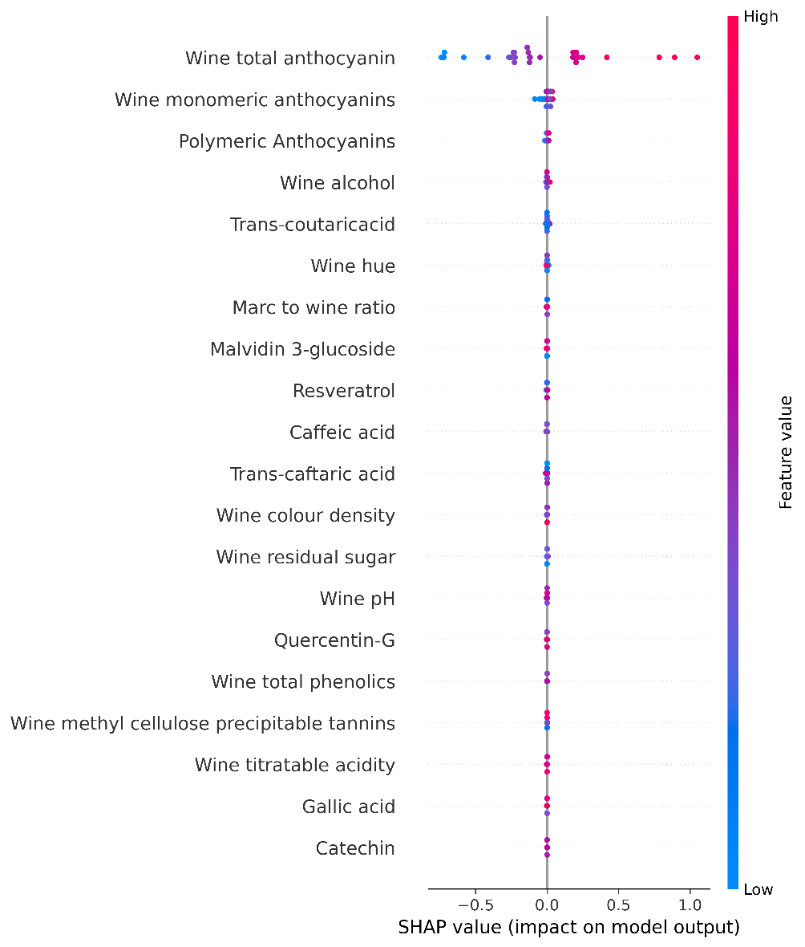

Figure 45: SHAP value summary plot for the quali

A2: Log normal transformations of inputs and exponential transformations for outputs of the four models

Model 1 Inputs:

$$x1=\ln{\frac{x1}{10}+1}$$

$$x2=\ln{\frac{x2}{50}+1}$$

$$x3=\ln{\frac{x3}{10}+1}$$

$$x4=\ln{\frac{x4}{10}+5}$$

Model 1 Outputs:

$$y1={(e}^{y1}-2)*10$$

$$y2={(e}^{y2}-2)*10$$

$$y3={(e}^{y3}-2)*10$$

Model 2 Inputs:

$$x1=\ln{\frac{x1}{10}+1}$$

$$x2=\ln{\frac{x2}{20}+20}$$

$$x3=\ln{\frac{x3}{10}+1}$$

$$x4=\ln{x4+2}$$

$$x5=\ln{\frac{x5}{1000}+10}$$

$$x6=\ln{x6+2}$$

Model 2 Outputs:

$$y1={(e}^{y1}-1)$$

$$y2={(e}^{y2}-1)$$

$$y3=y3$$

$$y4=e^{y4}$$

$$y5=e^{y5}$$

$$y6={(e}^{y6})*100$$

$$y7={(e}^{y7}-1)*10$$

$$y8=e^{y8}$$

$$y9=e^{y9}*10$$

$$y10=e^{y10}+6$$

$$y11={(e}^{y11}-2)*100$$

$$y12={(e}^{y12}-2)*1000$$

$y13={(e}^{y13}-2)*10$ 0

$$y14=e^{y14}$$

Model 3 Inputs:

$$x1=\ln{\frac{x1}{10}+1}$$

$$x2=\ln{x2+1}$$

$$x3=\ln{x3+2}$$

$$x4=\ln{\frac{x4}{10}}$$

$$x5=\ln{x5}$$

$$x6=\ln{\frac{x6}{100}}$$

$$x7=\ln{x7+1}$$

$$x8=\ln{x8}$$

$$x9=\ln{\frac{x9}{100}+1}$$

$$x10=\ln{\frac{x10}{1000}+1}$$

$$x11=\ln{\frac{x11}{1000}+1}$$

$$x12=\ln{\frac{x12}{1000}+2}$$

$$x13=\ln{\frac{x13}{200}+2}$$

Model 3 Outputs:

$$y1=e^{y1}$$

$$y2=e^{y2}$$

$$y3=e^{y3}*4$$

$$y4={(e}^{y4}-1)*500$$

$$y5={(e}^{y5}-1)*20$$

Model 4 Inputs:

$$x1=\ln{\frac{x1}{10}}$$

$$x2=\ln{x2}$$

$$x3=\ln{\frac{x3}{100}}$$

$$x4=\ln{\frac{x4}{100}}$$

$$x5=\ln{\frac{x5}{10}}$$

Model 4 Output:

$$y1=e^{y1}+1$$

USER manual for the Web application

Open any browser:

Chrome | Google Blog Microsoft Edge: Web Browser – Apps on Google Play 

Go to this URL:

<https://somin-s-wineprediction-app-ewbkrm.streamlitapp.com/>

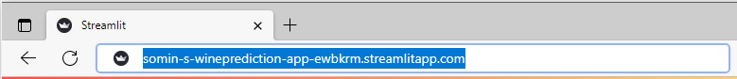

Arrange six input parameters:

Users input six wine features via the side panels. Remark: System sets average values for the parameters as the default value.

Output:

Three charts present predicted quality and value based on input wine features. The charts contain three types of data: yield per wine, yield per metre and yield per square metre in kilograms. The faceted chart separately presents the three types of data while the bigger chart present comparative information.

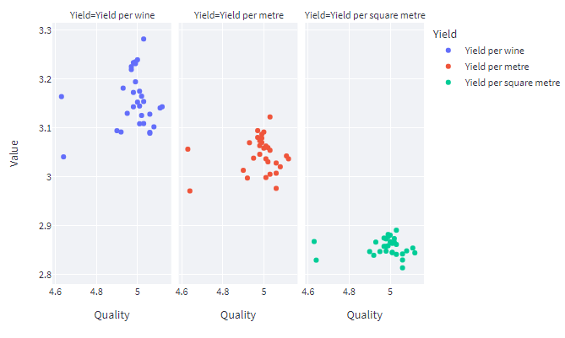

Click checkbox to show 20-sample data following the input parameters.



