Supplementary Data

Table 1. Results of DENV diagnostic tests. In this table is shown the information regarding to diagnostic tests of the samples and (Serology, RT-qPCR), copies number and Ct, DENV serotype and COMB-RT-LAMP results.
Code | Serology | RT-qPCR | CT | Copies number | Serotype | LAMP
DENV-CGN-001 | IgM (+) | POSITIVE | 21,14 | 57844659,59 | 1 | POSITIVE
DENV-CGN-002 | IgM (+) | POSITIVE | 22,44 | 19117139,47 | 2 | POSITIVE
DENV-CGN-003 | IgM (+) | POSITIVE | 27,09 | 364329,1538 | 2 | POSITIVE
DENV-CGN-004 | IgM (+) | POSITIVE | 30,09 | 28304,94548 | 2 | POSITIVE
DENV-CGN-005 | IgM (+) | POSITIVE | 30,11 | 27826,89689 | 1 | POSITIVE
DENV-CGN-006 | IgM (+) | POSITIVE | 18,03 | 817676213,2 | 1 | POSITIVO
DENV-CGN-007 | IgM (+) | POSITIVE | 23,45 | 8088107,89 | 1 | POSITIVE
DENV-CGN-008 | IgM (+) | POSITIVE | 27,09 | 364329,1538 | 2 | POSITIVE
DENV-CGN-009 | IgM (+) | POSITIVE | 23,39 | 8512155,876 | 1 | POSITIVE
DENV-CGN-010 | IgM (+) | POSITIVE | 31,77 | 6768,128964 | 2 | POSITIVE
DENV-CGN-011 | IgM (+) | POSITIVE | 29,54 | 45216,27517 | 1 | POSITIVE
DENV-CGN-012 | IgM (+) | POSITIVE | 30,25 | 24699,14789 | 1 | POSITIVE
DENV-CGN-013 | IgM (+) | NEGATIVE | N.A | N.A | N.A | NEGATIVE
DENV-CGN-014 | IgM (+) | POSITIVE | 20,88 | 72182403,98 | 1 | POSITIVE
DENV-CGN-015 | IgM (+) | POSITIVE | 20,14 | 135562781,3 | 2 | POSITIVE
DENV-CGN-016 | IgM (+) | POSITIVE | 23,62 | 6997901,282 | 1 | POSITIVE
DENV-CGN-017 | IgM (+) | POSITIVE | 27,58 | 240023,6837 | 1 | POSITIVE
DENV-CGN-018 | IgM (+) | POSITIVE | 29,65 | 41172,59981 | 1 | POSITIVE
DENV-CGN-019 | IgM (+) | POSITIVE | 30,03 | 29788,93349 | 1 | NEGATIVE
DENV-CGN-020 | IgM (+) | POSITIVE | 31,44 | 8964,541905 | 1 | NEGATIVE
DENV-CGN-021 | IgM (+) | POSITIVE | 24,32 | 3855260,877 | 1 | POSITIVE
DENV-CGN-022 | IgM (+) | NEGATIVE | N.A | NA | N.A | NEGATIVE
DENV-CGN-023 | IgM (+) | NEGATIVE | N.A | N.A | N.A | NEGATIVE
DENV-CGN-024 | IgM (+) | NEGATIVE | N.A | NA | N.A | NEGATIVE
DENV-CGN-025 | IgM (+) | NEGATIVE | N.A | NA | N.A | NEGATIVE
DENV-CGN-026 | IgM (+) | POSITIVE | 34,23 | 832,8575203 | 1 | NEGATIVE
DENV-CGN-027 | IgM (+) | POSITIVE | 28,14 | 148978,2486 | 1 | POSITIVE
DENV-CGN-028 | IgM (+) | POSITIVE | 26,92 | 421088,1783 | 1 | POSITIVE
DENV-CGN-029 | IgM (+) | POSITIVE | 24,85 | 2454815,488 | 2 | POSITIVE
DENV-CGN-030 | IgM (+) | POSITIVE | 27,93 | 178154,6148 | 1 | POSITIVE
DENV-CGN-031 | IgM (+) | POSITIVE | 27,47 | 263597,0762 | 1 | POSITIVE
DENV-CGN-032 | IgM (+) | POSITIVE | 26,54 | 582004,5575 | 1 | POSITIVE
DENV-CGN-033 | NS1 (+) | POSITIVE | 26,87 | 439406,9373 | 4 | POSITIVE
DENV-CGN-034 | NS1 (+) | NEGATIVE | N.A | NA | N.A | NEGATIVE
DENV-CGN-035 | NS1 (+) | POSITIVE | 29,89 | 33561,22179 | 4 | POSITIVE
DENV-CGN-036 | NS1 (+) | NEGATIVE | N.A | NA | N.A | NEGATIVE
DENV-CGN-037 | NS1 (+) | NEGATIVE | N.A | NA | N.A | NEGATIVE
DENV-CGN-038 | NS1 (+) | POSITIVE | 31,68 | 7307,3107 | 3 | NEGATIVE
DENV-CGN-039 | NS1 (+) | POSITIVE | 33,03 | 2314,319702 | 1 | NEGATIVE
DENV-CGN-040 | NS1 (-) | NEGATIVE | N.A | NA | N.A | NEGATIVE
DENV-CGN-041 | NS1 (-) | NEGATIVE | N.A | NA | N.A | NEGATIVE
DENV-CGN-042 | NS1 (-) | NEGATIVE | N.A | NA | N.A | NEGATIVE
DENV-CGN-043 | NS1 (-) | NEGATIVE | N.A | NA | N.A | NEGATIVE
DENV-CGN-044 | NS1 (-) | NEGATIVE | N.A | NA | N.A | NEGATIVE
DENV-CGN-045 | NS1 (-) | NEGATIVE | N.A | NA | N.A | NEGATIVE
DENV-CGN-046 | NS1 (-) | NEGATIVE | N.A | NA | N.A | NEGATIVE
DENV-CGN-047 | NS1 (-) | NEGATIVE | N.A | NA | N.A | NEGATIVE
DENV-CGN-048 | NS1 (-) | NEGATIVE | N.A | NA | N.A | NEGATIVE
DENV-CGN-049 | NS1 (-) | NEGATIVE | N.A | NA | N.A | NEGATIVE
DENV-CGN-050 | NS1 (-) | NEGATIVE | N.A | NA | N.A | NEGATIVE
DENV-CGN-051 | NS1 (-) | NEGATIVE | N.A | NA | N.A | NEGATIVE
DENV-CGN-052 | NS1 (-) | NEGATIVE | N.A | NA | N.A | NEGATIVE
DENV-CGN-053 | IgM (+) | NEGATIVE | N.A | NA | N.A | NEGATIVE
DENV-CGN-054 | IgM (+) | NEGATIVE | N.A | NA | N.A | NEGATIVE
DENV-CGN-055 | IgM (+) | NEGATIVE | N.A | NA | N.A | NEGATIVE
DENV-CGN-056 | IgM (+) | NEGATIVE | N.A | NA | N.A | NEGATIVE
DENV-CGN-057 | IgM (+) | NEGATIVE | N.A | NA | N.A | NEGATIVE
DENV-CGN-058 | IgM (+) | NEGATIVE | N.A | NA | N.A | NEGATIVE
DENV-CGN-059 | IgM (+) | NEGATIVE | N.A | NA | N.A | NEGATIVE
DENV-CGN-060 | IgM (+) | NEGATIVE | N.A | NA | N.A | NEGATIVE
DENV-CGN-061 | IgM (+) | NEGATIVE | N.A | NA | N.A | NEGATIVE
DENV-CGN-062 | IgM (+) | NEGATIVE | N.A | NA | N.A | NEGATIVE
DENV-CGN-063 | IgM (+) | NEGATIVE | N.A | NA | N.A | NEGATIVE
DENV-CGN-064 | IgM (+) | NEGATIVE | N.A | NA | N.A | NEGATIVE
DENV-CGN-065 | IgM (+) | NEGATIVE | N.A | NA | N.A | NEGATIVE
DENV-CGN-066 | IgM (-) | NEGATIVE | N.A | NA | N.A | NEGATIVE
DENV-CGN-067 | IgM (-) | NEGATIVE | N.A | NA | N.A | NEGATIVE
DENV-CGN-068 | IgM (-) | NEGATIVE | N.A | NA | N.A | NEGATIVE
DENV-CGN-069 | IgM (-) | NEGATIVE | N.A | NA | N.A | NEGATIVE
DENV-CGN-070 | IgM (-) | NEGATIVE | N.A | NA | N.A | NEGATIVE
DENV-CGN-071 | IgM (-) | NEGATIVE | N.A | NA | N.A | NEGATIVE
DENV-CGN-072 | IgM (-) | NEGATIVE | N.A | NA | N.A | NEGATIVE
DENV-CGN-073 | IgM (-) | NEGATIVE | N.A | NA | N.A | NEGATIVE
DENV-CGN-074 | NS1 (-) | NEGATIVE | N.A | NA | N.A | NEGATIVE
DENV-CGN-075 | IgM (+) | NEGATIVE | N.A | NA | N.A | NEGATIVE
DENV-CGN-076 | NS1 (+) | POSITIVE | 23,59 | 7179002,883 | 4 | POSITIVE
DENV-CGN-077 | IgM (-) | NEGATIVE | N.A | N.A | N.A | NEGATIVE
DENV-CGN-078 | IgM (-) | NEGATIVE | N.A | N.A | N.A | NEGATIVE
DENV-CGN-079 | NS1 (+) | POSITIVE | 27,72 | 213044,9718 | 4 | POSITIVE
DENV-CGN-080 | NS1 (-) | NEGATIVE | N.A | N.A | N.A | NEGATIVE
DENV-CGN-081 | NS1 (-) | NEGATIVE | N.A | N.A | N.A | NEGATIVE
DENV-CGN-082 | IgM (+) | NEGATIVE | N.A | N.A | N.A | NEGATIVE
DENV-CGN-083 | NS1 (-) | NEGATIVE | N.A | N.A | N.A | NEGATIVE
DENV-CGN-084 | NS1 (+) | NEGATIVE | N.A | N.A | N.A | NEGATIVE
DENV-CGN-085 | NS1 (-) | NEGATIVE | N.A | N.A | N.A | NEGATIVE
DENV-CGN-086 | IgM (+) | NEGATIVE | N.A | N.A | N.A | NEGATIVE
DENV-CGN-087 | IgM (-) | NEGATIVE | N.A | N.A | N.A | NEGATIVE
DENV-CGN-088 | NS1 (-) | NEGATIVE | N.A | N.A | N.A | POSITIVE
DENV-CGN-089 | IgM (+) | NEGATIVE | N.A | N.A | N.A | NEGATIVE
DENV-CGN-090 | IgM (-) | NEGATIVE | N.A | N.A | N.A | NEGATIVE
DENV-CGN-091 | NS1 (-) | POSITIVE | 32,53 | 3542,924951 | 3 | POSITIVE
DENV-CGN-092 | IgM (-) | POSITIVE | 27,3 | 304662,999 | 4 | POSITIVE
DENV-CGN-093 | NS1 (+) | POSITIVE | 29,58 | 43701,83723 | 1 | POSITIVE
DENV-CGN-094 | IgM (-) | NEGATIVE | N.A | N.A | N.A | NEGATIVE
DENV-CGN-095 | NS1 (-) | POSITIVE | 32,46 | 3760,567227 | 2 | POSITIVE
DENV-CGN-096 | IgM (-) | NEGATIVE | N.A | N.A | N.A | NEGATIVE
DENV-CGN-097 | NS1 (+) | POSITIVE | 34,22 | 839,9810405 | 2 | NEGATIVE
DENV-CGN-098 | NS1 (-) | NEGATIVE | N.A | N.A | N.A | POSITIVE
DENV-CGN-099 | IgM (-) | NEGATIVE | N.A | N.A | N.A | NEGATIVE
DENV-CGN-100 | NS1 (-) | NEGATIVE | N.A | N.A | N.A | NEGATIVE
DENV-CGN-101 | NS1 (-) | POSITIVE | 32,22 | 4613,429466 | 2 | POSITIVE
DENV-CGN-102 | IgM (-) | NEGATIVE | N.A | N.A | N.A | NEGATIVE
DENV-CGN-103 | IgM (-) | POSITIVE | 31 | 13039,89427 | 2 | POSITIVE
DENV-CGN-104 | NS1 (-) | POSITIVE | 32,05 | 5332,157994 | 1 | POSITIVE
DENV-CGN-105 | NS1 (-) | NEGATIVE | N.A | N.A | N.A | NEGATIVE
DENV-CGN-106 | NS1(+) | NEGATIVE | N.A | N.A | N.A | NEGATIVE
DENV-CGN-107 | NS1(+) | NEGATIVE | N.A | N.A | N.A | NEGATIVE
DENV-CGN-108 | NS1(+) | NEGATIVE | N.A | N.A | N.A | NEGATIVE
DENV-CGN-109 | NS1(+) | NEGATIVE | N.A | N.A | N.A | NEGATIVE
DENV-CGN-110 | NS1(+) | POSITIVE | 28.82 | 83484,59943 | 4 | POSITIVE
DENV-CGN-111 | NS1(+) | NEGATIVE | N.A | N.A | N.A | NEGATIVE
DENV-CGN-112 | IgM(+) | NEGATIVE | N.A | N.A | N.A | NEGATIVE
DENV-CGN-113 | IgM(+) | NEGATIVE | N.A | N.A | N.A | NEGATIVE
DENV-CGN-114 | NS1(+) | NEGATIVE | N.A | N.A | N.A | NEGATIVE
DENV-CGN-115 | IgM(+) | NEGATIVE | N.A | N.A | N.A | NEGATIVE
DENV-CGN-116 | IgM(+) | NEGATIVE | N.A | N.A | N.A | NEGATIVE
DENV-CGN-117 | NS1(+) | NEGATIVE | N.A | N.A | N.A | NEGATIVE
DENV-CGN-118 | IgM(+) | NEGATIVE | N.A | N.A | N.A | NEGATIVE
DENV-CGN-119 | IgM(+) | NEGATIVE | N.A | N.A | N.A | NEGATIVE
DENV-CGN-120 | IgM(+) | NEGATIVE | N.A | N.A | N.A | NEGATIVE
DENV-CGN-121 | NS1(+) | POSITIVE | 30,25 | 24699,14789 | 4 | POSITIVE
DENV-CGN-122 | NS1(+) | POSITIVE | 25,26 | 1731287,536 | 1 | POSITIVE
DENV-CGN-123 | NS1(+) | POSITIVE | 31,28 | 10273,26412 | 4 | POSITIVE
DENV-CGN-124 | IgM(+) | NEGATIVE | N.A | N.A | N.A | NEGATIVE
DENV-CGN-125 | NS1(+) | NEGATIVE | N.A | N.A | N.A | NEGATIVE
DENV-CGN-126 | IgM(+) | NEGATIVE | N.A | N.A | N.A | NEGATIVE
DENV-CGN-127 | NS1(+) | NEGATIVE | N.A | N.A | N.A | NEGATIVE
DENV-CGN-128 | IgM(+) | NEGATIVE | N.A | N.A | N.A | NEGATIVE
DENV-CGN-129 | NS1(+) | NEGATIVE | N.A | N.A | N.A | NEGATIVE
DENV-CGN-130 | IgM(+) | NEGATIVE | N.A | N.A | N.A | NEGATIVE
DENV-CGN-131 | NS1(+) | NEGATIVE | N.A | N.A | N.A | NEGATIVE
DENV-CGN-132 | IgM(+) | NEGATIVE | N.A | N.A | N.A | NEGATIVE
DENV-CGN-133 | IgM(+) | NEGATIVE | N.A | N.A | N.A | NEGATIVE
DENV-CGN-134 | NS1(+) | NEGATIVE | N.A | N.A | N.A | NEGATIVE
DENV-CGN-135 | NS1(+) | NEGATIVE | N.A | N.A | N.A | NEGATIVE
DENV-CGN-136 | NS1(+) | NEGATIVE | N.A | N.A | N.A | NEGATIVE
DENV-CGN-137 | IgM(+) | NEGATIVE | N.A | N.A | N.A | NEGATIVE
DENV-CGN-138 | NS1(+) | POSITIVE | 32,55 | 3483,087694 | 2 | POSITIVE
DENV-CGN-139 | NS1(+) | NEGATIVE | N.A | N.A | N.A | NEGATIVE
DENV-CGN-140 | IgM(+) | NEGATIVE | N.A | N.A | N.A | NEGATIVE
DENV-CGN-141 | IgM(+) | NEGATIVE | N.A | N.A | N.A | NEGATIVE
DENV-CGN-142 | IgM(-) | NEGATIVE | N.A | N.A | N.A | NEGATIVE
DENV-CGN-143 | NS1(+) | NEGATIVE | N.A | N.A | N.A | NEGATIVE
DENV-CGN-144 | IgM(+) | NEGATIVE | N.A | N.A | N.A | NEGATIVE
DENV-CGN-145 | NS1(+) | NEGATIVE | N.A | N.A | N.A | NEGATIVE
DENV-CGN-146 | NS1(+) | NEGATIVE | N.A | N.A | N.A | NEGATIVE
DENV-CGN-147 | IgM(+) | POSITIVE | 33 | 2374,212945 | 2 | POSITIVE
DENV-CGN-148 | IgM(+) | NEGATIVE | N.A | N.A | N.A | NEGATIVE
DENV-CGN-149 | IgM(+) | NEGATIVE | N.A | N.A | N.A | NEGATIVE
DENV-CGN-150 | NS1(+) | POSITIVE | 32 | 5564,124888 | 2 | POSITIVE
DENV-CGN-151 | NS1(+) | NEGATIVE | N.A | N.A | N.A | NEGATIVE
DENV-CGN-152 | IgM(+) | POSITIVE | 22 | 27807943,79 | 4 | POSITIVE
DENV-CGN-153 | NS1(+) | NEGATIVE | N.A | N.A | N.A | NEGATIVE
DENV-CGN-154 | NS1(+) | POSITIVE | 18 | 838837196,4 | 4 | POSITIVE
DENV-CGN-155 | IgM(+) | POSITIVE | 31 | 13039,89427 | 2 | POSITIVE
DENV-CGN-156 | IgM(+) | NEGATIVE | N.A | N.A | N.A | NEGATIVE
DENV-CGN-157 | NS1(+) | NEGATIVE | N.A | N.A | N.A | NEGATIVE
DENV-CGN-158 | IgM(+) | NEGATIVE | N.A | N.A | N.A | NEGATIVE

S1 S2 S3 S4 NC
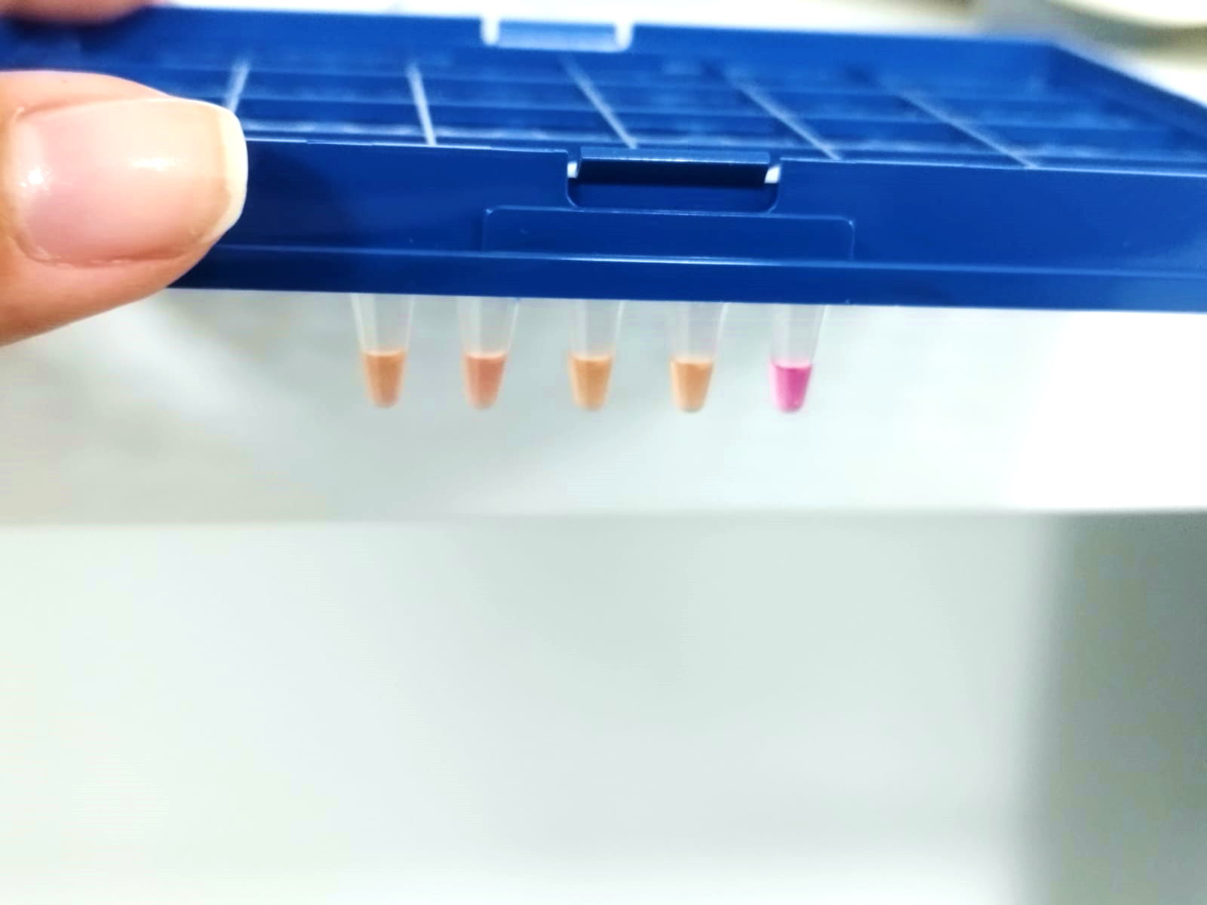

Supplementary figure 1. COMB-RT-LAMP DENV in blood samples. Blood Samples from seropositive patients (S1-S4) were analuyzed by PAN_LAMP reaction without previous RNA extraction. NC: Negative control.

