**SUPPORTING INFORMATION**

**Ternary ZnS/ZnO/graphitic carbon nitride heterojunction for efficient and stable hydrogen photocatalytic production**

Asset Bolatov 1,2, Alida Manjovelo 1, Bilel Chouchene 1, Lavinia Balan 3, Thomas Gries 4, Ghouti Medjahdi 4, Bolat Uralbekov 2 and Raphaël Schneider 1,*

1 Université de Lorraine, CNRS, LRGP, F-54000 Nancy, France

2 Al-Farabi Kazakh National University, Center of Physical-Chemical Methods of Research and Analysis, Al-Farabi Av., 71, Almaty 050040, Kazakhstan

3 CEMHTI-UPR 3079 CNRS, Site Haute Température, 1D avenue de la Recherche Scientifique, 45071 Orléans, France

4 Université de Lorraine, CNRS, IJL, F-54000 Nancy, France

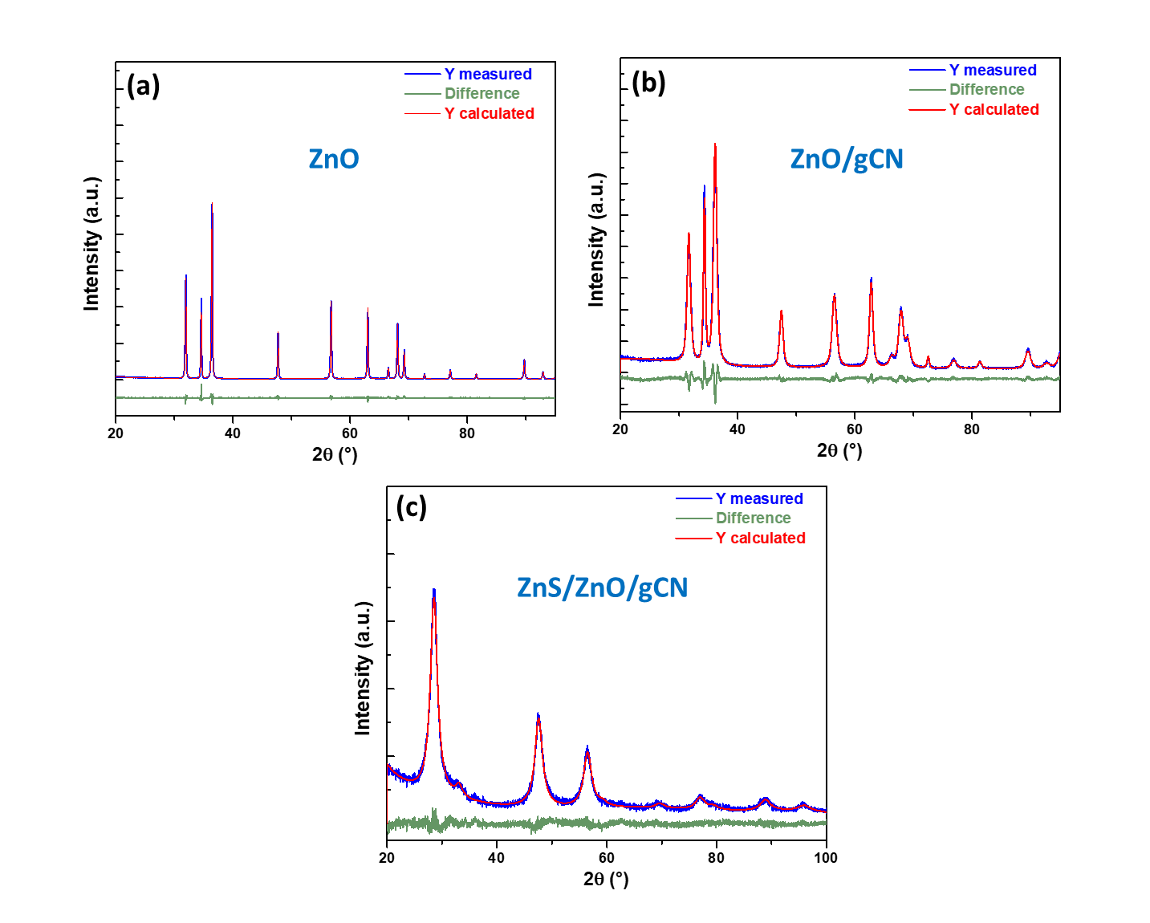

**Figure S1**. Rietveld refinement result of the powder XRD data for (a) ZnO, (b) ZnO/gCN and (c) ZnS/ZnO/gCN. The green curve illustrates the difference between data (blue curve) and simulation (red curve).

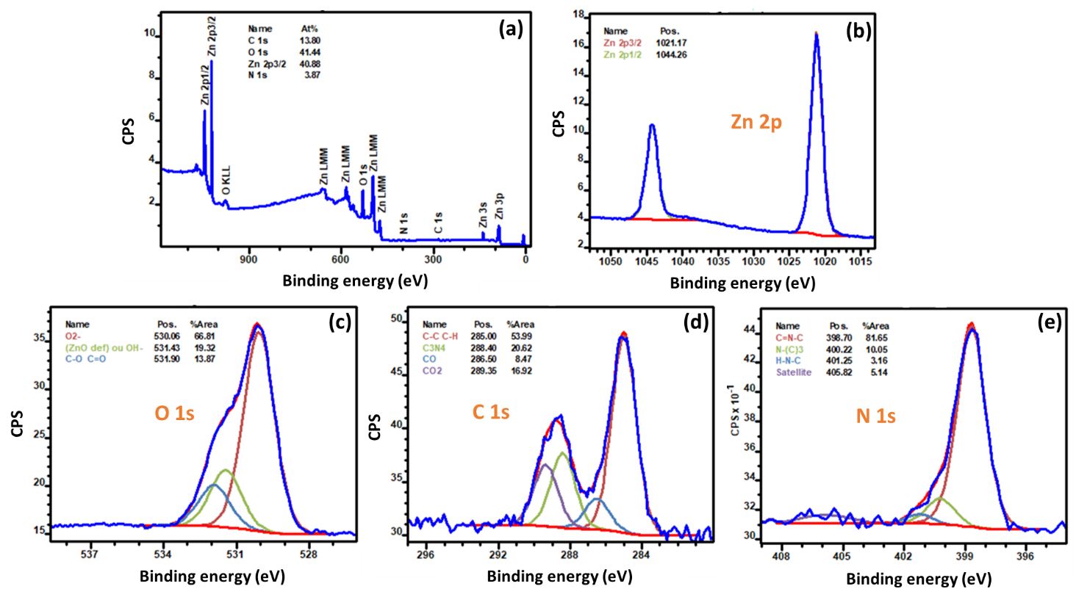

**Figure S2**. (a) Overview XPS spectrum of the ZnO/gCN (20%) photocatalyst. (b-e) are the HR-XPS spectra of Zn 2p, O 1s, C 1s and N 1s elements, respectively.

**Table S1**. Impedance parameters obtained after fitting the EIS curves with the Randles equivalent model.

|  |  |  |  |  |
| --- | --- | --- | --- | --- |
| Sample | Rs (Ω) | Q (F.sα-1) | α | Rct (Ω) |
| gCN | 72.83 | 6,912.10-6 | 0.9519 | 946489 |
| ZnO | 24.81 | 4,859.10-6 | 0.7396 | 560225 |
| ZnO/gCN | 56.57 | 20,94.10-6 | 0.5917 | 83745 |
| ZnS/ZnO/gCN | 234.2 | 13,21.10-6 | 0.955 | 43651 |