Supplementary Material

**Chemically degradable vitrimeric materials based on divanillin imine epoxy monomer and aliphatic diamines. Effect of transamination in the stress relaxation process**

Tommaso Telatin 1, Silvia De la Flor 2, Xavier Montané 1,* and Àngels Serra 1,*

1 Departament of Analytical and Organic Chemistry, Universitat Rovira i Virgili, C/ Marcel·lí Domingo 1, 43007 Tarragona, Spain

2 Department of Mechanical Engineering, Universitat Rovira i Virgili, Av. Països Catalans 26, 43007 Tarragona, Spain

* Corresponding authors.

E-mail address: xavier.montane@urv.cat; Tel.: +34-977559768 (X. Montané)

E-mail address: [angels.serra@urv.cat](mailto:angels.serra@urv.cat); Tel.: +34-977559768 (À. Serra)

**Table of Contents:**

1. **Structural characterization of the monomer S3**
2. **Study of the curing process by 1H NMR spectroscopy S5**
3. **Thermogravimetric analysis of the prepared materials S6**
4. **Storage moduli as a function of the angular frequency for the prepared materials S7**
5. **Stress relaxation profiles and Kohlrausch-Williams-Watts (KKW) model analysis S8**
6. **Frequency sweeps experiments for DIDE-PPO/MXDA S9**
7. **Frequency sweeps experiments for DIDE-PPO/IPDA S10**
8. **Carbon fibers reinforced composites S11**
9. **Structural characterization of the monomer**

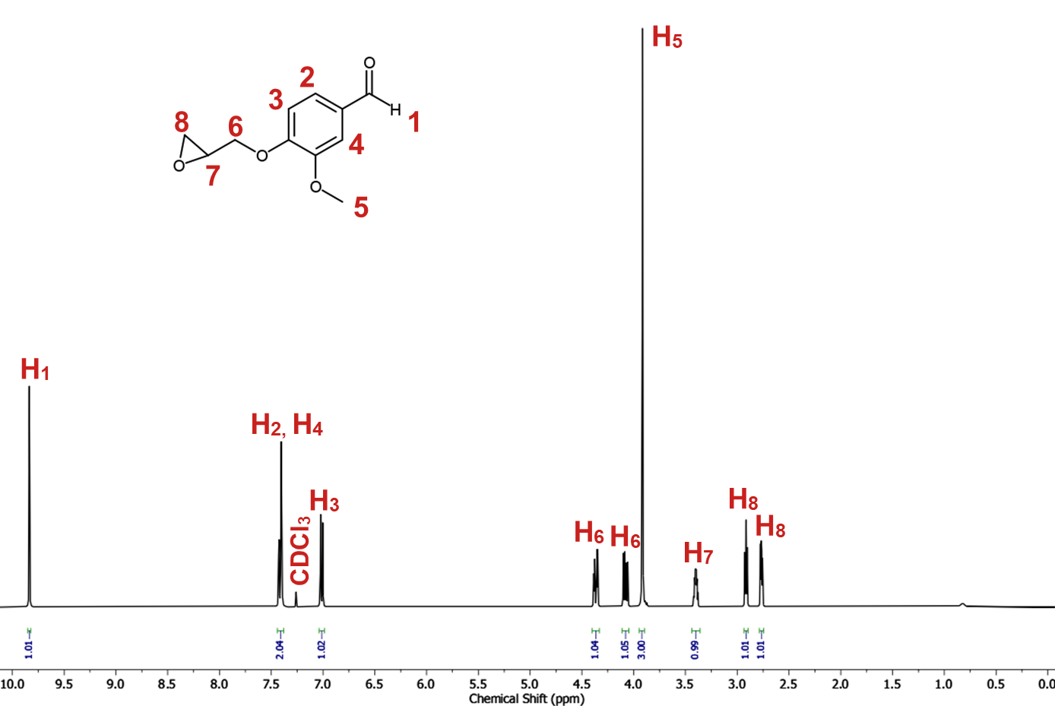

**Figure S1.** 1H NMR spectrum of EVan in CDCl3.

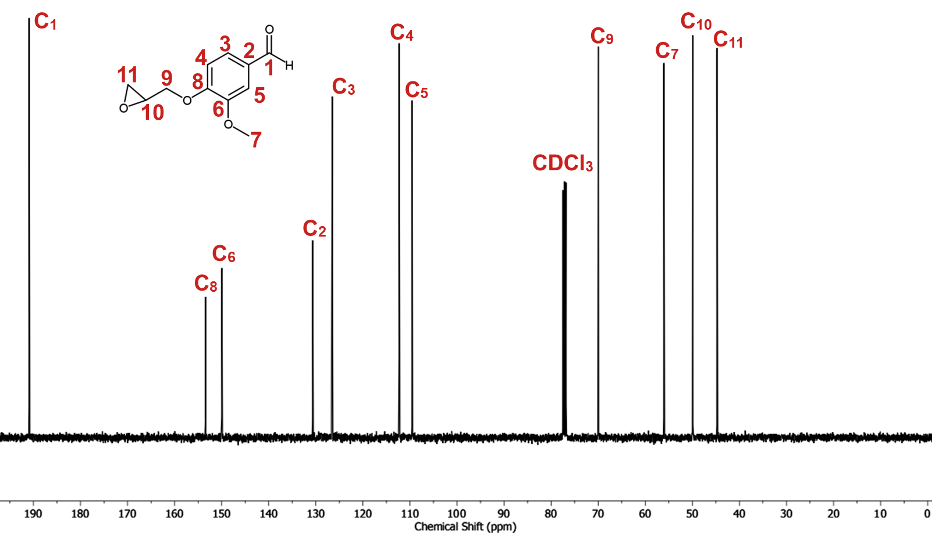

**Figure S2.** 13C NMR spectrum of EVan in CDCl3.

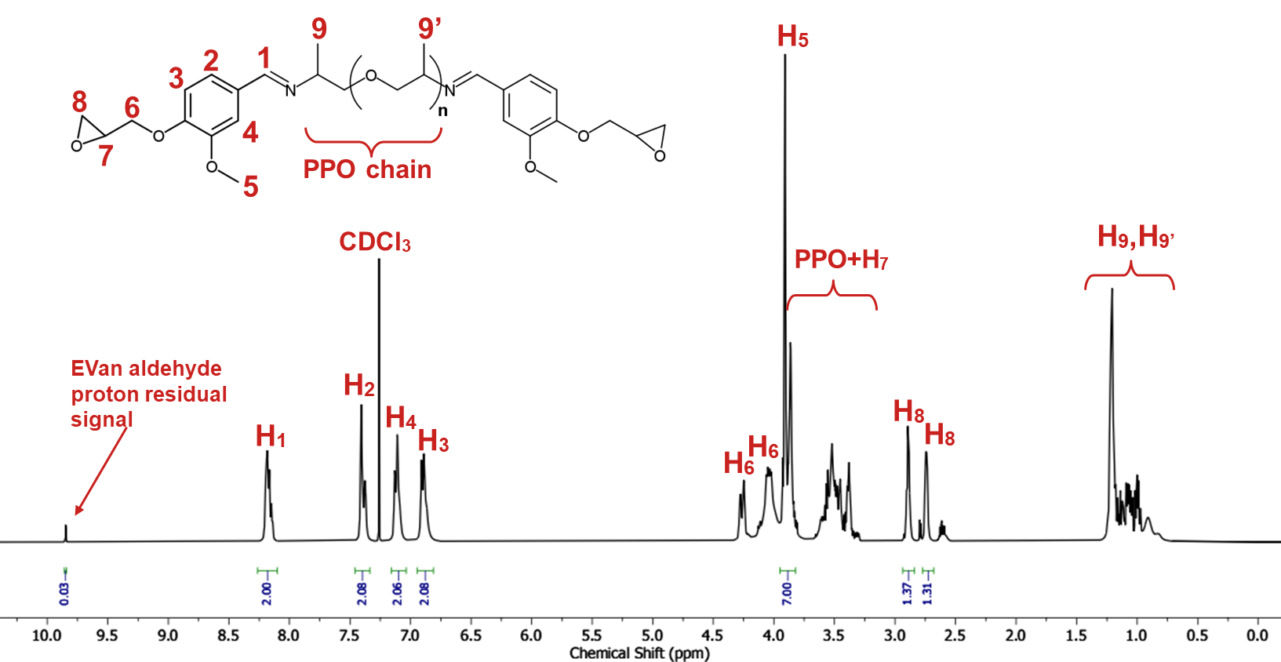

**Figure S3.** 1H NMR spectrum of DIDE-PPO in CDCl3.

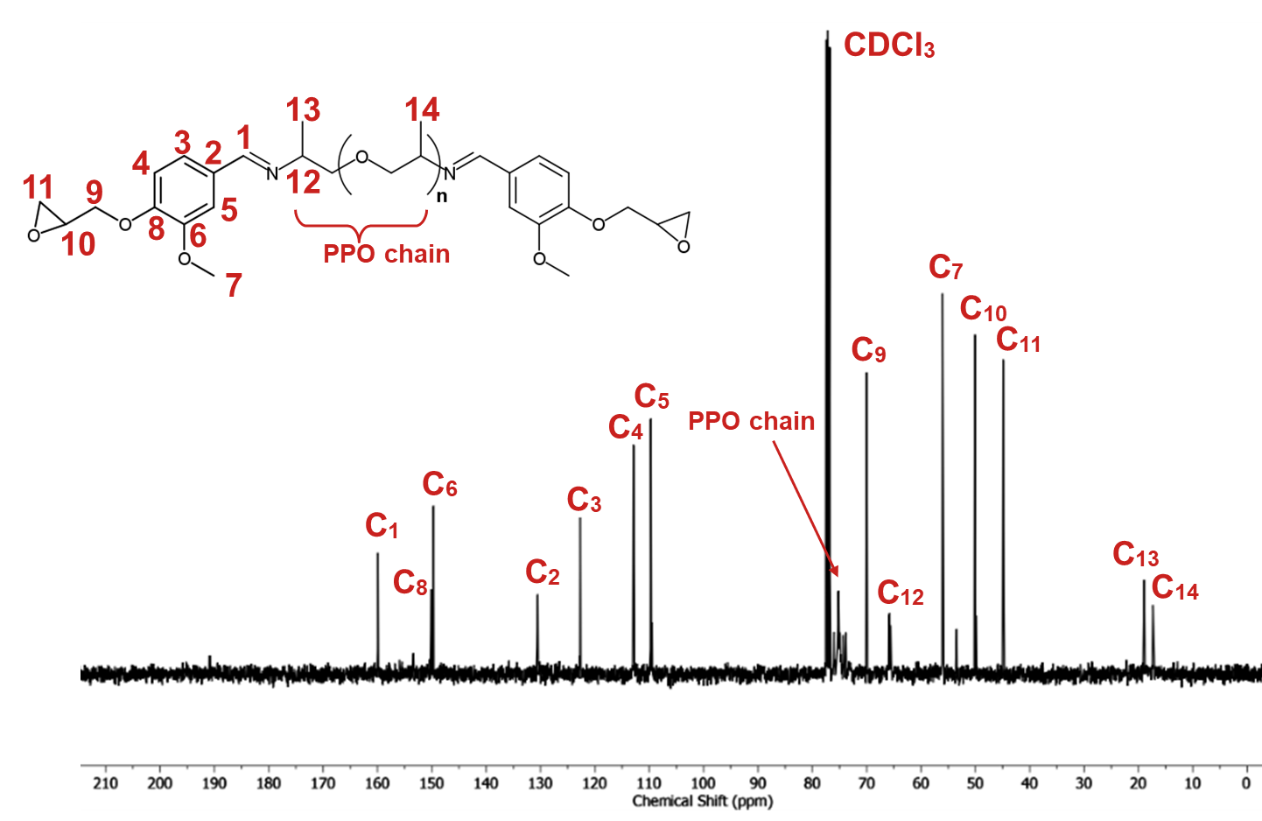

**Figure S4.** 13C NMR spectrum of DIDE-PPO in CDCl3.

1. **Study of the curing process by 1H NMR spectroscopy**

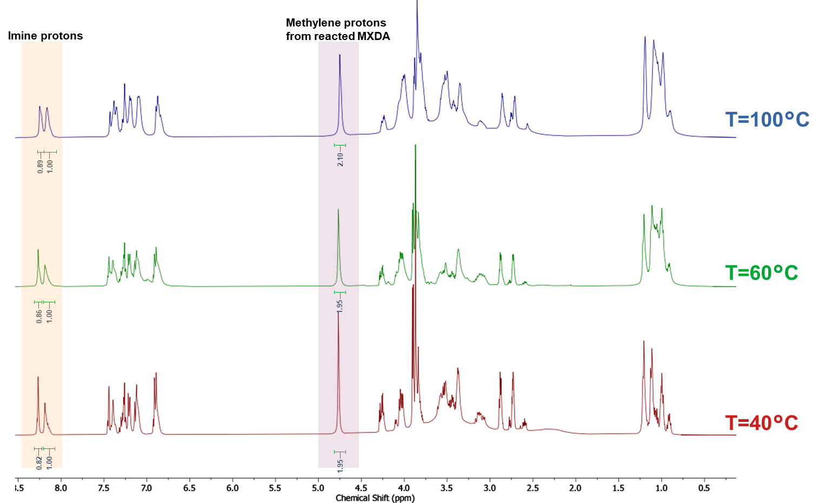

**Figure S5.** 1H NMR spectra in CDCl3 of the curing mixture at 40, 60 and 100 °C collected after 10 minutes of equilibration at each temperature.

**Table S1.** Integrals of the main peaks of the curing mixture at different temperatures.

|  |  |  |  |  |
| --- | --- | --- | --- | --- |
| **Temperature (°C)** | **I8.27 ppma** | **I8.18 ppmb** | **I4.77 ppmc** | **I8.18 ppm/I8.27 ppmd** |
| 40 | 1.00 | 0.82 | 1.95 | 0.82 |
| 60 | 1.00 | 0.86 | 1.95 | 0.86 |
| 100 | 1.00 | 0.89 | 2.10 | 0.89 |

a Normalized integral of the original imine proton signal.

b Normalized integral of the MXDA-derived imine proton signal.

c Normalized integral of the methylene protons signal relative to the reacted MXDA hardener.

d Ratio between the integrals of the two imine signals.

1. **Thermogravimetric analysis of the prepared materials**

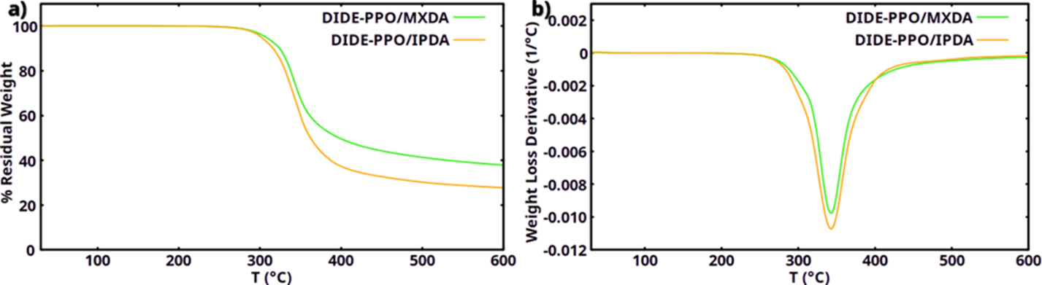

**Figure S6.** a) Thermogravimetric curves in N2 atmosphere and b) their derivatives for the materials prepared.

1. **Storage Moduli as a function of the angular frequency for the prepared materials**

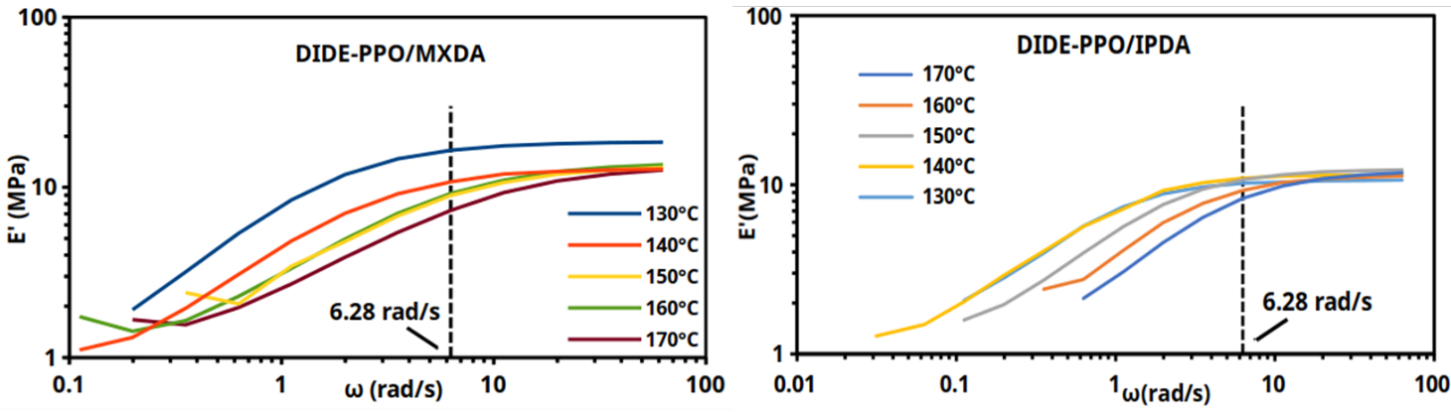

**Figure S7.** Storage modulus of DIDE-PPO/MXDA and DIDE-PPO/IPDA as a function of angular frequency at different temperatures.

1. **Stress relaxation profiles and Kohlrausch-Williams-Watts (KKW) model analysis**

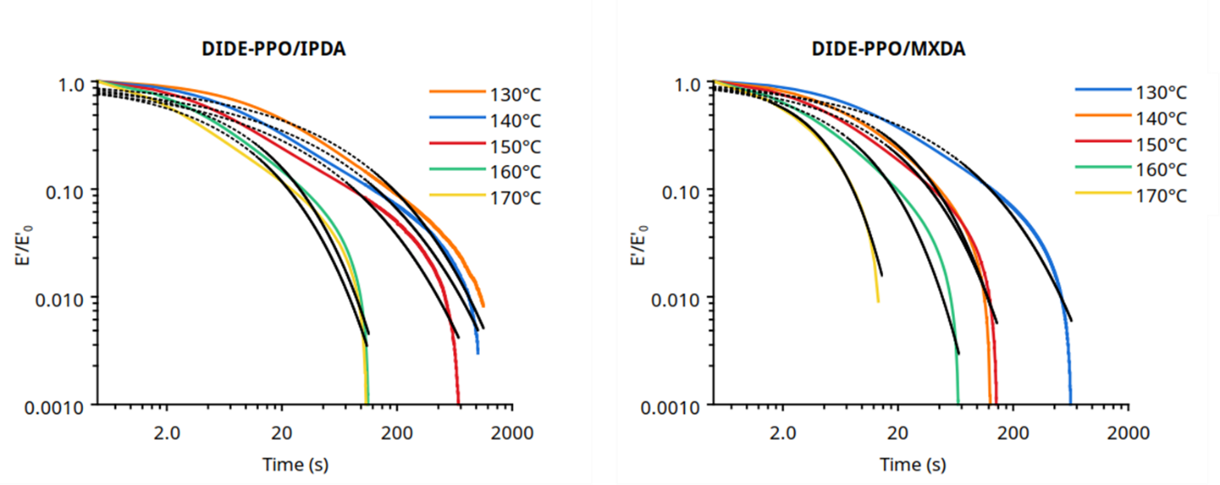

**Figure S8.** Tension mode stress relaxation profiles of the prepared materials (colored lines) fit by a stretched exponential decay function (dashed black lines).

**Table S2.** Fitting parameters for the stretched exponential decay function for the prepared materials.

|  |  |  |  |  |
| --- | --- | --- | --- | --- |
| **Sample** | **T (°C)** | **βa** | **τb (s)** | **R2** |
|  | 130 | 0.46 | 29.64 | 0.976 |
|  | 140 | 0.41 | 17.39 | 0.962 |
| **DIDE-PPO/IPDA** | 150 | 0.41 | 11.27 | 0.958 |
|  | 160 | 0.46 | 7.36 | 0.976 |
|  | 170 | 0.57 | 5.22 | 0.955 |
|  | 130 | 0.49 | 22.95 | 0.981 |
|  | 140 | 0.68 | 12.49 | 0.991 |
| **DIDE-PPO/MXDA** | 150 | 0.60 | 9.38 | 0.980 |
|  | 160 | 0.71 | 5.55 | 0.976 |
|  | 170 | 1.00 | 3.42 | 0.983 |

a Stretched exponential parameter.

b Characteristic relaxation time.

1. **Frequency sweeps experiments for DIDE-PPO/MXDA**

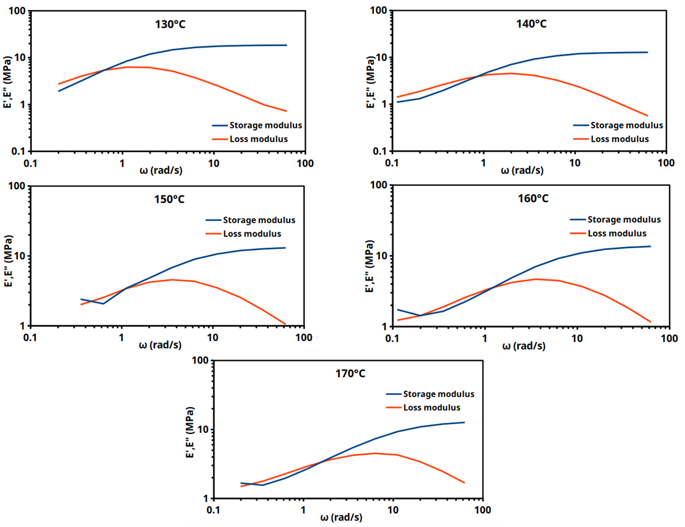

**Figure S9.** Storage and Loss Moduli of DIDE-PPO/MXDA as a function of the angular frequency.

1. **Frequency sweeps experiments for DIDE-PPO/IPDA**

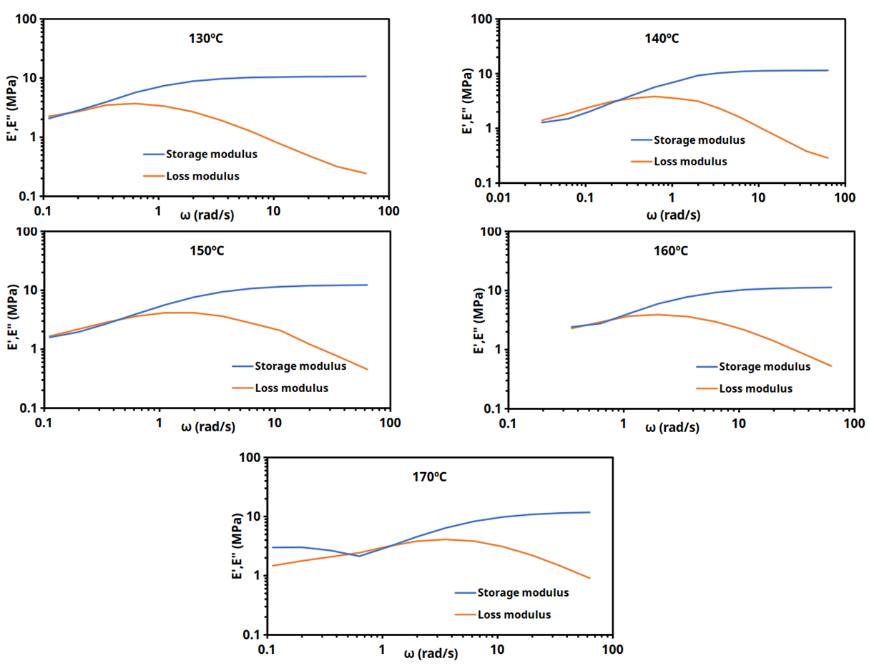

**Figure S10.** Storage and Loss Moduli of DIDE-PPO/IPDA as a function of the angular frequency.

1. **Carbon fibers reinforced composites**

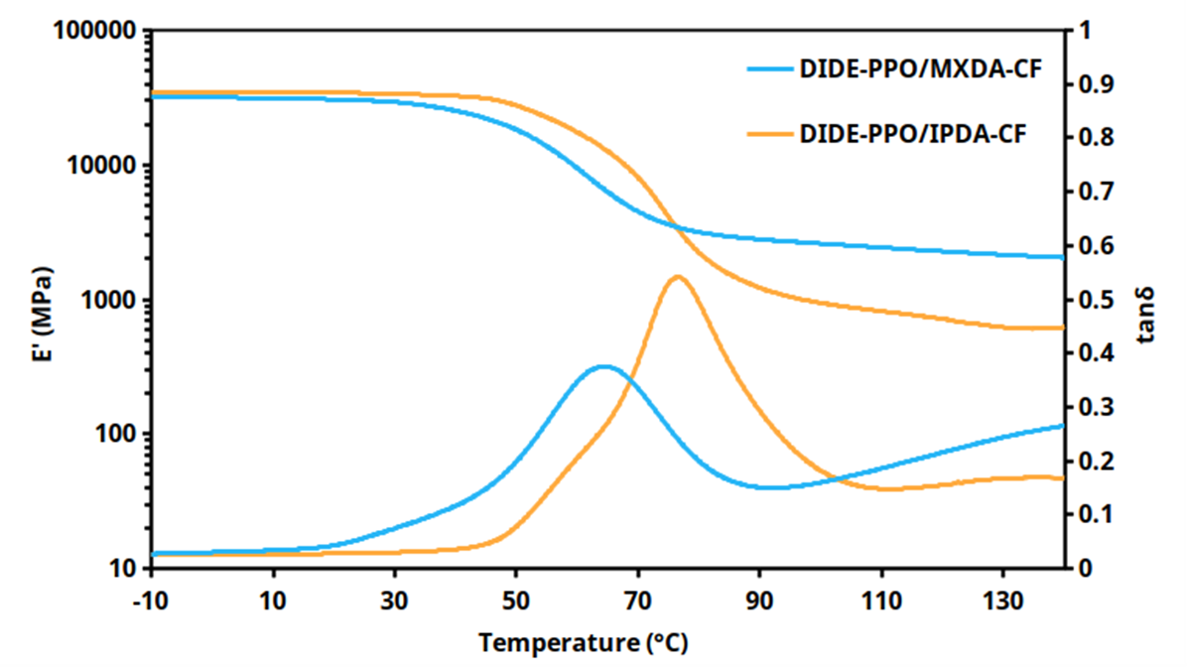

**Figure S11.** Evolution of storage modulus and tan δ with temperature for the prepared composite materials.

**Table S3.** Main thermomechanical properties of the prepared composite materials.

|  |  |  |  |
| --- | --- | --- | --- |
| **Sample** | **E’Glassy a (MPa)** | **E’Rubberyb (MPa)** | **Ttan δc** |
| **DIDE-PPO/IPDA-CF** | 34422 | 708 | 76 |
| **DIDE-PPO/MXDA-CF** | 31146 | 2427 | 64 |

**Table S4.** Creep rate and strain recovery for the prepared carbon fiber reinforced composites.

|  |  |  |
| --- | --- | --- |
| **Sample** | **dε/dta** | **% Residual deformationb** |
| **DIDE-PPO/IPDA** | 2.39 x 10-3 | 0.61 |
| **DIDE-PPO/MXDA** | 2.13 x 10-3 | 0.37 |
| **DIDE-PPO/IPDA-CF** | 4.24 x 10-4 | 0.13 |
| **DIDE-PPO/MXDA-CF** | 4.12 x 10-4 | 0.02 |

a Determined from the slope of the steady-state region of the creep curve.

b Determined after 30 min of releasing the stress.