***Supplementary Material***

**Peroxymonosulfate activation by** **Fe@N co-doped BC for the degradation of sulfamethoxazole: The key role of pyrrolic N**

**Tong Liua,b,** **Chen-Xuan Lia,b,** **Xing Chena,b, Yihan Chena,b, Kangping Cuia,b,*,** **Dejin Wang c,*, Qiang Weic,\***

a School of Resources and Environmental Engineering, Hefei University of Technology, Hefei 230009, P.R. China

b Key Laboratory of Nanominerals and Pollution Control of Higher Education Institutes, Hefei University of Technology, Hefei 230009, P.R. China

c School of Resources and Environment, Anqing Normal University, Anqing 246011, P.R. China

d CAS Key Laboratory of Urban Pollutant Conversion, Department of Environmental Science and Engineering, University of Science and Technology of China, Hefei 230026, P.R. China

*Corresponding Author.

E-mail address: cuikangping@hfut.edu.cn (K.P. Cui)

wangdj@aqnu.edu.cn

weiqiang07@ustc.edu.cn

Full postal address: School of Resources and Environmental Engineering, Hefei University of Technology, No. 193 Tunxi Road, Hefei 230009, P.R. China

School of Resources and Environment, Anqing Normal University, No. 1318 jixian North Road, Anqing 246011, P.R. China

Department of Environmental Science and Engineering, University of Science and Technology of China, No. 96 Jinzhai Road, Hefei 230026, P.R. China

Tel: +86 0551 62901541; +86 0551 63492298

**Reagents and chemicals**

The chemical reagents employed in this work include sulfamethoxazole (SMX, 98.0%, Rhawn), tetracycline hydrochloride (TC, 96.0%, Rhawn), 4-chloro-3-methyl phenol (CMP, 99.0%, Rhawn), norfloxacin (NOR, 98.0%, Rhawn), acetaminophen (ACT, 98.0%, Rhawn), sodium thiosulfate (Na2S2O3, 99.0%, Rhawn), *L*-histidine(*L*-his, 98.0%, Rhawn), *tert*-Butanol (TBA, ≥99.5%, Rhawn), methanol (MeOH, ≥99.5%, Rhawn), and *p*-Benzoquinone (*p*-BQ, ≥99.0%, Rhawn), furfuryl alcohol (FFA, ≥98.0%, Aladdin), hydrochloric acid (HCl, 36.0−38.0%, Rhawn), sulfuric acid (H2SO4, 98.0%, Rhawn), sodium hydroxide (NaOH, 97.0%, Rhawn), sodium chloride (NaCl, 99.5%, Aladdin), monopotassium phosphate (KH2PO4, 99.0%, Aladdin), sodium bicarbonate(NaHCO3, 99.8%, Aladdin), humic acid (HA, 98.0%, Aladdin), peroxymonosulfate (KHSO5·0.5KHSO4·0.5K2SO4, Oxone, Aladdin), 5,5-Dimethyl-1-pyrroline-N-oxide (DMPO, 97.0%, Rhawn), 2,2,6,6-tetramethyl-4-piperidinol (TEMP, ≥98.0%, Aladdin). All chemicals were employed without further purification and deionized water (18.2 MΩ/cm) was used throughout the experiments.

**Characterization and analysis methods**

Morphologies of Fe@N co-doped BC were observed by the scanning electron microscope (SEM, Hitachi SU8020) and high-resolution transmission electron microscope (HR-TEM, JEOL JEM-2100). The crystalline structure of Fe@N co-doped BC was detected by the X-ray diffractometer (PANalytical, Netherlands). ATR-FTIR spectra were obtained by a FT-IR spectrometer (Thermo, Nicolet 6700) in the 4,000−500 cm-1 range. The chemical states of Fe@N co-doped BC were analyzed by X-ray photoelectron spectroscopy (XPS, Thermo, ESCALAB250Xi). The SSAs and pore size distributions were analyzed with the Brunauer-Emmett-Teller (BET) method (Autosorb-IQ3, Quantachrome, USA). Raman spectrometer (HORIBA JOBIN YVON, LabRAM HR Evolution) was used to acquire Raman spectra.

SMX concentration was determined by high-performance liquid chromatography (HPLC, Shimadzu, LC-20AT). The mobile phase was SMX of acetonitrile/deionized water (0.1% formic acid) (70%/30%, v/v) at a ﬂow-rate of 1.0 mL⋅min−1. The wavelength and column temperature were set to 255 nm and 30℃, respectively. The decomposition rate of PMS was determined by an ABTS colorimetric method (Wu et al., 2020). Total organic carbon (TOC) was measured using a Shimadzu TOC-vcph analyzer (Multi N/C 3000). The zeta potential of Fe@N co-doped BC was determined with a Zetasizer NanoBrook Omni (Brookhaven). Radical studies were performed with a JES-FA200 (JEOL) spectrometer. The intermediates were detected with ultra-performance liquid chromatography to quadrupole time-of-flight mass spectrometry (UPLC-TOF/MS, ACQUITY UPLC LCT Premier XE, America).

**Theoretical calculations**

All DFT calculations are performed in Gaussian 16 software, using B3LYP/6-31 G (d, p) basis sets for optimization and transition state search for all configurations. All configuration optimization is carried out without symmetry restriction, and vibration analysis is performed after optimization to ensure no phantom frequency. Vibration analysis is performed on all transition state structures to ensure that there is only one virtual frequency, and that the virtual frequency corresponds to the direction of vibration to connect the reactants and products. The adsorption energy of AB structure is calculated based on the formula Eb = E (AB)−E (A)−E (B), and the Gibbs free energy variation (∆G) is also obtained under the method B3LYP/6-31G (d, p).

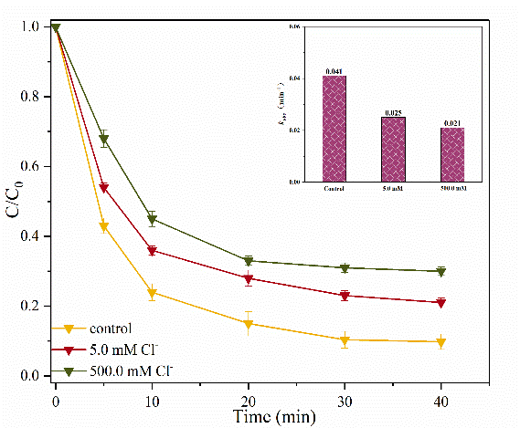

(a)

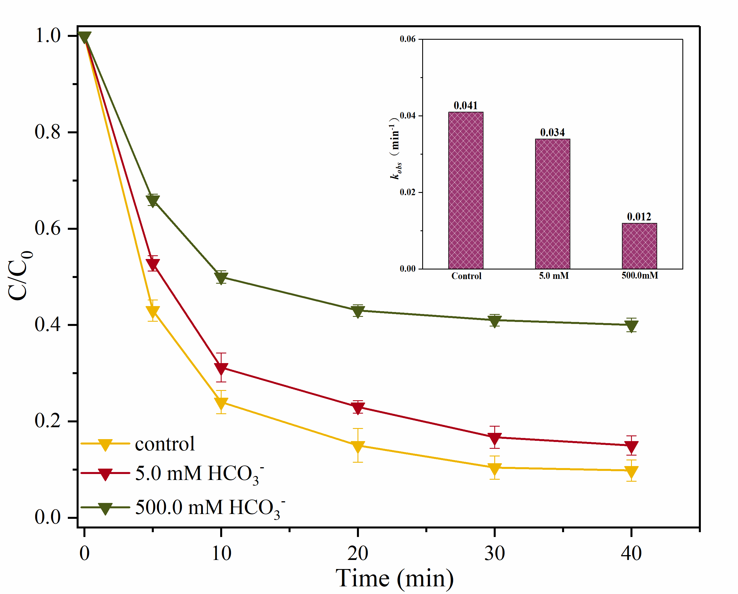

(b)

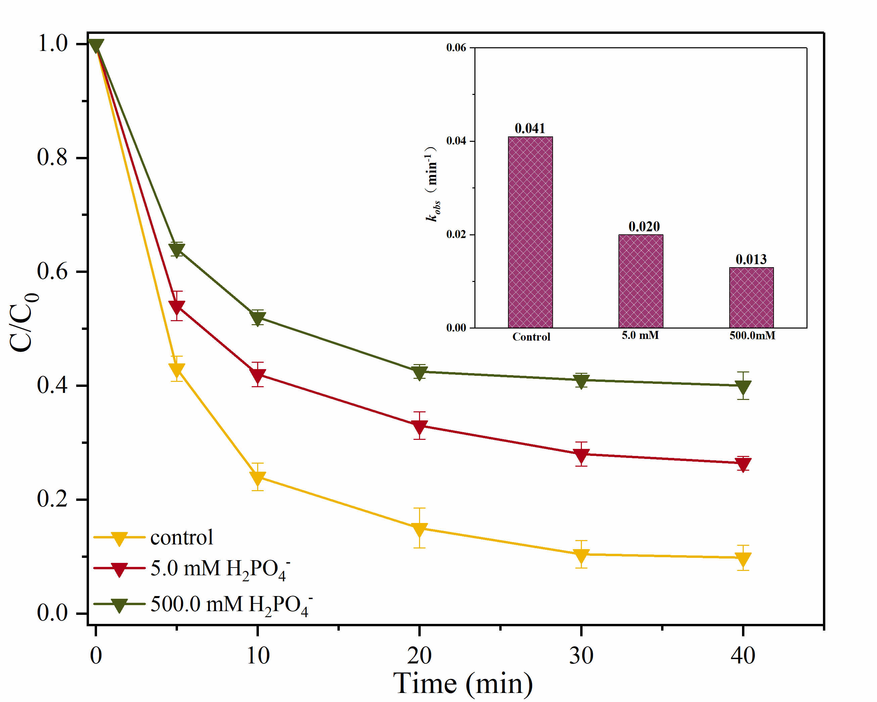

(c)

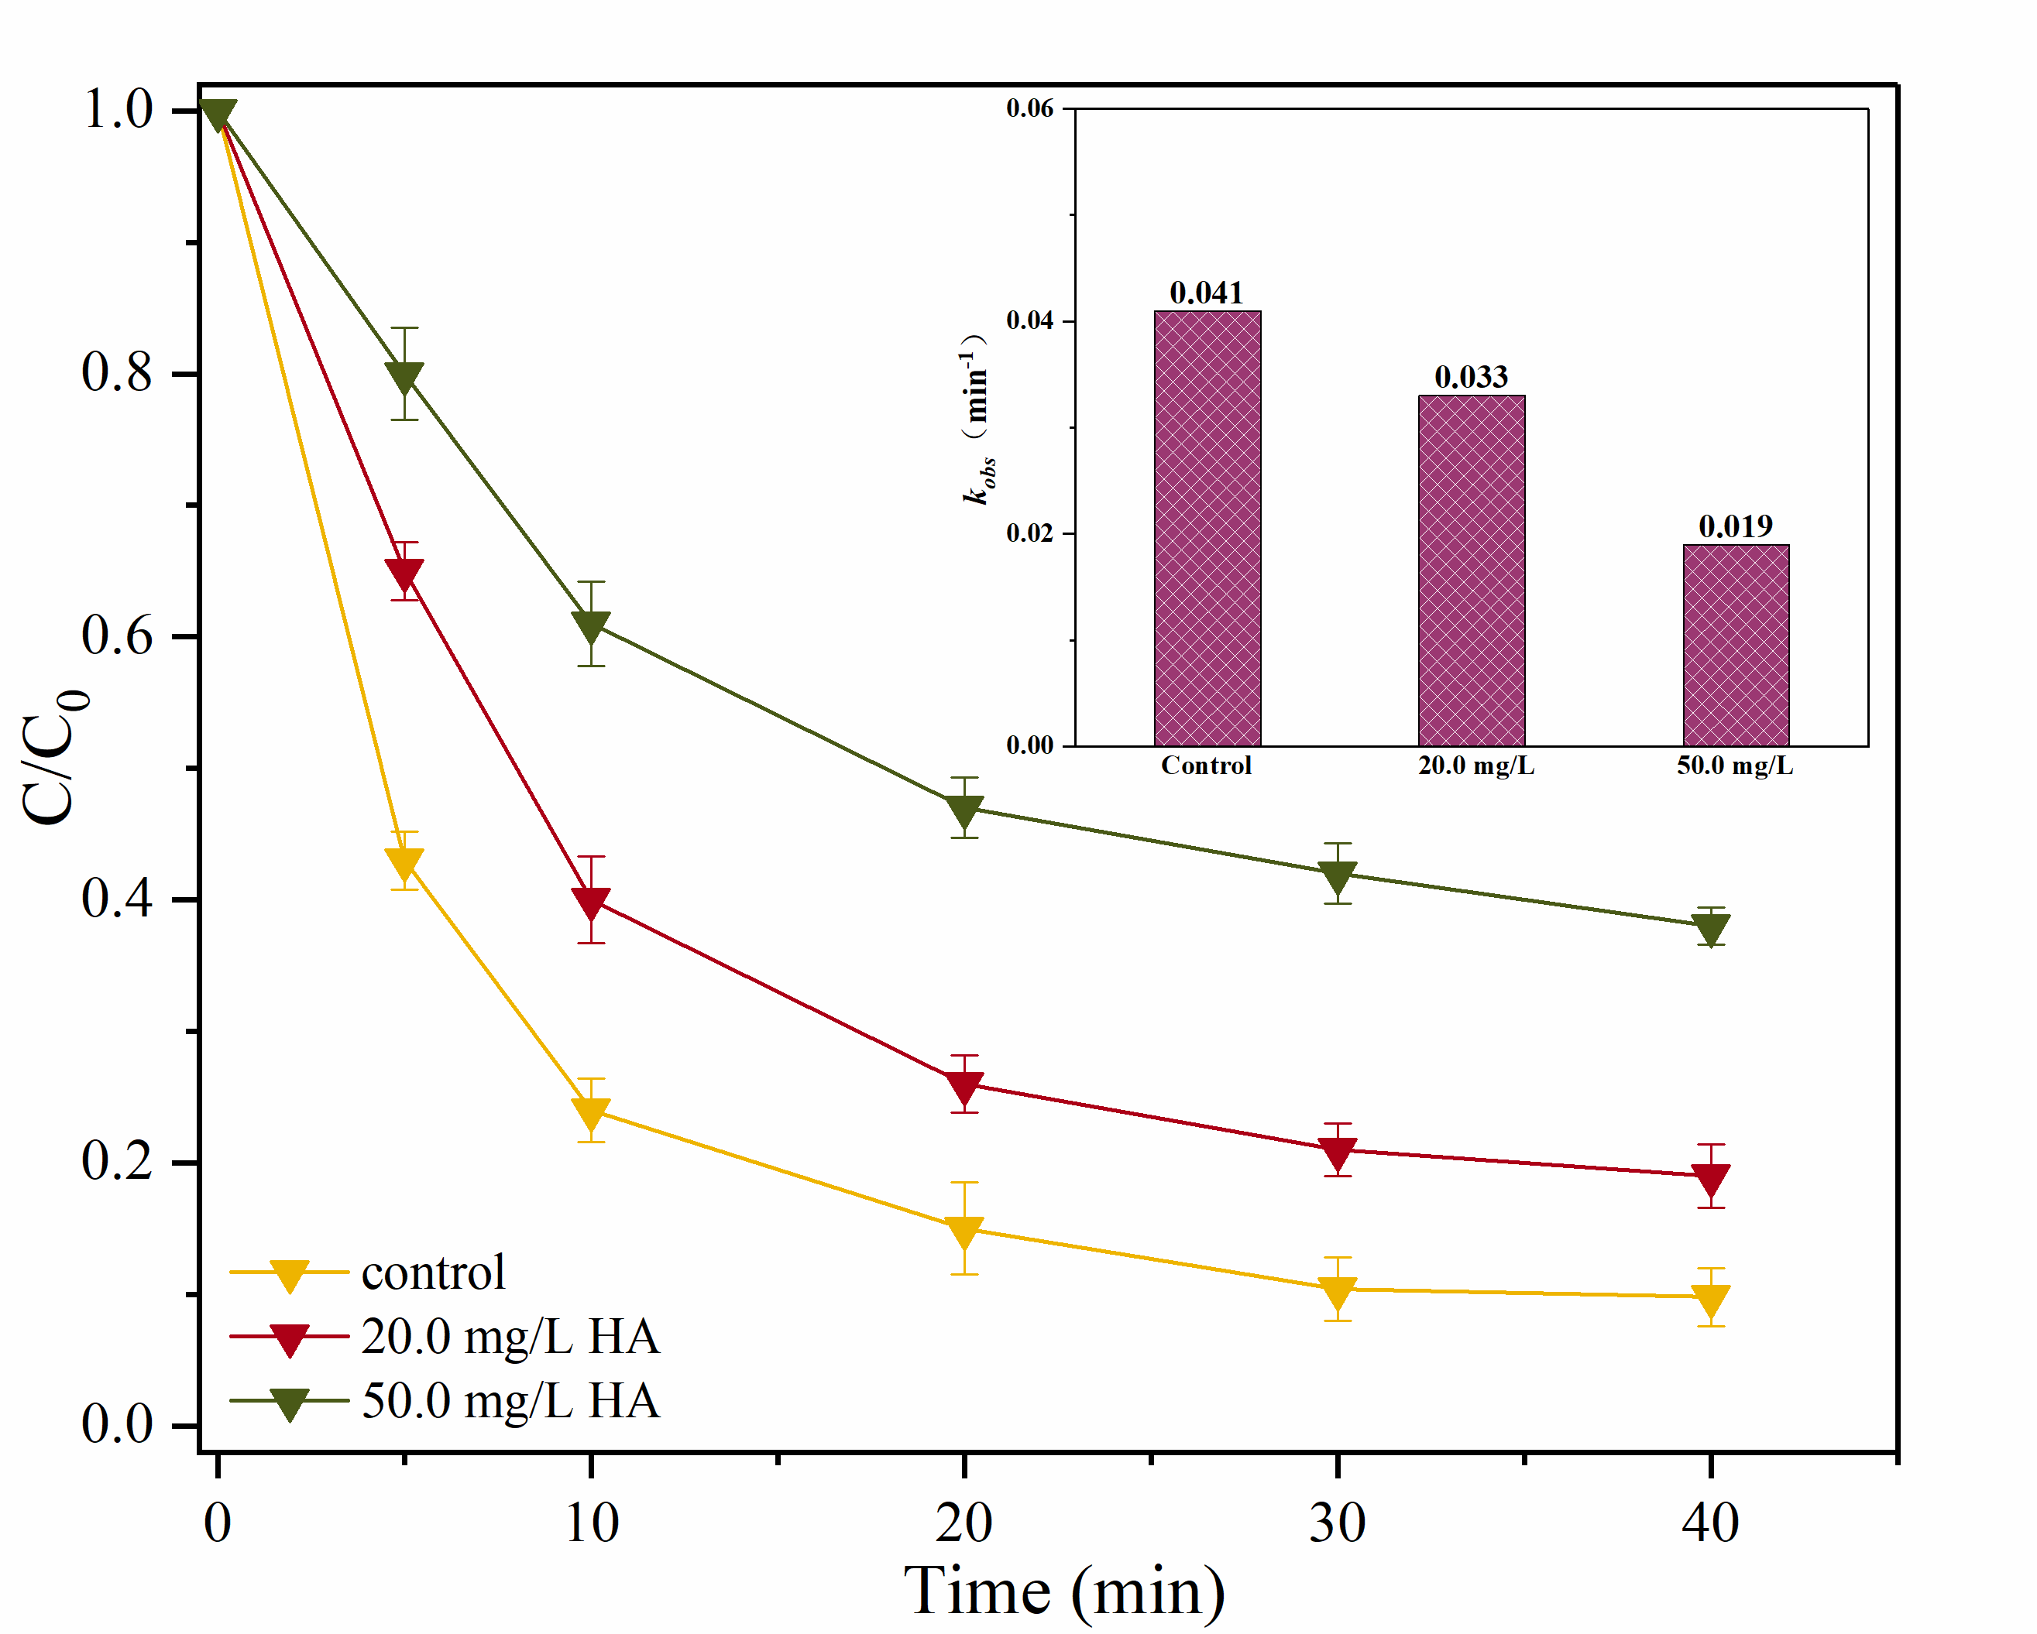

(d)

**Fig. S1.** Effects of Cl− (a), HCO3− (b), H2PO4− (c) and HA (d) on SMX degradation. (Conditions: [SMX]0 = 10.0 mg/L, [Fe@N co-doped BC] = 0.4 g/L, [PMS]0 = 0.6 mM, pH0 = 7.0, T = 25℃).

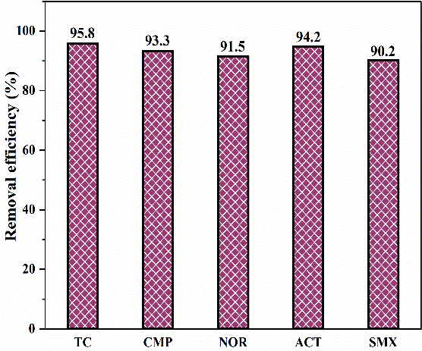

(a)

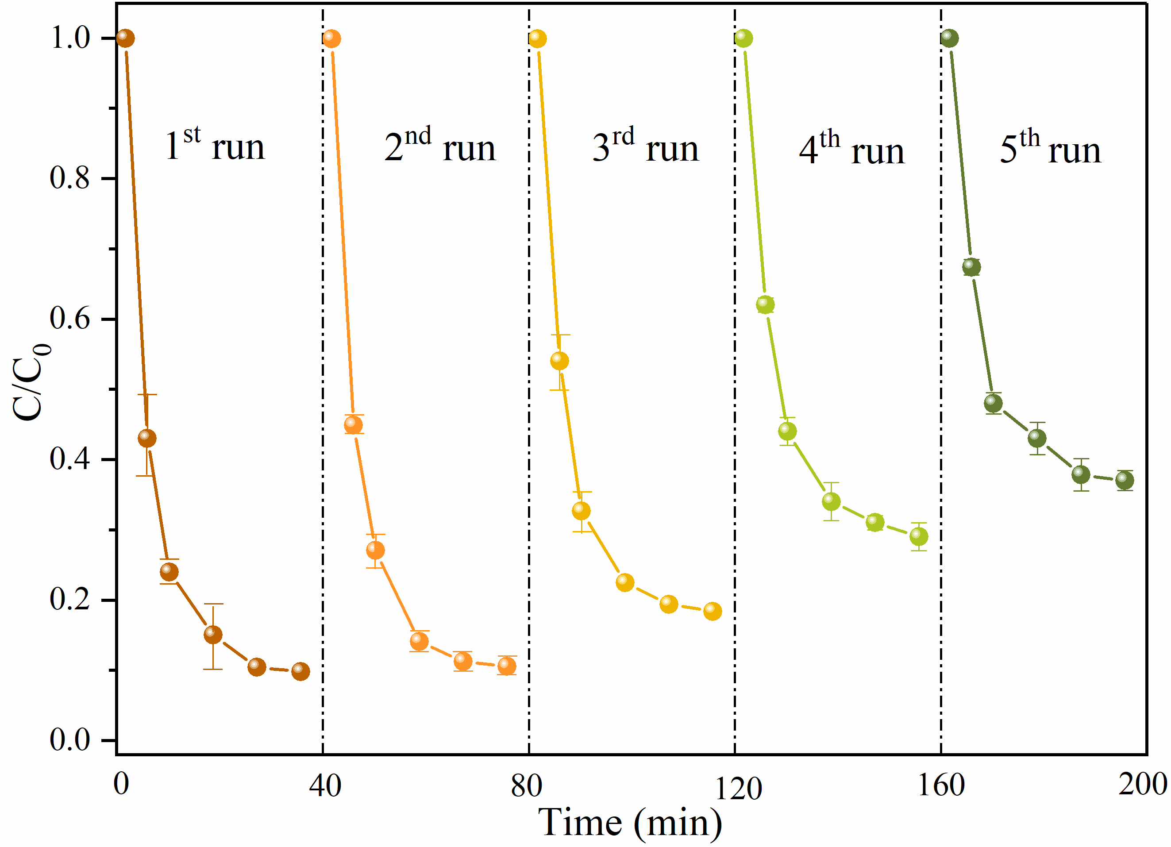

(b)

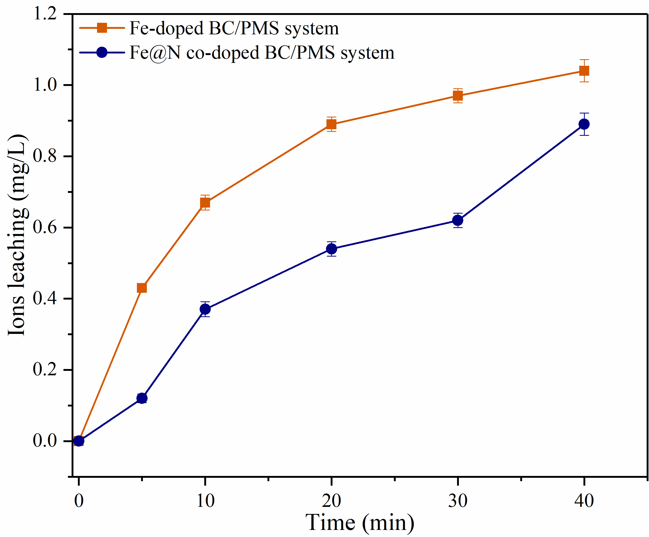

(d)

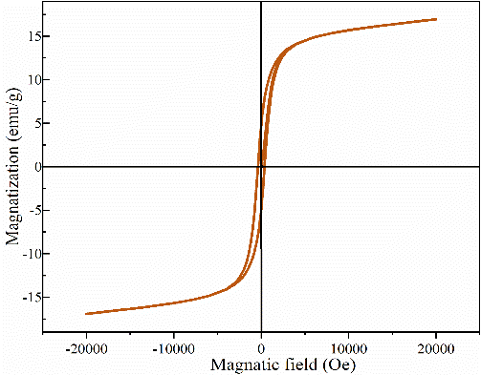

(c)

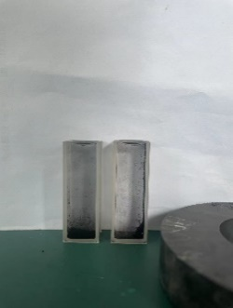

**Fig. S2.** The removal of various pollutants in Fe@N co-doped BC/PMS system (a), reusability of Fe@N co-doped BC after 5 consecutive cycles (b), room-temperature magnetization curve of Fe@N co-doped BC (c) and the concentration of leached ions (d). (Conditions: [substrate]0 = 10.0 mg/L; [Catalyst]0 = 0.4 g/L; [PMS]0 = 0.6 mM; pH = 7.0; T = 25℃)

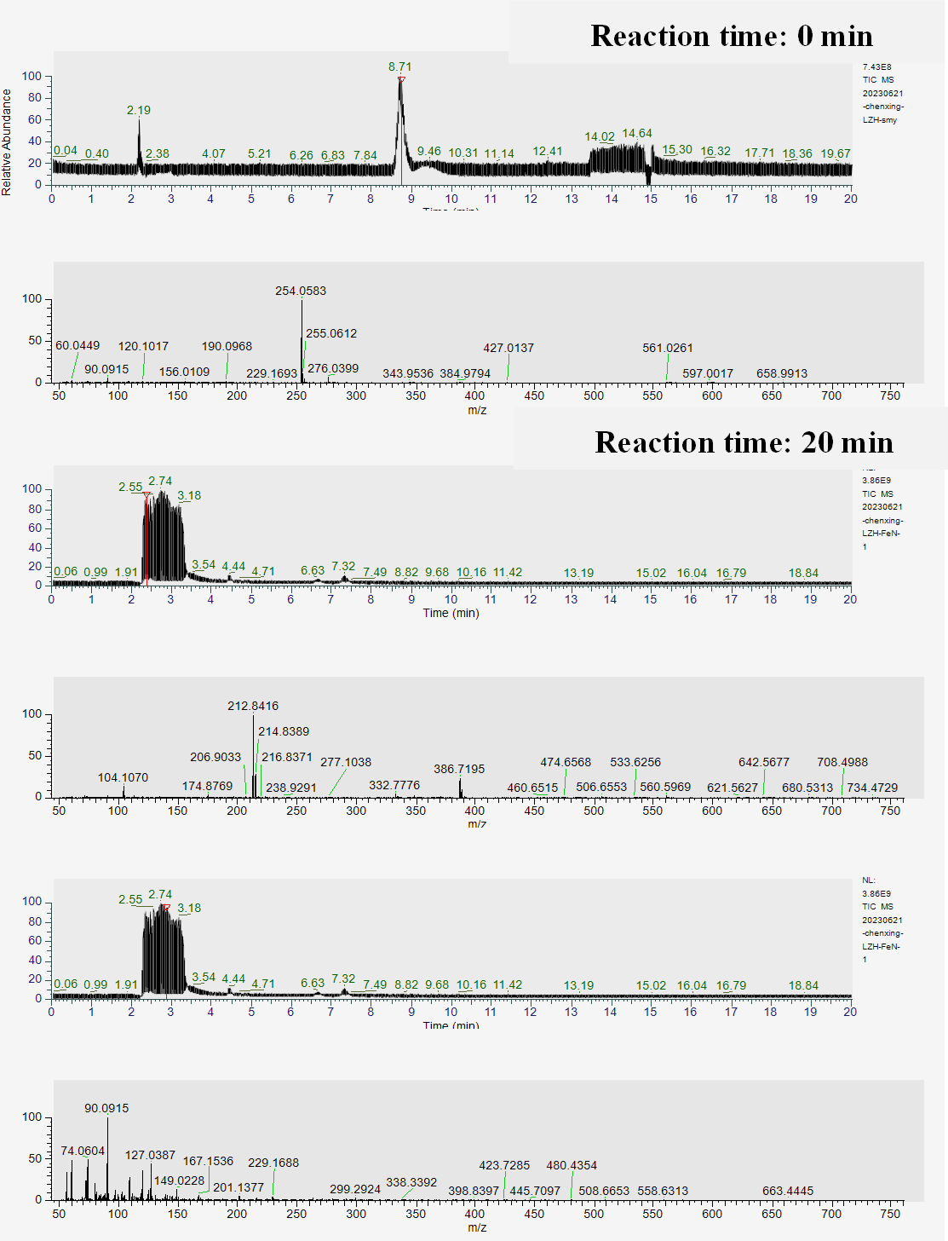**Fig. S3.** Mass spectra of intermediate products.



**Fig. S4.** Possible pathways for degradation of SMX in Fe@N co-doped BC/PMS system.

**Table S1.** Comparison of the *k*obs and R2 of different systems.

|  |  |  |
| --- | --- | --- |
| Systems | *k*obs (min-1) | R2 |
| BC+PMS | 0.026 | 0.95 |
| Fe-doped BC+PMS | 0.028 | 0.95 |
| N-doped BC+PMS | 0.027 | 0.97 |
| Fe@N co-doped BC+PMS | 0.041 | 0.90 |

**Table S2.** Studies of the typical pollutants degradation with PS activated by biochar-based catalysts.

|  |  |  |  |
| --- | --- | --- | --- |
| PPCPs | Catalyst | Oxidant source | Performance |
| 20.0 mg/L | 0.02 g/L CoS/BBC | 0.3 g/L PMS | The degradation efficiency of SMX reached 99.12% within 10 min in CoS/BBC/PMS system (Huang et al., 2022). |
| 10.0 mg/L | 0.2 g/L Co@RBC800 | 0.5 mM PMS | The optimal Co@RBC800 can degrade 100% of LVF in 10 min with a k of 0.331 min−1 (Liu et al., 2022). |
| 5.0 mg/L | 0.05 g/L EGB-900 | 4.0 mM PS | SMX can be completely removed within 90 min at EGB-900 concentration of 0.05 g/L and the *k*obs value was 0.0655 min−1 (Qi et al., 2020). |
| 20.0 mg/L | 0.3 g/L γ-Fe2O3@BC | 5.0 mM PS | A complete removal of BPA was obtained within 20 min with an observed rate constant (*k*obs) of 0.1849 min−1, which was almost two times as large as that (0.0956 min−1) of pure biochar (Rong et al., 2019). |
| 20.0 mg/L | 0.2 g/L Fe-N-BC | 1.0 mM PS | In the Fe-N-BC/PS system, almost all acid orange (AO7) was removed within 90 min with an apparent rate constant (*k*obs) of 0.114 min−1 (Li et al., 2020). |

**Table S3.** The contribution of each reactive species.

|  |  |  |  |  |  |
| --- | --- | --- | --- | --- | --- |
| Systems | •OH | SO4•− | O2•− | 1O2 | Degradation rates/% |
| Fe@N co-doped BC/PMS | √ | √ | √ | √ | 90.2 |
| Fe@N co-doped BC/PMS+MeOH | - | - | √ | √ | 33.4 |
| Fe@N co-doped BC/PMS+TBA | - | √ | √ | √ | 73.5 |
| Fe@N co-doped BC/PMS+*p*-BQ | √ | √ | - | √ | 84.7 |
| Fe@N co-doped BC/PMS+*L*-his | √ | √ | √ | - | 73.2 |
| Computation | 16.7% | 40.1% | 5.5% | 17.0% | - |
| Relative contribution | 21.1% | 50.2% | 7.2% | 21.5% | 100.0% |

**Table S4.** Main elements of the obtained catalysts.

|  |  |  |  |  |
| --- | --- | --- | --- | --- |
| Samples | C(at. %) | N(at. %) | O(at. %) | Fe(at. %) |
| Fresh Fe@N co-doped BC | 47.6 | 6.1 | 31.0 | 15.3 |
| Used Fe@N co-doped BC | 39.6 | 5.3 | 35.0 | 20.1 |

**Table S5.** Intermediates of SMX degradation detected by UPLC-TOF/MS.

|  |  |  |
| --- | --- | --- |
| Structural formula | Molecular formula | m/z |
|  | C10H11N3O3S | 284 |
|  | C10H12N3O5S | 288 |
|  | C8H11N3O4S | 246 |
|  | C7H9N3O3S | 216 |
|  | C7H7N3O2S | 198 |
|  | C10H10N3O4S | 270 |
|  | C6H7NO4S | 190 |
|  | C4H6N2O | 99 |
|  | C4H4N2O2 | 111 |
|  | C4H4N2O3 | 127 |

**References**

Huang, X., Yu, Z., Shi, Y., Liu, Q., Fang, S., 2022. Highly efficient activation of peroxymonosulfate by Co, S co-doped bamboo biochar for sulfamethoxazole degradation: Insights into the role of S. Journal of Environmental Chemical Engineering 10(5).

Li, X., Jia, Y., Zhou, M., Su, X., Sun, J., 2020. High-efficiency degradation of organic pollutants with Fe, N co-doped biochar catalysts via persulfate activation. J Hazard Mater 397, 122764.

Liu, J., Jiang, J., Wang, M., Kang, J., Zhang, J., Liu, S., Tang, Y., Li, S., 2022. Peroxymonosulfate activation by cobalt particles embedded into biochar for levofloxacin degradation: Efficiency, stability, and mechanism. Separation and Purification Technology 294.

Qi, Y., Ge, B., Zhang, Y., Jiang, B., Wang, C., Akram, M., Xu, X., 2020. Three-dimensional porous graphene-like biochar derived from Enteromorpha as a persulfate activator for sulfamethoxazole degradation: Role of graphitic N and radicals transformation. J Hazard Mater 399, 123039.

Rong, X., Xie, M., Kong, L., Natarajan, V., Ma, L., Zhan, J., 2019. The magnetic biochar derived from banana peels as a persulfate activator for organic contaminants degradation. Chemical Engineering Journal 372, 294-303.

Wu, Z., Wang, Y., Xiong, Z., Ao, Z., Pu, S., Yao, G., Lai, B., 2020. Core-shell magnetic Fe3O4@Zn/Co-ZIFs to activate peroxymonosulfate for highly efficient degradation of carbamazepine. Applied Catalysis B: Environmental 277.