SUPPLEMENTARY MATERIAL
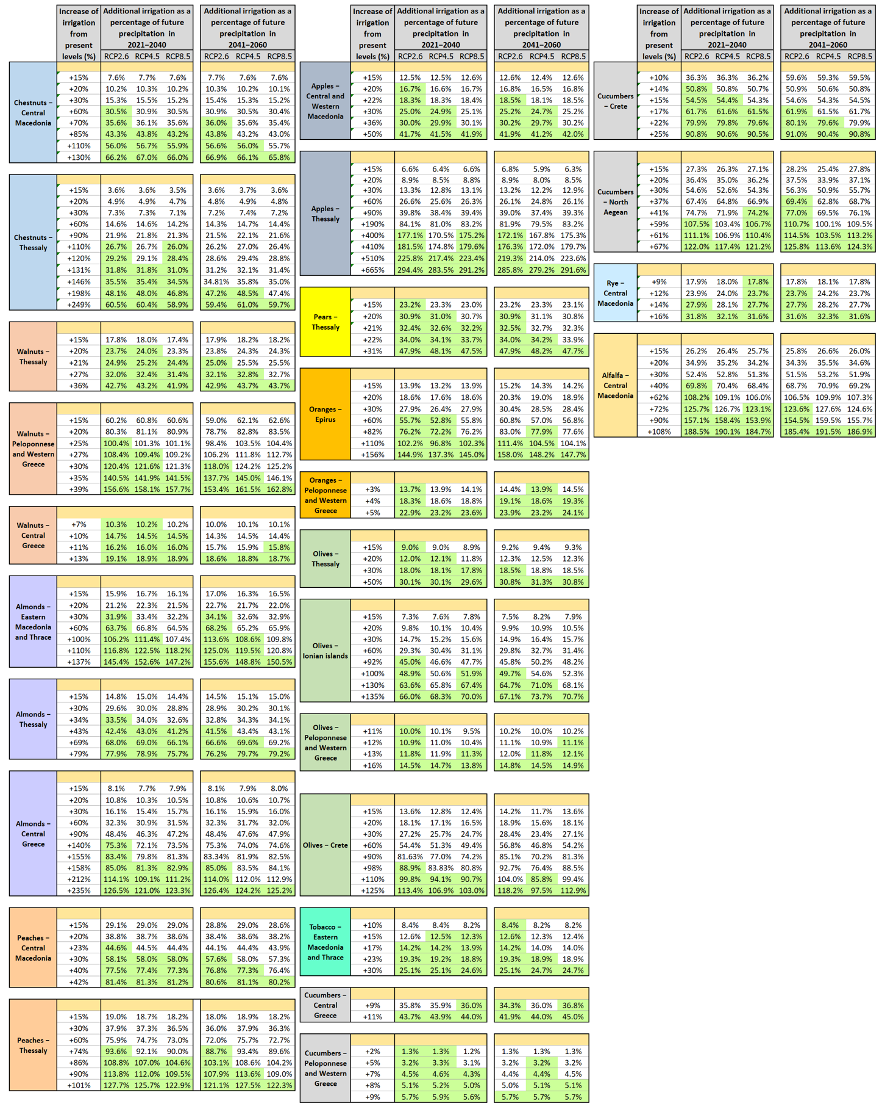
Figure S1. Percentage of cumulative future precipitation – during the months where precipitation is statistically significant in the statistical regression models linking crop yields with climatic parameters – to which each level of irrigation increase corresponds.

