**Appendix 1: Study Design**

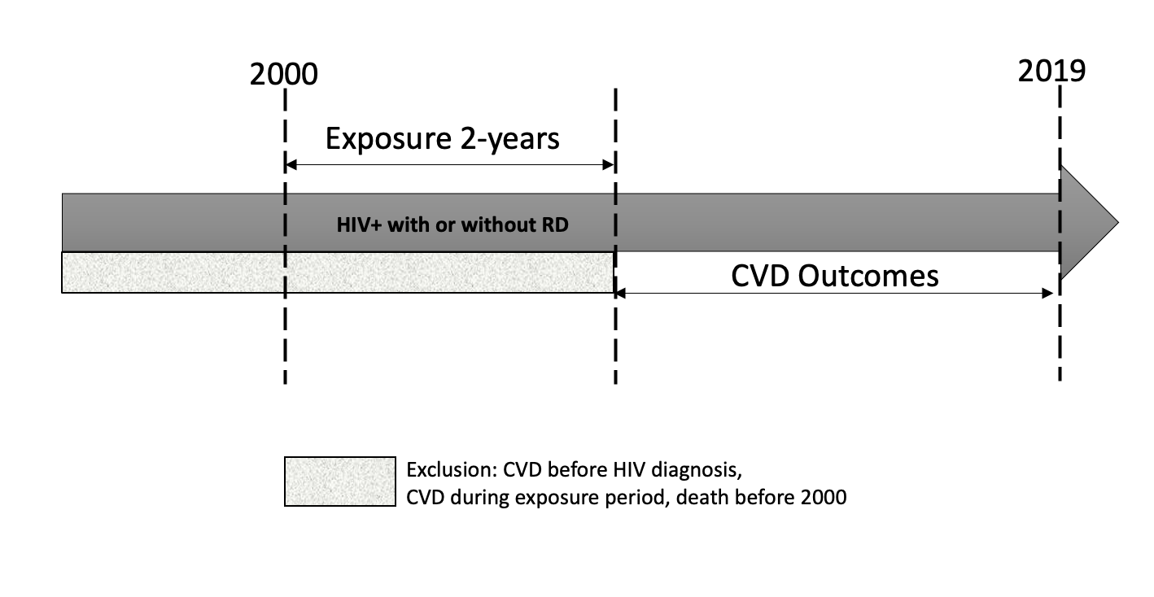

Legend: Overview of study design – Retrospective Cohort of US veterans with HIV

**Appendix 2:**

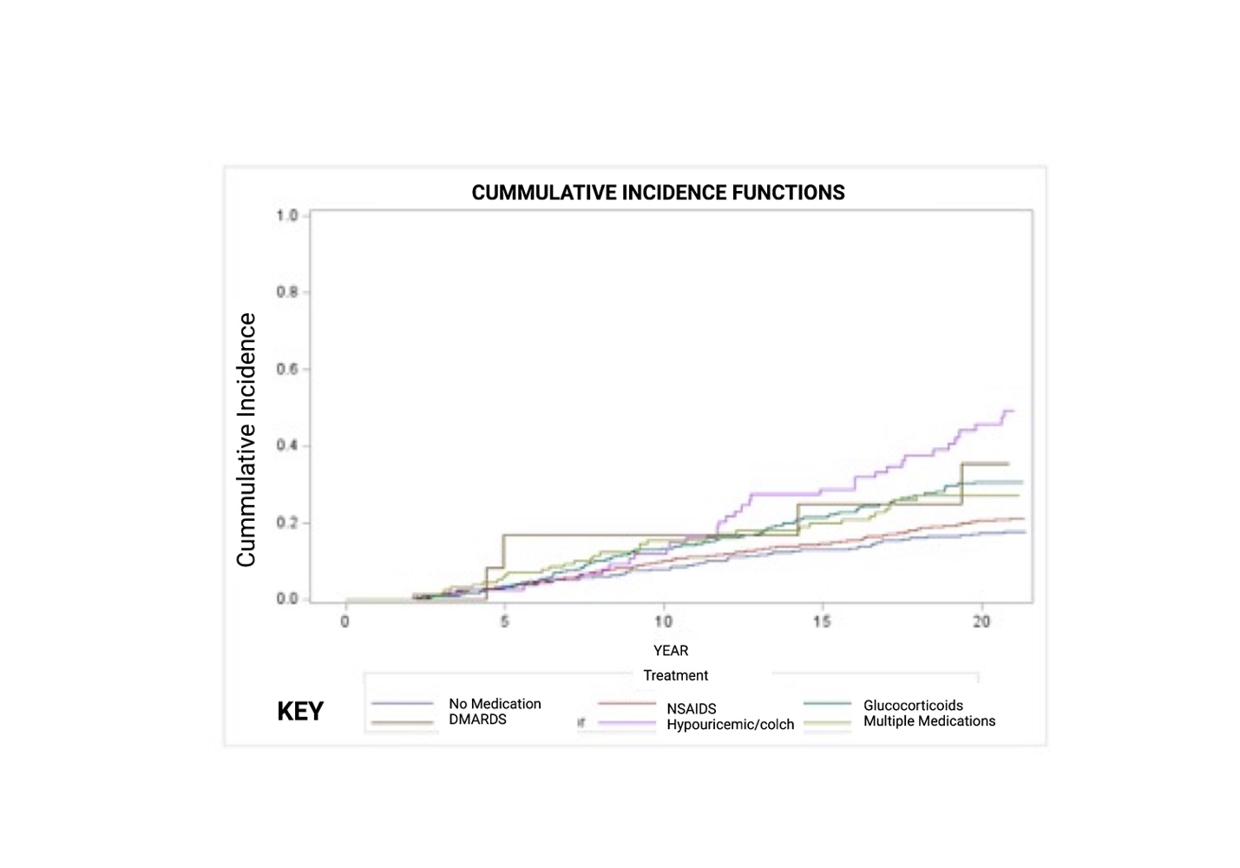

Cumulative incidence curves for CVD compared by exposure group.

**Appendix 3:** Adjusted Hazard Ratios (HR) for CVD events associated with RDT exposure stratified by RD status

|  |  |  |  |  |  |
| --- | --- | --- | --- | --- | --- |
| **Exposure** | **No.** | **HR** | **95%CI** | | **p-value** |
| **Without RD diagnosis** | | | | | |
| Multiple medication | 160 | **1.969** | **1.029** | **3.766** | **0.0379** |
| NSAIDs | 2072 | **1.750** | **1.218** | **2.514** | **0.0030** |
| Glucocorticoids | 529 | **2.464** | **1.640** | **3.701** | **<.0001** |
| DMARDs | 11 | 1.229 | 0.172 | 8.766 | 0.8411 |
| Hypouricemic agents and colchicine | 26 | 2.957 | 0.951 | 9.192 | 0.0626 |
| **With RD diagnosis** | | | | | |
| Multiple medication | 50 | 1.287 | 0.341 | 4.852 | 0.6567 |
| NSAIDs | 144 | 0.936 | 0.263 | 3.324 | 0.9562 |
| Glucocorticoids | 56 | 1.075 | 0.271 | 4.266 | 0.7904 |
| DMARDs | 6 | 1.095 | 0.130 | 9.227 | 0.9427 |
| Hypouricemic agents and colchicine | 79 | 1.779 | 0.341 | 4.852 | 0.3412 |

*Abbreviations –* RD-rheumatic disease, VACS-Veterans aging cohort study, DMARD-disease modifying anti-rheumatic medication, NSAIDS- non-steroidal anti-inflammatory drugs, HR-hazard ratio, CI-confidence interval, No.- number

**Appendix 4: ICD-9 and ICD-10 codes for rheumatic disease (RD)** **conditions**

|  |  |  |
| --- | --- | --- |
| **Rheumatic Disease** | **ICD9** | **ICD10** |
| Gout, Unspecified | 274.9 | M10.9 |
| Other disorders of calcium metabolism | 275.49 | E83.59 |
| Other specified disorders involving the immune mechanism | 279.8 | D89.89 |
| Psoriatic arthropathy | 696.0 | L40.54 |
| Other psoriatic arthropathy | 696.1 | L40.59 |
| SLE | 710 | M32.10 |
| Progressive systemic sclerosis | 710.1 | M34.0 |
| Sjögren syndrome | 710.2 | M35.00 |
| Dermato-polymyositis | 710.3 | M33.90 |
| Systemic involvement of connective tissue, | 710.1 | M35.9 |
| Crystal arthropathy, unspecified | 712.90 | M11.9 |
| Rheumatoid arthritis | 714.0 | M06.9 |
| Unspecified juvenile rheumatoid arthritis | 714.3 | M08.00 |
| Polymyalgia rheumatica | 725 | M35.3 |
| Sicca syndrome | 710.2 | M35.00 |

*Abbreviations –* Systemic Lupus erythematosus, ICD-International Classification for Disease

**Appendix 5: List and codes of rheumatic medication categories used in VA medical system**

|  |  |
| --- | --- |
| **Drug** | **VA class** |
| Immuno-suppressant | IM600 |
| Immunological agents (other) | IM900 |
| Antirheumatics | MS100 |
| Salicylates, antirheumatic | MS101 |
| Non- salicylates, NSAIDs anti-rheumatics | MS102 |
| Anti-gout agents | MS400 |
| Glucocorticoids | HS051 |
| Anti-rheumatics, other | MS190 |
| Anti-neoplastic, antimetabolites | AN300 |
| Sulfonamides /related antimicrobials | AM650 |

**Appendix 6: ICD-9 and ICD-10 codes for cardiovascular disease outcomes**

|  |  |  |
| --- | --- | --- |
| **Diagnosis** | **ICD-9** | **ICD-10** |
| Cardiovascular disease, unspecified | 429.2 | I25.10 |
| Congestive heart failure, unspecified | 428 | I50.9 |
| Acute, but ill-defined, cerebrovascular disease | 436 | I63.9 |
| Cerebral artery occlusion, unspecified with cerebral infarction | 434.91 | I65.29, |
| Occlusion and stenosis of carotid artery without mention of cerebral infarction | 433.1 | I65.23, I67.9 |
| Cerebral atherosclerosis | 437 | I67.2 |
| Peripheral vascular disease, unspecified | 443.9 | I73.9 |
| Angina pectoris | 413 | I20.9 |
| Acute myocardial infarction | 410 | I21.09. I21.3 |
| Old myocardial infarction | 412 | I25.2 |
| Coronary atherosclerosis | 414 | I25.10 |
| Chronic ischemic heart disease, unspecified | 414.9 | I125.9 |

*Abbreviations:*ICD –International Classification for Disease

**Appendix 7: Rheumatic disease diagnoses of study participants included in the study**

|  |  |
| --- | --- |
| **Diagnosis** | **N (%)** |
| Autoimmune hepatitis | 4 (1.1) |
| Biliary Cirrhosis | 4 (1.1) |
| Celiac disease | 4 (1.1) |
| Cholangitis | 6 (1.7) |
| Crohns’ disease unspecified, without complications | 10 (2.8) |
| Crystal arthropathy unspecified | 2 (0.6) |
| Drug Induced Autoimmune hemolytic anemia | 1 (0.3) |
| Gout arthropathy | 225 (62.2) |
| Psoriatic arthropathy | 3 (0.8) |
| Other Psoriasis | 14 (3.8) |
| Psoriasis vulgaris | 8 (2.2) |
| Systemic lupus erythematosus | 2 (0.6) |
| Regional enteritis | 13 (3.5) |
| Rheumatoid arthritis, unspecified | 7 (1.9) |
| Sicca syndrome | 9 (2.5) |
| Systemic Sclerosis | 2 (0.6) |
| Sarcoidosis, unspecified | 9 (2.5) |
| Systemic involvement of connective tissue, unspecified | 1 (0.3) |
| Ulcerative colitis | 17 (4.6) |
| Other hemolytic anemias | 1 (0.3) |
| Other Disorders of Calcium Metabolism | 16 (4.4) |
| Other unspecified disorders involving the immune mechanism | 4 (1.1) |
| **Total** | **362 (100)** |

**Appendix 8:**

Legend: Study flow-diagram showing breakdown of study participants excluded and those included in the analysis classified by medication exposure category.

