Article
Anthropic-induced variability of greenhouse gases and aerosols at the WMO/GAW coastal site of Lamezia Terme (Calabria, Southern Italy): towards a new method to assess the weekly distribution of gathered data
Supplementary Materials
Available Supplementary Materials integrate the plots seen in Fig. 2, 9, 11. Where possible, y axis scales are the same as in the main plots. However, due to the presence of peaks and the need to ensure optimal data visualizations, some scales differ.

Day | CO (ppb) |  |  |  | CO₂ (ppm)
 | Q1 | Mean | Q3 | 97,5% | Q1 | Mean | Q3 | 97,5%
MON | 106.35 | 136.43 | 152.59 | 260.10 | 404.02 | 415.68 | 420.40 | 106.35
TUE | 106.43 | 139.04 | 154.01 | 258.39 | 404.11 | 415.58 | 418.72 | 106.43
WED | 107.74 | 138.70 | 154.17 | 238.25 | 404.71 | 416.43 | 420.02 | 107.74
THU | 108.62 | 141.06 | 154.70 | 270.58 | 404.91 | 416.99 | 423.69 | 108.62
FRI | 108.27 | 138.79 | 153.35 | 251.70 | 404.72 | 417.48 | 421.61 | 108.27
SAT | 110.21 | 140.05 | 154.33 | 267.42 | 404.49 | 415.97 | 422.58 | 110.21
SUN | 110.33 | 139.33 | 156.84 | 263.51 | 404.07 | 416.75 | 424.41 | 110.33
Average | 108.28 | 139.06 | 154.28 | 258.56 | 404.43 | 416.41 | 421.63 | 472.36
Day | CH₄ (ppb) |  |  |  | eBC (μg /m³)
 | Q1 | Mean | Q3 | 97.5% | Q1 | Mean | Q3 | 97.5%
MON | 1903.46 | 1978.81 | 1981.75 | 2415.58 | 0.21 | 0.54 | 0.68 | 1.98
TUE | 1903.27 | 1968.63 | 1975.99 | 2342.59 | 0.20 | 0.52 | 0.67 | 1.90
WED | 1906.86 | 1980.11 | 1985.57 | 2409.22 | 0.21 | 0.56 | 0.72 | 1.96
THU | 1903.80 | 1979.44 | 2001.09 | 2355.90 | 0.23 | 0.60 | 0.77 | 2.18
FRI | 1902.19 | 1977.34 | 1989.57 | 2447.45 | 0.23 | 0.59 | 0.77 | 2.04
SAT | 1905.92 | 1990.56 | 2012.11 | 2468.32 | 0.24 | 0.57 | 0.76 | 1.78
SUN | 1902.87 | 1990.79 | 2022.66 | 2429.00 | 0.24 | 0.54 | 0.69 | 1.66
Average | 1904.05 | 1980.81 | 1995.53 | 2409.72 | 0.22 | 0.56 | 0.72 | 1.93

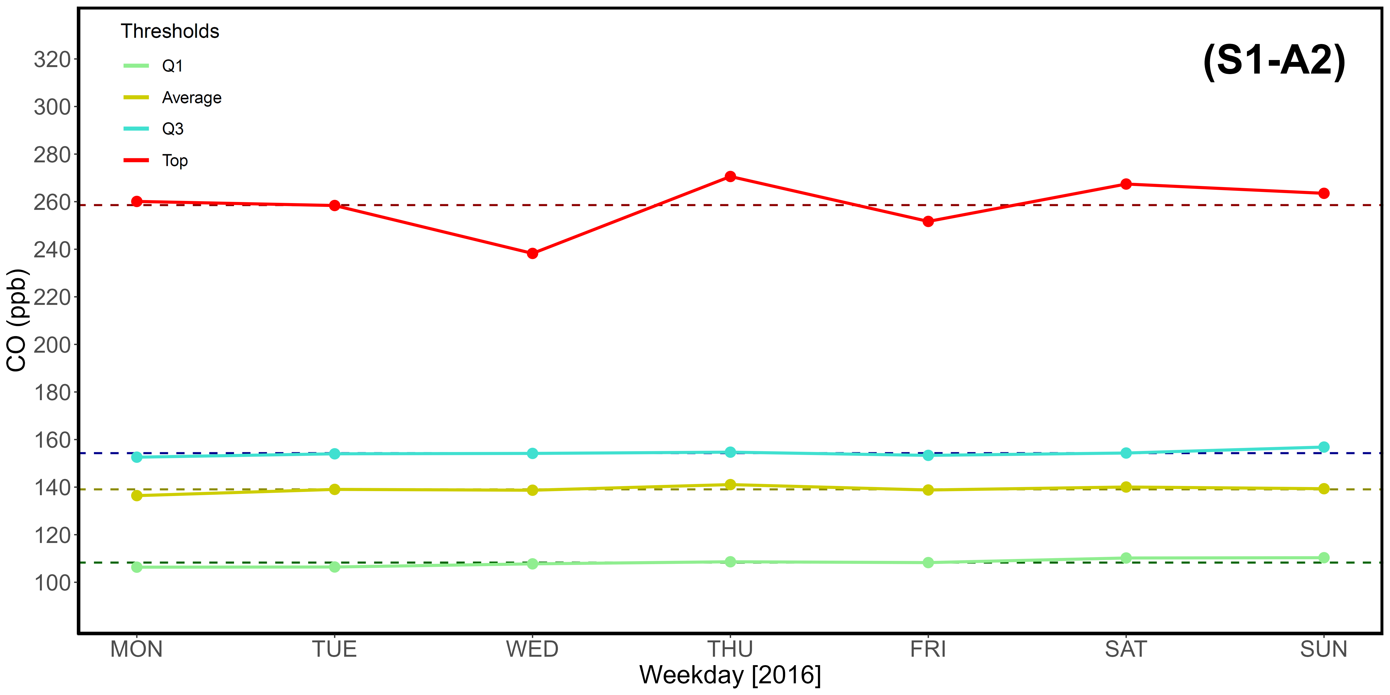
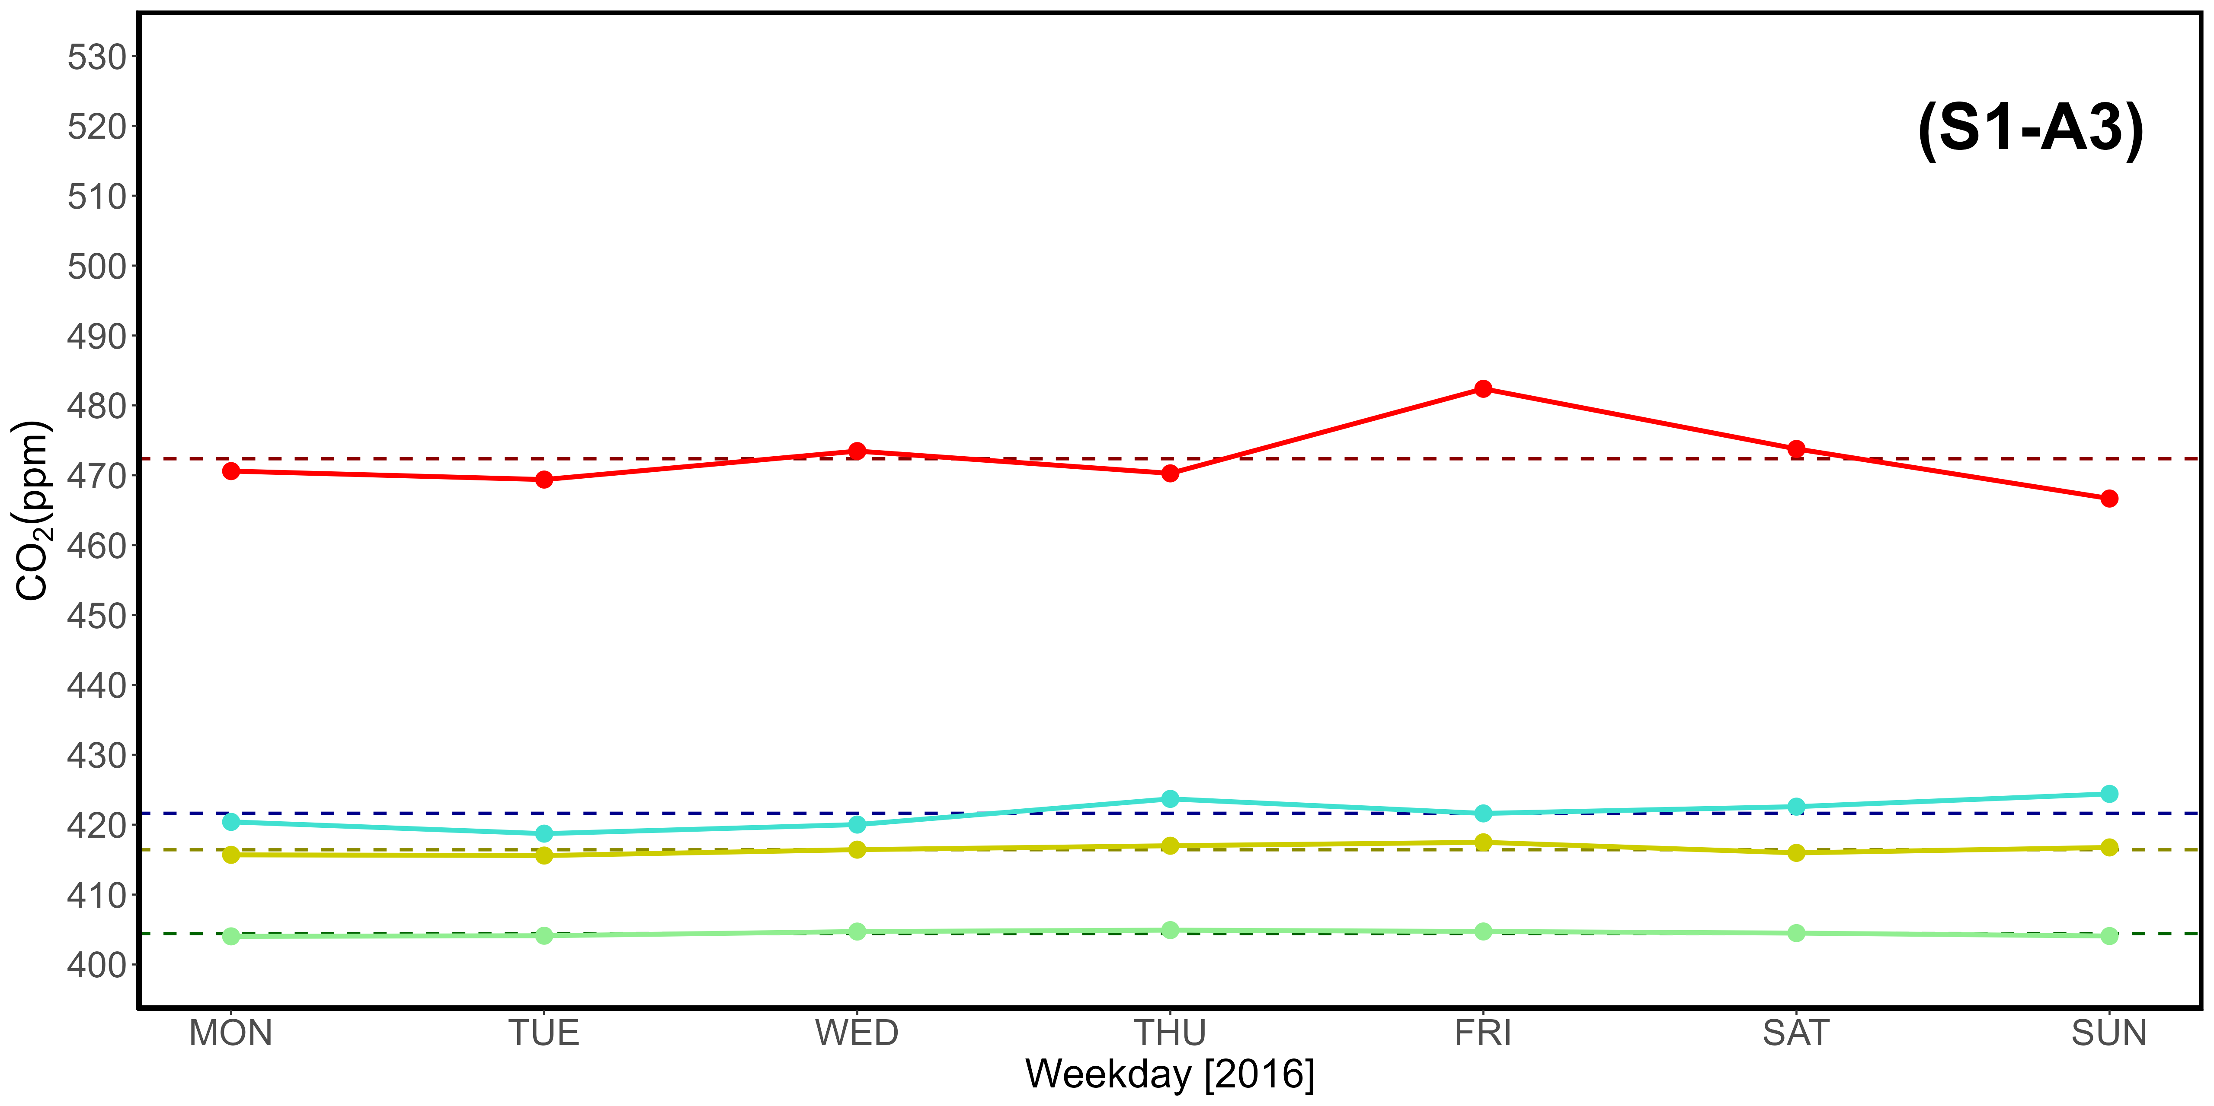
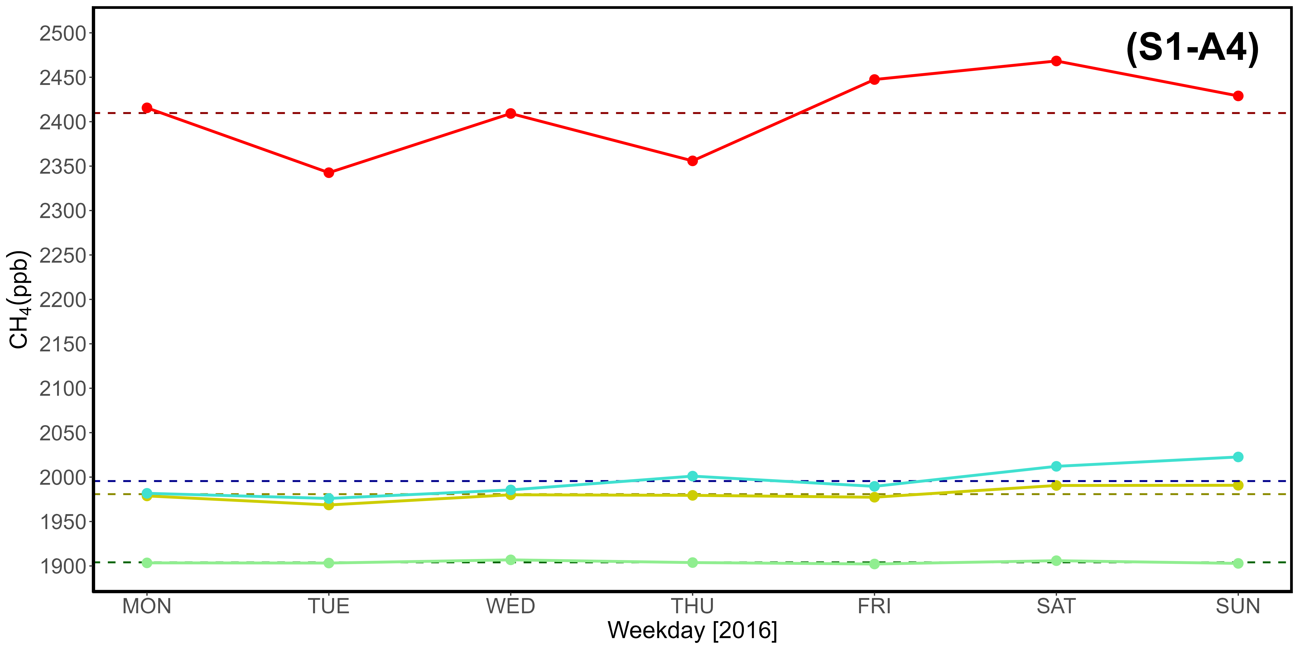
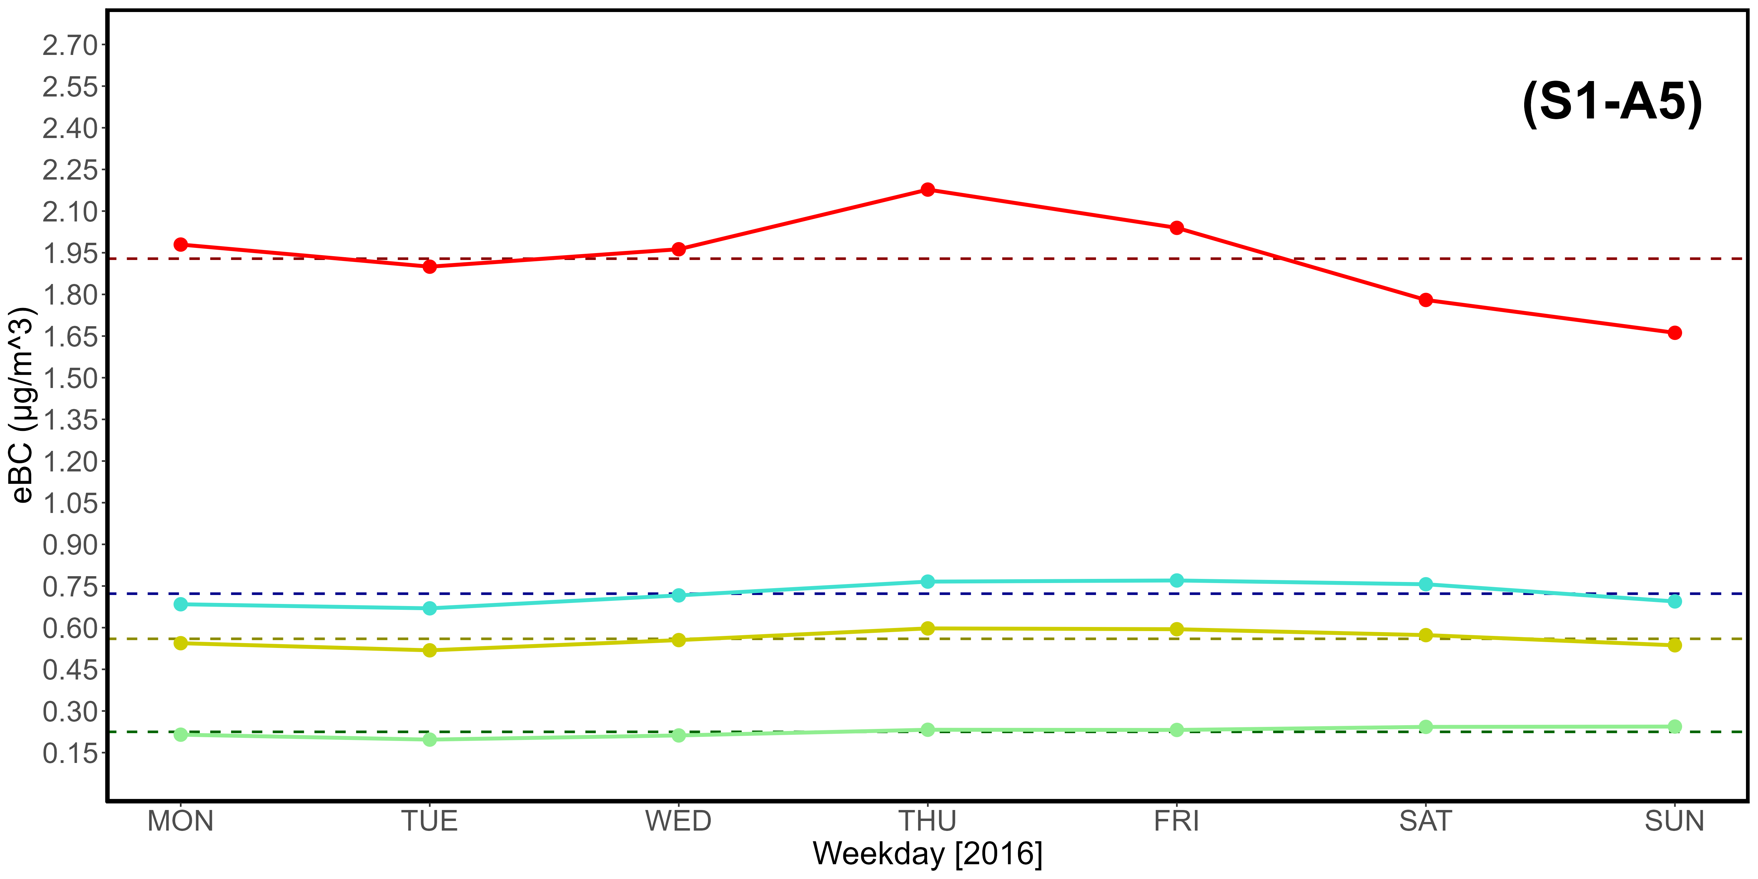
Supplementary Material S1-A1, S1-A2, S1-A3, S1-A4, S1-A5. Table (A1) and CO (A2), CO₂ (A3), CH₄ (A4), eBC (A5) plots reporting key statistical data from 2016.

Day | CO (ppb) |  |  |  | CO₂ (ppm)
 | Q1 | Mean | Q3 | 97,5% | Q1 | Mean | Q3 | 97,5%
MON | 106.21 | 138.71 | 152.52 | 270.23 | 407.45 | 417.68 | 423.99 | 463.85
TUE | 113.61 | 151.87 | 172.22 | 306.33 | 408.85 | 420.81 | 429.41 | 470.51
WED | 114.66 | 155.29 | 177.91 | 322.37 | 408.64 | 420.30 | 428.13 | 471.81
THU | 110.95 | 150.70 | 170.54 | 322.96 | 408.76 | 420.59 | 428.37 | 475.38
FRI | 109.20 | 145.70 | 164.40 | 286.70 | 408.08 | 420.36 | 428.59 | 468.34
SAT | 108.47 | 140.64 | 161.74 | 266.48 | 407.77 | 419.37 | 426.66 | 464.84
SUN | 107.39 | 137.80 | 151.85 | 257.83 | 407.73 | 417.62 | 422.52 | 465.31
Average | 110.07 | 145.82 | 164.46 | 290.41 | 408.18 | 419.53 | 426.81 | 468.58
Day | CH₄ (ppb) |  |  |  | eBC (μg /m³)
 | Q1 | Mean | Q3 | 97.5% | Q1 | Mean | Q3 | 97.5%
MON | 1916.80 | 1990.13 | 2014.95 | 2354.20 | 0.20 | 0.52 | 0.69 | 1.82
TUE | 1920.11 | 2010.88 | 2049.34 | 2422.53 | 0.23 | 0.65 | 0.82 | 2.43
WED | 1922.02 | 2014.32 | 2059.66 | 2409.75 | 0.26 | 0.68 | 0.85 | 2.46
THU | 1916.02 | 2001.81 | 2044.66 | 2374.36 | 0.24 | 0.68 | 0.87 | 2.53
FRI | 1915.64 | 1998.98 | 2031.92 | 2410.75 | 0.28 | 0.67 | 0.86 | 2.29
SAT | 1915.57 | 1990.79 | 2020.57 | 2379.65 | 0.25 | 0.59 | 0.77 | 2.10
SUN | 1912.92 | 1990.34 | 2000.80 | 2411.97 | 0.19 | 0.50 | 0.65 | 1.85
Average | 1917.01 | 1999.61 | 2031.70 | 2394.74 | 0.23 | 0.61 | 0.79 | 2.21

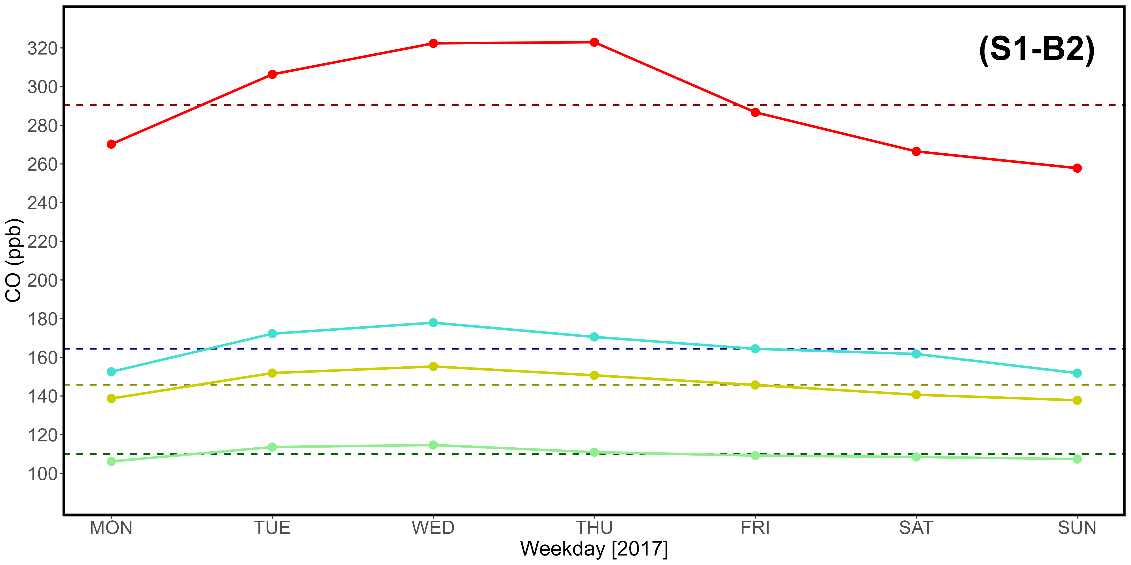
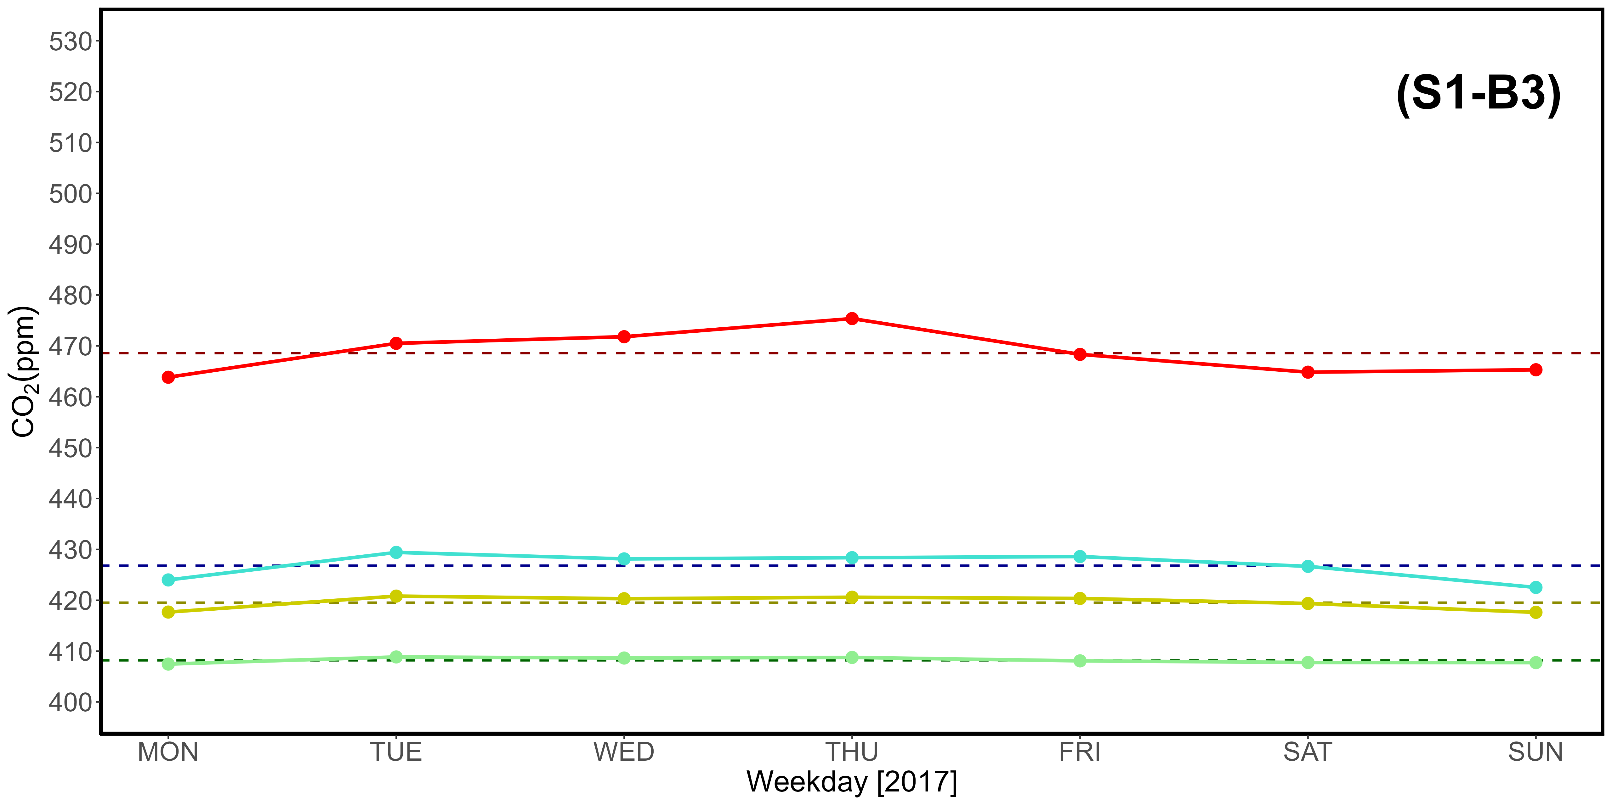
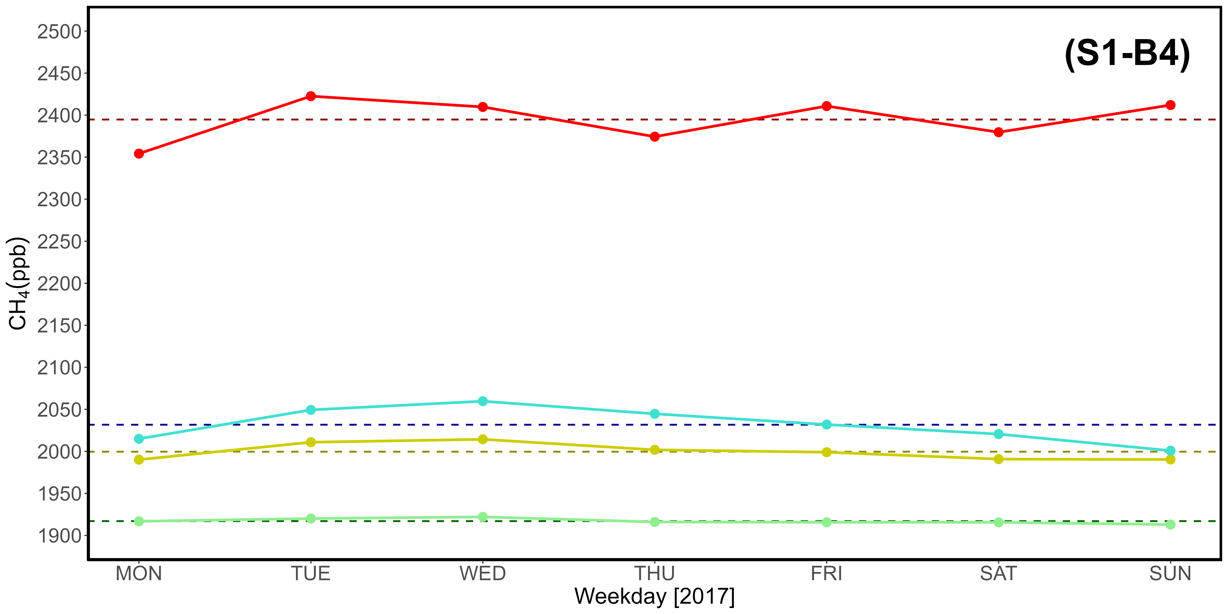
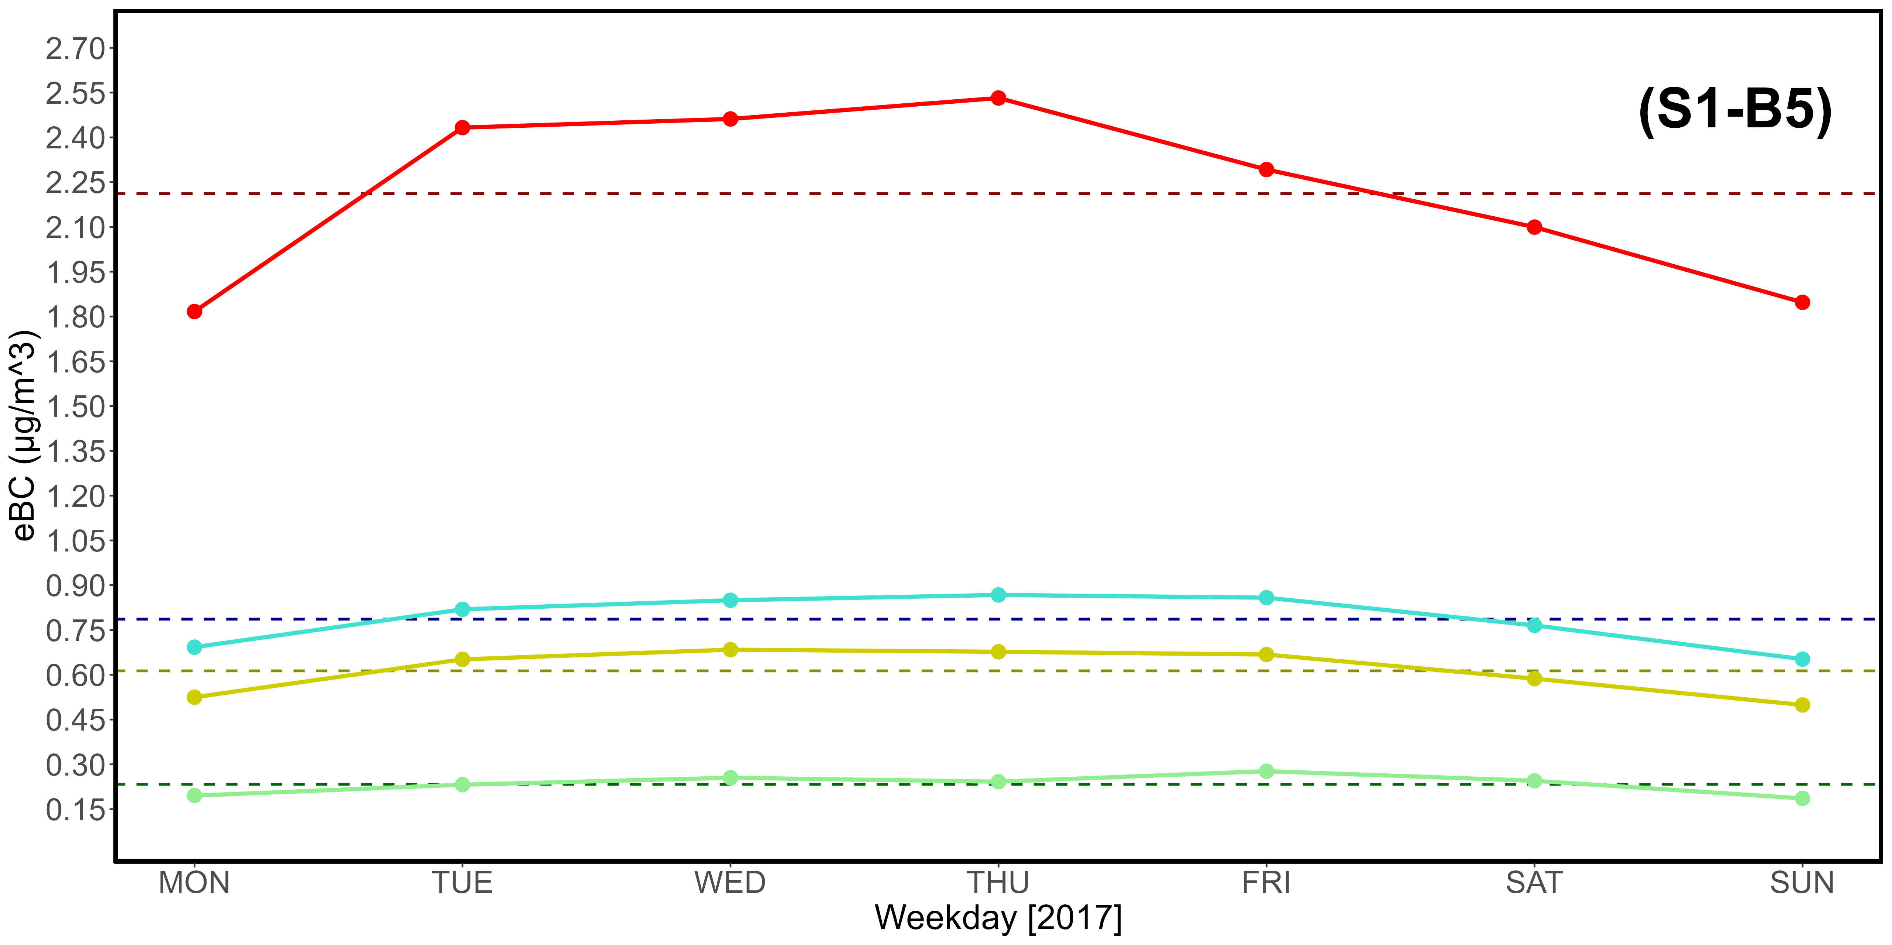
Supplementary Material S1-B1, S1-B2, S1-B3, S1-B4, S1-B5. Table (B1) and CO (B2), CO₂ (B3), CH₄ (B4), eBC (B5) plots reporting key statistical data from 2017.

Day | CO (ppb) |  |  |  | CO₂ (ppm)
 | Q1 | Mean | Q3 | 97,5% | Q1 | Mean | Q3 | 97,5%
MON | 101.61 | 133.27 | 145.34 | 267.16 | 410.81 | 421.85 | 426.50 | 477.53
TUE | 106.47 | 129.75 | 141.37 | 244.81 | 410.55 | 422.07 | 426.31 | 480.91
WED | 108.09 | 138.08 | 155.51 | 272.12 | 410.32 | 422.61 | 429.61 | 474.66
THU | 105.34 | 142.03 | 163.85 | 283.64 | 410.59 | 425.05 | 431.63 | 491.24
FRI | 106.51 | 141.55 | 158.27 | 281.63 | 410.17 | 423.84 | 431.08 | 481.52
SAT | 104.56 | 142.24 | 161.77 | 309.84 | 410.16 | 422.12 | 429.07 | 473.98
SUN | 104.99 | 136.70 | 149.09 | 288.21 | 410.57 | 422.66 | 429.24 | 477.58
Average | 105.37 | 137.66 | 153.60 | 278.20 | 410.45 | 422.88 | 429.06 | 479.63
Day | CH₄ (ppb) |  |  |  | eBC (μg /m³)
 | Q1 | Mean | Q3 | 97.5% | Q1 | Mean | Q3 | 97.5%
MON | 1920.83 | 1982.60 | 1999.77 | 2333.10 | 0.18 | 0.49 | 0.66 | 1.67
TUE | 1926.60 | 1985.23 | 2011.45 | 2285.26 | 0.18 | 0.47 | 0.64 | 1.71
WED | 1926.68 | 2000.82 | 2011.47 | 2365.85 | 0.17 | 0.51 | 0.65 | 1.91
THU | 1929.33 | 2001.52 | 2033.16 | 2348.89 | 0.20 | 0.57 | 0.71 | 2.28
FRI | 1924.06 | 2003.79 | 2022.46 | 2388.47 | 0.25 | 0.60 | 0.77 | 2.13
SAT | 1925.71 | 1990.84 | 2017.04 | 2315.30 | 0.22 | 0.53 | 0.66 | 1.79
SUN | 1926.47 | 1997.61 | 2014.06 | 2377.84 | 0.21 | 0.51 | 0.67 | 1.81
Average | 1925.67 | 1994.63 | 2015.63 | 2344.96 | 0.20 | 0.53 | 0.68 | 1.90

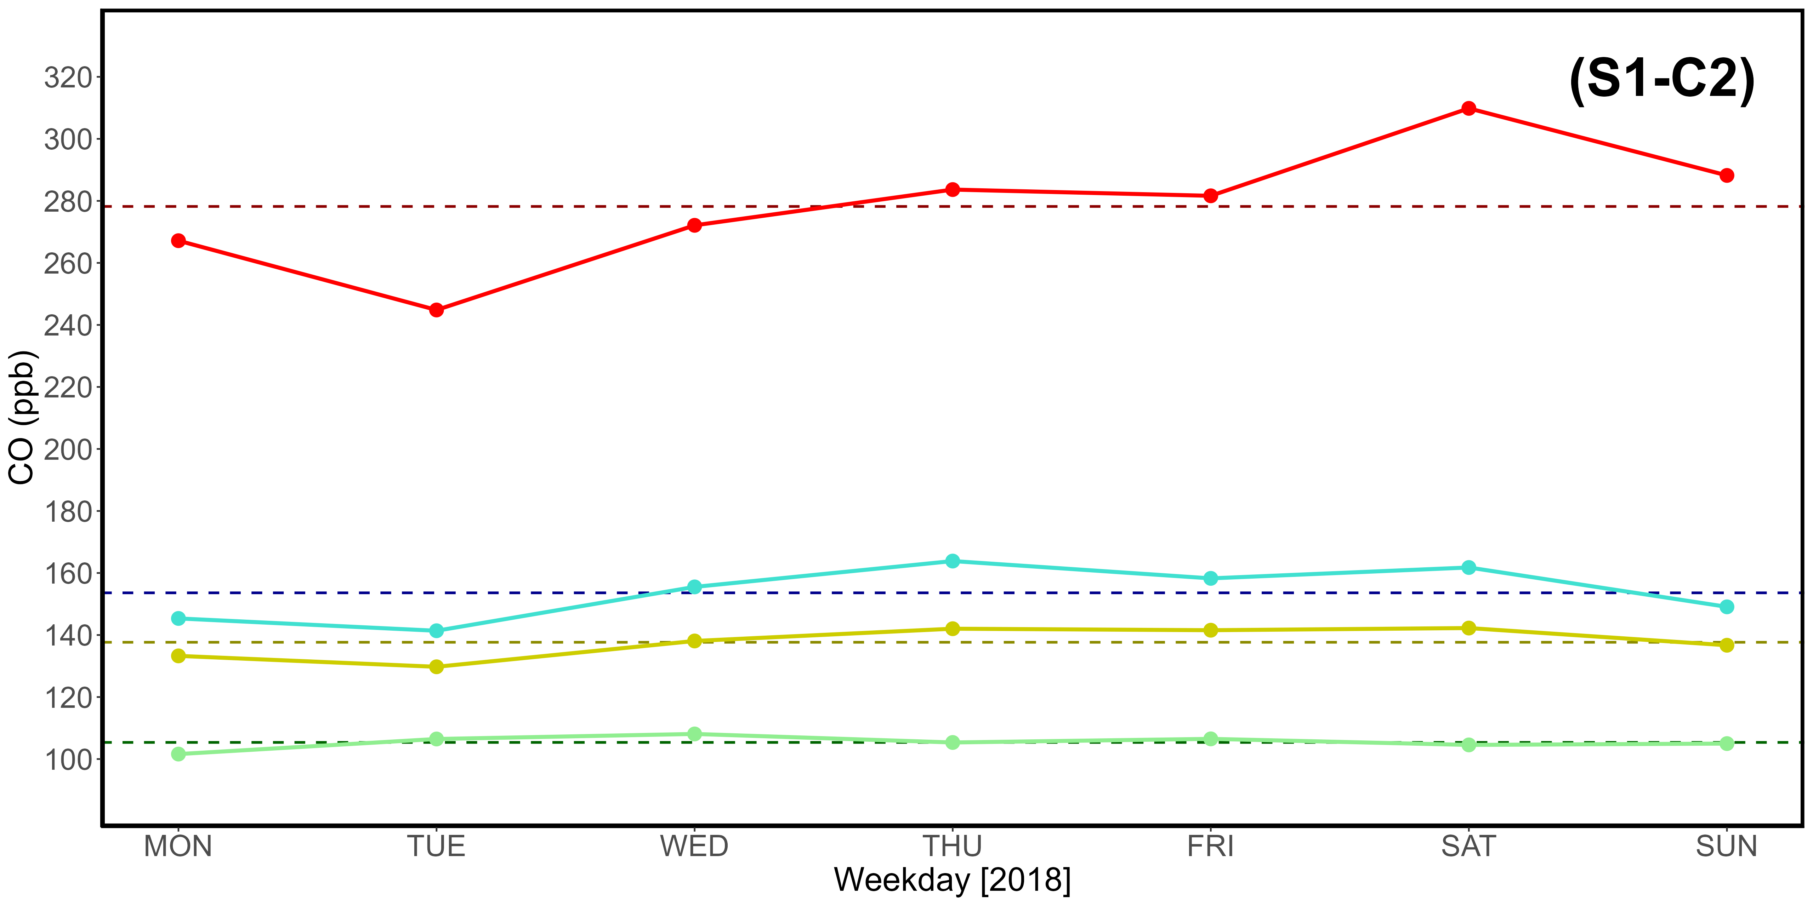
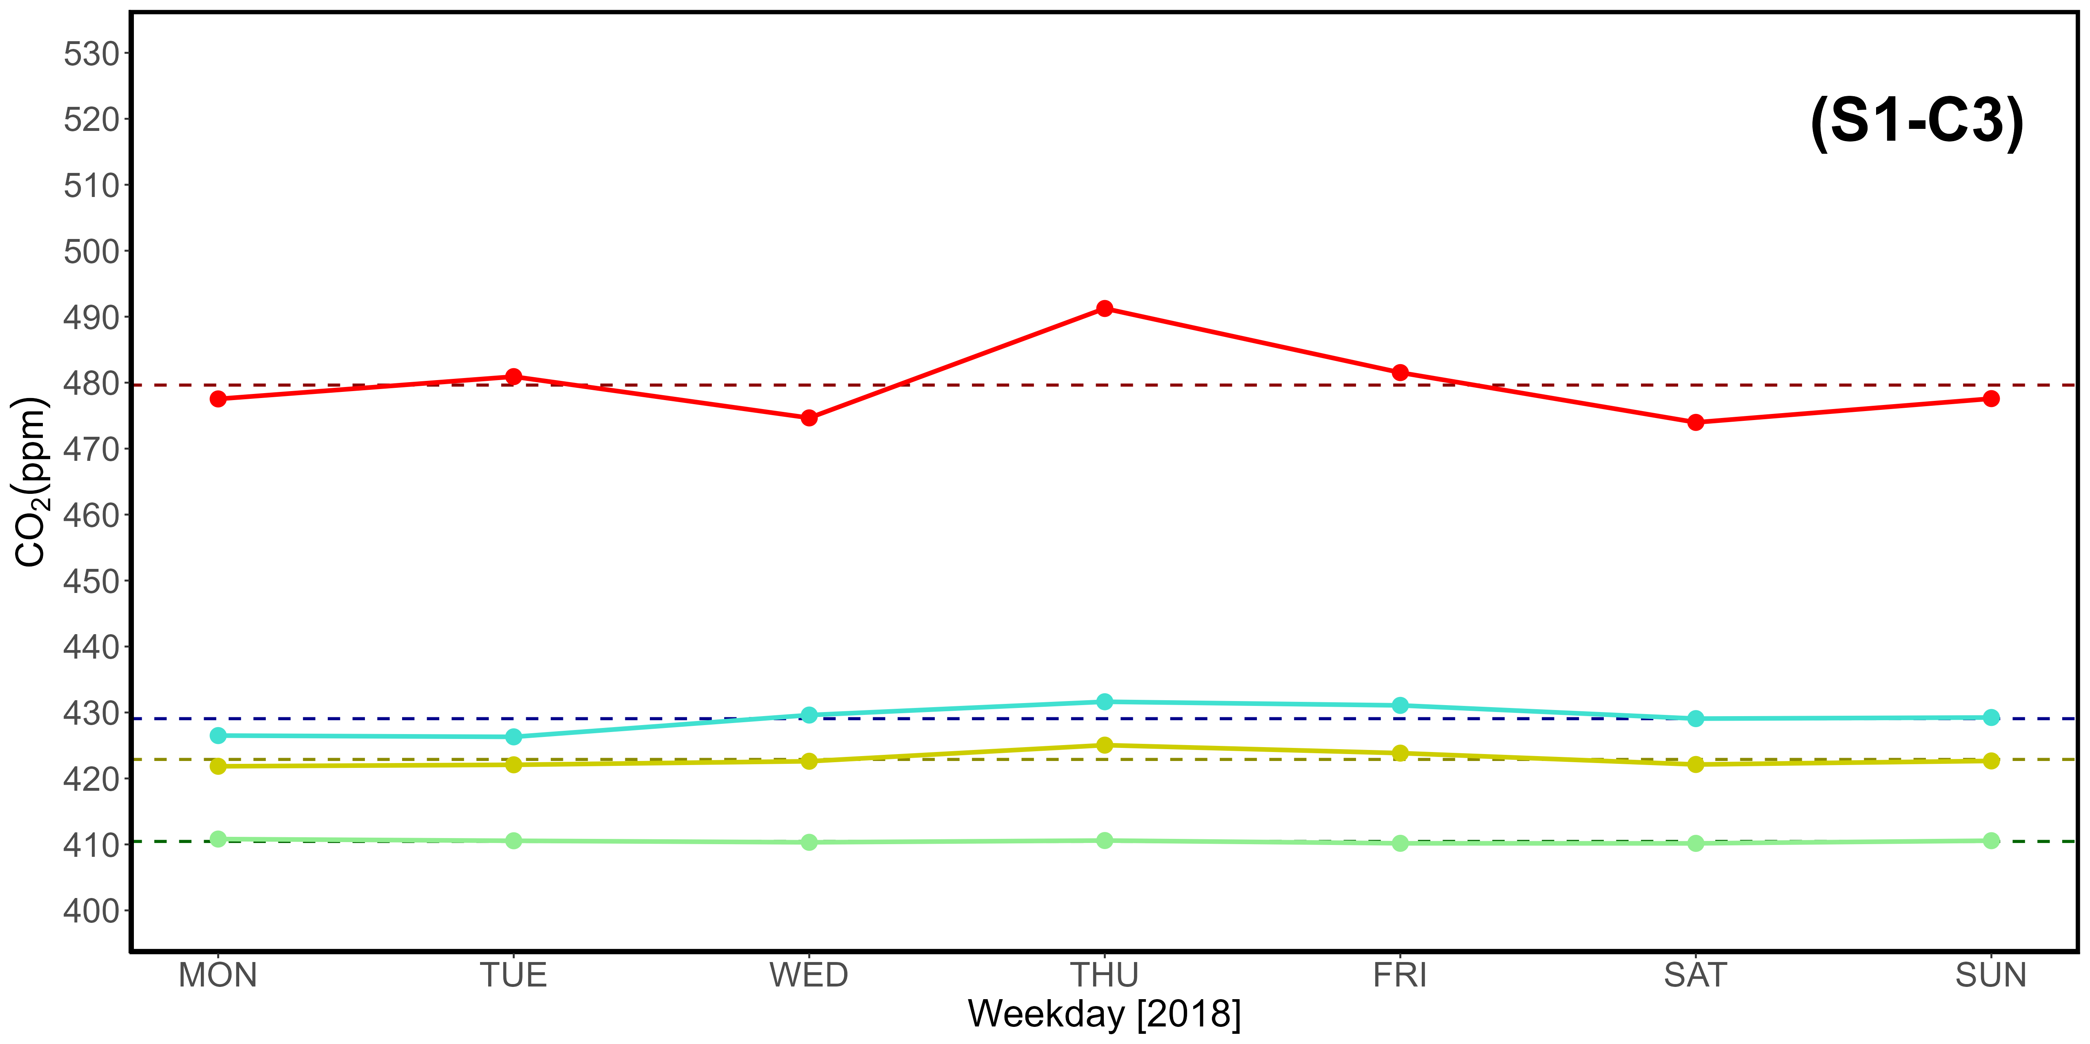
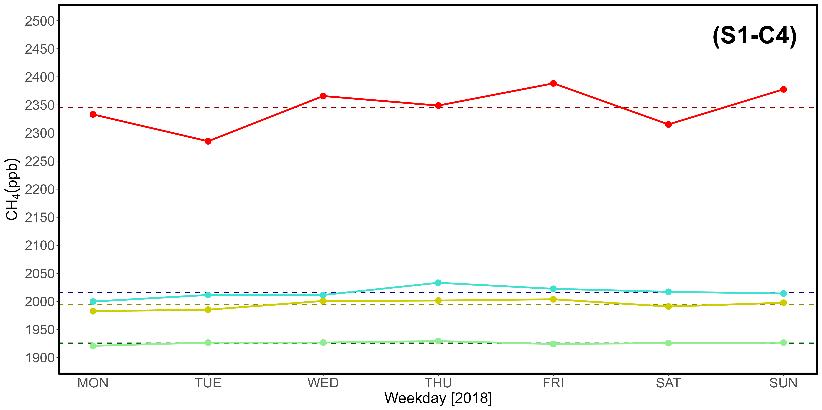
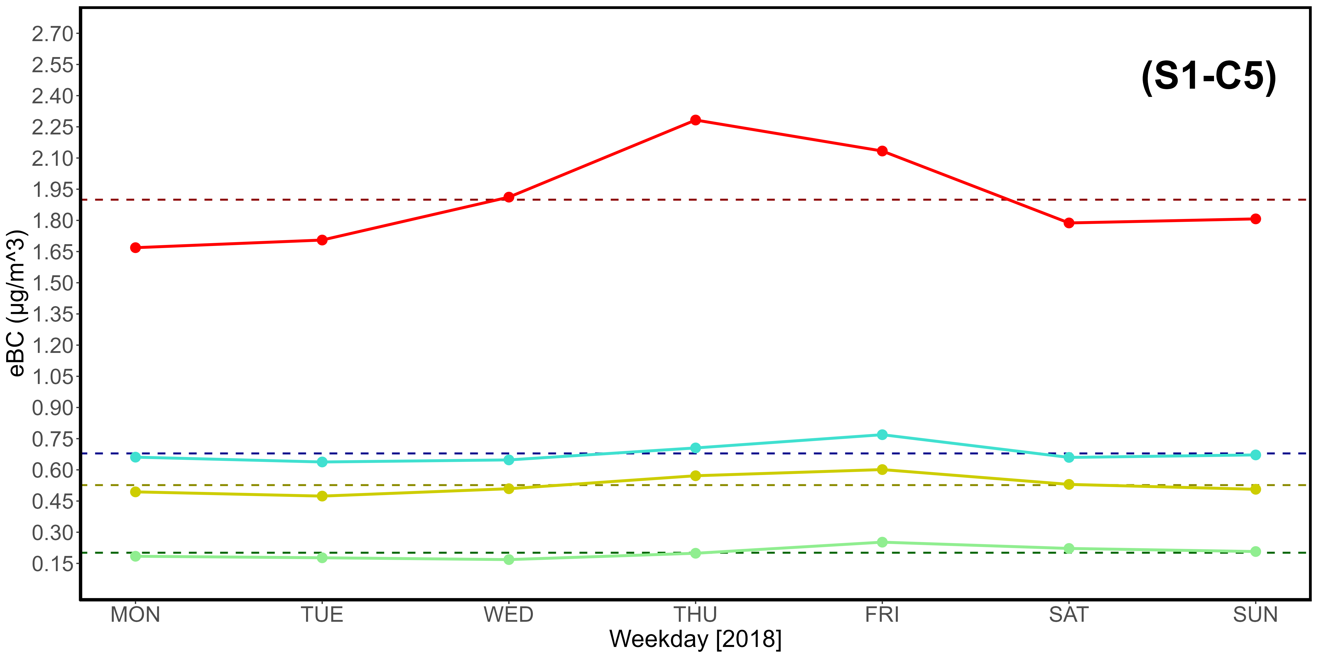
Supplementary Material S1-C1, S1-C2, S1-C3, S1-C4, S1-C5. Table (C1) and CO (C2), CO₂ (C3), CH₄ (C4), eBC (C5) plots reporting key statistical data from 2018.

Day | CO (ppb) |  |  |  | CO₂ (ppm)
 | Q1 | Mean | Q3 | 97,5% | Q1 | Mean | Q3 | 97,5%
MON | 101.39 | 136.83 | 146.03 | 306.71 | 413.43 | 424.02 | 430.53 | 468.84
TUE | 103.43 | 137.69 | 145.14 | 324.31 | 413.38 | 424.28 | 430.75 | 467.70
WED | 100.67 | 135.68 | 147.55 | 279.31 | 413.40 | 425.12 | 430.76 | 477.65
THU | 102.32 | 134.95 | 151.50 | 264.09 | 413.52 | 425.48 | 434.77 | 474.87
FRI | 101.13 | 138.15 | 155.00 | 269.54 | 413.50 | 427.26 | 437.72 | 479.76
SAT | 102.49 | 134.45 | 149.93 | 278.83 | 413.84 | 424.97 | 430.82 | 474.37
SUN | 100.54 | 138.79 | 152.12 | 322.91 | 413.32 | 424.91 | 431.80 | 476.82
Average | 101.71 | 136.65 | 149.61 | 292.24 | 413.48 | 425.15 | 432.45 | 474.29
Day | CH₄ (ppb) |  |  |  | eBC (μg /m³)
 | Q1 | Mean | Q3 | 97.5% | Q1 | Mean | Q3 | 97.5%
MON | 1938.15 | 1998.40 | 2023.30 | 2273.00 | 0.20 | 0.52 | 0.69 | 2.04
TUE | 1940.68 | 1998.87 | 2018.91 | 2296.83 | 0.17 | 0.50 | 0.63 | 1.91
WED | 1939.44 | 1999.80 | 2021.11 | 2295.95 | 0.18 | 0.52 | 0.70 | 1.74
THU | 1938.36 | 2004.34 | 2033.69 | 2312.14 | 0.21 | 0.53 | 0.72 | 1.53
FRI | 1941.02 | 2013.78 | 2053.17 | 2324.75 | 0.26 | 0.58 | 0.76 | 1.69
SAT | 1937.49 | 2000.19 | 2024.11 | 2284.75 | 0.23 | 0.53 | 0.68 | 1.83
SUN | 1939.35 | 2001.51 | 2021.25 | 2308.78 | 0.19 | 0.52 | 0.68 | 1.81
Average | 1939.21 | 2002.41 | 2027.93 | 2299.46 | 0.21 | 0.53 | 0.69 | 1.79

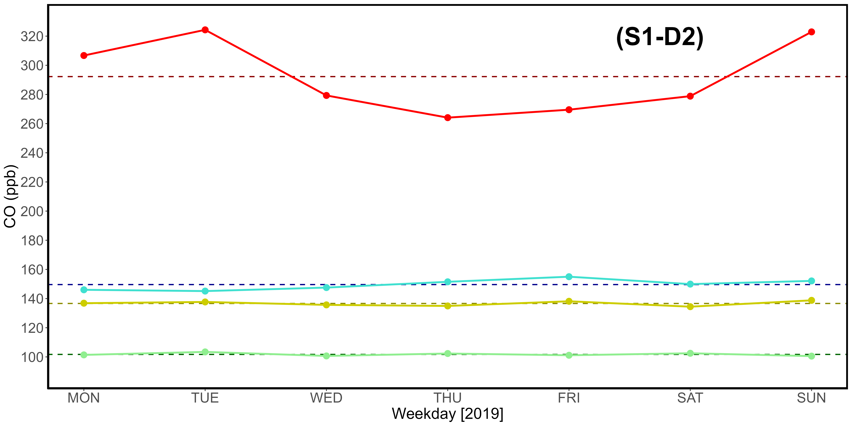
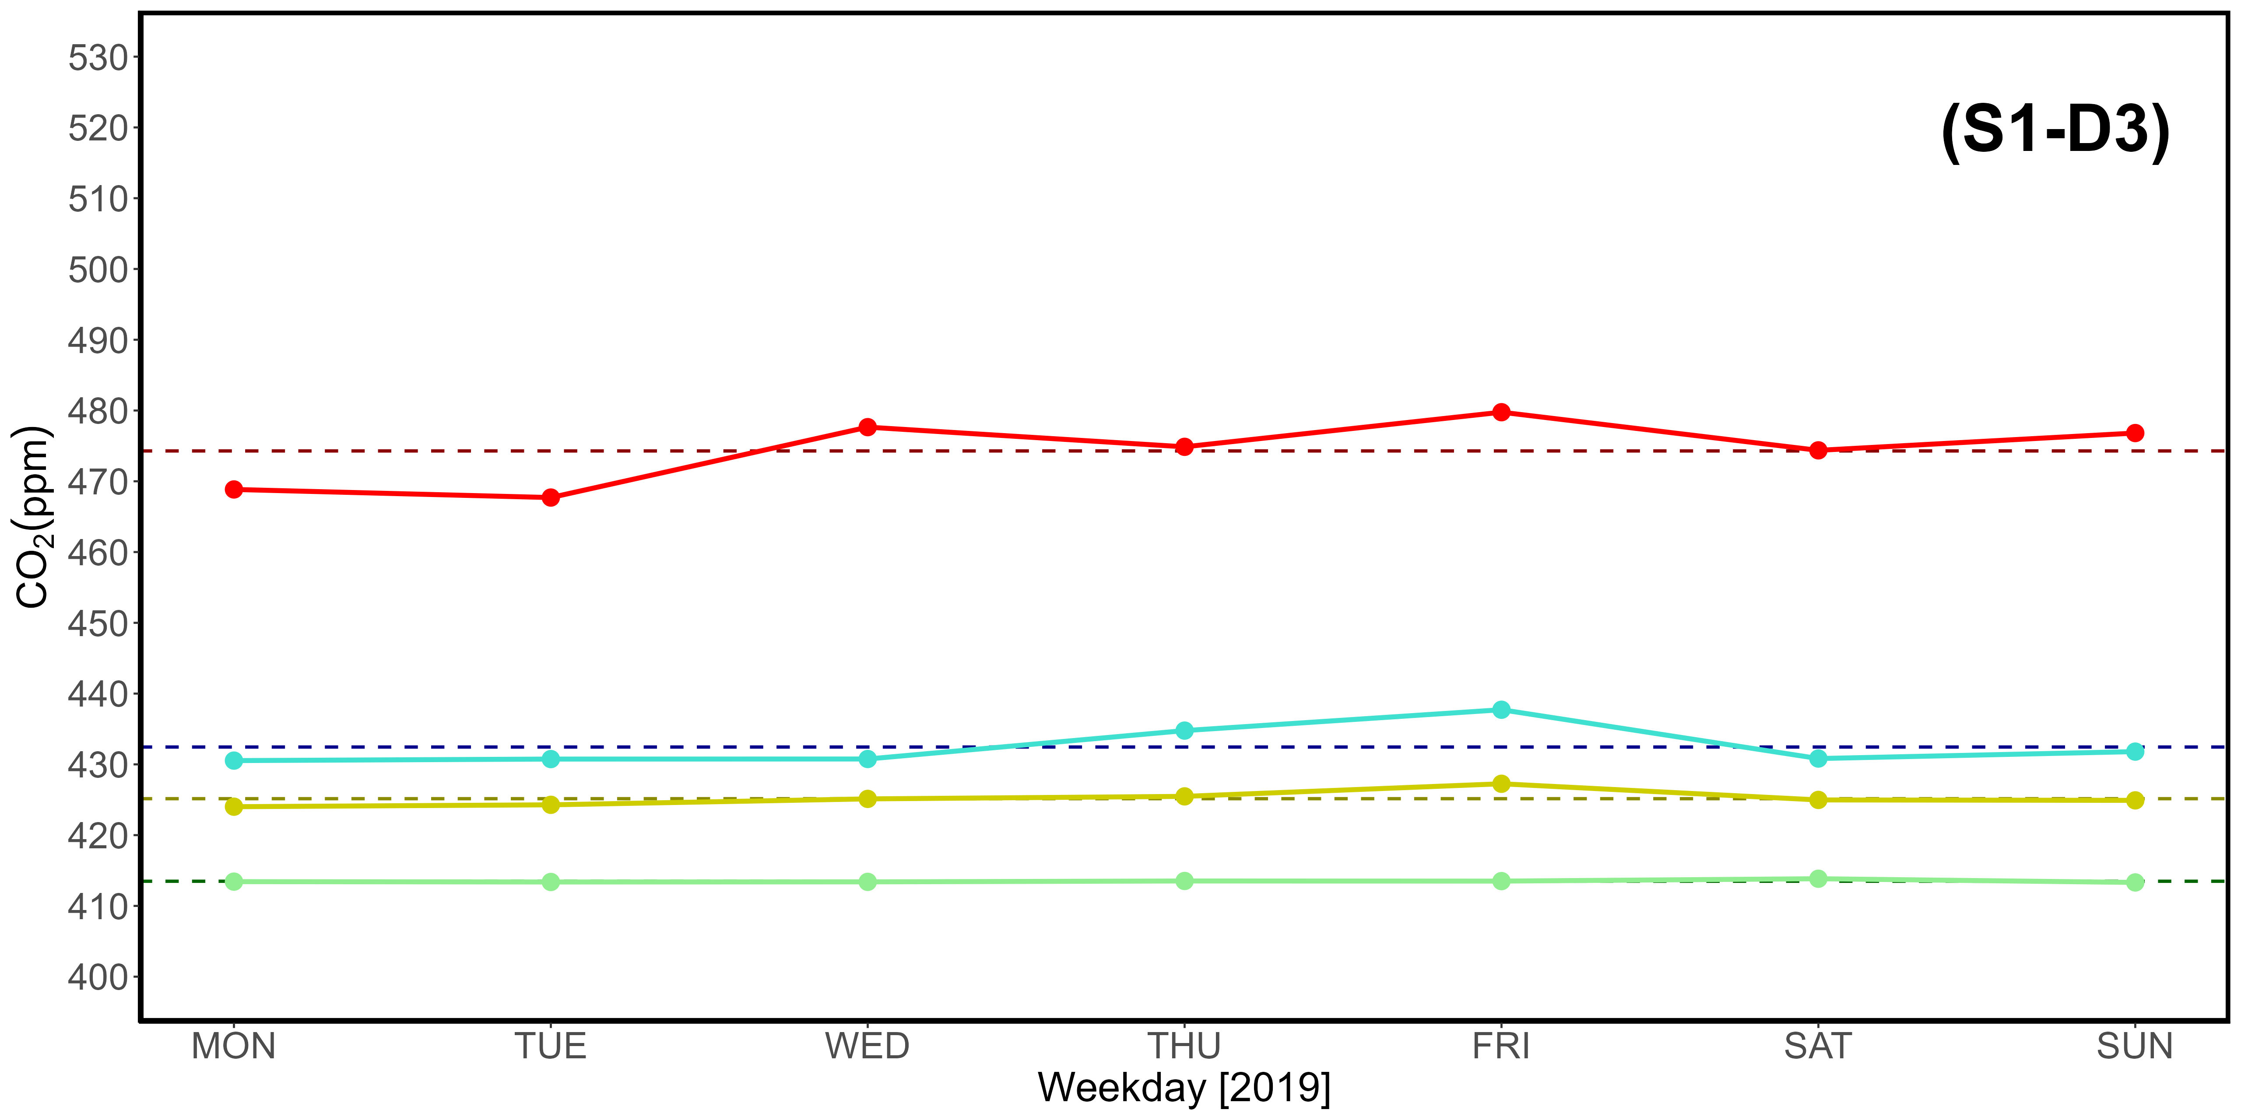
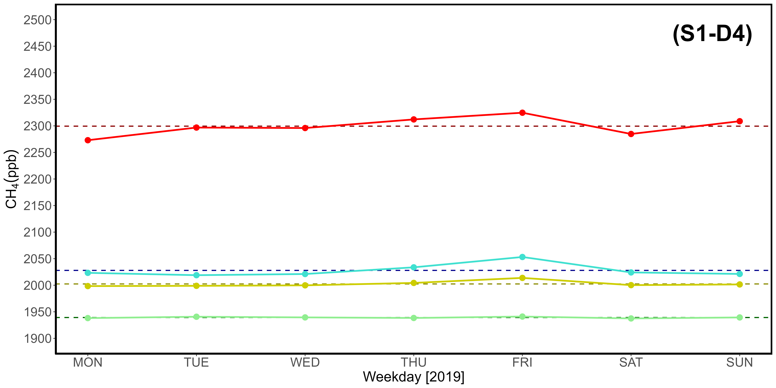
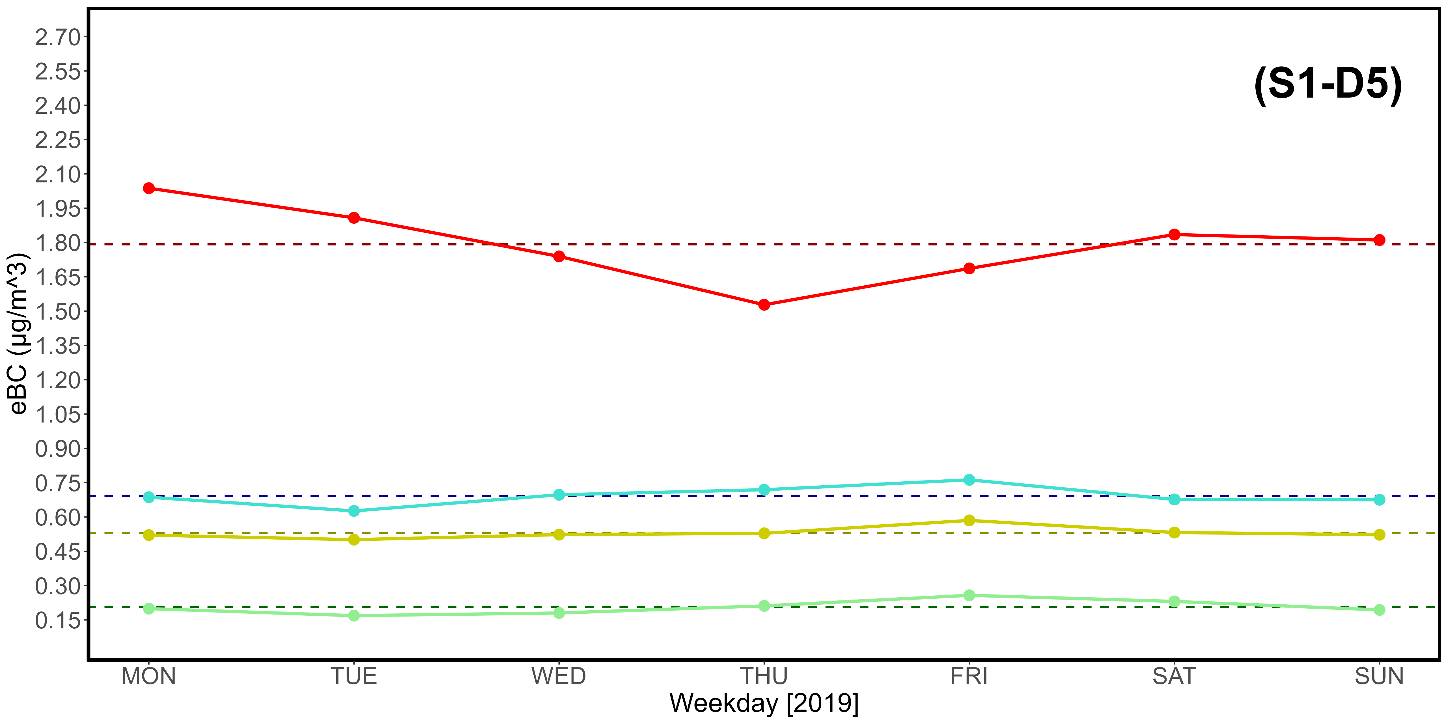
Supplementary Material S1-D1, S1-D2, S1-D3, S1-D4, S1-D5. Table (D1) and CO (D2), CO₂ (D3), CH₄ (D4), eBC (D5) plots reporting key statistical data from 2019.

Day | CO (ppb) |  |  |  | CO₂ (ppm)
 | Q1 | Mean | Q3 | 97,5% | Q1 | Mean | Q3 | 97,5%
MON | 97.41 | 131.24 | 150.96 | 258.22 | 415.93 | 429.41 | 439.30 | 487.63
TUE | 97.87 | 132.78 | 155.84 | 251.99 | 415.59 | 427.93 | 437.04 | 472.34
WED | 98.90 | 132.53 | 150.77 | 291.72 | 415.39 | 428.82 | 439.88 | 488.59
THU | 99.02 | 130.73 | 148.33 | 273.93 | 415.79 | 428.38 | 437.50 | 476.55
FRI | 99.66 | 135.37 | 159.34 | 248.47 | 415.99 | 430.84 | 442.04 | 486.58
SAT | 100.78 | 132.88 | 151.94 | 253.71 | 415.47 | 429.90 | 439.81 | 482.81
SUN | 96.78 | 127.69 | 145.50 | 247.67 | 415.80 | 428.80 | 438.58 | 481.09
Average | 98.63 | 131.89 | 151.81 | 260.82 | 415.71 | 429.15 | 439.16 | 482.23
Day | CH₄ (ppb) |  |  |  | eBC (μg /m³)
 | Q1 | Mean | Q3 | 97.5% | Q1 | Mean | Q3 | 97.5%
MON | 1954.90 | 2016.09 | 2045.54 | 2278.83 | 0.20 | 0.54 | 0.66 | 1.99
TUE | 1954.78 | 2015.29 | 2050.87 | 2281.75 | 0.20 | 0.51 | 0.67 | 1.75
WED | 1951.42 | 2017.34 | 2063.66 | 2259.46 | 0.16 | 0.51 | 0.67 | 1.86
THU | 1956.44 | 2012.40 | 2044.94 | 2246.47 | 0.14 | 0.50 | 0.68 | 1.94
FRI | 1959.05 | 2028.11 | 2069.62 | 2326.06 | 0.22 | 0.56 | 0.73 | 1.76
SAT | 1958.27 | 2023.15 | 2068.97 | 2263.25 | 0.23 | 0.53 | 0.70 | 1.79
SUN | 1955.75 | 2018.29 | 2050.70 | 2308.21 | 0.16 | 0.47 | 0.62 | 1.65
Average | 1955.80 | 2018.67 | 2056.33 | 2280.58 | 0.19 | 0.52 | 0.68 | 1.82

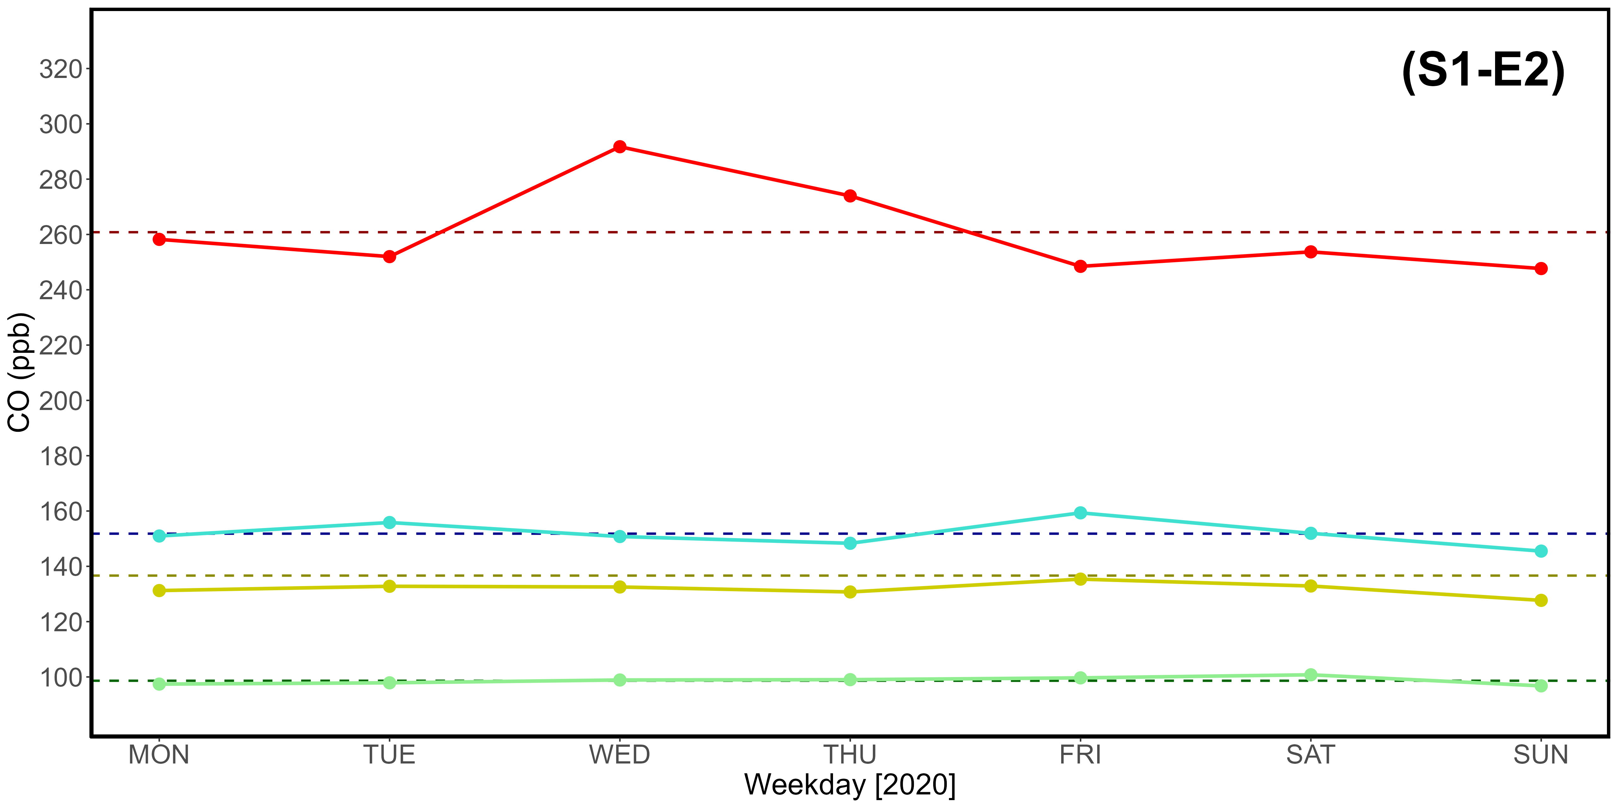
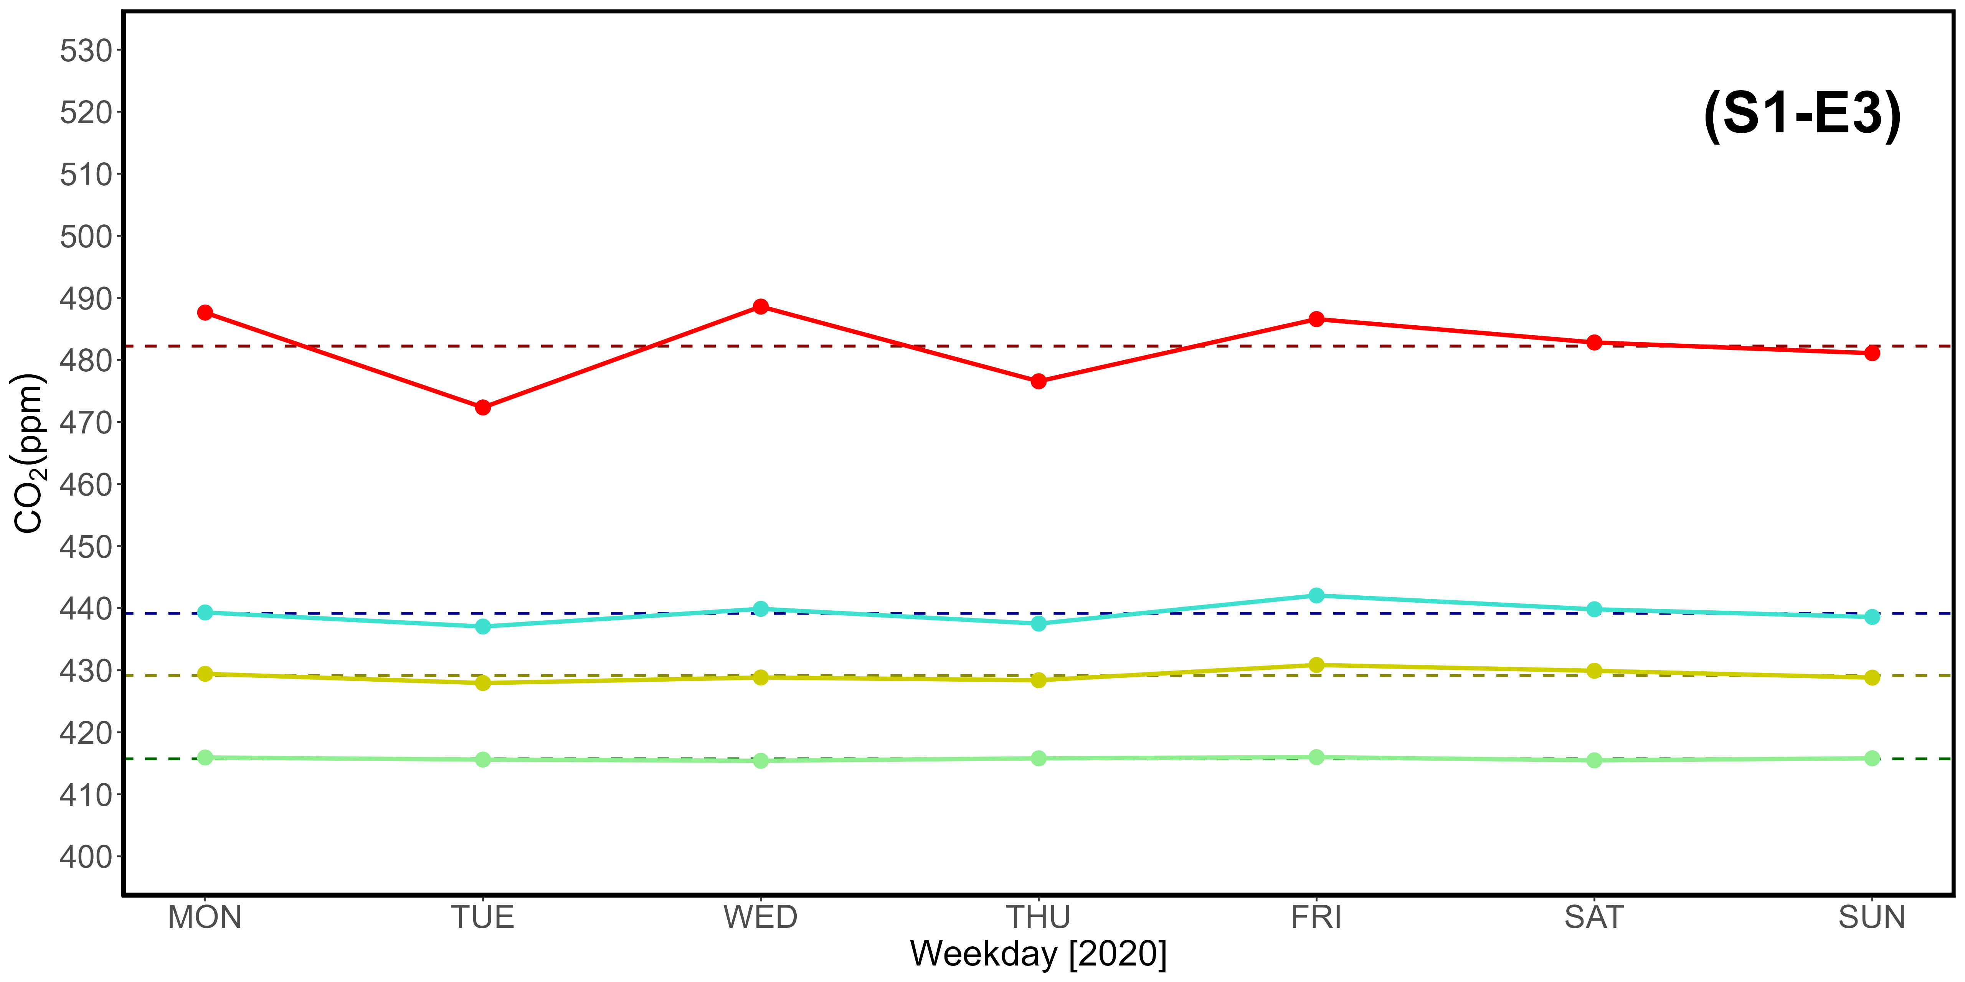
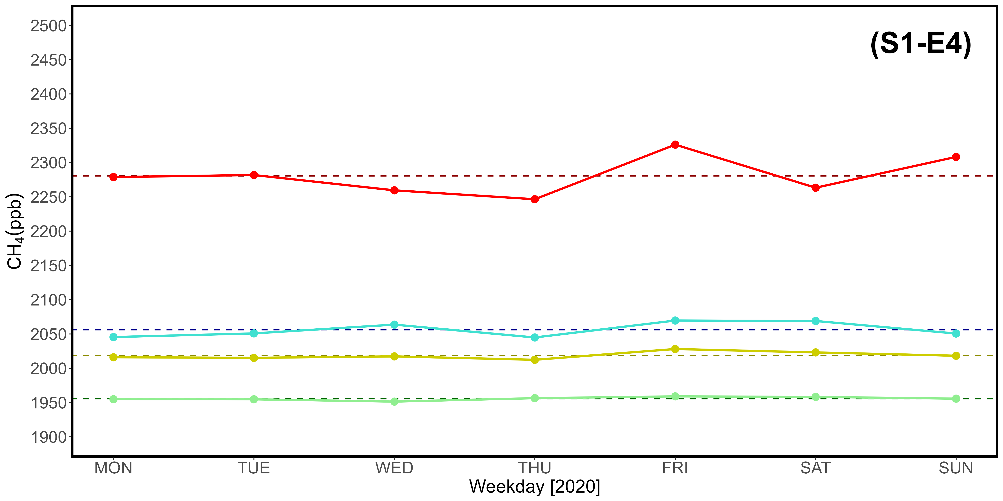
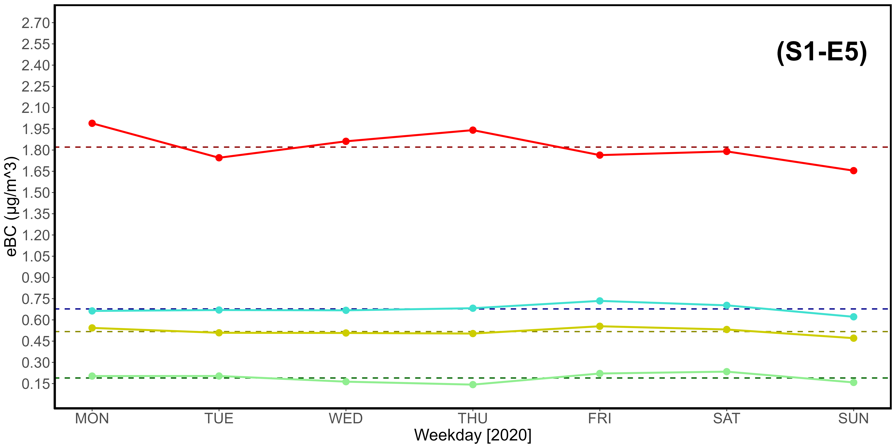
Supplementary Material S1-E1, S1-E2, S1-E3, S1-E4, S1-E5. Table (E1) and CO (E2), CO₂ (E3), CH₄ (E4), eBC (E5) plots reporting key statistical data from 2020.

Day | CO (ppb) |  |  |  | CO₂ (ppm)
 | Q1 | Mean | Q3 | 97,5% | Q1 | Mean | Q3 | 97,5%
MON | 104.12 | 130.31 | 148.01 | 236.72 | 418.61 | 429.59 | 434.17 | 479.73
TUE | 106.20 | 133.64 | 151.85 | 246.55 | 419.24 | 431.67 | 440.75 | 480.31
WED | 104.66 | 133.54 | 147.64 | 250.96 | 419.68 | 431.67 | 437.63 | 486.00
THU | 103.90 | 134.65 | 148.81 | 249.34 | 419.07 | 431.50 | 439.32 | 486.43
FRI | 105.27 | 132.78 | 148.88 | 235.43 | 418.75 | 430.91 | 438.65 | 483.81
SAT | 101.63 | 130.58 | 146.66 | 230.53 | 418.75 | 430.54 | 436.53 | 482.03
SUN | 103.39 | 131.16 | 150.19 | 234.27 | 418.64 | 431.89 | 438.53 | 487.52
Average | 104.17 | 132.38 | 148.86 | 240.54 | 418.96 | 431.11 | 437.94 | 483.69
Day | CH₄ (ppb) |  |  |  | eBC (μg /m³)
 | Q1 | Mean | Q3 | 97.5% | Q1 | Mean | Q3 | 97.5%
MON | 1977.00 | 2034.57 | 2052.61 | 2312.60 | 0.16 | 0.41 | 0.52 | 1.38
TUE | 1975.14 | 2042.80 | 2078.75 | 2329.89 | 0.17 | 0.44 | 0.58 | 1.48
WED | 1972.99 | 2041.45 | 2068.12 | 2369.94 | 0.18 | 0.47 | 0.57 | 1.72
THU | 1973.87 | 2039.90 | 2069.05 | 2324.97 | 0.20 | 0.49 | 0.64 | 1.76
FRI | 1981.12 | 2041.73 | 2070.33 | 2335.98 | 0.22 | 0.48 | 0.62 | 1.57
SAT | 1978.04 | 2041.21 | 2063.26 | 2368.47 | 0.20 | 0.44 | 0.54 | 1.46
SUN | 1975.25 | 2043.87 | 2076.30 | 2334.57 | 0.19 | 0.42 | 0.54 | 1.46
Average | 1976.20 | 2040.79 | 2068.35 | 2339.49 | 0.19 | 0.45 | 0.57 | 1.55

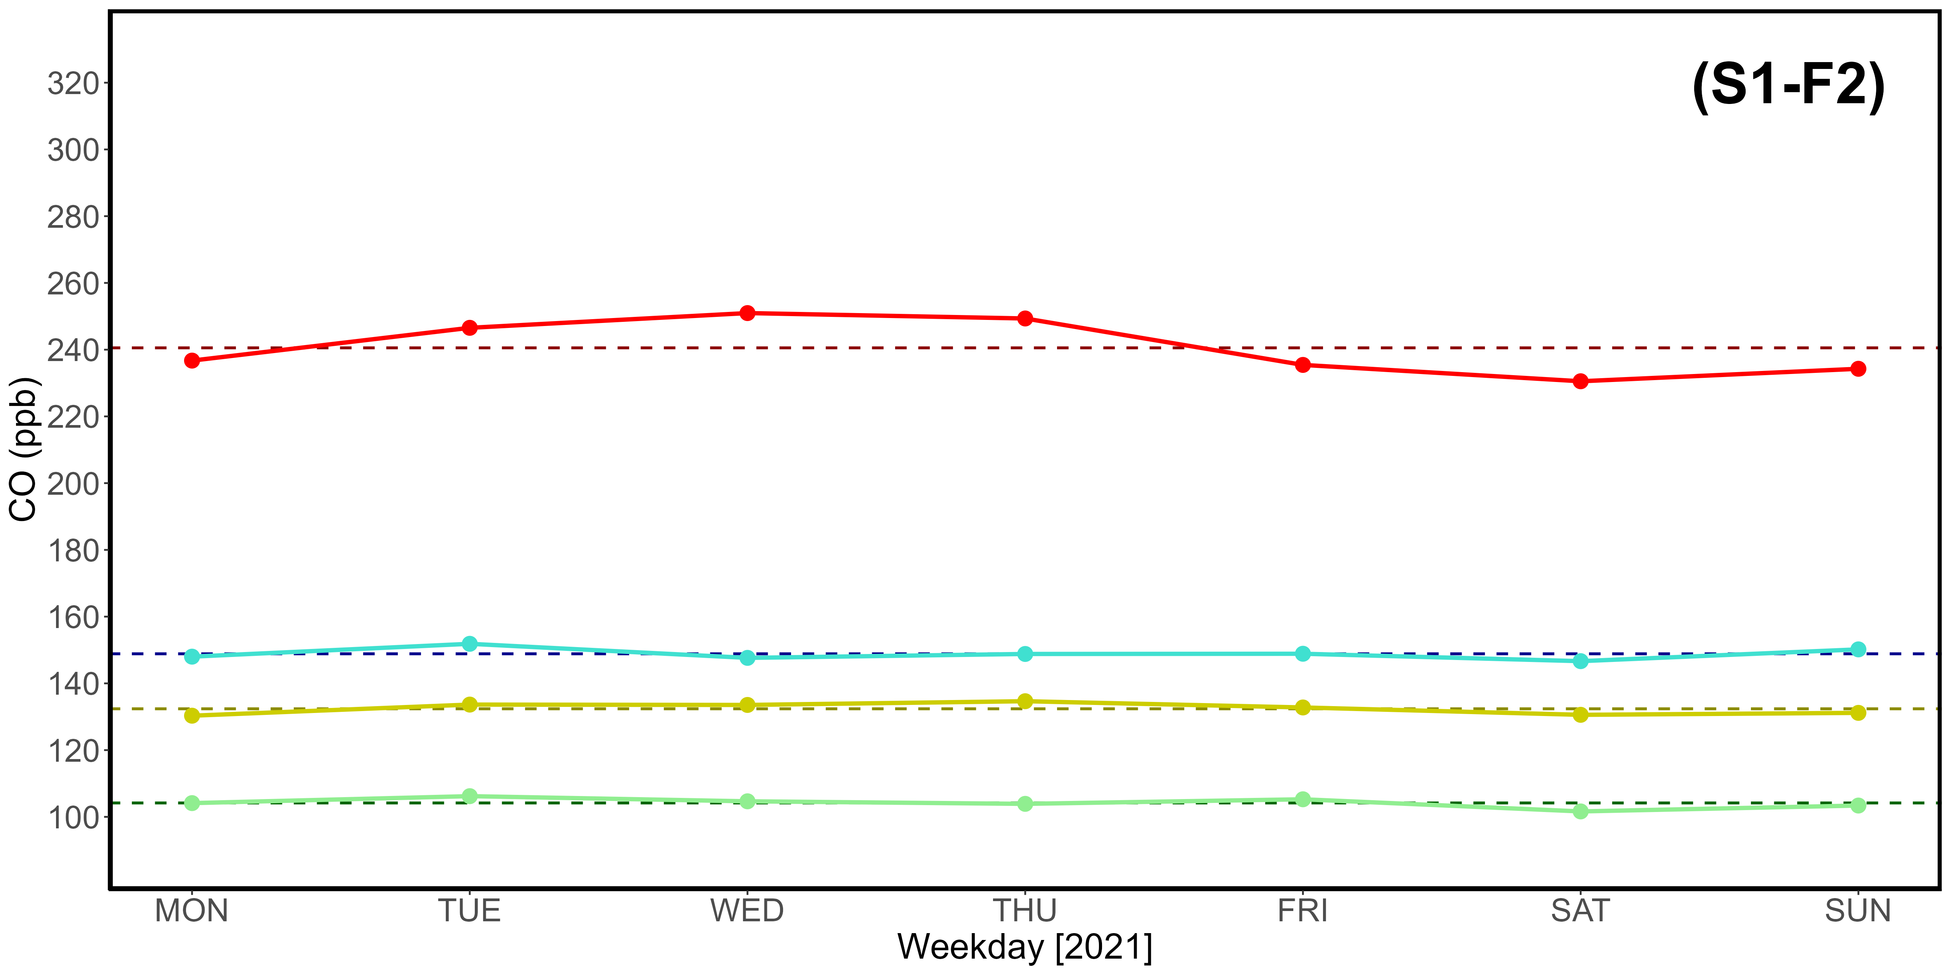
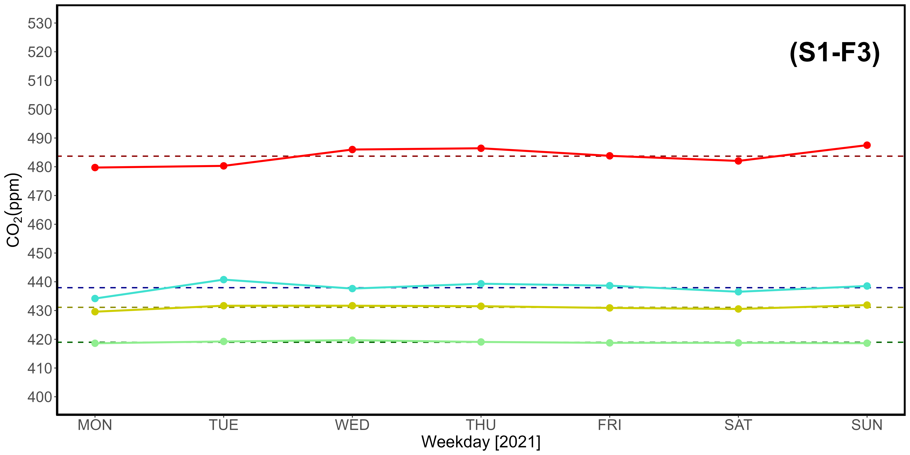
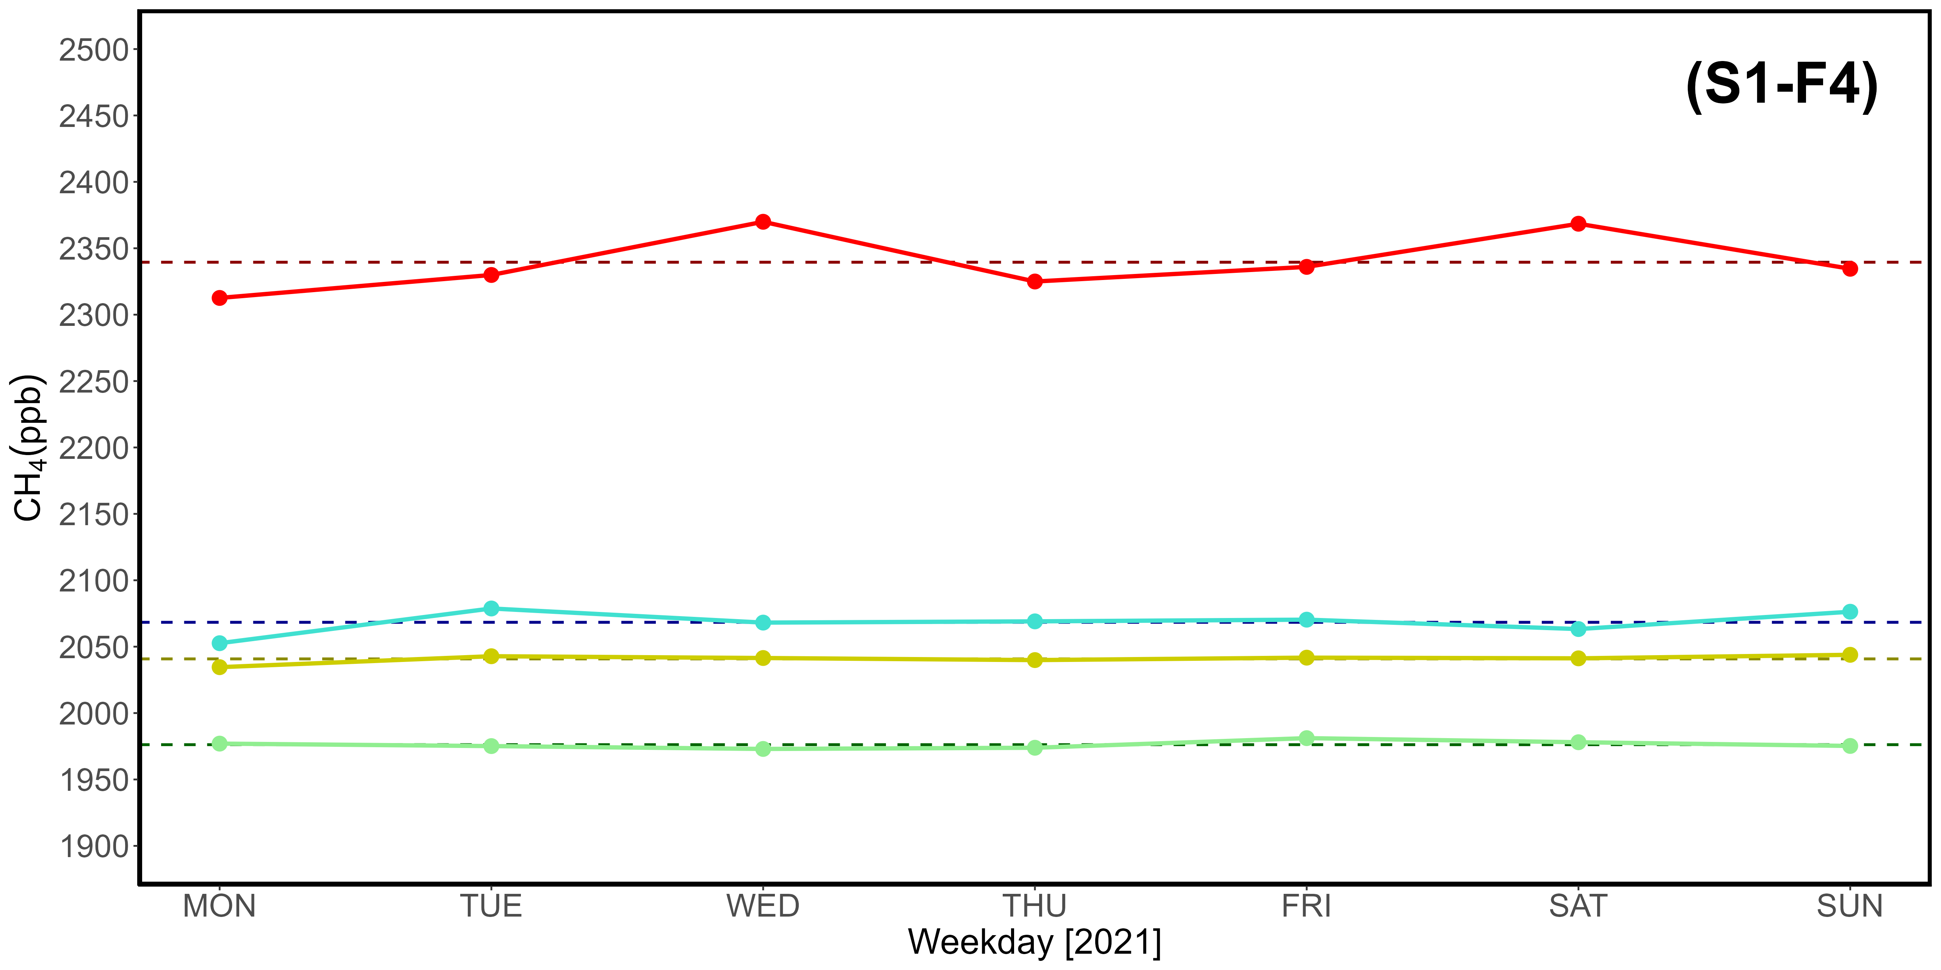
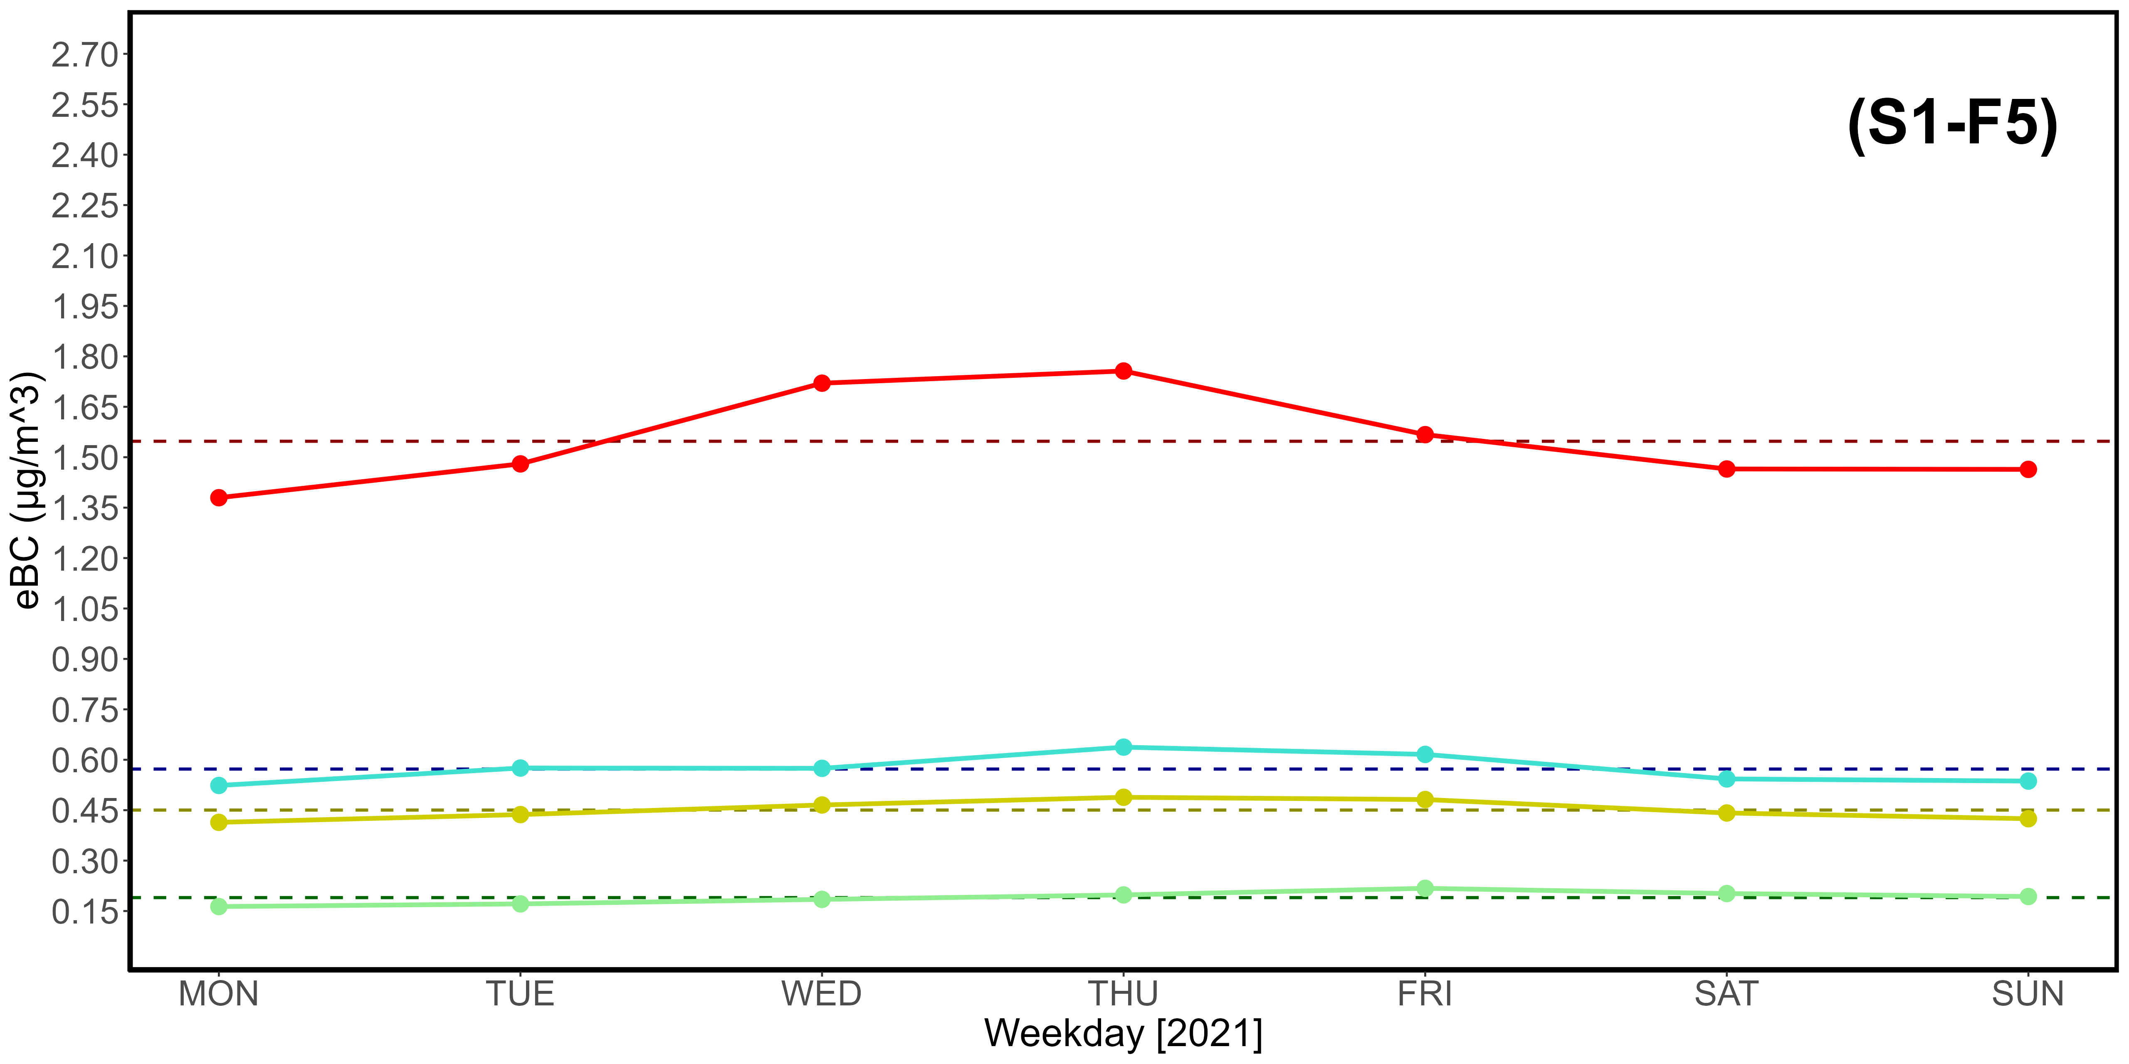
Supplementary Material S1-F1, S1-F2, S1-F3, S1-F4, S1-F5. Table (F1) and CO (F2), CO₂ (F3), CH₄ (F4), eBC (F5) plots reporting key statistical data from 2021.

Day | CO (ppb) |  |  |  | CO₂ (ppm)
 | Q1 | Mean | Q3 | 97,5% | Q1 | Mean | Q3 | 97,5%
MON | 108.10 | 131.83 | 146.79 | 224.34 | 422.03 | 478.47 | 448.84 | 520.00
TUE | 113.31 | 144.00 | 159.55 | 271.17 | 423.72 | 447.06 | 450.34 | 492.81
WED | 113.14 | 144.11 | 159.36 | 263.40 | 423.45 | 439.53 | 450.09 | 492.88
THU | 116.21 | 144.27 | 157.09 | 266.18 | 423.73 | 439.28 | 451.46 | 496.39
FRI | 112.92 | 141.58 | 153.71 | 278.01 | 422.10 | 439.13 | 450.93 | 492.68
SAT | 108.57 | 134.41 | 149.18 | 246.68 | 422.12 | 454.48 | 442.62 | 515.86
SUN | 105.63 | 133.16 | 148.16 | 242.73 | 422.92 | 474.87 | 442.39 | 513.80
Average | 111.13 | 139.05 | 153.41 | 256.07 | 422.87 | 453.26 | 448.10 | 503.49
Day | CH₄ (ppb) |  |  |  | eBC (μg /m³)
 | Q1 | Mean | Q3 | 97.5% | Q1 | Mean | Q3 | 97.5%
MON | 1991.66 | 2075.18 | 2120.76 | 2430.51 | 0.20 | 0.44 | 0.55 | 1.40
TUE | 1997.69 | 2080.85 | 2132.86 | 2402.06 | 0.22 | 0.52 | 0.63 | 2.13
WED | 2000.15 | 2081.64 | 2128.04 | 2433.05 | 0.25 | 0.54 | 0.69 | 1.86
THU | 2000.06 | 2083.12 | 2121.89 | 2482.63 | 0.25 | 0.53 | 0.67 | 1.67
FRI | 1993.06 | 2078.29 | 2128.02 | 2449.16 | 0.23 | 0.53 | 0.68 | 1.86
SAT | 1993.79 | 2064.20 | 2083.99 | 2440.96 | 0.20 | 0.46 | 0.60 | 1.54
SUN | 1994.26 | 2059.88 | 2087.27 | 2387.44 | 0.16 | 0.38 | 0.51 | 1.20
Average | 1995.81 | 2074.74 | 2114.69 | 2432.26 | 0.22 | 0.49 | 0.62 | 1.66

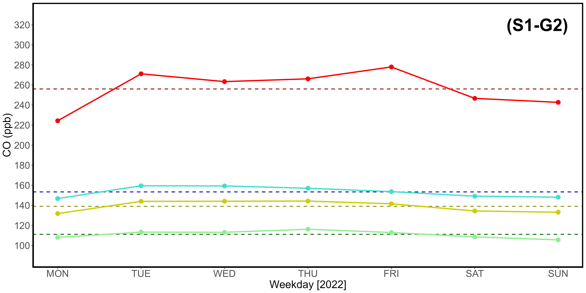
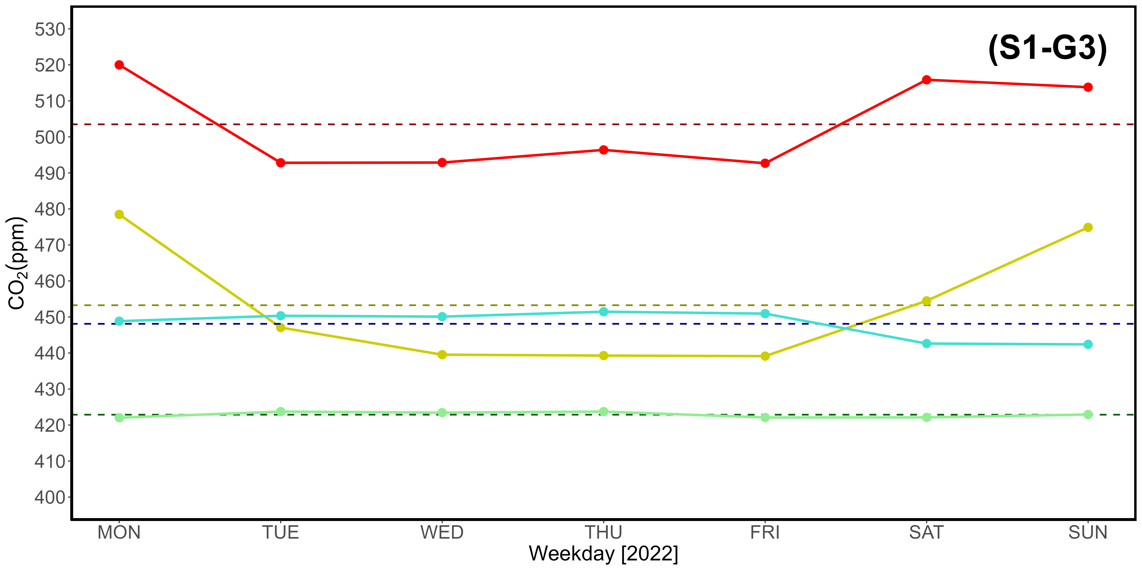
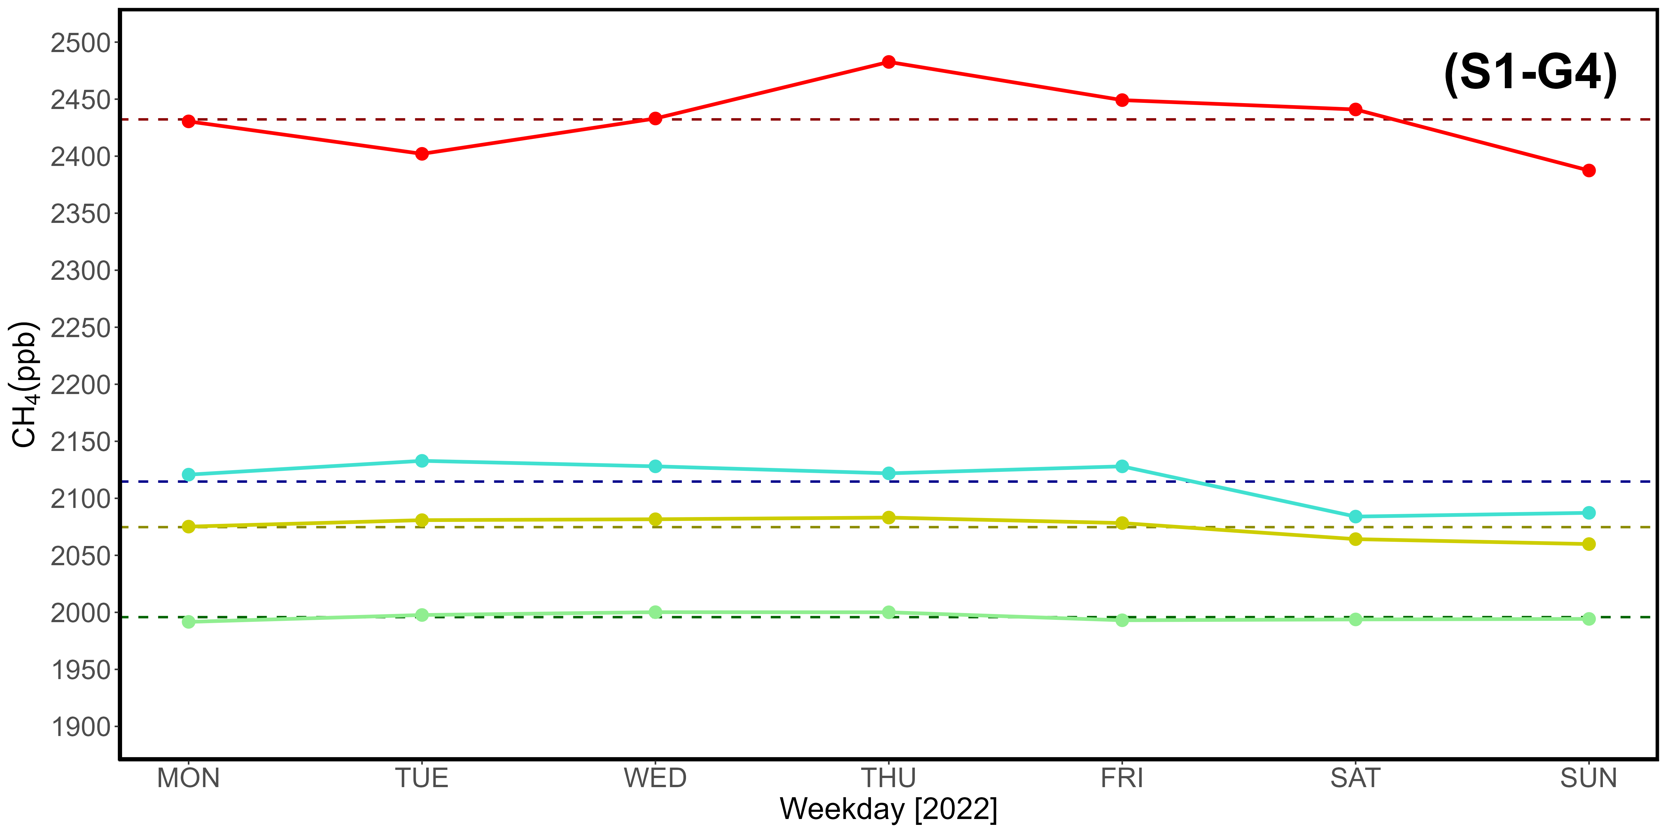
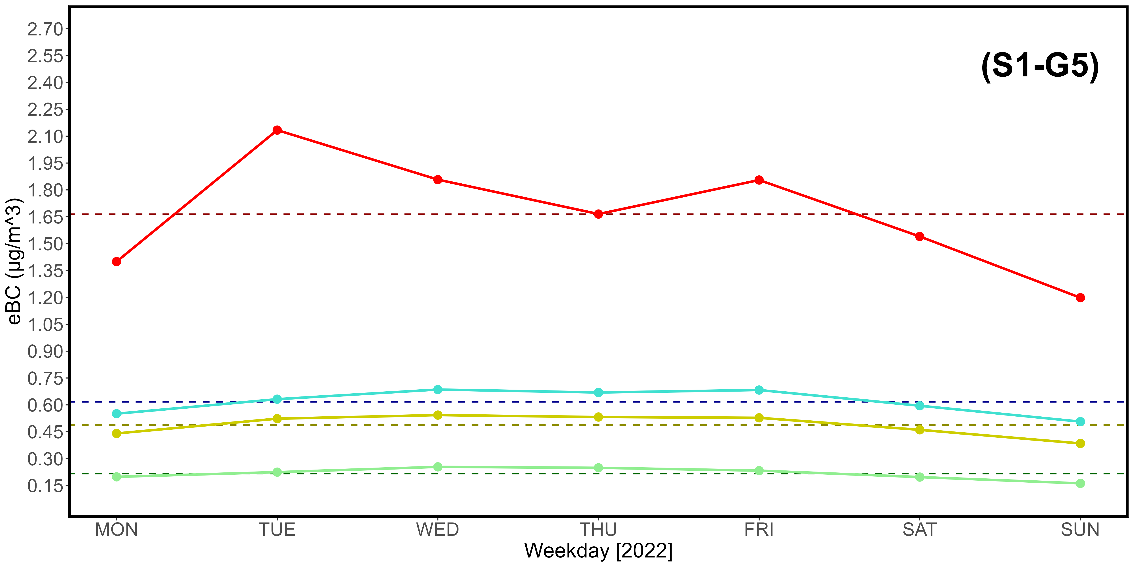
Supplementary Material S1-G1, S1-G2, S1-G3, S1-G4, S1-G5. Table (G1) and CO (G2), CO₂ (G3), CH₄ (G4), eBC (G5) plots reporting key statistical data from 2022.
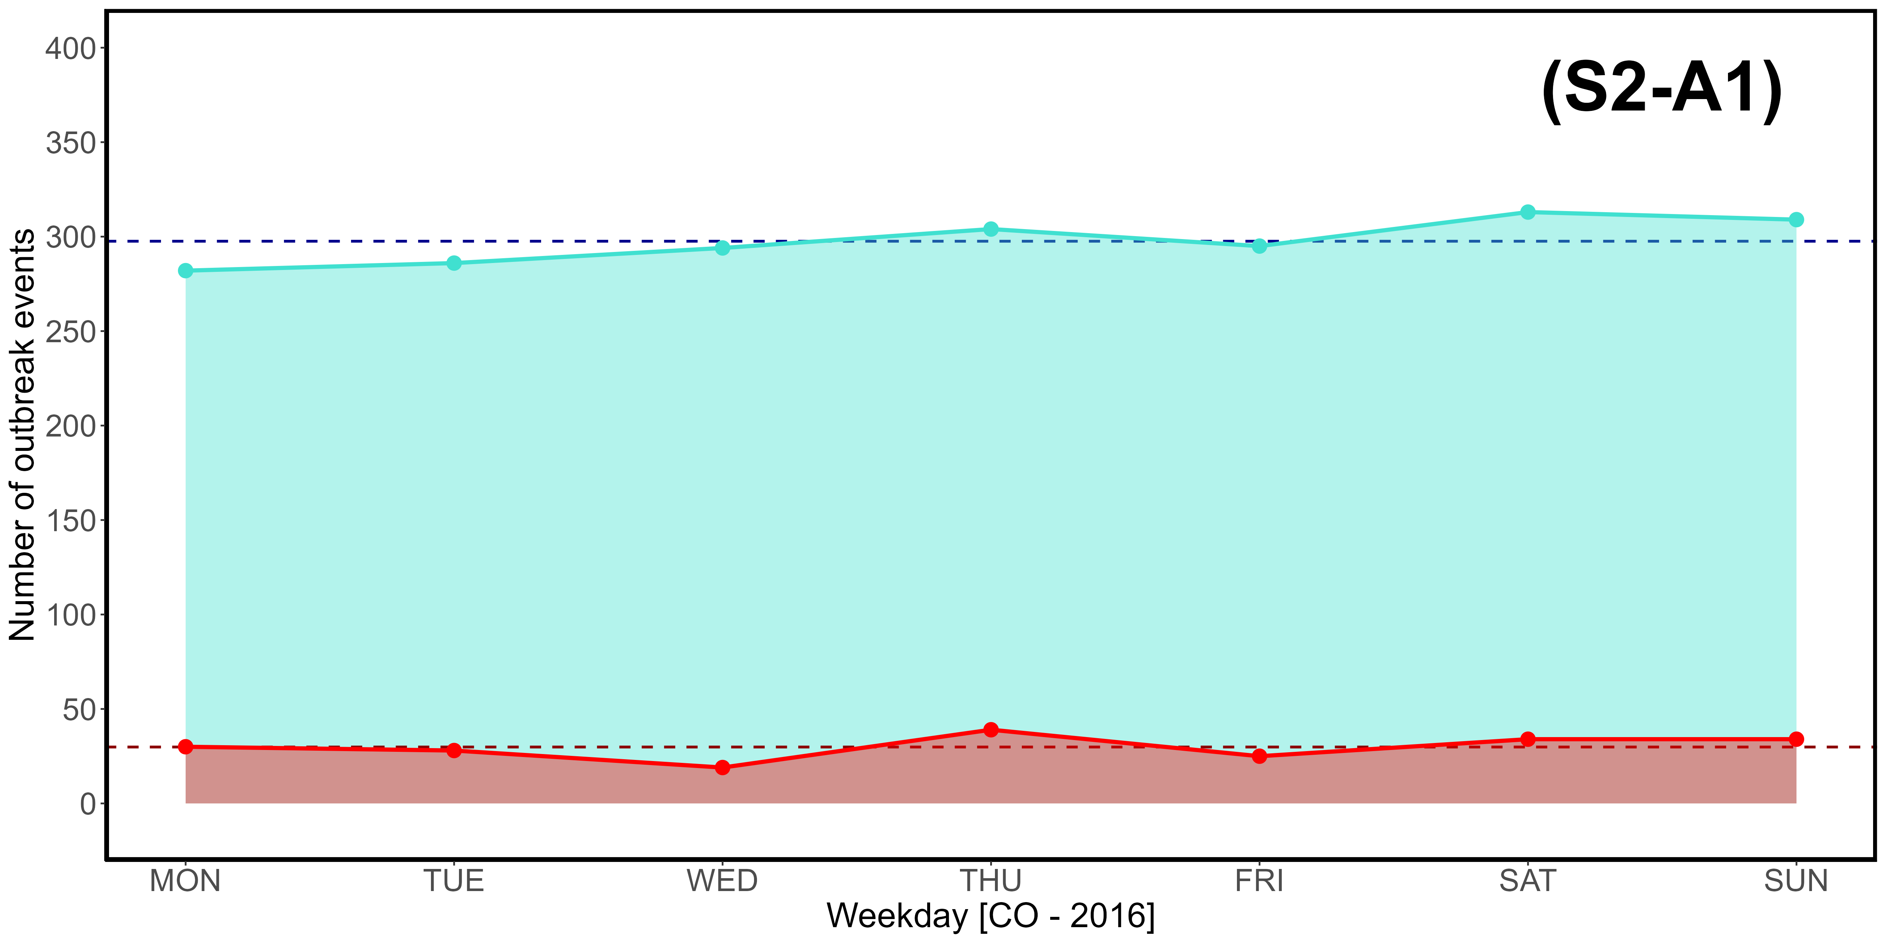
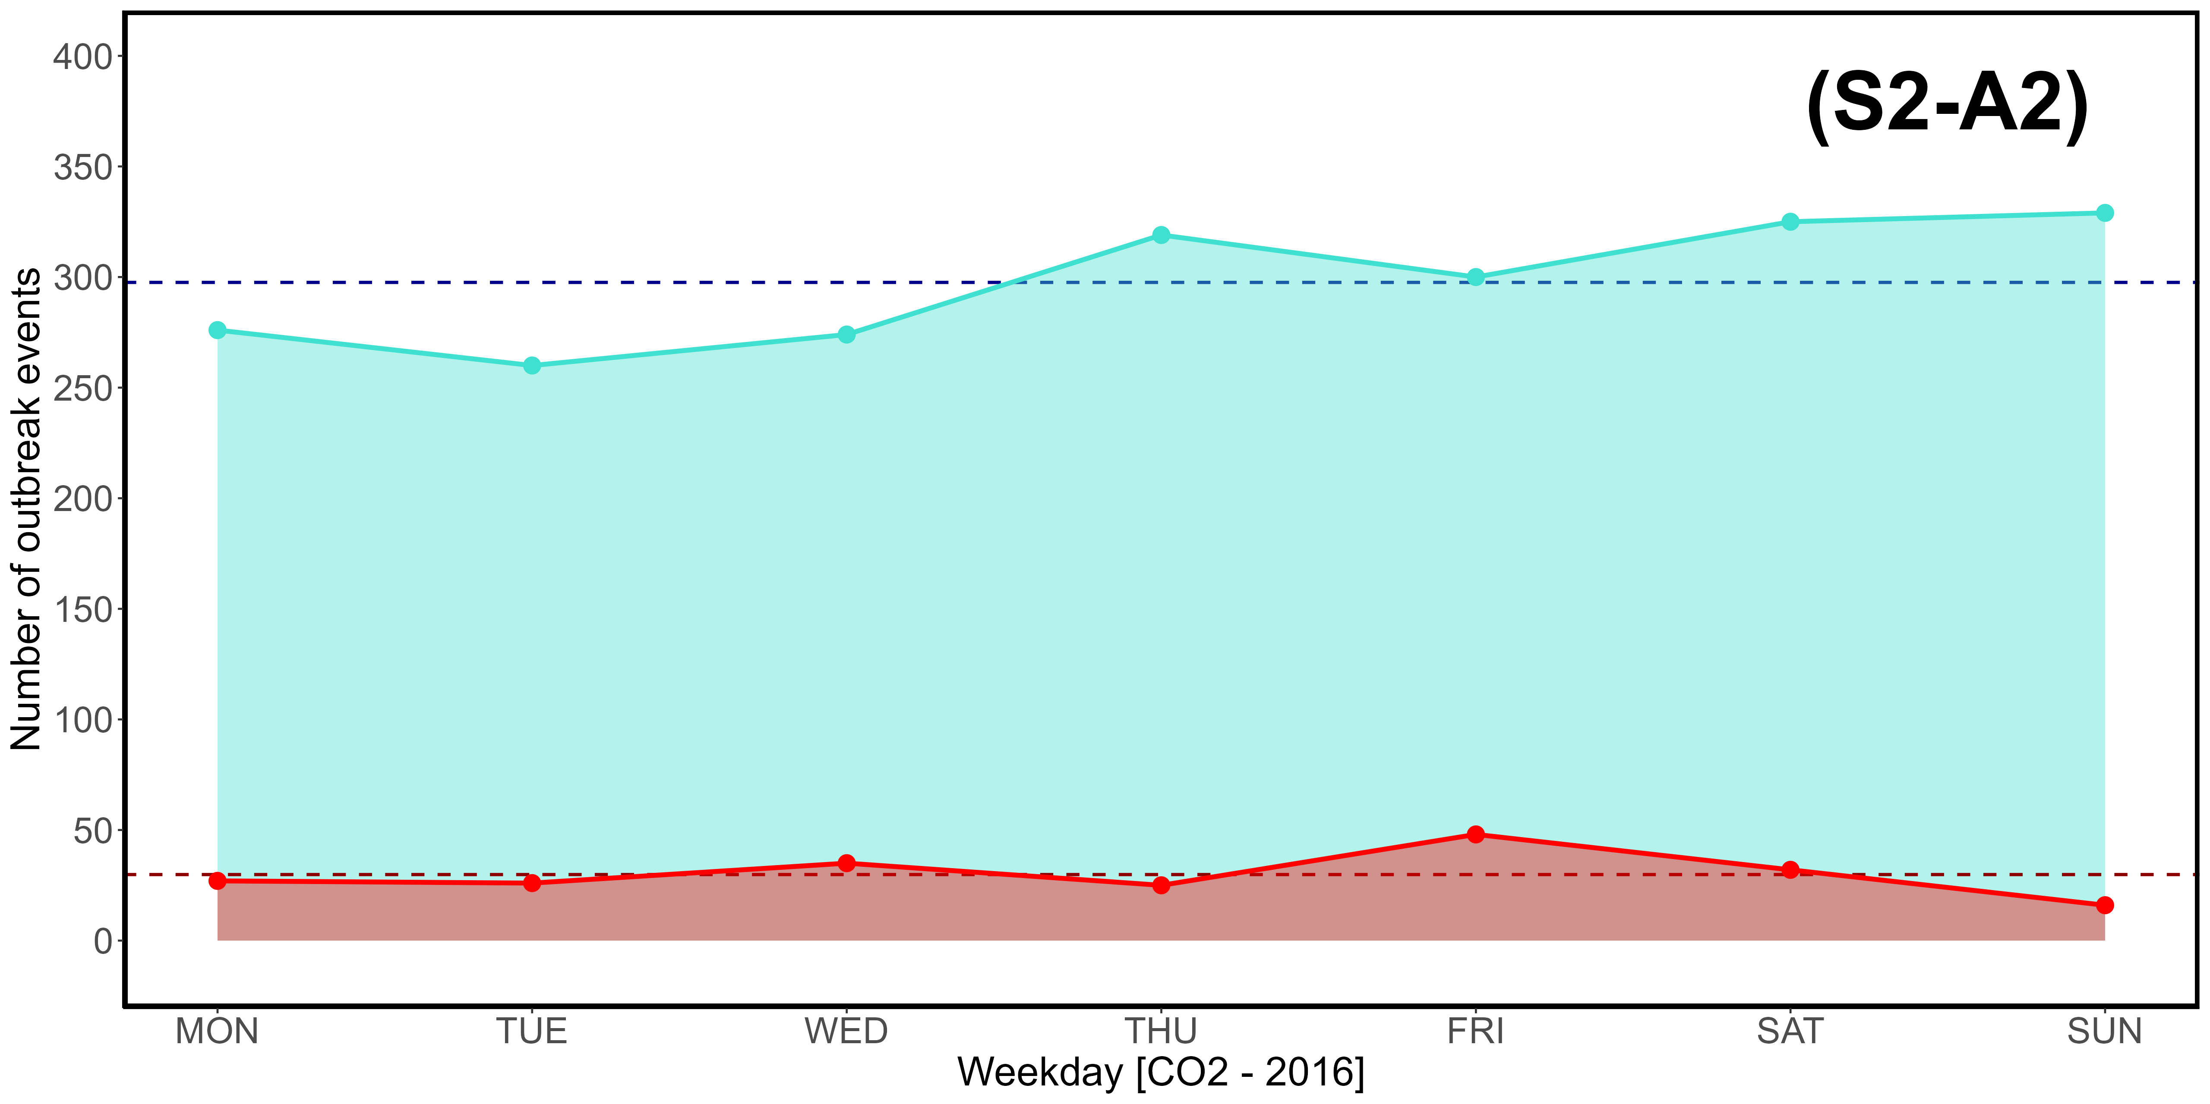
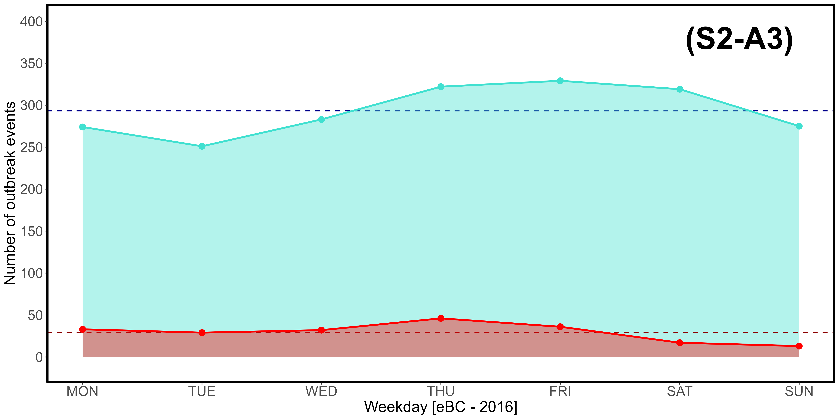
Supplementary Material S2-A1, S2-A2, S2-A3. Weekly (MON-SUN) distribution of CO (A1), CO₂ (A2), and eBC (A3) outbreak events exceeding the 3rd quartile (turquoise) and 97,5% threshold (red) in 2016.
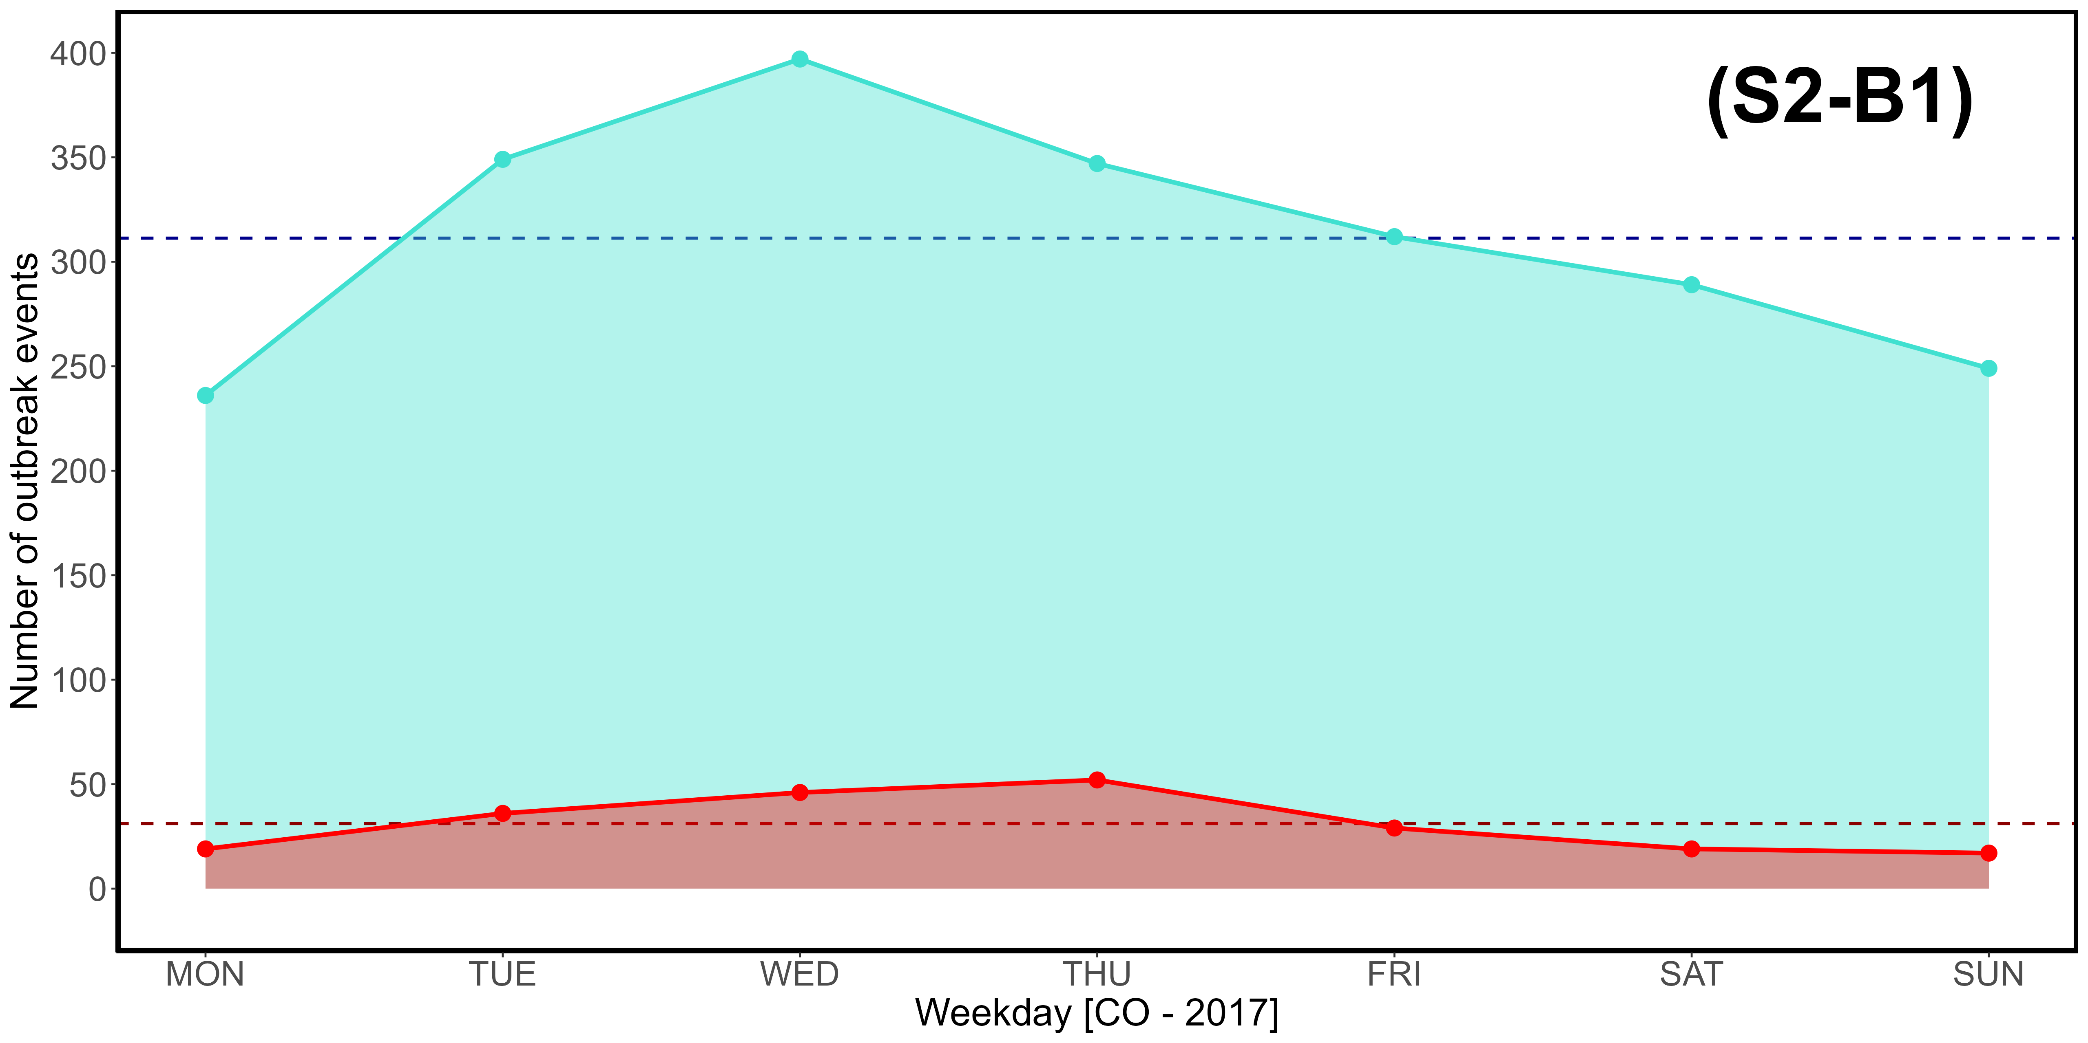
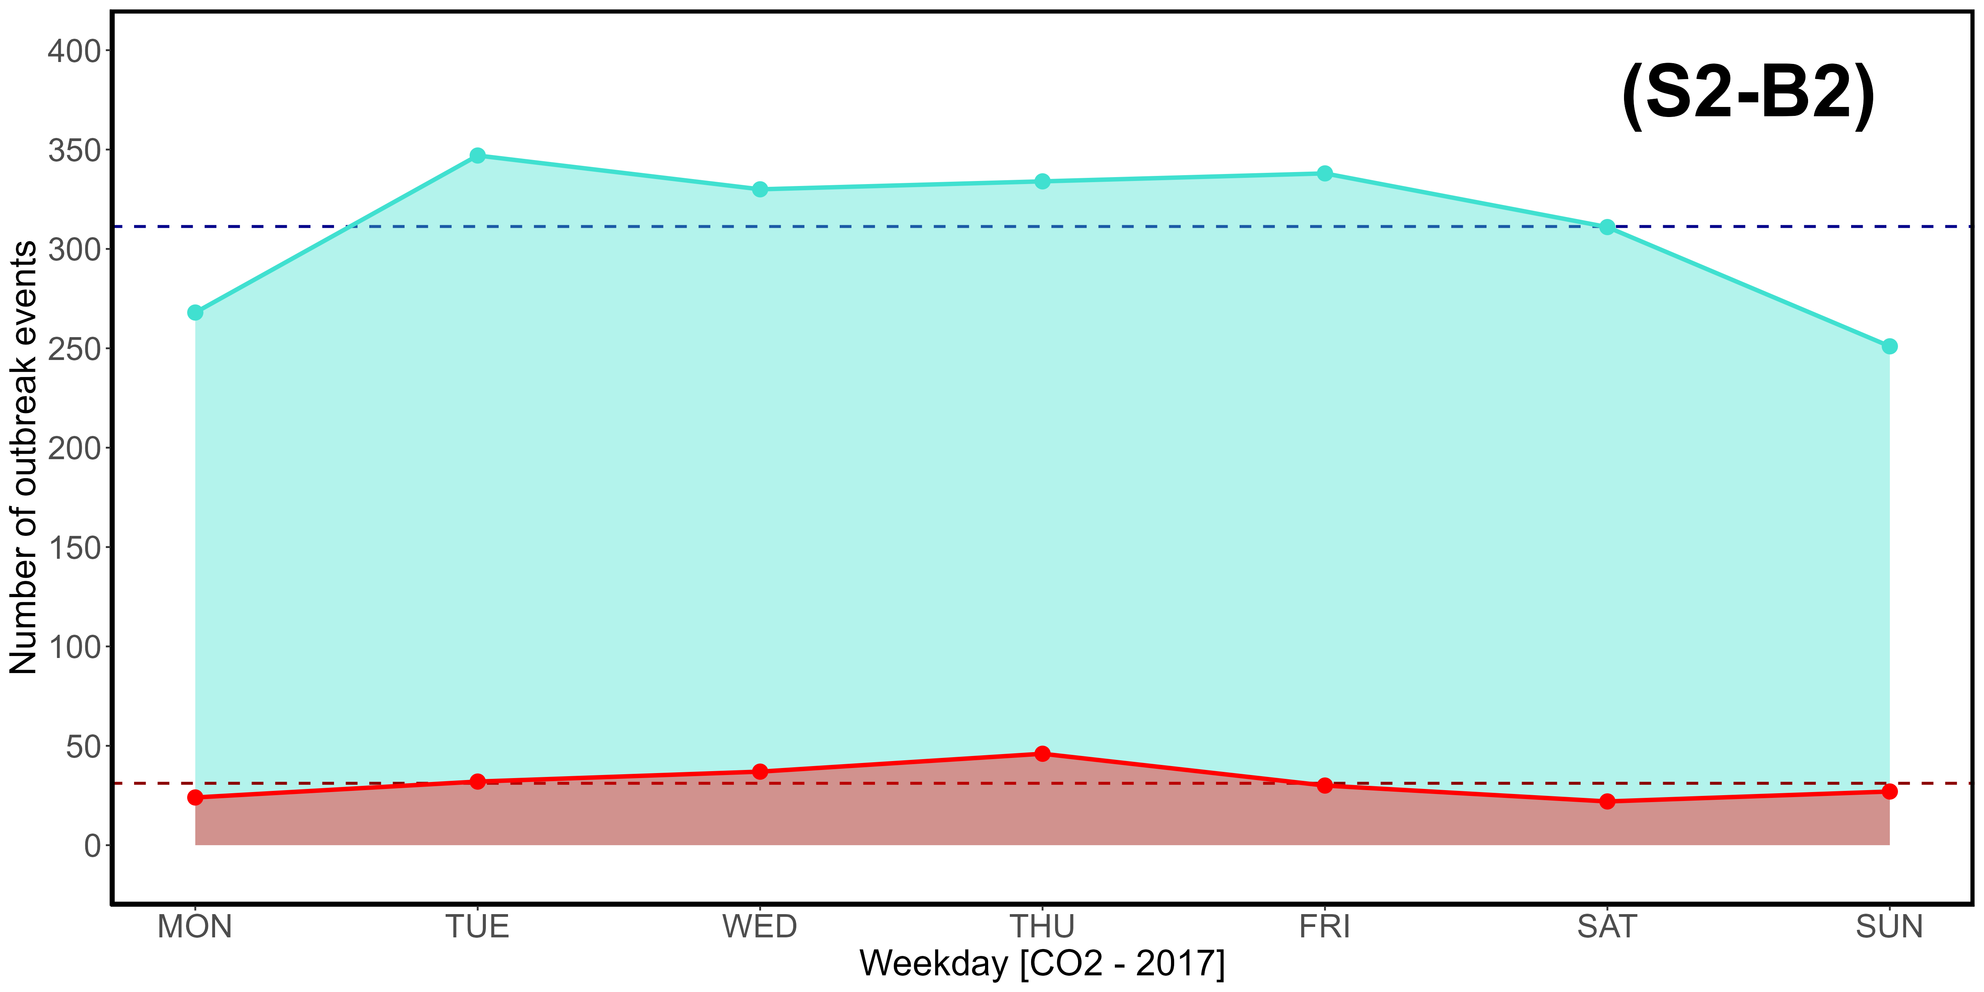
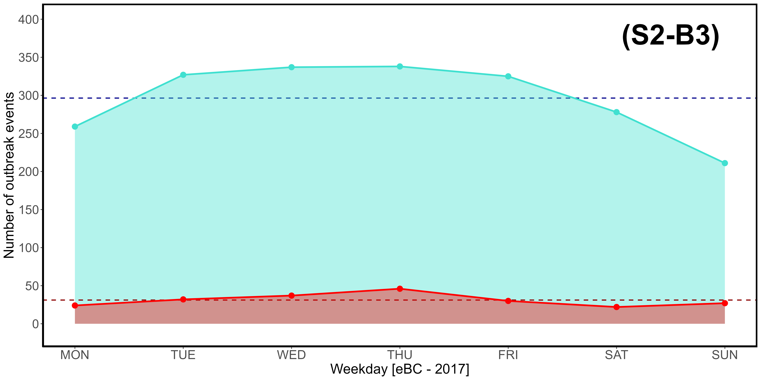
Supplementary Material S2-B1, S2-B2, S2-B3. Weekly (MON-SUN) distribution of CO (B1), CO₂ (B2), and eBC (B3) outbreak events exceeding the 3rd quartile (turquoise) and 97,5% threshold (red) in 2017.
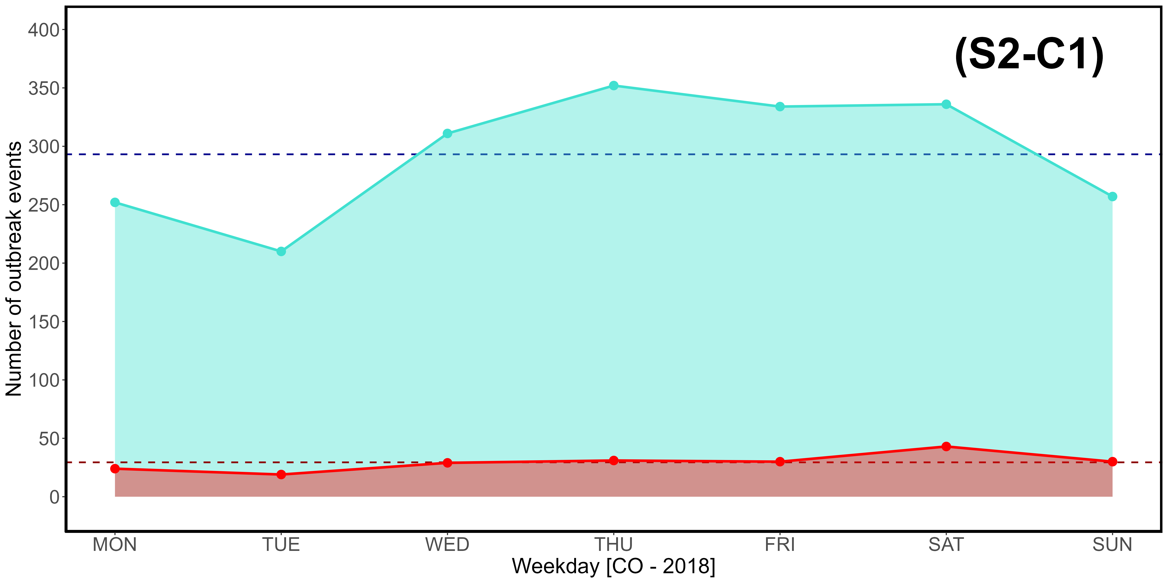
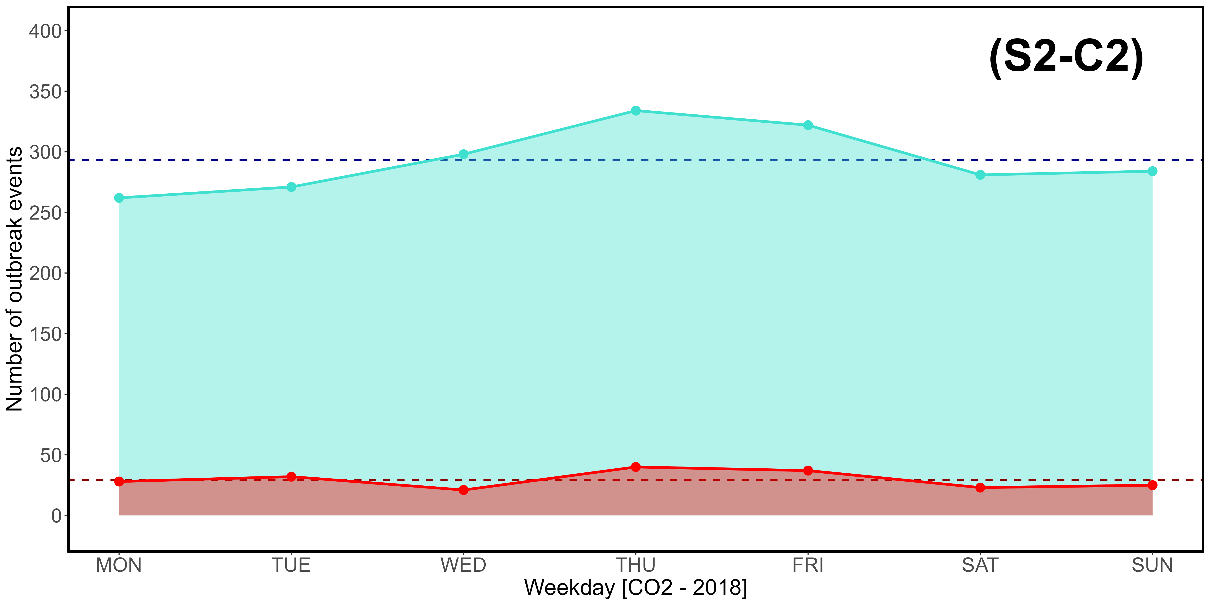
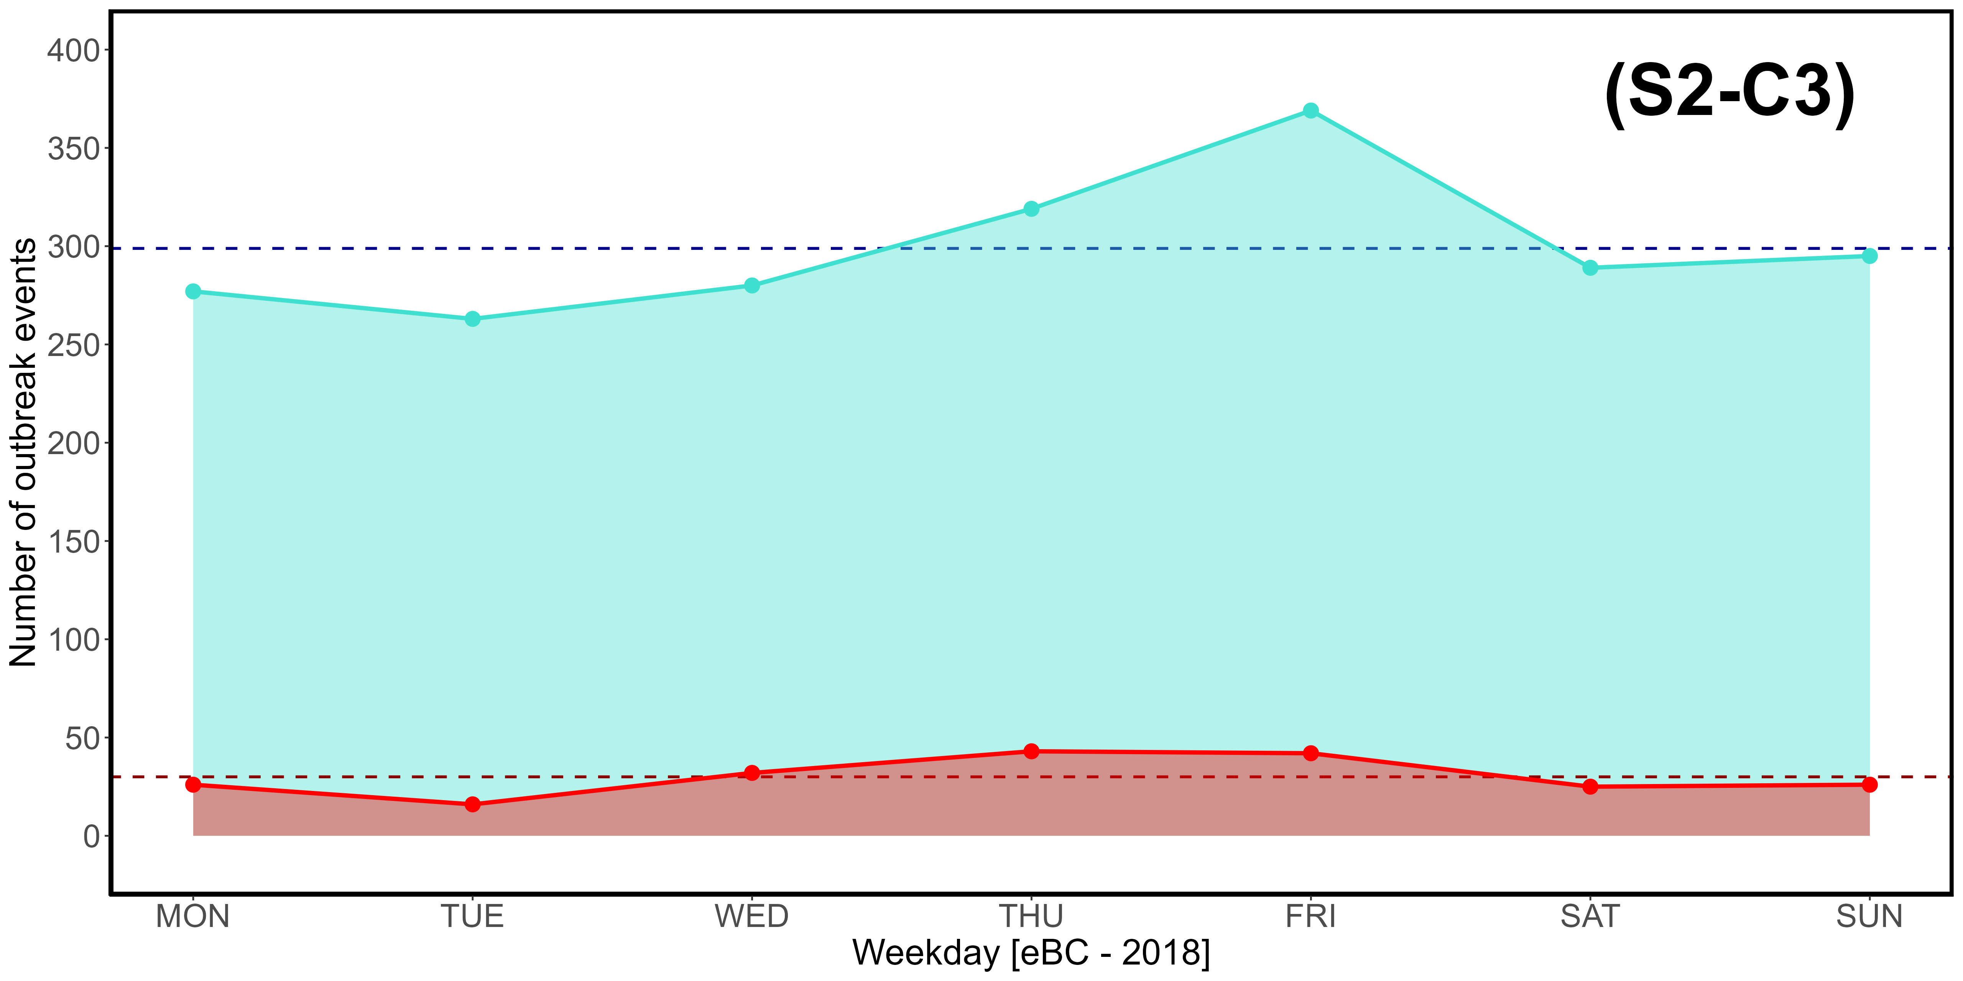
Supplementary Material S2-C1, S2-C2, S2-C3. Weekly (MON-SUN) distribution of CO (C1), CO₂ (C2), and eBC (C3) outbreak events exceeding the 3rd quartile (turquoise) and 97,5% threshold (red) in 2018.
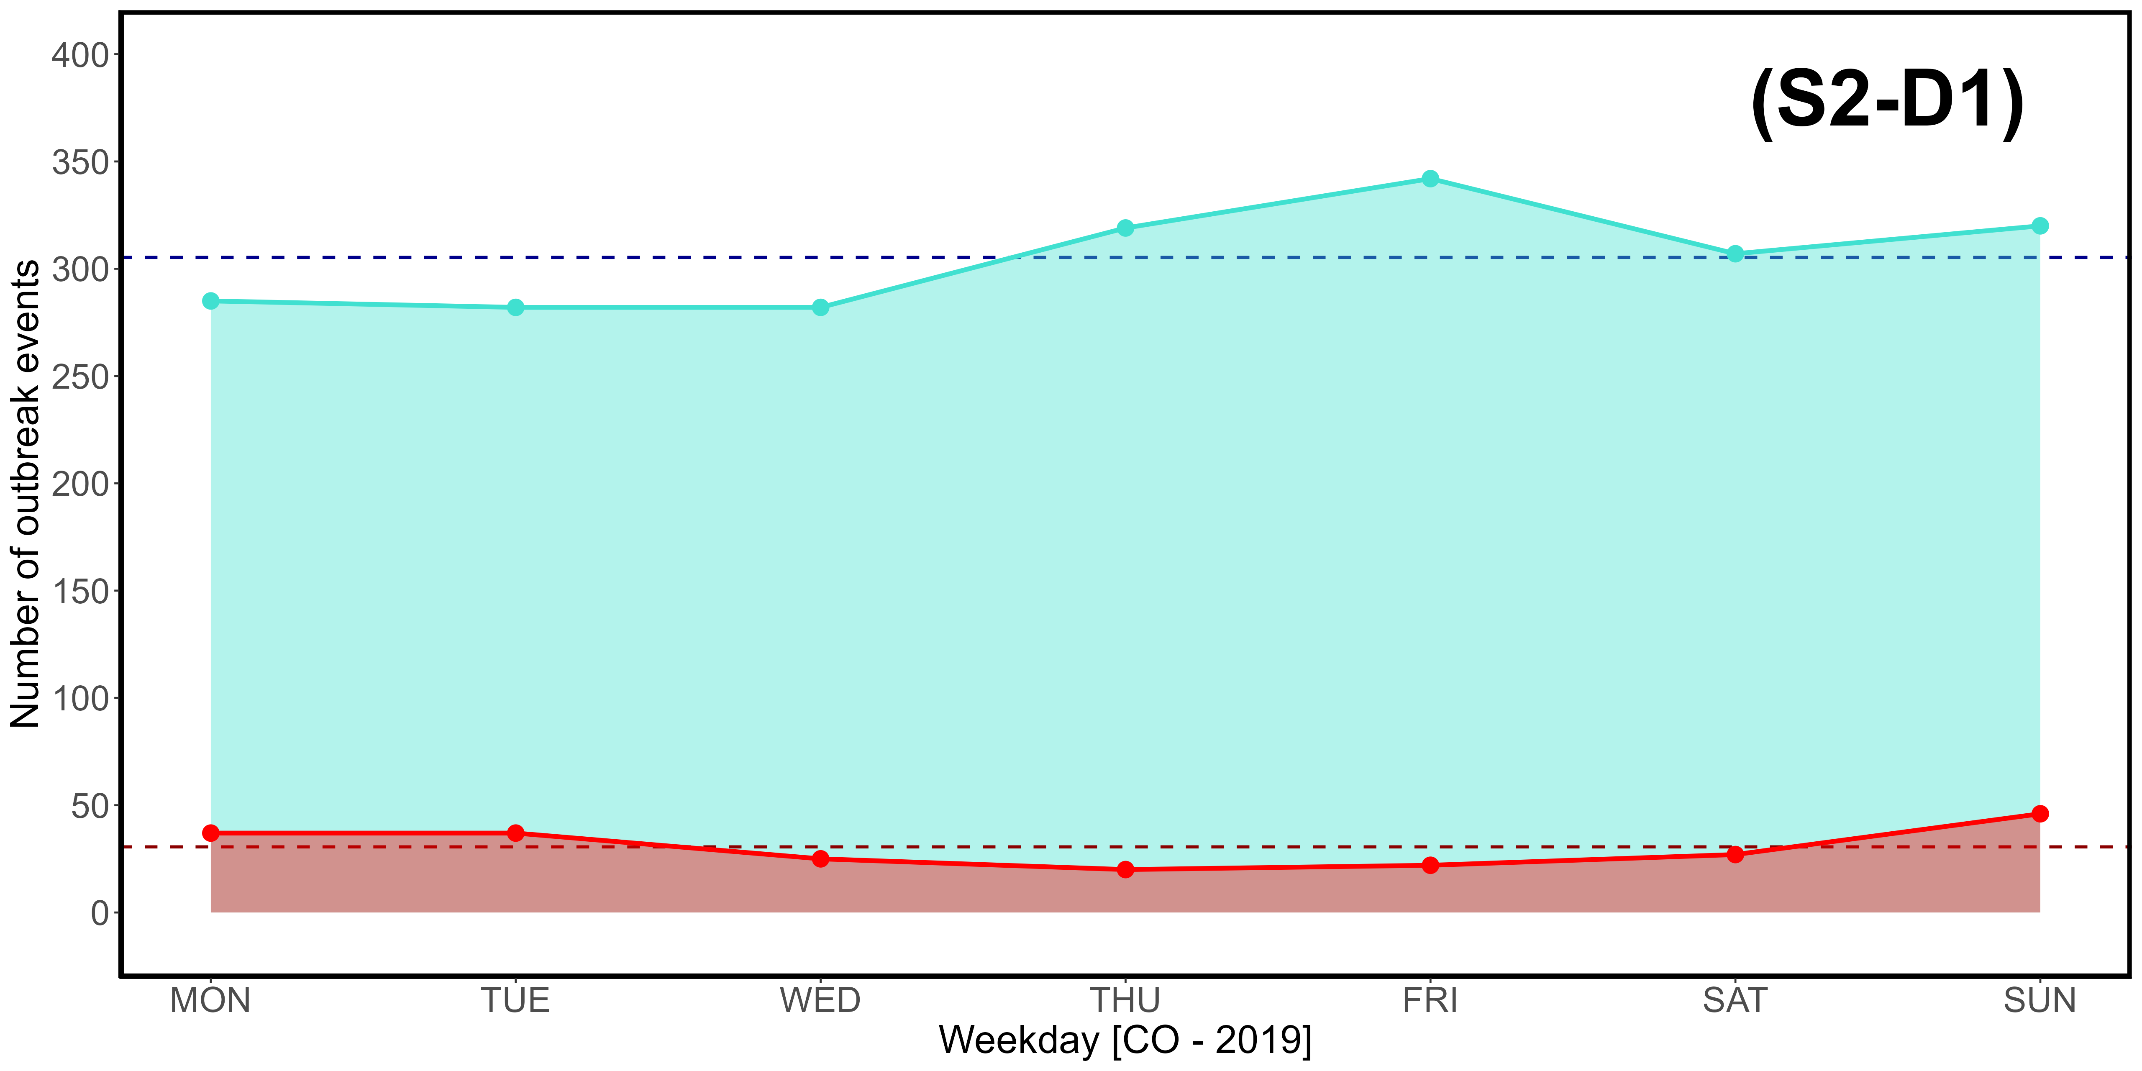
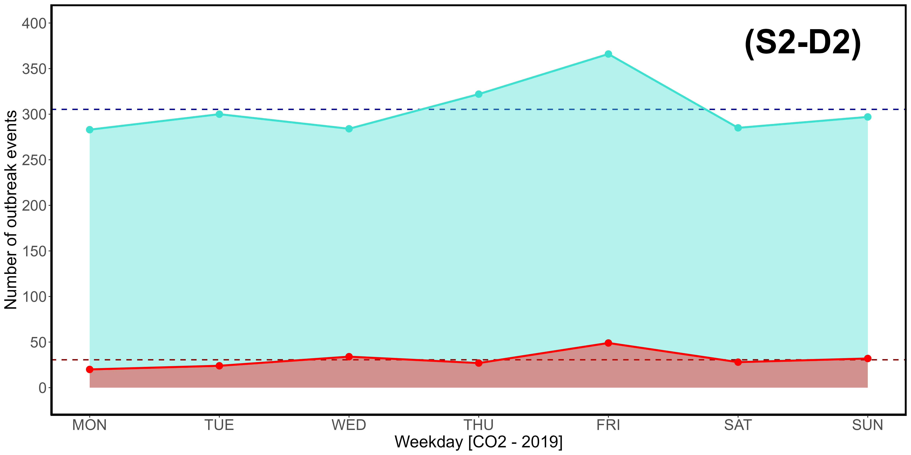
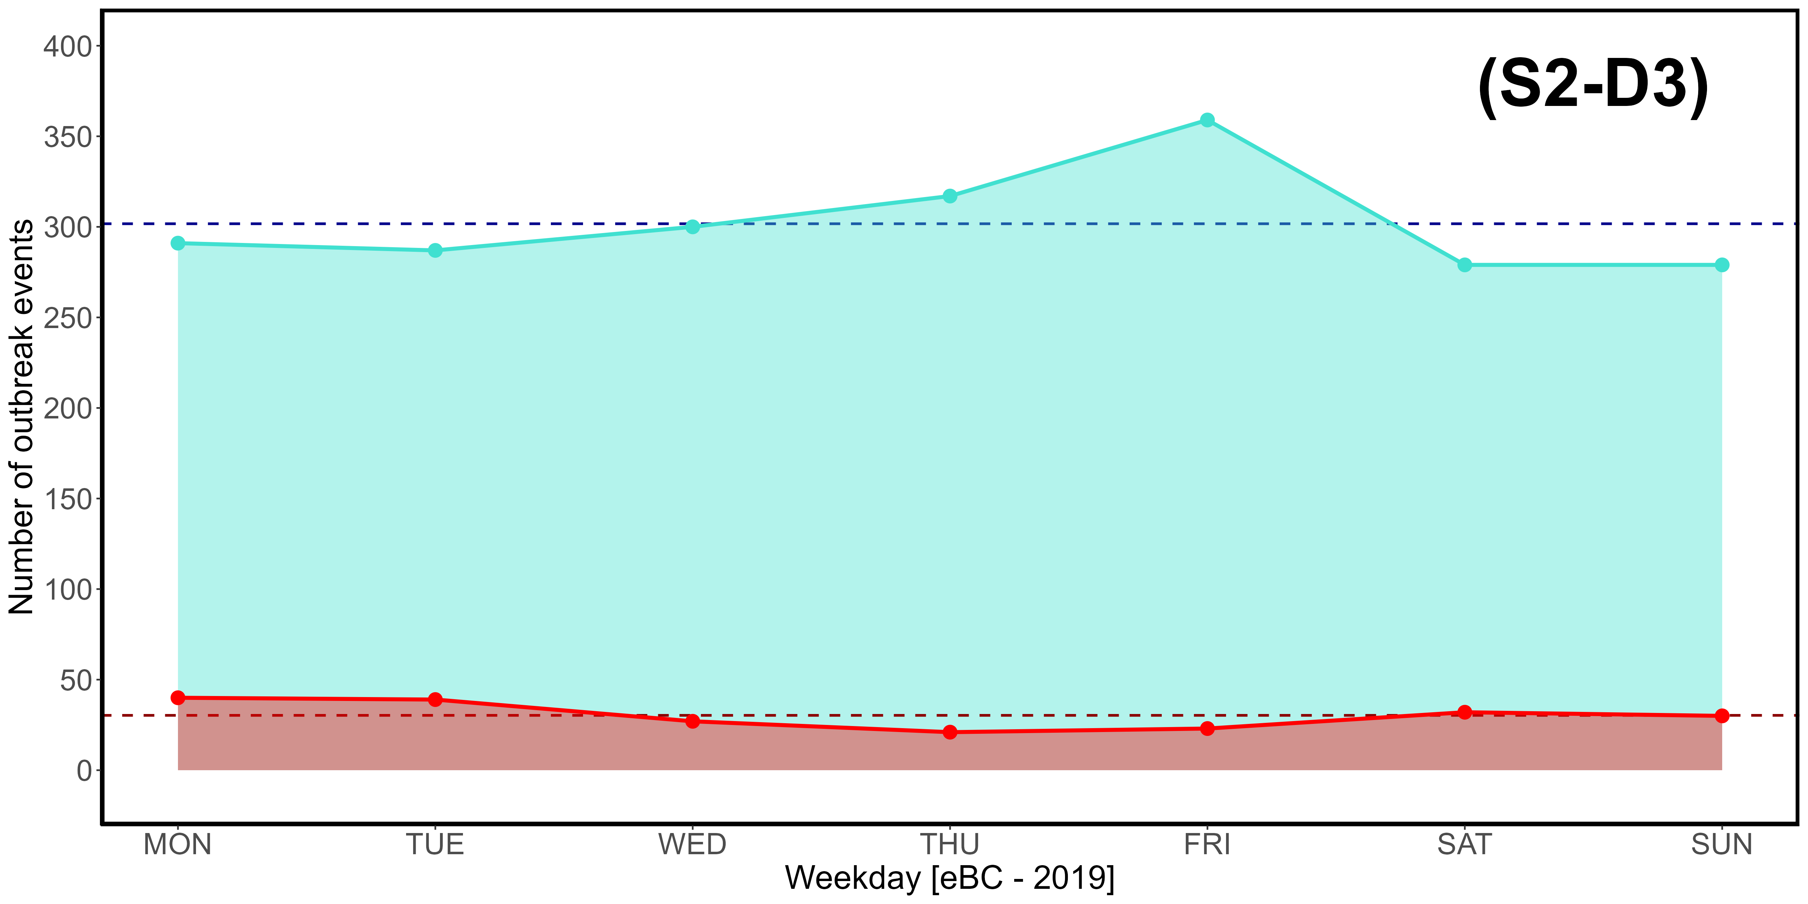
Supplementary Material S2-D1, S2-D2, S2-D3. Weekly (MON-SUN) distribution of CO (D1), CO₂ (D2), and eBC (D3) outbreak events exceeding the 3rd quartile (turquoise) and 97,5% threshold (red) in 2019.
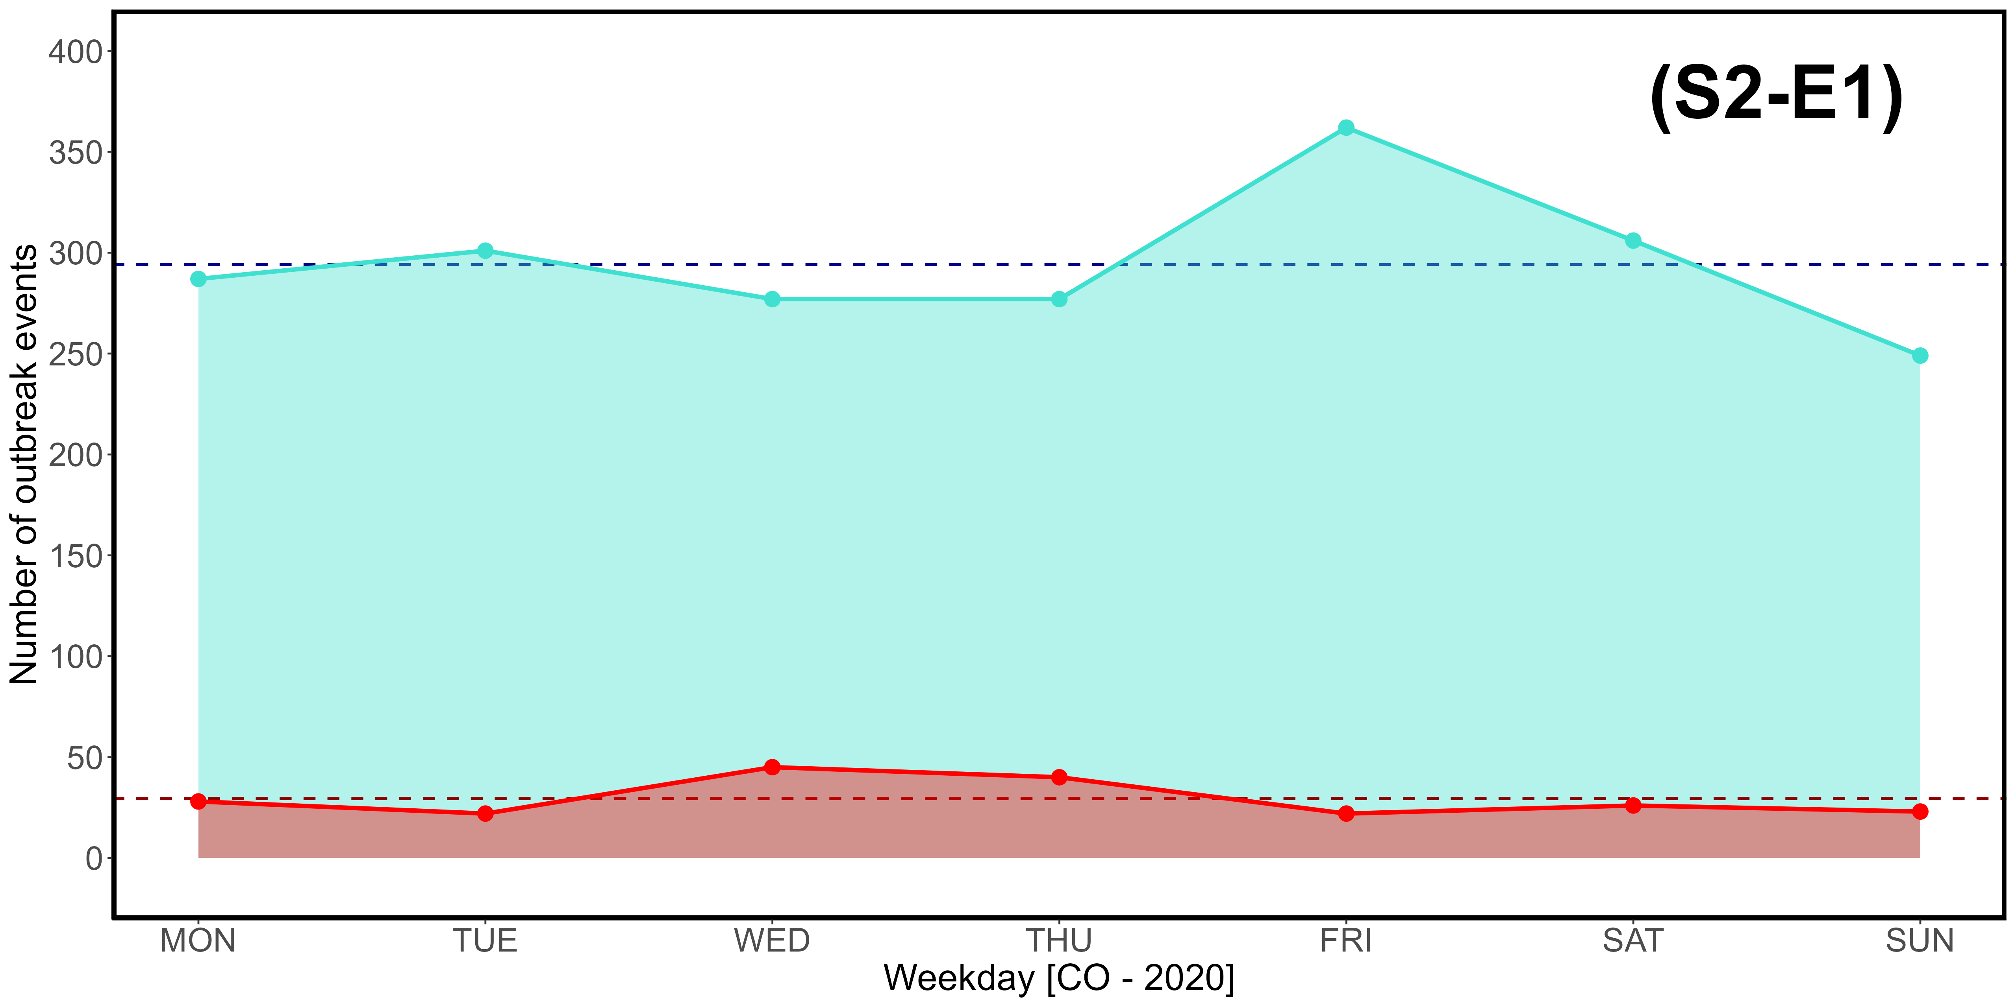
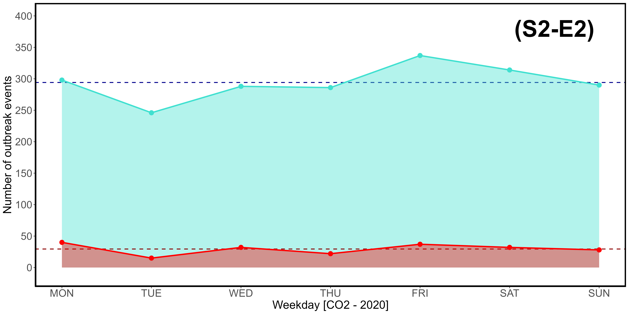
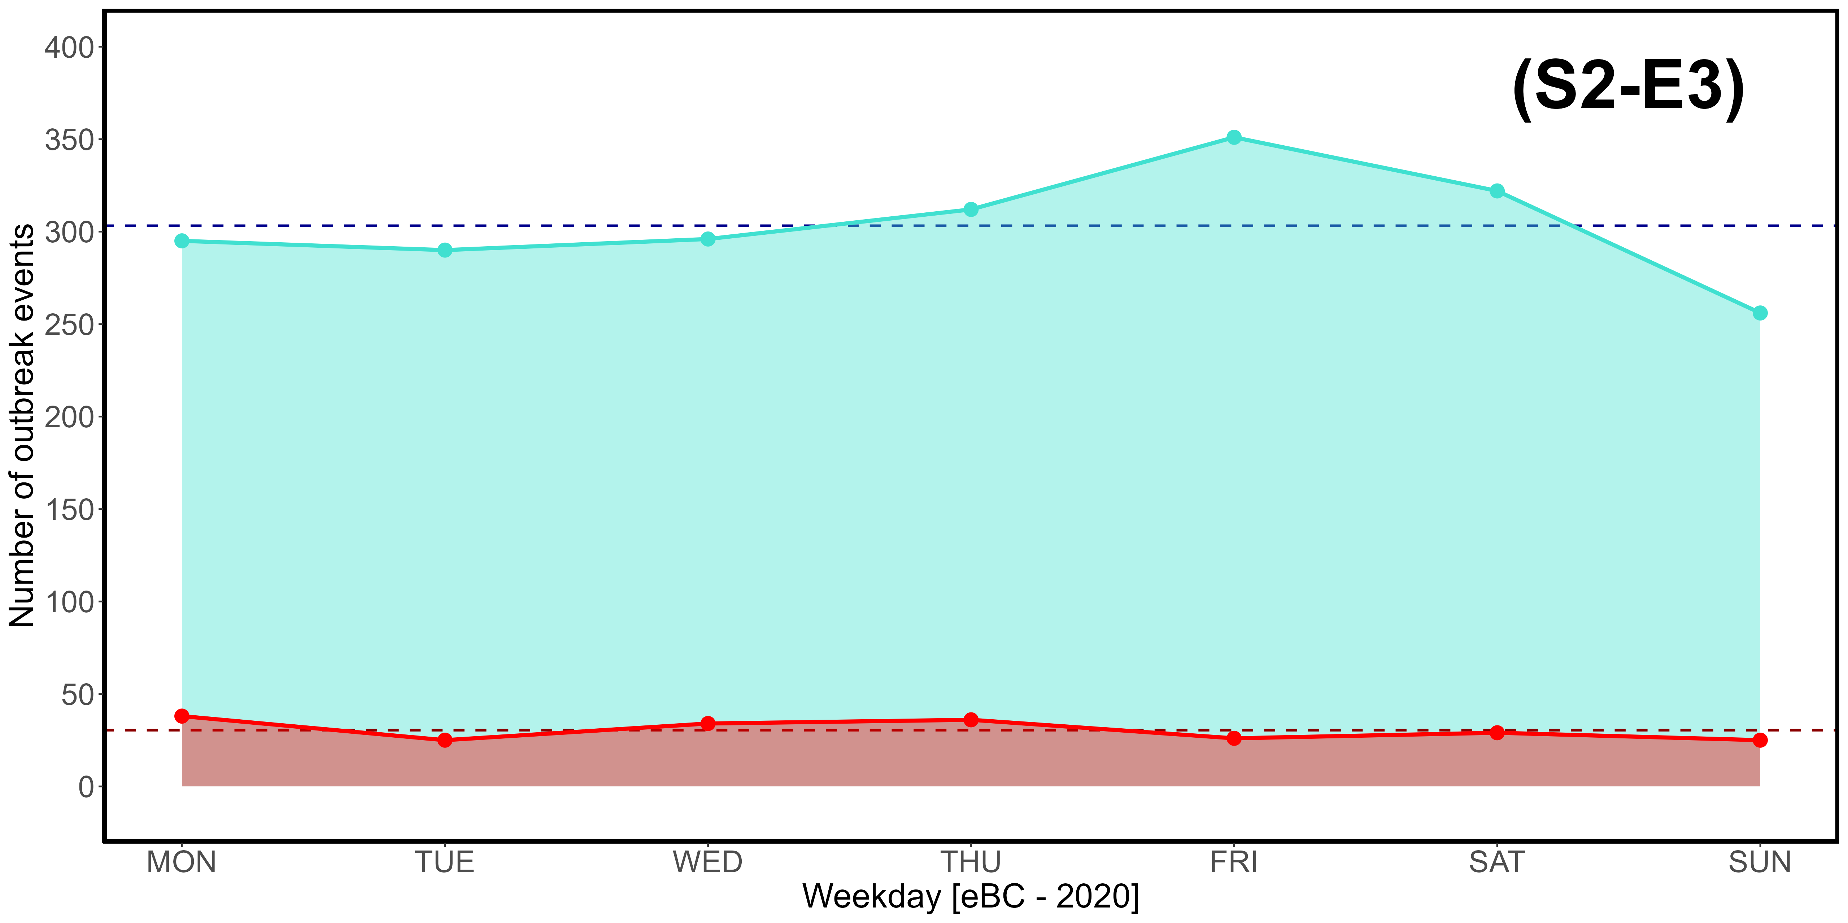
Supplementary Material S2-E1, S2-E2, S2-E3. Weekly (MON-SUN) distribution of CO (E1), CO₂ (E2), and eBC (E3) outbreak events exceeding the 3rd quartile (turquoise) and 97,5% threshold (red) in 2020.
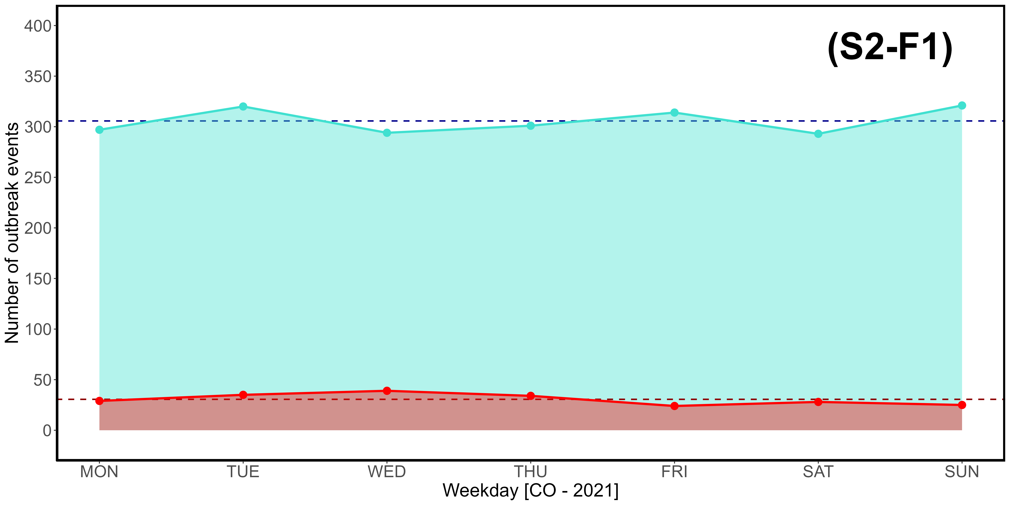
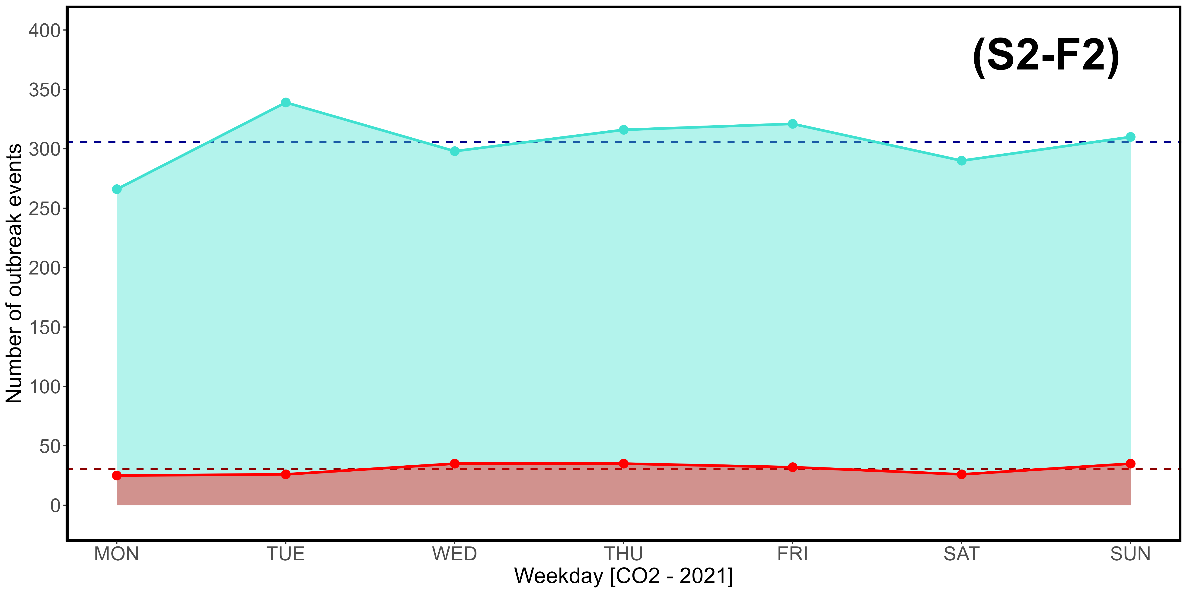
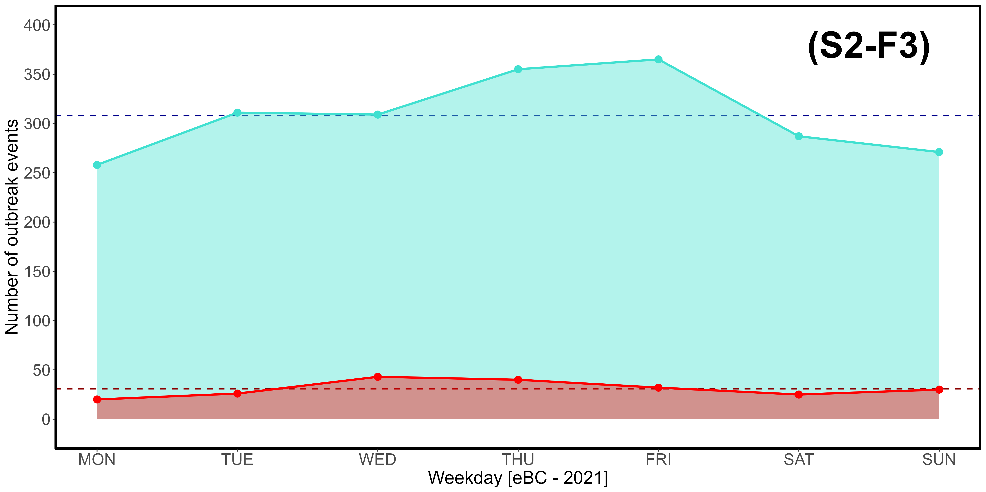
Supplementary Material S2-F1, S2-F2, S2-F3. Weekly (MON-SUN) distribution of CO (F1), CO₂ (F2), and eBC (F3) outbreak events exceeding the 3rd quartile (turquoise) and 97,5% threshold (red) in 2021.
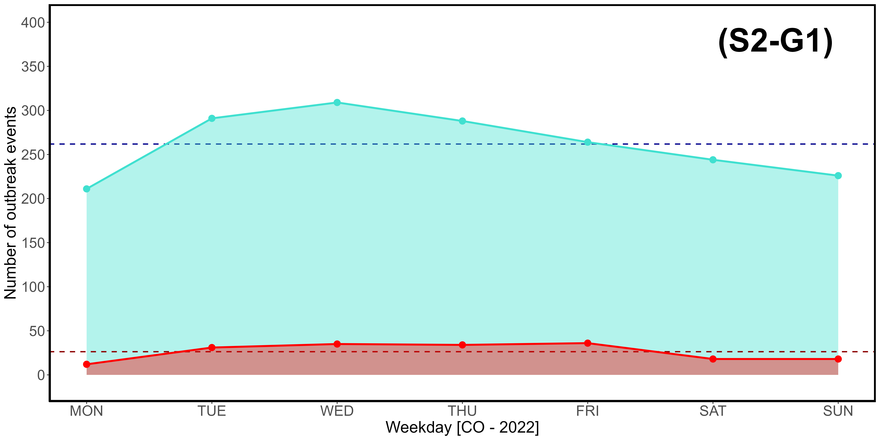
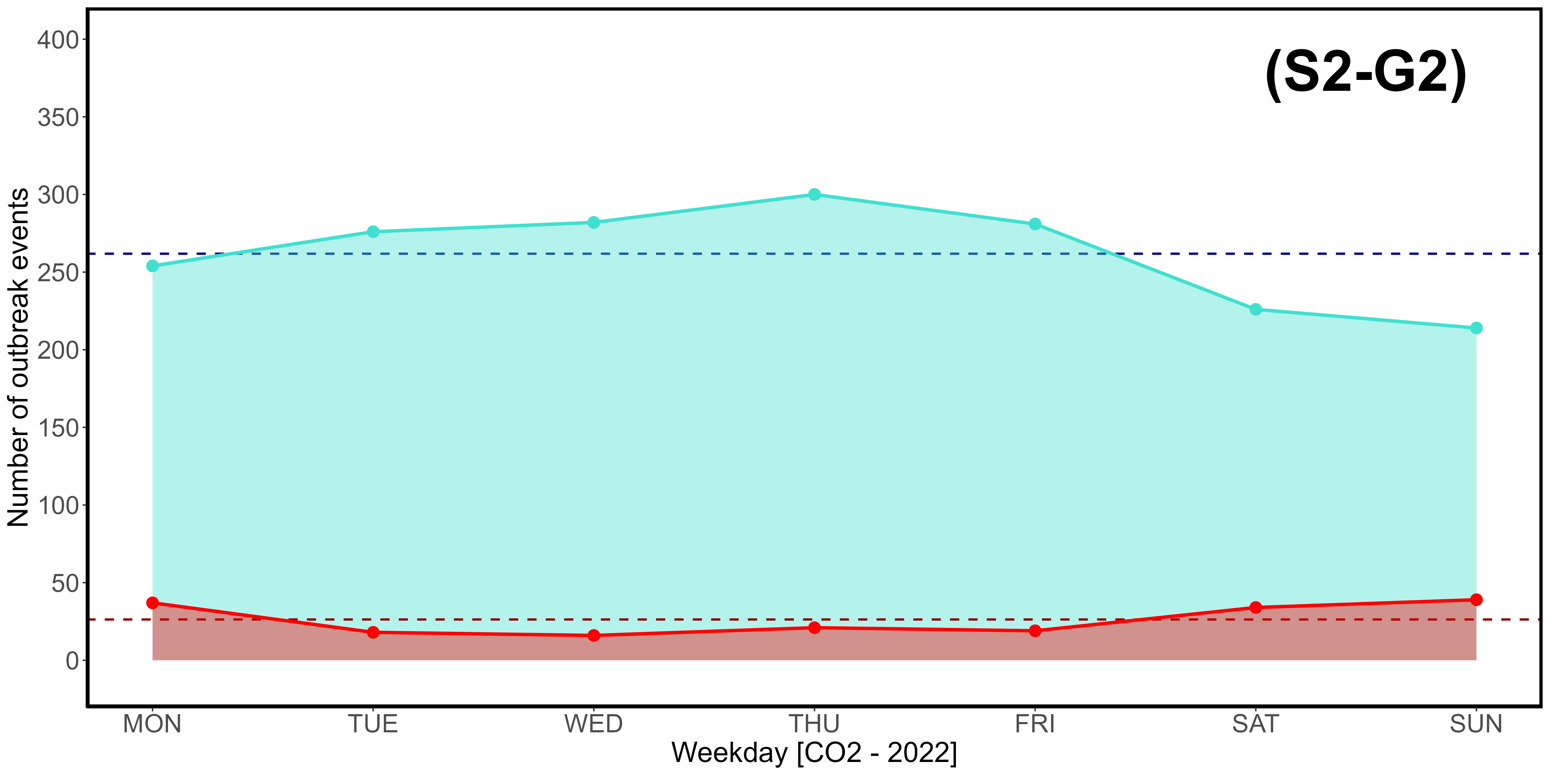
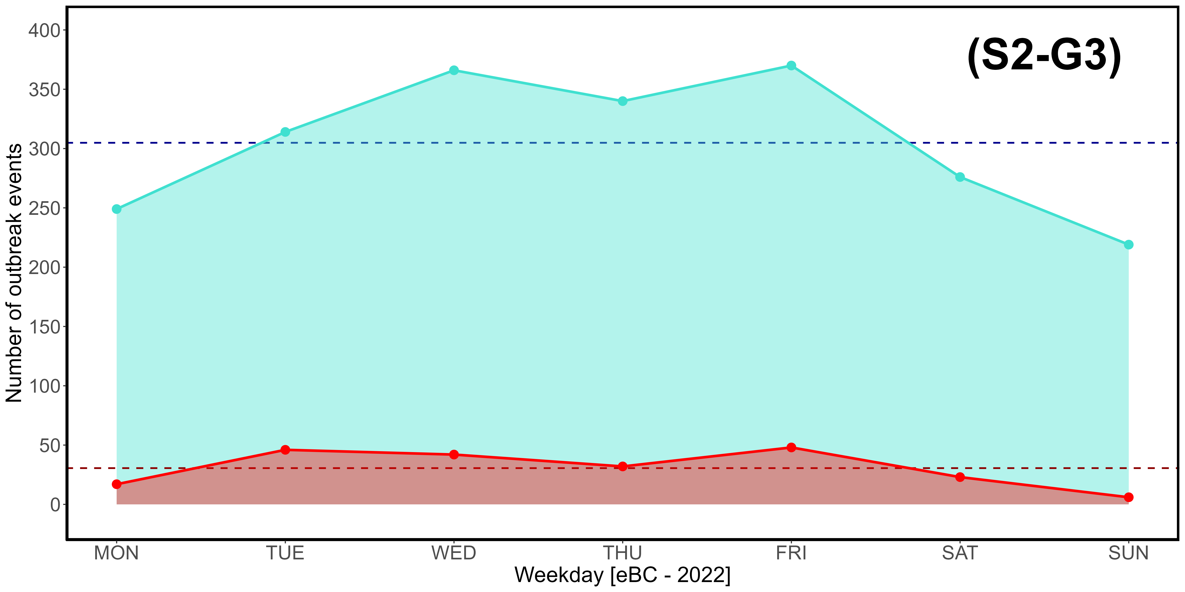
Supplementary Material S2-G1, S2-G2, S2-G3. Weekly (MON-SUN) distribution of CO (G1), CO₂ (G2), and eBC (G3) outbreak events exceeding the 3rd quartile (turquoise) and 97,5% threshold (red) in 2022.
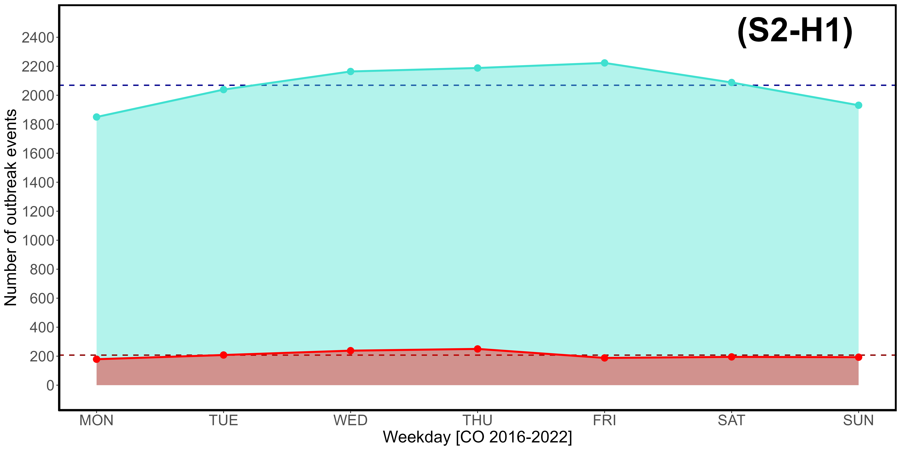
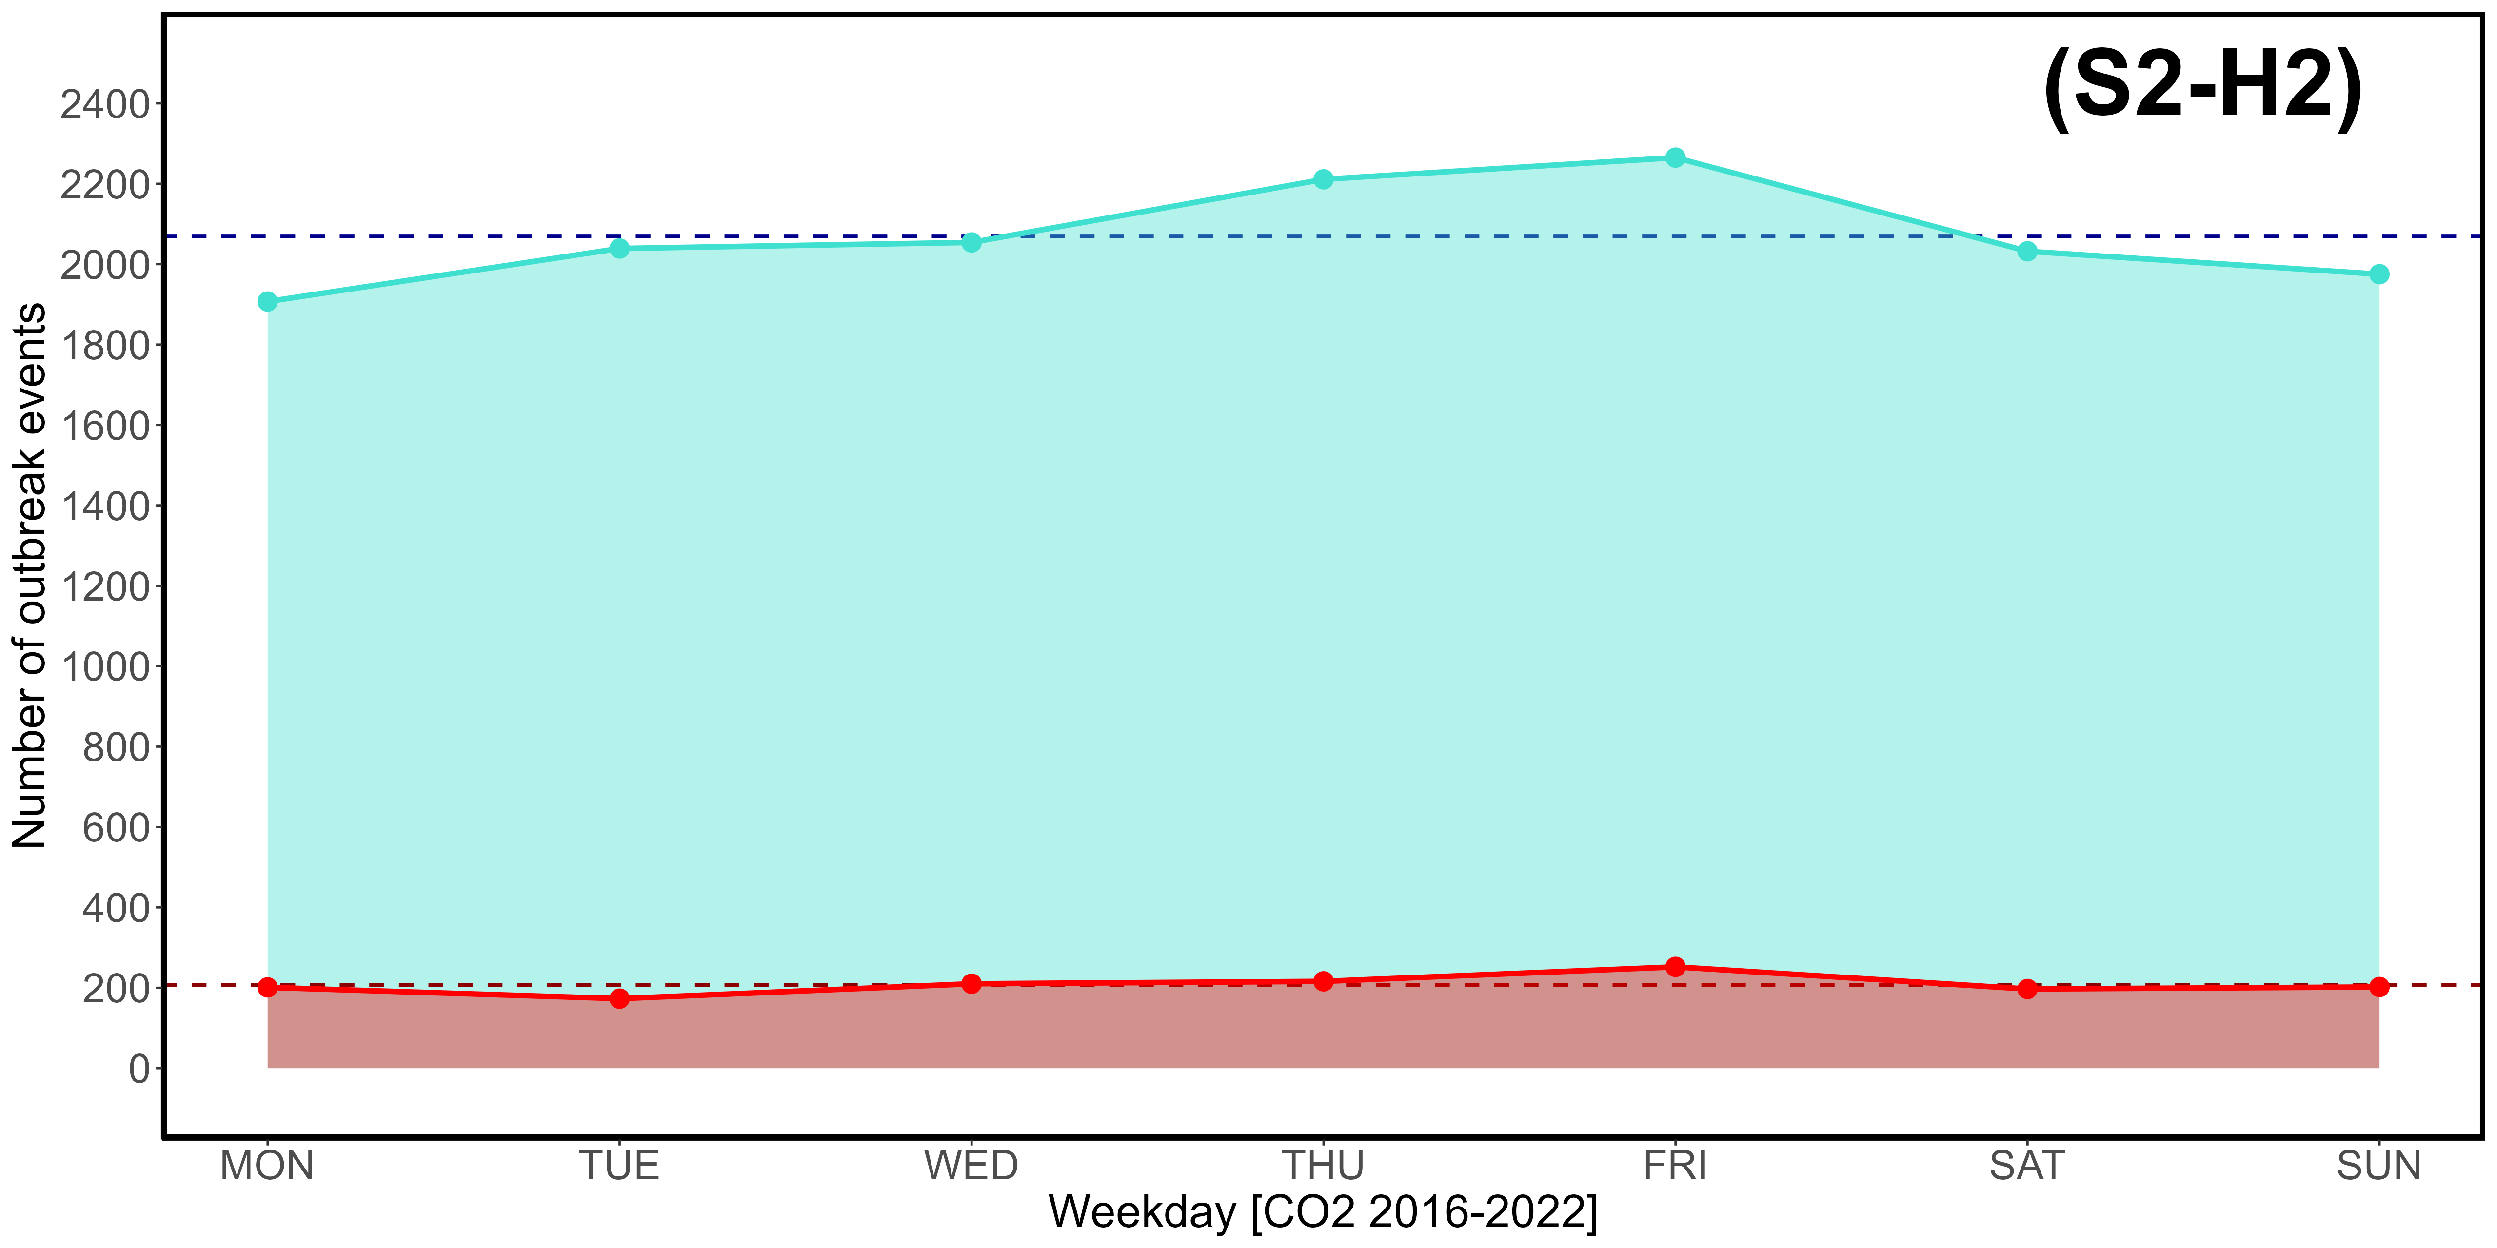
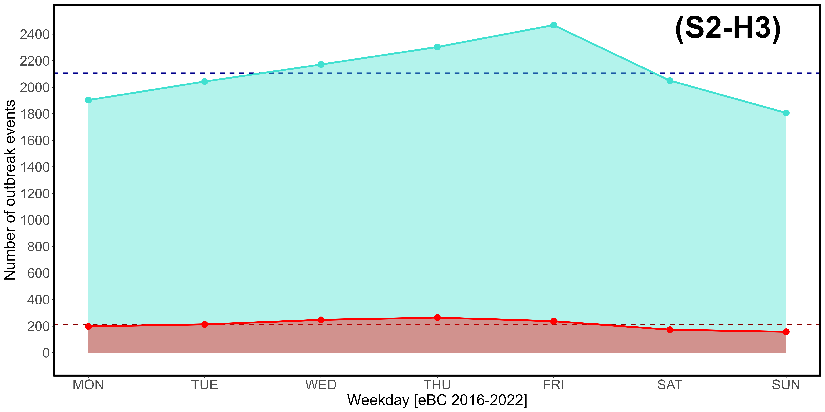

Supplementary Material S2-H1, S2-H2, S2-H3. Weekly (MON-SUN) distribution of CO (H1), CO2 (H2), and eBC (H3) out-break events exceeding the 3rd quartile (turquoise) and 97,5% threshold (red) over the entire observation period 2016-2022. Please note that the vertical scale used is different from that of Supplementary Material S2-A through S2-G.

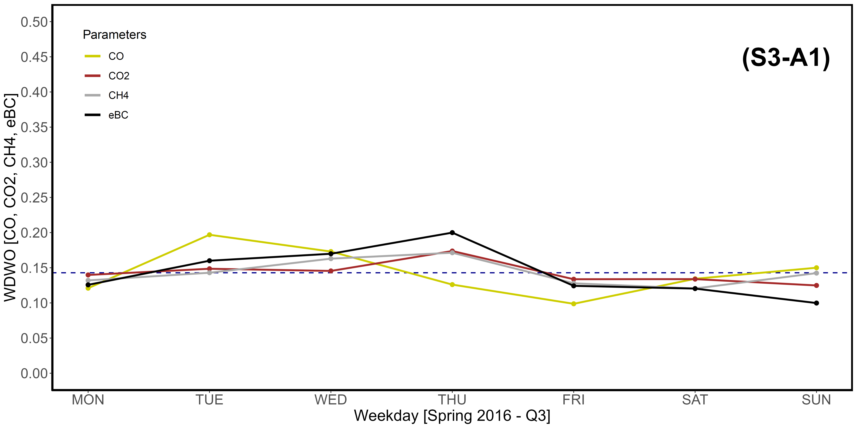
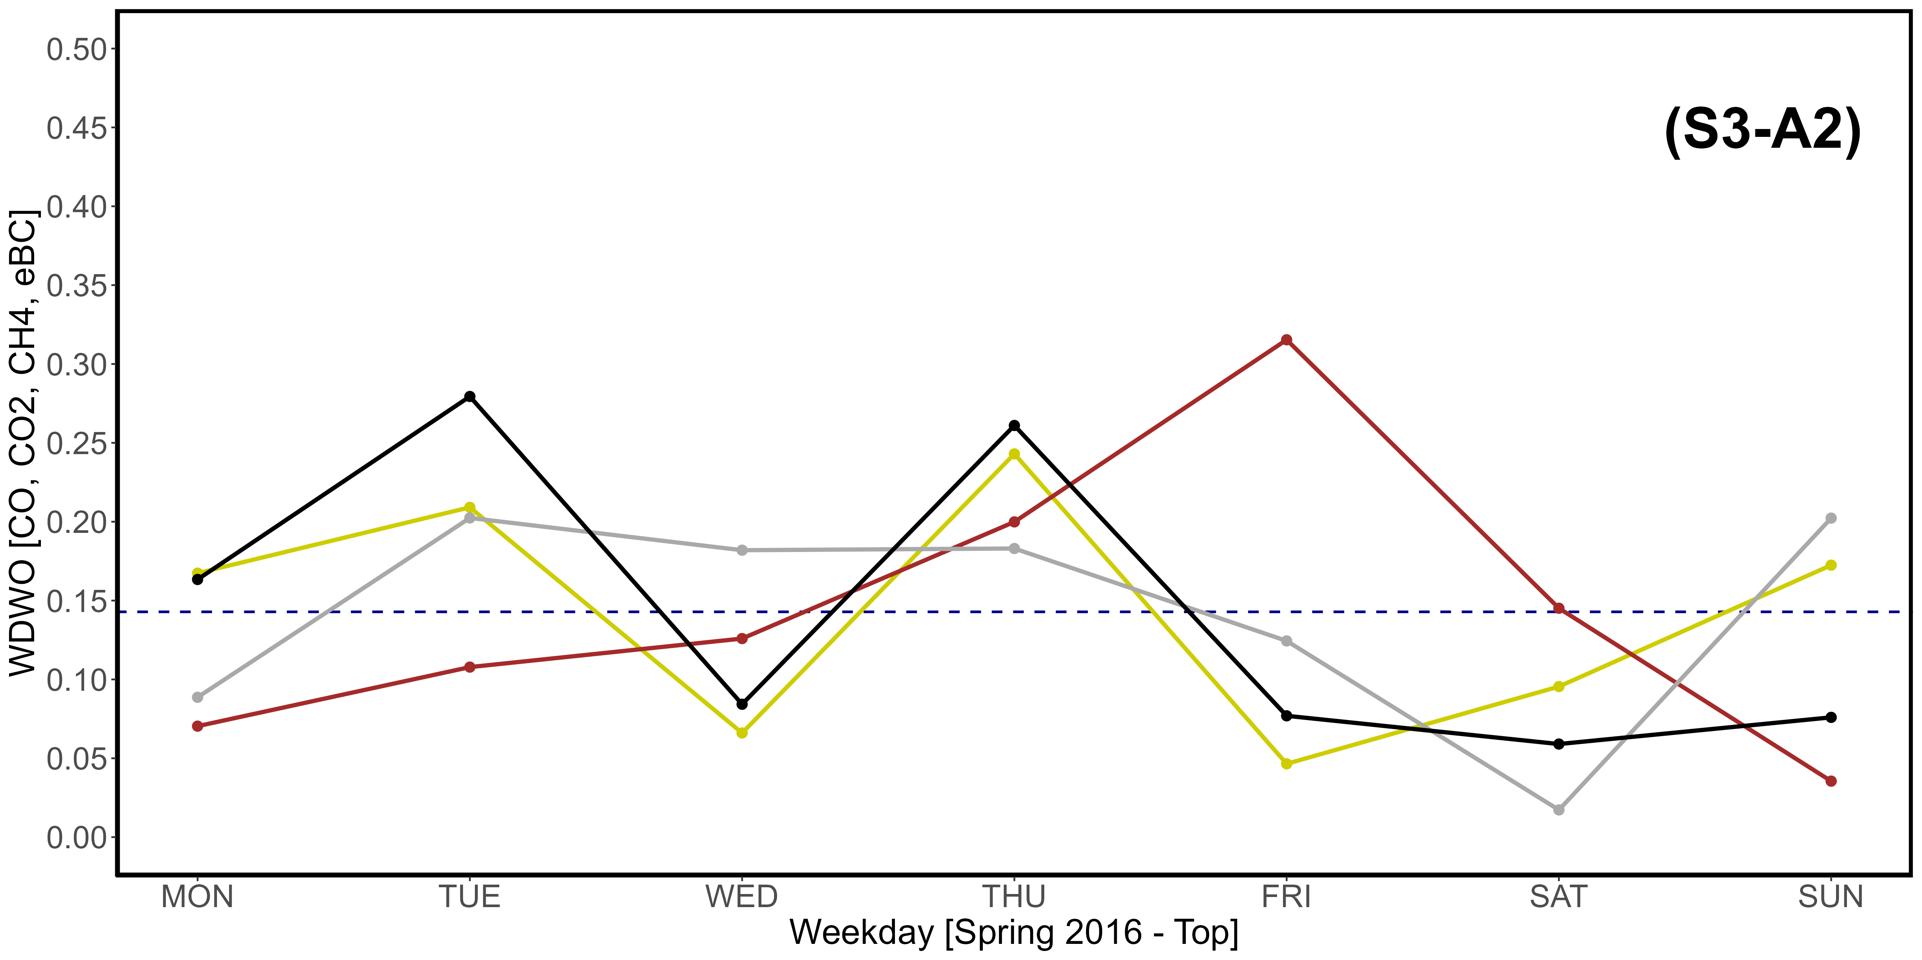
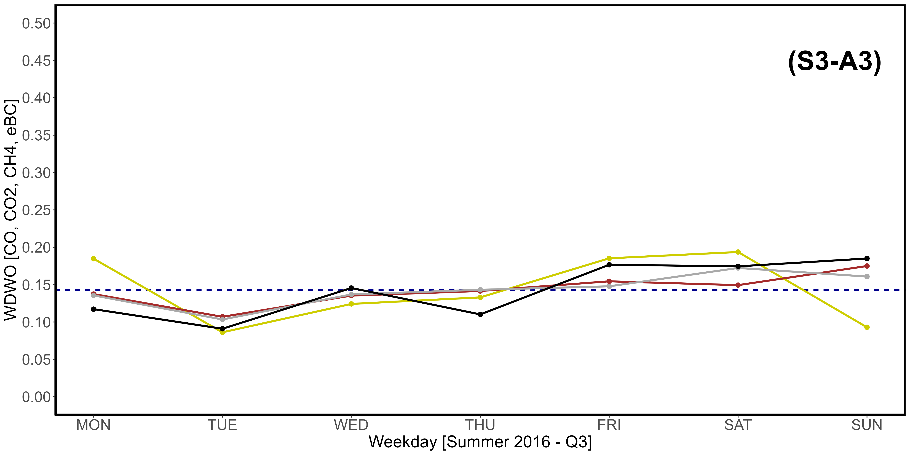
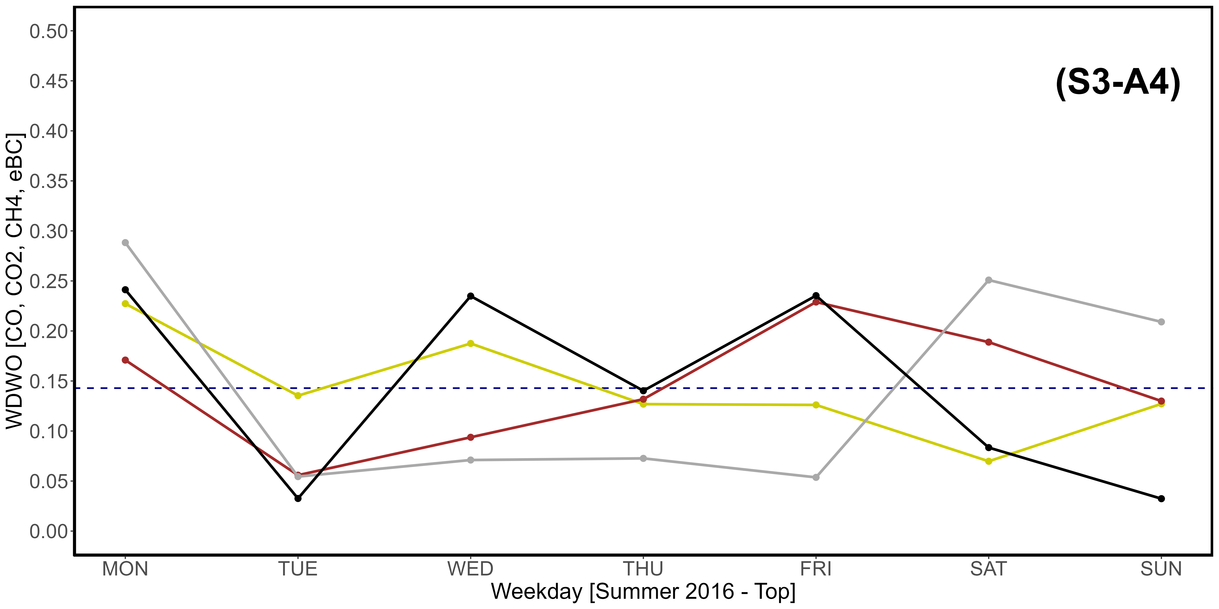
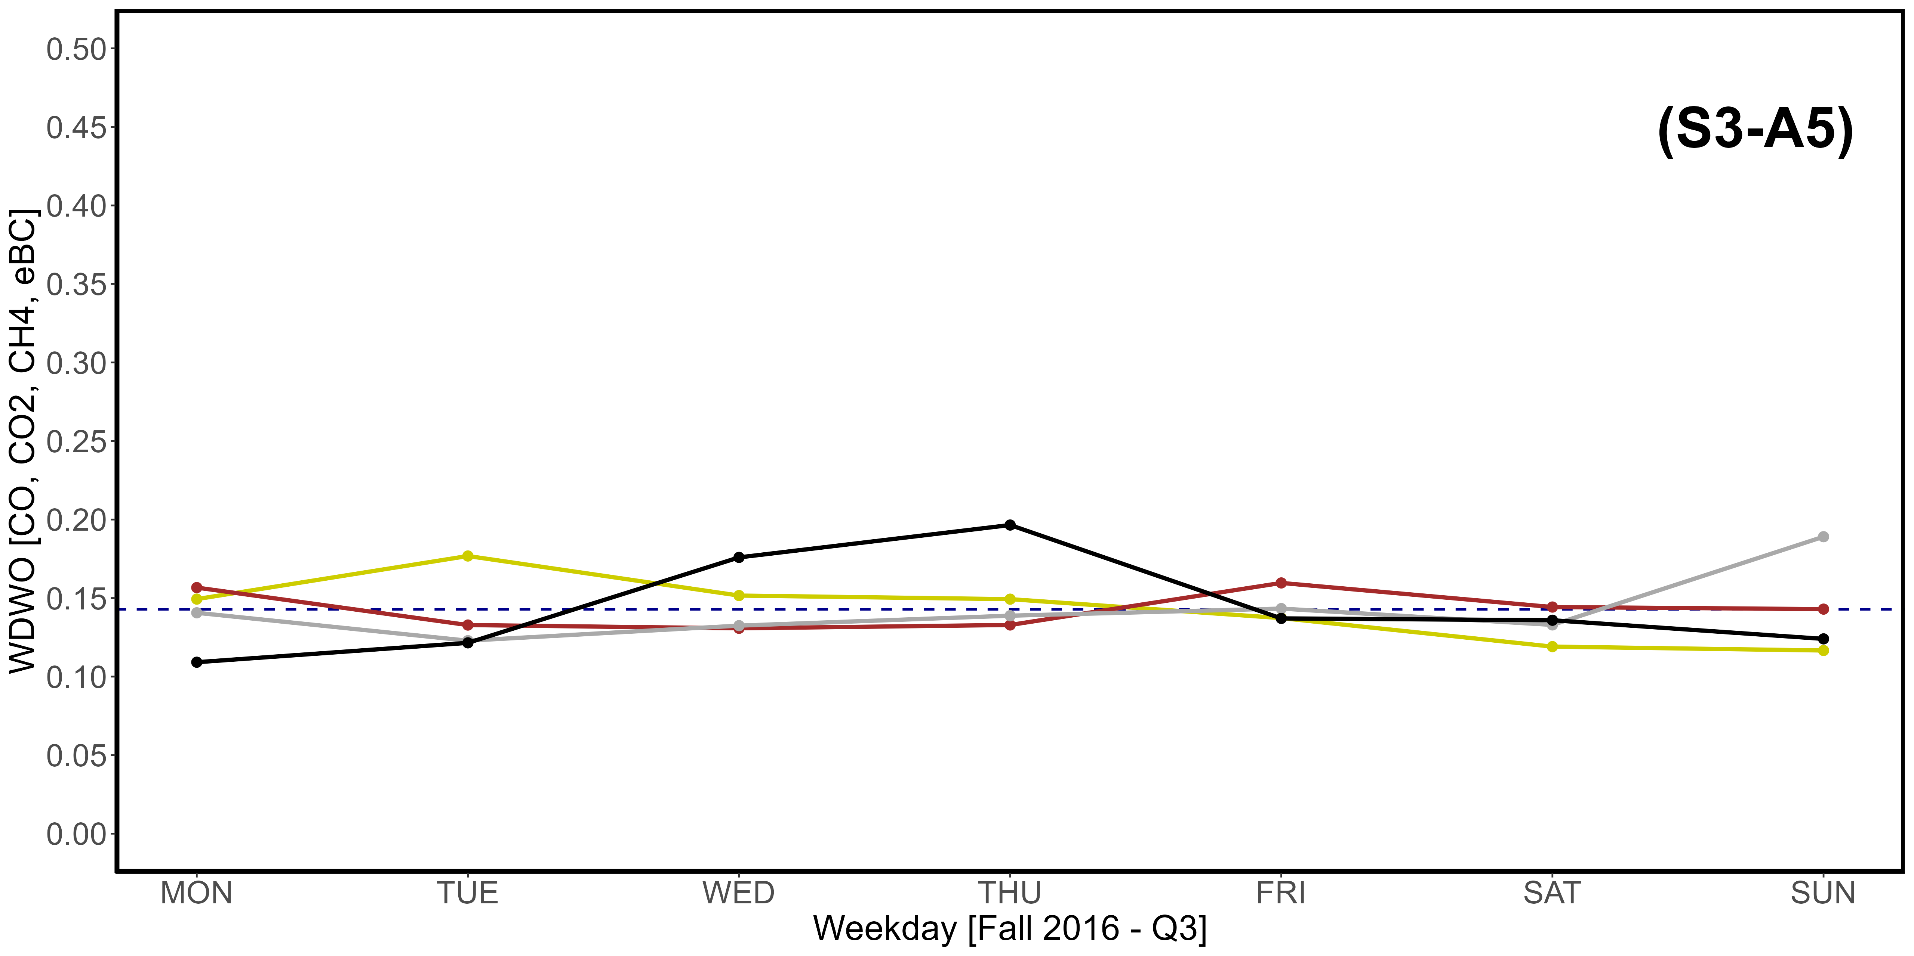
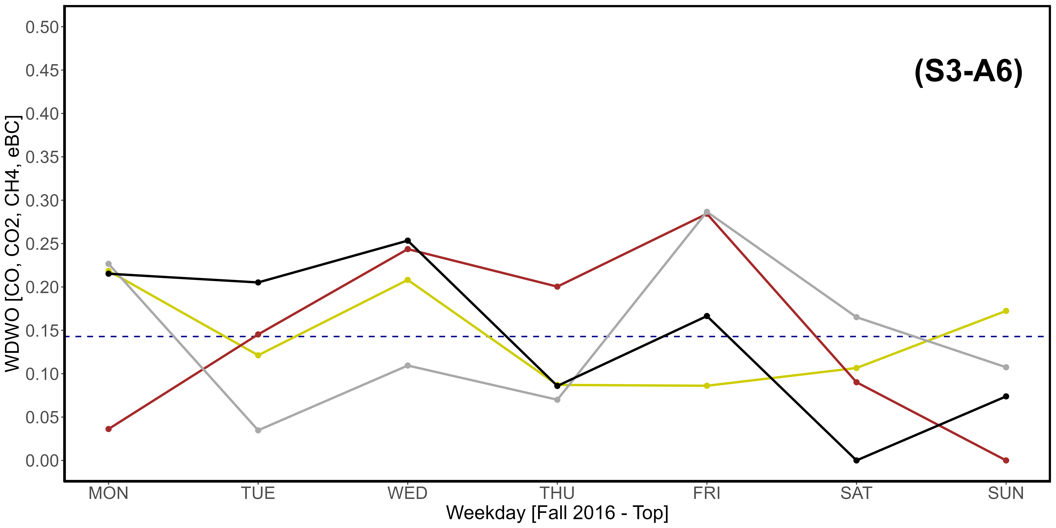
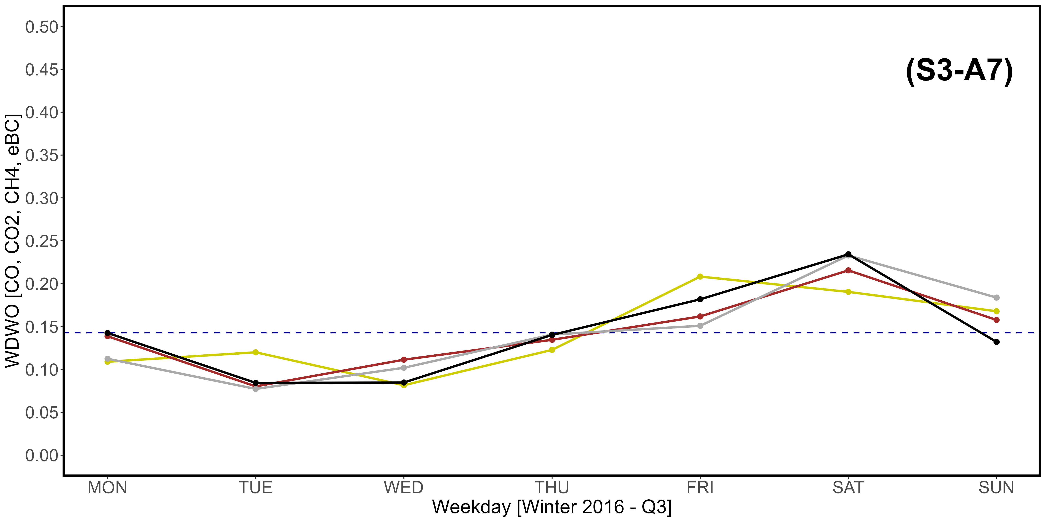
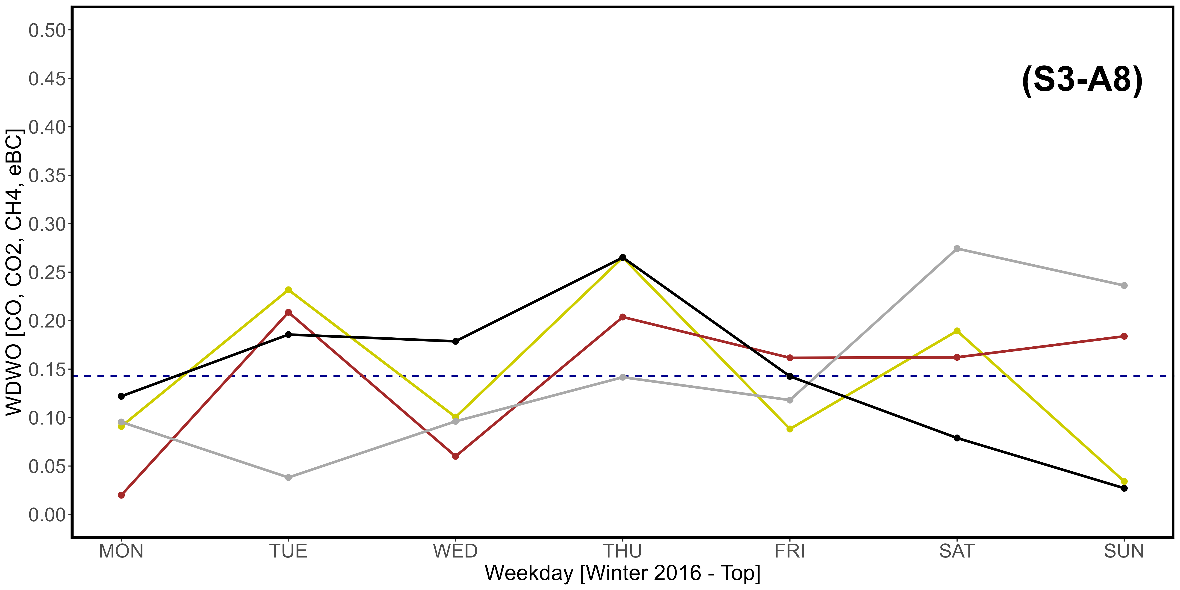
Supplementary Material S3-A1, S3-A2, S3-A3, S3-A4, S3-A5, S3-A7, S3-A7, S3-A8. Seasonal variations of the newly introduced WDWO parameter for CO (yellow), CO₂ (brown), CH₄ (dark gray) and eBC (black), referring specifically to the year 2016. A: Spring; B: Summer; C: Fall; D: Winter. “1” images refer to the Q3 threshold, while “2” refer to the top 2,5% of data. The intercept parallel to the x axis indicates the average expected value per day, which is 0,1428. The vertical scale is different compared to that used in Fig. 11.

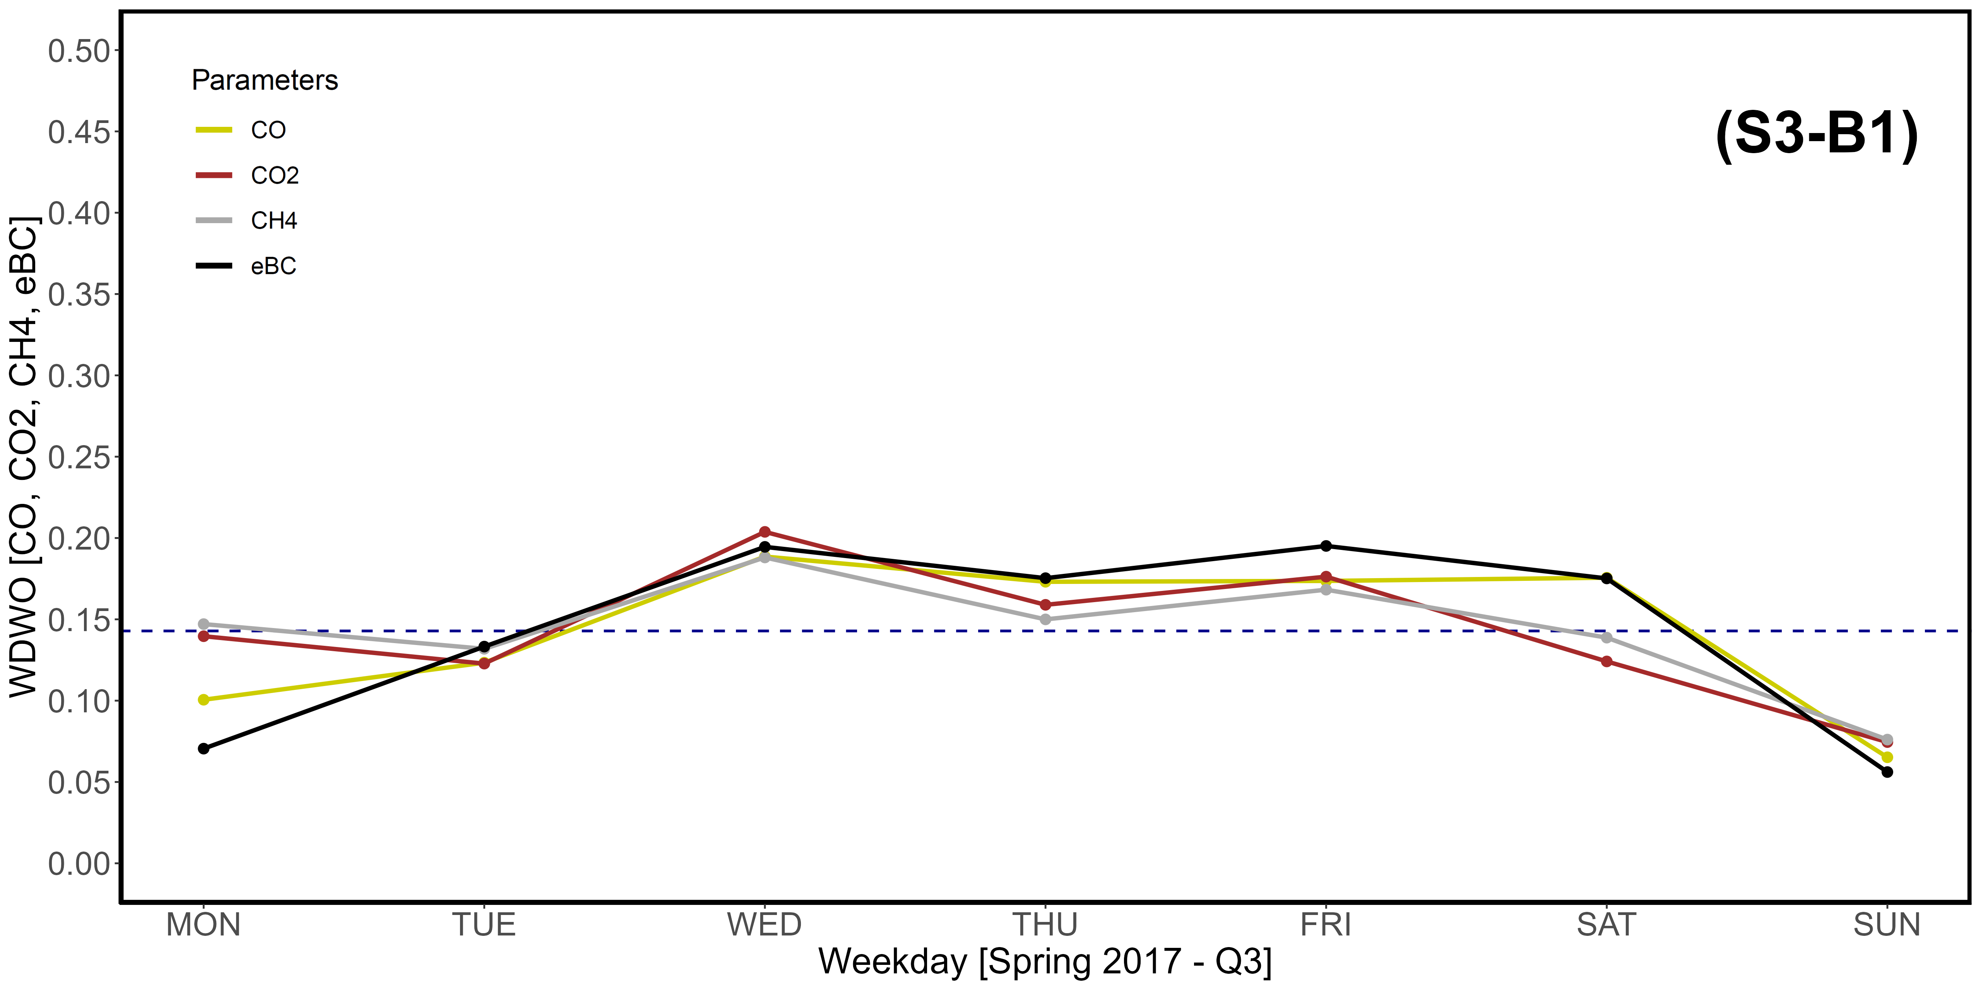
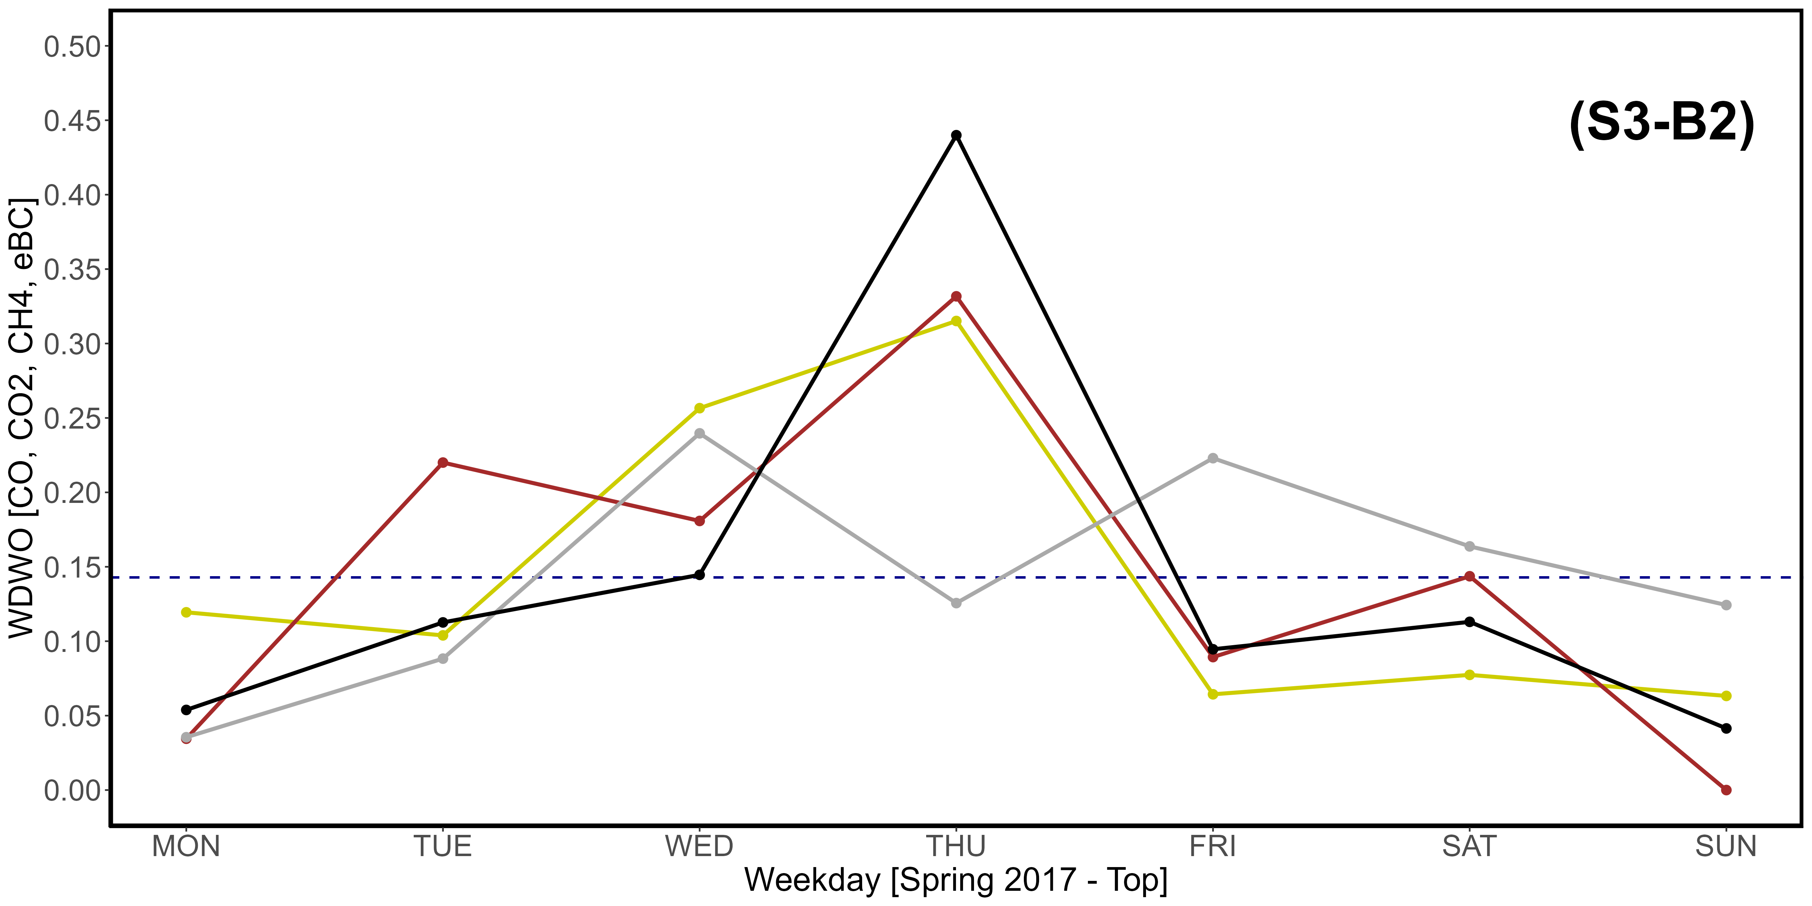
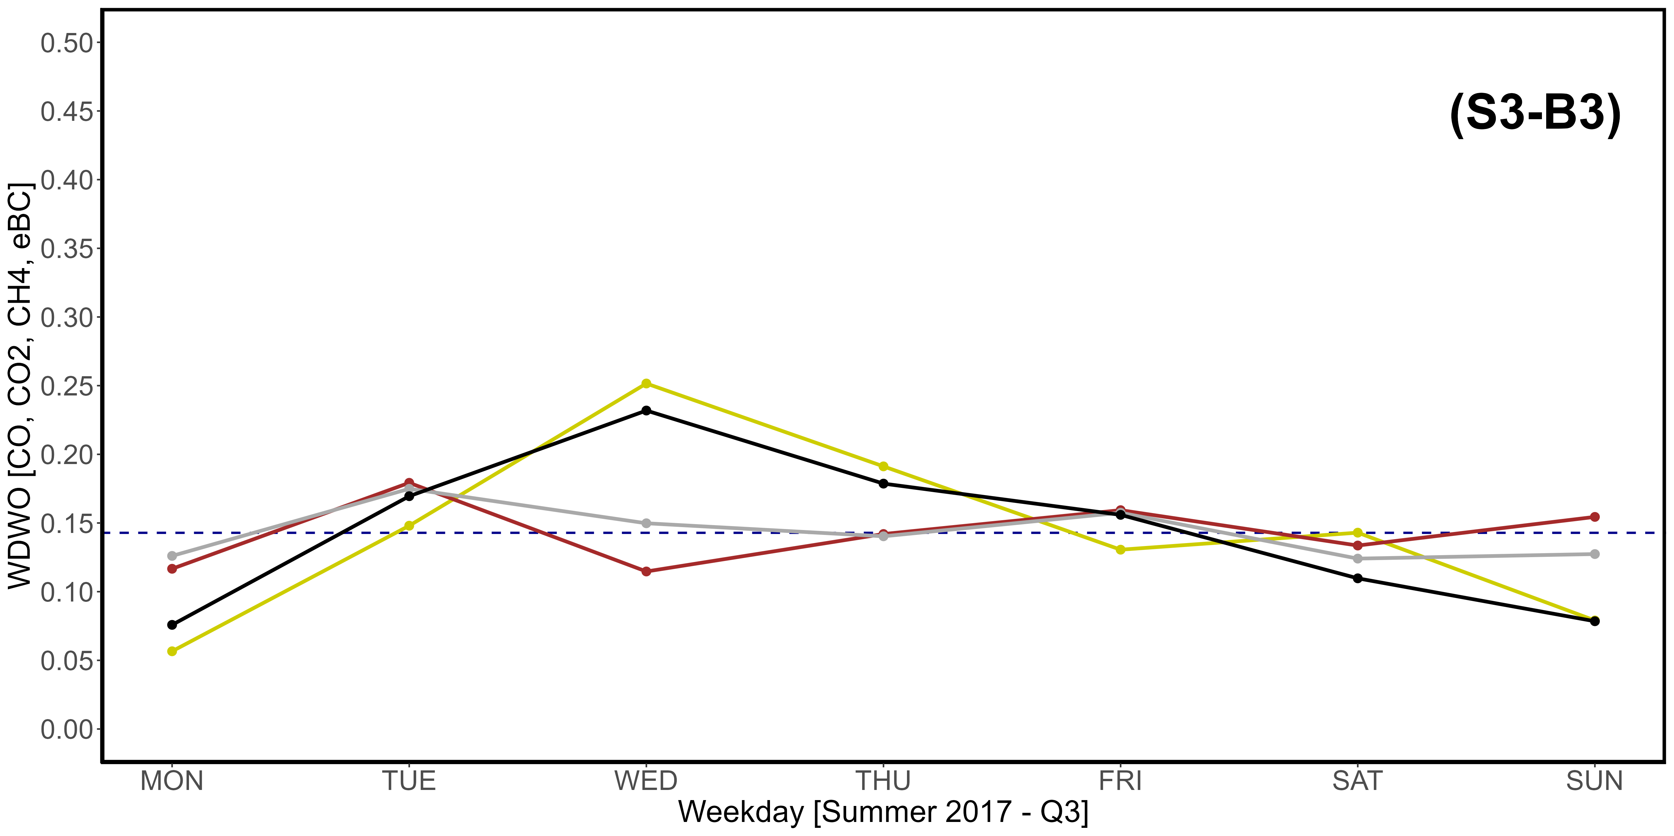
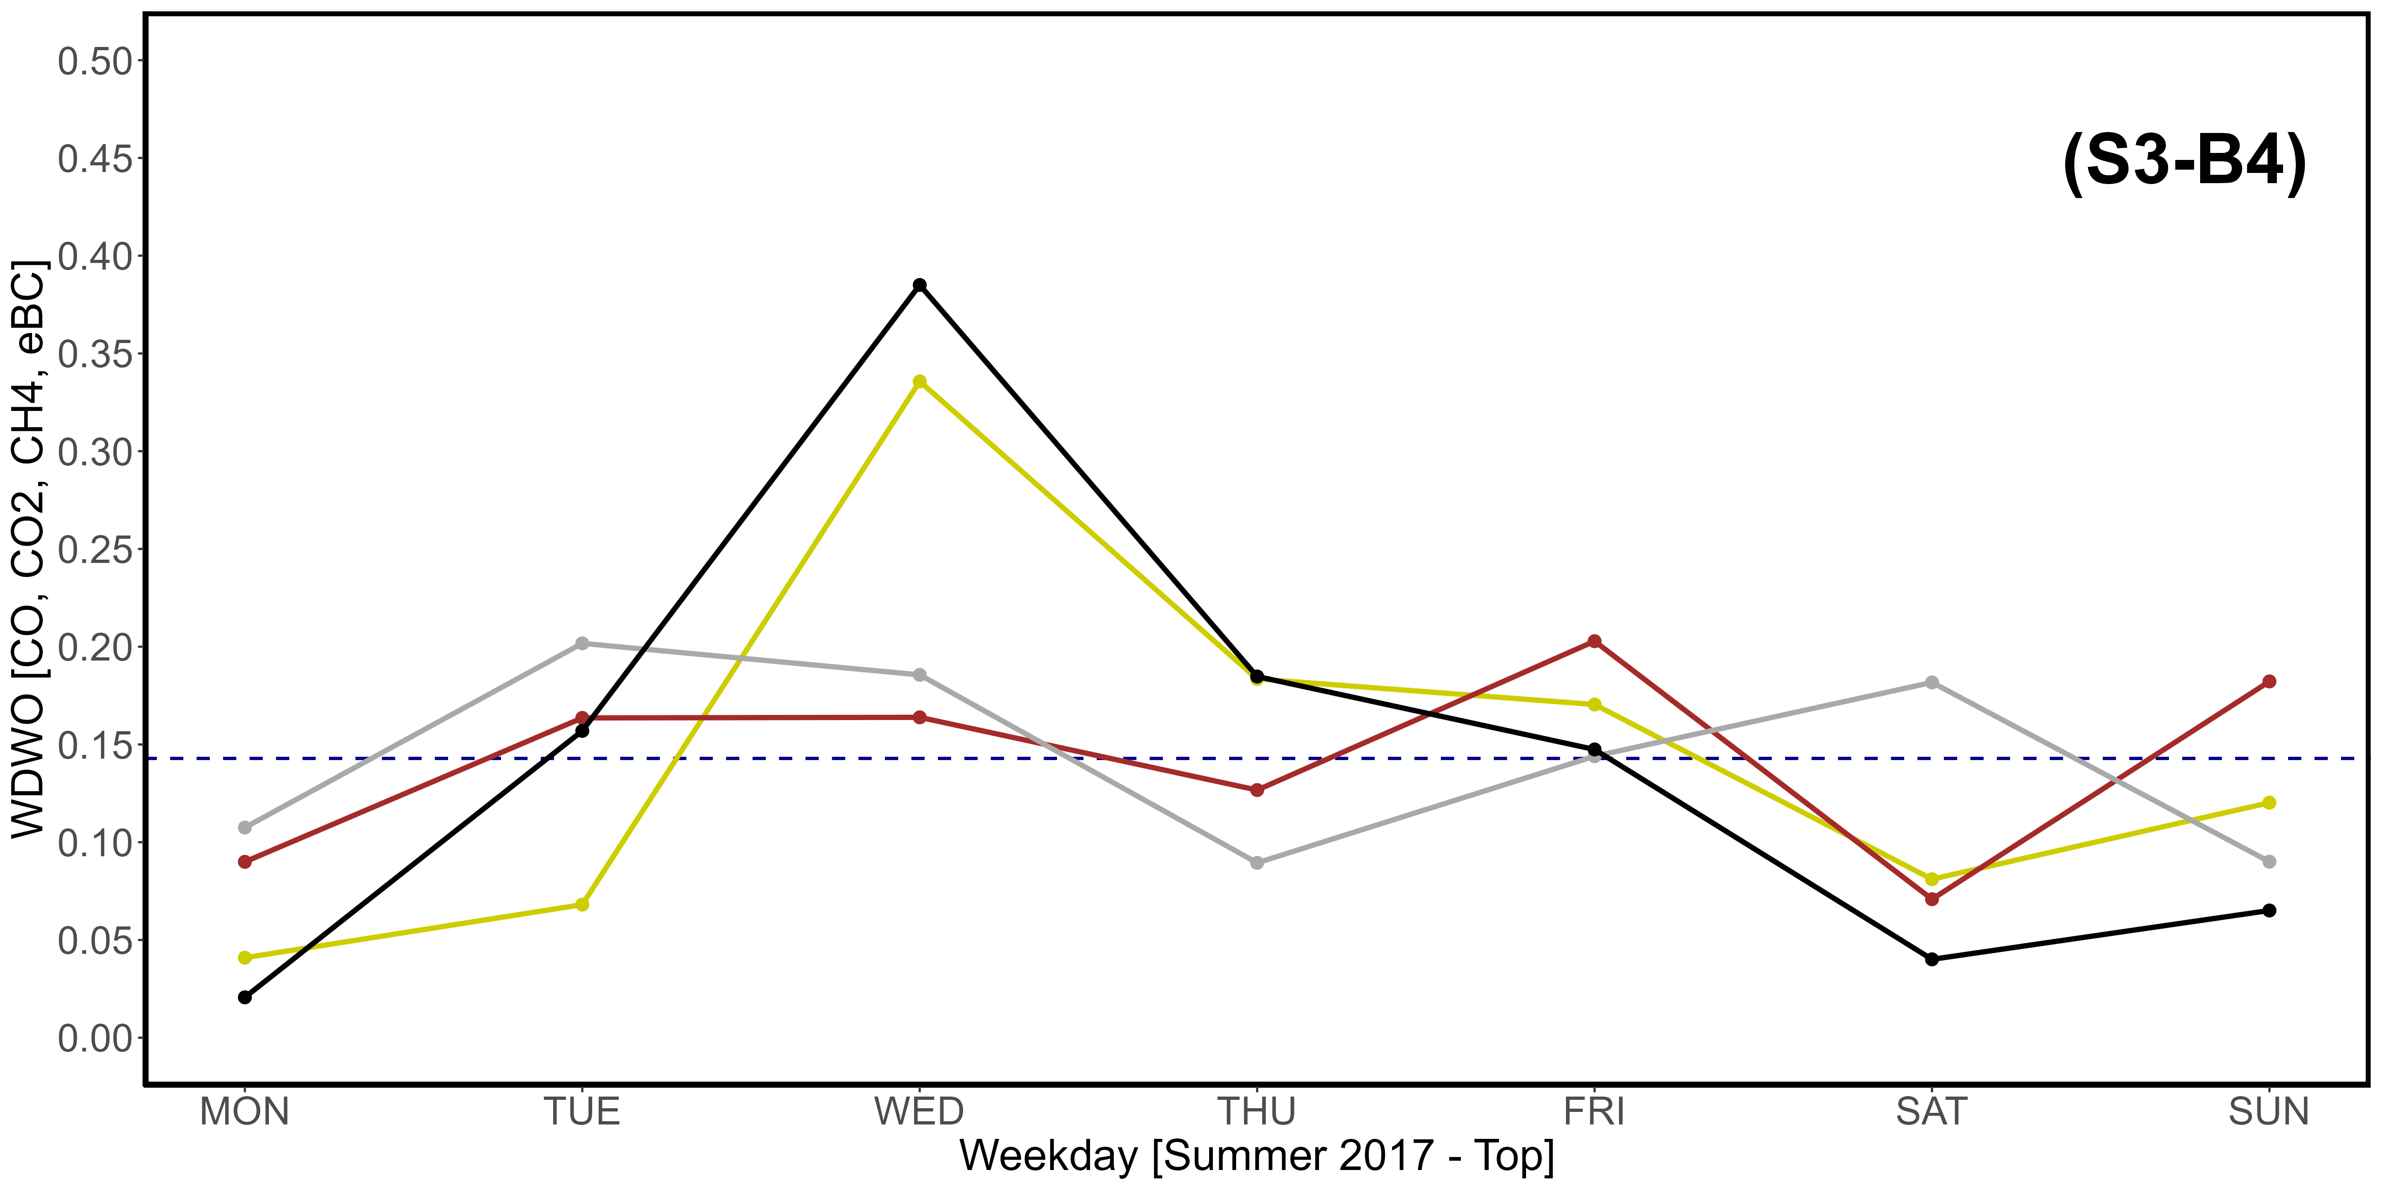
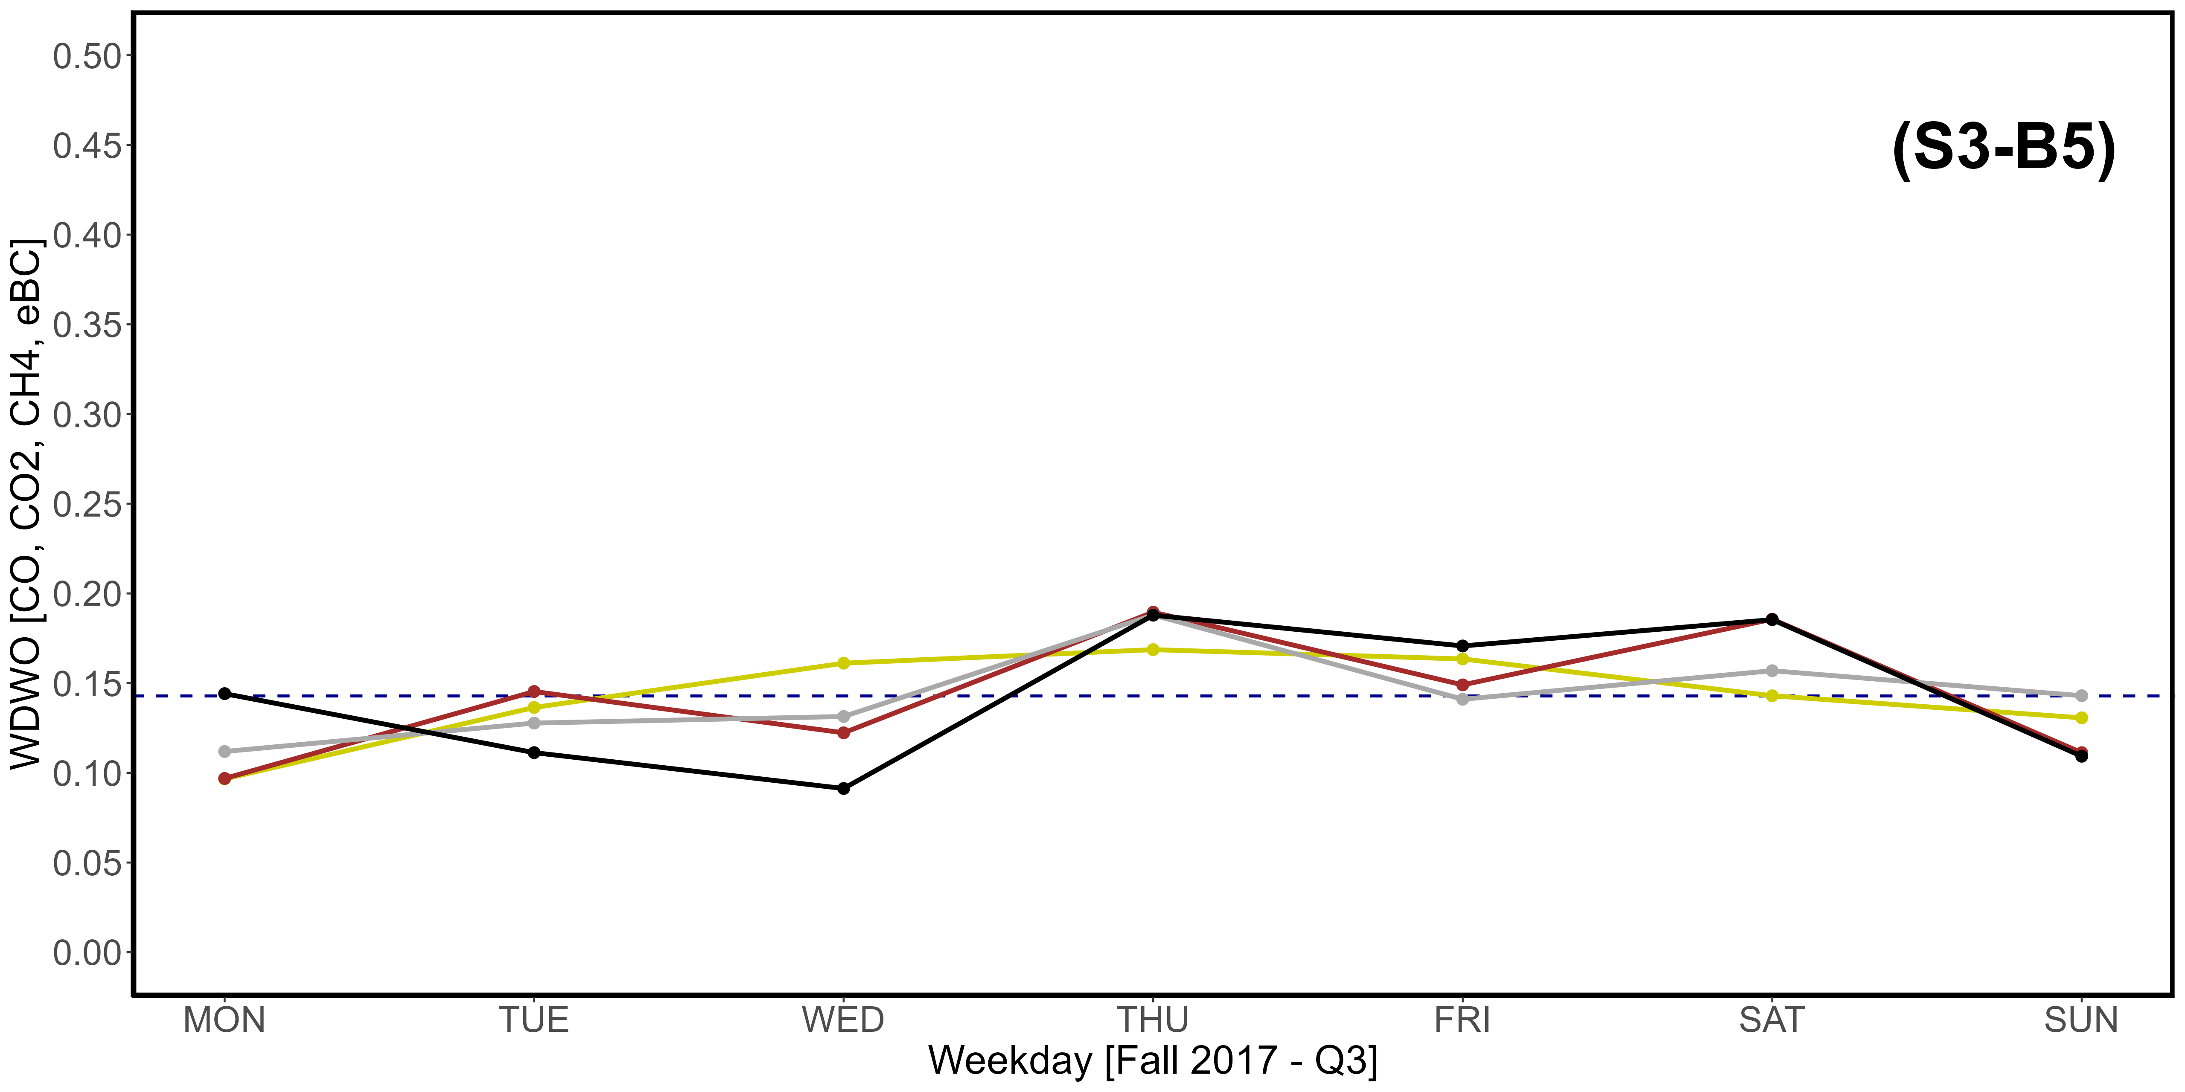
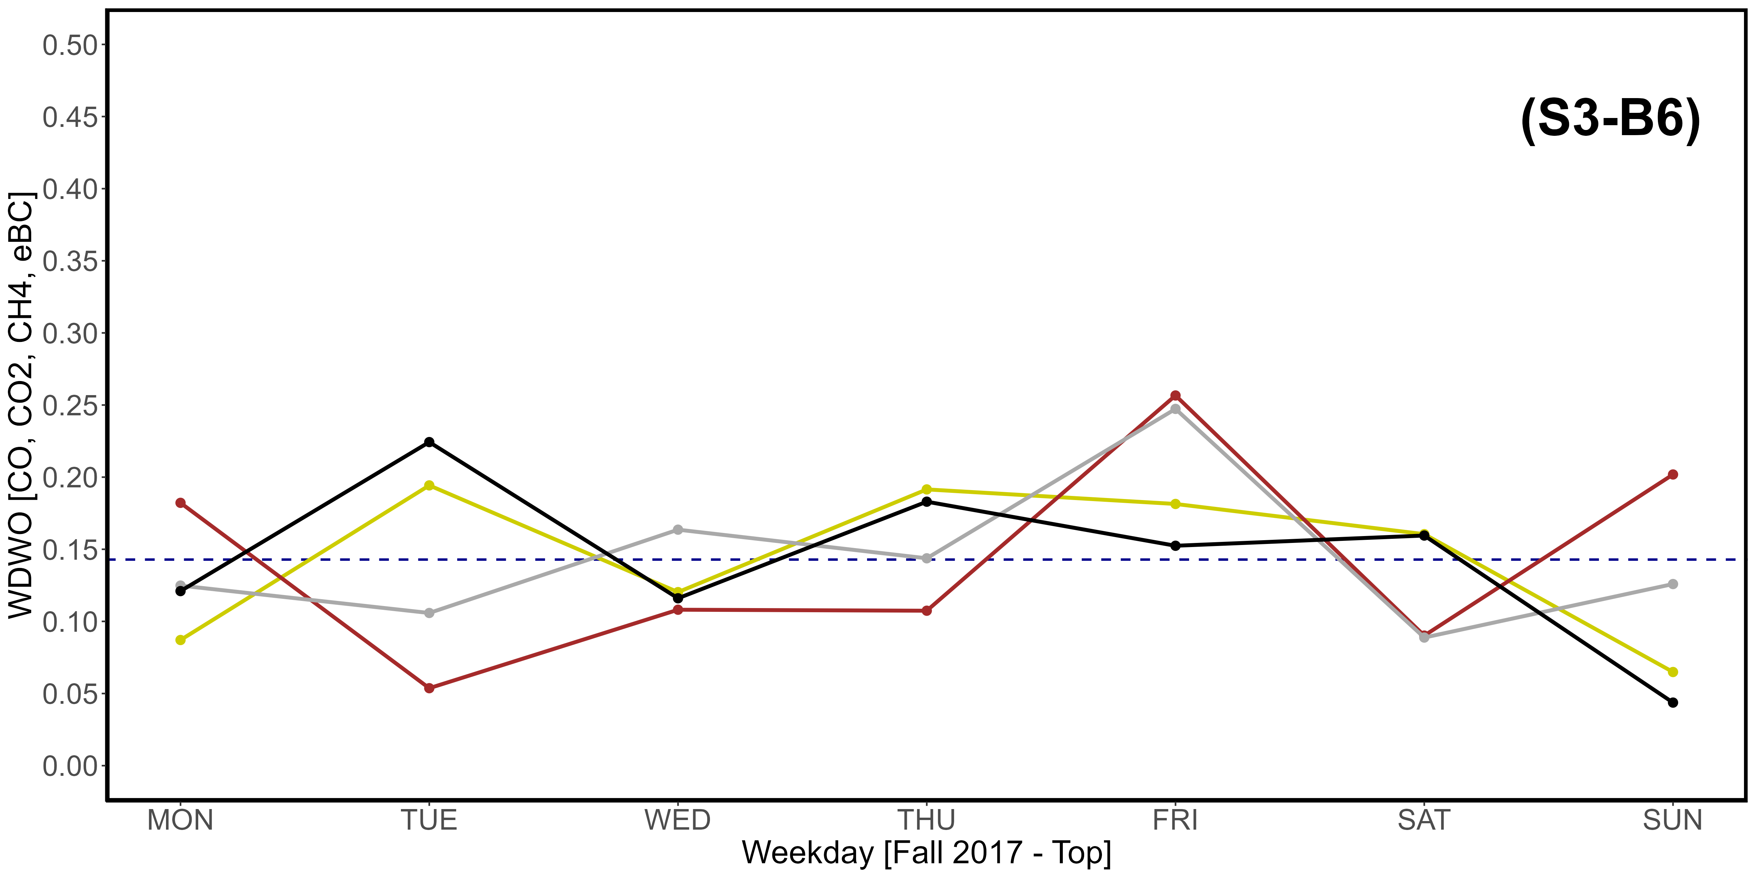
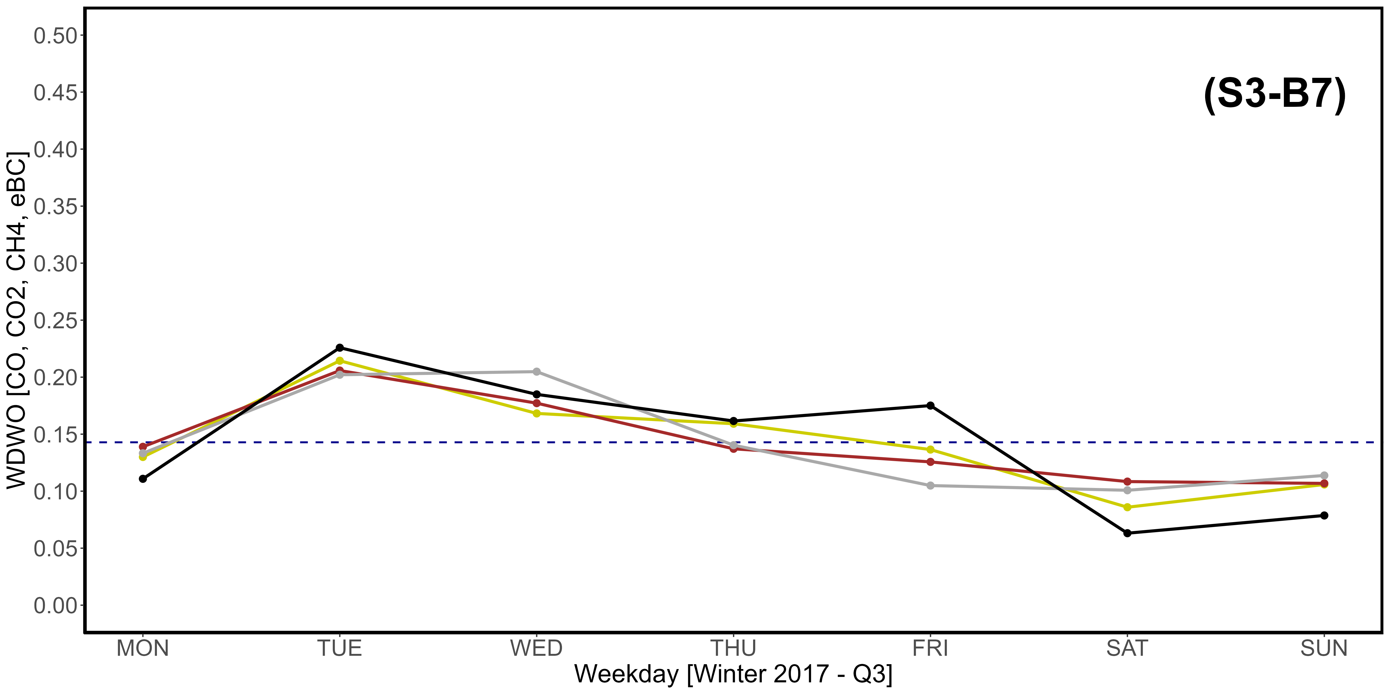
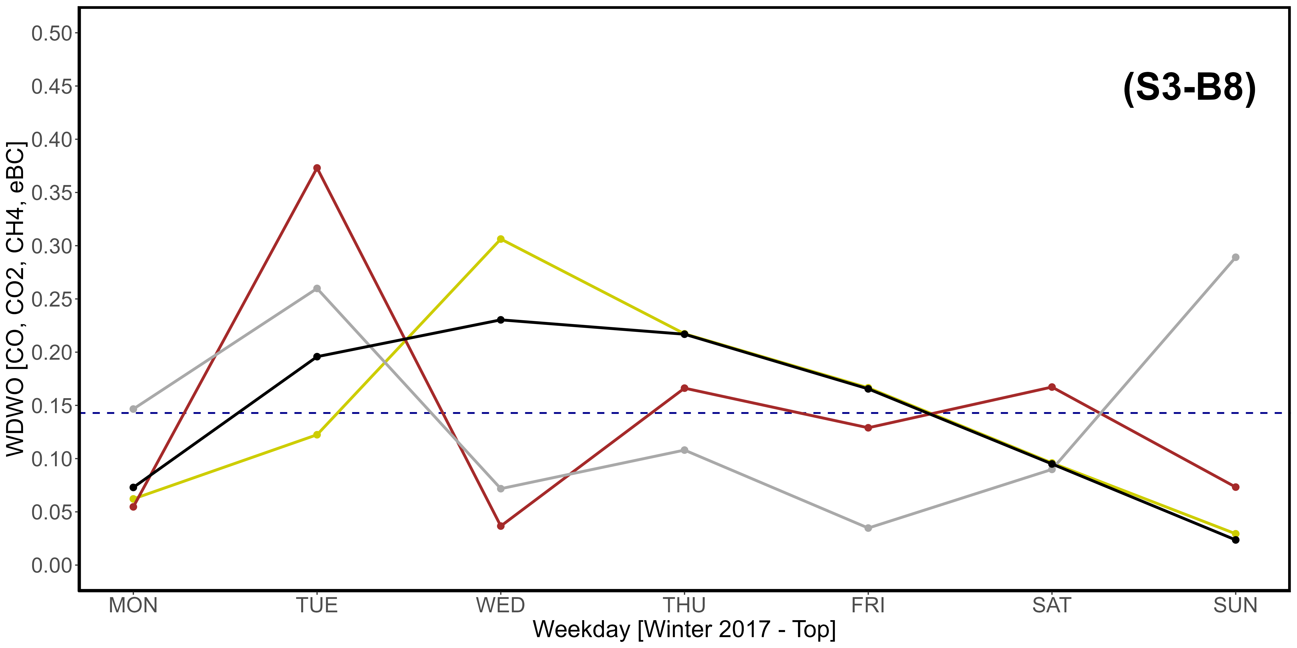
Supplementary Material S3-B1, S3-B2, S3-B3, S3-B4, S3-B5, S3-B7, S3-B7, S3-B8. Seasonal variations of the newly introduced WDWO parameter for CO (yellow), CO₂ (brown), CH₄ (dark gray) and eBC (black), referring specifically to the year 2017. A: Spring; B: Summer; C: Fall; D: Winter. “1” images refer to the Q3 threshold, while “2” refer to the top 2,5% of data. The intercept parallel to the x axis indicates the average expected value per day, which is 0,1428. The vertical scale is different compared to that used in Fig. 11.

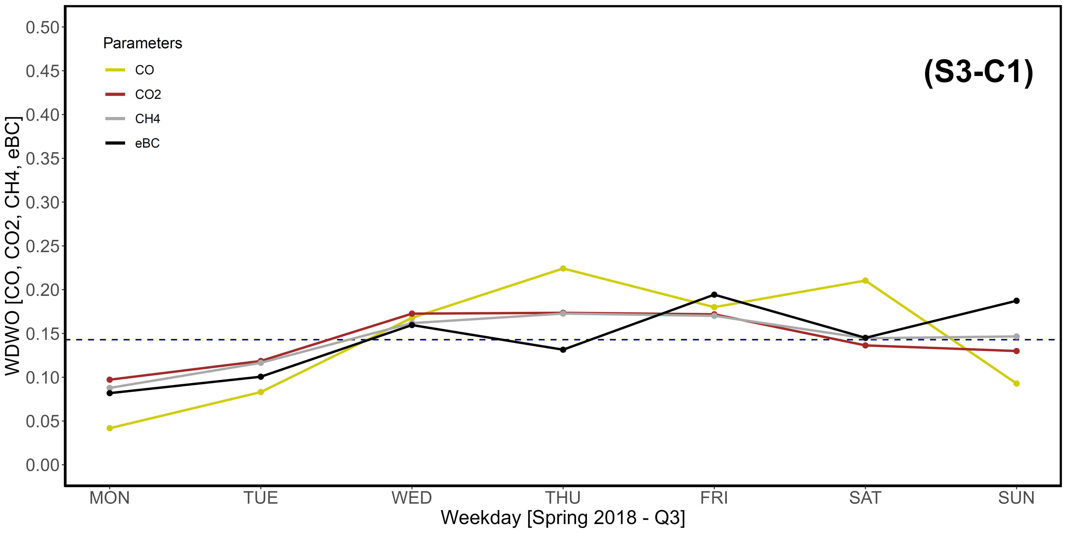
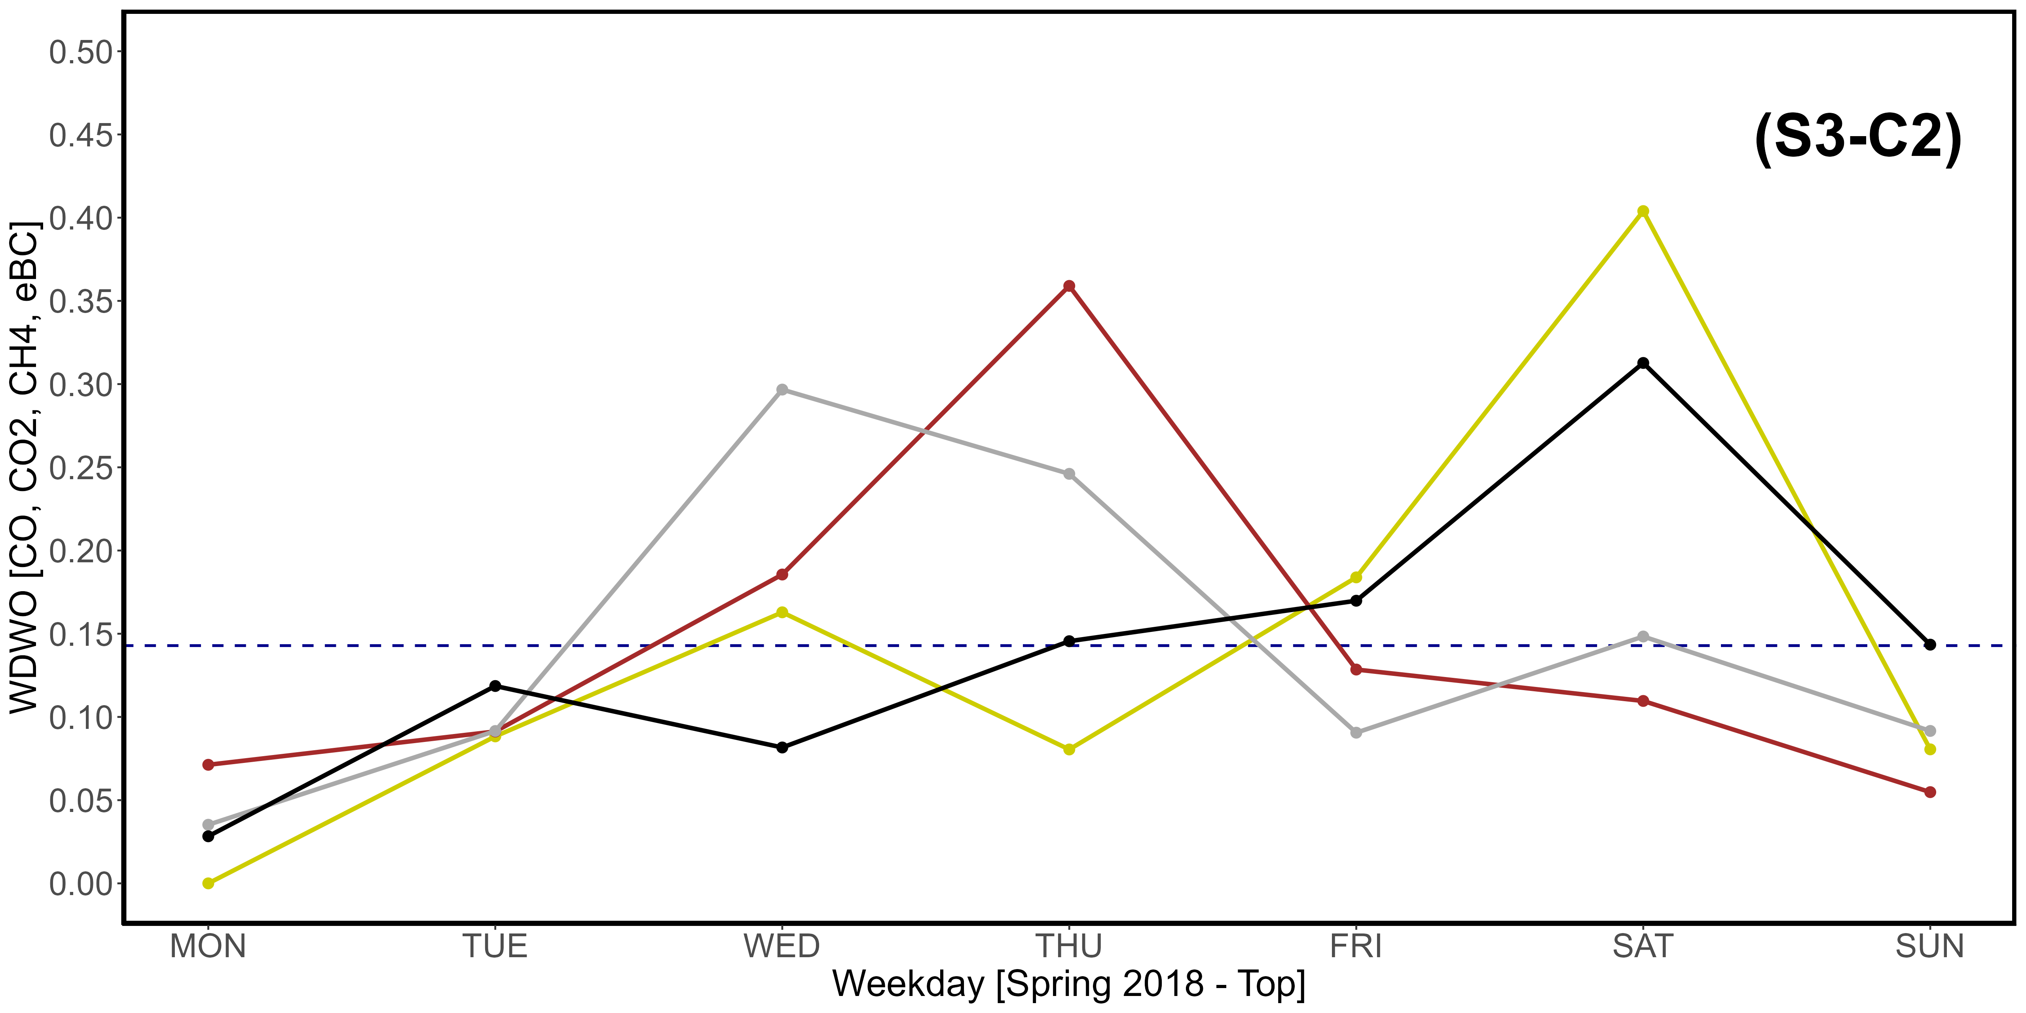
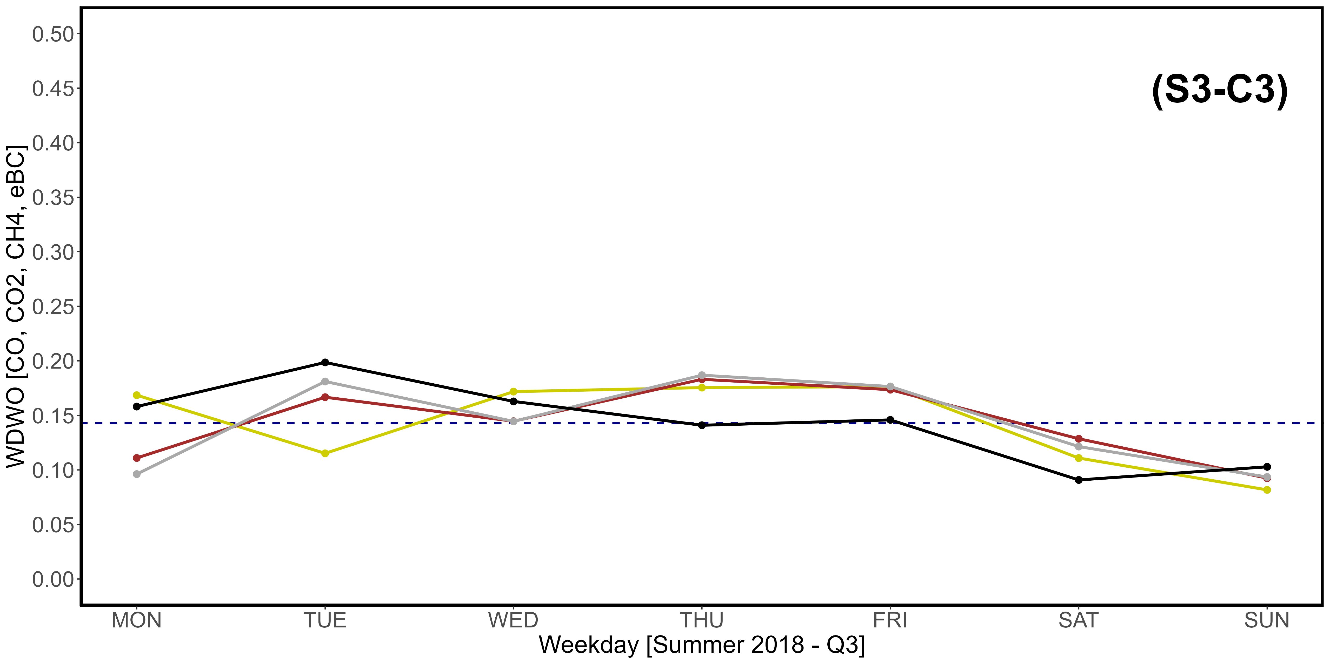
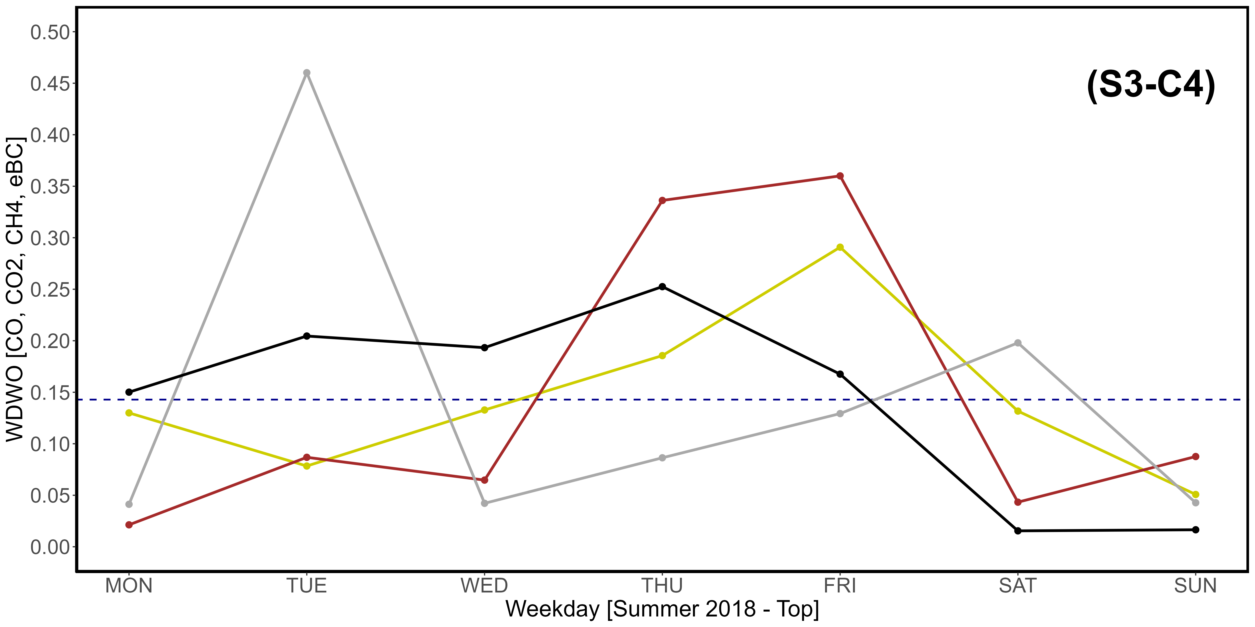
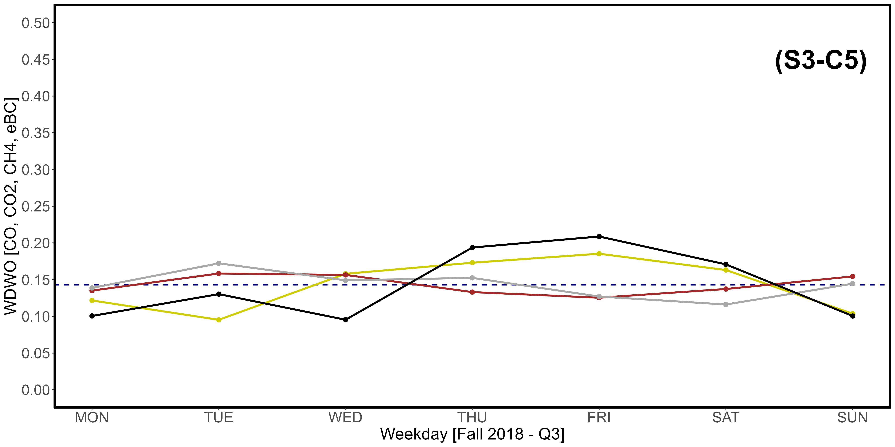
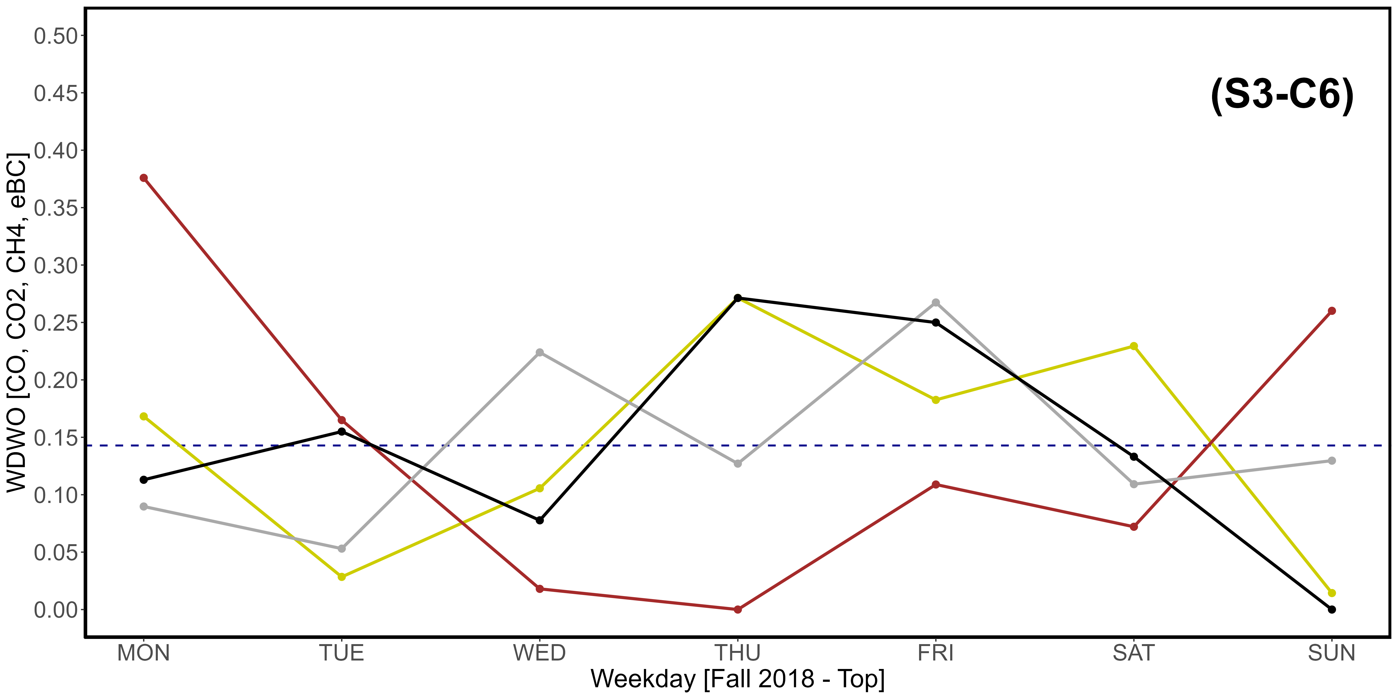
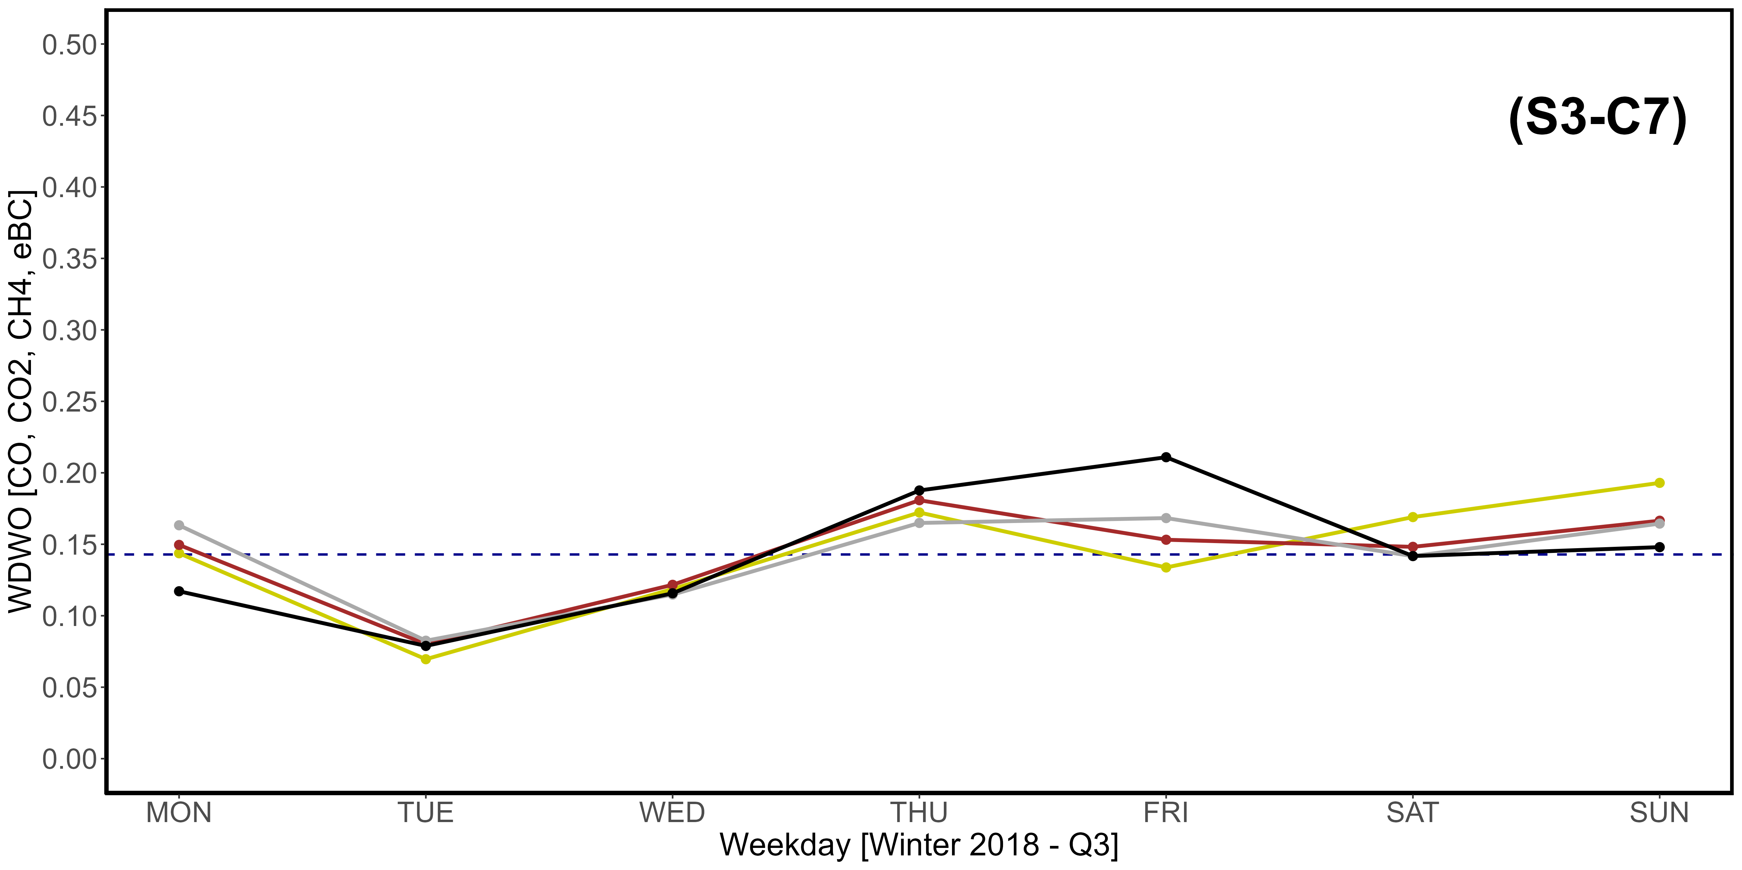
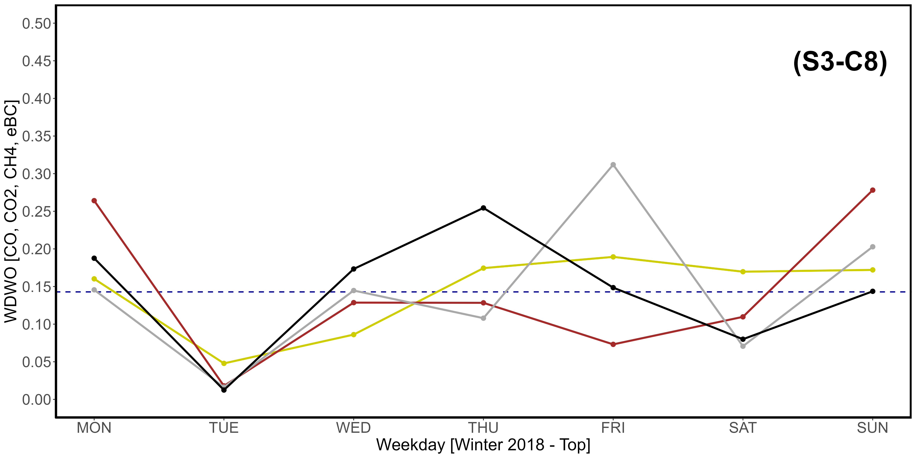
Supplementary Material S3-C1, S3-C2, S3-C3, S3-C4, S3-C5, S3-C7, S3-C7, S3-C8. Seasonal variations of the newly introduced WDWO parameter for CO (yellow), CO₂ (brown), CH₄ (dark gray) and eBC (black), referring specifically to the year 2018. A: Spring; B: Summer; C: Fall; D: Winter. “1” images refer to the Q3 threshold, while “2” refer to the top 2,5% of data. The intercept parallel to the x axis indicates the average expected value per day, which is 0,1428. The vertical scale is different compared to that used in Fig. 11.

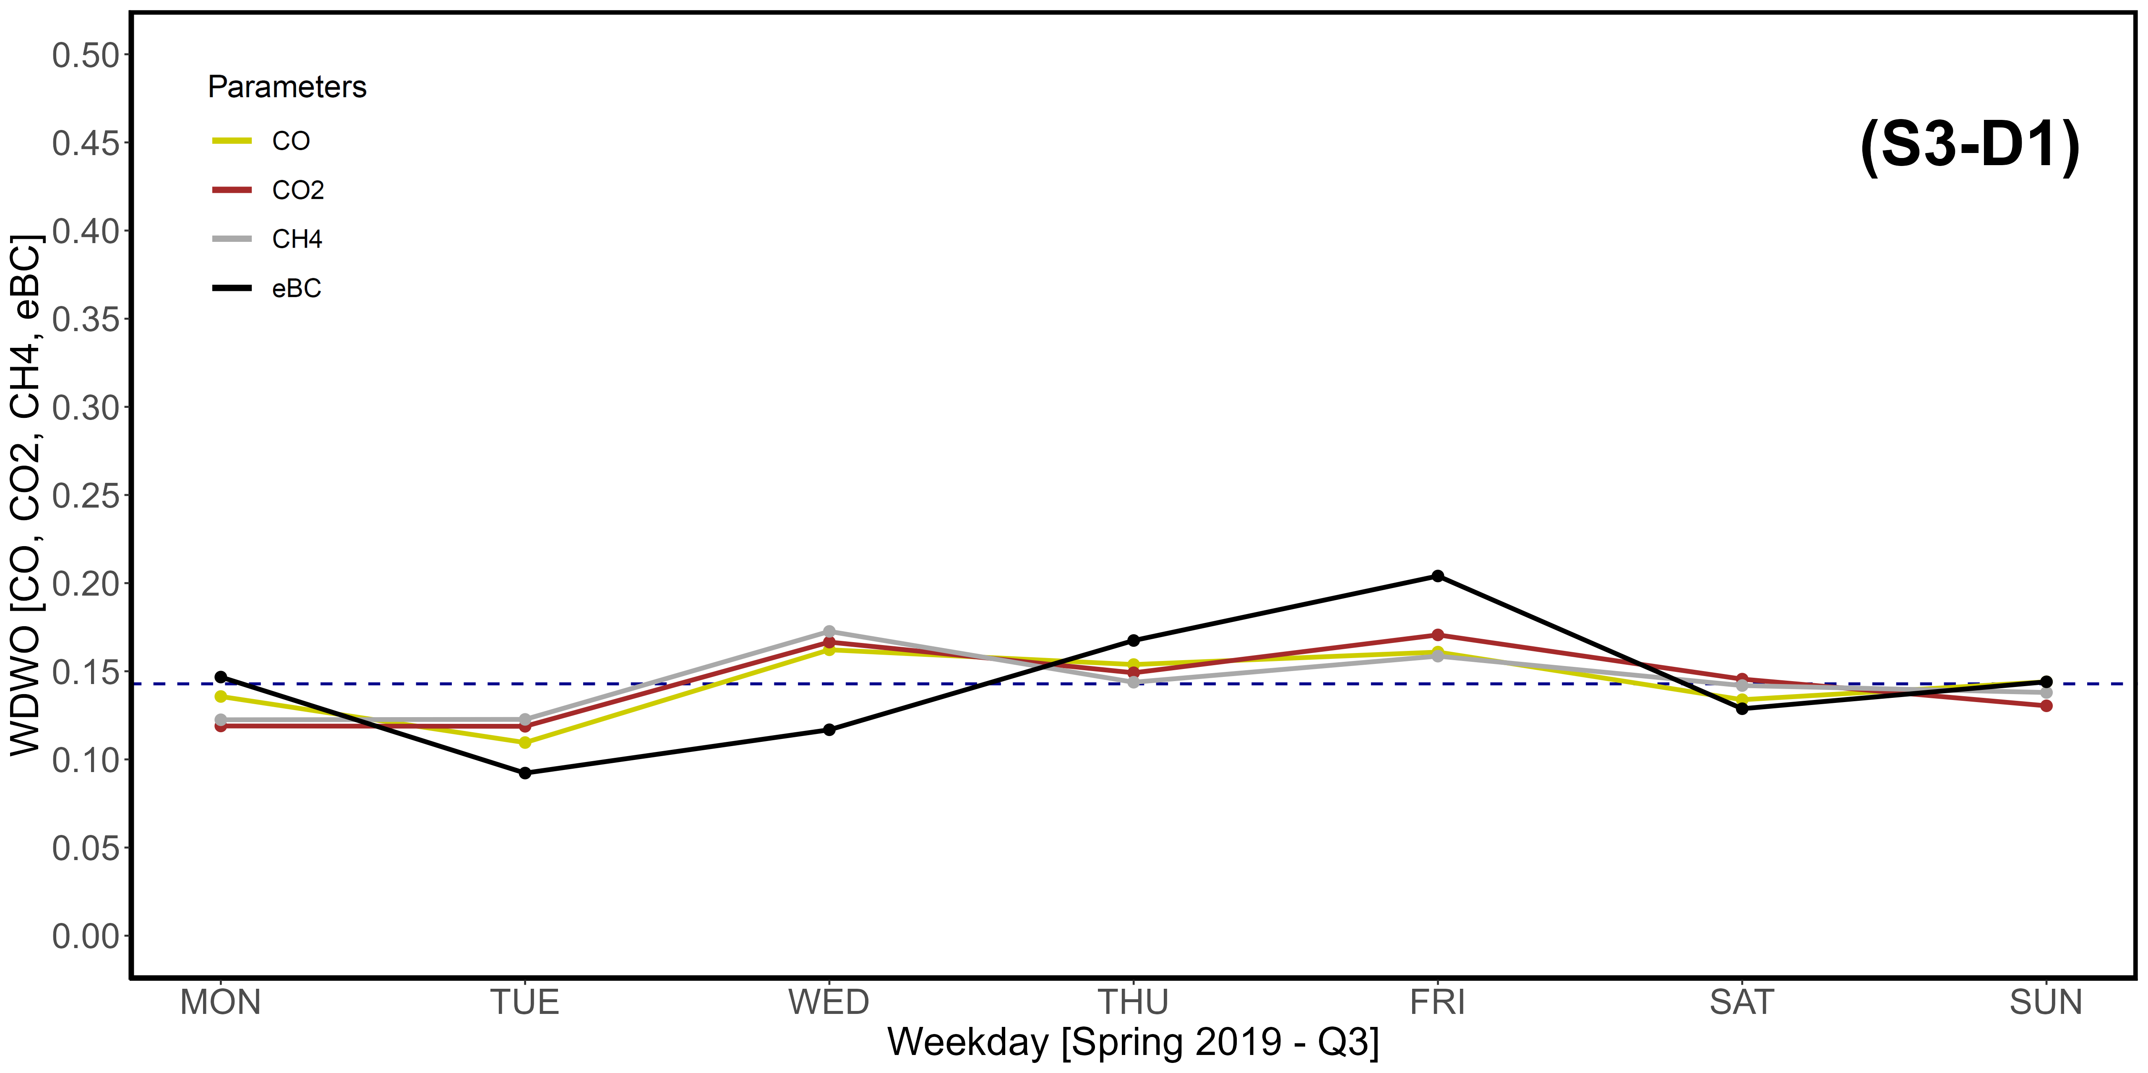
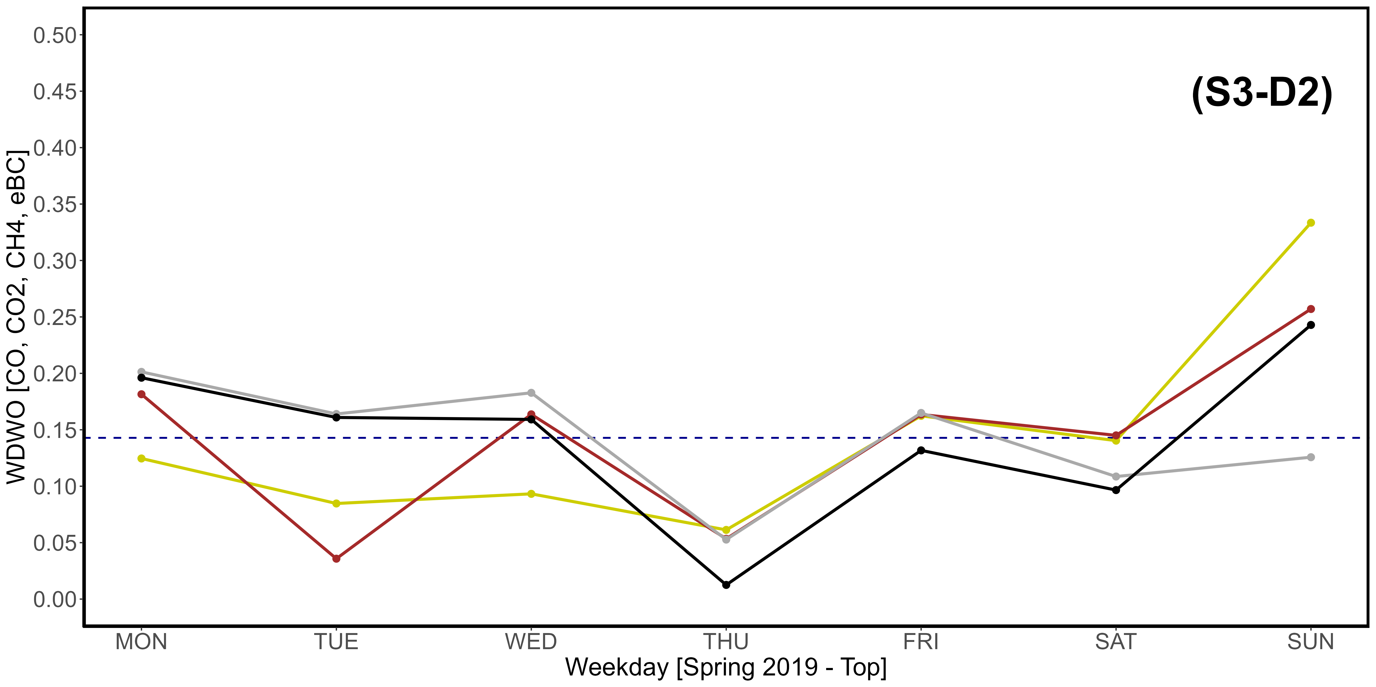
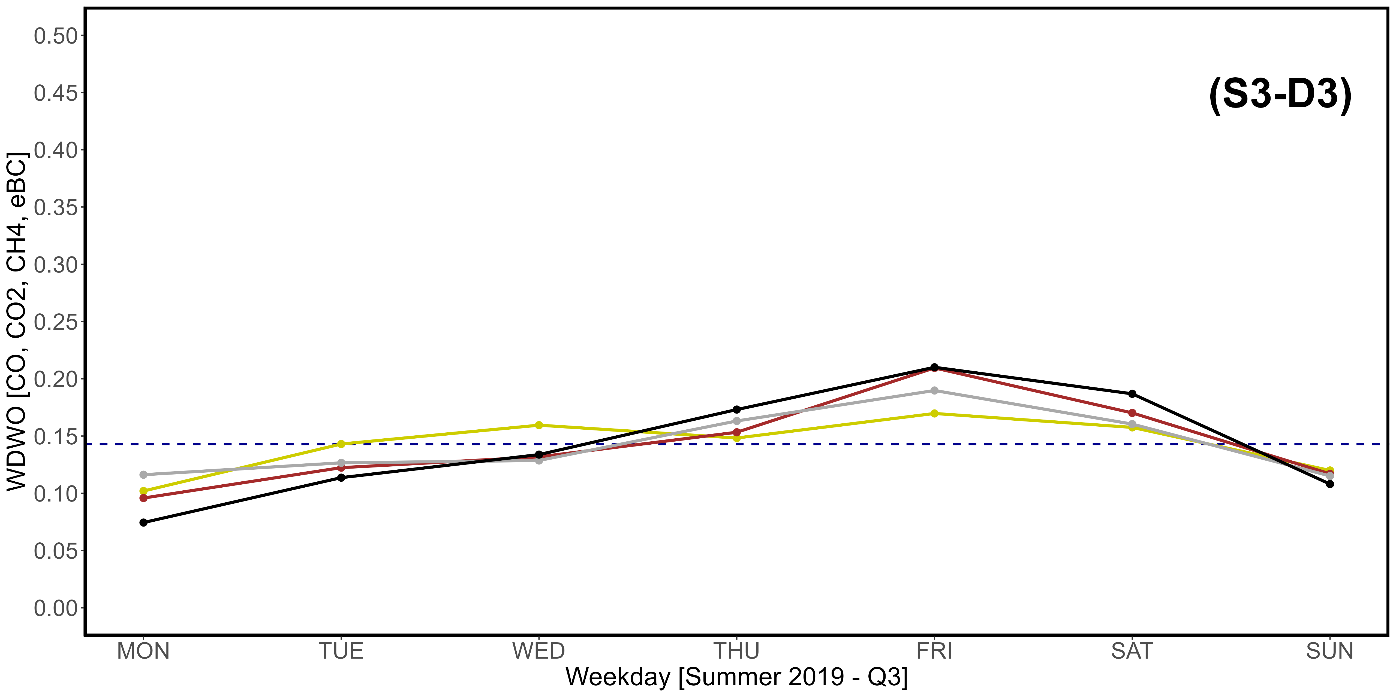
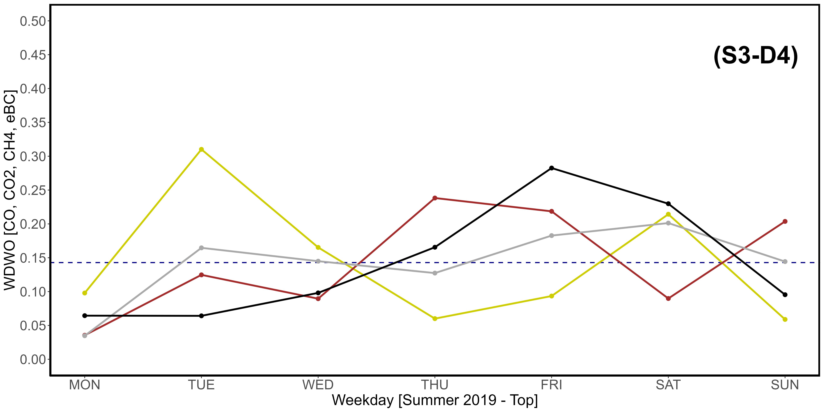
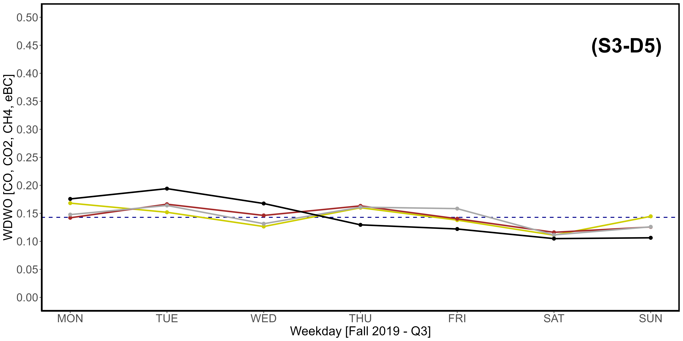
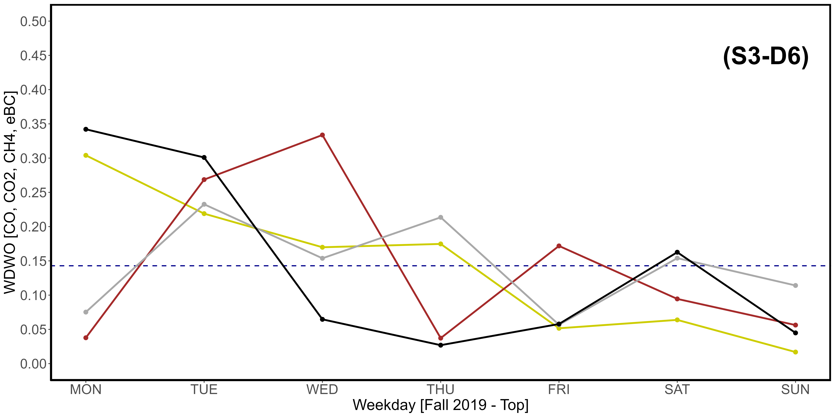
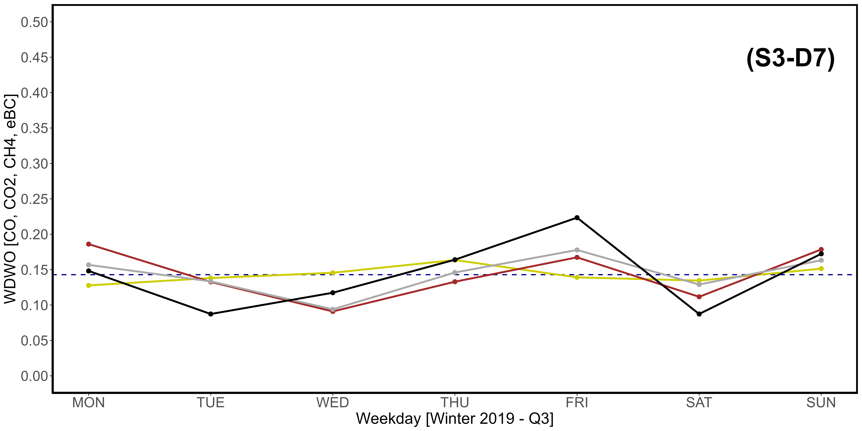
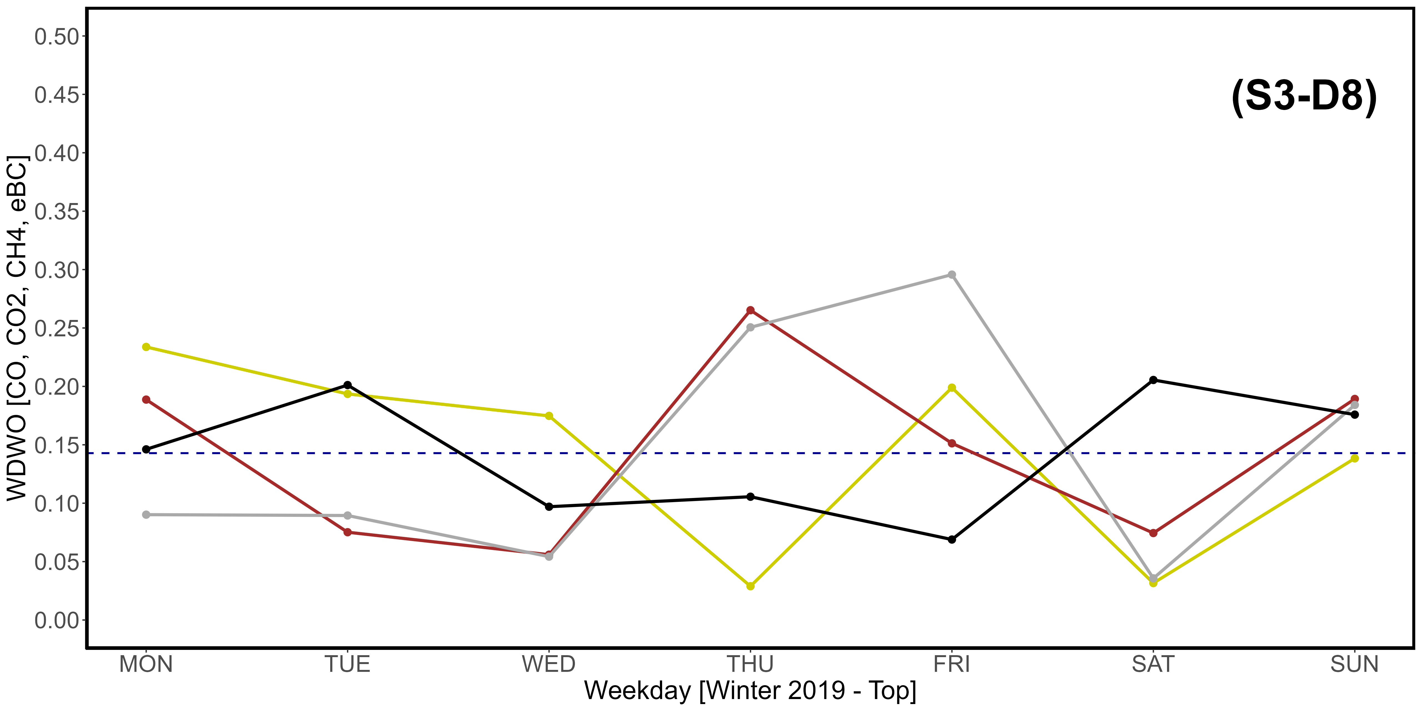
Supplementary Material S3-D1, S3-D2, S3-D3, S3-D4, S3-D5, S3-D7, S3-D7, S3-D8. Seasonal variations of the newly introduced WDWO parameter for CO (yellow), CO₂ (brown), CH₄ (dark gray) and eBC (black), referring specifically to the year 2019. A: Spring; B: Summer; C: Fall; D: Winter. “1” images refer to the Q3 threshold, while “2” refer to the top 2,5% of data. The intercept parallel to the x axis indicates the average expected value per day, which is 0,1428. The vertical scale is different compared to that used in Fig. 11.

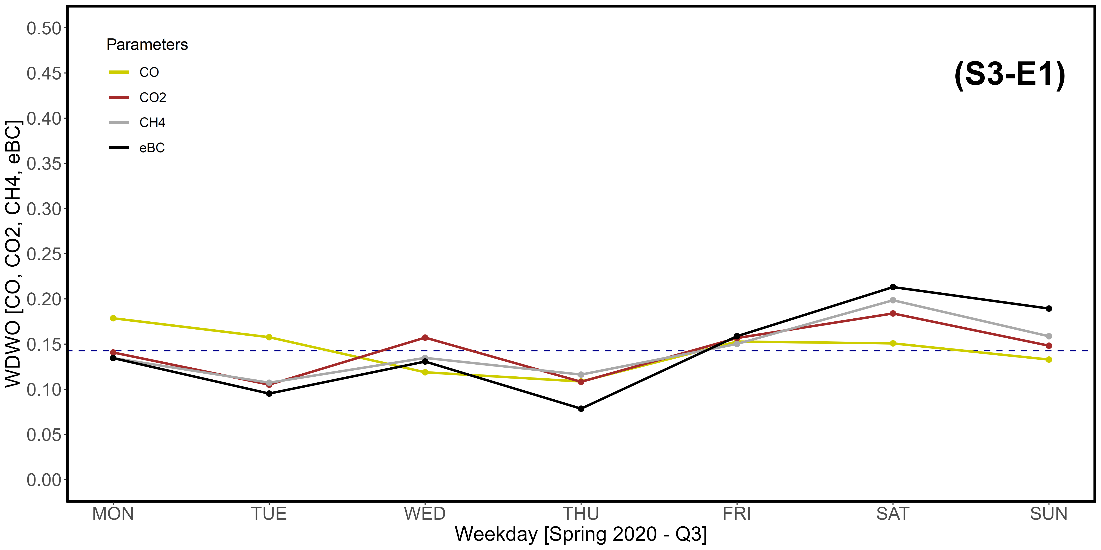
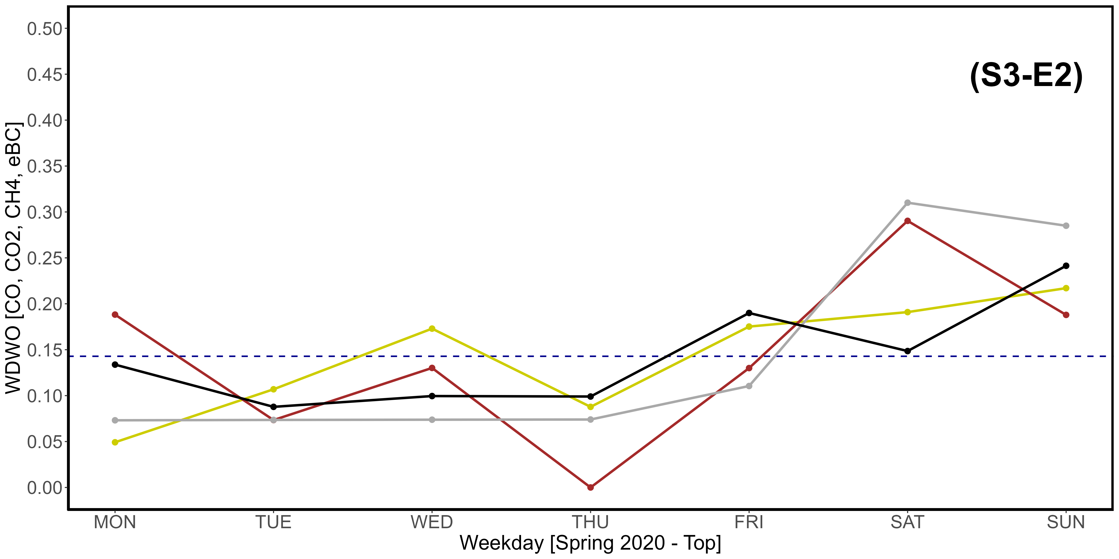
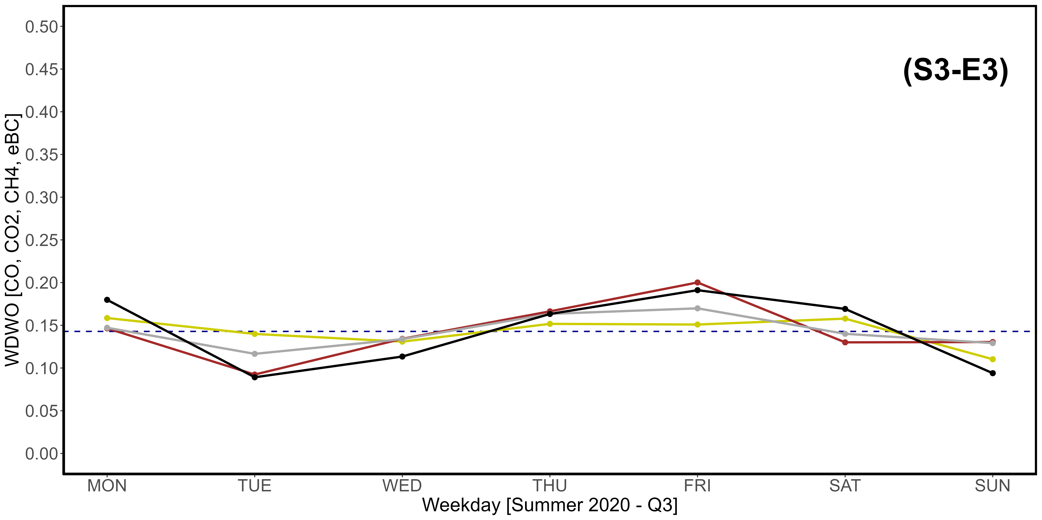
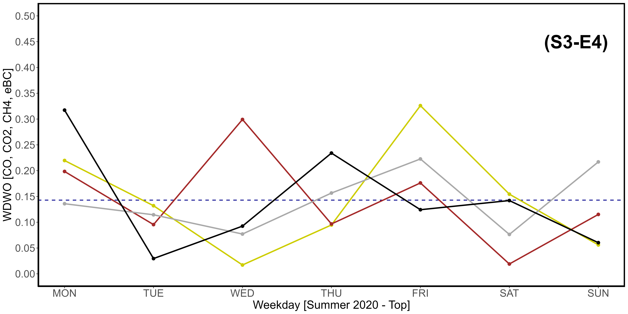
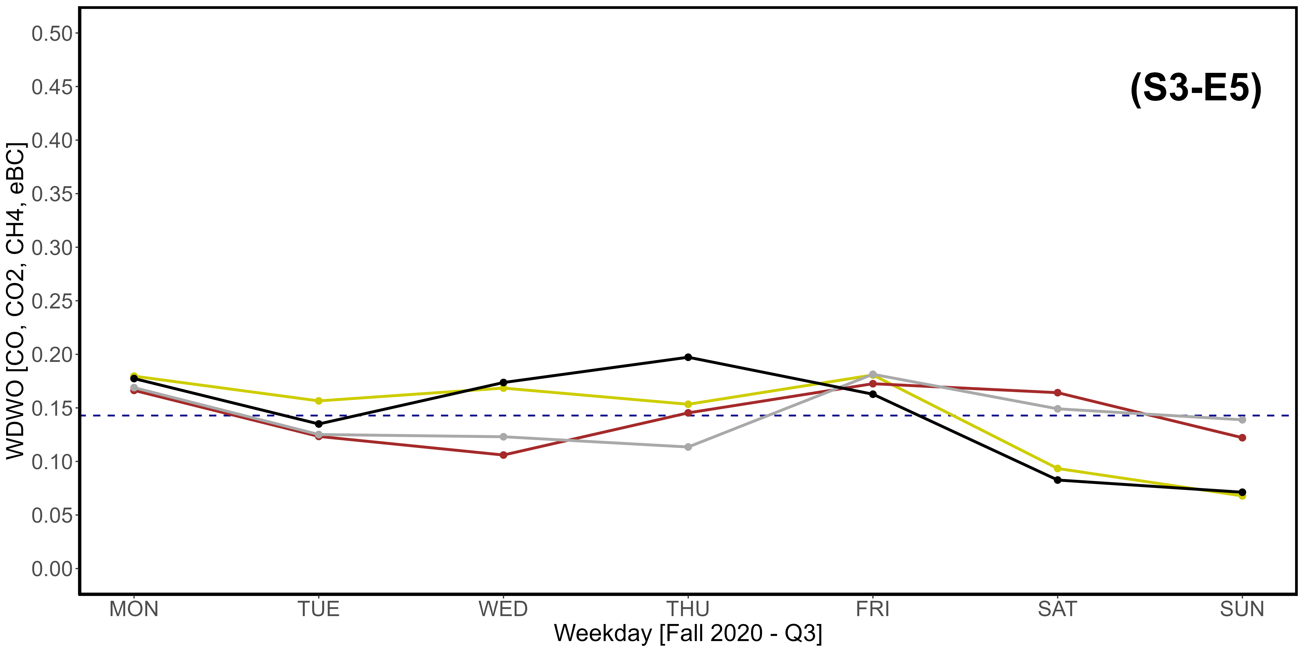
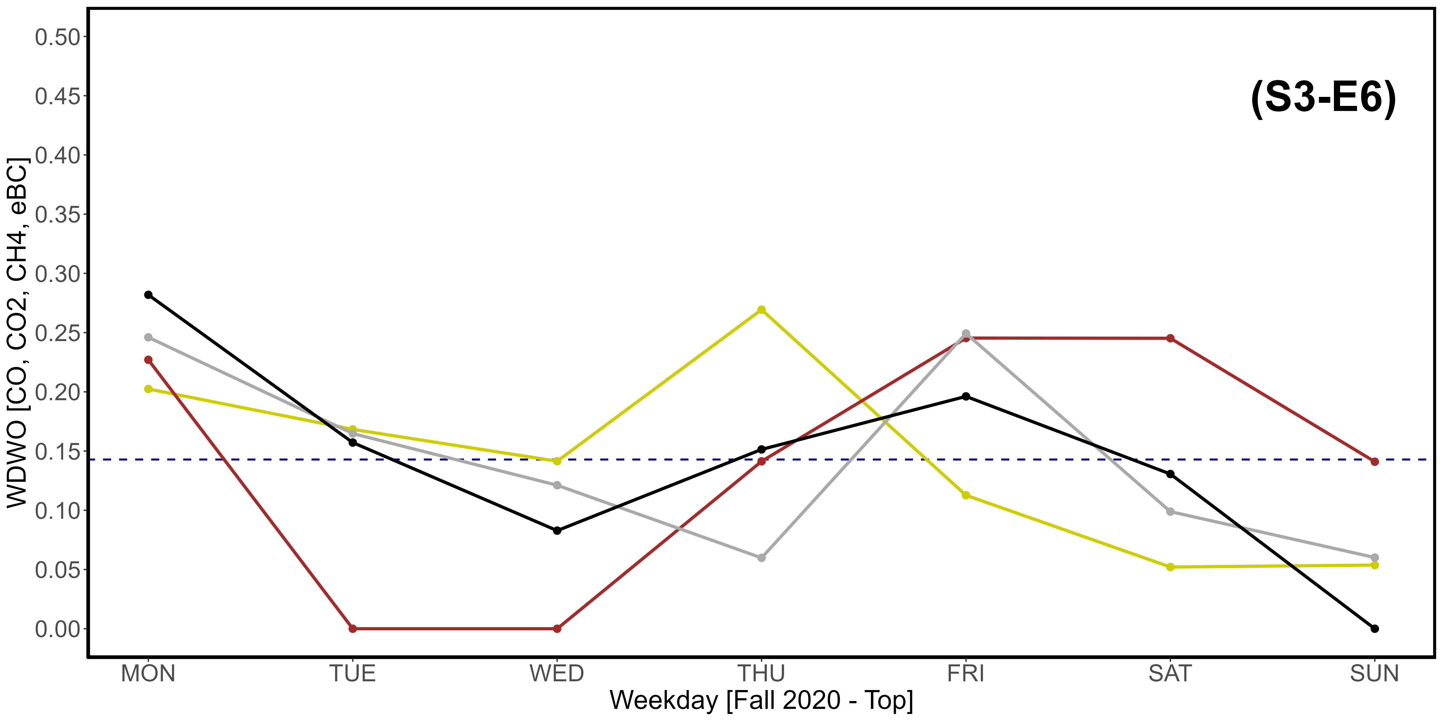
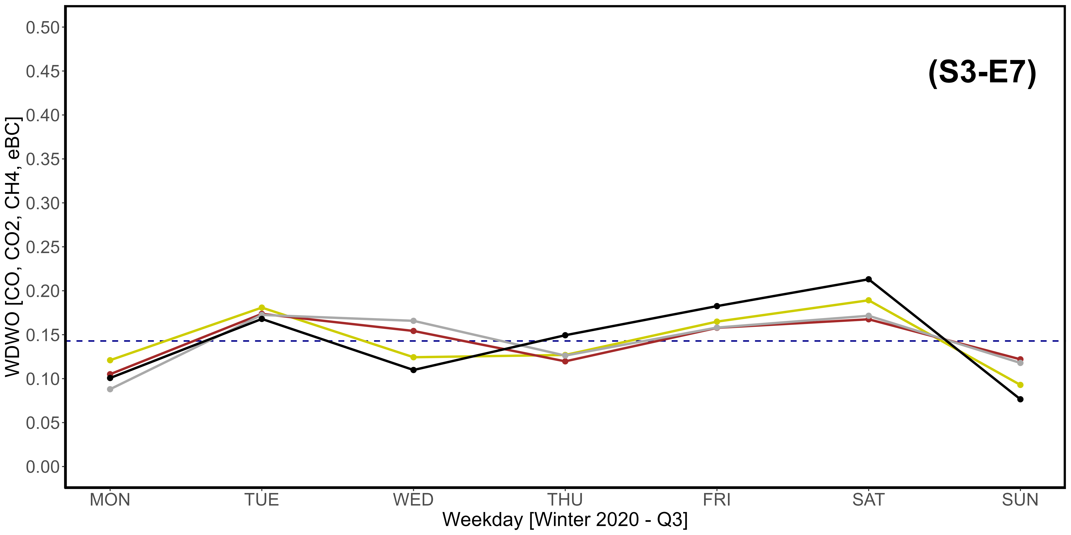
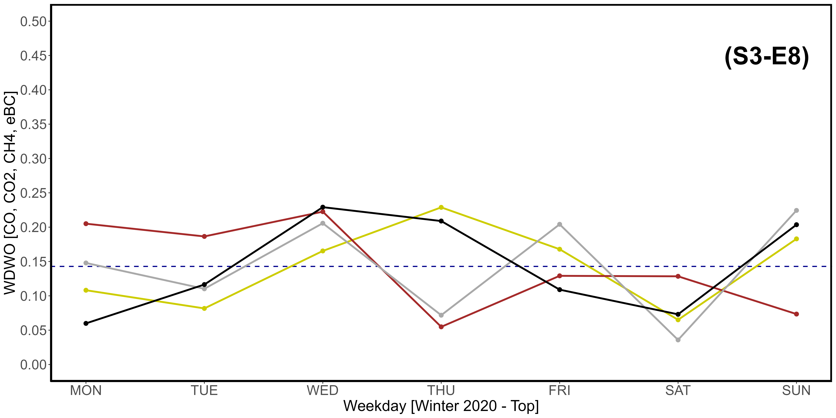
Supplementary Material S3-E1, S3-E2, S3-E3, S3-E4, S3-E5, S3-E7, S3-E7, S3-E8. Seasonal variations of the newly introduced WDWO parameter for CO (yellow), CO₂ (brown), CH₄ (dark gray) and eBC (black), referring specifically to the year 2020. A: Spring; B: Summer; C: Fall; D: Winter. “1” images refer to the Q3 threshold, while “2” refer to the top 2,5% of data. The intercept parallel to the x axis indicates the average expected value per day, which is 0,1428. The vertical scale is different compared to that used in Fig. 11.

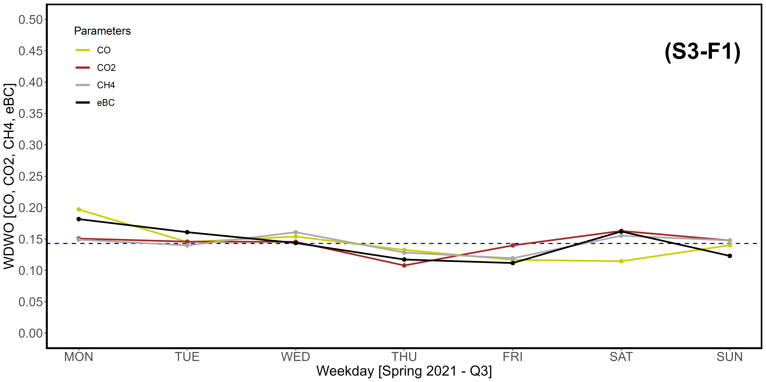
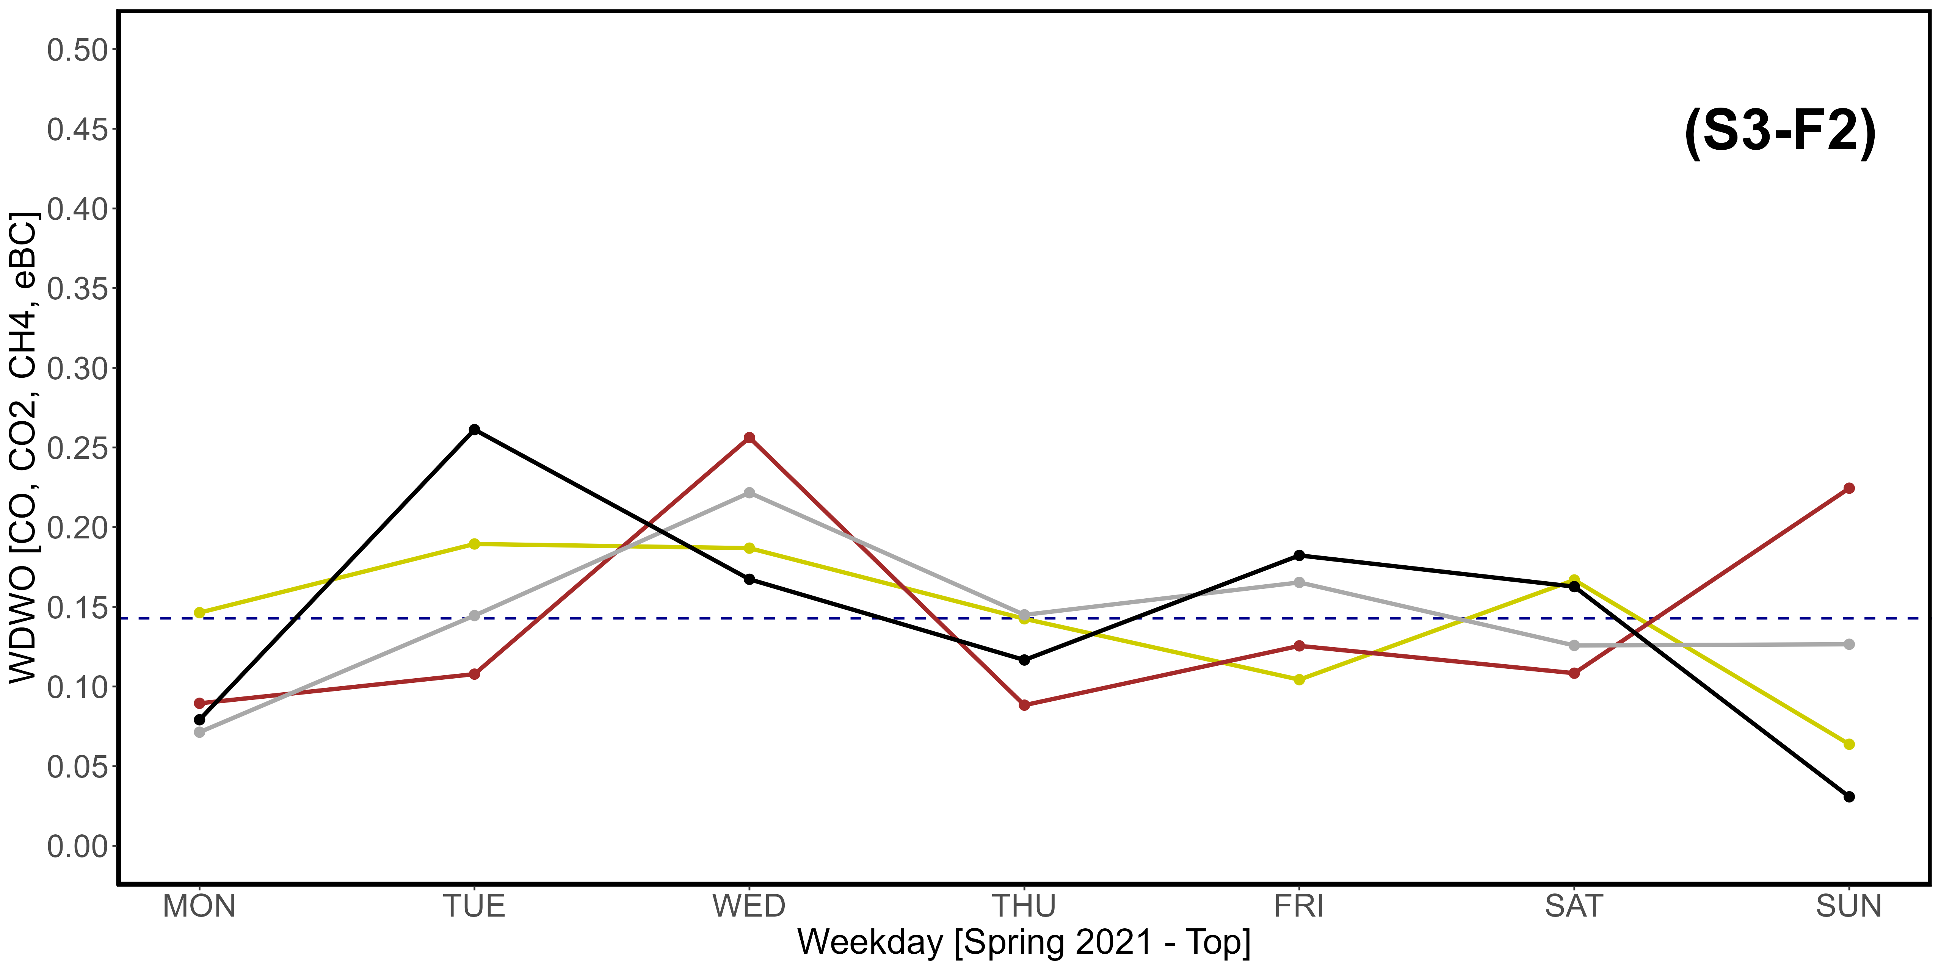
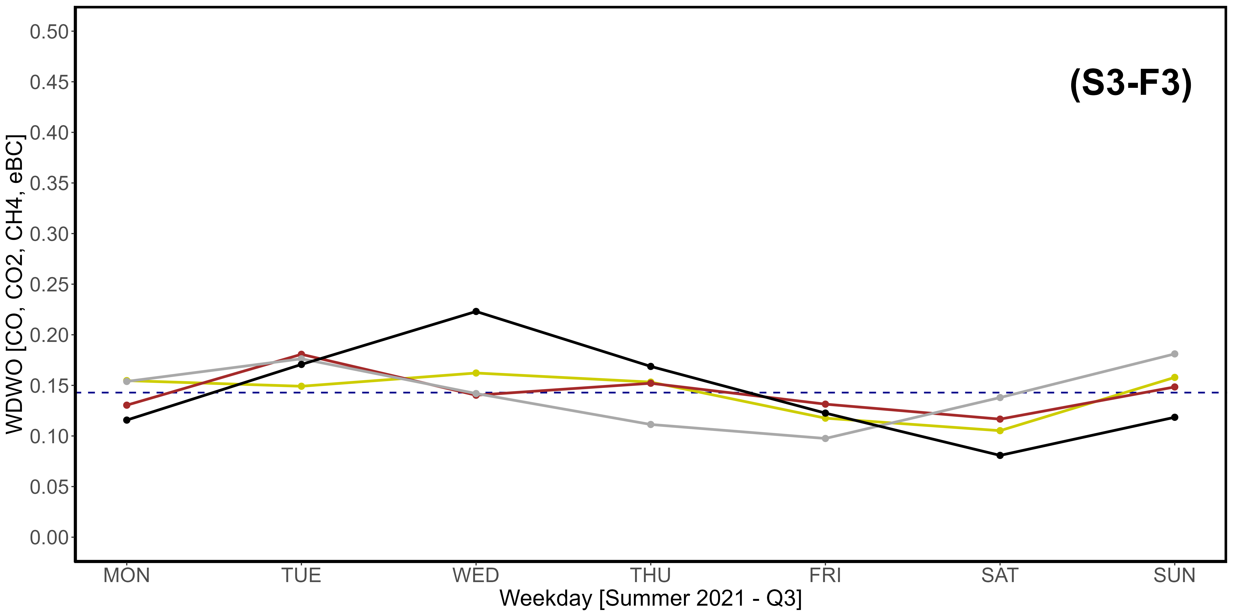
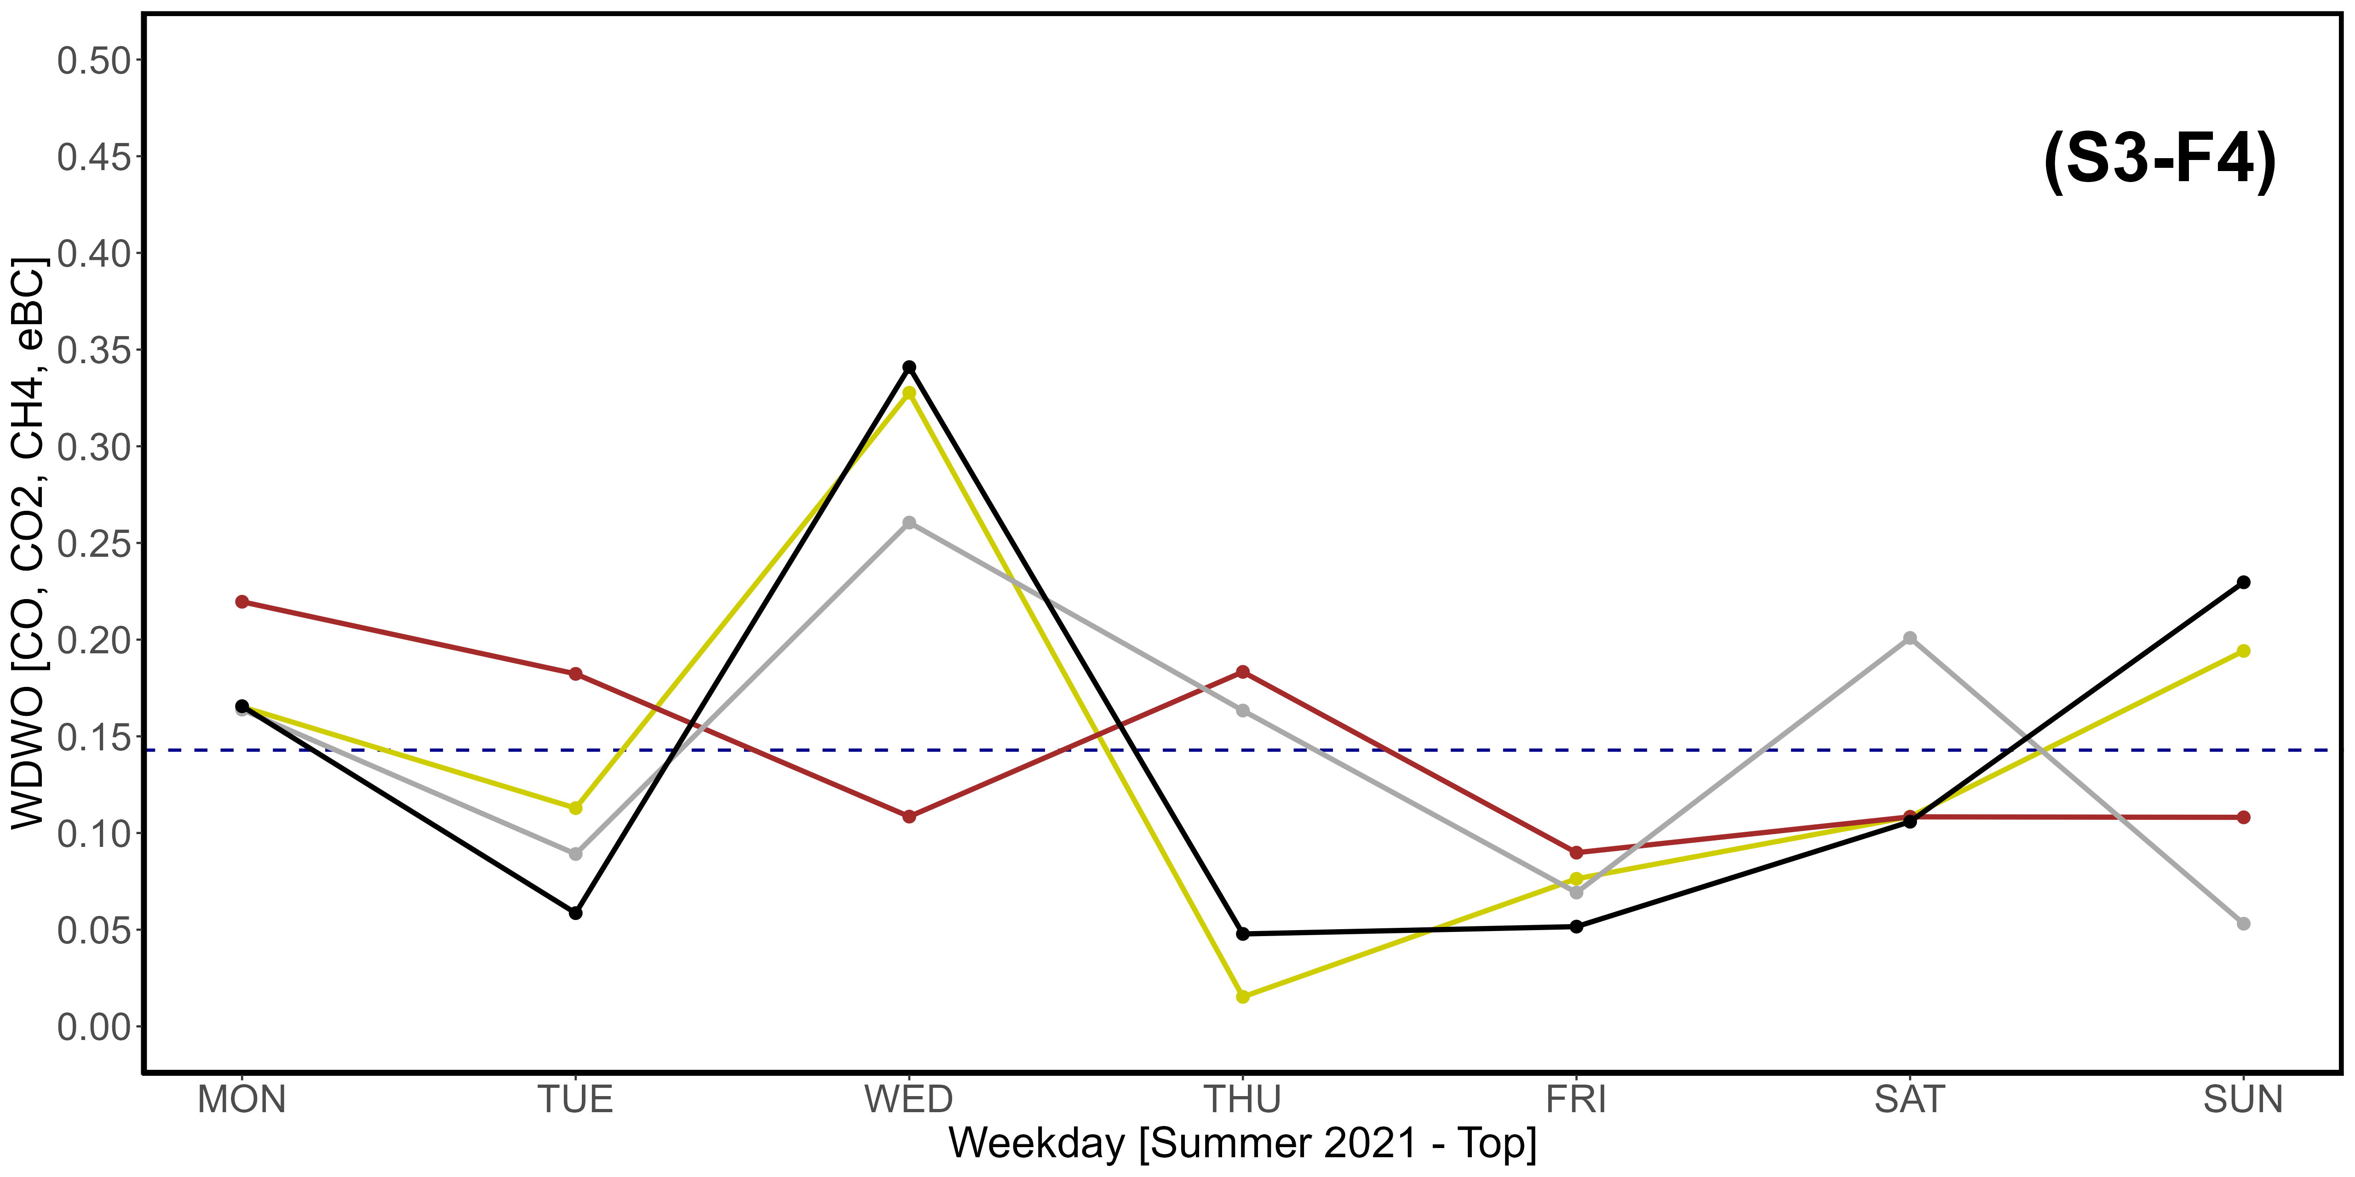
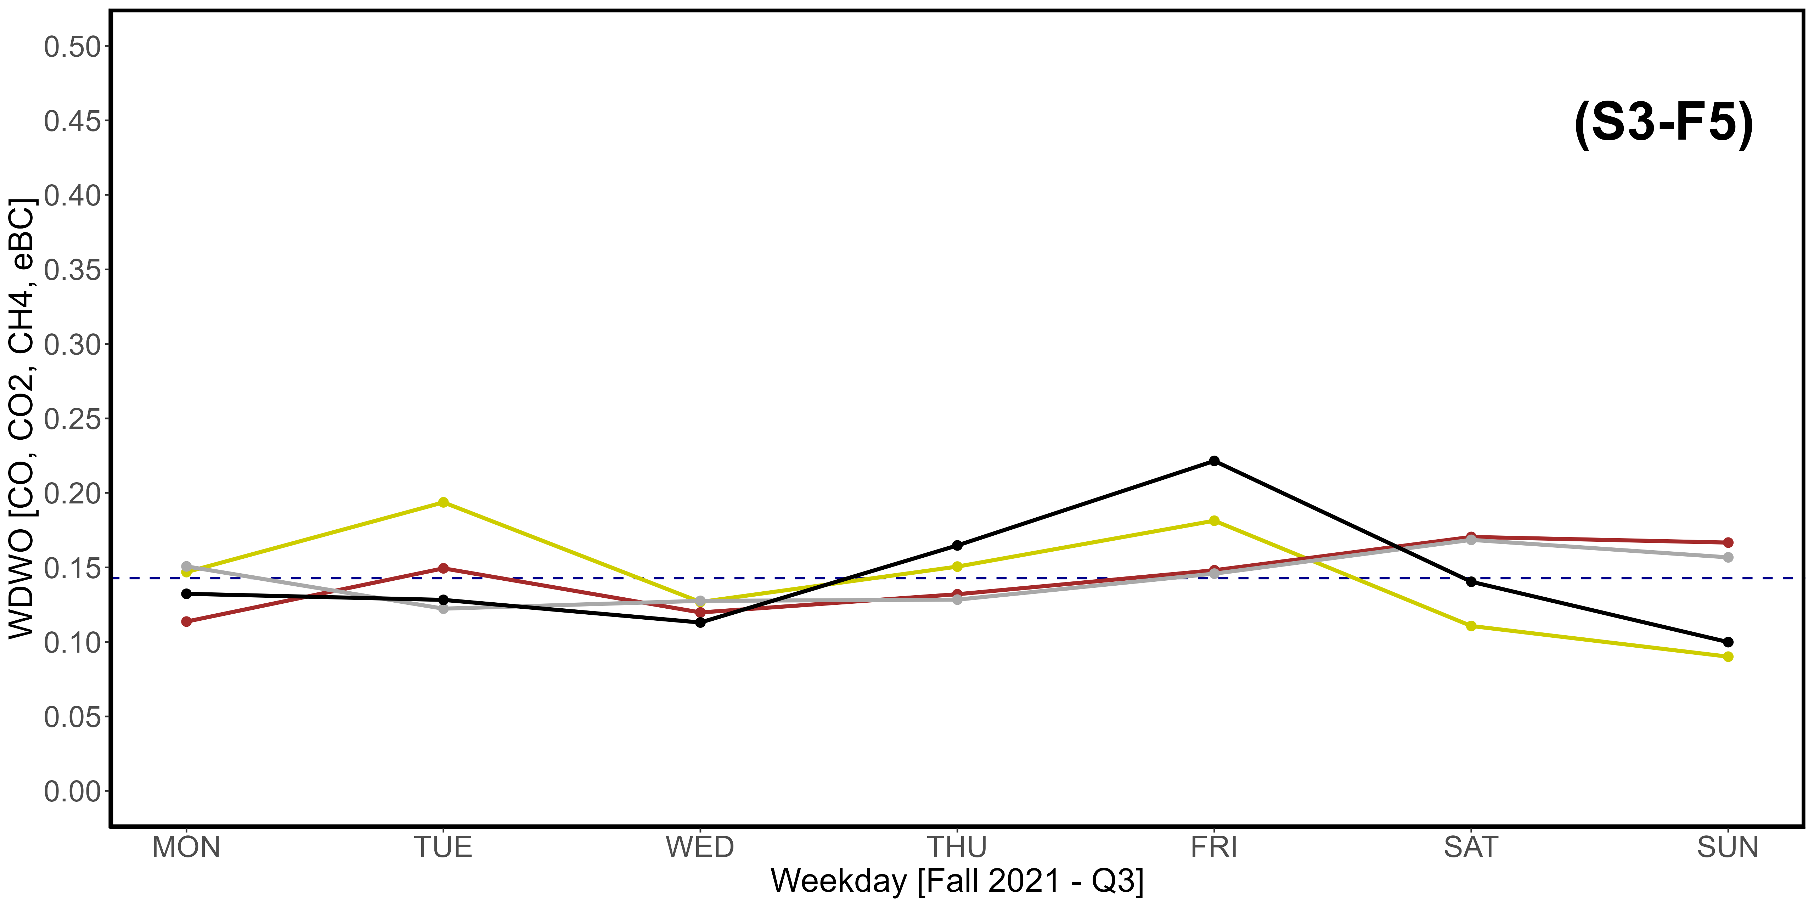
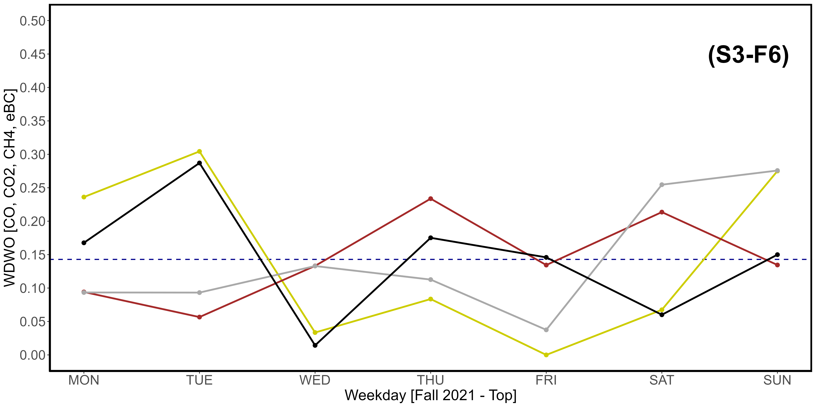
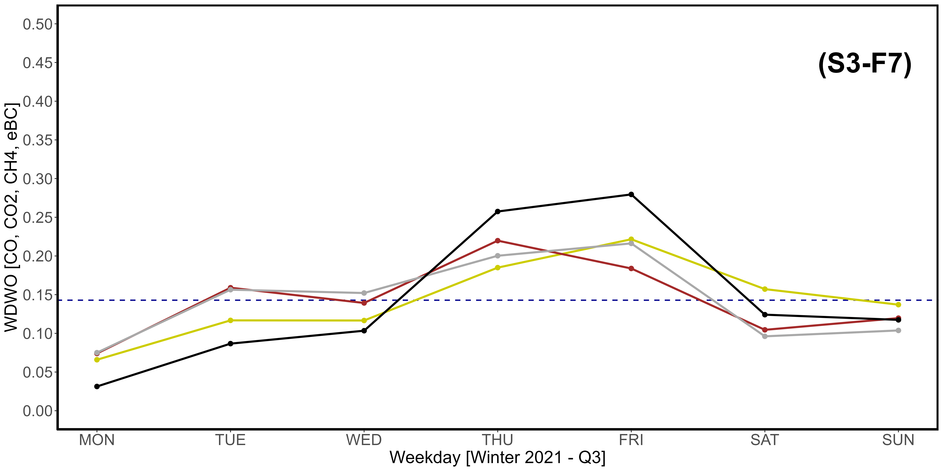
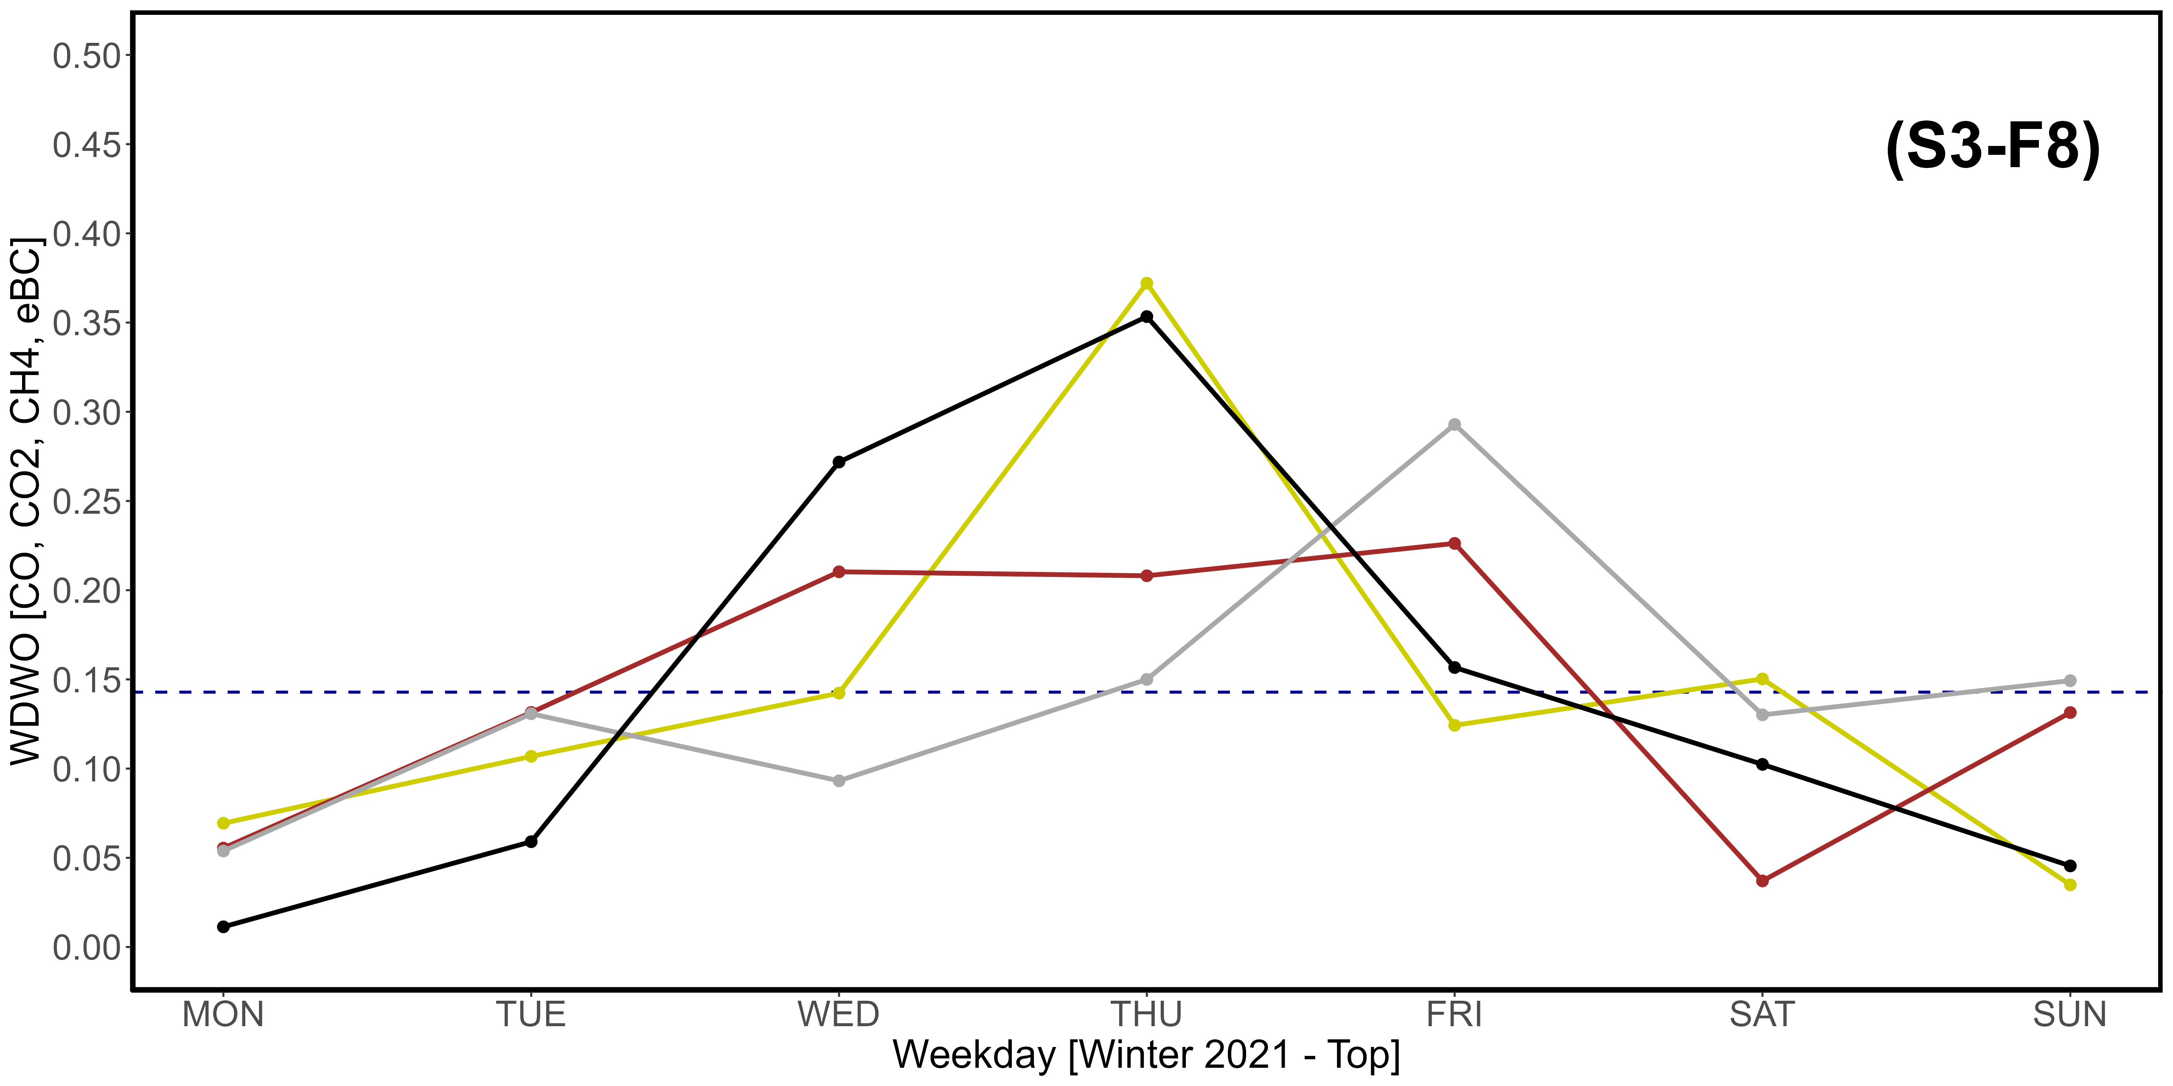
Supplementary Material S3-F1, S3-F2, S3-F3, S3-F4, S3-F5, S3-F7, S3-F7, S3-F8. Seasonal variations of the newly introduced WDWO parameter for CO (yellow), CO₂ (brown), CH₄ (dark gray) and eBC (black), referring specifically to the year 2021. A: Spring; B: Summer; C: Fall; D: Winter. “1” images refer to the Q3 threshold, while “2” refer to the top 2,5% of data. The intercept parallel to the x axis indicates the average expected value per day, which is 0,1428. The vertical scale is different compared to that used in Fig. 11.

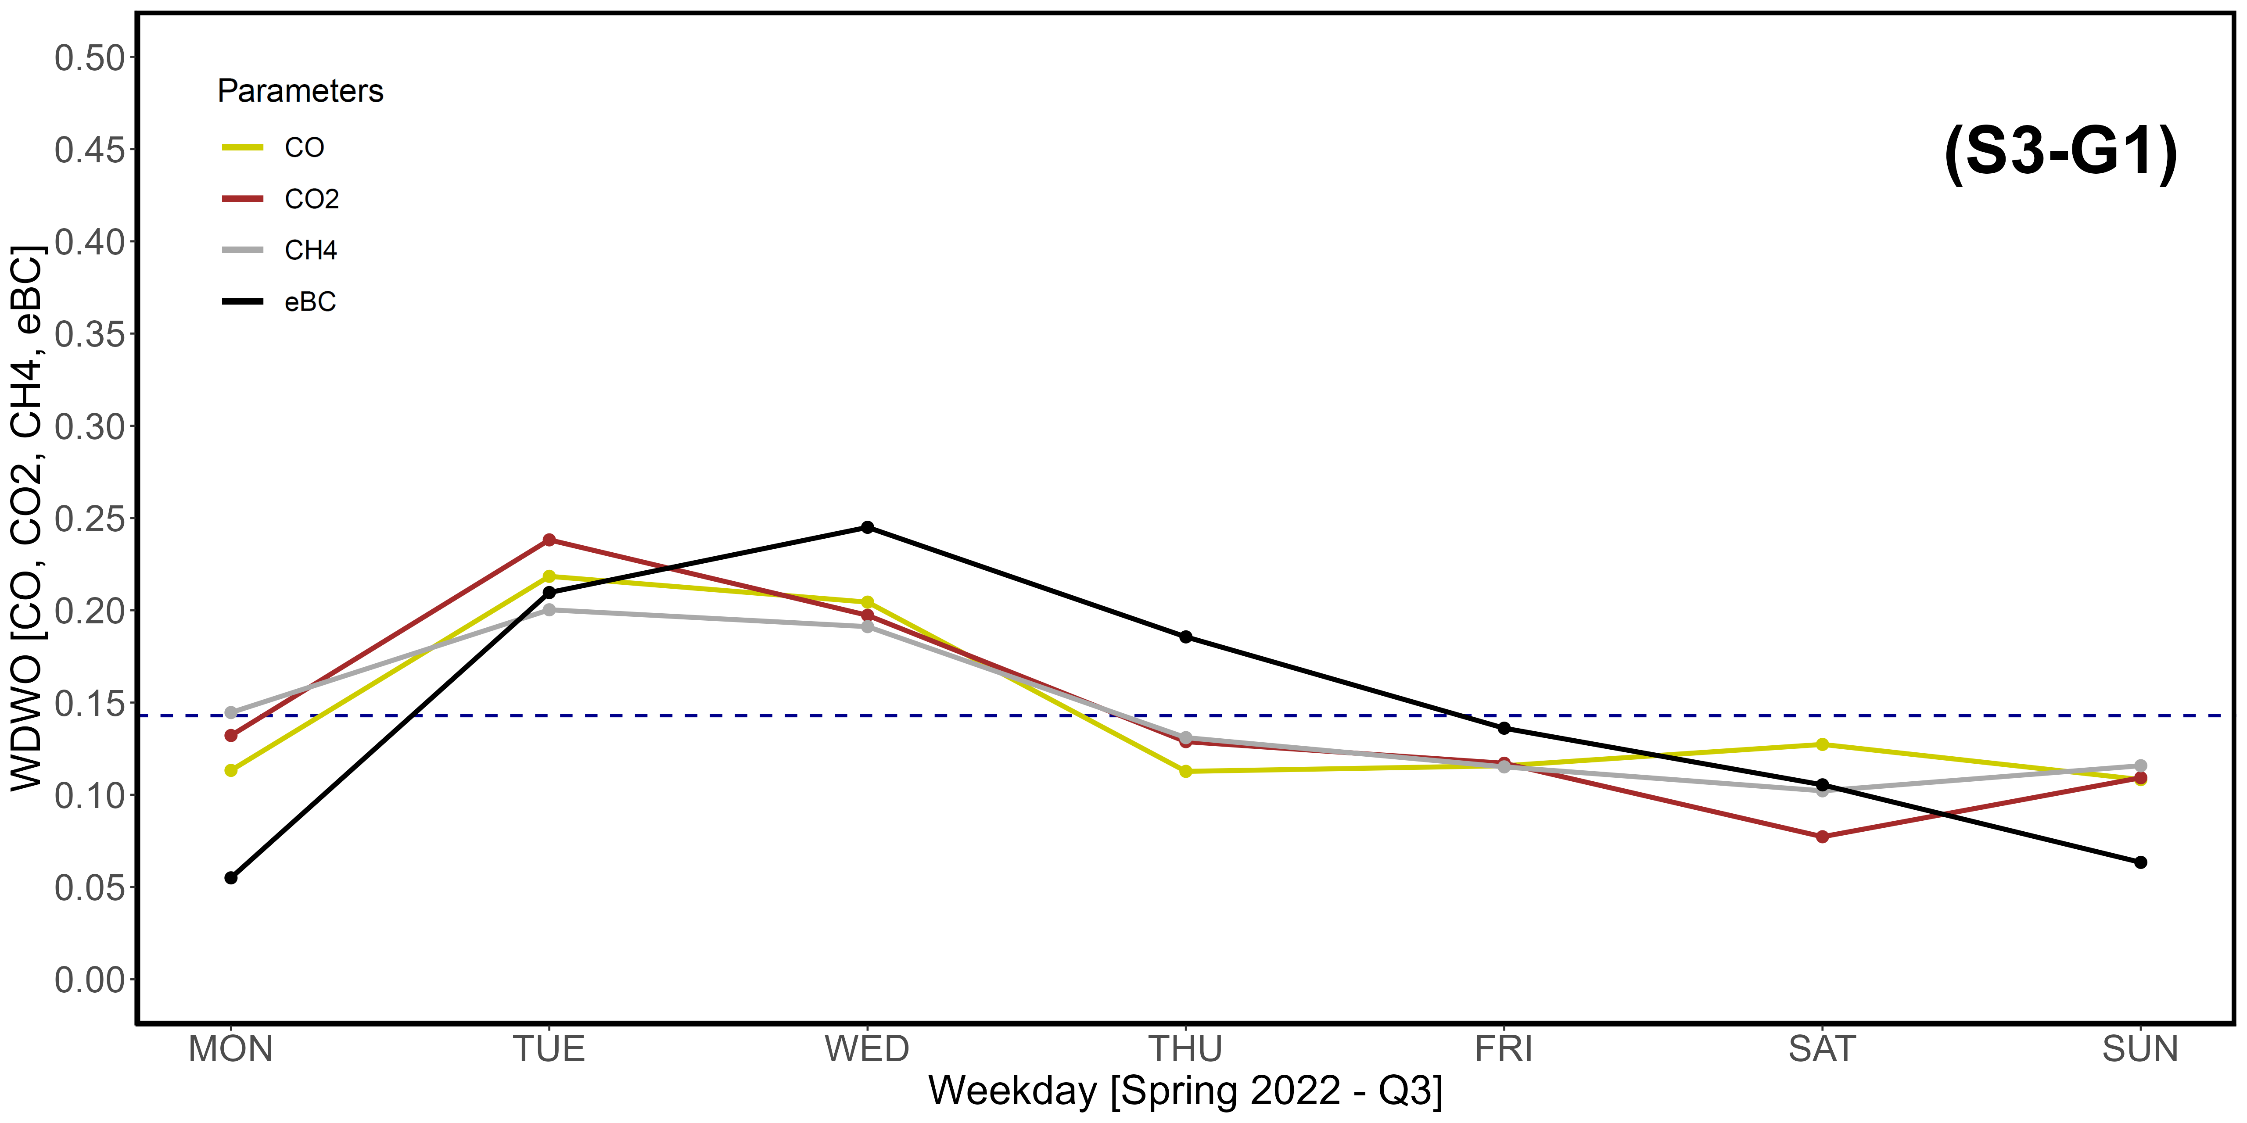
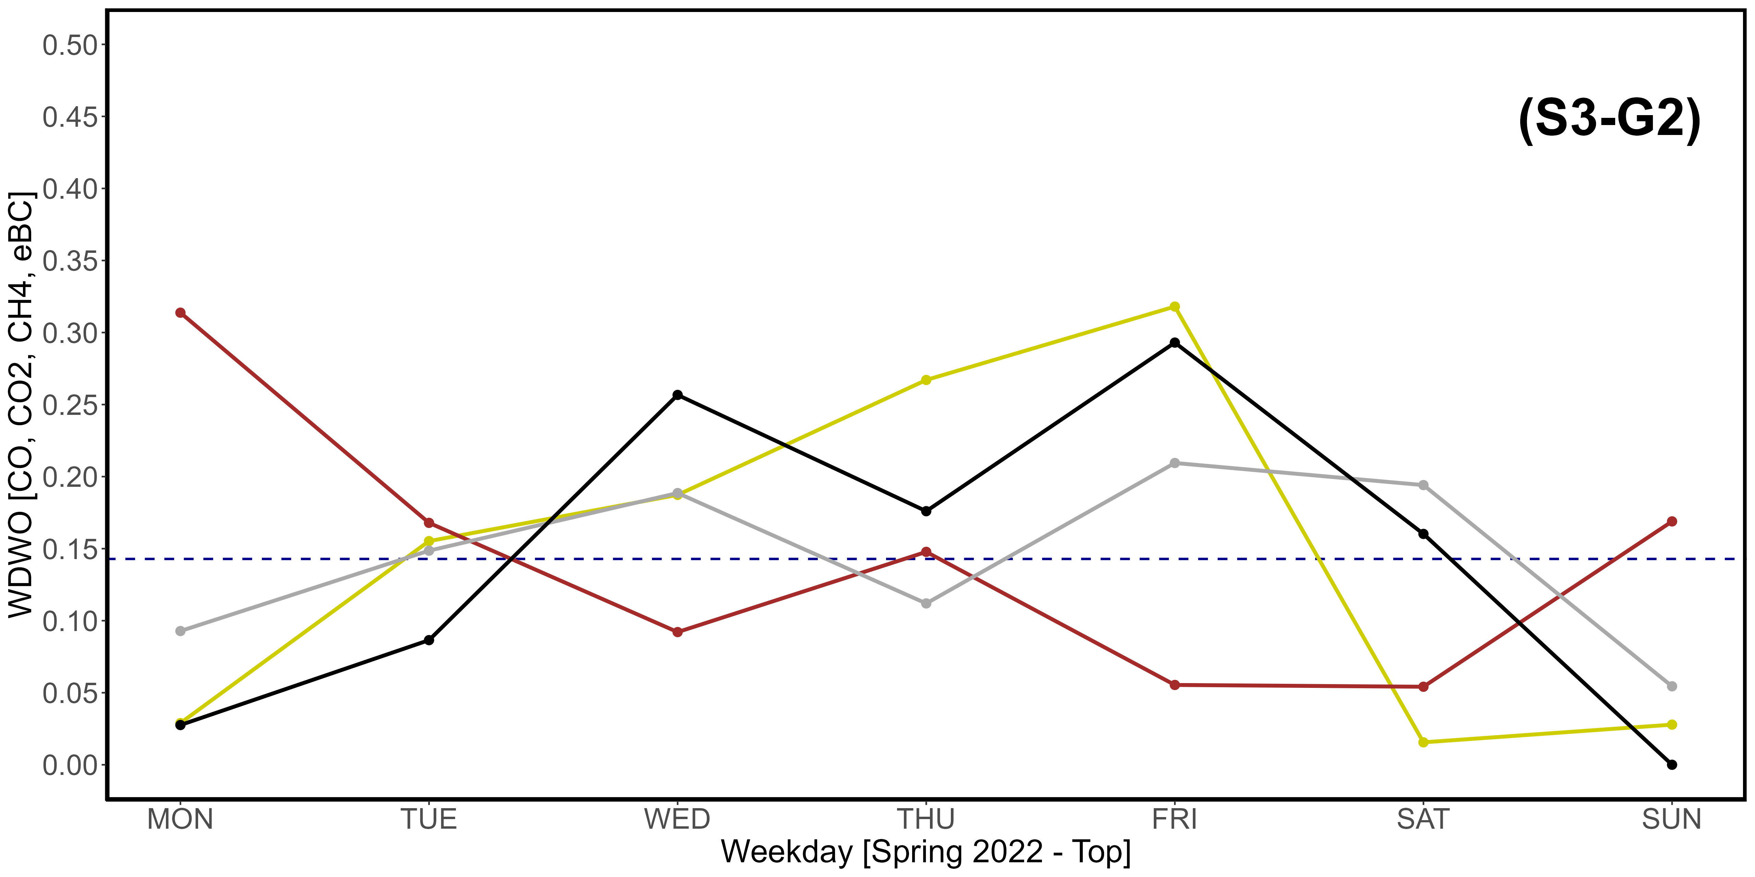
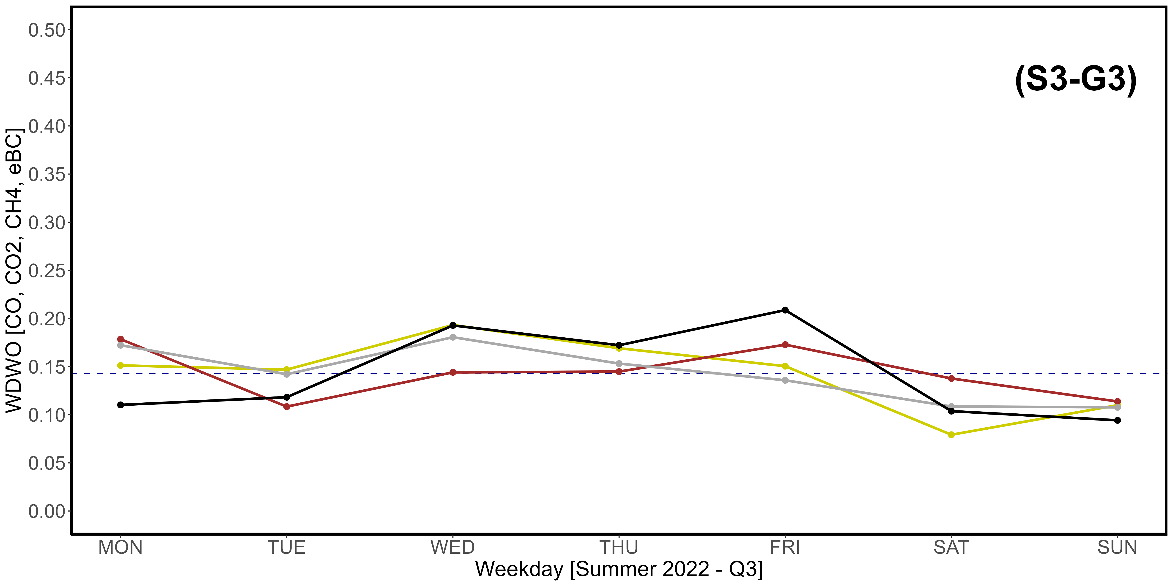
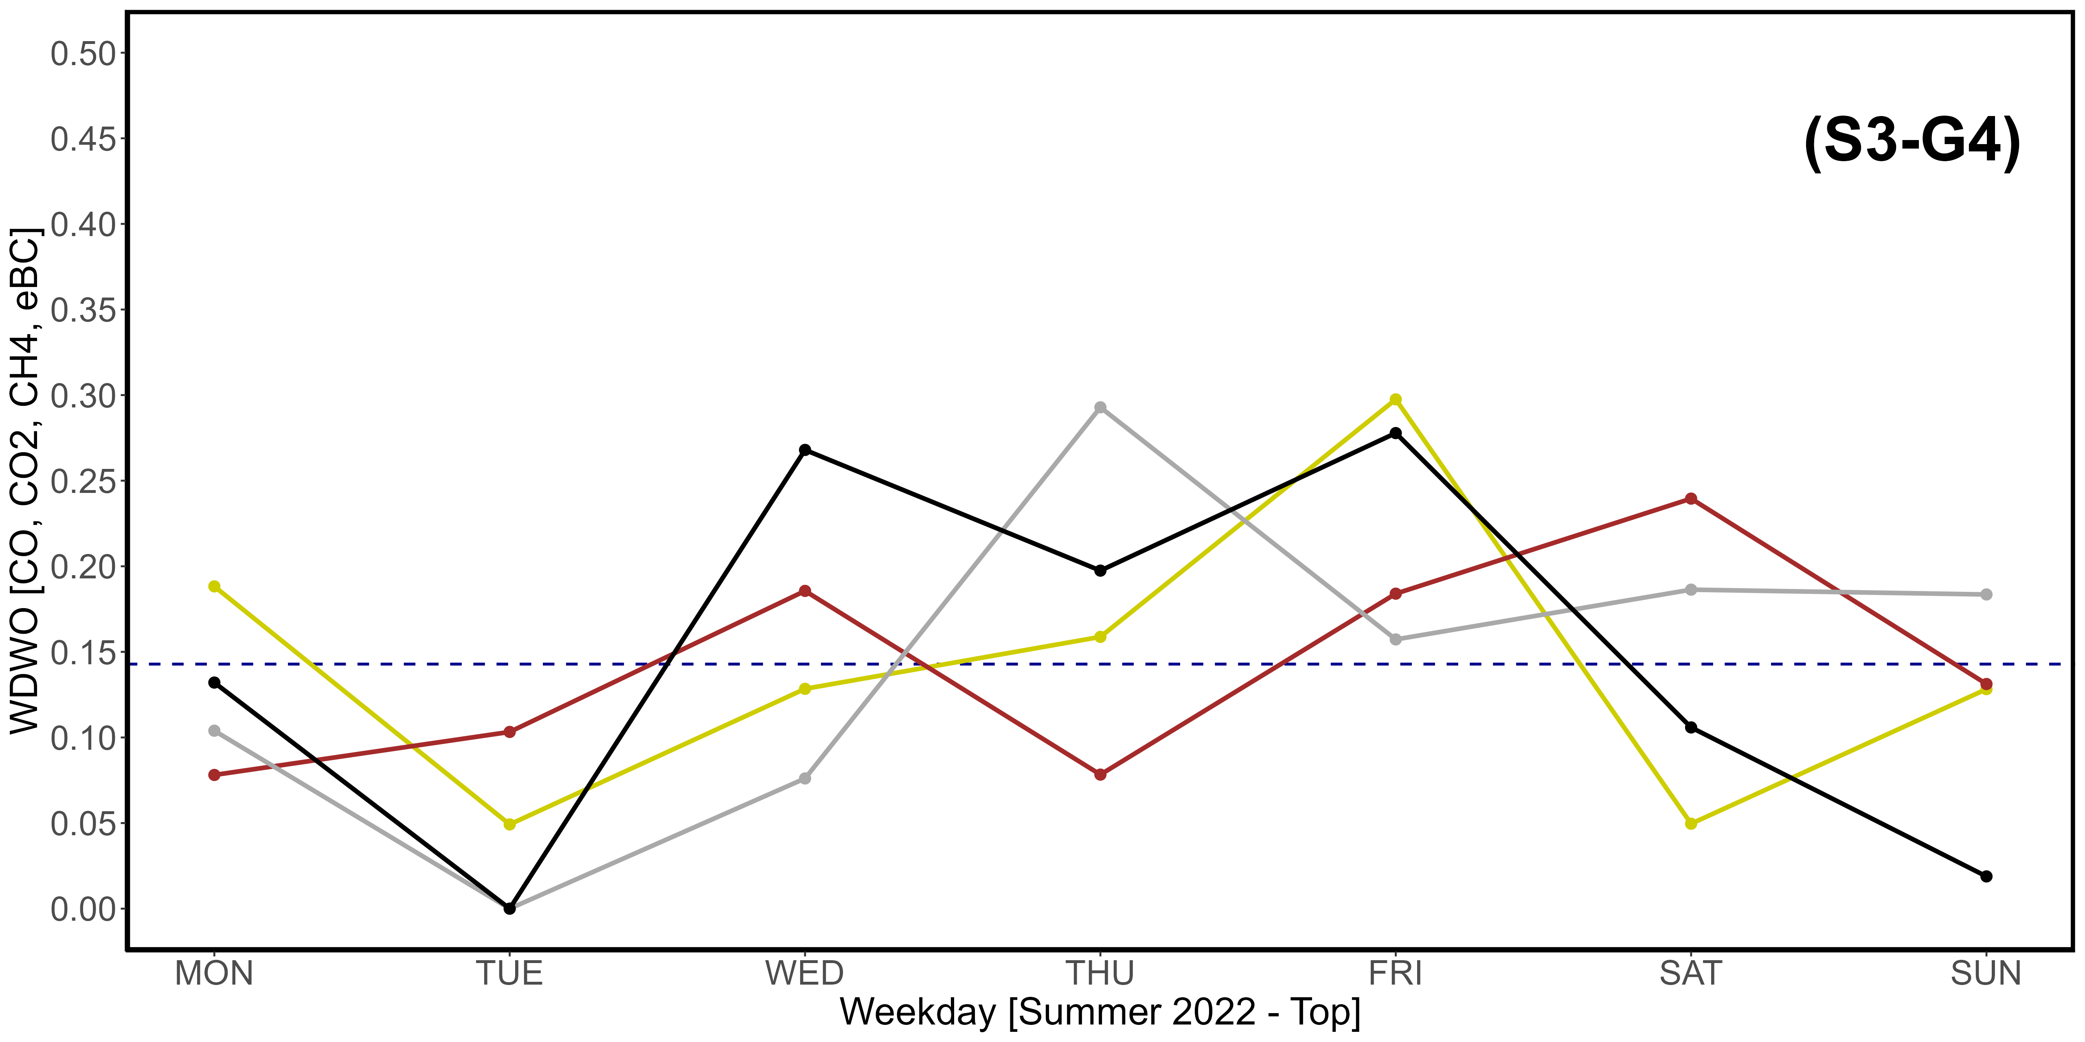
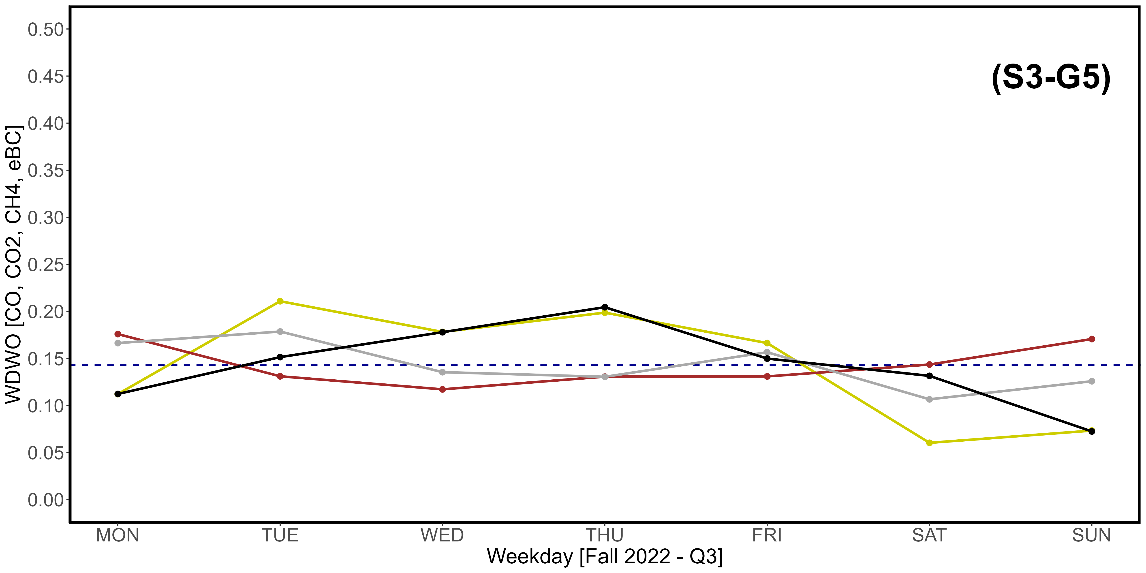
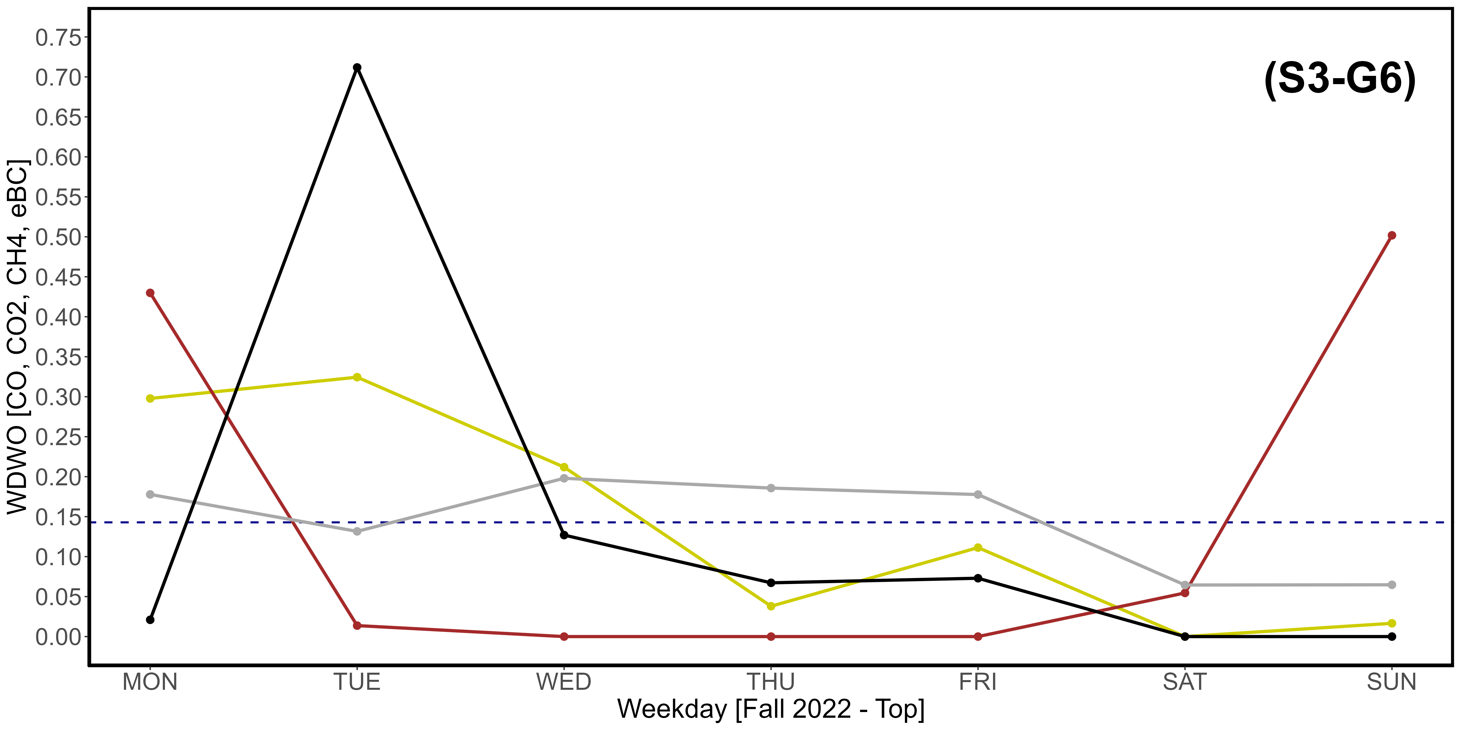
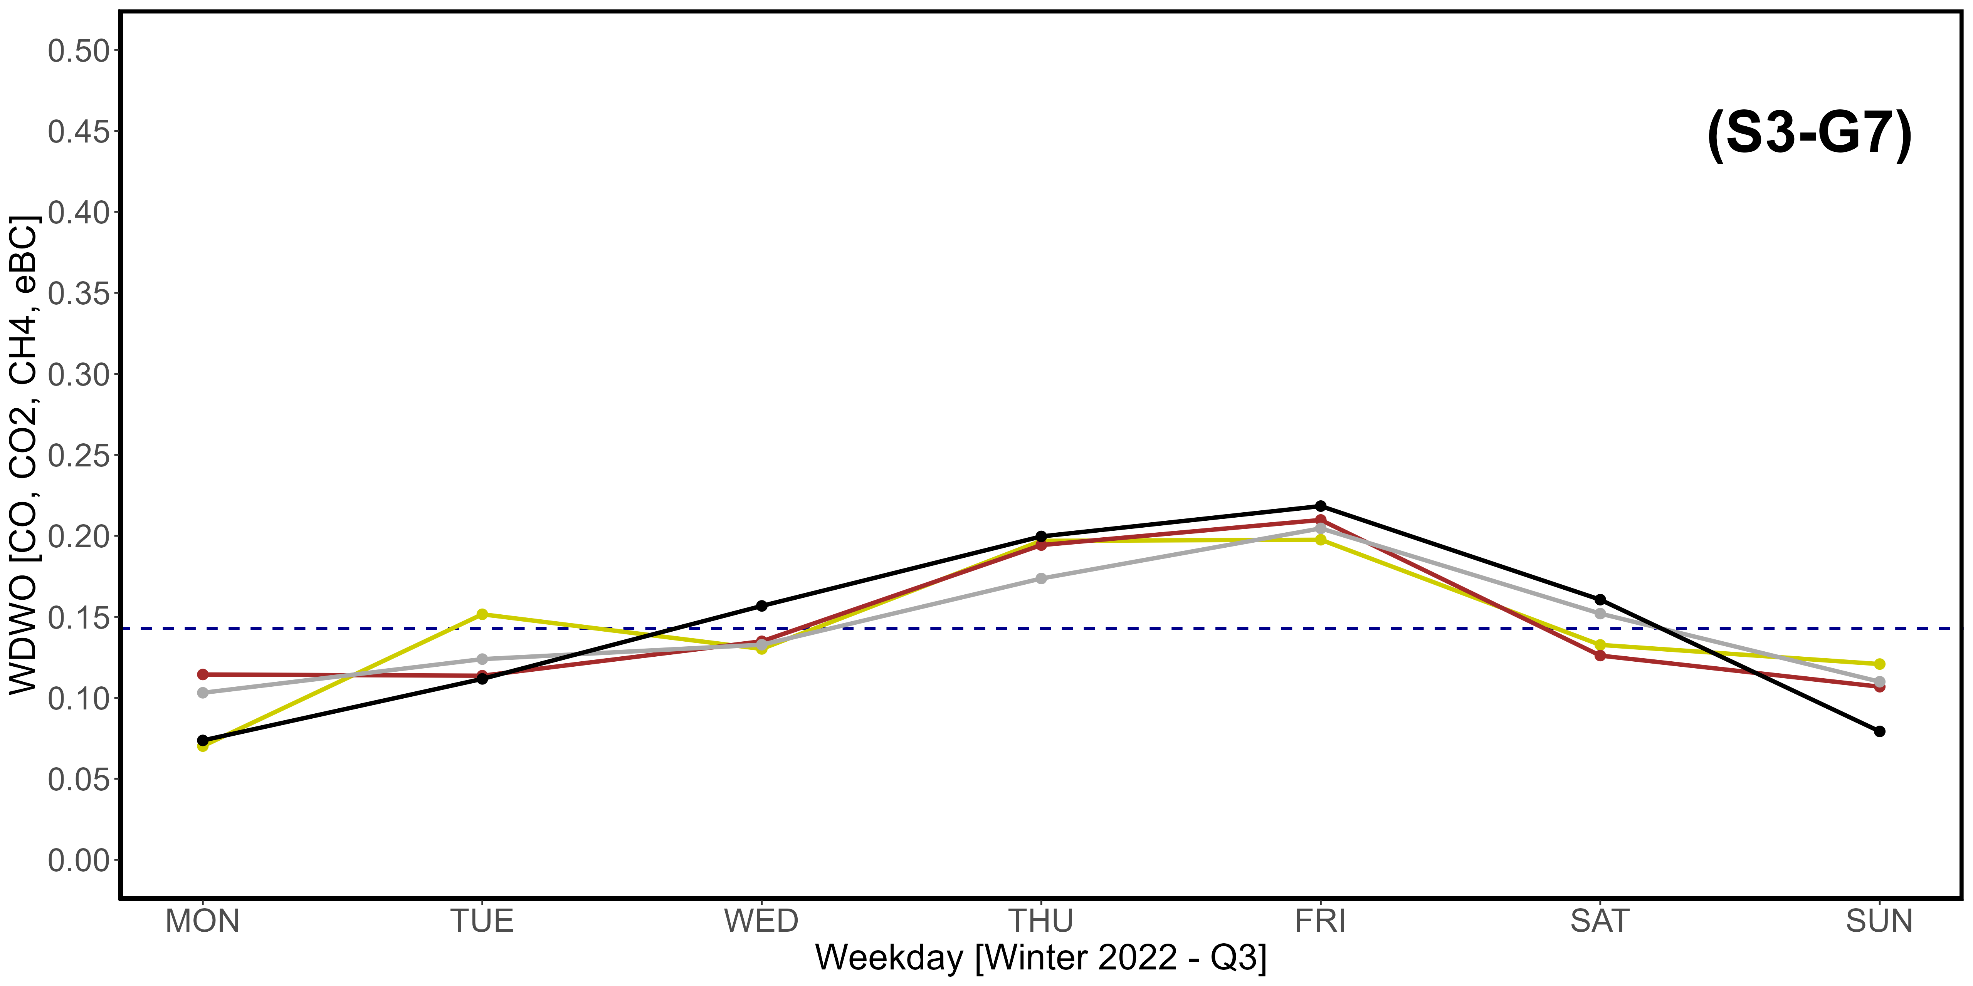
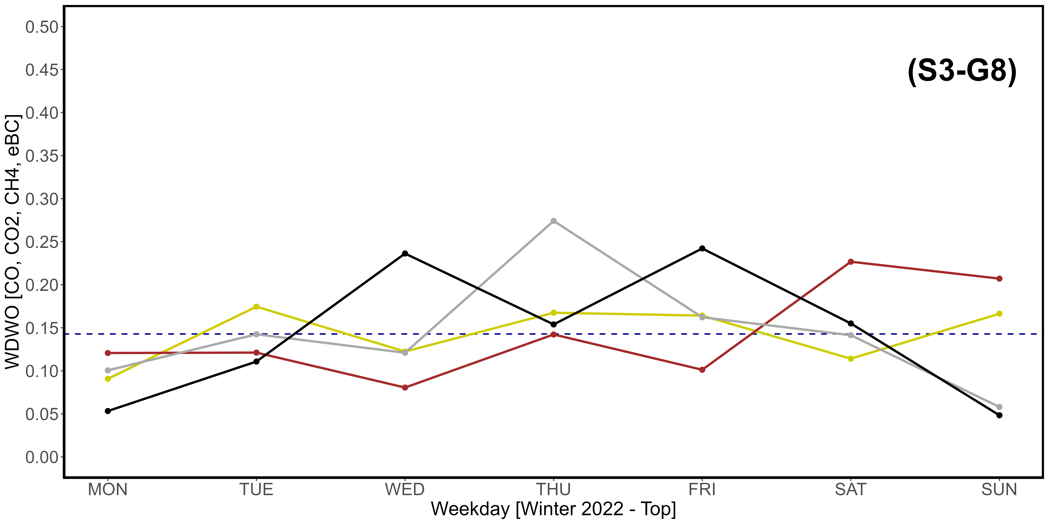
Supplementary Material S3-G1, S3-G2, S3-G3, S3-G4, S3-G5, S3-G7, S3-G7, S3-G8. Seasonal variations of the newly introduced WDWO parameter for CO (yellow), CO₂ (brown), CH₄ (dark gray) and eBC (black), referring specifically to the year 2022. A: Spring; B: Summer; C: Fall; D: Winter. “1” images refer to the Q3 threshold, while “2” refer to the top 2,5% of data. The intercept parallel to the x axis indicates the average expected value per day, which is 0,1428. The vertical scale is different compared to that used in Fig. 11. The scale of S3-G6 is also different due to a very high eBC peak value.

