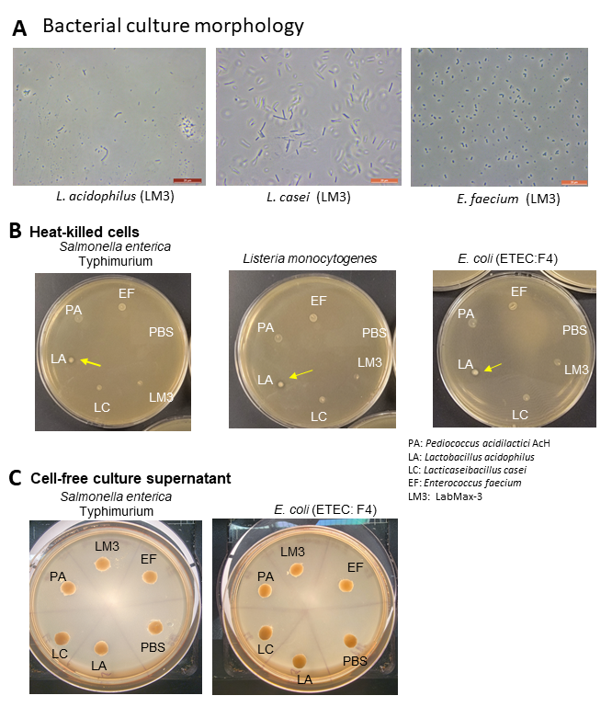**Supplementary figure**

**Figure S1.** Probiotic culture isolates morphology (A) and antimicrobial activity of heat-killed (B), and cell-free culture supernatants (C) against pathogens. In panel A, the morphology of probiotic culture isolates were examined under a phase contrast microscope. In Panel B, heat-killed cells (10 µl) were deposited on MRS agar plate, which was overlaid with test strains suspended in TSA soft agar (0.8%) preparation suspended in test pathogens. Zone of Inhibition was produced only by heat-killed LA cells. In Panel C, cell-free culture supernatants (40 µl) were deposited on blotting paper discs on a lawn of pathogens on BHI agar surface.