Supplemental material

Assessing the pathogenicity of Berkeleyomyces rouxiae and Fusarium oxysporum f. sp. vasinfectum on cotton (Gossypium hirsutum) using a rapid and robust seedling screen method
Andrew Chen ^{1,} *, Duy P. Le ², Linda J. Smith ³, Dinesh Kafle ³, Elizabeth A. B. Aitken ^{1,} * and Donald M. Gardiner ^{4,} *.

Table S1. Primers used for PCR in this study.
Primer name | 5' to 3' sequence | Product (bp) | PCR¹ (C) | Reference
Cer-MCM7F | ACICGIGTITCIGAYGTNAAGCC | 628 | 55 | de Beer et al. 2014
Cer-MCM7R | TTRGCAACACCAGGRTCACCCAT
RPB2-5Fb | GAYGAYCGTGATCACTTYGG | 1129 | 55 | Fourie et al. 2015
RPB2-7Rb | CCCATRGCYTGYTTRCCCAT
EF-1-728F | CATCGAGAAGTTCGAGAAGG | ~620 | 52 | Le et al. 2020
EF-2 | GGARGTACCAGTSATCATGTT |  |  | O’Donnell et al. 1998
FovSIX6-F2 | CTTCACGGCAGACCCG | ~467 | 55 | Chakrabarti et al. 2011
SIX6-R1 | CAAGACCAGGTGTAGGCATT
SIX1-F | TCTCCATTACTTTGTCTCACG | 694-733 | 55 | Czislowski et al. 2021
SIX1-R | CGATTTAGGCGATTCGGGG
SIX2-F | GGTTCCCATCGTTGAAGC | 327-330 | 55 | Czislowski et al. 2021
SIX2-R | TTGGTTTAAATCTGCGTGTC
SIX3-F | TTACTACGAGCTTCAGCACC | 223 | 55 | Czislowski et al. 2021
SIX3-R | GCATTAGGTGTTGCAACAGG
SIX4-F | CAGCTCAGACAGTCAGCC | ~491 | 55 | Czislowski et al. 2021
SIX4-R | GGCCTTGAGTCGAATGAGC
SIX5-F | TCA TCA GTA CTG TGC TTG CC | 347-354 | 55 | Czislowski et al. 2021
SIX5-R | CAT GTT GAG TCT GCT CCT CC
SIX6-F | CTCTCGAGACACSCTTCC | 396-399 | 52 | Czislowski et al. 2021
SIX6-R | GATCCACCAATACCTTCAT
SIX7-F | GAGGTGACATTTGACATCACC | 113 | 55 | Czislowski et al. 2021
SIX7-R | TAGTATGCGCGCCATTGG
SIX8-F | CCCTAGCCGTCTCTGTGGC | 163-165 | 60 | Czislowski et al. 2021
SIX8-R | CGTTCGACAAGGGCTCTCTCG
SIX9-G1-F | TTCAAGTCGGTTGCTACGC | 118 | 55 | Czislowski et al. 2021
SIX9-G1-R | GCATCCCAAAATCCAAAGCG
SIX10-F | TCACGTTTCGAGTTGGTCC | 202 | 55 | Czislowski et al. 2021
SIX10-R | ACACCAAATCGAGTCGATGC
SIX11-F | GTTGCTCCTCCTTTGCTGG | 163 | 56 | Czislowski et al. 2021
SIX11-R | TACCACTCTGACCAGTCACC
SIX12-F | CAGAATGCTTGTGTGTGTGG | 171 | 56 | Czislowski et al. 2021
SIX12-R | ATCACCAGAGCATGAACCCC
SIX13-F | TCTGATCAGCCTCCTAGCG | 840 | 58 | Czislowski et al. 2021
SIX13-R | CCACTGTAACTCGGCATCGA
SIX14-F | TGTCTCAGCGTATCCTCGGC | 147-197 | 58 | Czislowski et al. 2021
SIX14-R | ATTCAGTGACAACGGGACCG
¹ The annealing temperatures used in PCR.
Table S2. Spore concentrations of the liquid cultures determined on the day of inoculation.
Isolate name | Spore conc. (conidia/mL)¹ | Volume (mL)¹ | Spore conc. (conidia/mL)² | Volume (mL)² | Root dipping (conidia/mL)³ | Volume (mL)³
Fov SG1 | 2.075×10⁷ | 500 | - | - | 2.075×10⁷ | 500
Fov SG26 | 2.7×10⁵ | 500 | - | - | 2.7×10⁵ | 500
Fov SG55 | 3.775×10⁷ | 500 | - | - | 3.775×10⁷ | 500
Fov TH1 | 2.45×10⁷ | 500 | - | - | 2.45×10⁷ | 500
RVB4.1 | 1.245×10⁶ | 200 | 3.55×10⁶ | 45 | 8.175×10⁵ | 500
StrB22 | 1.25×10⁴ | 200 | 2.5×10³ | 45 | 5.225×10³ | 500
BRR4 | 4.25×10⁴ | 200 | 1.7825×10⁶ | 45 | 1.77425×10⁵ | 500
22BRR77 | 2.45×10⁶ | 200 | 4.15×10⁶ | 45 | 1.3535×10⁶ | 500
Fo BRF1⁴ | 2.35×10⁷ | 500 | - | - | 2.35×10⁷ | 500
Fo BRF2⁴ | 2.0×10⁷ | 500 | - | - | 2.0×10⁷ | 500
Fo SHF6⁴ | 2.675×10⁷ | 500 | - | - | 2.675×10⁷ | 500
Fo WRF2⁴ | 6.7×10⁶ | 500 | - | - | 6.7×10⁶ | 500
Fov SG1⁴ | 3.375×10⁷ | 500 |  |  | 3.375×10⁷ | 500
¹ Liquid culture established using half-strength PDB (Fov and Fo) and 10% carrot extract (v/v) in sterile water (B. rouxiae). ² Plate cultures using half-strength PDA (Fov and Fo) and 10% carrot extract (v/v) supplemented with 1.5% agar in sterile water (B. rouxiae). Five plates per B. rouxiae isolate were flooded with 10mL of sterile water. Spores and mycelia were collected and pooled totaling 45mL per isolate. ³ Spore concentrations of liquid and plate cultures combined in a total volume of 500mL. These cultures were used for root dipping. ⁴ This experiment was conducted at a later date independently of the first experiment. Both experiments used the same growth chamber and the same set of growth parameters.

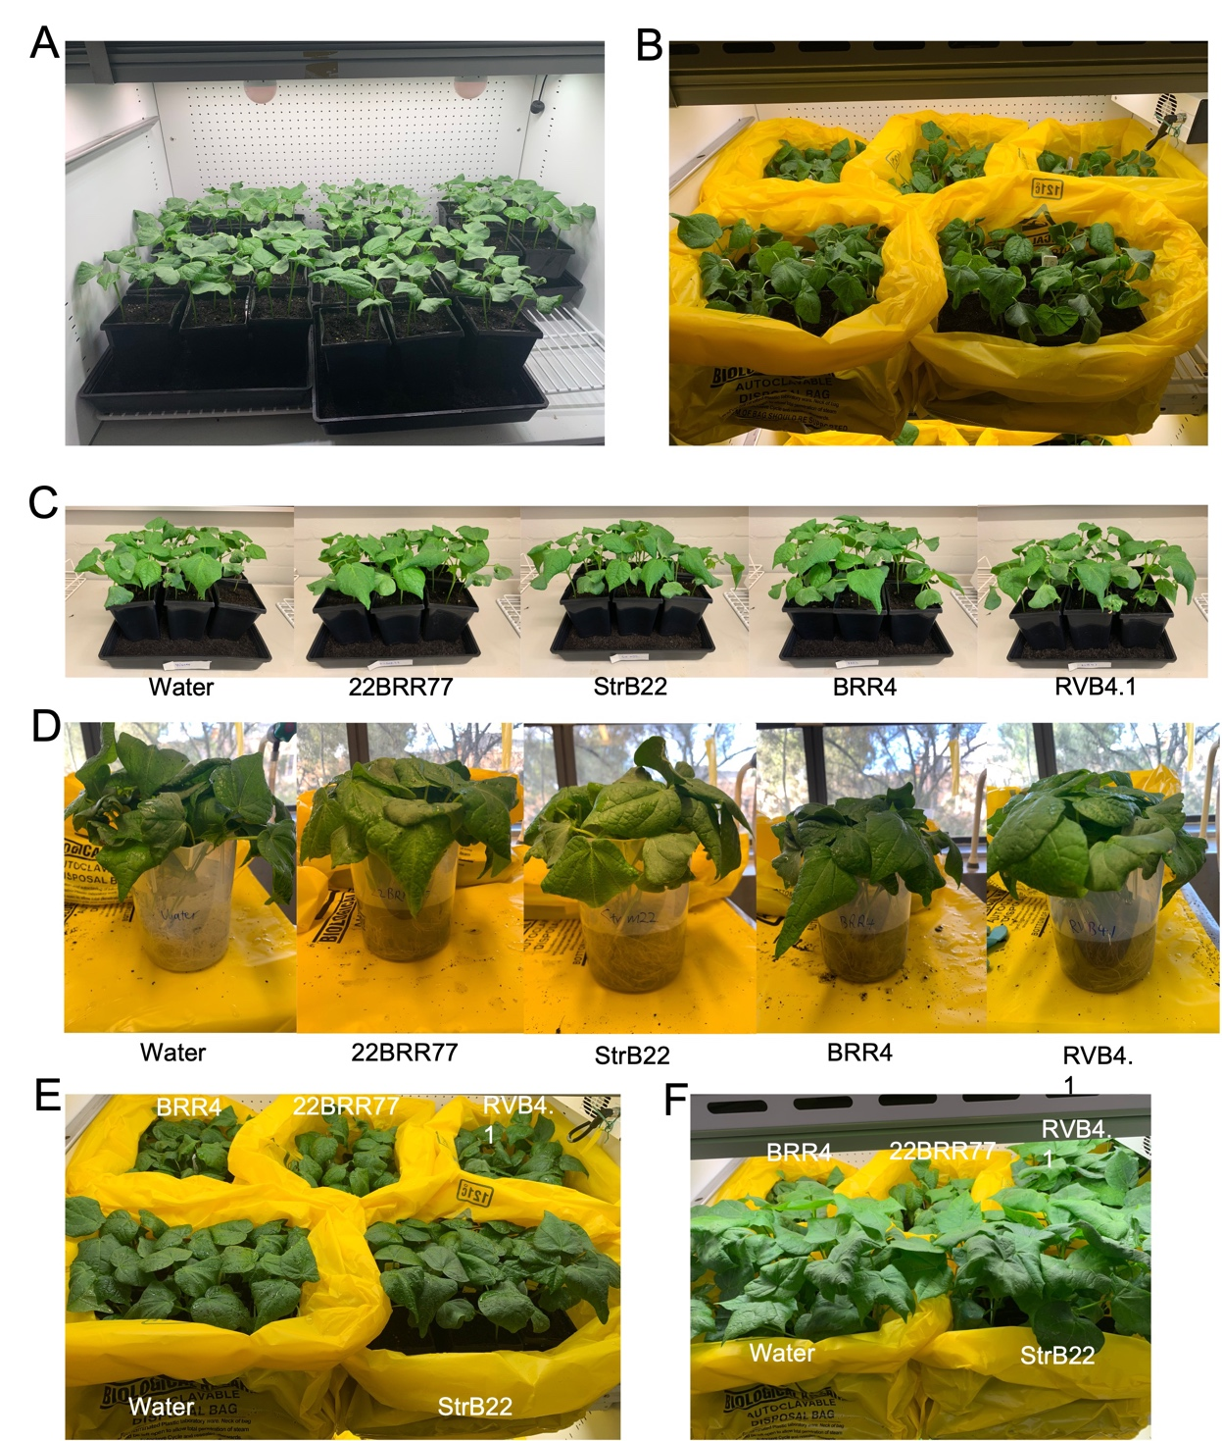
Figure S1. Plant growth before and after inoculation with Berkeleyomyces rouxiae isolates. (A) 12 days old Sicot746 B3F seedlings sitting in a double-tier growth chamber. (B) 14 days old Sicot746 B3F seedlings immediately after inoculation. (C) 14 days old Sicot746 B3F seedlings before inoculation. (D) Root dipping was performed using unfiltered cultures. (E) Sicot746 B3F seedlings were recovering in the growth chamber at 4 days post inoculation (dpi). (F) Sicot746 B3F seedlings were recovering in the growth chamber at 12 dpi.
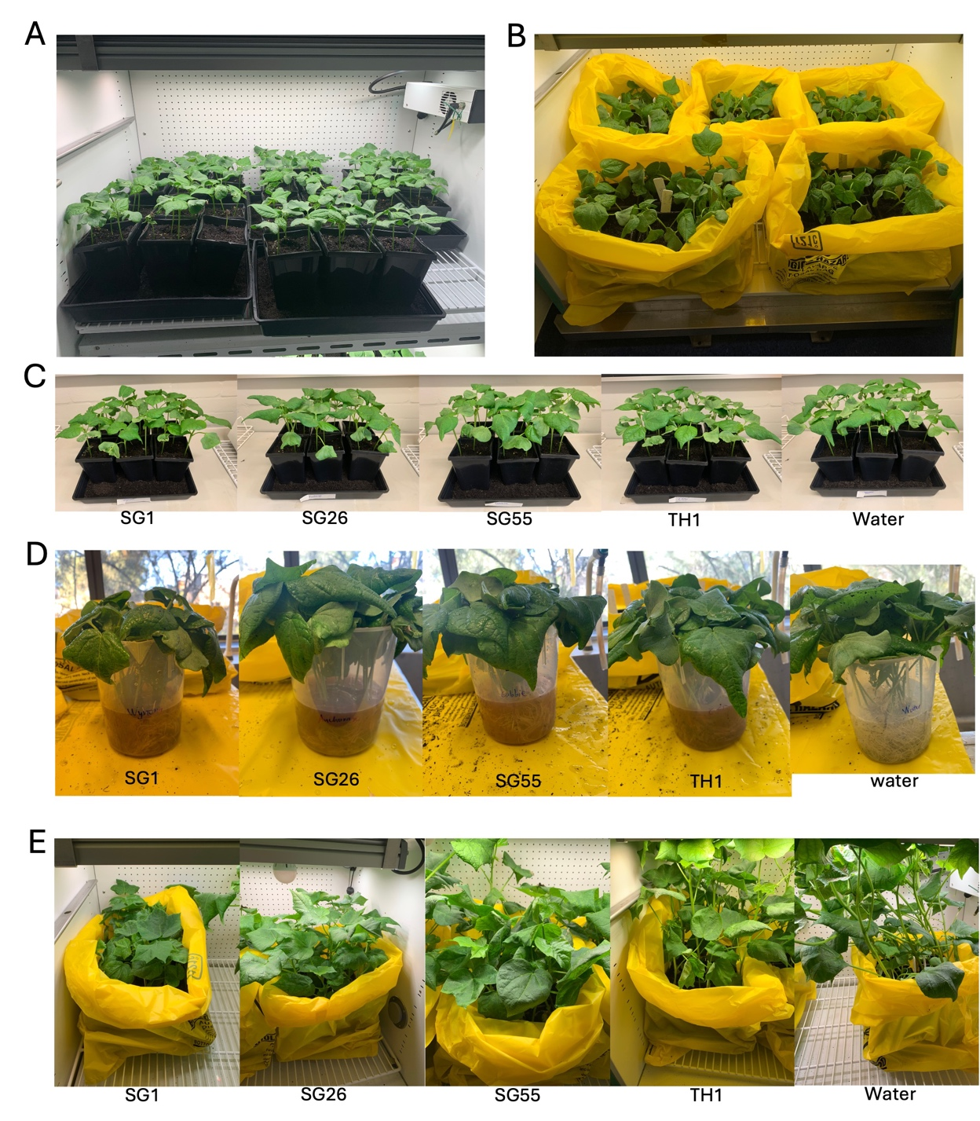
Figure S2. Plant growth before and after inoculation with Fusarium oxysporum f. sp. vasinfectum isolates. (A) 12 days old Sicot746 B3F seedlings sitting in a double-tier growth chamber. (B) 14 days old Sicot746 B3F seedlings immediately after inoculation. (C) 14 days old Sicot746 B3F seedlings before inoculation. (D) Root dipping was performed using unfiltered cultures. (E) Sicot746 B3F seedlings were recovering in the growth chamber at 19 days post inoculation.

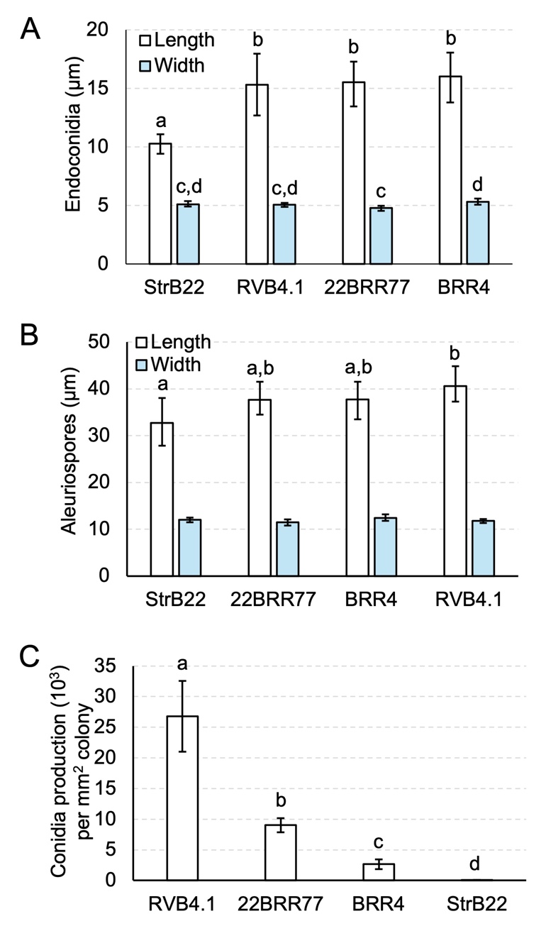
Figure S3. The spore size and growth rates of Berkeleyomyces rouxiae isolates after 3 weeks of growth on half-strength PDA plates. (A) Endoconidia size (n = 12). (B) Aleuriospore size (n = 12). (C) Growth rates in conidia production per mm² colony (n = 6). Letters indicate separation of means by Tukey's range test at p = 0.05. Error bars indicate a 95% confidence interval.
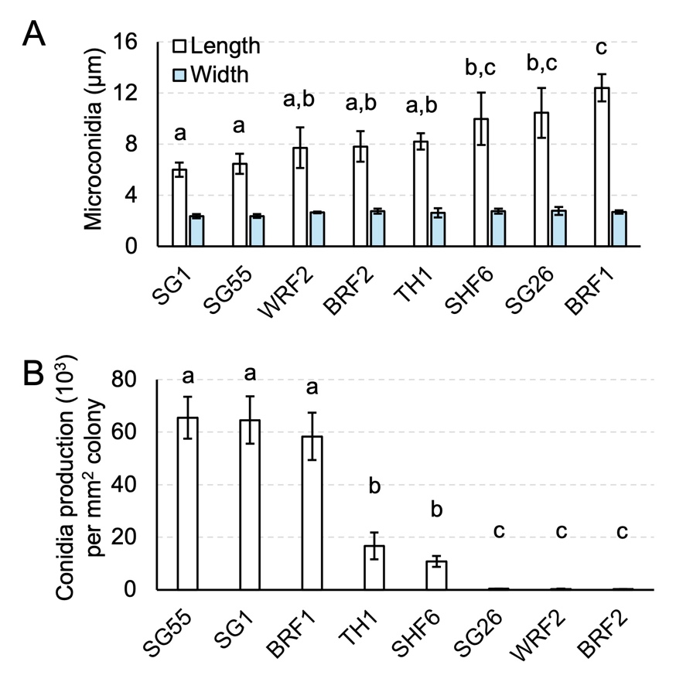
Figure S4. The spore size and growth rates of Fusarium oxysporum isolates after seven days of growth on half-strength PDA plates. (A) Microconidia size (n = 12). (B) Growth rates in conidia production per mm² colony (n = 5). Letters indicate significant separation of means by Tukey's range test at p = 0.05. Error bars indicate a 95% confidence interval.

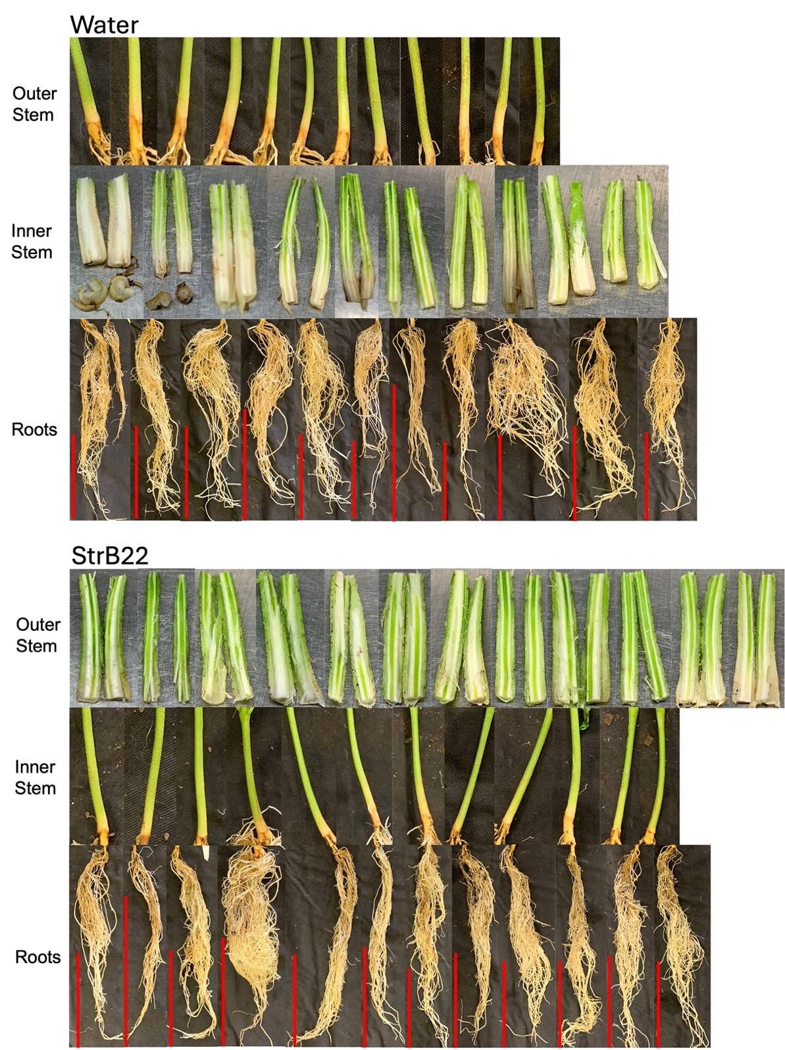
Figure S5. Symptomatology of Sicot746 B3F seedlings inoculated with Berkeleyomyces rouxiae at harvest (15 — 20 days post inoculation). Uninoculated controls and plants inoculated with StrB22 are shown. Red vertical bars indicate a scale of 10 cm.
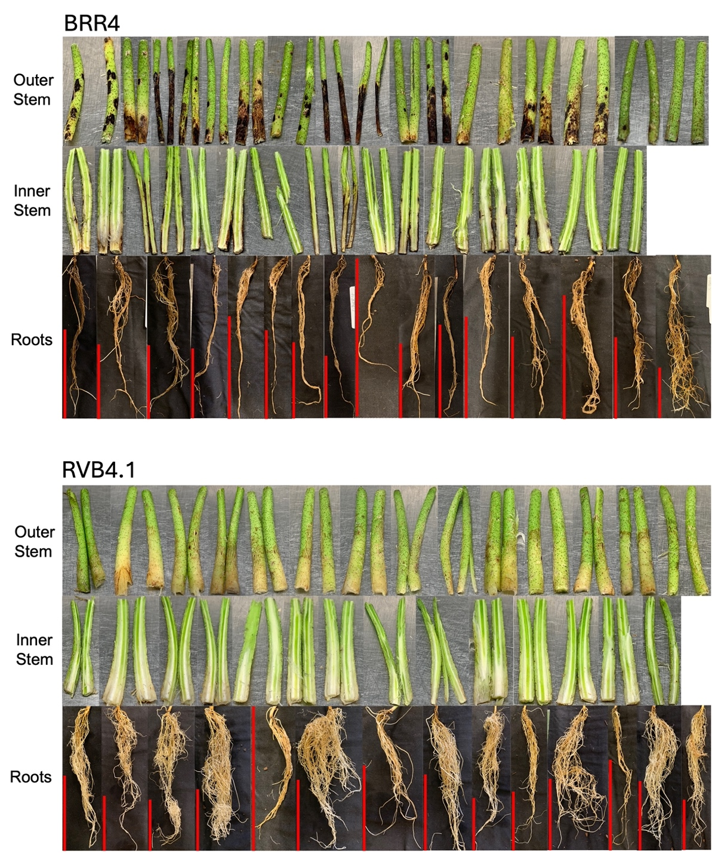
Figure S6. Symptomatology of Sicot746 B3F seedlings inoculated with Berkeleyomyces rouxiae at harvest (15 — 20 days post inoculation). Plants inoculated with BRR4 and RVB4.1 are shown. Red vertical bars indicate a scale of 10 cm.
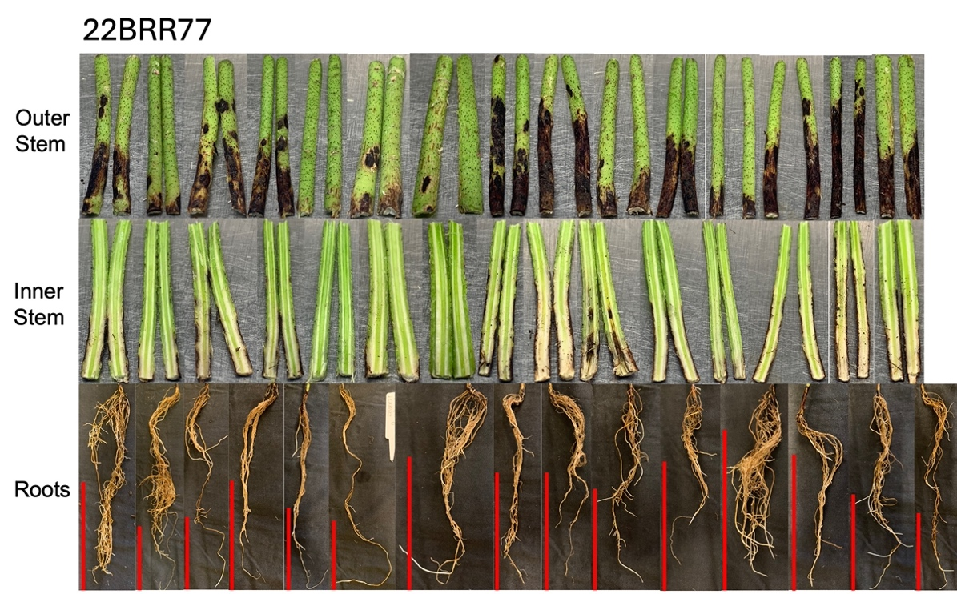
Figure S7. Symptomatology of Sicot746 B3F seedlings inoculated with Berkeleyomyces rouxiae at harvest (15 — 20 days post inoculation). Plants inoculated with 22BRR77 are shown. Red vertical bars indicate a scale of 10 cm.
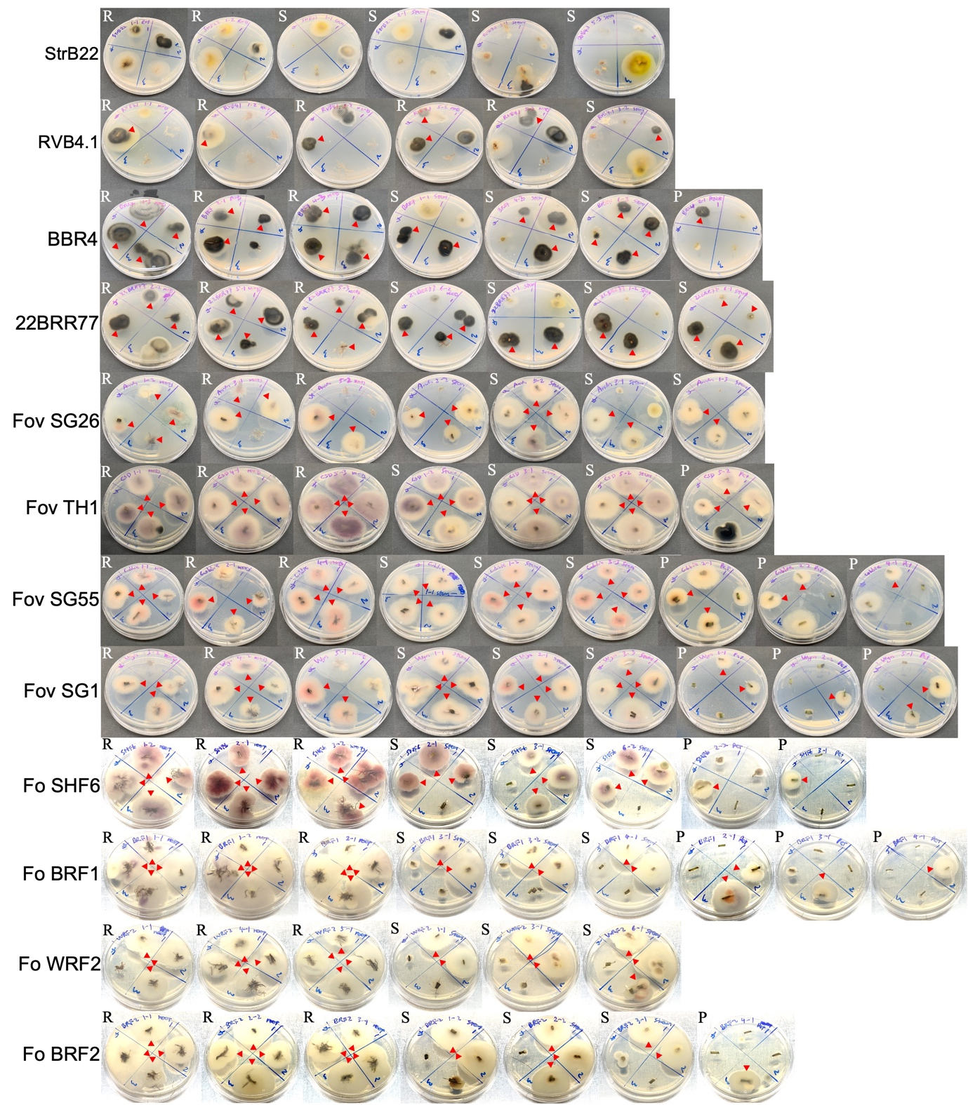
Figure S8. Reisolation of the Berkeleyomyces rouxiae and Fusarium oxysporum isolates from cotton plants on half-strength PDA plates (reverse view). Red arrows indicate B. rouxiae and F. oxysporum morphology positively identified under a compound microscope. R = roots; S = stem; P = petiole.

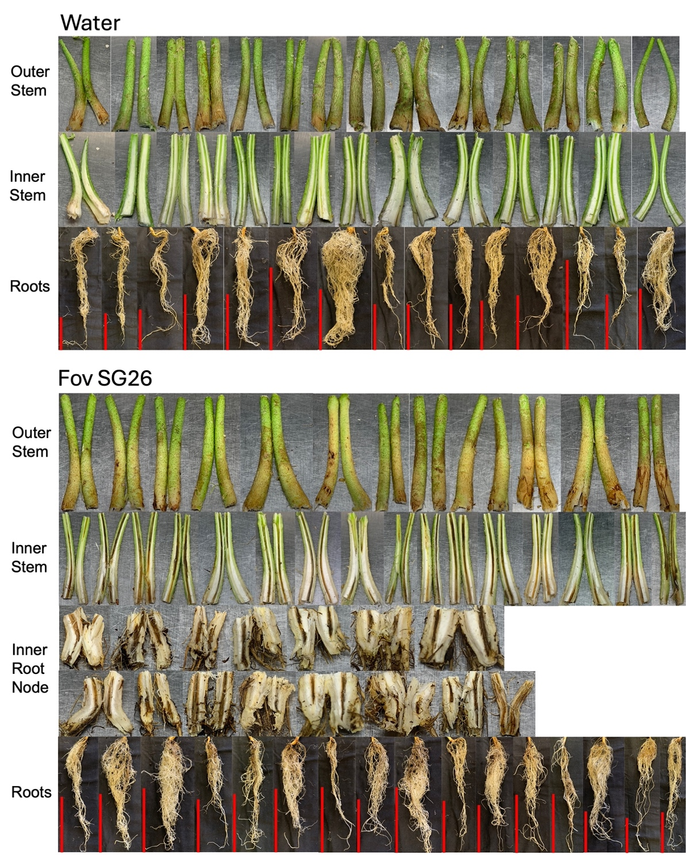
Figure S9. Symptomatology of Sicot746 B3F seedlings inoculated with Fusarium oxysporum f. sp. vasinfectum at harvest (27 — 34 days post inoculation). Uninoculated controls and Plants inoculated with Fov SG26 are shown. Red vertical bars indicate a scale of 10 cm.
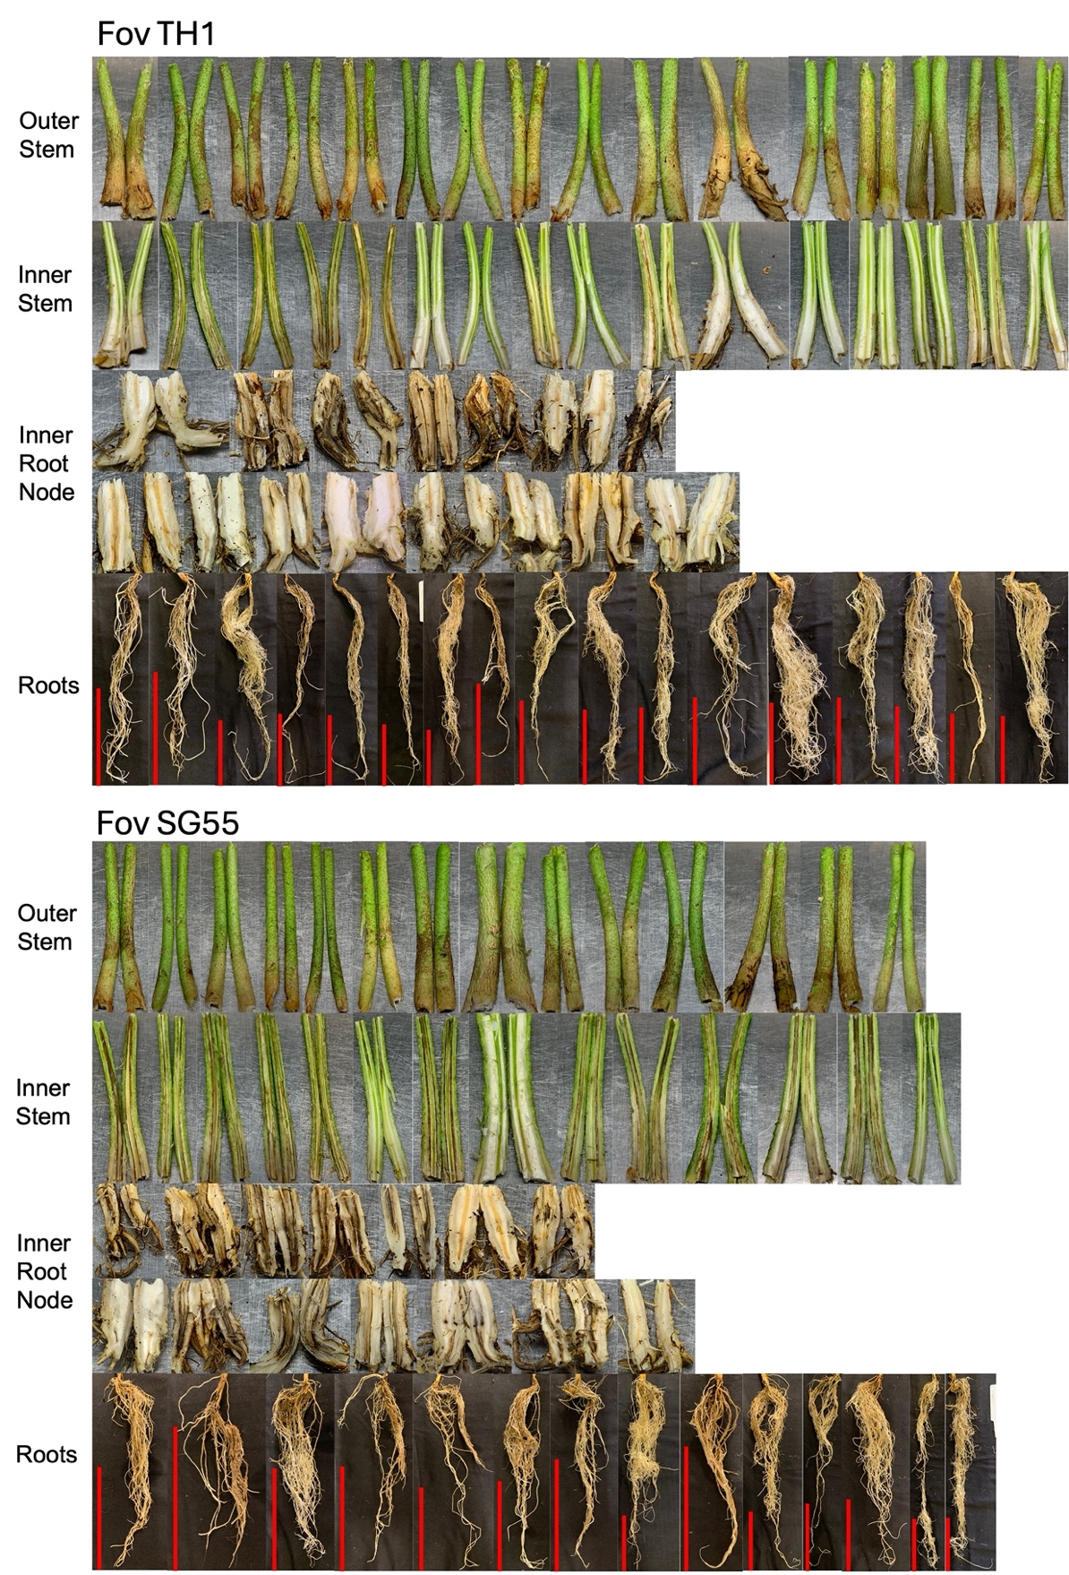
Figure S10. Symptomatology of Sicot746 B3F seedlings inoculated with Fusarium oxysporum f. sp. vasinfectum at harvest (27 — 34 days post inoculation). Plants inoculated with Fov TH1 and Fov SG55 are shown. Red vertical bars indicate a scale of 10 cm.
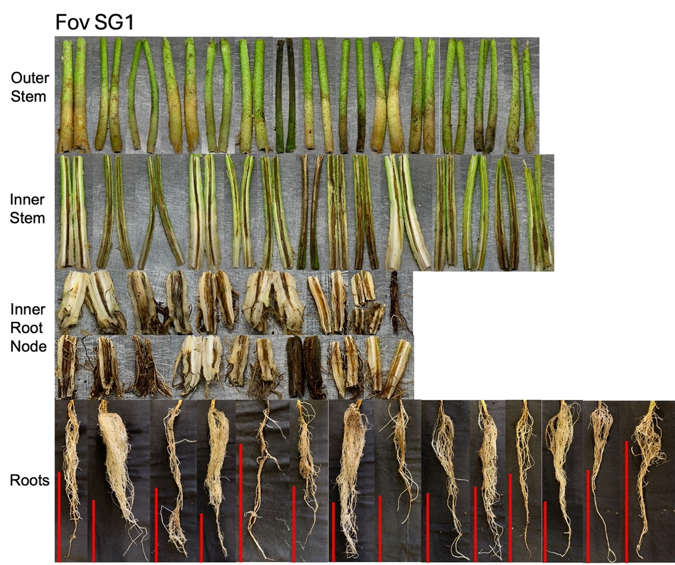
Figure S11. Symptomatology of Sicot746 B3F seedlings inoculated with Fusarium oxysporum f. sp. vasinfectum at harvest (27 — 34 days post inoculation). Plants inoculated with Fov SG1 are shown. Red vertical bars indicate a scale of 10 cm.
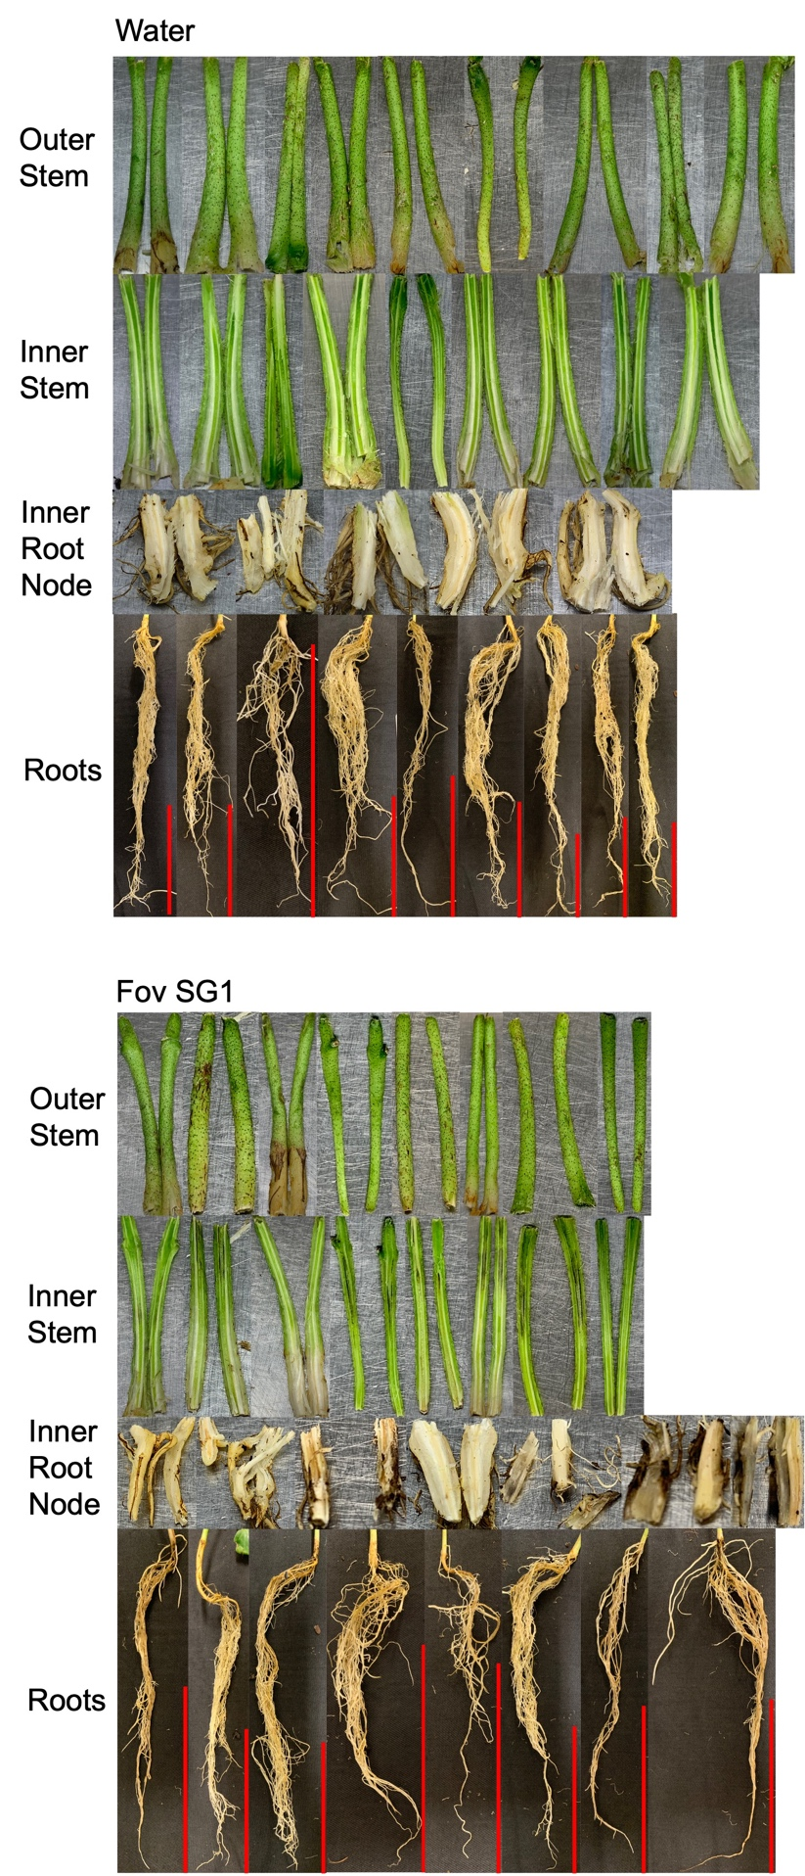
Figure S12. Symptomatology of Sicot746 B3F seedlings inoculated with Fusarium oxysporum spp. at harvest (17 — 22 days post inoculation). Uninoculated plants and plants inoculated with Fov SG1 (positive controls) are shown. Red vertical bars indicate a scale of 10 cm.

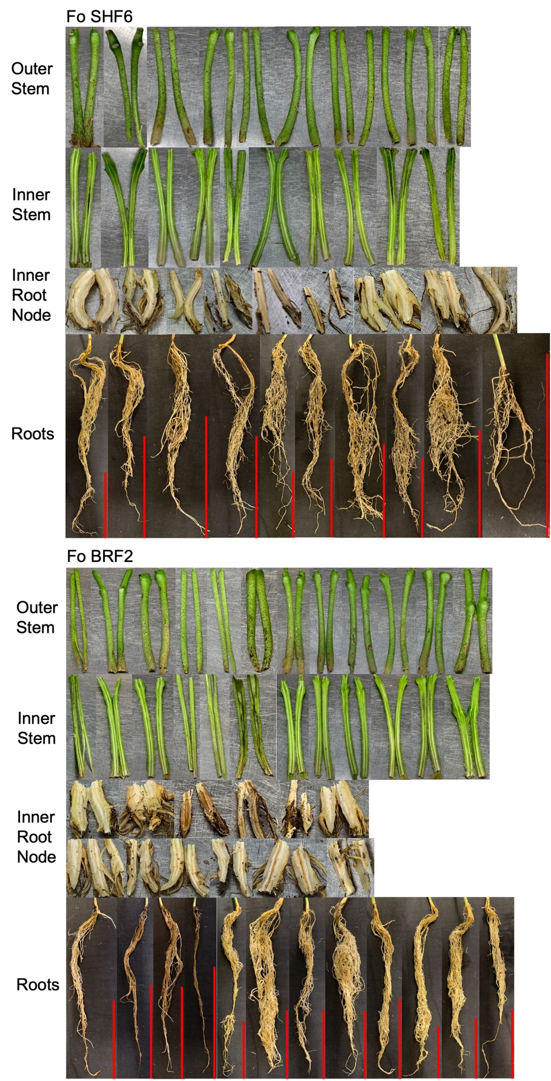
Figure S13. Symptomatology of Sicot746 B3F seedlings inoculated with Fusarium oxysporum spp. at harvest (17 — 22 days post inoculation). Plants inoculated with Fo SHF6 and Fo BRF2 are shown. Red vertical bars indicate a scale of 10 cm.
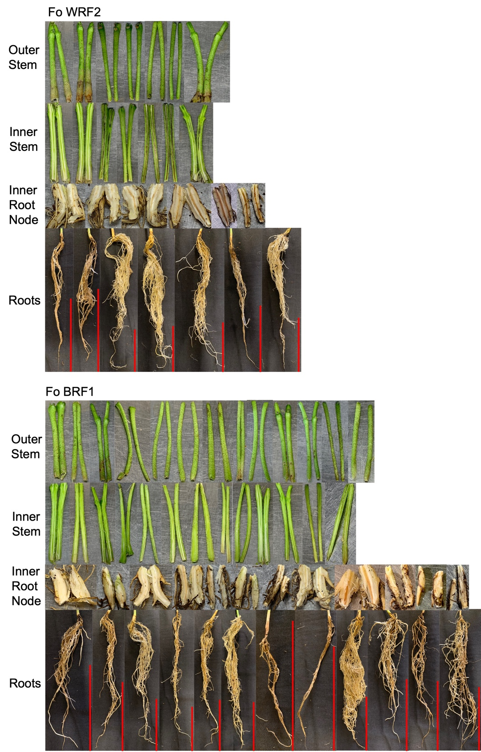
Figure S14. Symptomatology of Sicot746 B3F seedlings inoculated with Fusarium oxysporum spp. at harvest (17 — 22 days post inoculation). Plants inoculated with Fo WRF2 and Fo BRF1 are shown. Red vertical bars indicate a scale of 10 cm.

