Supplemental material 1 ACB intervention logic model

Supplemental material 2 Baseline, 6- and 12-weeks questionnaires for patient participants

Baseline questionnaire

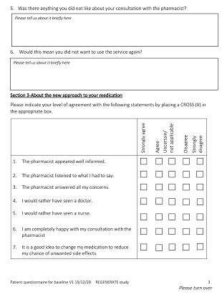



6- weeks questionnaire

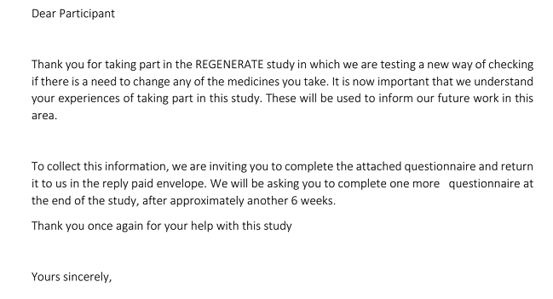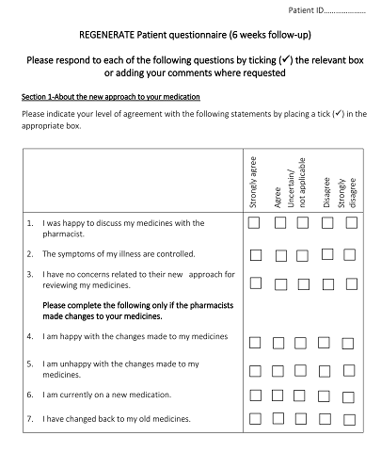

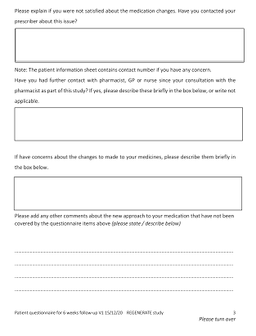 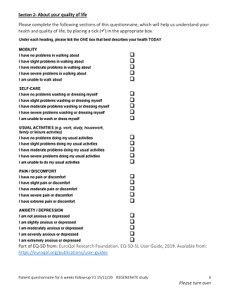

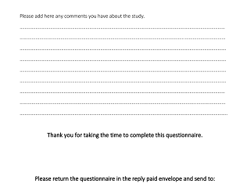

12- weeks questionnaire

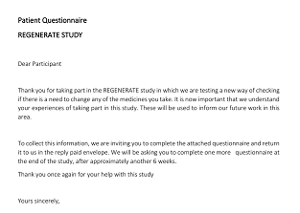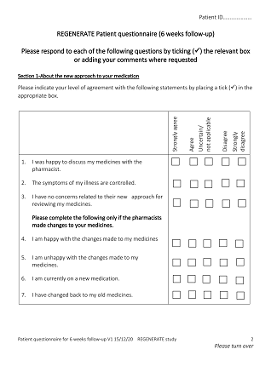

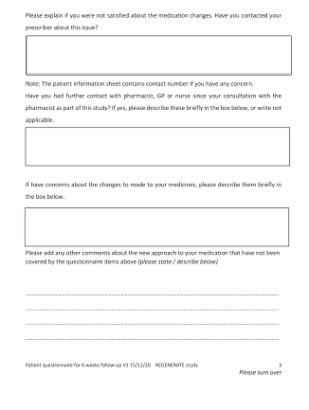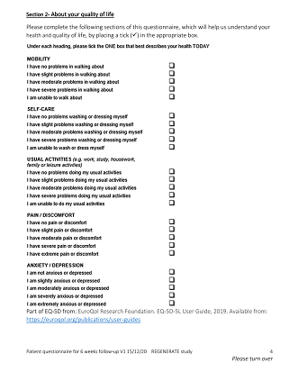

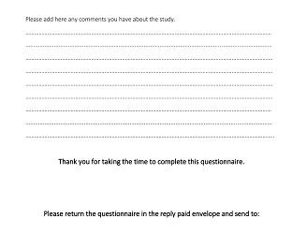

Supplemental material 3 Interviews guides for doctors, pharmacists and patients.

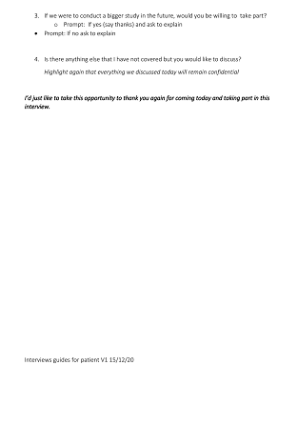

**Author Contributions:** All authors have substantial contributions to the conception or design of the work, analysis, or interpretation of data for the work, AN drafted the work and other authors revised paper critically for important intellectual content, final approval of the version to be published and agreement to be accountable for all aspects of the work in ensuring that questions related to the accuracy or integrity of any part of the work are appropriately investigated and resolved.

Conceptualization, A.N, C.B., M.C, R.N. and P.K.M.; Methodology, A.N, C.B., M.C, R.N. and P.K.M.; Investigation, A.N.; Data Curation, A.N. and P.K.M.; Writing – Original Draft Preparation, A.N.; Writing – Review & Editing, C.B., M.C, R.N. and P.K.M.

**Funding:** This research was funded by the University of Aberdeen.

**Institutional Review Board Statement:** The study was conducted according to the guidelines of the Declaration of Helsinki and approved by the East of Scotland Research Ethics Committee (protocol code: 2-094-20 and date of approval: 8 April 2021).

**Informed Consent Statement:**  Informed consent was obtained from all subjects involved in the study.

**Acknowledgments: We would like to thank Mrs. Valerie Sillito for her role as a primary care pharmacist in this study.**

**Conflicts of Interest:** The authors declare no conflict of interest.

**References:**

1. World Health Organization, 2021-last update, Ageing and health. Available: <https://www.who.int/news-room/fact-sheets/detail/ageing-and-health> [12/August, 2021].
2. Maher, R.L., Hanlon, J.T. and Hajjar, E.R., 2014. Clinical consequences of polypharmacy in elderly. *Expert Opinion on Drug Safety,* 2014, 13(1), pp. 1-11.
3. Katzenschlager, R., Sampaio, C., Costa, J. and Lees, A. Anticholinergics for symptomatic management of Parkinson´s disease. *Cochrane Database of Systematic Reviews,* 2022, (3), pp. 1-19.
4. O'Donnell, K.L., Gnjidic, D., Nahas, R., Bell, J.S. and Hilmer, S.N. Anticholinergic burden: Considerations for older adults. *Journal of Pharmacy Practice and Research,* 201747(1), pp. 67-77.
5. Vardanyan, R.S. and Hruby, V.J. Anticholinergic drugs. In: R.S. VARDANYAN and V.J. HRUBY, eds, *Synthesis of essential drugs,* 2006*.* Elsevier, pp. 195-208.
6. Rudolph, J.L., Salow, M.J., Anglini, M.C. and Mcglinchey, R.E. The anticholinergic risk scale and anticholinergic adverse effects in older persons. *Arch Intern Med,* 2008,168(5), pp. 508-513.
7. Ancelin, M.L., Artero, S., Portet, F., Dupuy, A., Touchon, J. and Ritchie, K. Non-degenerative mild cognitive impairment in elderly people and use of anticholinergic drugs: longitudinal cohort study. *British Medical Journal,* 2006, 332, pp. 455-459.
8. Ehrt, U., Broich, K. and Larsen, J.P. Use of drugs with anticholinergic effect and impact on cognition in Parkinson's disease: A cohort study. *Journal of Neurology, Neurosurgery, and Psychiatry,* 2010, 81, pp. 160-165.
9. Kersten, H. and Wyller, T.B. Anticholinergic drug burden in older people's brain - how well is it measured? *Basic & clinical pharmacology & toxicology,* 2014, 114(2), pp. 151-9.
10. Ablett, A.D., Wood, A.D., BarrA, R., Guillot, J., Black, A.J., Macdonald, H.M., Reid, D.M. and Myint, P.K. A high anticholinergic burden is associated with a history of falls in the previous year in middle-aged women: findings from the Aberdeen prospective osteoporosis screening study. *Annals of Epidemiology,* 2018, 28, pp. 557-562.
11. Nakham, A., Myint, P.K., Bond, C.M., Newlands, R., Loke, Y.K. and Cruickshank, M. Interventions to reduce anticholinergic burden in adults aged 65 and older: A systematic review. *Journal of the American Medical Directors Association,* 2020, 21(2), pp. 170-180.
12. Krishnaswami, A., Steinman A. M., Goyal, P., Zullo, R.A., Anderson, S.T., Birtcher, K.K., Goodlin, J.S., Maurer, S.M., Alexander, P.K., Rich, W.M. and Tjia, J. Deprescribing in older adults with cardiovascular disease. *Journal of the American College of Cardiology,* 2019, 73(20), pp. 2584-2595.
13. Michael, S. and Reeve, E. *Deprescribing.* <https://www.uptodate.com/contents/deprescribing#:~:text=Common%20goals%20for%20deprescribing%20include,to%20improving%20quality%20of%20life.> edn. UpToDate, 2022.
14. Olasehinde-Williams, O., July, 2020-last update, Deprescribing guide, 2020. Available: <https://southendccg.nhs.uk/your-health-services/healthcare-professionals/medicines-management/medicines-management-resources/2308-deprescribing-guide/file> [April/03, 2020].
15. Craig, P., Dieppe, P., Macintyre, S., Michie, S., Nazareth, I. and Petticrew, M., 2019-last update, Developing and evaluating complex interventions: Following considerable development in the field since 2006, MRC and NIHR have jointly commissioned an update of this guidance to be published in 2019. Available: <https://mrc.ukri.org/documents/pdf/complex-interventions-guidance/> [05/01, 2021].
16. Stewart, C., Gallacher, K., Nakham, A., Cruickshank, M., Newlands, R., Bond, C., Myint, P.K., Bhattacharya, D. and Mair, F.S. Barriers and facilitators to reducing anticholinergic burden: a qualitative systematic review. *International Journal of Clinical Pharmacy,* 2021,43, pp. 1451-1460.
17. Cunningham, Y., Wood, C., Stewart, C., Nakham, A., Newlands, R., Gallacher, K.I., Quinn, T.J., Ellis, G., Lowrie, R., Myint, P.K., Bond, C. and Mair, F.M. Understanding Stakeholder Views Regarding the Design of an Intervention Trial to Reduce Anticholinergic Burden: A Qualitative Study. *Frontiers in Pharmacology,* 2021, 12, pp. 1-10.
18. Boustani, M., Campbell, N., Munger, S., Maidment, I. and Fox, C. Impact of anticholinergics on the aging brain: A review and practical application. *Aging Health,* 2008,4(3), pp. 311-320.
19. Bruhn, H., Bond, C.M., Elliott, A.M. Pharmacist led management of chronic pain in primary care: results from a randomised controlled exploratory trial. *BMJ Open*, 2013, 3:e002361. doi:10.1136/bmjopen-2012
20. Wickware, C. When will England get a 'Pharmacy First' service? *The Pharmaceutical Journal*, 2023, 310(7969): DOI: 10.1211/PJ.2022.1.126642
21. Okeowo, D.A., Zaidi, S.T.R., Fylan, B. and Alldred, D.P. Barriers and facilitators of implementing proactive deprescribing within primary care: a systematic review. *International Journal of Pharmacy Practice*, 2023, 31(2), pp.126-152.
22. Kua, C., Mak, V.S.L. and Lee, S.W.H. Health Outcomes of Deprescribing Interventions among older residents in nursing homes: A systematic review and meta-analysis. *Journal of the American Medical Directors Association,* 2019, 20(3), pp. 362-372.
23. Thillainadesan, J., Gnjidic, D., Green, S. and Hilmer, S.N.  
    Impact of deprescribing interventions in older hospitalised patients on prescribing and clinical outcomes: a systematic review of randomised trials.  *Drugs Aging,* 2018, 35(4), pp. 303-319.
24. Ulley, J., Harrop, D., Ali, Ali, Alton, S. and Davis, S.F. Deprescribing interventions and their impact on medication adherence in community-dwelling older adults with polypharmacy: a systematic review. *BMC Geriatrics,* 2019, 19(15), pp. 1-13.