Table S1. Selected Cannabis sativa L.-derived cannabinoids, their targets, mechanisms of action, and potential resultant pharmacological effects – Table adapted from (Christensen et al., 2023)
Structures | Targets | Mechanisms of Action | Potential Pharmacological effects
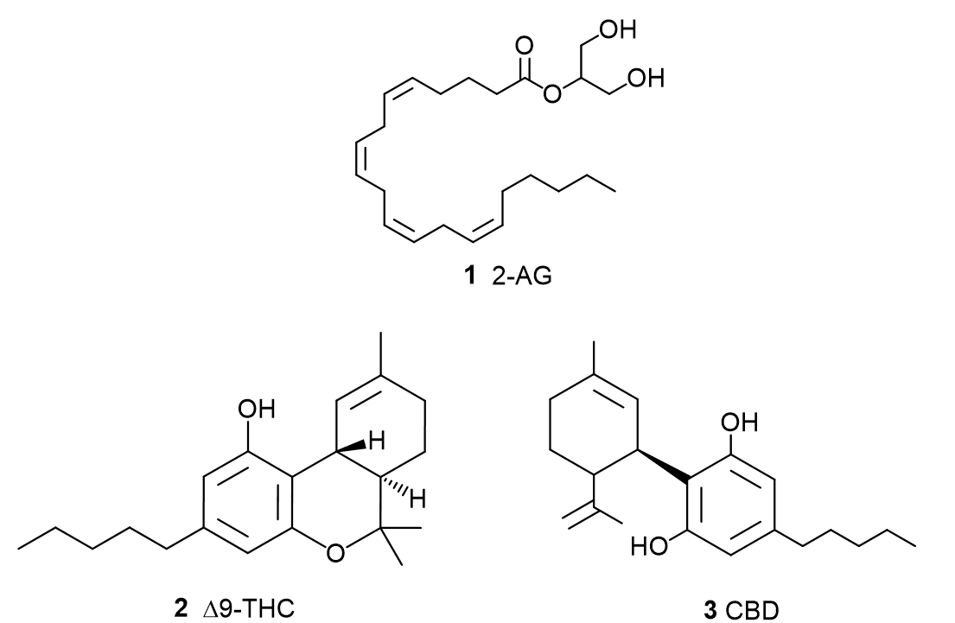Δ9-Tetrahydrocannabinol (THC) (2) | CB1 | Partial agonist | Analgesic **, ***  Anti-convulsant **  Anti-epileptic **  Sleep improvement **, ***  Anti-anorectic **, ***  appetite stimulating **, ***  Anti-emetic **, ***  Anxiolytic **
 | CB2 | Partial agonist | Analgesic **, ***
 | GPR55 | Agonist | Not reported
 | GPR18 | Agonist | Not reported
 | 5-HT-3A | Antagonist | Anti-nociception *  Anti- emetic *
 | DOR | Negative allosteric modulator | Not reported
 | MOR | Negative allosteric modulator | Not reported
 | PPAR-y | Agonist | Anti-cancer, anti-proliferative *, **
 | GlyR | Agonist | Analgesic *, **
 | TRPV2 | Agonist | Not reported
 | TRPV3 | Agonist | Not reported
 | TRPV4 | Agonist | Not reported
 | TRPA1 | Agonist | Not reported
 | TRPM8 | Antagonist | Not reported
Cannabidiol (CBD) (3)  Cannabidiol (CBD) (3)  Cannabidiol (CBD) (3)  Cannabidiol (CBD) (3) | CB1 | Negative allosteric modulator  Antagonist | THC-related adverse effects modulation **, ***  Anxiolytic **  Antidepressant **  Vasorelaxant **
 | CB2 | Partial agonist  Negative allosteric modulator  Antagonist | Seizure reduction **  Anti-epileptic **  Anti-inflammatory **  Anti-cancer *, **  Body weight decrease **  Neuroprotection **
 | GPR3 | Inverse agonist | Alzheimer’s disease improvement *
 | GPR6 | Inverse agonist | Parkinson’s disease improvement *
 | GPR12 | Inverse agonist | Anti-cancer *
 | GPR55 | Antagonist | Anti-epileptic **, ***  Seizure dampening **  Bone resorption inhibition **  Parkinson’s motor skills improvement **  Cancer cell migration inhibition
 | FAAH | Inhibitor | AEA increase and related effects *  Sleep induction *, **  Stress reduction ***  Anxiolytic ***  Anti-depressant **
 | 5-HT-1A | Agonist  Inverse agonist | Anti-emetic *, **  Analgesic **  Chemotherapy induced neuropathic pain reduction *, **  Anxiolytic **  Anti-depressant **  Cognitive performance improvement **  Anti-epileptic *, **, ***  Seizure reduction **  Anti-stress **  Neuroprotection **
 | 5-HT-3A | Antagonist | Anti-emetic **  Cardiovascular effects **
 | A1A | Agonist | Anti-arrhythmic **  Analgesic **
 | A2A | Agonist | Anti-inflammatory *, **  Cognitive performance improvement **
 | PPAR-γ | Agonist | β-amyloid-induced neuroinflammation reduction *, **  Hippocampal neurogenesis *, **  Alzheimer’s disease improvement *, **
 | Immune cell (not further specified) | Inhibitor  Activator | Anti-inflammatory *, **  Immunosuppressive *, **  Cytokine release reduction/increase *, **  Anti-arthritic **  Multiple sclerosis amelioration **
 | Gly-α1 | Positive allosteric modulator  Agonist | Anti-inflammatory *  Neuroprotective *
 | Gly-α3 | Positive allosteric modulator | Analgesic **
 | GABA-A | Positive allosteric modulator | Anti-convulsant **  Anti-epileptic **
 | TRPV1 | Agonist | Neuron anti-hyperexcitability *  Anxiolytic **  Anti-cancer, apoptosis *  Microglial phagocytosis enhancement *  Cardiovascular effects **
 | TRPV2 | Agonist | Microglial phagocytosis enhancement *
 | TRPV3 | Agonist | Not report
 | TRPV4 | Agonist | Not report
 | TRPA1 | Agonist | Analgesic **
 | TRPM8 | Antagonist | Not reported
 | DOR | Negative allosteric modulator | Not reported
 | MOR | Negative allosteric modulator | Not reported
 | D2 | Partial agonist | Anti-psychotic*
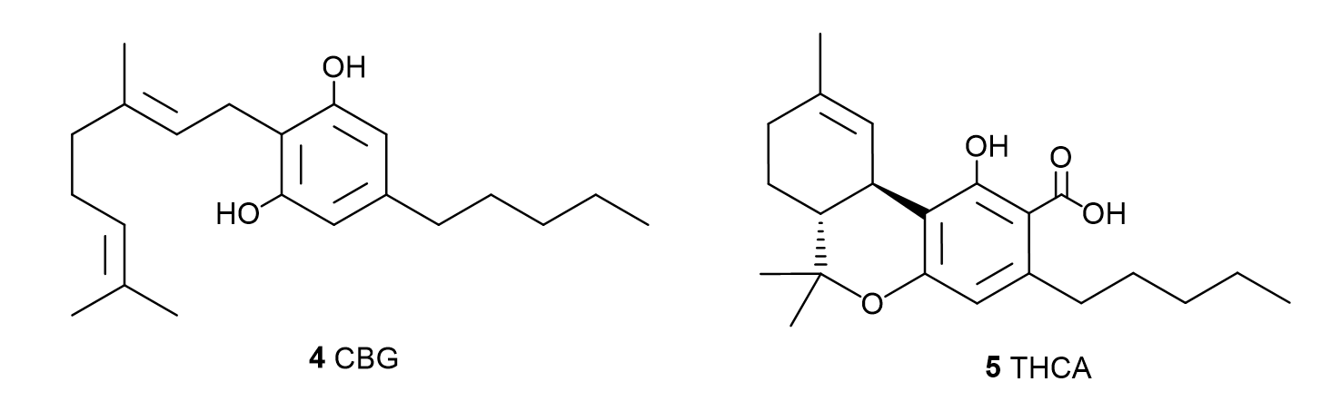  Cannabigerol (CBG) (4) | CB2 | Partial agonist | Anti-inflammatory *, **  Colitis attenuation *, **
 | AEA uptake | Inhibitory | Various effects related to AEA *
 | 5-HT-1A | Antagonist | Reverse anti-emetic effect of, e.g. CBD **
 | A2A | Agonist | Not reported
 | TRPV1 | Agonist | Not reported
 | TRPA1 | Agonist | Not reported
 | TRPM8 | Antagonist | Colon anti-cancer **
Δ9-Tetrahydrocannabinolic acid (THCA) (5)  Δ9-Tetrahydrocannabinolic acid (THCA) (5) | CB1 | Partial agonist | Anti-nociceptive **  Anti-inflammatory
 | CB2 | Agonist | Not reported
 | PPAR-γ | Agonist | Adiposity reduction **  Metabolic syndrome prevention **  Anti-inflammatory **  Neuroprotective *, **
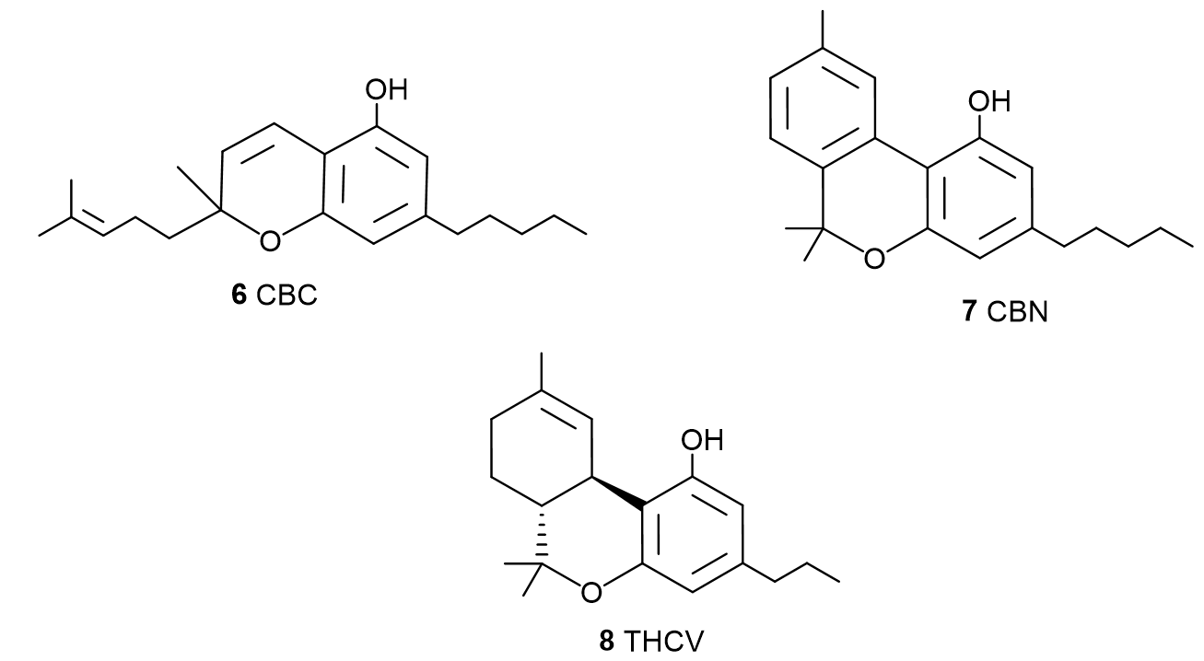  Cannabichromene (CBC) (6) | CB2 | Agonist | Anti-inflammatory *
 | AEA uptake | Inhibitor | Various effects related to AEA *
 | TRPV3 | Agonist | Not reported
 | TRPV4 | Agonist | Not reported
 | TRPA1 | Agonist | Anti-inflamatory **  Colitis reduction **  Analgesic **
 | TRPM8 | Antagonist | Not reported
Cannabinol (CBN) (7) | CB1 | Agonist | Appetite increase **
 | CB2 | Agonist  Inverse agonist | Not reported
 | TRPA1 | Agonist | Not reported
 | TRPM8 | Antagonist | Not reported
Δ8-Tetrahydrocannabivarin (THCV) (8)  Δ8-Tetrahydrocannabivarin (THCV) (8) | CB1 | Agonist  Antagonist | Anti-psychoactive (e.g. reverse THC-induced psychoactive effects) **  Analgesic **  Anti-convulsant **  Anti-epileptic *  Hypophagia and weight reduction **  Glycemic control improvement **, ***
 | CB2 | Partial agonist  Antagonist | Anti-inflammatory **  Inflammatory pain reduction **
 | 5-HT-1A | Agonist | Antipsychotic *, **
 | TRPV2 | Agonist | Not reported
 | TRPA1 | Agonist | Not reported
 | TRPM8 | Antagonist | Not reported
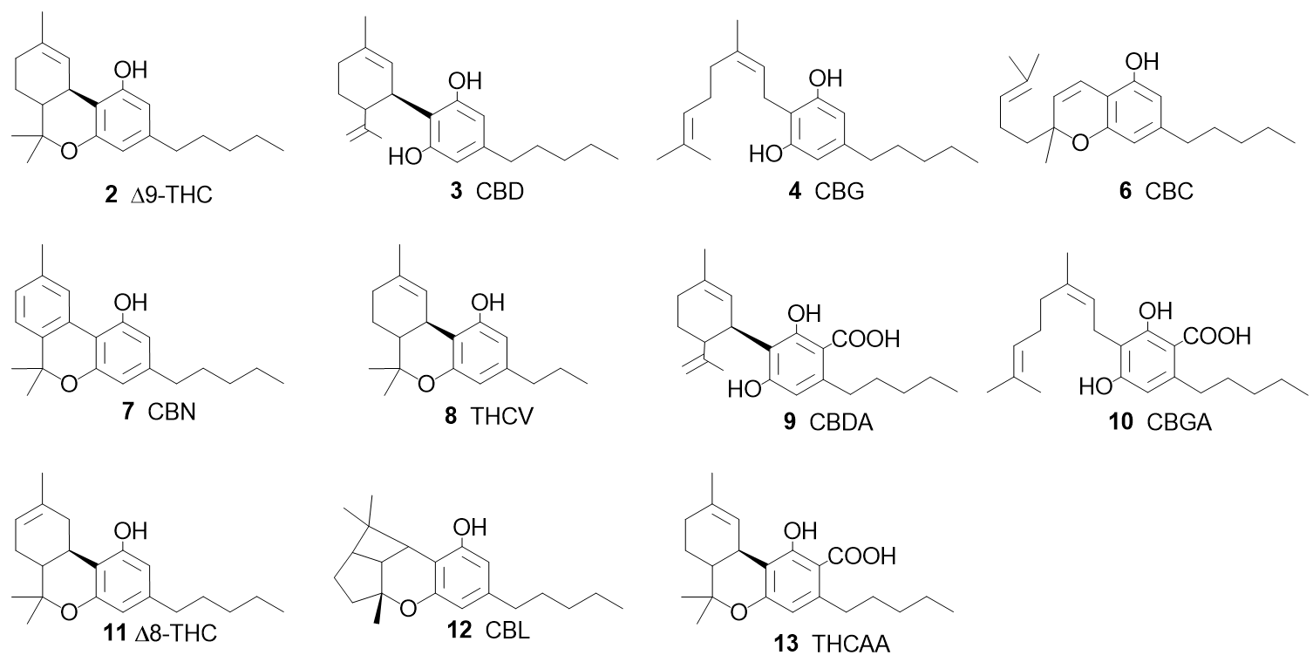  Cannabidiolic acid (CBDA) (9) | CB2 | Partial agonist | Not reported
 | 5-HT-1A | Agonist | Anti-emetic **  Anti-convulsant **  Anxiolytic **
 | TRPV1 | Agonist | Anti-heperalgesic **
Δ8-Tetrahydrocannabinol  (THC) (11) | CB1 | Partial agonist | Appetite stimulant **
 | CB2 | Agonist | Not reported
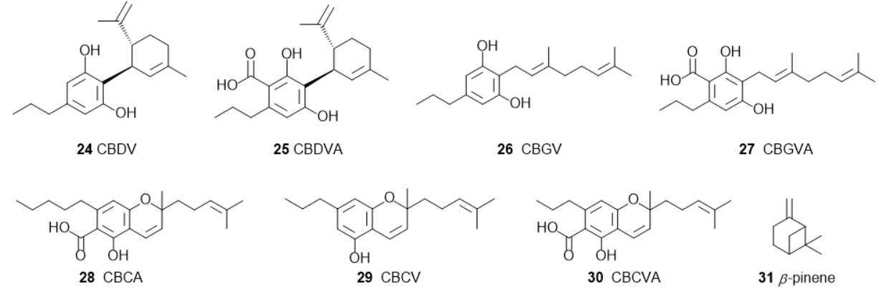  Cannabivarin (CBDV) (24) | GABA-A | Positive allosteric modulator | Anticonvulsive *, ***  Anti-epileptic *, ***
 | TRPV1 | Agonist | Neuronal anti-heperexcitability *  Anti-convulsant **
 | TRPV2 | Agonist | Not reported
 | TRPV3 | Agonist | Not reported
 | TRPA1 | Agonist | Not reported
*: Pre-clinical in vitro study; **: pre-clinical in vivo study; ***: clinical study; N.B.: This table is non-exhaustive, broadly elucidating selected compounds and some of their potential pharmacological effects currently present in the pre-clinical literature. Depending on study parameters, the compounds show differing, sometimes biphasic, affinities and effects at different targets, thus highlighting the contradictory and equivocal evidence state. Abbreviations: 5-hydroxytryptamine receptor 1A (5-HT-1A); 5-hydroxytryptamine receptor 3A (5-HT-3A); adrenergic receptor alpha-1 (A1A); adrenergic receptor alpha-2 (A2A); anandamide endocannabinoid (AEA); cannabinoid receptor 1 (CB1); cannabinoid receptor 2 (CB2); delta-opioid receptor (DOR); dopamine D2 receptor (D2); fatty acid amide hydrolase enzyme (FAAH); gamma-aminobutyric acid type A receptor (GABA-A); glycine receptor (GlyR); glycine receptor type α1 (GlyR-α1); glycine receptor type α 3 (GlyR-α3 ); G-protein-coupled receptor 2 (GPR2); Gprotein- coupled receptor 3 (GPR3); G-protein-coupled receptor 6 (GPR6); G-protein-coupled receptor 12 (GPR12); G-protein-coupled receptor 18 (GPR18); G-protein-coupled receptor 55 (GPR55); Mu-opioid receptor (MOR); peroxisome proliferator-activated receptor gamma (PPAR-γ); transient receptor potential cation channel type A1 (TRPA1); transient receptor potential cation channel 8 (TRPM8); transient receptor potential vanilloid type 1 (TRPV1); transient receptor potential vanilloid type 2 (TRPV2); transient receptor potential vanilloid type 3 (TRPV3); transient receptor potential vanilloid type 4 (TRPV4).

Table S2. Selected Cannabis sativa L.-derived terpenes, their targets, mechanisms of action, and potential resultant pharmacological effects. Table adapted from (Christensen et al., 2023)
Structures | Targets | Mechanisms of Action | Potential Pharmacological effects
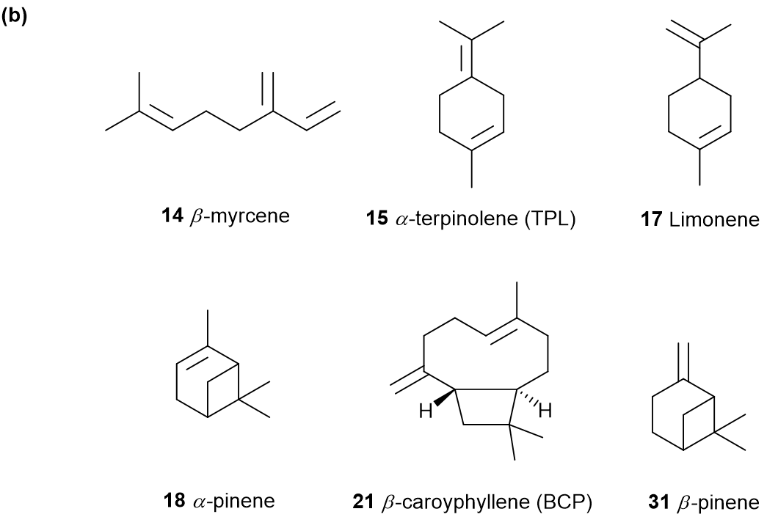  Myrcene (14) | TRPV1 | Agonist | Analgesic *
 | A2A | Agonist | Analgesic **
Limonene (17) | 5-HT-1A | Agonist | Anti-stress **  Anxiolytic **  Anti-depressant **
 | TRPA1 | Agonist | Analgesic **
 | NFκB | Inhibitor | Anti-inflammatory **, ***  Analgesic **  Colitis reduction **
 | A2A | Agonist | Not reported
 | FTase | Inhibitor | Anti-cancer **
 | MAPK NFκB | Inhibitor | Anti-inflammatory **
 | ERK/AKT | Agonist | Anti-cancer *, **
 | Virus particle  (not further specified) | Inhibitor | Anti-viral *
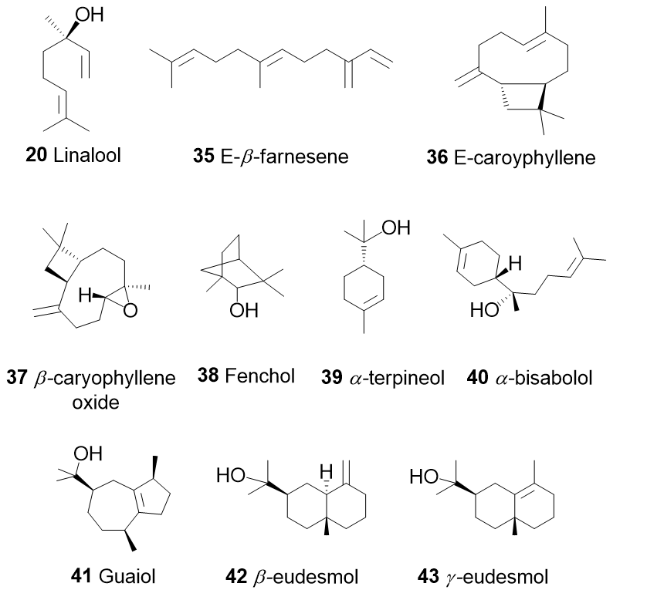  Linalool (20) | A1A | Agonist | Analgesic **
 | A2A | Agonist | Analgesic **
 | GABA-A | Agonist | Anxiolytic **
 | Cancer cell  (not further specified) | Inhibitor | Anti-cancer *, **
Caryophyllene (21)  Caryophyllene (21) | CB2 | Agonist | Analgesic **  Chemotherapy-induced peripheral neuropathy attenuation **  Anti-inflammatory**  Steatohepatitis protecting **  Metabolic dysregulation attenuation **
 | PPAR-α | Agonist | Intracellular lipid modification*  Steatohepatitis protecting*
 | PPAR-γ | Agonist | Intracellular lipid modification*  Steatohepatitis protecting*
 | MAPK | Inhibitor  Agonist | Chemotherapy-induced peripheral neuropathy attenuation **  Anti-cancer *
 | TLR4 | Inhibitor | Microglial activation inhibition **  Neuroprotective *, **  Anti-inflammatory *, **
* Pre-clinical in vitro study. ** Pre-clinical in vivo study. *** Clinical study. N.B.: This table is non-exhaustive, broadly elucidating selected compounds and some of their potential pharmacological effects currently present in the pre-clinical literature. Depending on study parameters, the compounds show differing, sometimes biphasic, affinities and effects at different targets, thus highlighting the contradictory and equivocal evidence state. Abbreviations: 5-hydroxytryptamine receptor 1A (5-HT-1A); adrenergic receptor alpha-1 (A1A); adrenergic receptor alpha- 2 (A2A); cannabinoid receptor 2 (CB2); Extracellular-regulated kinase/serine/threonine kinase (ERK/AKT); farnesyltransferase (FTase); gamma-aminobutyric acid type A receptor(GABA-A); mitogen-activated protein kinase (MAPK); Nuclear factor kappa B (NFκB); peroxisome proliferator-activated receptor alpha/gamma (PPAR- α/γ); Toll-like receptor 4 (TLR4); transient receptor potential cation channel type A1 (TRPA1); transient receptor potential vanilloid type 1 (TRPV1).

