Supporting information

1. Assessment of ChatGPT’s performance in the field of chemistry and physics for K-12 students
The real competencies of ChatGPT to mentor 15-16-years-old students learning chemistry and physics subject were assessed by careful evaluation of the AI’s answers to a set of 52 questions covering the knowledge to be acquired during a complete academic year, included in the Methodology section of the manuscript.
Preliminary tests were conducted to judge the best procedure to ask ChatGPT these questions. First, the importance of the language over the answers provided by the AI was evaluated by posing the same question in Spanish and English, and there was no conceptual difference in the answer (Figures S7 and S8). Second, the straight question asked to the AI ended up with a relatively short answer, while using a more specific prompt (“Acting as a chemistry/physics teacher, please explain…”) provided more detailed but still clear answers. As a consequence, the 52 questions were assessed by using English language and the specific prompt already mentioned.

  - A) Explain the experiment and also the atomic model proposed by Dalton, Thomson and Rutherford. B) Indicate the atomic number and atomic mass of the following atoms, ions or isotopes: ${}_{2}^{5}{He}, {}_{92}^{236}U, {{}_{15}^{31}P}^{3-}$, ${{}_{22}^{56}{Fe}}^{2+}$, ${{}_{1}^{2}H}^{1+}$, ${{}_{79}^{196}{Au}}^{3+}$, ${}_{6}^{14}C, {{}_{11}^{23}{Na}}^{1+}$. Score: 1/1
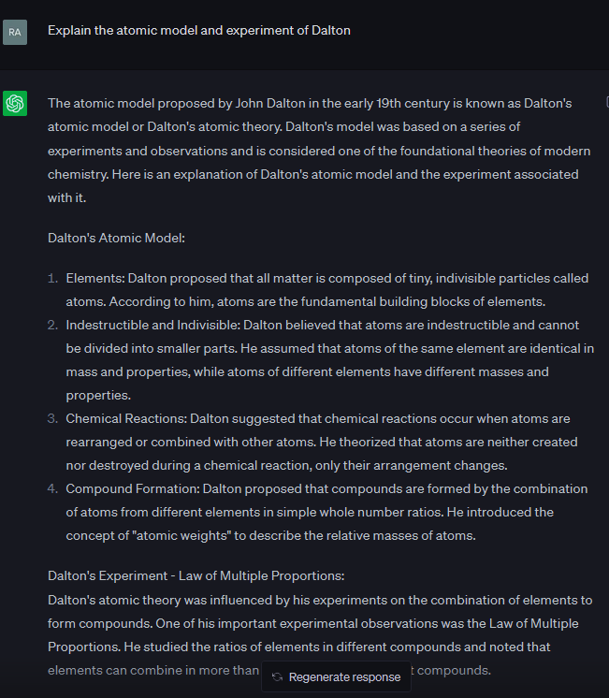
Fig. S1. Question 1a1, and the answer provided by the AI.
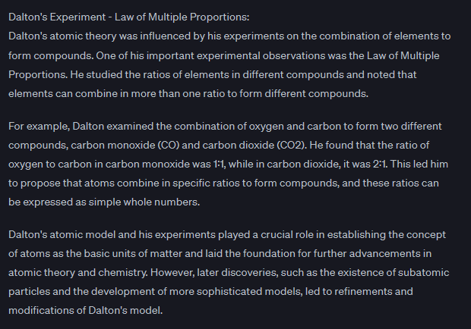
Fig. S1. Question 1a1, and the answer provided by the AI.
In this case, the AI made a clear explanation of this law and its consequences.
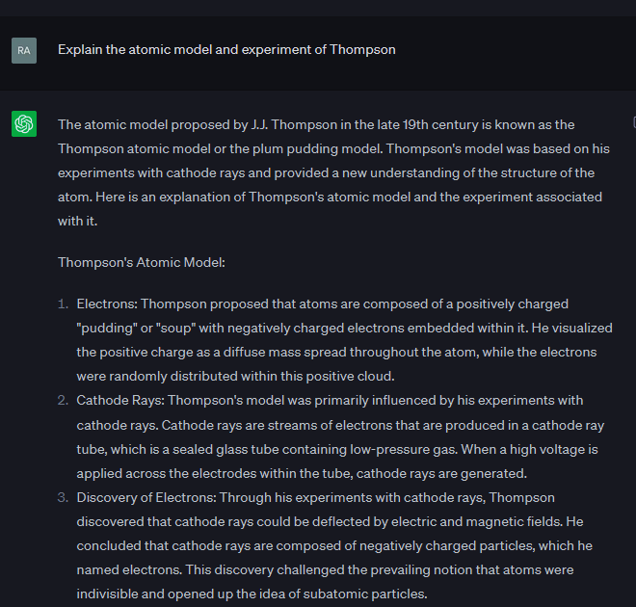
Fig. S2. Question 1a2, and the answer provided by the AI.

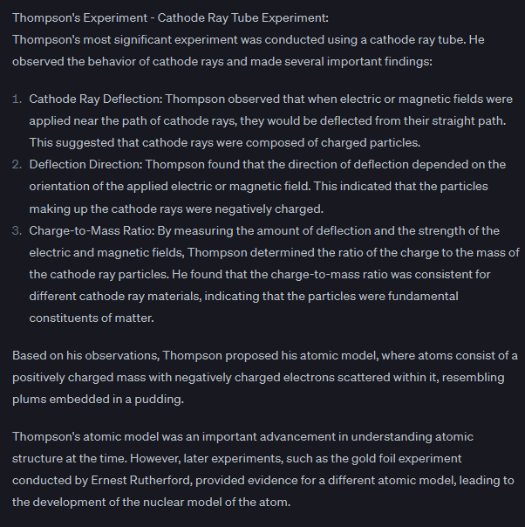
Fig. S2. Question 1a2, and the answer provided by the AI.
ChatGPT provided a simple and illustrative description of both the Thomson model and the experiment. It emphasized the two blocks of information requested by a schematic manner of presenting the information. This is quite useful for K-12 students, who might use it as a starting point to the atom studies.
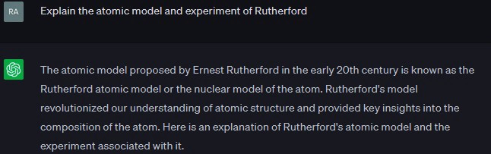
Fig. S3. Question 1a3, and the answer provided by the AI.

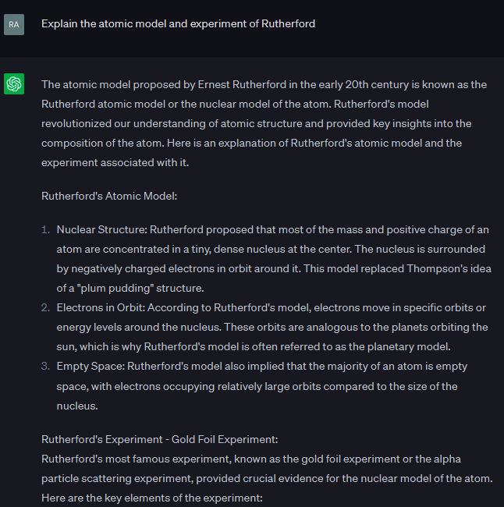
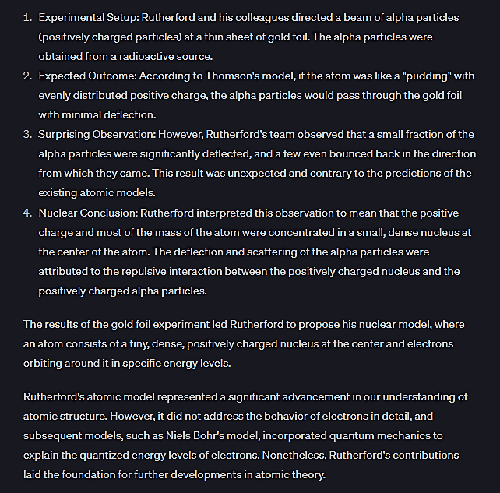
Fig. S3. Question 1a3, and the answer provided by the AI.
Once again, the AI provided a very comprehensive response including the description of the experiment. It also described how the charge of the new particles was determined in the ray through electric and magnetic fields. Its q/m ratio indicated that it was a very small particle, much more than the atom itself.
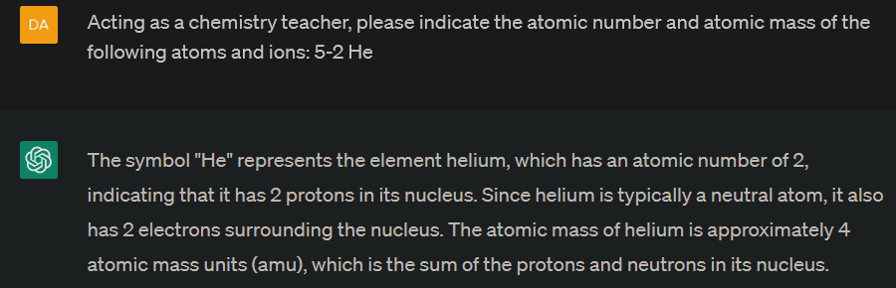
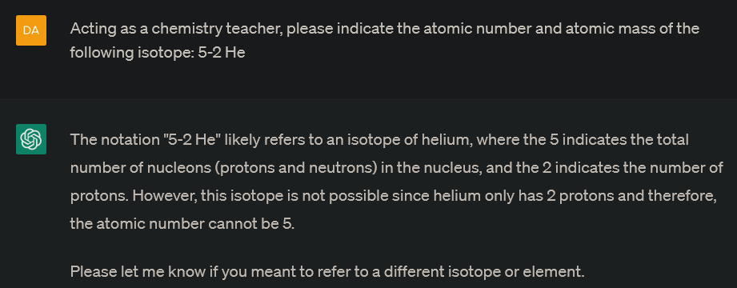
Fig. S4. Question 1b, and the answer provided by the AI.
The user must literally specify that the question deals with an isotope, otherwise it forgets about the chemical meaning of the number 5. When specifying the isotopic nature of the object of study, ChatGPT recognized 5 as the atomic mass, even if the final answer was still incorrect (concluding an atomic number of 5 was just not possible). However, ChatGPT was able to take into account the context, opening the door to receive a precise explanation of the user notation (which is not standard), guaranteeing a better solution:
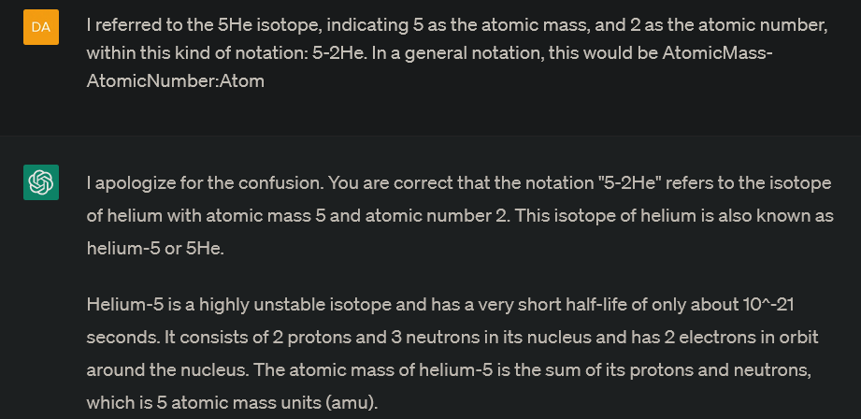
Fig. S5. Notation explanation to the AI, and the answer provided by ChatGPT.
After that, and based on the previous notation description, all the questions were tested successfully:
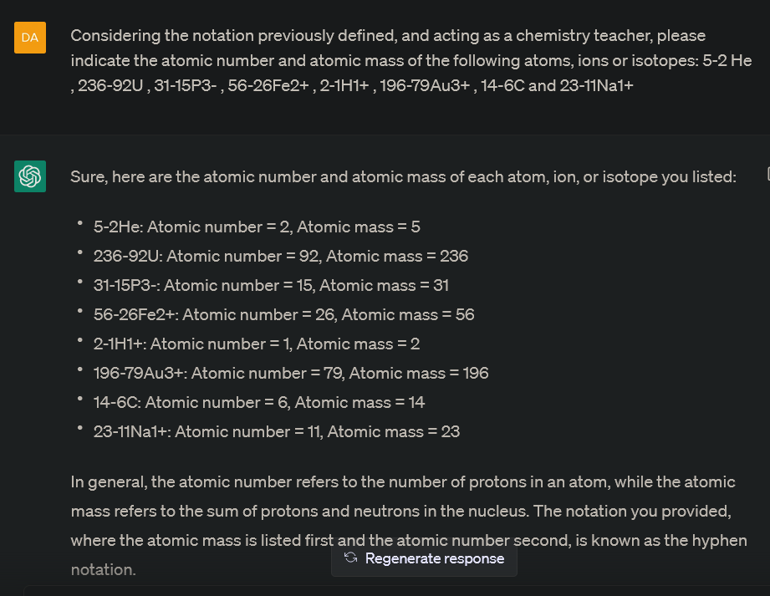
Fig. S6. Correct answer to question 1b provided by ChatGPT after notation explanation.

  - Write the electronic configuration of the following atoms or ions: C, Fe²⁺, K⁺, P, Al³⁺, Cl⁻, Ag. Score: 1/1
First question was performed in Spanish (Figure S7), and the same answer was obtained when using English (Figure S8).
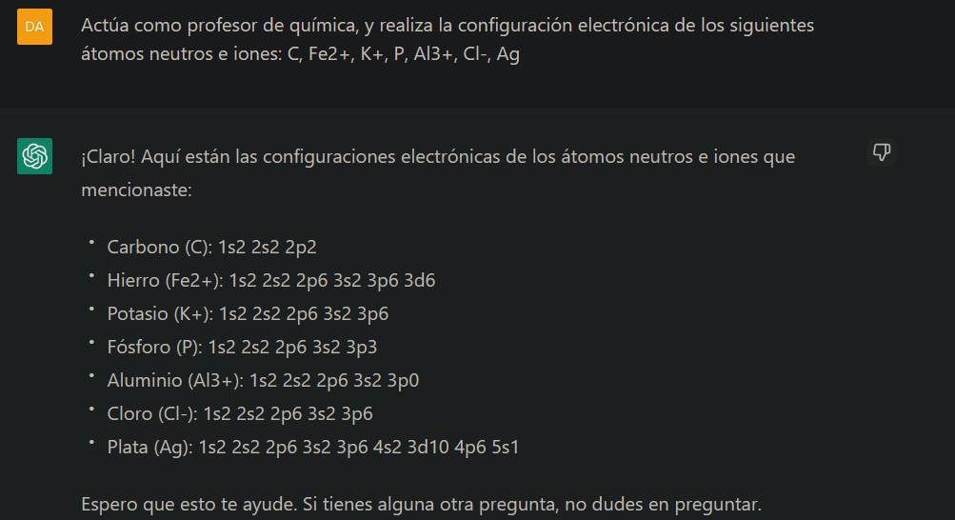
Fig. S7. Question 2 posed in Spanish, and the answer provided by the AI.
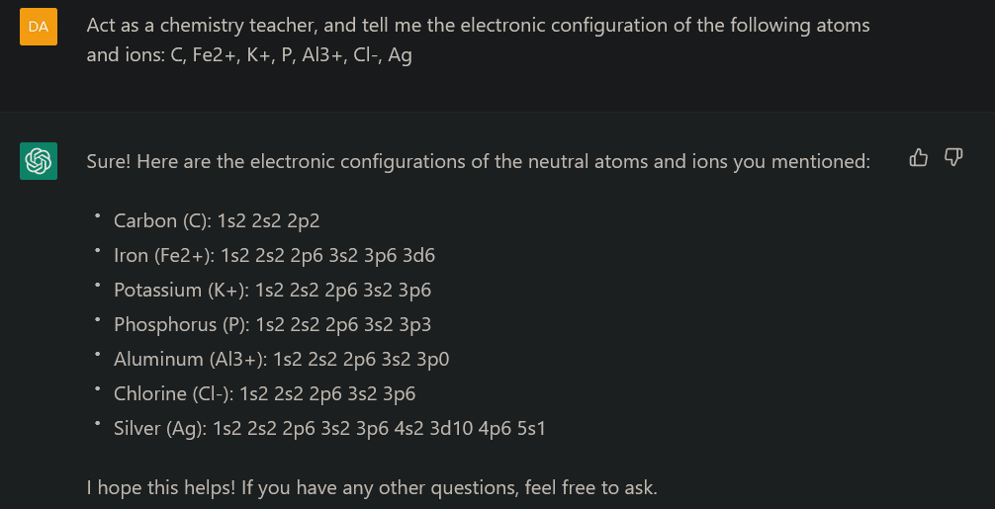
Fig. S8. Question 2 posed in English, and the answer provided by the AI.
No differences arose when using English or Spanish. In both cases, 6 of 7 electronic configurations were correct. The problem appeared with the Al³⁺ ion, whose real electronic configuration is 1s²2s²2p⁶. It is difficult to infer the origin of the problem because the configuration of a similar ion (Fe²⁺) was correctly provided by the AI, removing two electrons from the configuration of a neutral atom of Fe. Despite this, ChatGPT removed only one electron from the neutral Al atom configuration in the case of Al³⁺.
However, when requesting the AI for the electronic configuration of Al(III), see Figure S9, it understoods again Al³⁺, but this time ChatGPT answered correctly (removing three electrons from the neutral atom configuration). Surprisingly, within the same question the AI was also requested to provide the electronic configuration of another trivalent ion different from Al³⁺, which is B³⁺, and the answer was also correct (Figure S9).
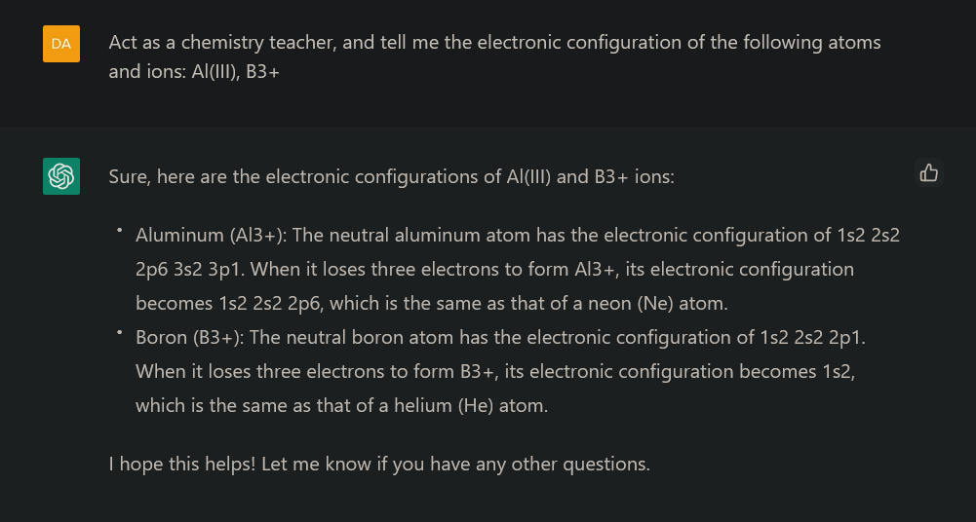
Fig. S9. Electronic configuration of Al(III), instead of Al³⁺, and that of B³⁺.
Finally, when asking for only two electronic configurations (indeed only one because it is the same ion, Al³⁺ and Al(III)), the answer was not only correct, but also better explained (Figure S10).
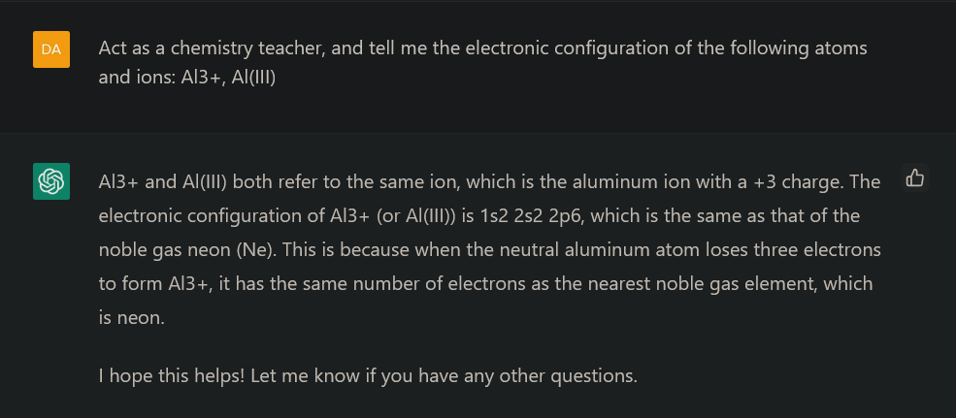
Fig. S10. Electronic configuration of Al³⁺ and Al(III).
In conclusion, it seems that ChatGPT’s answers depend on the length of the question: shorter questions usually receive more detailed answers. Besides, when the AI follows a more detailed procedure to determine the electronic configuration of an atom/ion, it provides a correct solution. Thus, a simple manner to improve the answers and look for the best performance might be dividing questions in small parts. This way, ChatGPT’s performance raised from 86 % (6/7) to 100 % (7/7).
Besides, the problem was corrected within the last update (ChatGPT 4.0 version 3), Figure S11, as it directly provided correct solutions for all of the atoms/ions, following a simple procedure of describing first the electronic configuration of the neutral atom, and then that of the requested or even potential ion.
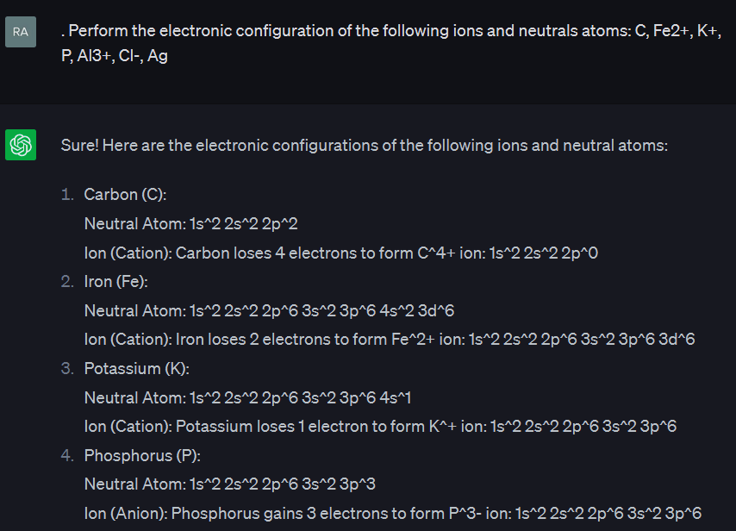
Fig. S11. Electronic configuration of the atoms and ions requested to ChatGPT (GPT-4)in question 2.
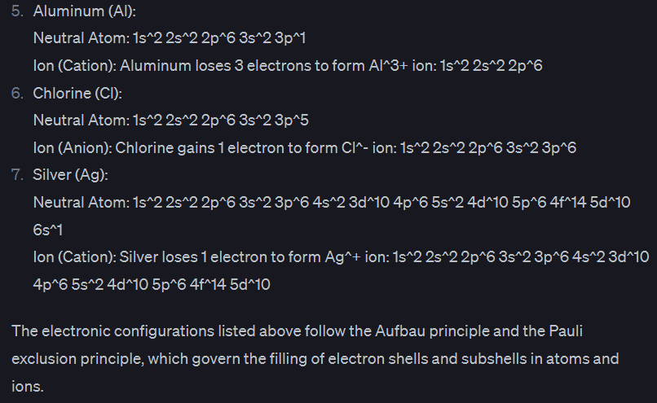
Fig. S11. Electronic configuration of the atoms and ions requested to ChatGPT in question 2.
Finally, the answer is quite useful to K-12 students as it made reference to Aufbau´s and Pauli’s Principles, which students should understand to reach the correct answer.

  - Correct the following incorrect electronic configurations: a) 1s² 1p² ; b) 1s² 2s² 2p⁶ 2d⁵ ; c) 1s² 2s³ 2p⁵ ; d) 1s² 2s² 2p⁸ . Score: 1/1
As there are 4 configurations in the exercise, each one was separately requested to ChatGPT.
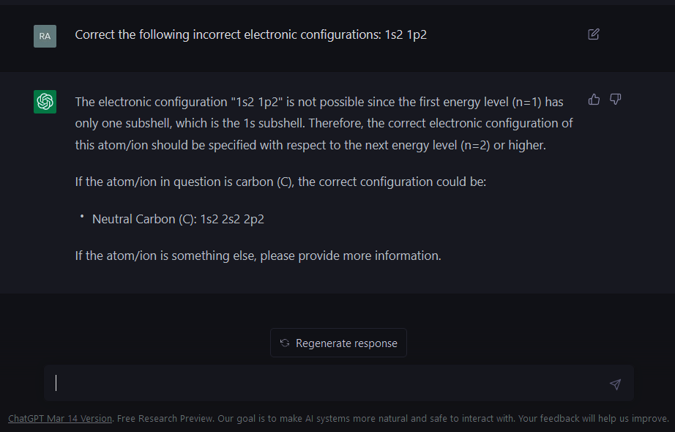
Fig. S12. Question 3a, and the answer provided by the AI.
ChatGPT recognized there is a problem underneath the question, which is the multiple manners of correcting the electronic configuration (whether fixing the atomic number, or the last orbital with electrons, as correct). Despite this, the chatbot pointed out the problem (there is no 1p subshell), and demonstrated proactivity, offering a valid alternative assuming the last subshell should be p2, which is a good solution.
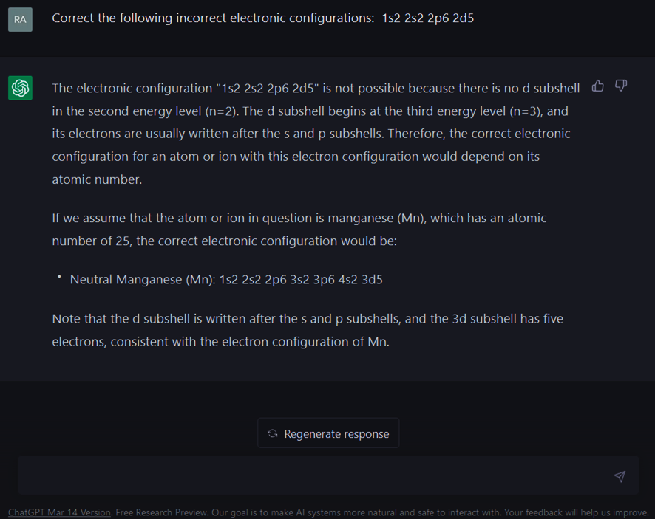
Fig. S13. Question 3b, and the answer provided by the AI.
Then, the AI identified again the problem (there is no 2d subshell), and suggested 3d as the last occupying subshell, with five electrons, leading to Z=25 (Manganese atom) as a valid solution.
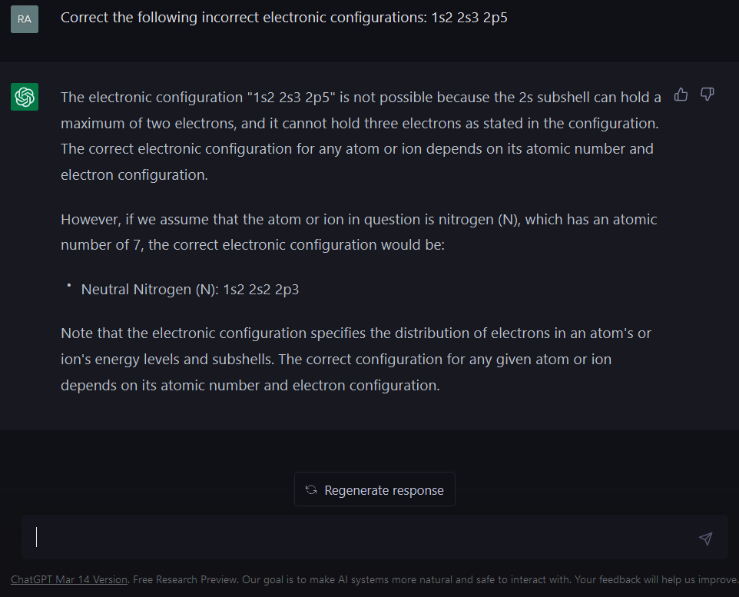
Fig. S14. Question 3c, and the answer provided by the AI.
Once more, ChatGPT pointed out the problem: surpassing a maximum of 2 electrons in the 2s subshell. However, the AI in this case removed the extra electron in the 2s subshell, but surprisingly provided a solution changing the number of the final subshell suggested (2p5) to 2p3, corresponding to Nitrogen. Despite this unforeseen variation, these differences probe the exercise might be correctly solved in several ways, which is quite useful to K-12 students.
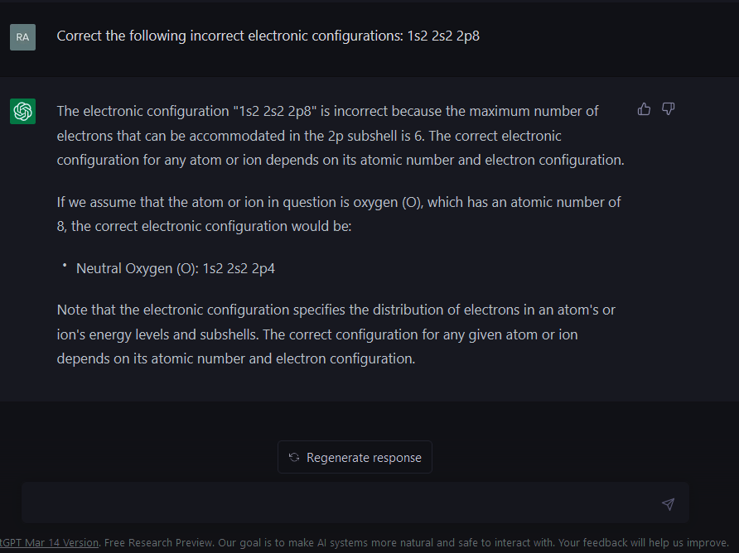
Fig. S15. Question 3d, and the answer provided by the AI.
Again, ChatGPT first identified the trouble: surpassing a maximum of six electrons in the 2p subshell. Among the different possibilities, the chatbot suggested a valid solution counting on four electrons in the last subshell.

  - Indicate which of the following elements belong to the same chemical group: a) 1s² ; b) 1s² 2s² 2p⁶ 3s² 3p³ ; c) 1s² 2s¹; d) 1s² 2s² 2p⁶ 3s² 3p⁵ ; e) 1s² 2s² 2p³; f) 1s² 2s² 2p⁶ 3s² 3p⁶ 4s² . Score: 1/1
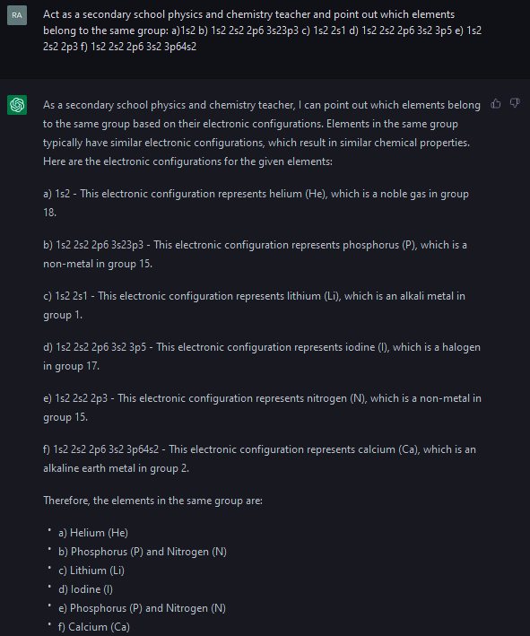
Fig. S16. Question 4, and the answer provided by the AI.
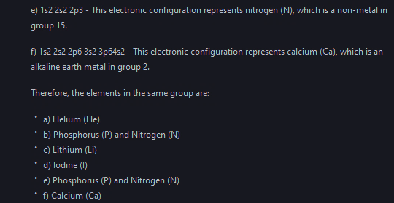
Fig. S16. Question 4, and the answer provided by the AI.
Even if this question (including several parts) was directly asked to ChatGPT, the results were satisfactory, as the electronic assignations were correct, as well as the assignment of elements in the same group, which is very didactic for K-12 students.

  - Explain which element (in each group) will display a bigger radius and which will be more active: a) Al, Mg and Na; b) Cl, P and S; c) Ca, Sr and Mg; d) S, Se and O. Score: 1/1
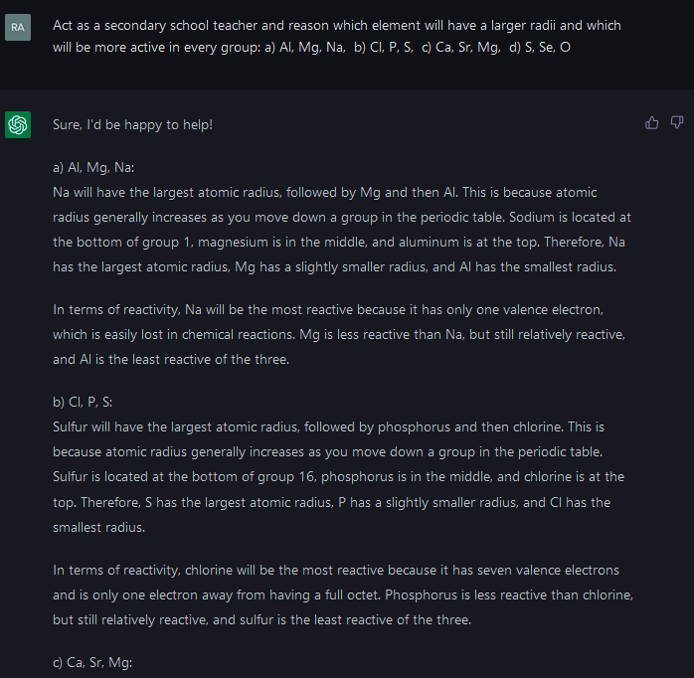
Fig. S17. Question 5, and the answer furnished by the AI.
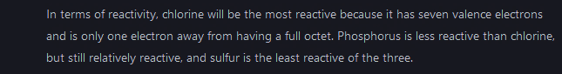
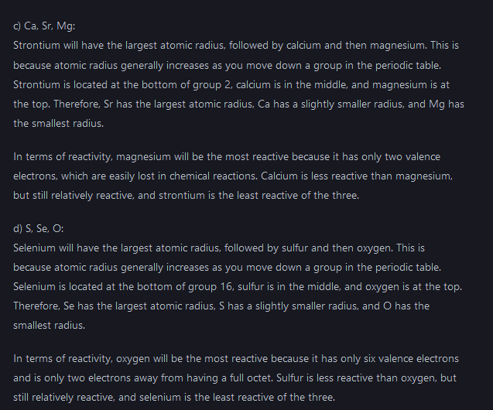
Fig. S17. Question 5, and the answer furnished by the chatbot.
This exercise allowed testing how ChatGPT handled with periodic properties, which are the direct consequence of electronic configurations. Regretfully, the AI only took into account the differences arising from elements within the same group, and not within the same period. Therefore, the answers were not correct (but the radius in c and d cases) and K-12 students might get confused with this explanation. The answer might also consider the differences arising between elements of the same period, involving the influence of the nuclear charge pull, and also some explanations about the shielding effect of the nuclear charge suffered from outer electrons.
However, this has been corrected in 2024, displaying correct and clear answers in all cases, justifying them with chemical criteria.
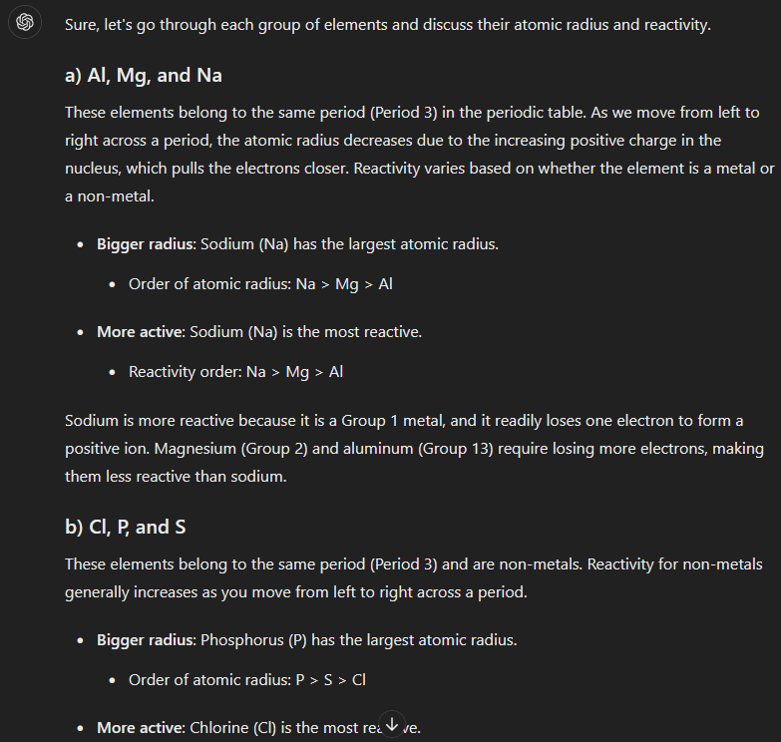
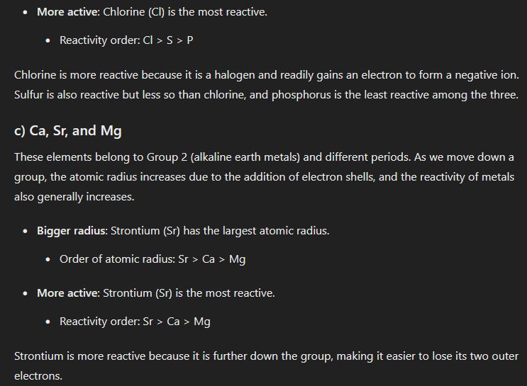
Fig. S17b. Question 5, and the answer furnished by the chatbot in 2024.

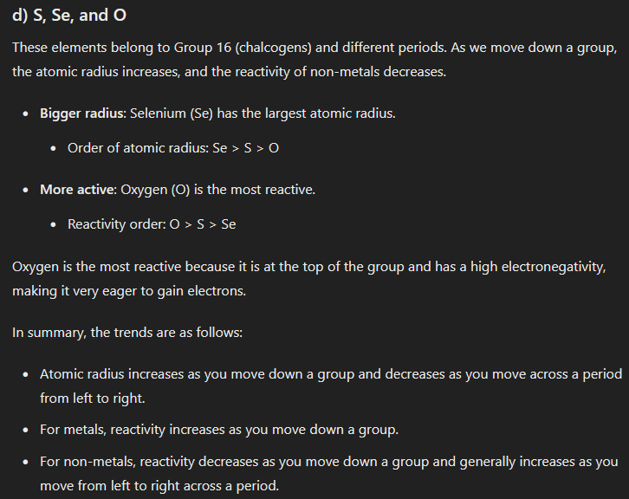
Fig. S17b. Question 5, and the answer furnished by the chatbot in 2024.

  - A sulfur crystal is made of S₈ octa-atomic structures. a) Which force will be stronger, either the intramolecular (between the atoms building up one S₈ molecule) or the intermolecular (between several S₈ structures) one? b) Why a set of intermolecular S₈ structures can be considered a “giant molecule”? Score: 1/1

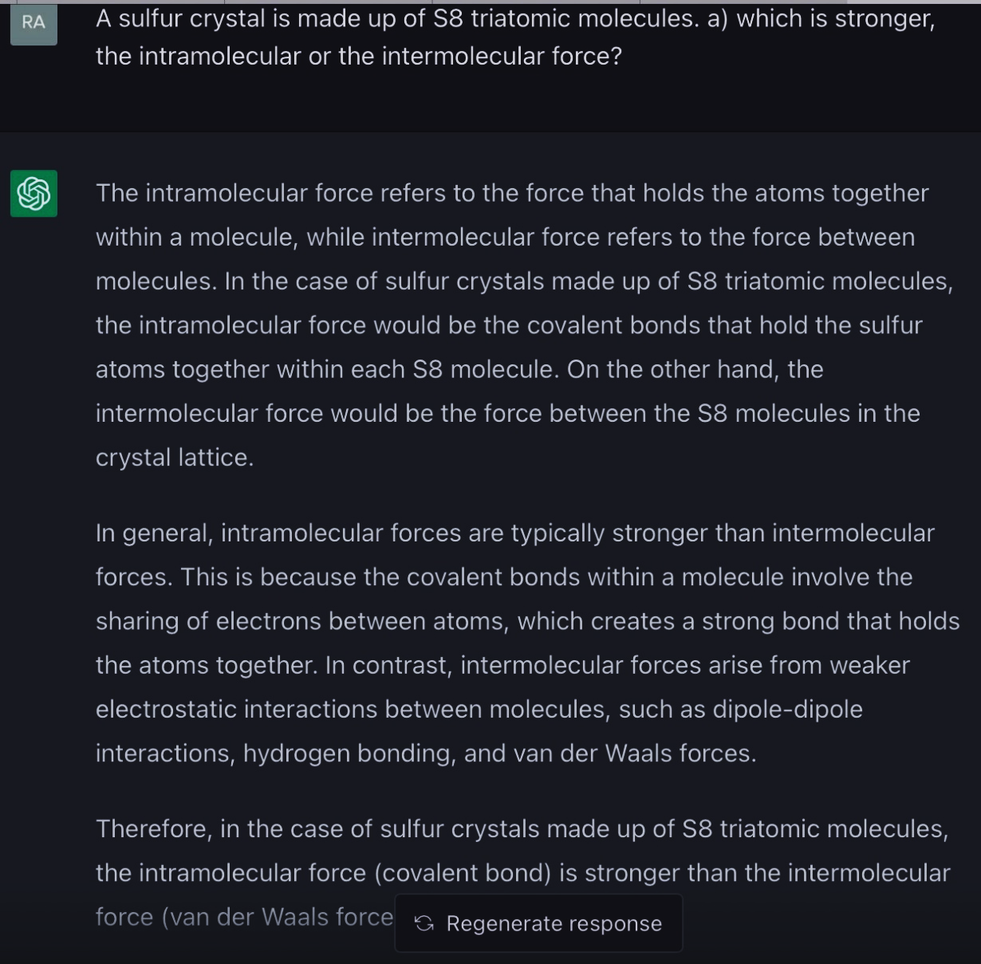
Fig. S18. Question 6a, and the answer provided by the AI.
In this case, ChatGPT correctly explained the relative intensity of the forces inside and outside the molecule (intramolecular vs. intermolecular forces), so the answer was correct. Despite this, there was an astonishing mistake dealing with language: the answer referred to S8 “triatomic” molecules, when they are obviously made of 8 atoms, that is, octatomic molecules. Anyhow, the answer was correct apart from this minor error, which was by the way corrected by GPT-4 version.
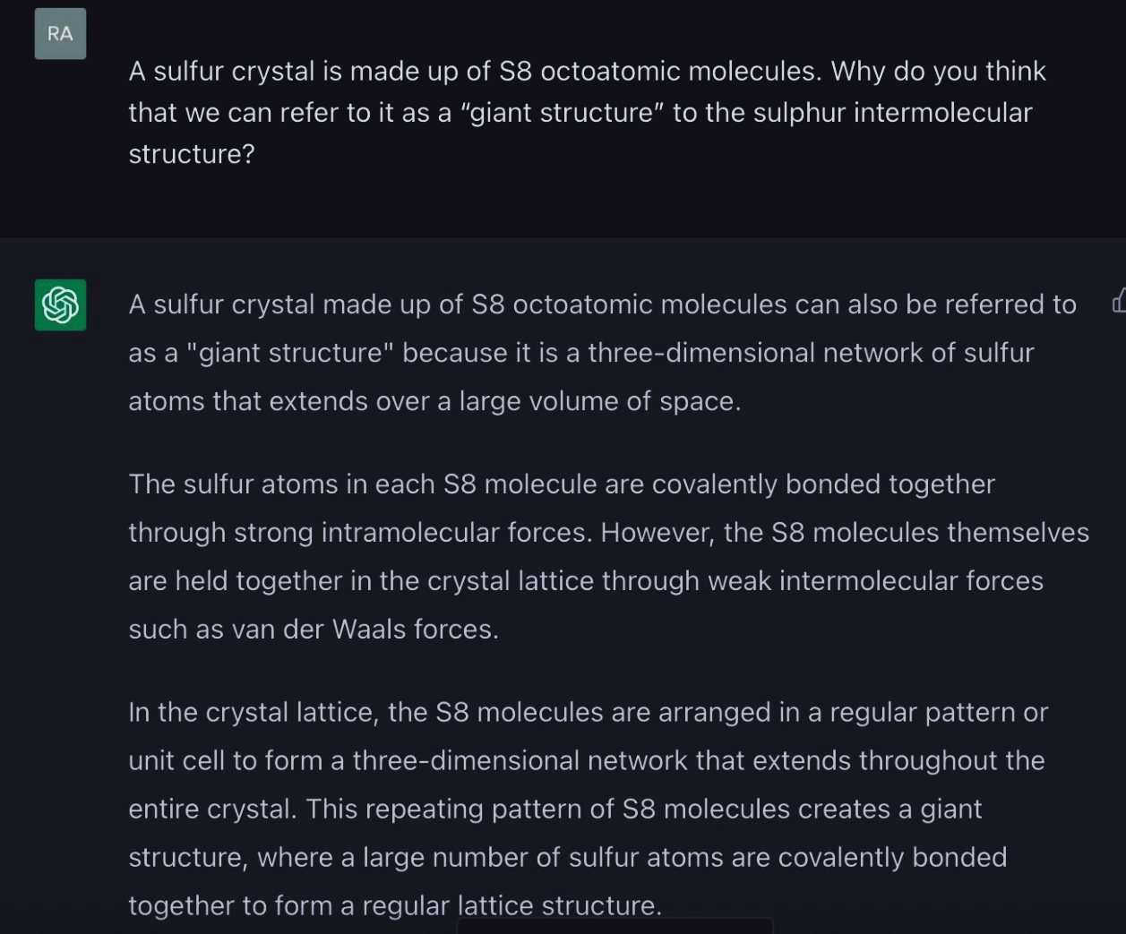
Fig. S19. Question 6b, and the answer provided by the AI.
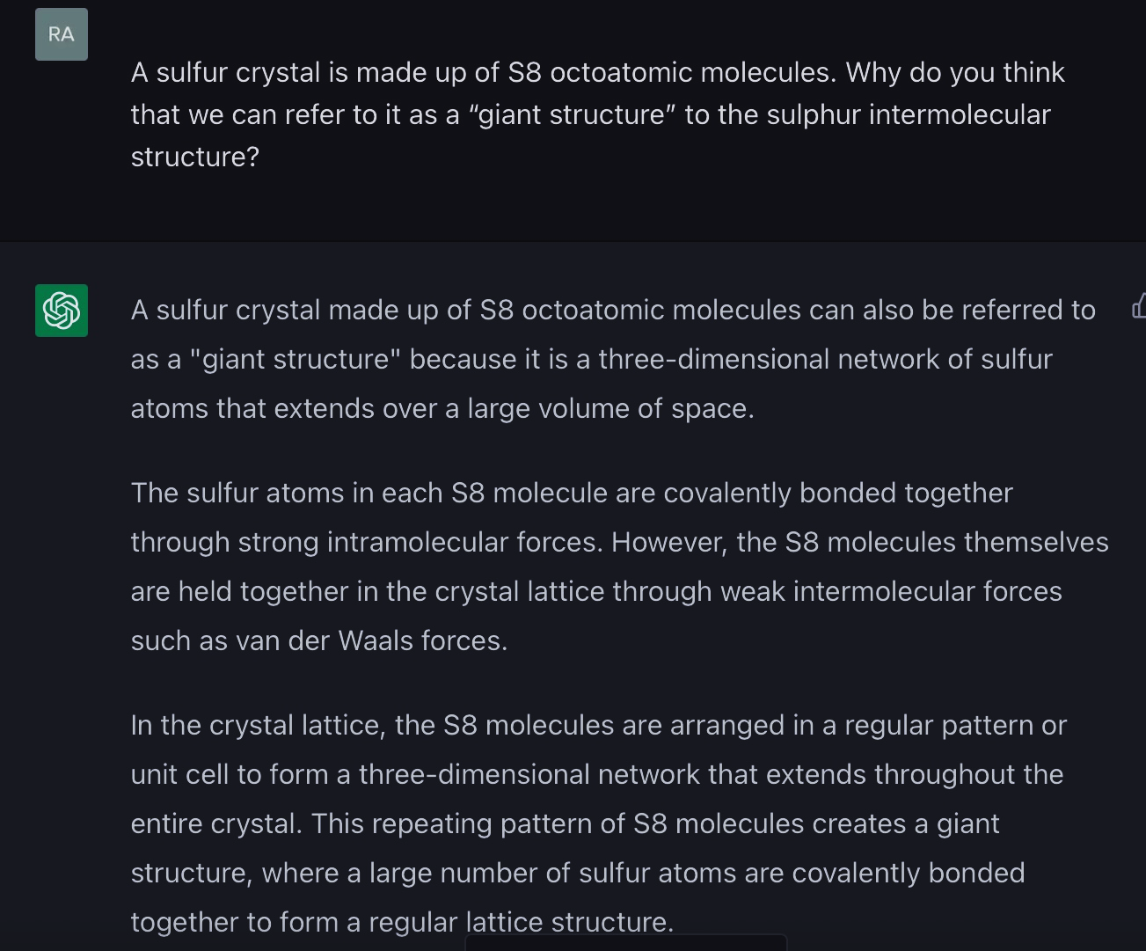
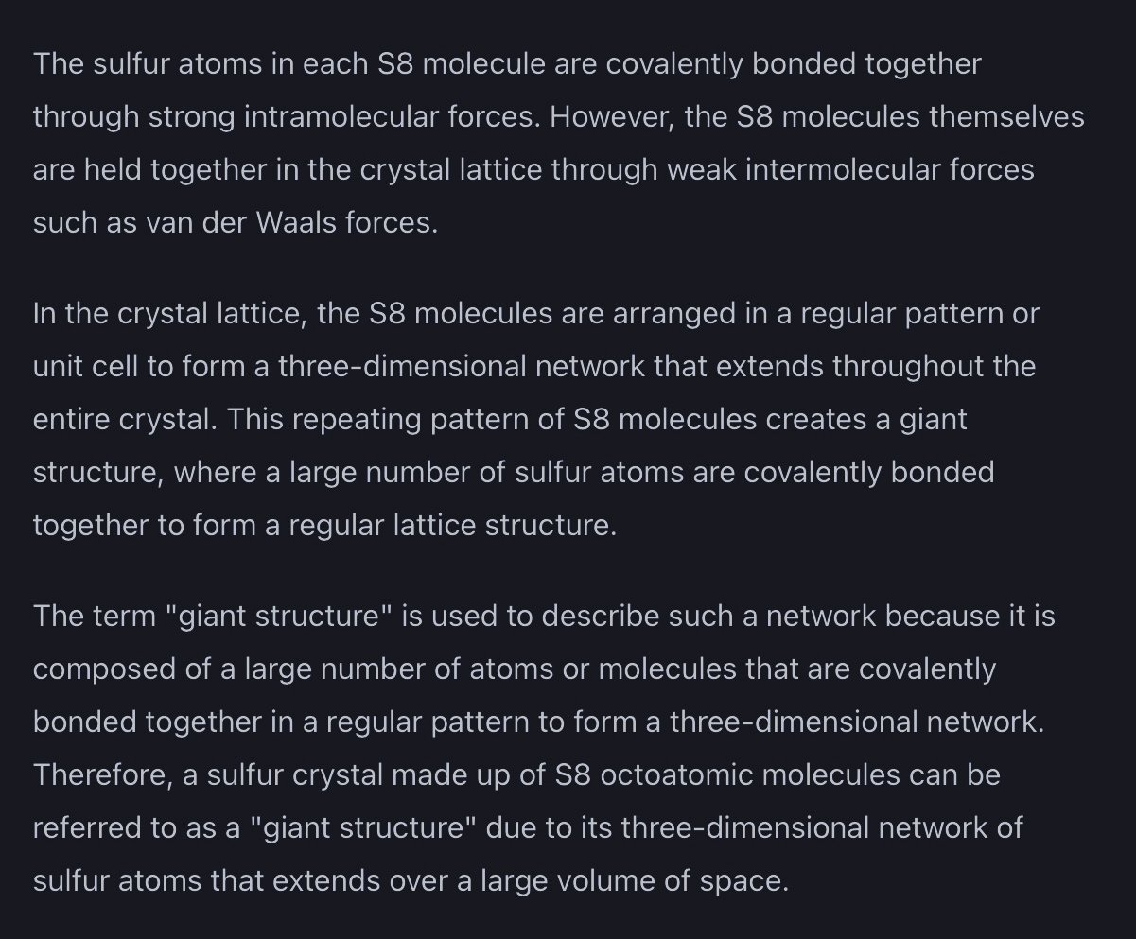
Fig. S19. Question 6b, and the answer returned by the AI.
The answer was not only simple and correct, but also very useful to K-12 students as it related covalent bonding, intra and intermolecular forces, and lattice arrangement.

  - Copper, as many other metals, can conduct electricity. a) What does this phenomenon suggest concerning the mobility of valence electrons, taking into account the metallic bonding model. b) Why NaI (solid) does not present electric conductivity though its constituents are electrically charged particles (ions)? Score: 1/1

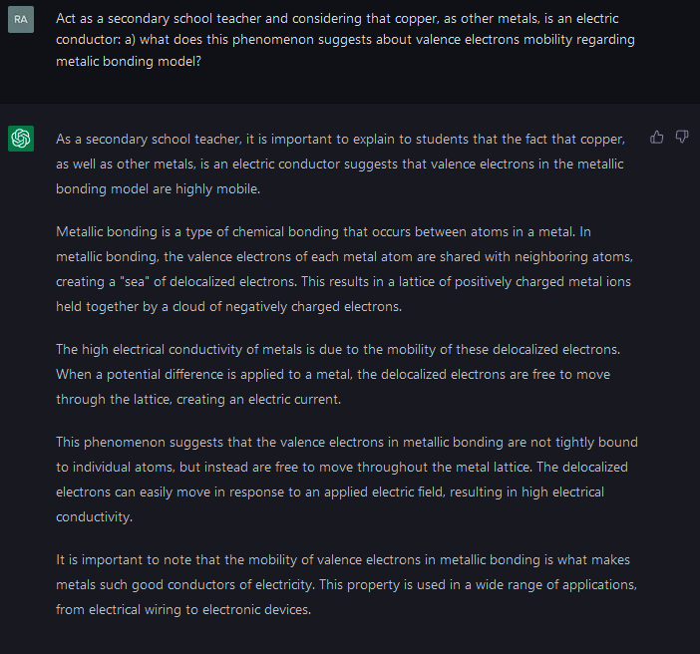
Fig. S20. Question 7a, and the answer provided by ChatGPT.
The answer concerning the electric conductivity of some metallic material, copper in this example, was quite visual and valid for K12 students.
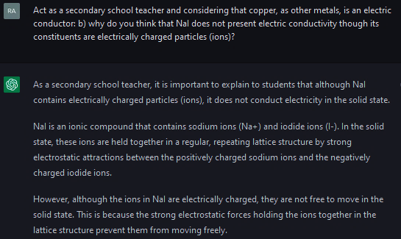
Fig. S21. Question 7b, and the answer provided by ChatGPT.
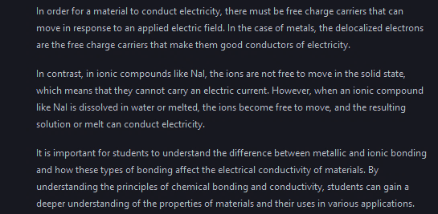
Fig. S21. Question 7b, and the answer provided by ChatGPT.
These questions concerning the electric conductivity of ionic substances were quite explanatory and provided a final remark regarding the understanding the principles of chemical bonding and reactivity.
  - Discuss if the following sentences are true or false: a) Ionic crystals are electric conductors; b) The melting point of ionic compounds is usually high; c) Ionic compounds form molecules. Score: 1/1
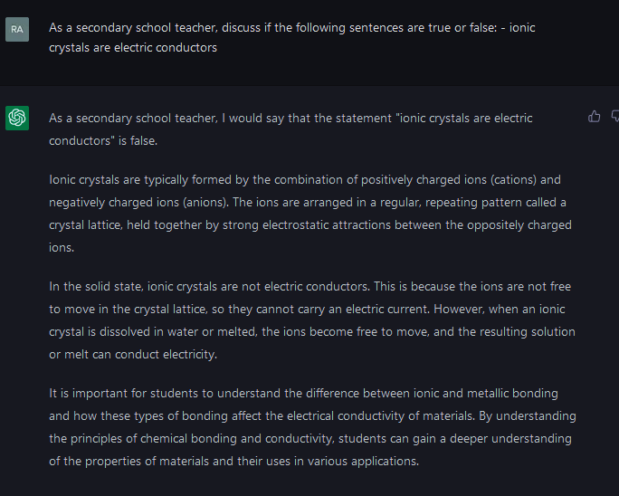
Fig. S22. Question 8a, and the answer provided by ChatGPT.

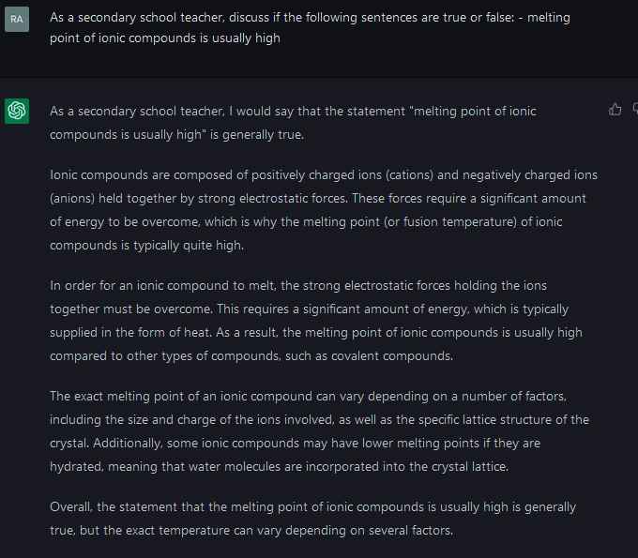
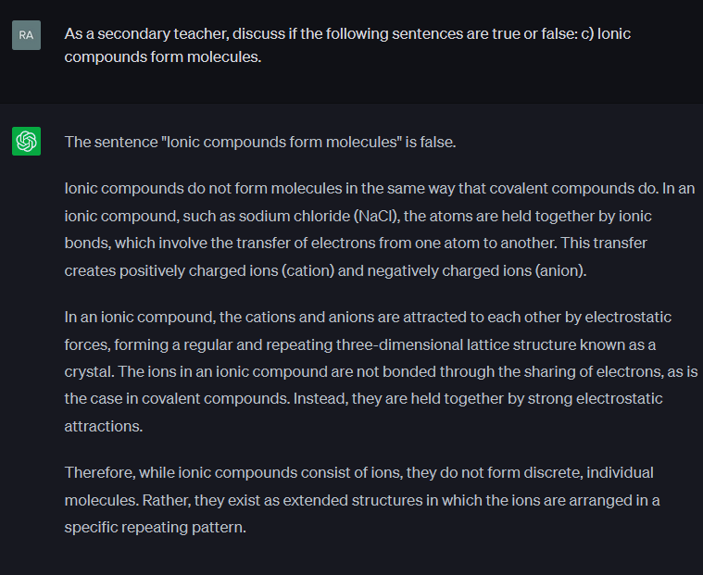
Fig. S23. Questions 8b and 8c, and the answer returned by ChatGPT.
All these answers provided basic principles of ionic substances properties as electric conductivity, melting point, or the nature of extended lattices, which is quite profitable for K-12 students.
  - Draw and explain Lewis diagrams of the following molecules: a) Cl₂; b) H₂O; c) NH₃. Score: 0.33/1
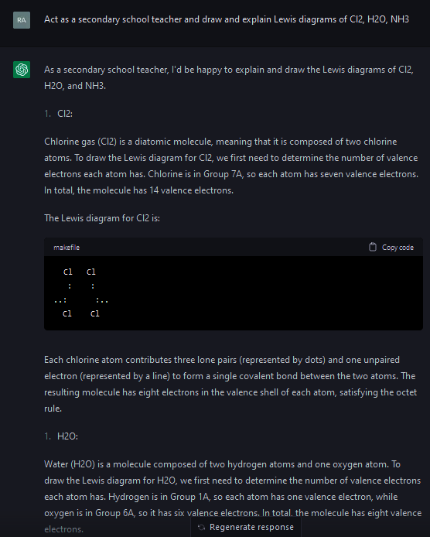

Fig. S24. Question 9, and the answer furnished by the AI in 2023.

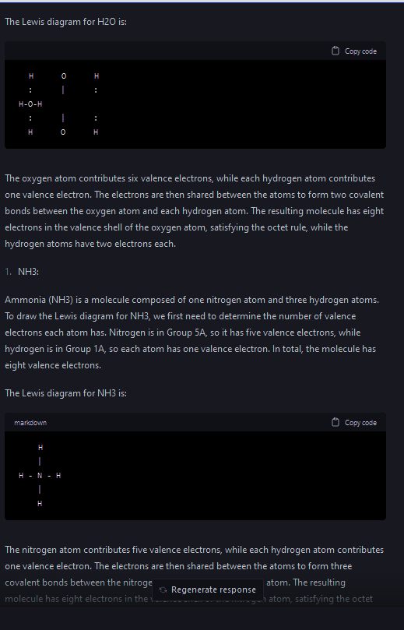
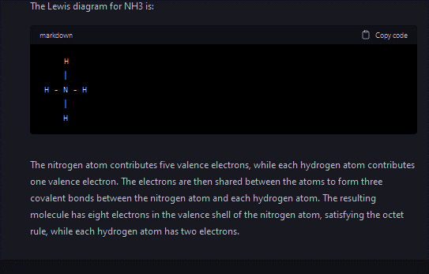
Fig. S24. Question 9, and the answer provided by the AI in 2023.
In this answer, ChatGPT showed one of its current weaknesses, which is the limited ability to turn image feedback. Despite this, the AI tried to add some drawings (that were not correct), and also included textual descriptions of the Lewis diagrams which were correct but might be improved in order to be more didactic.
However, the same question was better answered in 2024 (more organized, clearer and correct textual descriptions of what should look like the Lewis diagram, and how it can be obtained). Regretfully, only one image of the Lewis diagrams was totally correct (that of NH₃), which might drive students to certain confusion. Thus, only one third of the question is correct.
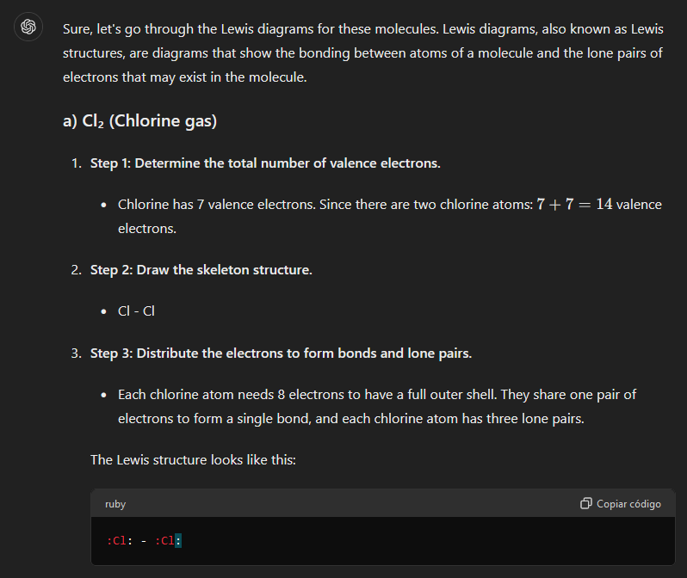
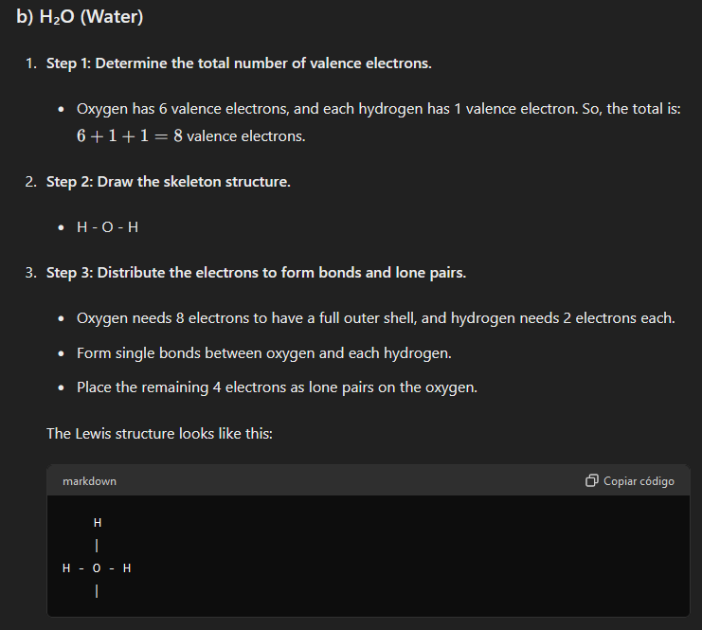
Fig. S24b. Question 9, and the answer provided by the AI in 2024.
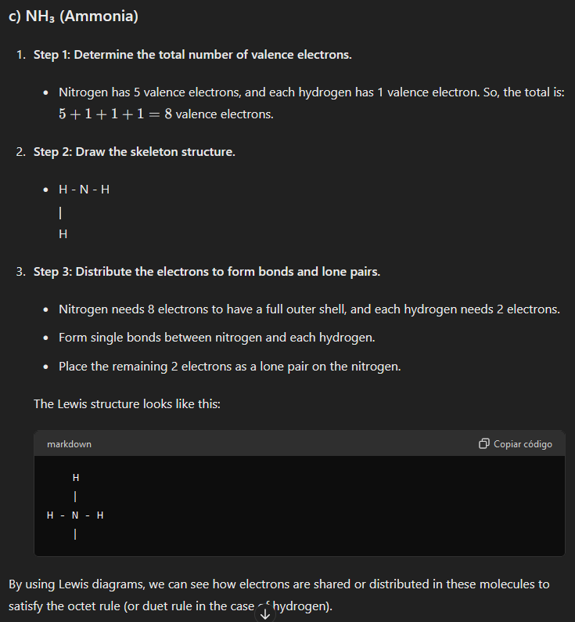
Fig. S24b. Question 9, and the answer provided by the AI in 2024.

  - Predict the geometry of the following molecules attending to their polarity: a) H₂O (polar); b) CO₂ (non-polar). Score: 1/1
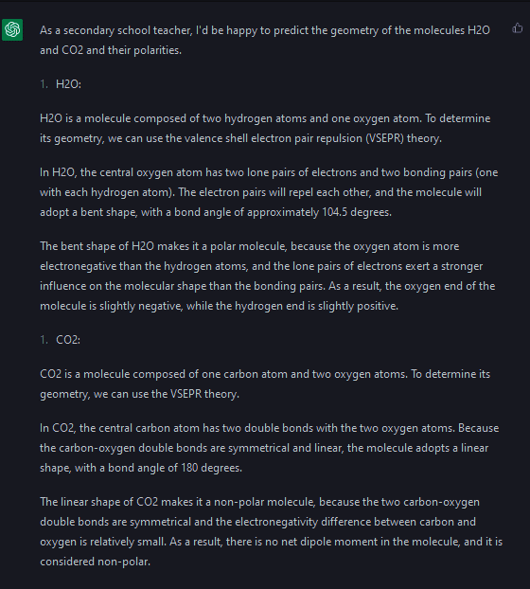
Fig. S25. Question 10, and the answer provided by the chatbot.
ChatGPT determined the geometry of two simple molecules such as H₂O and CO₂ and provided satisfactory explanations for K-12 students.

  - Explain the difference between dipole-dipole forces and dispersion forces. Score: 1/1
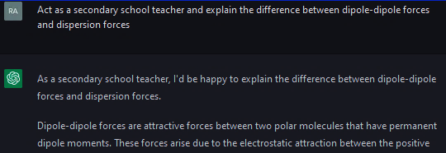
Fig. S26. Question 11, and the answer provided by the chatbot.
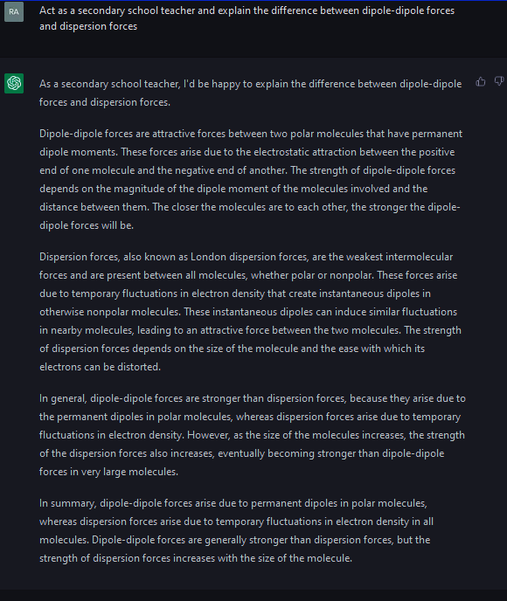
Fig. S26. Question 11, and the answer provided by the chatbot.
The AI disclosed in this answer the nature of both dipole-dipole and dispersion forces, providing very useful explanations for K-12 students.

  - Classify the following substances in increasing order of boiling point and justify your answer: a) N₂ (g), NO (g), O₂ (g); b) CCl₄ (l), Cl₂ (g), HCl (g), N₂ (g). Score: 1/1
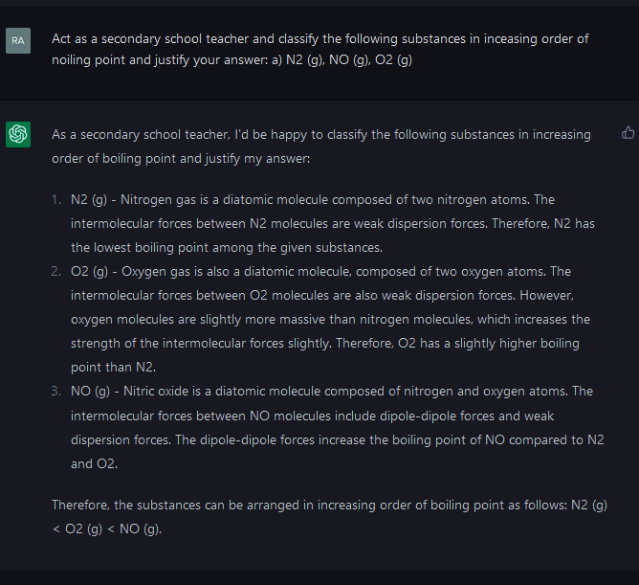
Fig. S27. Question 12a, and the answer provided by ChatGPT.
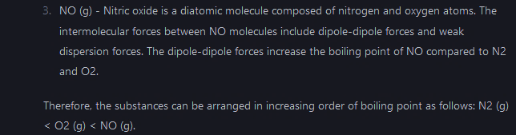
Fig. S27. Question 12a, and the answer provided by ChatGPT.
The answer was not only correct, but also explained in detail, balancing intermolecular forces of different types and molecular mass.
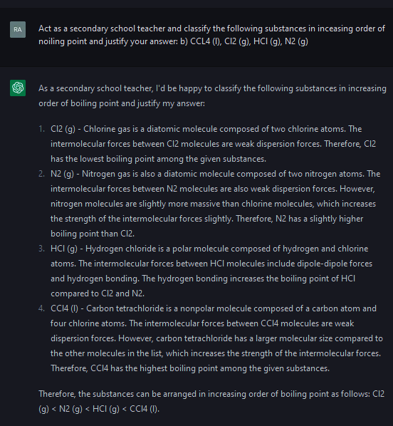
Fig. S28. Question 12b, and the answer provided by ChatGPT.
In this case, there was a mistake assuming N₂ is “slightly more massive than chlorine molecules”, thus the order was not correct, being N₂ < Cl₂.
This question was reformulated to ChatGPT using GPT-4 model, and it provided a better answer (Figure S29).
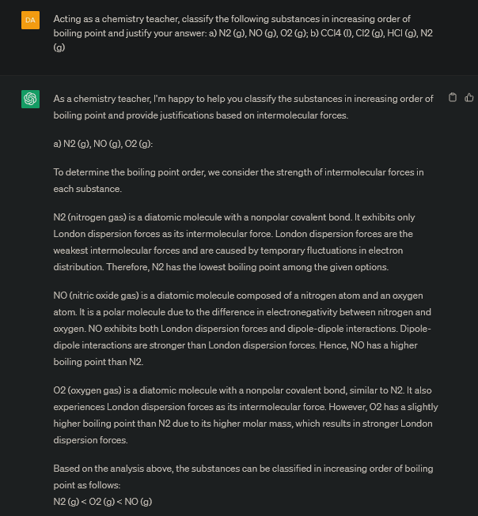
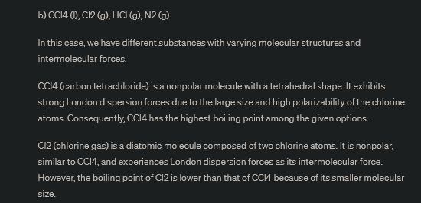
Fig. S29. Question 12, and the answer provided by ChatGPT with GPT-4 model.

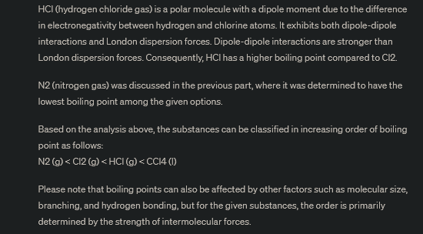
Fig. S29. Question 12, and the answer returned by ChatGPT with GPT-4 model.
  - Explain why ethanol is water soluble. Score: 1/1
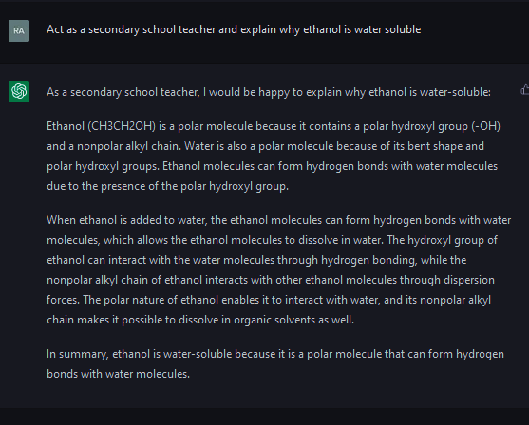
Fig. S30. Question 13, and the answer provided by the chatbot.
ChatGPT offered an answer focused on hydrogen bonding between ethanol and water molecules, which is a suitable explanation for K-12 students.
  - Explain why the electric resistance of an electric conductor usually increases with temperature. Score: 1/1
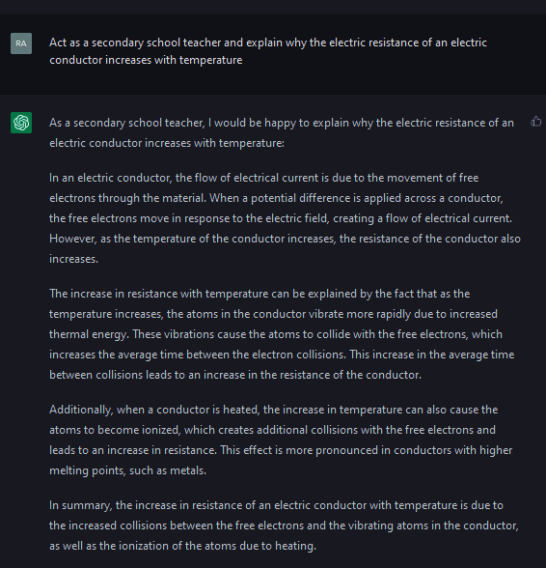
Fig. S31. Question 14, and the answer furnished by the AI.
The AI explained the influence of temperature on the electric resistance of an electric conductor as a consequence of the increase in vibrational effects. It is an adequate explanation for K-12 students.
  - Discuss the meaning of the following chemical equations: a) S (s) + H₂ (g) H₂S (g) ; b) H₂ (g) + O₂ (g) H₂O₂ (l) ; c) CaCO₃ (s) ---- CaO (s) + CO₂ (g). Score: 1/1
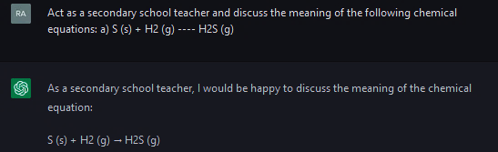
Fig. S32. Question 15a, and the answer provided by the AI.

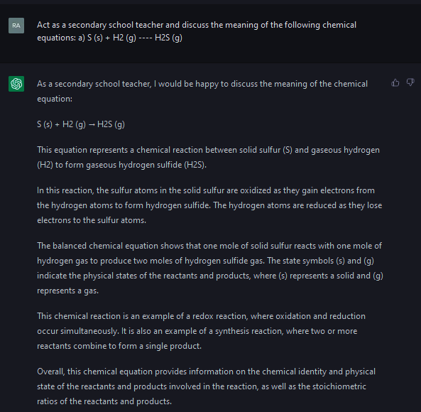
Fig. S32. Question 15a, and the answer provided by the AI.
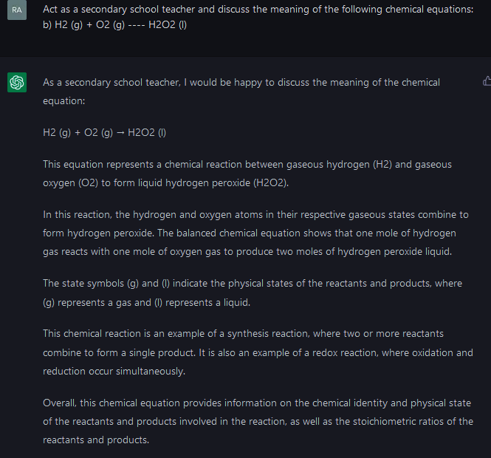
Fig. S33. Question 15b, and the answer provided by the chatbot.
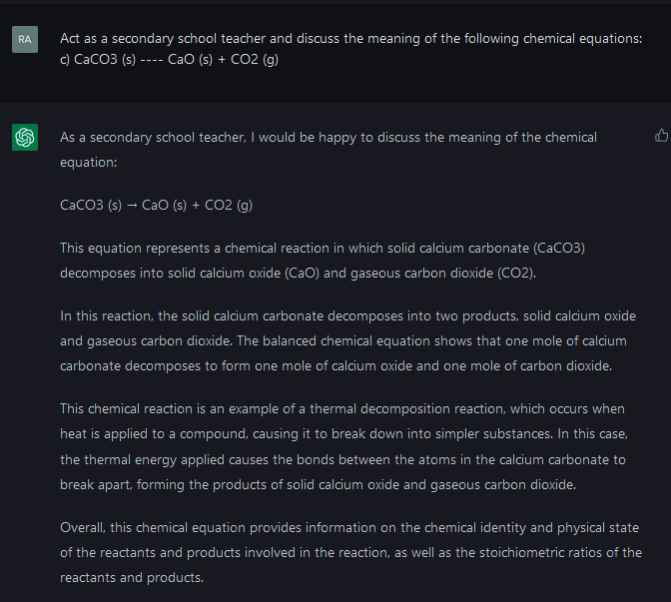
Fig. S34. Question 15c, and the answer provided by ChatGPT.
The chatbot provided a very clear explanation of what a chemical equation is, pointing out the type of chemical reaction (formation, a), and b); decomposition, c)), and the names and physical state of the chemical species involved, which is a very useful material for K-12 students.
  - Point out if the following events imply physical changes, justifying your answer: a) Modifying a piece of play dough; b) Heating milk in a pot; c) Cutting a carton piece with a scissors; d) Burning a piece of paper. Score: 1/1
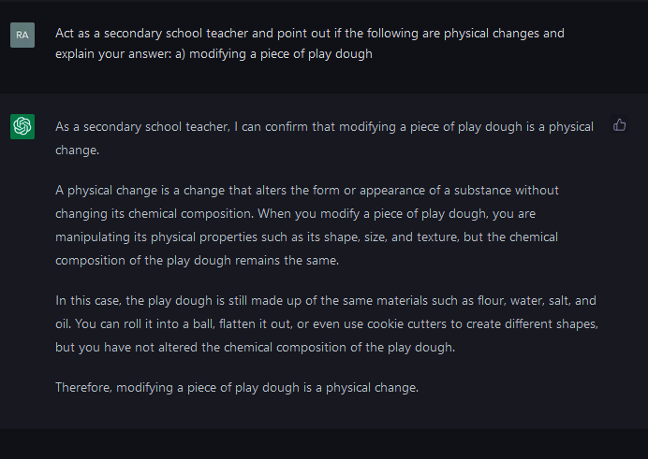
Fig. S35. Question 16a, and the answer provided by the AI.

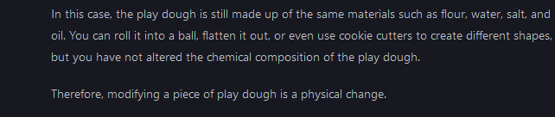
Fig. S35. Question 16a, and the answer provided by the AI.
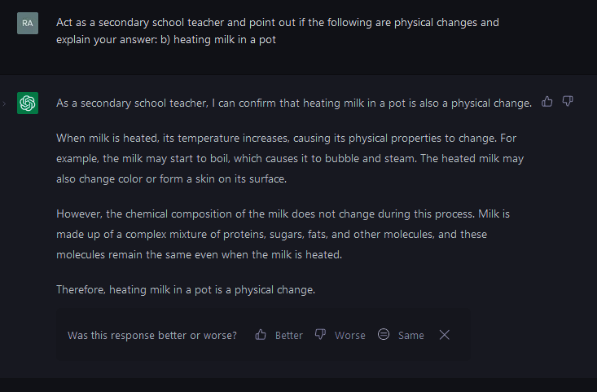
Fig. S36. Question 16b, and the answer provided by the AI.
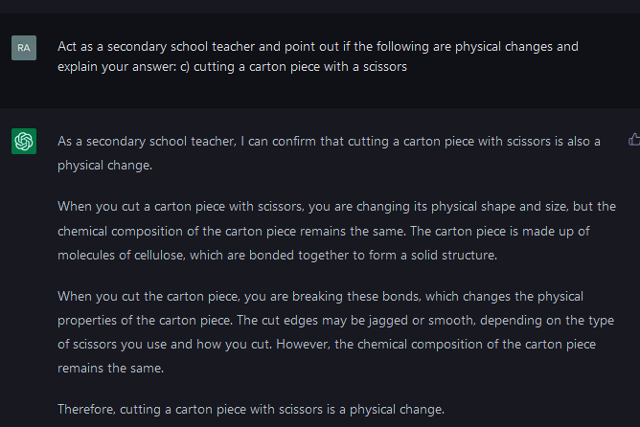
Fig. S37. Question 16c, and the answer provided by the AI.
The AI was again very skilled solving descriptive exercises, in this case explaining the differences between chemical and physical changes.

  - It is experimentally established that 73g of HCl react exactly with 100g CaCO₃. What is the total mass of reactants before the reaction? What is the total mass of products at the end of the reaction? Point out the CO₂ mass produced if the mass of the rest of the products is 129g. Score: 1/1
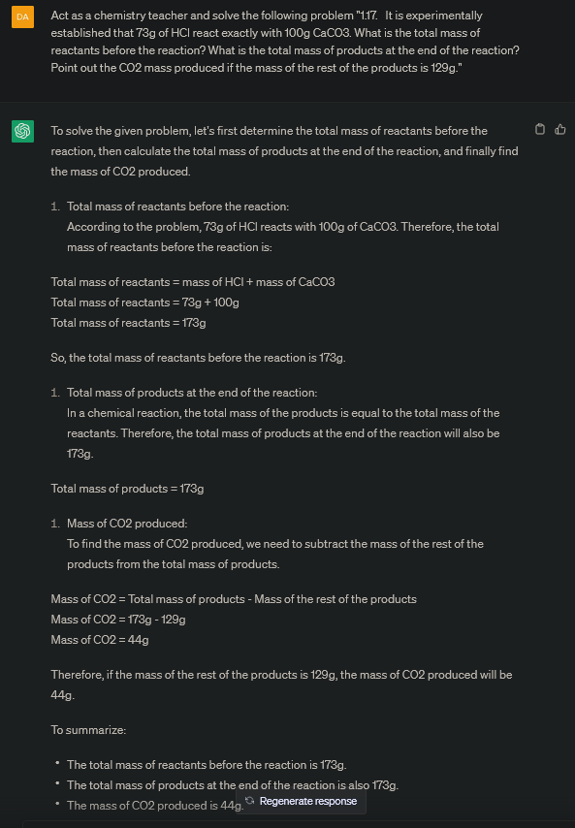
Fig. S38. Question 17, and the answer provided by the chatbot.
The AI did not make any reference to the law of conservation of mass but applied it nicely.
  - Explain if all the collisions between molecules induce the breaking of their bonds. Besides, describe the relationship between the energy of the molecules and the effective collisions. Score: 1/1
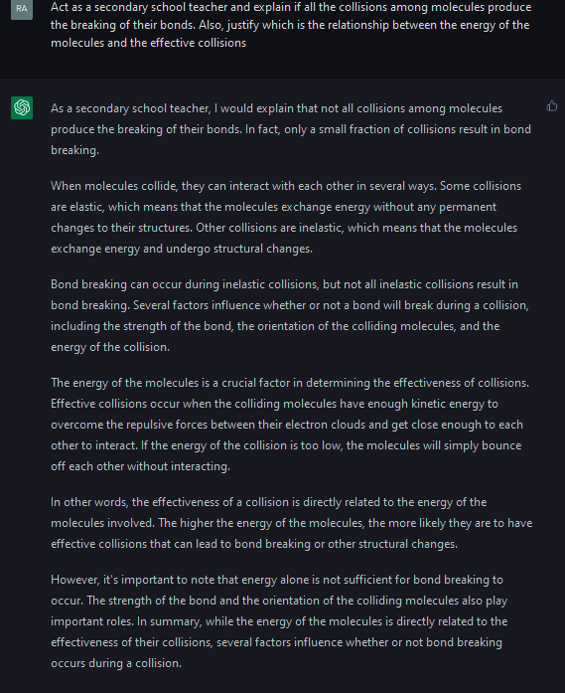
Fig. S39. Question 18, and the answer provided by the AI.
The chatbot provided a very detailed answer to the concepts of chemical bond breaking and effective collisions, based in kinetic theory of gases and energetic parameters, in a simple manner that is very useful for K-12 students.

  - Calculate the number of total molecules and atoms in: a) 10 moles of water; b) 154g of carbon tetrachloride; c) 2 moles of methane and 32 g of methane. Score: 1/1
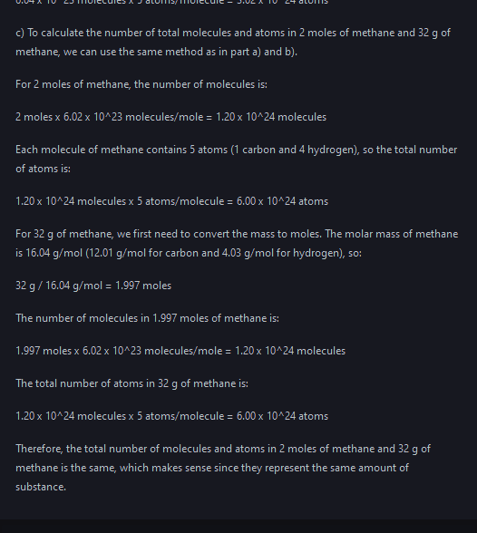
Fig. S40. Question 19, and the answer provided by ChatGPT.
The AI calculated the amount of moles and atoms in each case and realized that 2 moles of CH₄ and 32 g of CH₄ represents the same amount of substance, which is quite illustrative for K-12 students.
  - Explain what an acid and a base is according to the Arrhenius theory. Point out what is a neutralization reaction and provide a quantitative relationship between the reactants. Score: 1/1
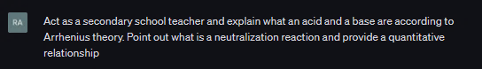
Fig. S41. Question 20, and the answer provided by ChatGPT.
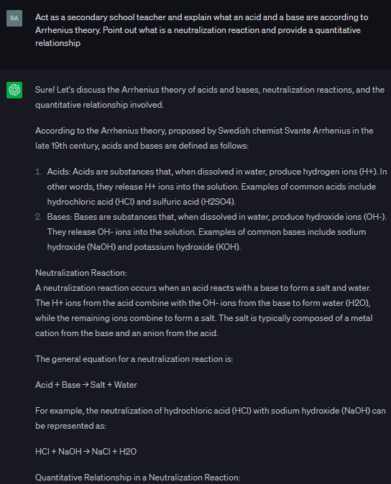
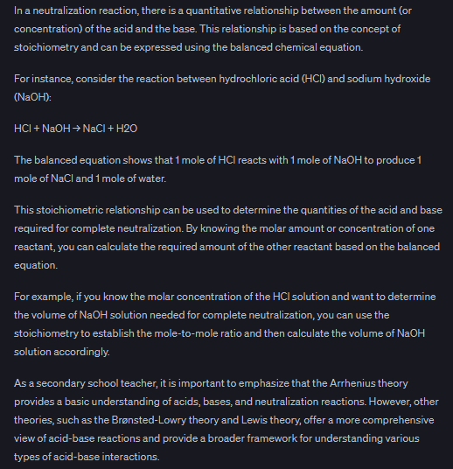
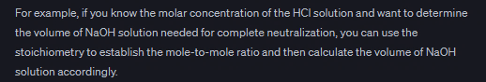
Fig. S41. Question 20, and the answer provided by ChatGPT.
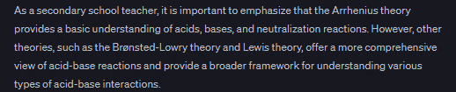
Fig. S41. Question 20, and the answer furnished by ChatGPT.
The chatbot perfectly described what an acid and a base are according to Arrhenius theory and provided the requested quantitative information.
  - The combustion reaction of methane generates 800kJ. a) Write the corresponding thermochemical equation; b) Draw the energetic diagram of the reaction; c) how many methane moles must be burned to obtain 200kJ? Score: 0.67/1
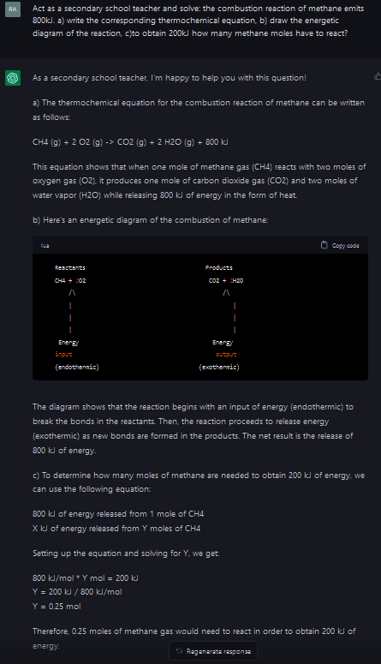
Fig. S42. Question 21, and the answer provided by the AI.
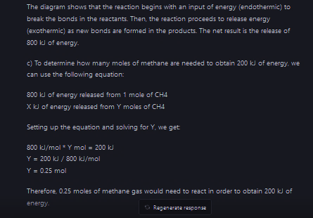
Fig. S42. Question 21, and the answer provided by the AI.
In this case, the descriptive answers were correct. However, the diagram was not correct because drawing is not an option for ChatGPT.
When using GPT-4 model, it described the diagram (which is a step forward), but it still did not provide the diagram, because ChatGPT cannot return images as feedback.
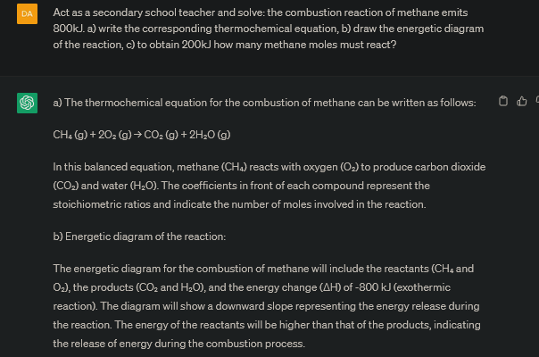
Fig. S43. Question 21, and the answer provided by the AI with GPT-4 model.

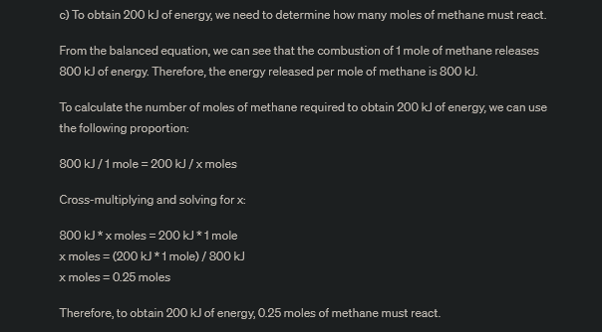
Fig. S43. Question 21, and the answer provided by the AI with GPT-4 model.
In 2024 we repeated the question, and the answer was even clearer, and the AI also made an attempt to draw the energetic diagram. However, the energy scale was inverted, which is not intuitive for the student. Therefore, only two parts of three were correct. The image feedback must still be improved.
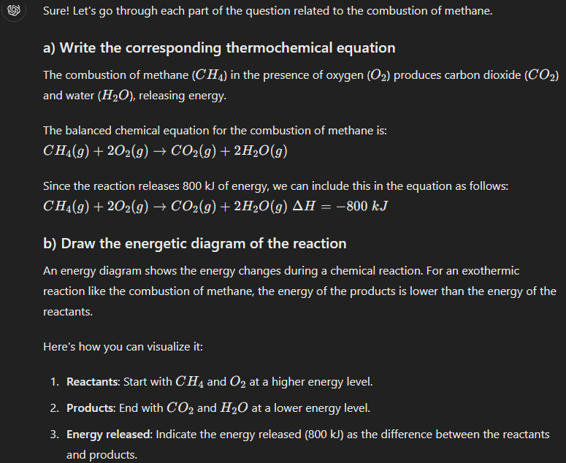
Fig. S43b. Question 21, and the answer provided by the AI with GPT-4 model in 2024.

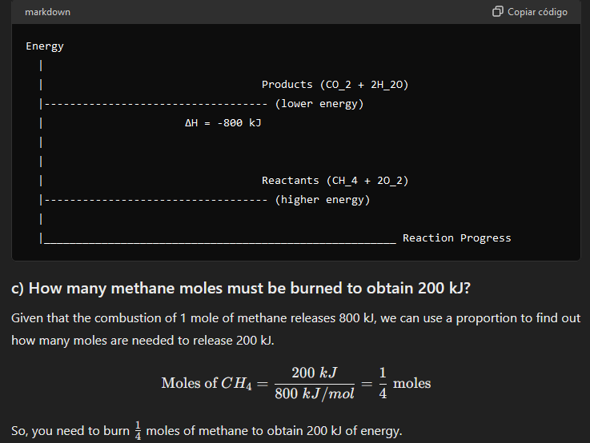
Fig. S43b. Question 21, and the answer provided by the AI with GPT-4 model in 2024.

  - Reason when a higher reaction rate will be achieved: when the reactants are in solid state or when they are in dissolution. Score: 1/1
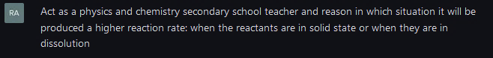
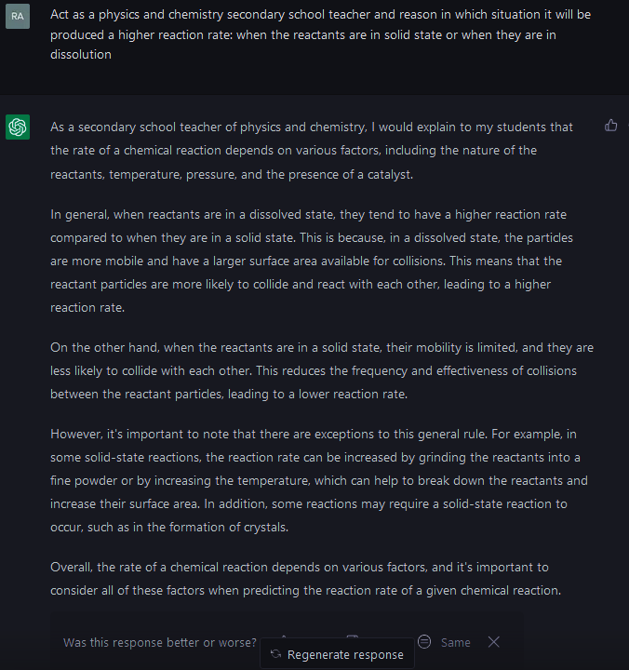
Fig. S44. Question 22, and the answer provided by the AI.

ChatGPT revised in this question the factors affecting the chemical reaction rate, putting the focus on the aggregation state of matter, in a clear and illustrative way.

  - Calculate the average speed in moles per second by adding a 10 g piece of calcium carbonate in hydrochloric acid that reduces it mass to a quarter in fifteen minutes. Score: 1/1
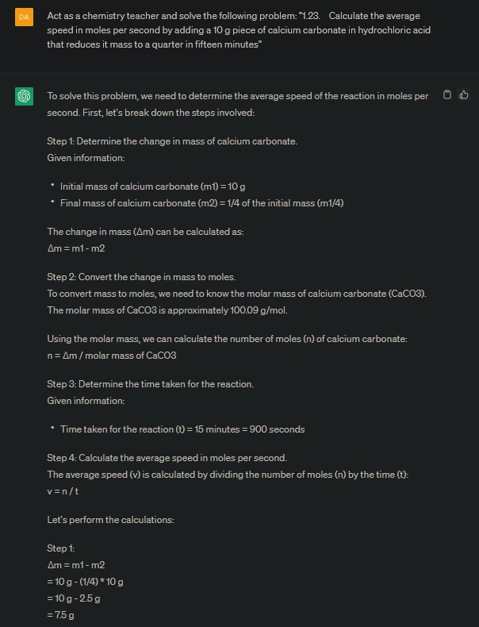
Fig. S45. Question 23, and the answer furnished by the AI.

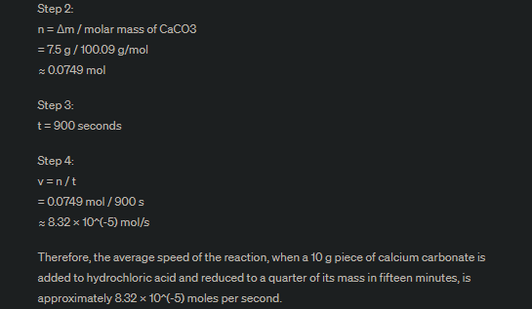
Fig. S45. Question 23, and the answer furnished by the AI.
The chatbot solved the problem in a simple and illustrative manner, providing the student with a nice example of a problem-solving procedure.
  - Act as a secondary school teacher and consider the stoichiometric coefficients of the ammonia synthesis equation. N₂ + 3 H₂ --> 2 NH₃. According to this, what relationship between speeds of reactions is the correct one, among the following possibilities?:
- the rate of decomposition of nitrogen is three times the rate of decomposition of hydrogen.
- the rate of decomposition of nitrogen is two times the rate of ammonia formation speed.
- the rate of decomposition of hydrogen is higher than ammonia formation speed.
Score: 1/1

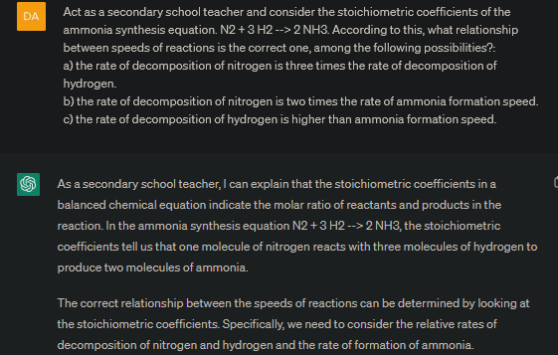
Fig. S46. Question 24, and the answer furnished by the AI.
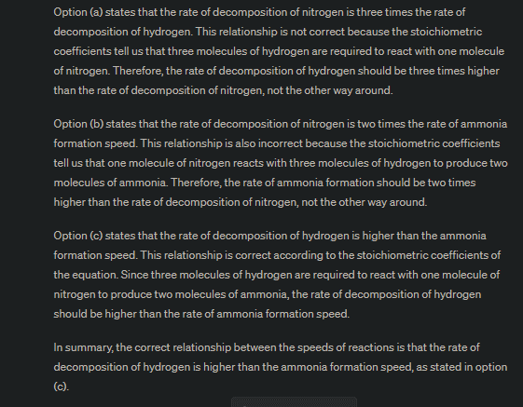
Fig. S46. Question 24, and the answer provided by the AI.
ChatGPT found the right answer, bringing the student several reasons why it was correct, while the other options were not, in a very human natural way of thinking.

  - Explain the increase in the boiling point of lineal alkane when increasing the chain length as a function of intermolecular forces. What kind of forces they are? Score: 1/1
Once more, the AI provided a correct answer to a theoretical question.

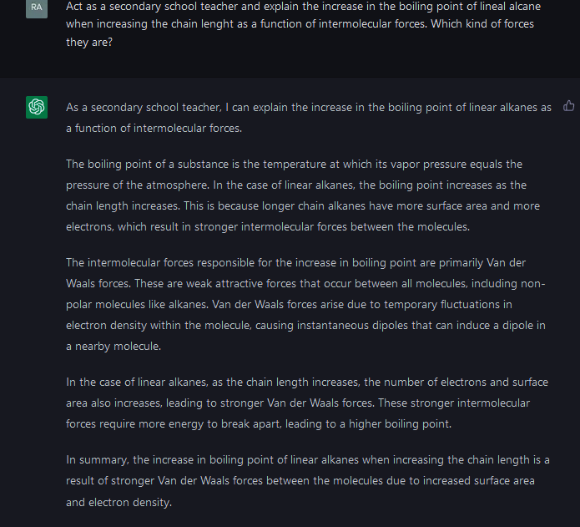
Fig. S47. Question 25, and the answer provided by the AI.
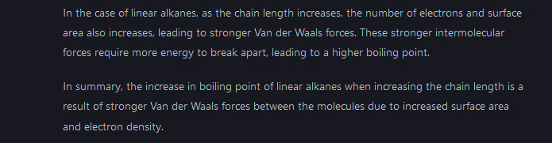
Fig. S47. Question 25, and the answer provided by the AI.

  - Indicate the functional group and the name of this compounds: a) HCOOH; b) CH₃-CH₂-NH-CH₃; c) CH₃-O-CH₃. Score: 1/1
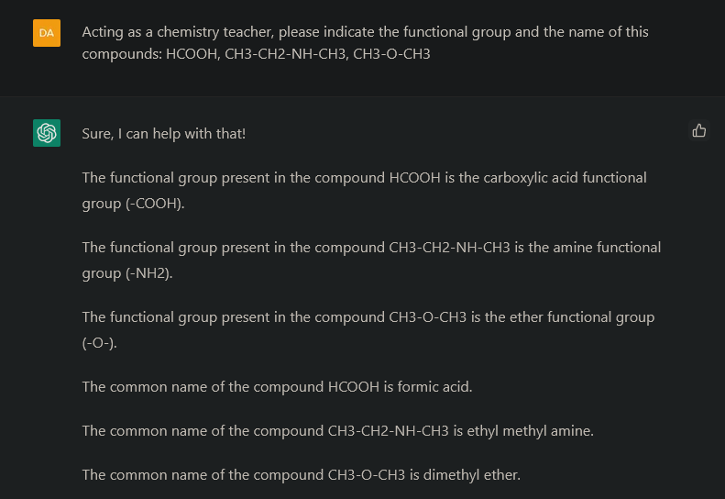
Fig. S48. Question 26, and the answer furnished by the chatbot.
Splitting the question into several parts, ChatGPT (powered by GPT-3) provided a more detailed explanation (Figure S48). As a consequence, the student will get more information splitting questions as much as possible. Anyway, both answers were correct.
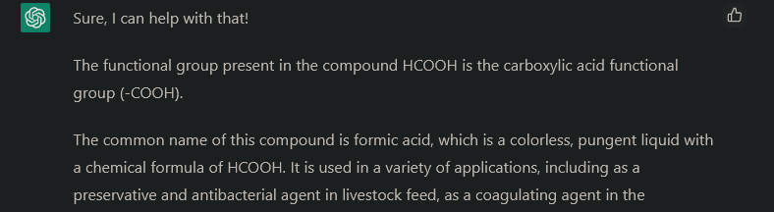
Fig. S49. A small part of question 26, and the answer furnished by the AI.
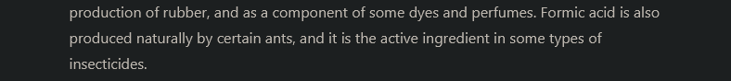
Fig. S49. A small part of question 26, and the answer furnished by the AI.

  - Indicate the ester molecules responsible for flavors of bananas, apples, and oranges. Score: 1/1
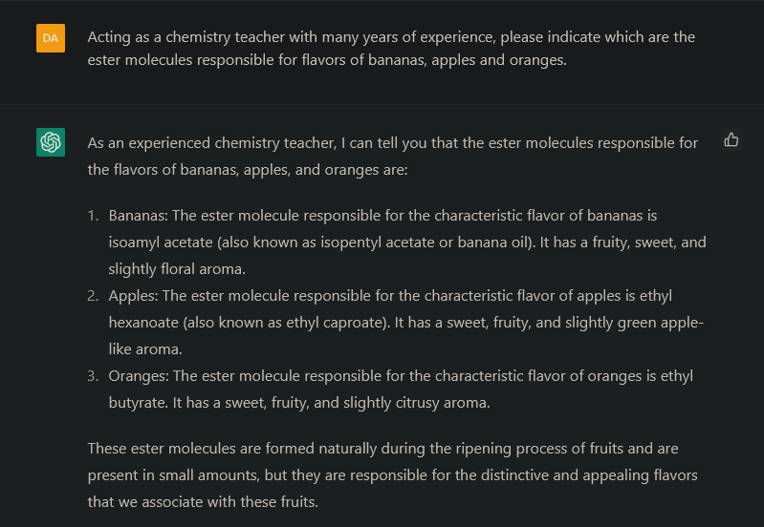
Fig. S50. Question 27, and the answer provided by the AI.
All the answers were correct. Even if there are some other esters also responsible for those flavors and even odors, the information is enough for these students.
  - Explain the difference between relative and absolute reference systems. Score: 1/1
The answer was correct, and the examples provided to better illustrate the differences were really useful.
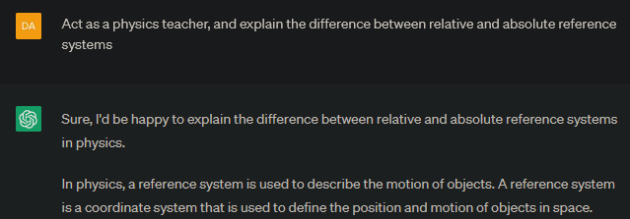
Fig. S51. Question 28, and the answer returned by ChatGPT.

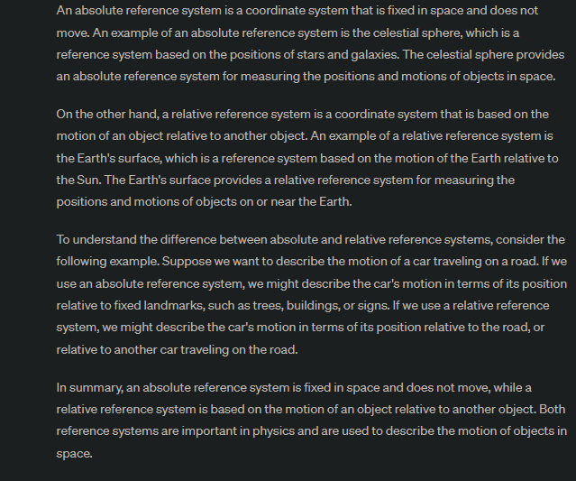
Fig. S51. Question 28, and the answer returned by ChatGPT.

  - a) Define the concepts of displacement vector and space traveled, including an example. b) An athlete runs 100 meters in 10.2 seconds, while a swimmer swims 100 meters in 54 seconds. Calculate and compare both average velocities. Score: 1/1
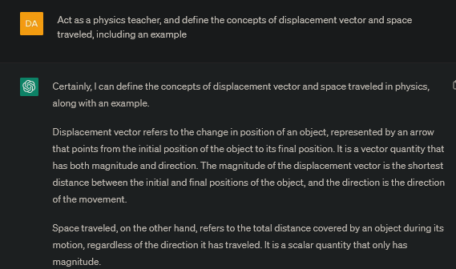
Fig. S52. Question 29a, and the answer provided by the chatbot.
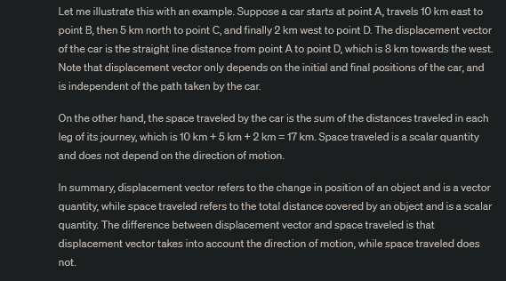
Fig. S52. Question 29a, and the answer provided by the chatbot.
The concepts requested in the question 29a were correct. The following question, 29 b, evidenced the robustness of ChatGPT’s answers concerning the different ways to write the unities, showing its strength when dealing with language issues. The answer was the same even if the whole unit or just the corresponding symbol according to the International System of Units (ISU) was written.
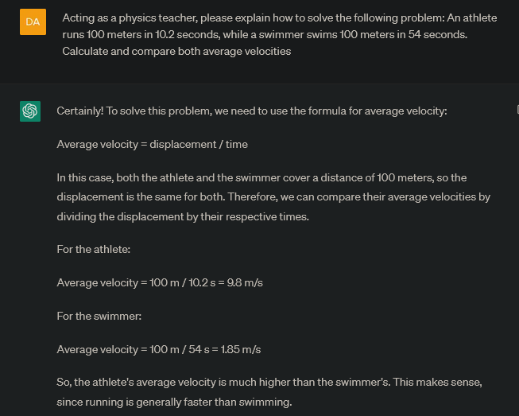
Fig. S53. AI’s answer to question 29b with complete units written.

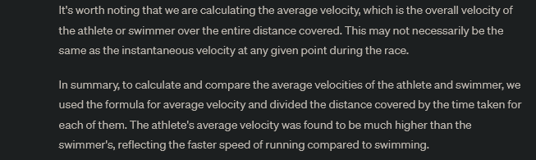
Fig. S53. AI’s answer to question 29b with complete units written.

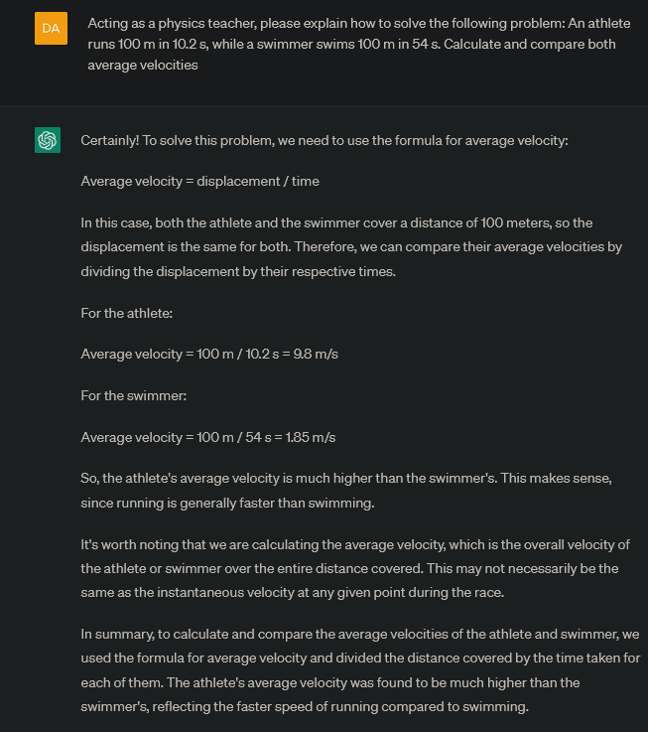
Fig. S54. AI’s answer to question 29b with symbols of units written.

  - An electric scooter travels at 40 km/h. 5 km far from the scooter position, a truck travels in the same sense at 80 km/h. How much time will the truck invest in reaching the scooter? What distance will the truck travel until it reaches the scooter? Score: 1/1
The problem was perfectly solved from the theoretical point of view, and the numerical solution is also correct, which was usually a problem for GPT3.5. GPT4 has clearly improved this old issue.
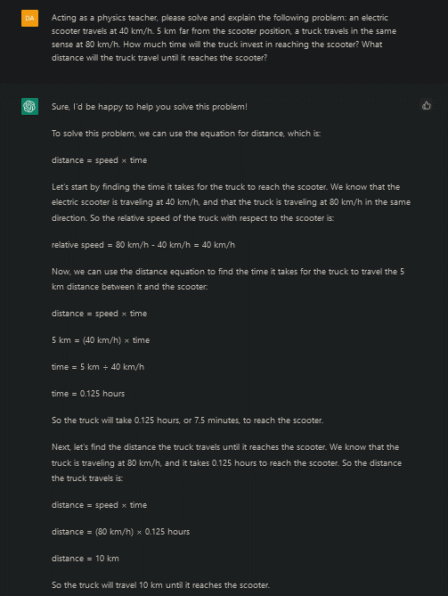
Fig. S55. Question 30, and the answer provided by the AI.

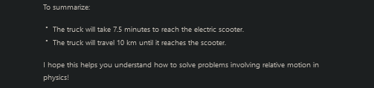
Fig. S55. Question 30, and the answer provided by the AI.

  - Indicate whether the following sentence is correct or incorrect: a) there is no uniform movement displaying acceleration; b) depending on how a ball is thrown into the air, it may result in rectilinear or curvilinear motion; c) a microwave dish describes a uniform circular movement. Score: 1/1
The AI returned a correct answer for each sentence, providing students with clear and illustrative reasons.
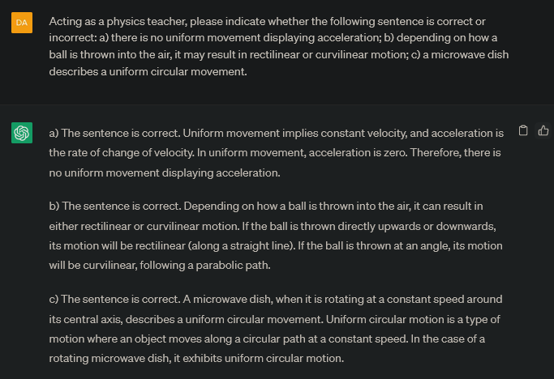
Fig. S56. Question 31, and the answer furnished by the chatbot.

  - Explain what forces are and how they are measured. Score: 1/1
Another correct and detailed answer from the AI to a theoretical question.

Fig. S57. Question 32, and the answer provided by the AI.

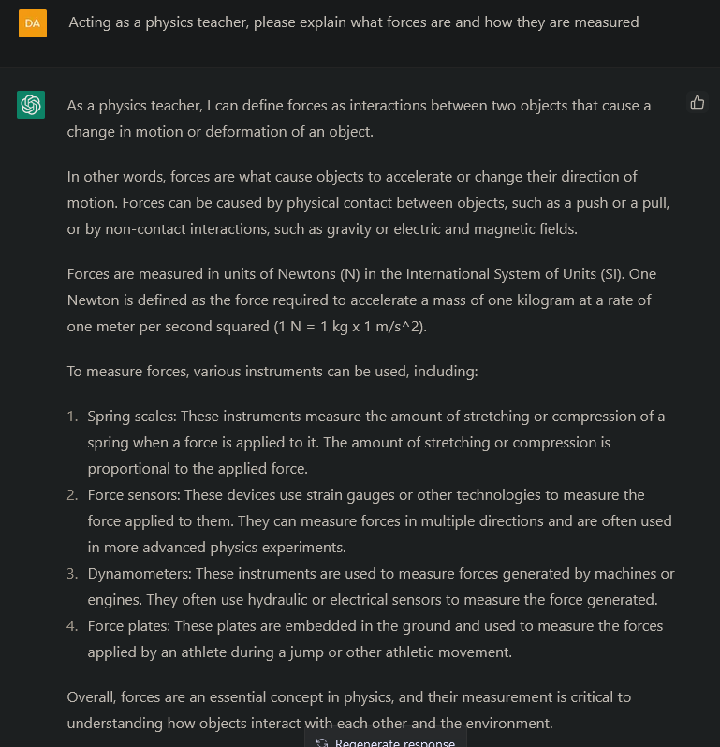
Fig. S57. Question 32, and the answer provided by the AI.

  - Indicate how do forces add and decompose. Score: 1/1
In this case, there were substantial differences between the answer with GPT-3 and GPT-4. The oldest model misunderstood the concepts of vector addition and force decomposition, (correlating them with addition or cancellation of forces, respectively, which is obviously not correct), and missed some images that are theoretically included. On the contrary, the newest model made clear reference to addition of forces as an event when forces can add or cancel each other, and described force decomposition into components, which is clear and correct.
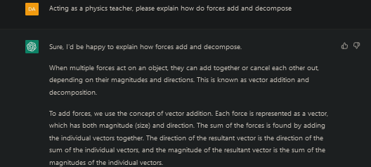
Fig. S58. Question 33, and the answer provided by ChatGPT powered by GPT-3.
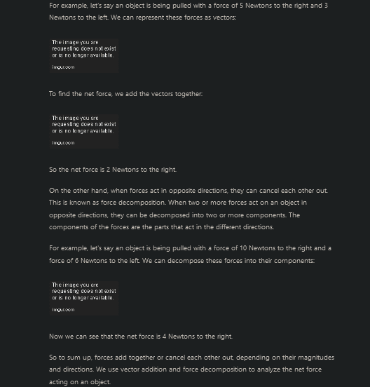
Fig. S58. Question 33, and the answer provided by ChatGPT powered by GPT-3.

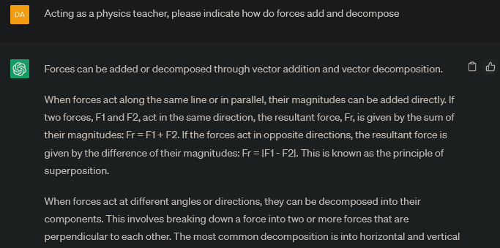
Fig. S59. Question 33, and the answer provided by ChatGPT powered by GPT-4.
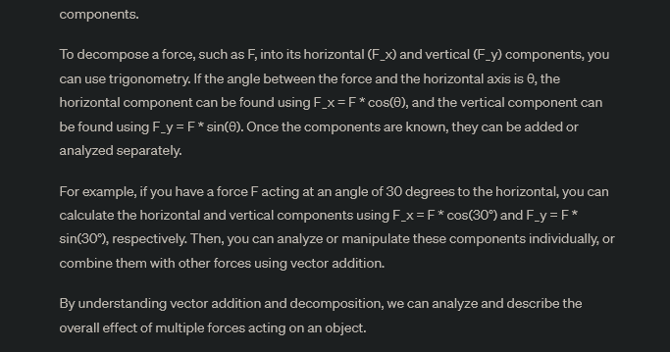
Fig. S59. Question 33, and the answer provided by ChatGPT powered by GPT-4.
In 2024, the AI answered in a more organized, step-by-step manner, and still correct.
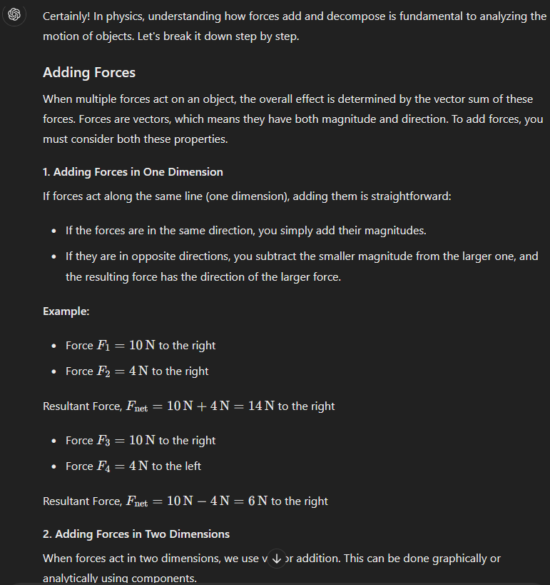
Fig. S59b. Question 33, and the answer provided by ChatGPT powered by GPT-4 in 2024.

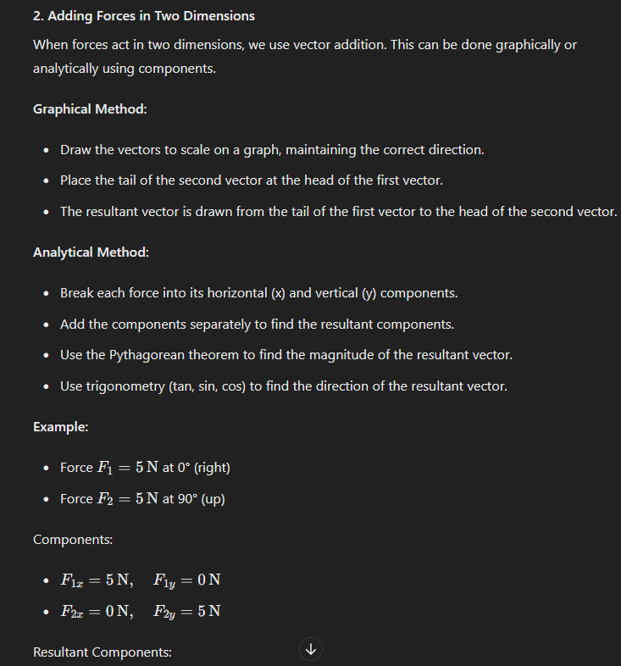
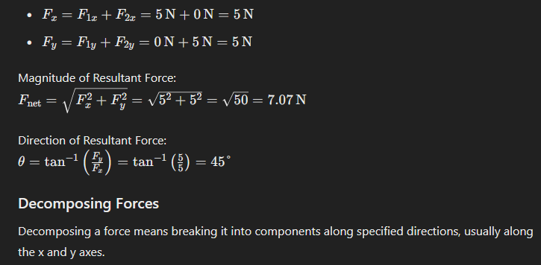
Fig. S59b. Question 33, and the answer provided by ChatGPT powered by GPT-4 in 2024.

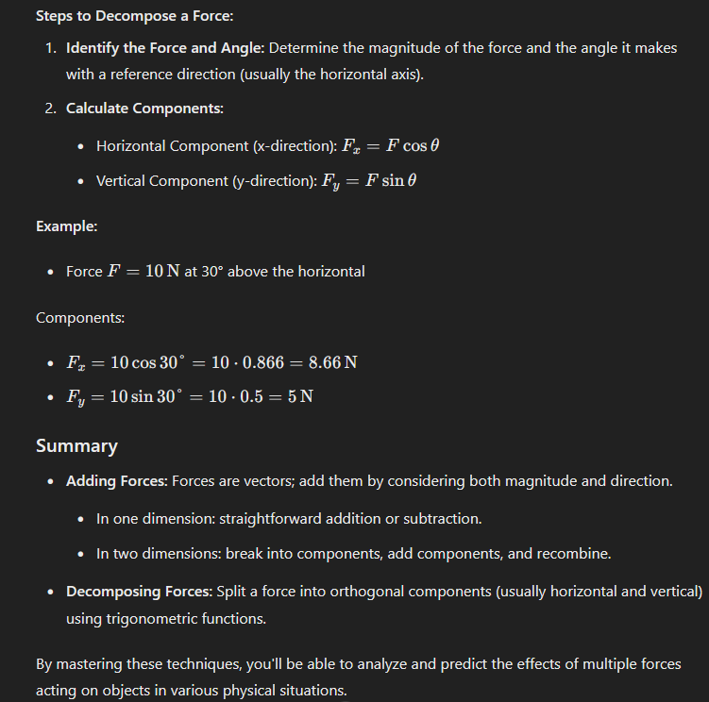
Fig. S59b. Question 33, and the answer provided by ChatGPT powered by GPT-4 in 2024.
Requesting the AI to provide graphical examples on how to add and decompose forces, provides a simple but didactic representation of the subject being described.
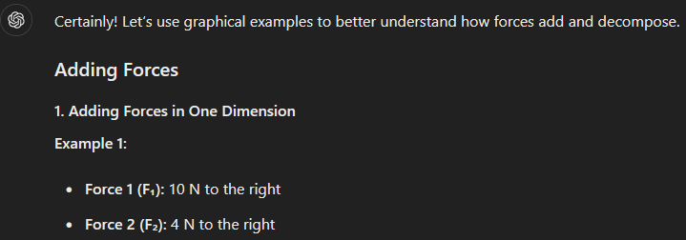
Fig. S59c. Question 33, and the answer provided by ChatGPT powered by GPT-4 in 2024, when graphical examples are also requested.

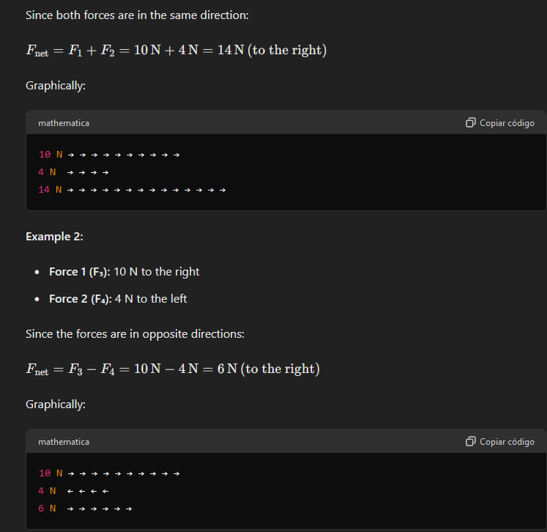
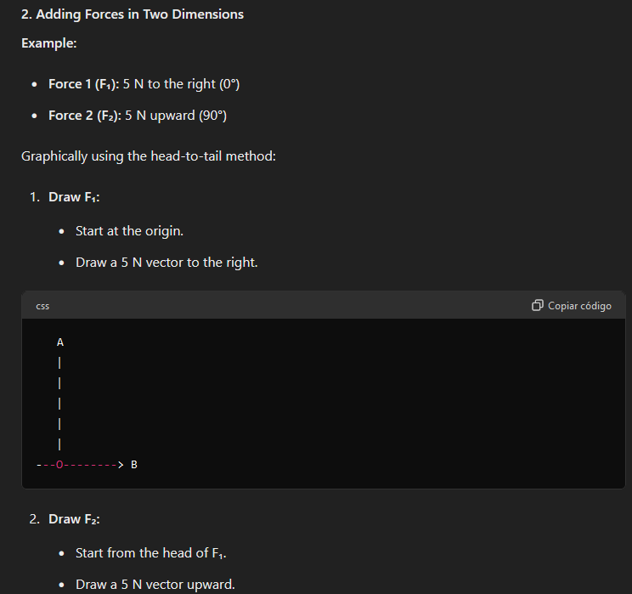
Fig. S59c. Question 33, and the answer provided by ChatGPT powered by GPT-4 in 2024, when graphical examples are also requested.

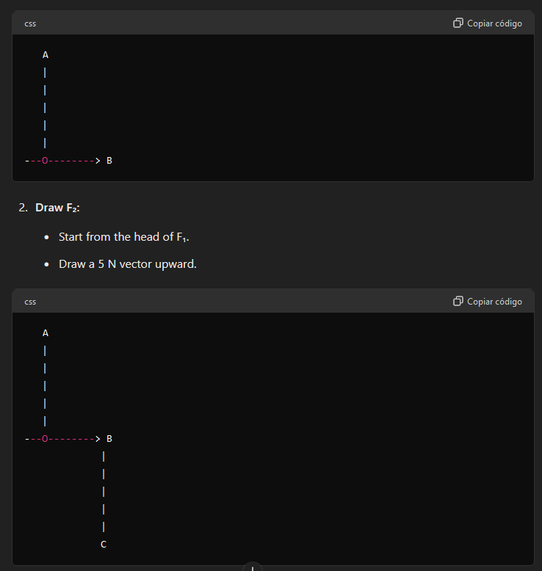
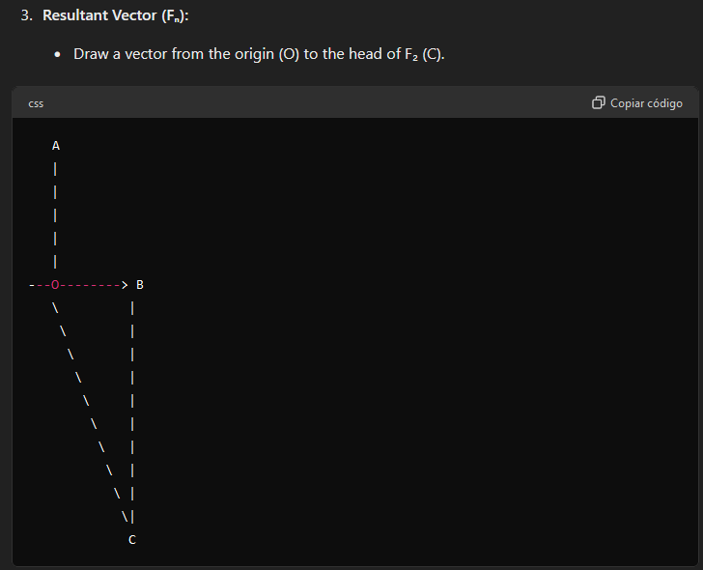
Fig. S59c. Question 33, and the answer provided by ChatGPT powered by GPT-4 in 2024, when graphical examples are also requested.
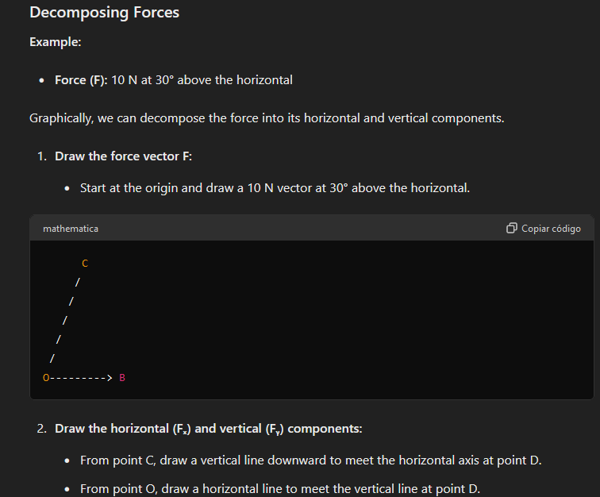
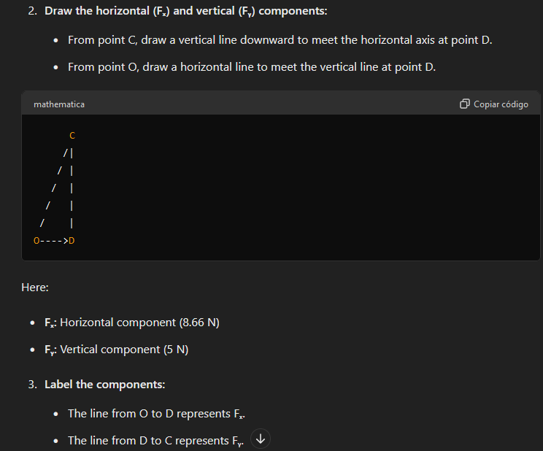
Fig. S59c. Question 33, and the answer provided by ChatGPT powered by GPT-4 in 2024, when graphical examples are also requested.

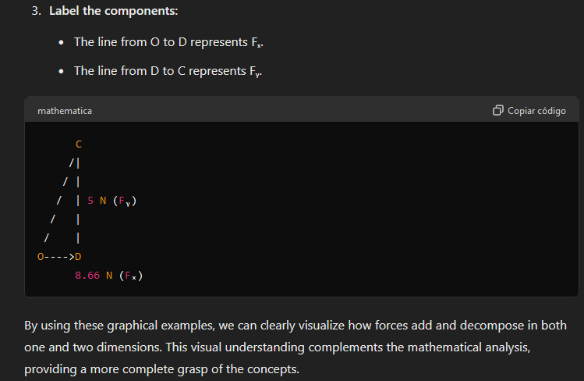
Fig. S59c. Question 33, and the answer provided by ChatGPT powered by GPT-4 in 2024, when graphical examples are also requested.

  - Explain how a body behaves when a null resultant force applies over it. Score: 1/1
The AI answered this question in a clear, correct, and comprehensive manner.
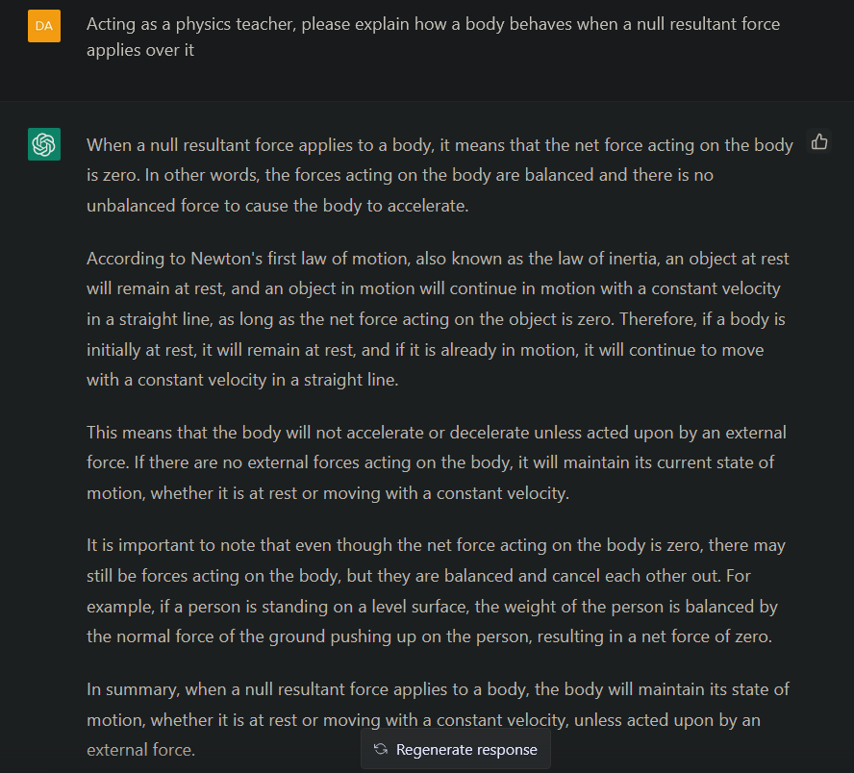
Fig. S60. Question 34, and the answer returned by the chatbot.

  - What is the relationship between the force acting on a body and the acceleration it acquires? Score: 1/1
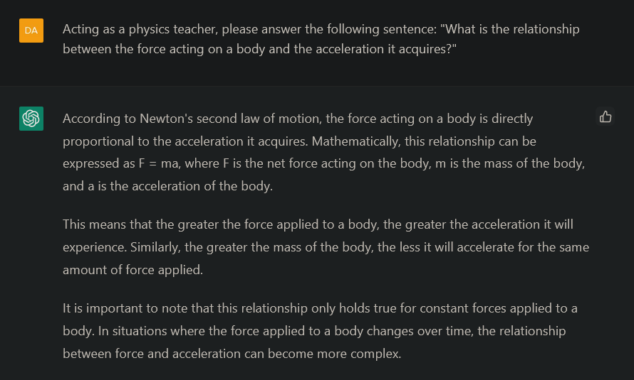
Fig. S61. Question 35, and the answer furnished by the AI.
In this case, ChatGPT provided the student with the right context to explain the requested concepts, including a final remark limiting the validity of the answer to systems where constant forces are applied to a body.
  - Why is it said that forces act in pairs? Score: 1/1
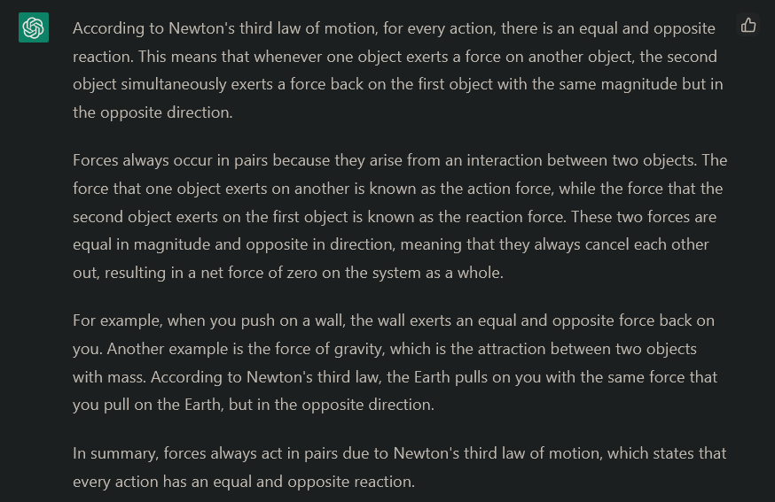
Fig. S62. Question 36, and the answer provided by ChatGPT.
The AI explained in a simple but precise way the third law of motion, including two clear examples (force on a wall and earth pulling on each person) that perfectly illustrate the concept.

  - To study Hooke's law, an unknown weight has been placed on a dynamometer with a spring constant of K = 500 N/m, and the spring undergoes an elongation of 7.2 cm. How much force does the weight exert on the spring? Score: 1/1
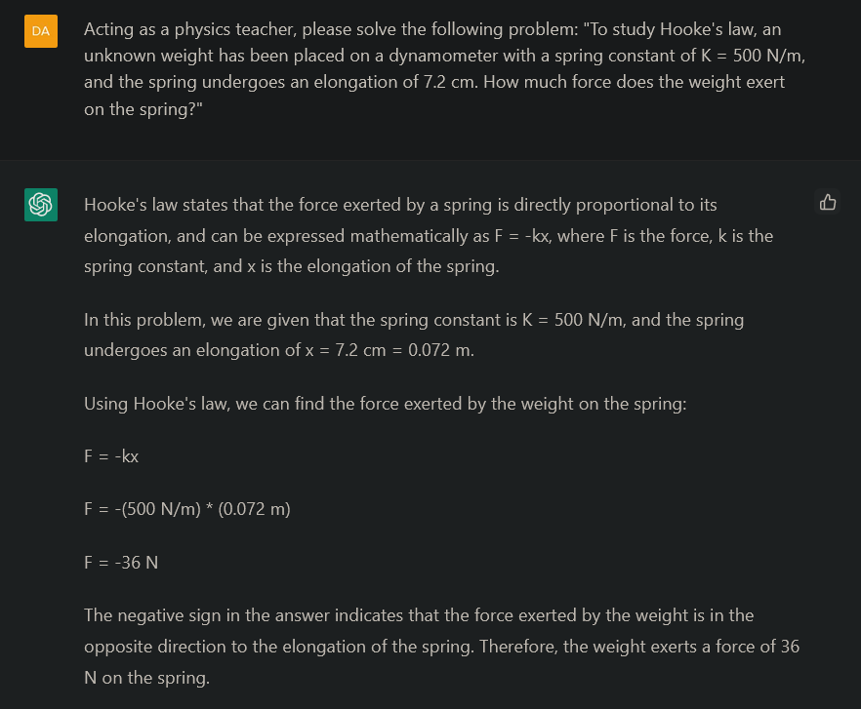
Fig. S63. Question 37, and the answer provided by the AI.
The answer was not only correct, but it also showed the students how to follow a nice procedure to solve the problem: Law to determine Force, known data including conversion to SI units, application of the formula, and a final clarification of the negative sign meaning.
  - Tell what the following sentence lacks to be correct: "F net = 0 <==> v = constant". Score: 1/1
This was another example of ChatGPT’s weaknesses, at the moment. The true expression is that in Figure S64, but the image should be turned into something typeable.
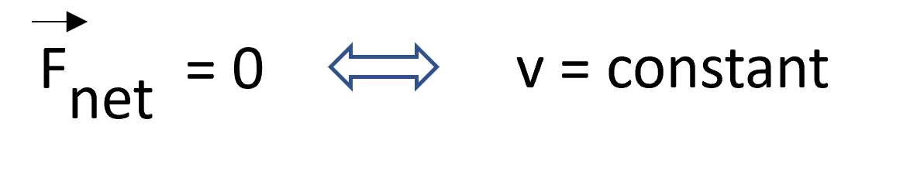
Fig. S64. Expression in question 38.
The first problem was the vectorial character of the force could not be included neither using text nor using images, as they are not valid inputs (at least at that moment). Thus, the chatbot did not perceive that the vectorial character should also be extended to velocity, as simple as that, and then started providing plenty of reasons why something lacked in the expression.
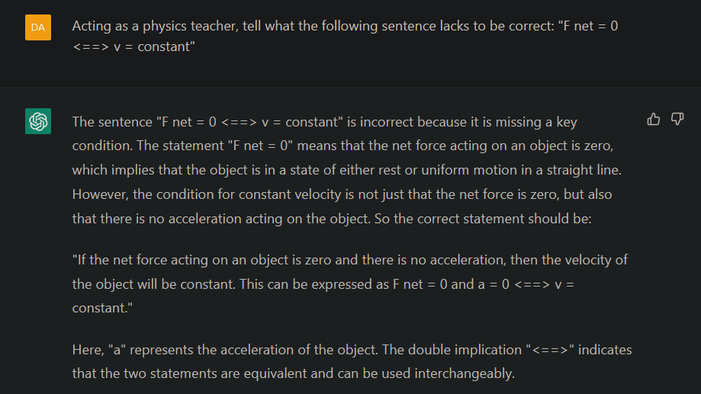
Fig. S65. Question 38, and the answer returned by the AI.
The explanation provided by ChatGPT was correct, but it was not answering the question, as it could not detect the vectorial character of F and v, neither draw it. It was not what the exercise was looking for.
However, the free version in 2024 solved this issue, as it already accepted images as inputs, and surprisingly recognize what the expression lacked perfectly, providing a correct answer to this question.
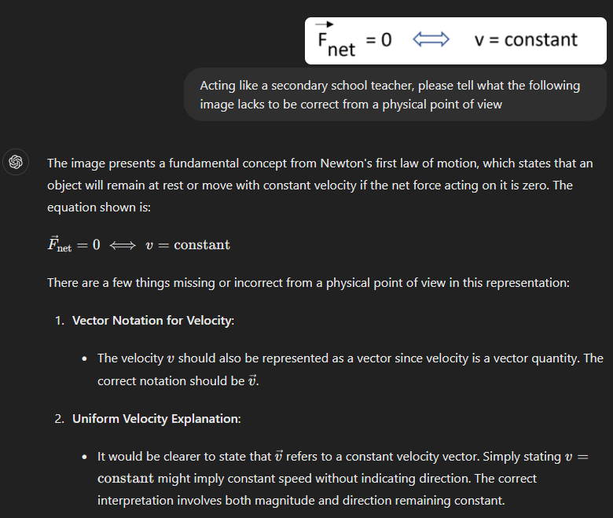
Fig. S65b. Question 38, and the answer returned by the AI in 2024.

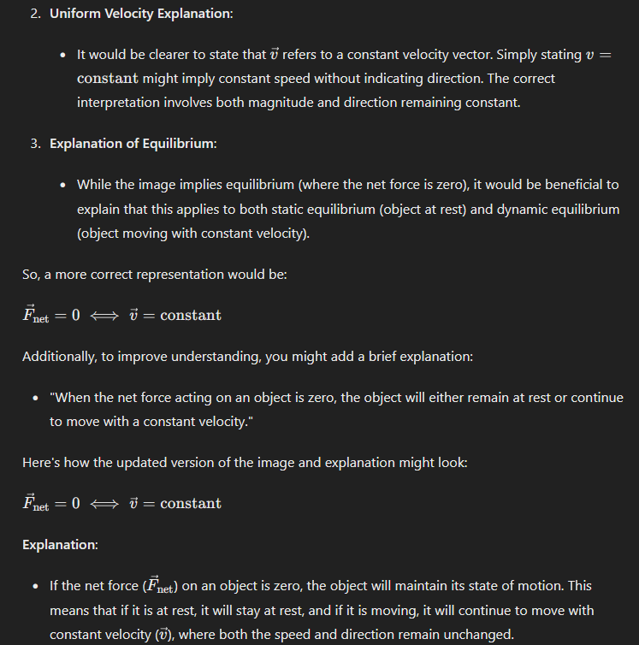
Fig. S65b. Question 38, and the answer returned by the AI in 2024.

  - Explain Galileo's study of movement and the Relativity Principle of Galileo. Score: 1/1
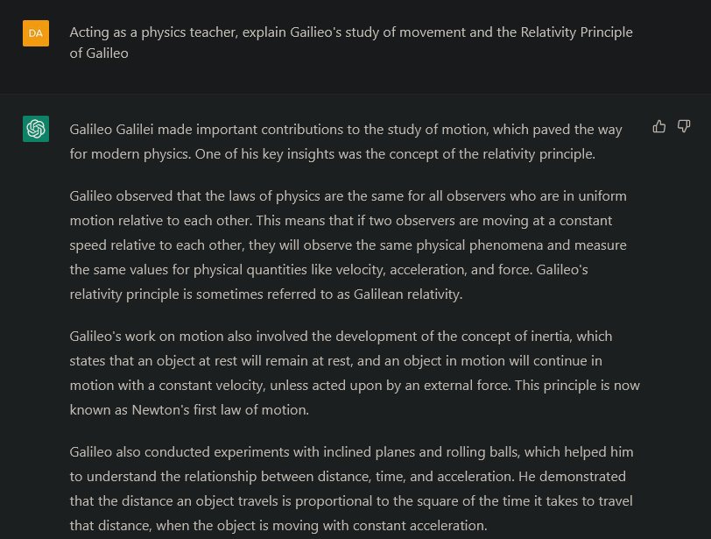
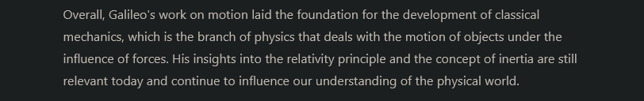
Fig. S66. Question 39, and the answer returned by the AI.
The answer furnished by the chatbot was correct, clear and sufficiently detailed for these students. This question evidence that ChatGPT handles well with theoretical explanations.

  - Explain within the frame of the first law of Newton (Principle of Inertia) whether equilibrium state is the same as a rest state. Score: 1/1
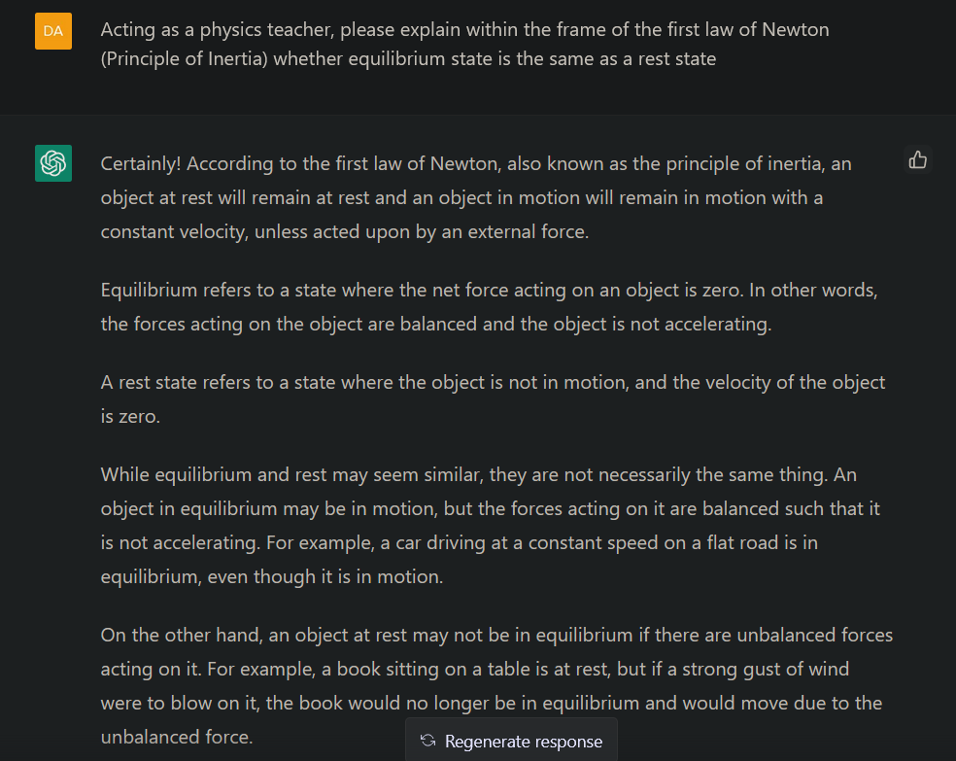
Fig. S67. Question 40, and the answer provided by the chatbot.
Again, the answer was quite clear and illustrative.
  - Use the second law of Newton to calculate the acceleration that an object of m = 30 kg acquires when two forces act on it: a force of 20 N in north direction, and a force of 8 N in south direction. Score: 1/1


Fig. S68. Question 41, and the answer provided by the chatbot.
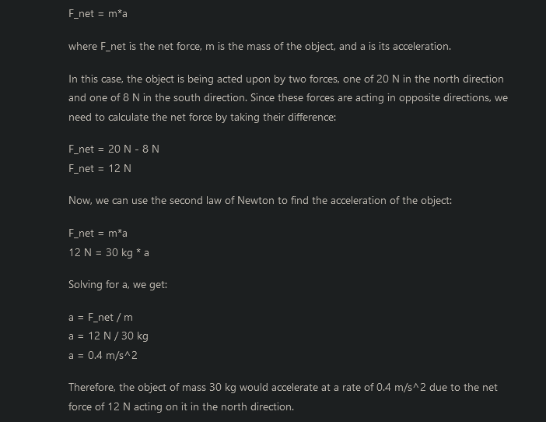
Fig. S68. Question 41, and the answer provided by the chatbot.
This is another example of ChatGPT’s strengths concerning its ability to mentor chemistry and physics students. It not only provided a good result, but also explained step by step and in detail how to solve it, as a human teacher would do, in a simple and clear way.
  - Explain the recoil effect of weapons, justifying the answer in the third law of Newton. Score: 1/1
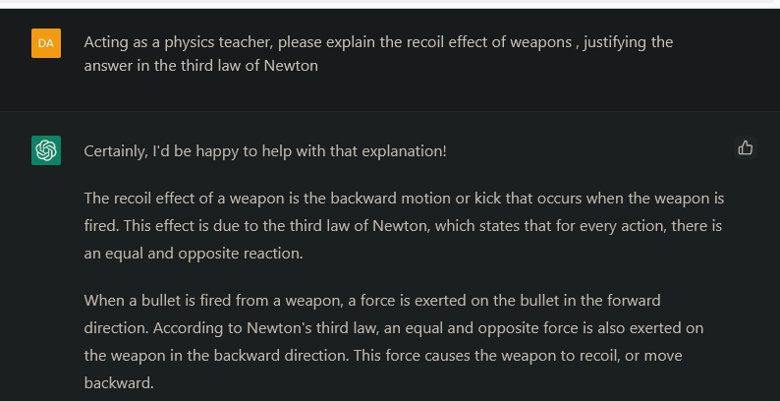
Fig. S69. Question 42, and the answer provided by the AI.

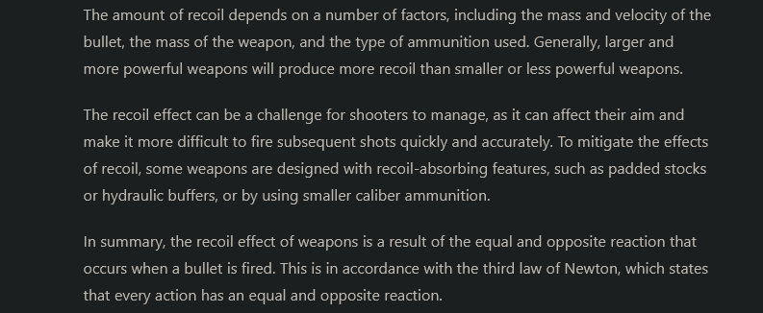
Fig. S69. Question 42, and the answer provided by the IA.
This theoretical question had a detailed answer from the chatbot, in connection with the third law of Newton.
  - Explain how to calculate the pressure exerted by a box of 40 cm x 20 cm x 15 cm on the floor, in each of the 3 possible positions. Score: 1/1
The AI provided a general explanation regarding the procedure to calculate the pressure in each position, and then demonstrated proactivity trying to exemplify the situation by fixing the mass of the box, in order to furnish numerical results able to illustrate the final conclusion: the pressure is different depending on its position, and it is usually higher when the box lies on a smaller surface. Clear, simple and illustrative answer.
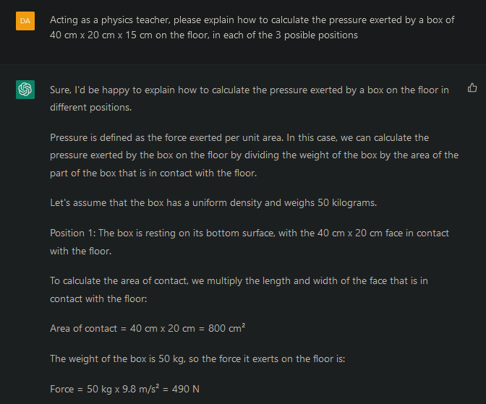
Fig. S70. Question 43, and the answer returned by ChatGPT.

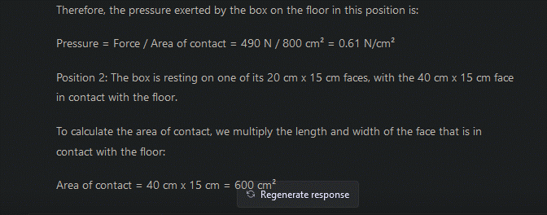
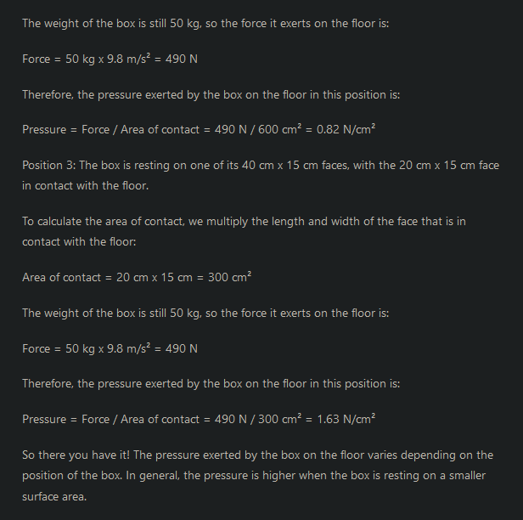
Fig. S70. Question 43, and the answer returned by ChatGPT.

  - Provide a definition of hydrostatic and explain what the communicating vessels are. Score: 1/1
Again, the chatbot returned a simple and illustrative answer to this theoretical question.
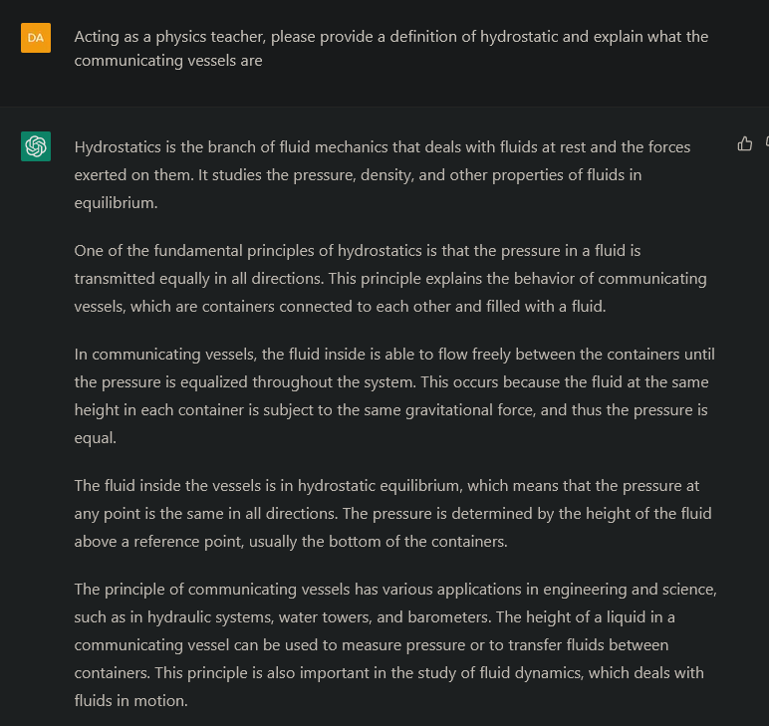
Fig. S71. Question 44, and the answer provided by the AI.

  - What is the pressure due to water (d=1000kg/m3) at the bottom of a 3m-depth pool, and also in a lateral wall, at 1m-depth from the surface. Score: 1/1
Despite being a language model, ChatGPT powered with GPT-3 could not correctly understand the second height (1m depth from the surface), and mistakenly understood the height was 2m instead of 1m (3m-1m), Figure S70.
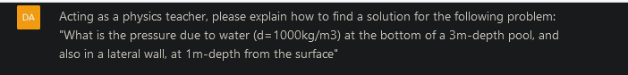
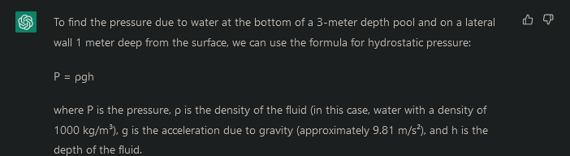
Fig. S72. Question 45, and the answer provided by the chatbot.
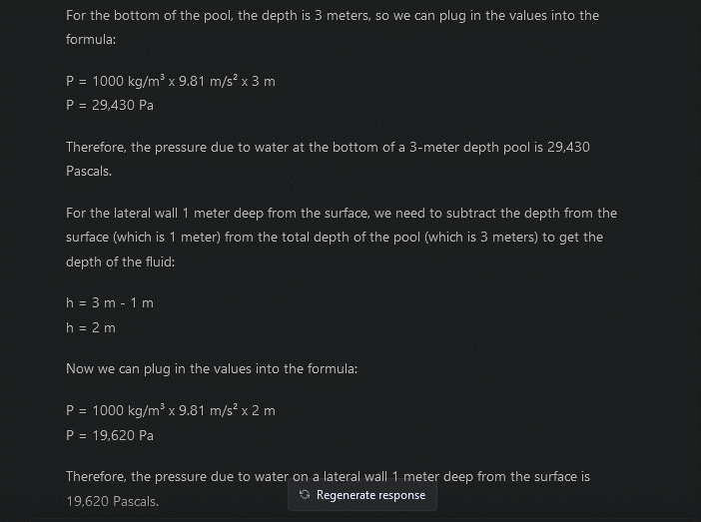
Fig. S72. Question 45, and the answer provided by the chatbot.
Removing the reference to the distance “to the surface”, ChatGPT powered by GPT-3 solved the problem perfectly (Figure S71).
Fig. S73. Question 45, and the answer fursnished by ChatGPT powered with GPT-3.

Besides, ChatGPT powered by GPT-4 solved perfectly the language problem, as even the original question provided a correct answer (Figure S72).
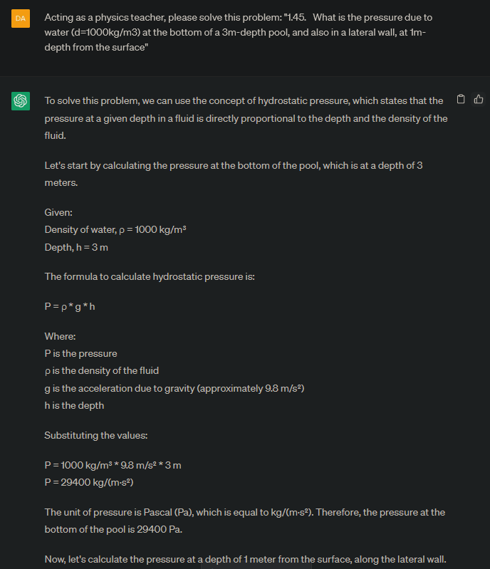
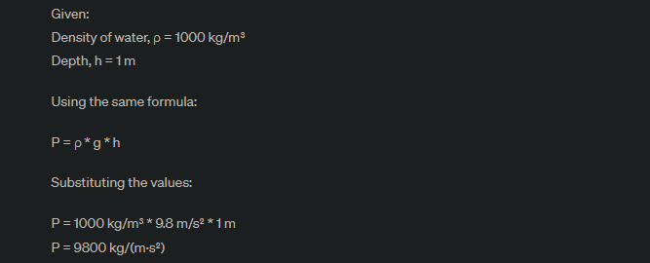
Fig. S74. Question 45, and the answer furnished by ChatGPT powered with GPT-4.

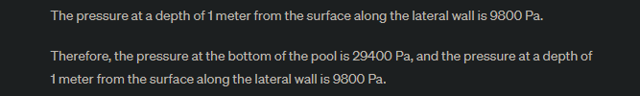
Fig. S74. Question 45, and the answer furnished by ChatGPT powered with GPT-4.

  - Explain why cargo ships, being made in high density steel alloys, can float in the sea. Score: 1/1
This is another example of a right and illustrative answer for a theoretical question.
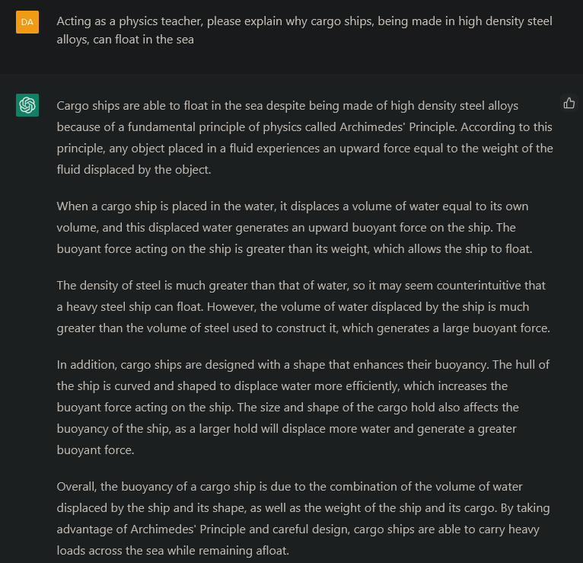
Fig. S75. Question 46, and the answer provided by the chatbot.

  - A 45 kg swimmer is in a springboard at 4m distance over the water. Calculate her potential energy at that height, and also when she jumps and travels 2m, and then when she arrives to the water level. Score: 1/1
Through this question, ChatGPT teached perfectly the concept of potential energy from a very illustrative perspective, taking into account several situations with different heights.
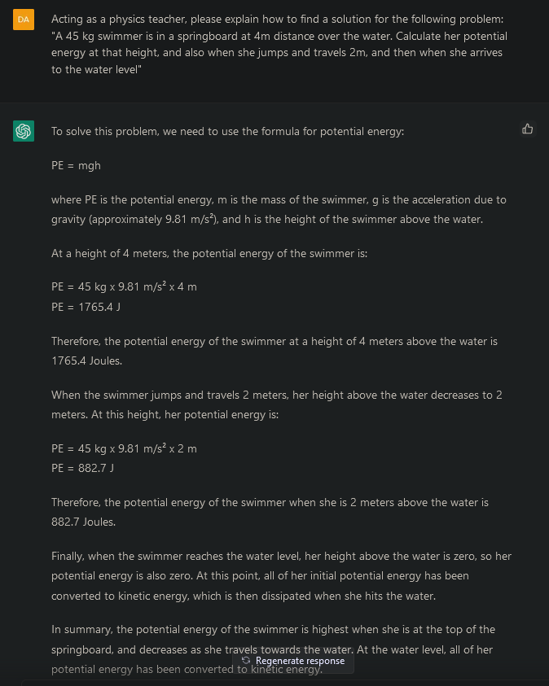
Fig. S76. Question 47, and the answer provided by the AI.

  - Explain the type of energy (kinetic or potential energy) that is exploited in the following sources of energy: eolic, hydraulic and tidal energy. Reason your answer. Score: 1/1
First, tidal energy was associated with kinetic energy, but in the summary, it was associated with potential energy without any other explanation (Figure S75). This might be somehow confusing for students, and the reason lies in the fact that tidal energy can be harvested from structures acting like dams (exploiting potential and kinetic energy) or turbines (kinetic energy), but was insufficiently explained.
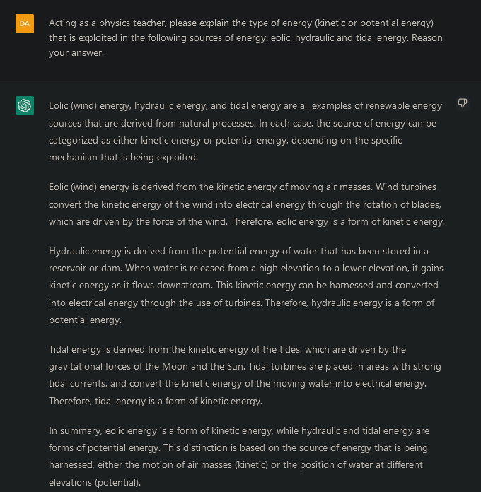
Fig. S77. Question 48, and the answer provided by the AI.
When providing negative feedback to ChatGPT, it suggested a new answer that was more detailed, considering both kinetic and potential contributions to tidal energy, even if kinetic is the main source of energy (Figure S78).
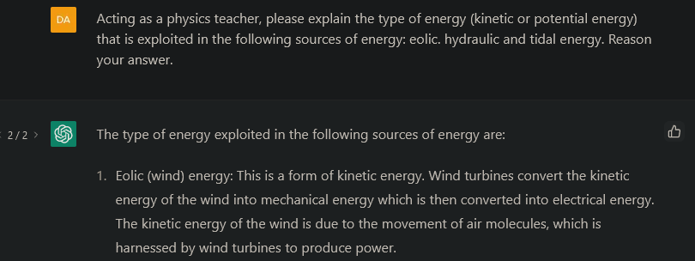
Fig. S78. Question 48, and the answer provided by the AI.

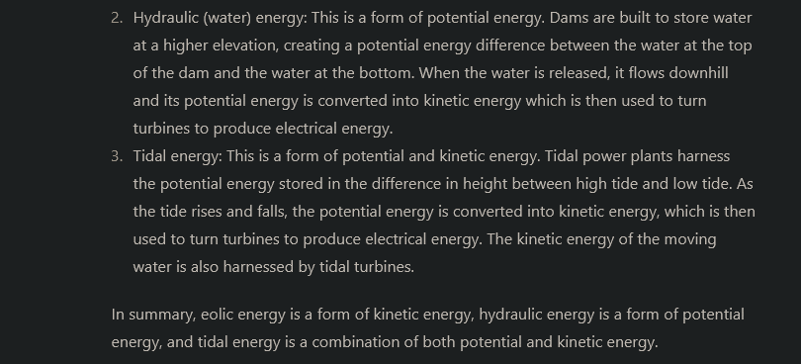
Fig. S78. Question 48, and the answer provided by the AI.
However, the answer of ChatGPT powered by GPT-4 (in 2023) only considered the exploitation of kinetic energy when harvesting the tidal energy, so it was not as correct as the previous one.

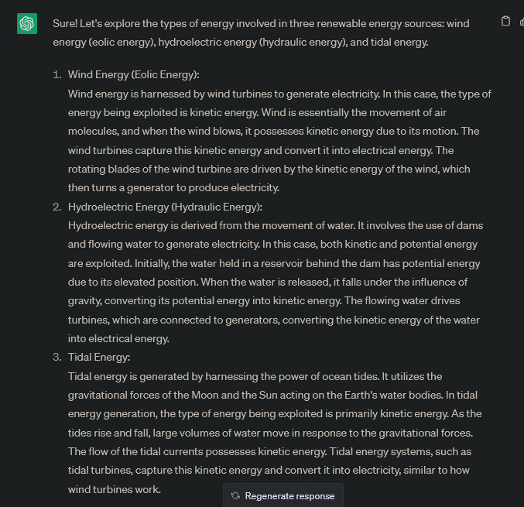
Fig. S79. Question 48, and the answer provided by the AI in 2023.
Finally, the answer of ChatGPT in 2024 is much more accurate, and can be considered not only as completely correct, but much clearer. The training has objectively improved the model.
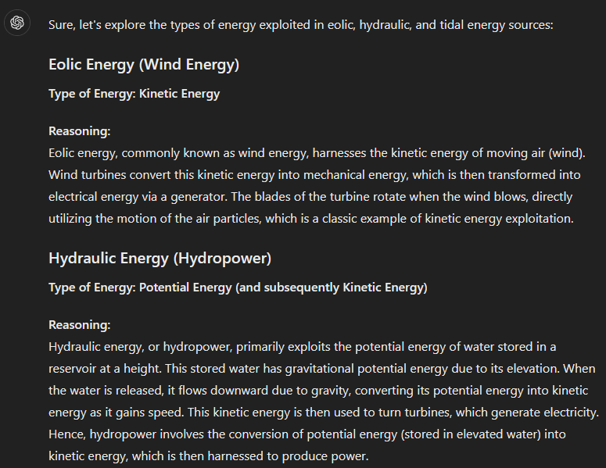
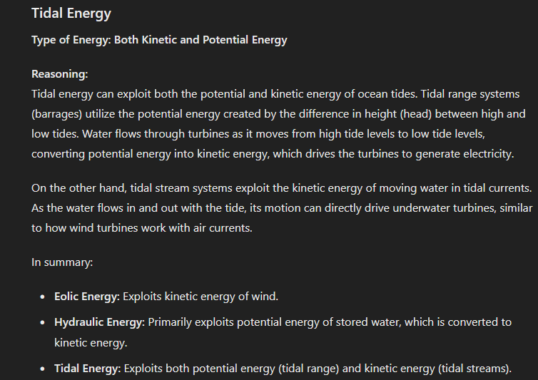
Fig. S79b. Question 48, and the answer provided by the AI in 2024.

  - A car engine develops a power of 100 CV when moving at 90 km/h on the road, following a uniform motion. Then: a) How much force pushes the car forward?; b) How much friction force experiments the car; c) How much work produces the engine during half an hour of function? Additionally, explain which engine develops more work, if a truck engine is more powerful than that of a car. Score: 1/1
In this case, the chatbot followed a clear procedure to explain the theoretical concepts and then applied them perfectly.
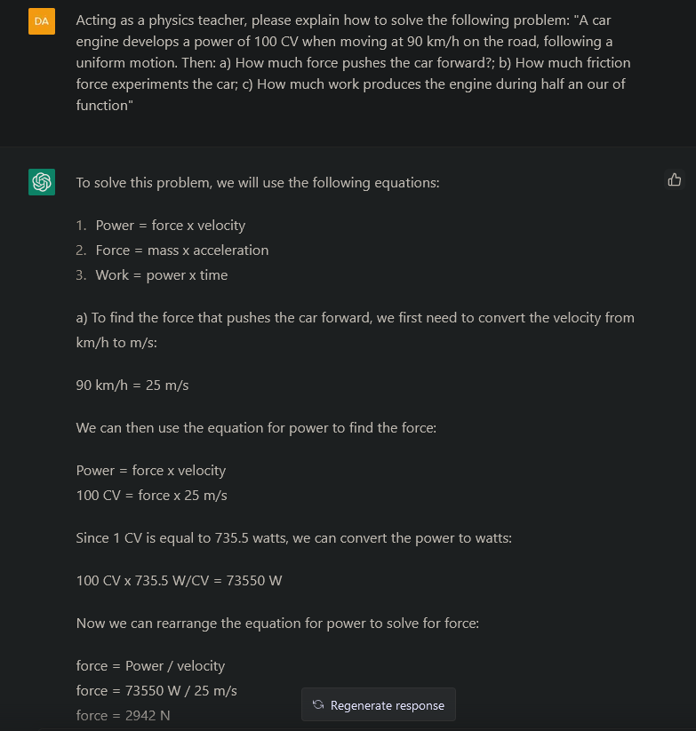
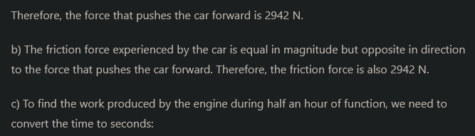
Fig. S80. Question 49, and the answer returned by the chatbot.

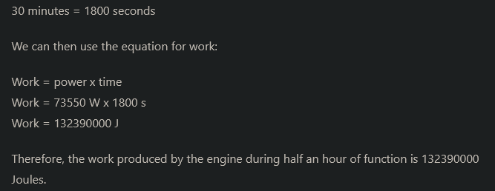
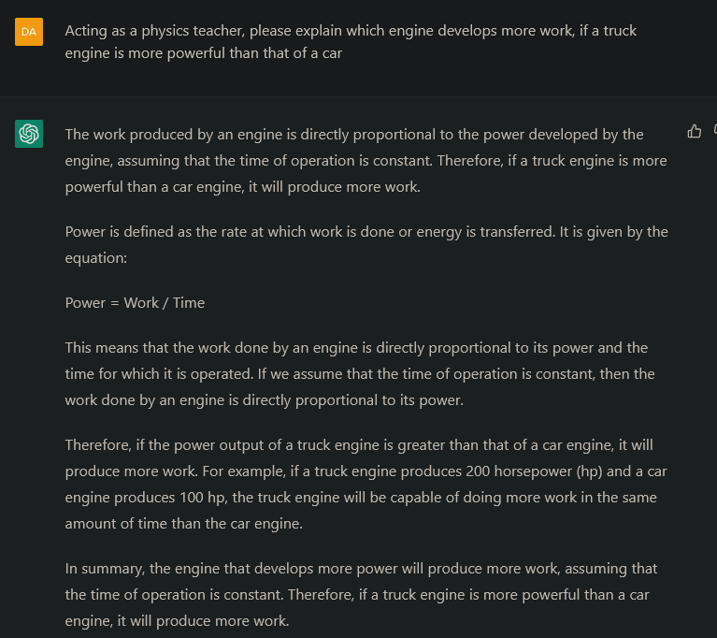
Fig. S80. Question 49, and the answer returned by the chatbot.

  - An object of m = 200 g at T = 80 ºC is placed in a flask with 150 g of water at T = 20 ºC. The thermal equilibrium is reached at T = 67.8 ºC. What is the specific heat of the object (knowing the specific heat of liquid water is 4180 J/KgºC? Score: 0.5/1
ChatGPT provided a clear explanation and correct theoretical resolution, but surprisingly failed when trying to solve the numerical problem, even if the formula was correctly defined and terms were duly substituted by adequate values.
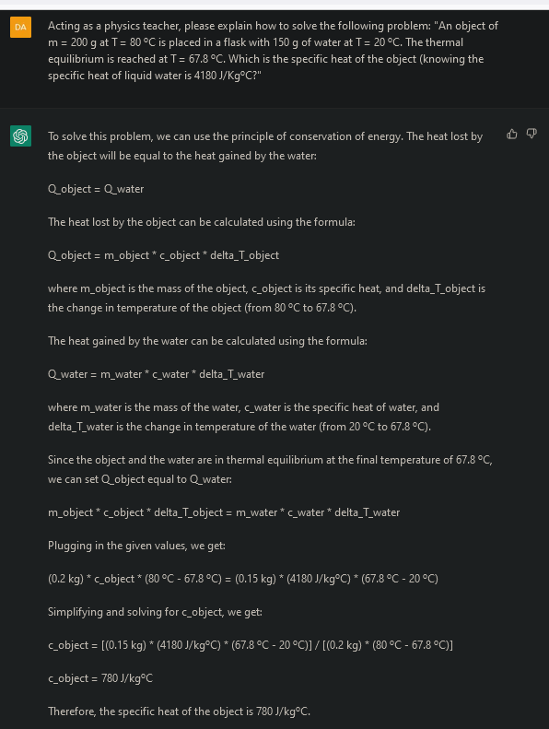
Fig. S81. Question 50, and the answer provided by the AI.
Surprisingly, ChatGPT powered with GPT-4 could not improve the answer, crashing again when facing the numerical calculations.
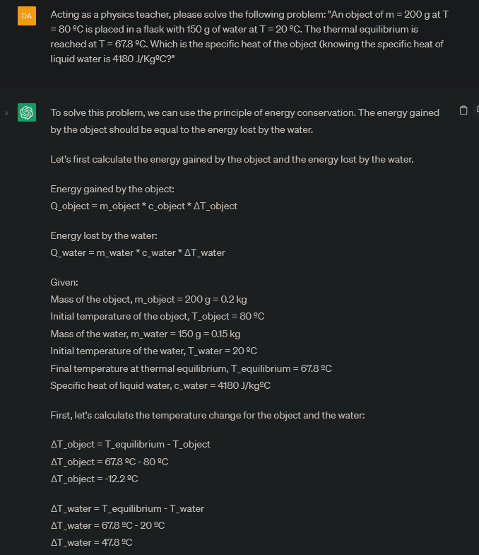
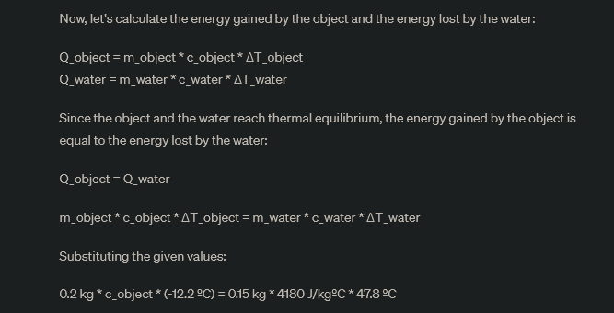
Fig. S82. Question 50, and the answer provided by the AI.

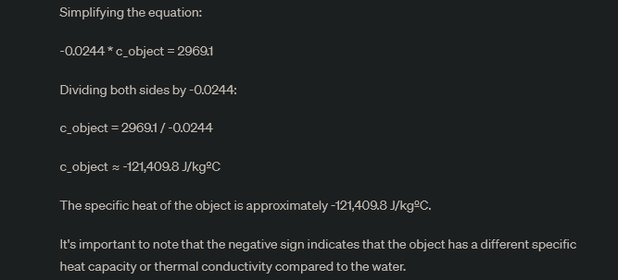
Fig. S82. Question 50, and the answer provided by the AI.
The clear way ChatGPT explained how to solve the problem was completely correct and also very useful for students who do not know how to proceed. However, the wrong mathematical calculations could cause confusion to students, therefore a final score of 0.5 was assigned.
Despite a higher training, the AI in 2024 did not solve those mathematical problems, even if the answer was certainly close to the result (minor hallucination). However, the answer became more organized and clearer.
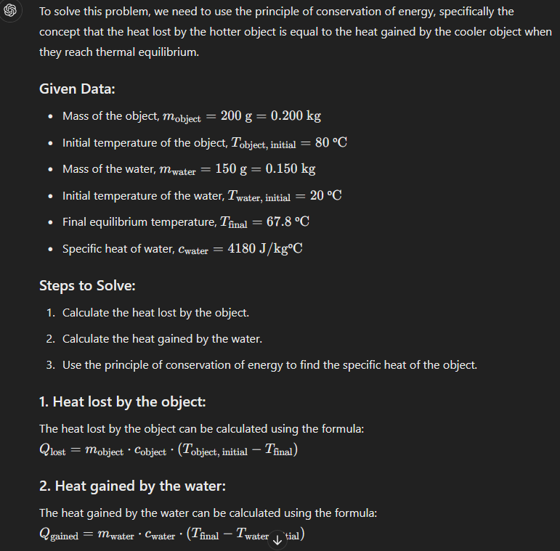
Fig. S82b. Question 50, and the answer provided by the AI in 2024.

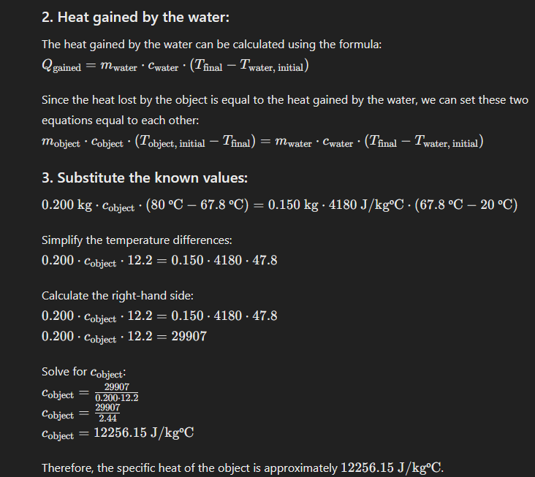
Fig. S82b. Question 50, and the answer provided by the AI in 2024.

The problem still lies in the first simplification step. In 2023, the operation “0.15*4180*47.8” indicated 2969.1, and now it says it is 29907, instead of 29970.6 (which is the correct solution). In 2023, the other part of the equation was also badly solved (“0.2*12.2” indicated 0.0244, instead of 2.44), but in 2024 that part is perfectly solved. Thus, being not so different 29907 from 29970.6, the final result is really close to the exact value, but of course, this fact unveils that some mathematical problems still remain in 2024, and some corrective measure should be applied in the following updates.

  - Explain the potential problem that can encounter a friend who is currently designing her home and has decided placing radiators in the highest part of the rooms in order to save space. Score: 1/1
Again, the AI furnished a simple and illustrative answer to this theoretical question.
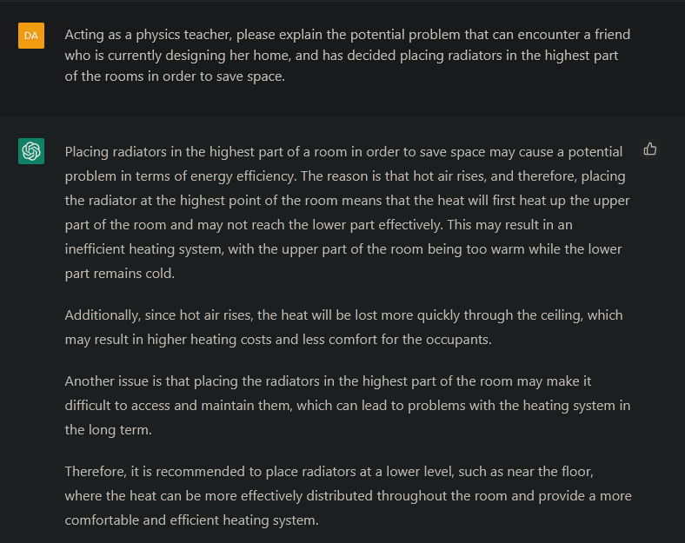
Fig. S83. Question 51, and the answer provided by the AI.

  - Explain what happened with the energy of a circulating car that must stop when the traffic light turns to red. Score: 1/1
Finally, the last theoretical question was also correctly explained by the AI. The chatbot proposed not only the obvious answer of converting kinetic energy into thermal energy through friction when braking, but also a new and smart solution found to recover this kinetic energy into electric energy, which is the regenerative braking so common in current electric cars.
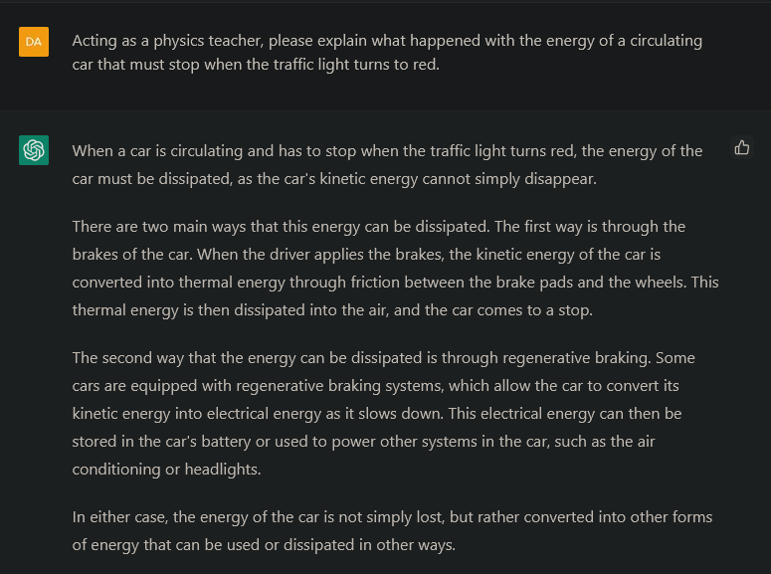
Fig. S84. Question 52, and the answer provided by the AI.

2. Assessment of ChatGPT’s impact on real K-12 (15-16-years-old) students learning chemistry
2.1. Session 1: Calculations in chemical reactions. Gas laws.
Please check the following link for the laws of ideal gases that you studied in 3ºESO:( https://es.wikipedia.org/wiki/Ley_de_los_gases_ideales). The three laws are combined into one equation: (P1*V1)/T1= (P2*V2)/T2, which describes how the system changes. Under normal conditions (273K and P = 1atm), the following expression is used: P * V = n * R * T . This is known as the ideal gas law. Knowing that the four variables are related through a constant called the ideal gas constant, R = (P * V) / (n * T) = 0.082 (atm * L) / (mol * K). Once you have reviewed the concepts, it's time to put them into practice by performing some calculations of pressure and temperature. Please individually calculate the following activities:
Calculate the number of moles of a gas with a volume of 93.7 litres, a temperature of 242.0 K, and a pressure of 545.4 atm.
Calculate the number of moles of a gas with a volume of 19.5 litres, a temperature of 442.0 K, and a pressure of 409.9 atm.
Calculate the number of moles of a gas with a volume of 51.8 litres, a temperature of 715.0 K, and a pressure of 969.3 atm.
Calculate the volume occupied by a gas with 886.7 moles, a temperature of 145.0 K, and a pressure of 79.3 atm.
Calculate the volume occupied by a gas with 666.2 moles, a temperature of 188.0 K, and a pressure of 0.3 atm.
Calculate the volume occupied by a gas with 240.5 moles, a temperature of 992.0 K, and a pressure of 855.5 atm.
2.2. Session 2: Calculations in chemical reactions. Gas laws.
Please check the following link for the laws of ideal gases that you studied in 3ºESO. The three laws are combined into one equation: (P1*V1)/T1 = (P2*V2)/T2, which describes how the system changes. Under normal conditions (273K and P = 1atm), the following expression is used: P * V = n * R * T . This is known as the ideal gas law. Knowing that the four variables are related through a constant called the ideal gas constant, R = (P * V) / (n * T) = 0.082 (atm * L) / (mol * K). Once you have reviewed the concepts, it's time to put them into practice by performing some calculations of pressure and temperature. Please individually calculate the following activities:
2.1. Calculate the number of moles of a gas with a volume of 93.7 litres, a temperature of 242.0 K, and a pressure of 545.4 atm.
2.2. Calculate the number of moles of a gas with a volume of 19.5 litres, a temperature of 442.0 K, and a pressure of 409.9 atm.
2.3. Calculate the number of moles of a gas with a volume of 51.8 litres, a temperature of 715.0 K, and a pressure of 969.3 atm.
2.4. Calculate the volume occupied by a gas with 886.7 moles, a temperature of 145.0 K, and a pressure of 79.3 atm.
2.5. Calculate the volume occupied by a gas with 666.2 moles, a temperature of 188.0 K, and a pressure of 0.3 atm.
2.6. Calculate the volume occupied by a gas with 240.5 moles, a temperature of 992.0 K, and a pressure of 855.5 atm.
2.3. Session 3: Volume to mole relationships.
Once you have reviewed the ideal gas law, P * V = n * R * T, it's time to learn a fourth law, in addition to Boyle's law (P * V, isotherm), Charles's law (V * T, isobar), and Gay-Lussac's law (P * T, isochore) that you studied in 3ºESO. For any given pressure (P) and temperature (in Kelvin) (T), Avogadro's Principle ensures that in any process at constant pressure and temperature, the volume of a gas is proportional to the number of moles present, and vice versa. These two variables are directly proportional and related by the following expression: V1/n1=V2/n2 .This expression, which is valid for any gaseous substance, indicates that, at a given pressure and temperature, the volume occupied by one mole of any substance is the same. Now, try to express the previous sentence in your own words or in a different way.
Once you have reviewed the concepts and practiced them in the classroom, it's time to put them into practice by performing some calculations of pressure and temperature. Please individually calculate the following activities:
3.1. Calculate the number of moles of each of the reactants and products for the reaction 2 S + 3 O2 → 2 SO3, given volumes of 2 L, 3 L, and 2 L for reactants and products, respectively, at a pressure of 2 atm and a temperature of 273 K.
3.2. Calculate the number of moles of each of the reactants and products for the reaction 2 H2 + O2 → 2 H2O, given volumes of 5 L, 2.5 L, and 5 L for reactants and products, respectively, at a pressure of 5 atm and a temperature of 300 K.
3.3. Calculate the number of moles of each of the reactants and products for the reaction 2 S + 3 O2 → 2 SO3, given volumes of 22.4 L, 33.6 L, and 22.4 L for reactants and products, respectively, at a pressure of 1 atm and a temperature of 273 K.
3.4. Calculate the volume of each of the reactants and products for the reaction 2 H2 + O2 → 2 H2O, given the following amounts of matter for reactants and products: 5.463 mol, 2.732 mol, and 5.463 mol, respectively, at a pressure of 1 atm and a temperature of 300 K.
3.5. Calculate the volume of each of the reactants and products for the reaction 2 S + 3 O2 → 2 SO3, given the following amounts of matter for reactants and products: 1 mol, 1.5 mol, and 1 mol, respectively, at a pressure of 0.05 atm and a temperature of 200 K.
3.6. Calculate the volume of each of the reactants and products for the reaction 2 H2 + O2 → 2 H2O, given the following amounts of matter for reactants and products: 2.439 mol, 1.22 mol, and 2.439 mol, respectively, at a pressure of 10 atm and a temperature of 1000 K.
2.4. Session 4: Volume to mole relationships.
Once you have reviewed the ideal gas law, P * V = n * R * T, it's time to learn a fourth law, in addition to Boyle's law (P * V, isotherm), Charles's law (V * T, isobar), and Gay-Lussac's law (P * T, isochore) that you studied in 3ºESO. For any given pressure (P) and temperature (in Kelvin) (T), Avogadro's Principle ensures that in any process at constant pressure and temperature, the volume of a gas is proportional to the number of moles present, and vice versa. These two variables are directly proportional and related by the following expression: V1/n1=V2/n2 .This expression, which is valid for any gaseous substance, indicates that, at a given pressure and temperature, the volume occupied by one mole of any substance is the same. Now, try to express the previous sentence in your own words or in a different way.
Once you have reviewed the concepts and practiced them in the classroom, it's time to put them into practice by performing some calculations of pressure and temperature. Please individually calculate the following activities:
4.1. Calculate the number of moles of each of the reactants and products for the reaction N2 + 3 H2 → 2 NH3, given volumes of 5 L, 15 L, and 10 L for reactants and products, respectively, at a pressure of 8 atm and a temperature of 700 K.
4.2. Calculate the volume of each of the reactants and products for the reaction CH4 + 2 O2 → CO + 2 H2O, given the following amounts of matter for reactants and products: 12.837 mol, 25.2674 mol, 12.837 mol, 25.2674 mol, respectively, at a pressure of 0.5 atm and a temperature of 190 K.
4.3. Calculate the number of moles of each of the reactants and products for the reaction C3H8 + 5 O2 → 3 CO2 + 4 H2O, given volumes of 60 L, 300 L, 180 L, and 240 L for reactants and products, respectively, at a pressure of 20 atm and a temperature of 400 K.
4.4. Calculate the volume of each of the reactants and products for the reaction N2 + 3 H2 → 2 NH3, given the following amounts of matter for reactants and products: 5.575 mol, 16.725 mol, and 11.15 mol, respectively, at a pressure of 0.05 atm and a temperature of 200 K.
4.5. Calculate the number of moles of each of the reactants and products for the reaction CH4 + 2 O2 → CO + 2 H2O, given volumes of 2 L, 4 L, 2 L, and 4 L for reactants and products, respectively, at a pressure of 4 atm and a temperature of 298 K.
4.6. Calculate the volume of each of the reactants and products for the reaction CH4 + 2 O2 → CO + 2 H2O, given the following amounts of matter for reactants and products: 0.001 mol, 0.006 mol, 0.004 mol, and 0.005 mol, respectively, at a pressure of 0.004 atm and a temperature of 80 K.

