Supplementary Figures
Fig. S1
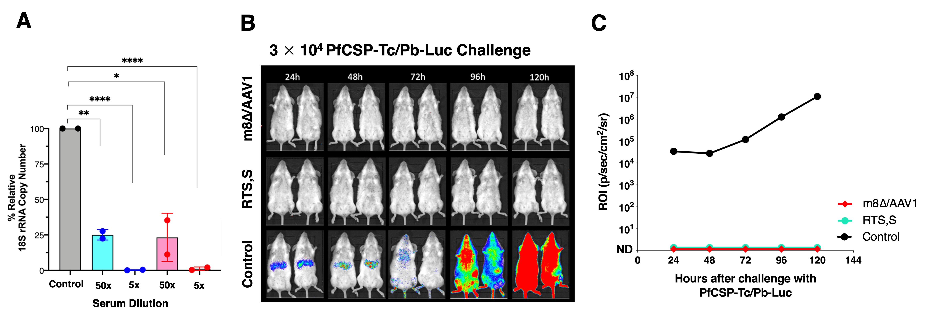
Figure S1. Transgenic sporozoite-neutralizing activity. (A) Sera from BALB/c mice immunized with m8∆/AAV1 or RTS,S/AS01 (RTS,S) were tested in transgenic sporozoite neutralization assay. PfCSP-Tc/Pb sporozoites were incubated with control mice sera or immune sera at two serum dilutions (1:5 or 1:50) before addition to HepG2 cells. After 48 h of culture, levels of parasites in HepG2 cell extracts were measured by real-time PCR. Results are shown as percentage relative 18S rRNA copy number. Differences between groups were analyzed using an unpaired t-test. *p < 0.05, **p < 0.01, ****p < 0.0001. (B) BALB/c mice, n = 2 per group, were inoculated with m8∆/AAV1 or RTS,S to form the immunized groups, and PBS was used for the control group. Four weeks after the final immunization, mice were challenged with 3 × 10⁴ PfCSP-Tc/Pb sporozoites expressing the luciferase gene (PfCSP-Tc/Pb Luc). The mean total photon flux (whole body) from 24–120 h after intravenous administration of PfCSP-Tc/Pb Luc is shown. ROI: region of interest, ND: not detected.

Fig. S2
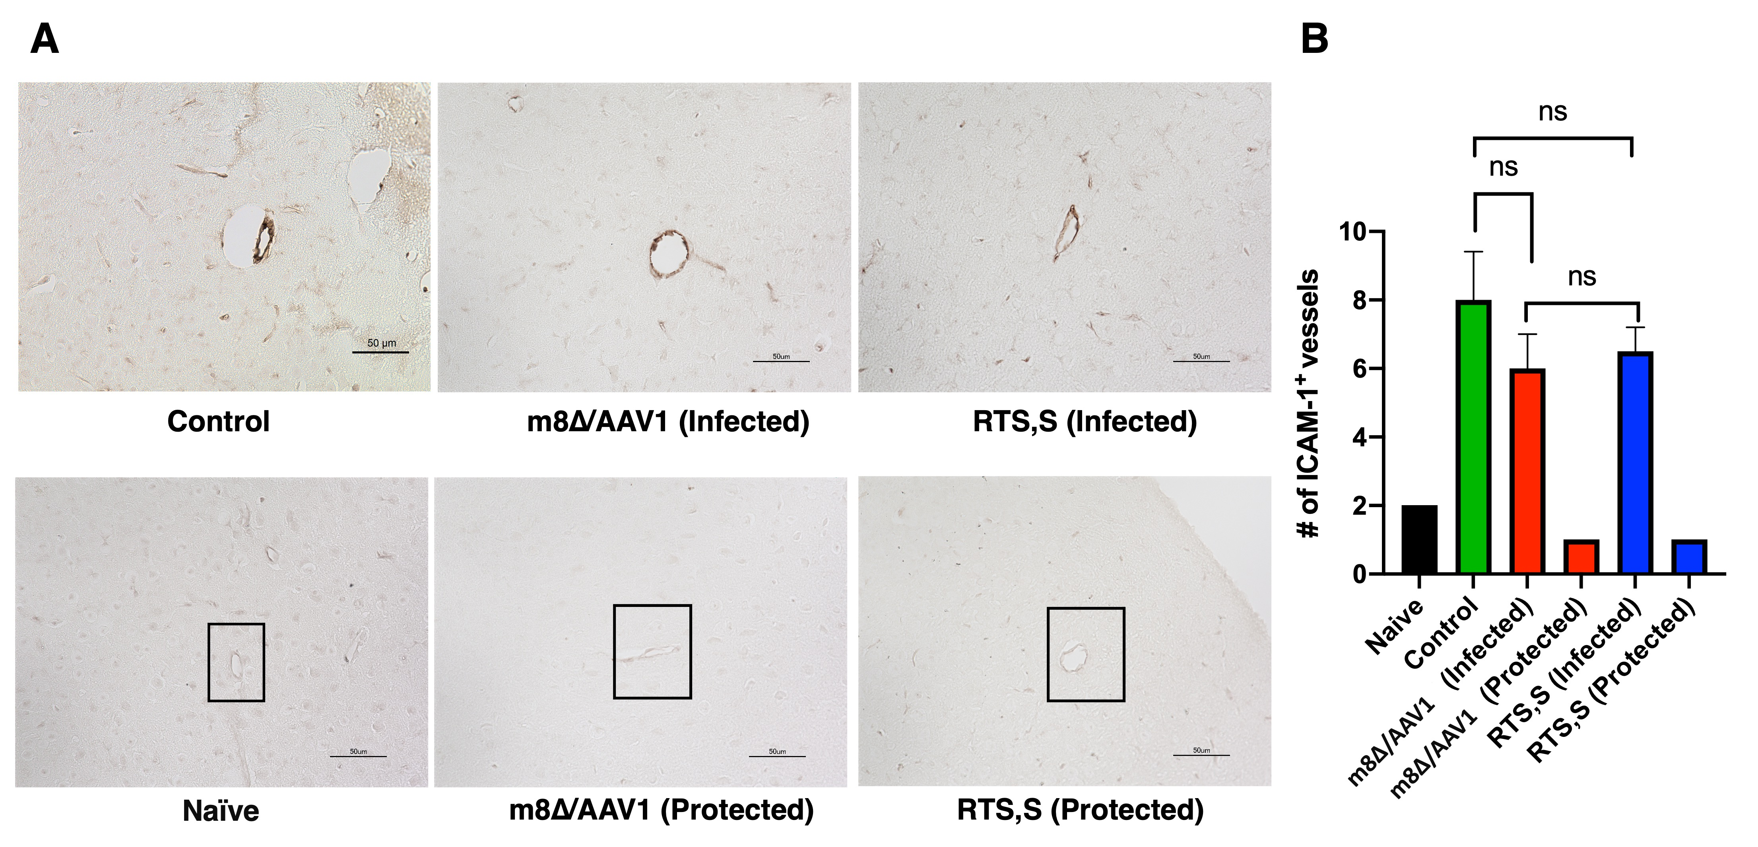

Figure S2. Assessment of vaccine efficacy against cerebral malaria. Immunohistochemical staining for ICAM-1 in cerebral vessel endothelia of vaccinated C57BL/6 mice on day 8 after challenge with 1 × 10³ Pfs25-PfCSP/Pb sporozoites. (A) Representative images showing ICAM-1 expression in control, m8∆/AAV1 (infected), RTS,S (infected) and almost no ICAM-1 expression in naïve, m8∆/AAV1 (protected), and RTS,S (protected) groups. Scale bar: 50 μm. (B) Quantification of ICAM-1-positive vessels across different groups. Data represent the mean number of positive vessels per 20 fields at 400× magnification for each group; error bars denote SEM. Differences between groups were analyzed using unpaired t-test. “ns” indicates no significant differences between groups.

