Supplementary Material
Sustainable synthesis of new antioxidants from hydroxytyrosol by direct biocatalytic esterification in ionic liquids
Susana Nieto*, Inmaculada Lozano, Francisco J. Ruiz, Jose F. Costa, Rocío Villa, Pedro Lozano*.
Departamento de Bioquímica y Biología Molecular B e Inmunología. Facultad de Química, Universidad de Murcia, E-30100 Murcia, Spain
* Corresponding author. To whom all the correspondence should be addressed.

1. Confirmation of the synthesis of hydroxytyrosyl hexanoate.
1.1. FTIR analyses
The esterification of HT with hexanoic acid was selected a reaction model to test the suitability of the biocatalytic approach developed in ILs. FTIR analyses were conducted to identify the vibration bands of the functional groups in HT, FFAs and the ester products using a FT/IR-4700 (JASCO Analytical Instruments, Easton, PA, EE.UU.) with a range of measurement 3,500 - 400 cm⁻¹ and 0.4 cm⁻¹ resolution.
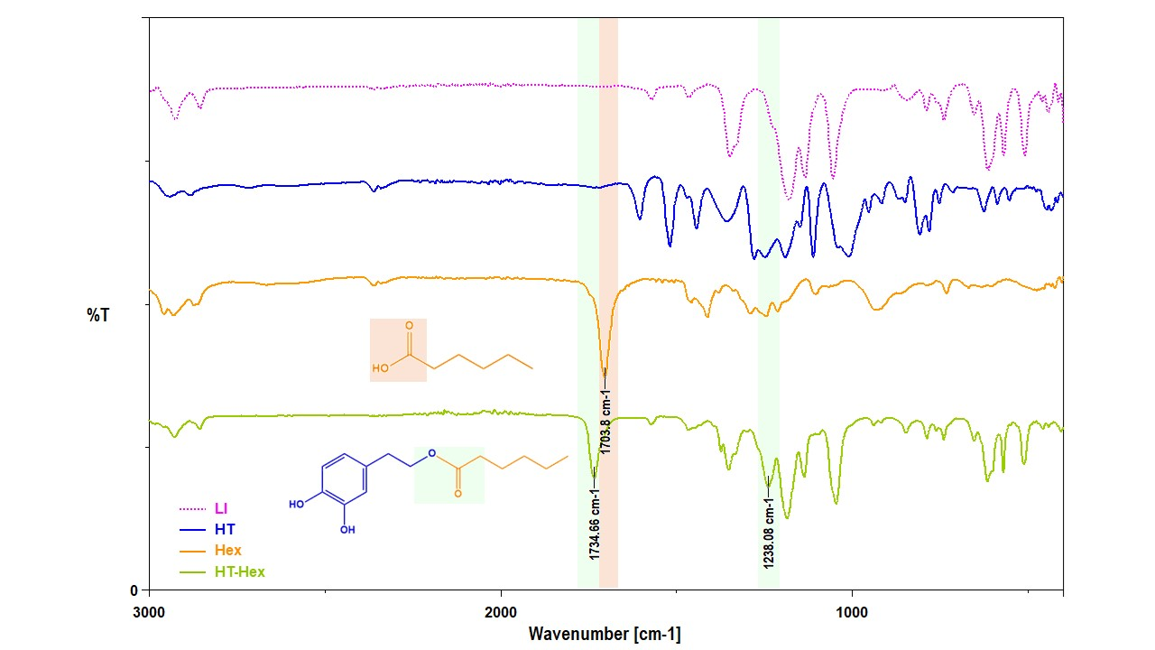

Figure S1. FTIR spectra of HT, Hex, HT-Hex ester and the LI-[C₁₂mim][NTf₂].
The shift of the vibration band of the carbonyl group from 1704 cm⁻¹ to 1735 cm⁻¹ is due to the stretching provoked by the ester bond. The new C-O-C bond also leads to the detection of a new band at 1238 cm⁻¹.

1.2. HPLC-MS analysis
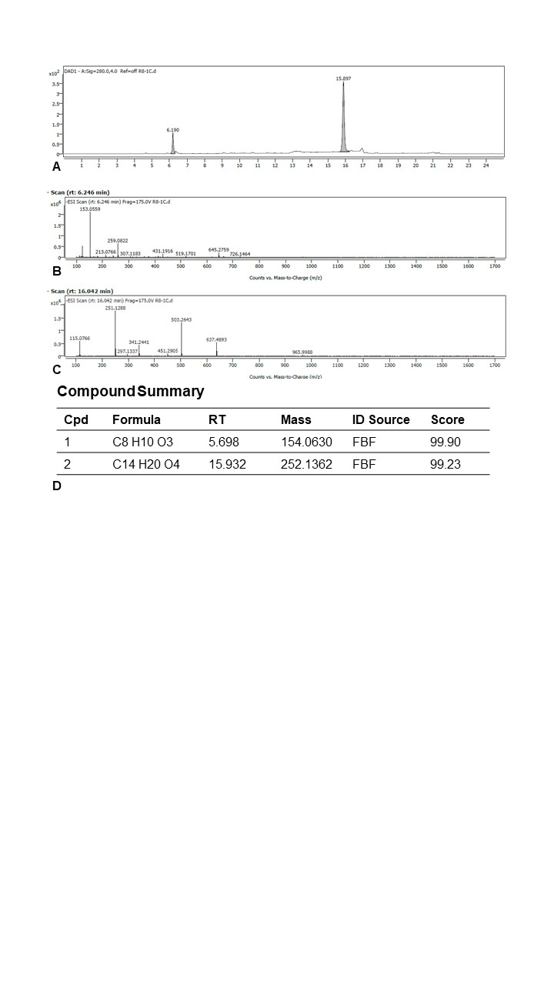
HPLC-MS analyses were performed with a HPLC-DAD Agilent 1200 equipped with a RP-C18 column (250 mm × 5 μm) and an electrospray detector ESI-TOF Agilent 6220 (Agilent, USA). Signals were obtained by scanning in the range 100-1000 m/z operating in negative ion mode. The ion spectra were compared with a NIST library for the identification of the reaction species (Figure S2).

Figure S2. HPLC-MS analysis in negative ion mode of the esterification of HT with hexanoic acid. A. Peaks of HT (6.2 min) and HT-Hex (15.9 min) detected at 280 nm. B. ESI chromatogram of the peak at 6.2 min retention time containing ions with m/z=153, corresponding to HT. C. SI chromatogram of the peak at 15.9 min retention time. Ions with m/z=251 are detected, corresponding to HT-Hex. D. Table of compounds identification.
The absorption chromatogram at 280 nm reveals two peaks (Figure S2.A), the first one corresponding to non-reacted HT (m/z=154, Figure S2.B) and a more important peak corresponding to HT-Hex (m/z= 252, Figure S2.C).

1.3. NMR analyses
Additionally, ¹H-NMR and ¹³C-NMR assays provide relevant information about the synthesis and structure of HT-Hex. Samples of 50 μL of HT, Hex, [C₁₂mim][NTf₂] and the reaction media containing HT-Hex, were diluted with DMSO-δ6 up to 400 μL final volume and analyzed in a Bruker Avance, 400 MHz spectrometer.

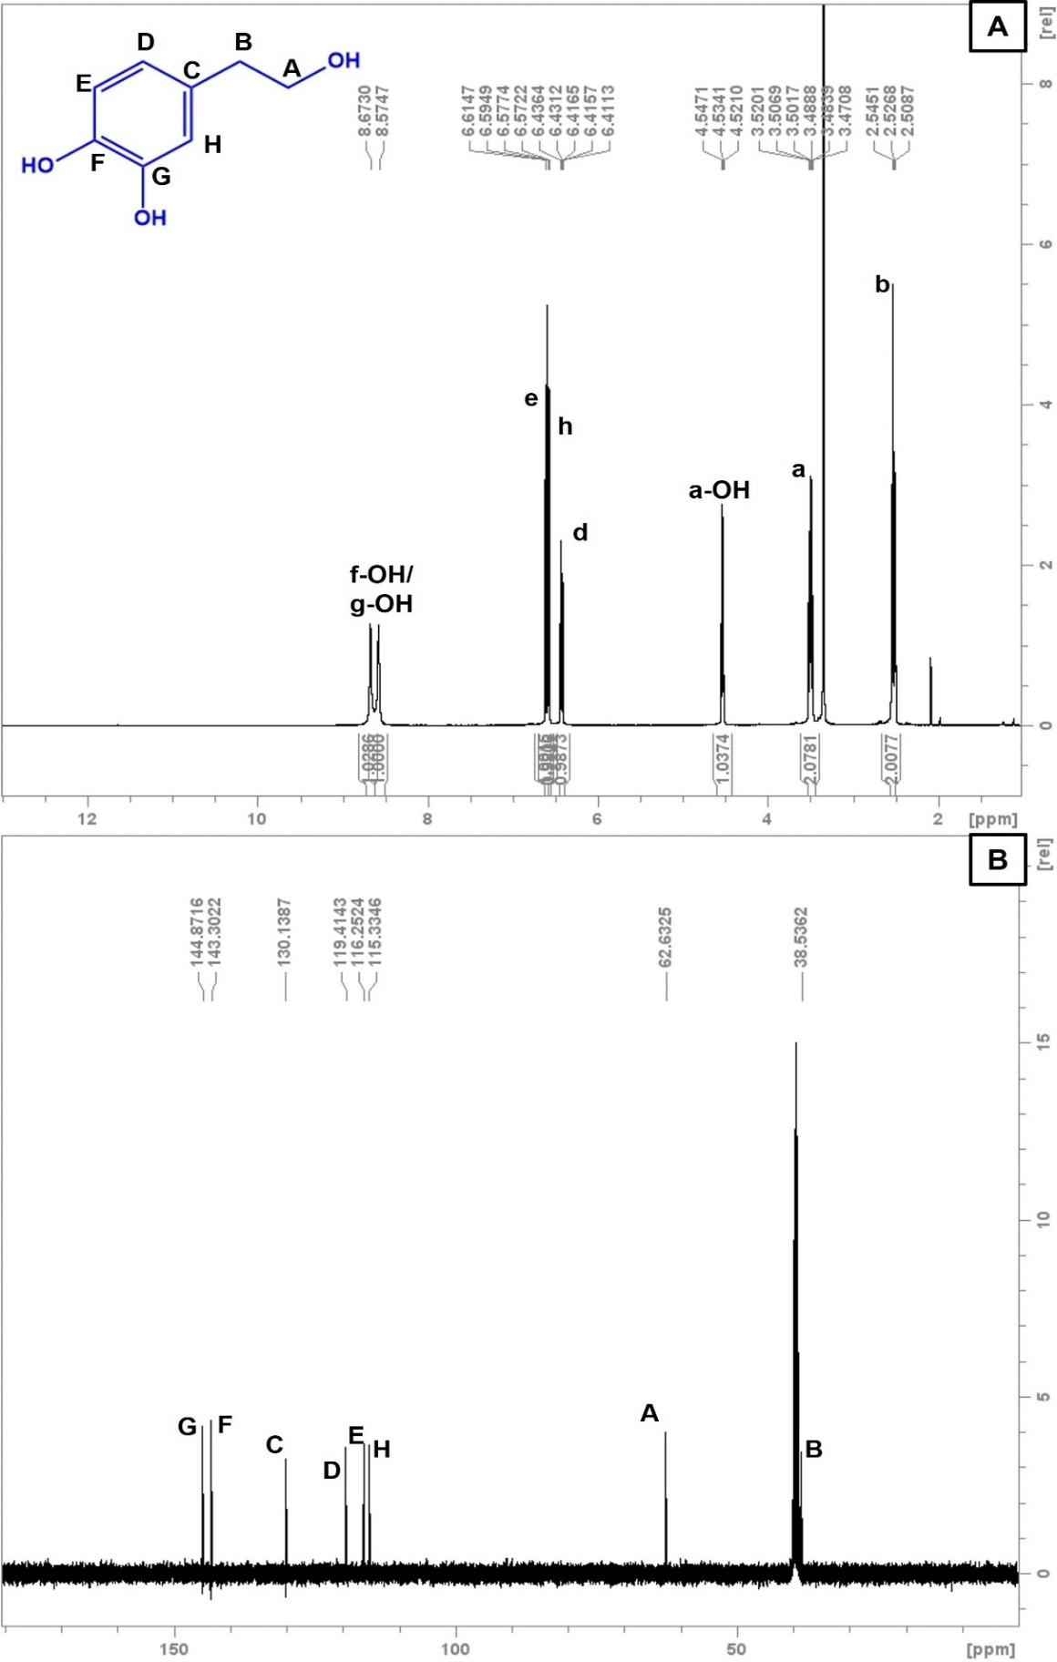

Figure S3. ¹H-NMR (A) and ¹³C-NMR (B) spectra of commercial hydroxytyrosol (TCI).

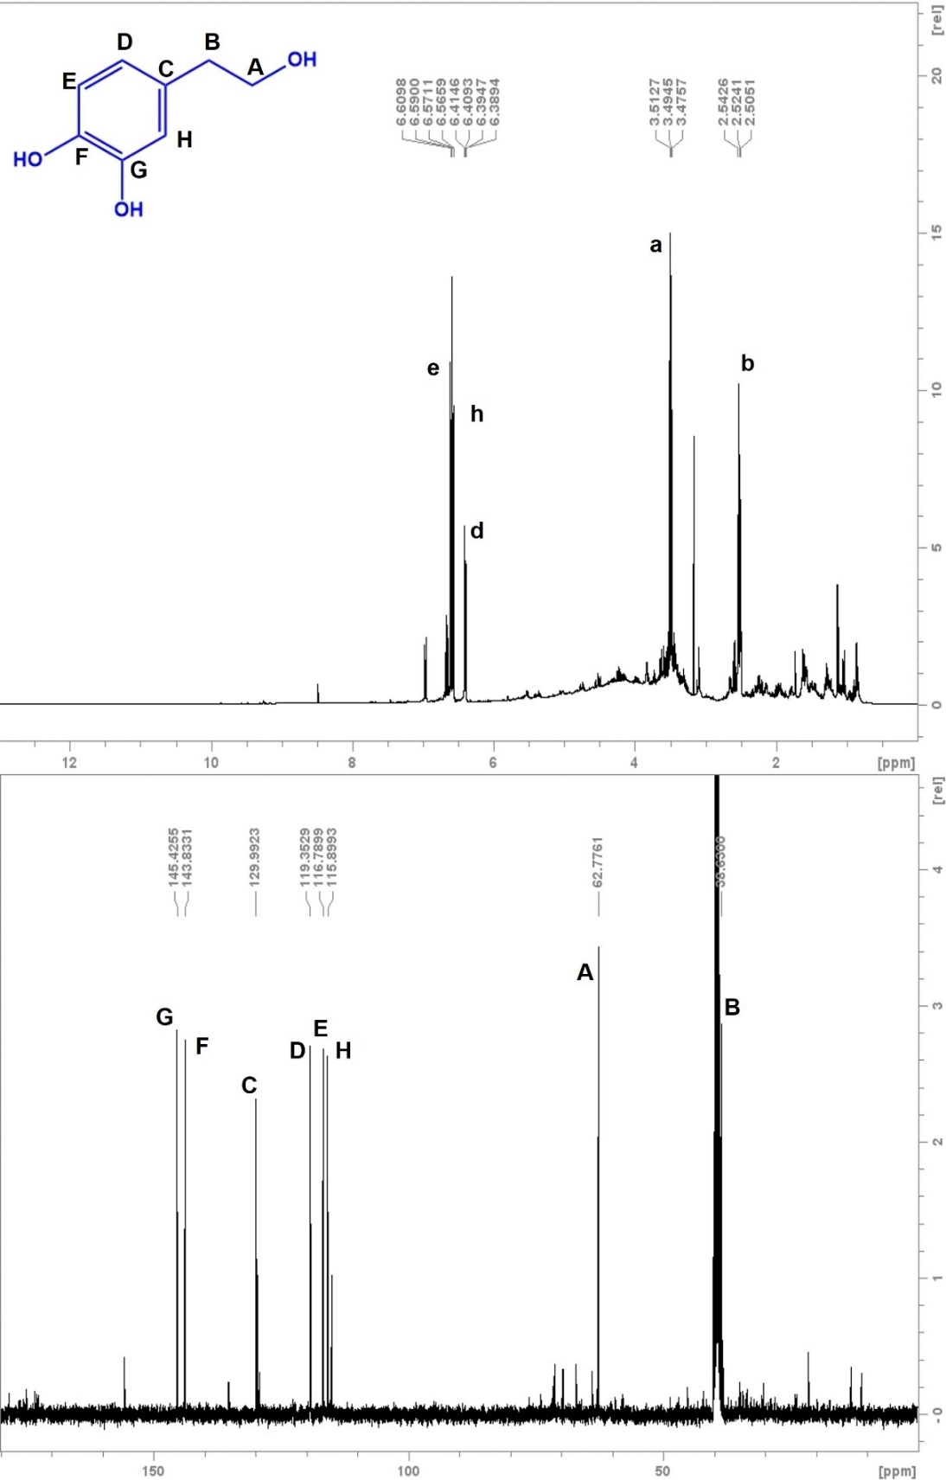

Figure S4. ¹H-NMR (A) and ¹³C-NMR (B) spectra of hydroxytyrosol used in this work, kindly gifted by Deretil Nature S.A.

Hydroxytyrosol: ¹H-NMR δ(ppm): 3.48 (dt, 2H, H_{a}); 4.53 (t, 1H, H_{a}-OH); 2.52 (t, 2H, H_{b}); 6.42 (dd, 1H, H_{d}); 6.60 (d, 1H, H_{e}); 8.57/8.67 (s, 1H, H_{f}-OH or H_{g}-OH, indistinguishable); 6.57 (d, 1H, H_{h}). ¹³C-NMR δ(ppm): 62.6 (C_{A}); 38.5 (C_{B}); 130.1 (C_{C}); 119.4 (C_{D}); 116.3 (C_{E}); 143.3 (C_{F}); 144.9 (C_{G}); 115.4 (C_{H}).
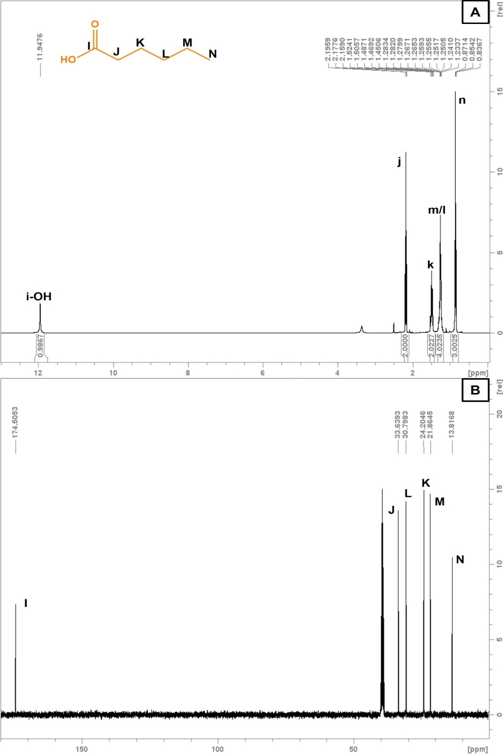

Figure S5. ¹H-NMR (A) and ¹³C-NMR (B) spectra of hexanoic acid.
Hexanoic acid: ¹H-NMR δ(ppm): 11.95 (s, 1H, H_{i}-OH); 2.18 (t, 2H, H_{j}); 1.48 (q, 2H, H_{k}); 1.18-1.33 (m, 4H, H_{l} and H_{m}, indistinguishable); 0.85 (t, 3H, H_{n}). ¹³C-NMR δ(ppm): 174.5 (C_{I}); 33.6 (C_{J}); 24.2 (C_{K}); 30.8 (C_{L}); 21.9 (C_{M}); 13.8 (C_{N}).
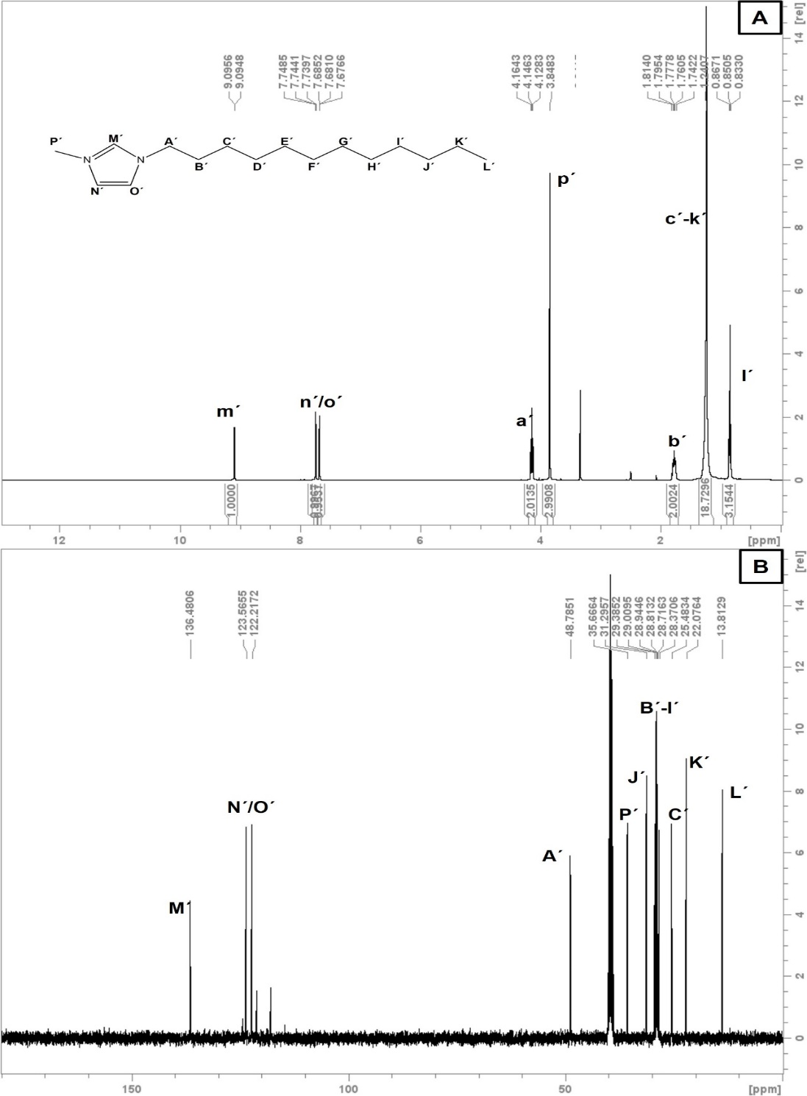

Figure S6. ¹H-NMR (A) and ¹³C-NMR (B) spectra of IL [C₁₂mim][NTf₂].

1-Dodecyl-3-methylimidazolium bis(trifluoromethylsulfonyl)imide: ¹H-NMR δ(ppm): 4.14 (t, 2 H, H_{a´}); 1.77 (q, 2 H, H_{b´}); from 1.32 to 1.15 (m, 18 H, from H_{c´} to H_{k´,} indistinguishable); 0.85 (t, 2H, H_{l´}); 9.09 (dd, 1H, H_{m´}); 7.75 (dd, 1H, H_{n´}); 7.76 (dd, 1H, H_{o´}); 3.84 (s, 3H, H_{p´}). ¹³C-NMR δ(ppm): 48.8 (C_{A´}); from 29.3 to 28.4 (from C_{B´}to C_{I´}, indistinguishable); 25.5 (C_{C´}); 31.3 (C_{J´}); 22.1 (C_{K´}); 13.8 (C_{L´}); 136.5 (C_{M´}); 123.6 and 122.1 (C_{N´}and C_{O´}, indistinguishable).

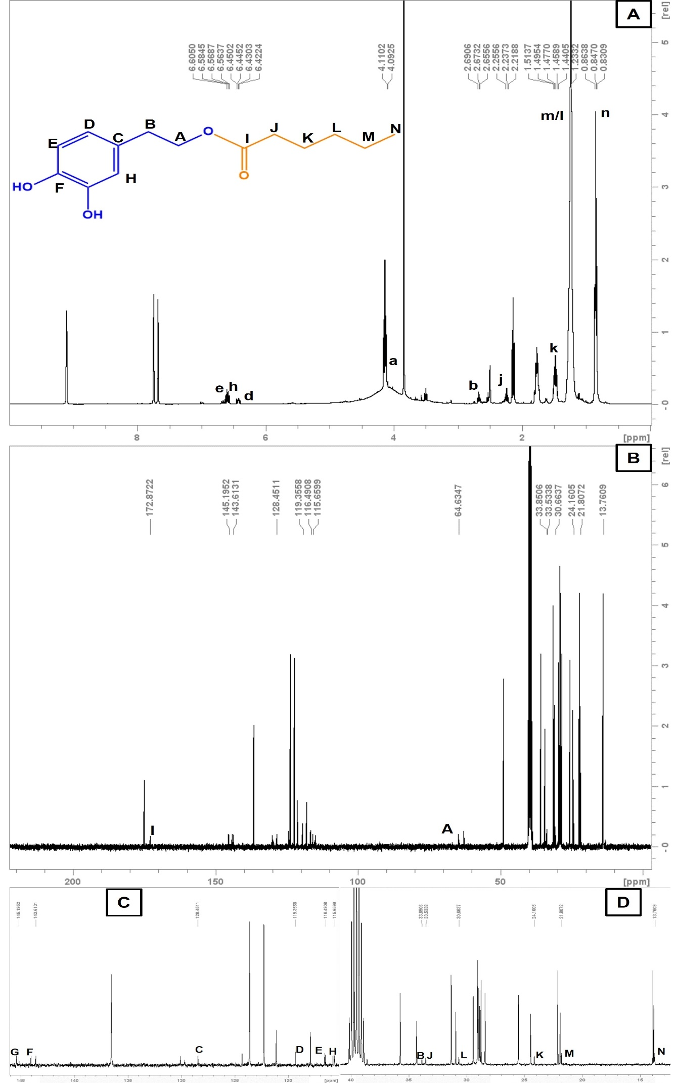

Figure S7. ¹H-NMR (A) and ¹³C-NMR (B) spectra of the reaction medium of HT-Hex synthesis. (C) and (D) are expanded regions of ¹³C-NMR (B) spectra. Reaction performed with 1:4 HT:Hex (mol:mol), 80 ºC, 1h, in the SLIL [C₁₂mim][NTf₂] 70 % (w/w).

Hydroxytyrosyl hexanoate: ¹H-NMR δ(ppm):4.11 (t, 2H, H_{a}); 2.67 (t, 2H, H_{b}); 6.43 (dd, 1H, H_{d}); 6.59, (d, 1H, H_{e}); 6.56 (d, 1H, H_{h}); 2.23 (t, 2H, H_{j}); 1.47 (q, 2H, H_{k}); 1.18-1.33 (m, 4H, H_{l} and H_{m}, indistinguishable); 0.85 (t, 3H, H_{n}). ¹³C-NMR δ(ppm): 64.6 (C_{A}); 33.8 (C_{B}); 128.5 (C_{C}); 119.4 (C_{D}); 116.5 (C_{E}); 143.6 (C_{F}); 145.1 (C_{G}); 115.7 (C_{H}); 172.9 (C_{I}); 33.5 (C_{J}); 24.1 (C_{K}); 30.7 (C_{L}); 21.8 (C_{M}); 13.8 (C_{N}).

2. Determination of residual IL in extracted HT-Hex by ¹⁹F-RMN.
The esterification of HT at high scale was selected to perform the extraction of the HT-Hex product. A liquid-liquid extraction with five volumes of a mixture of PG:H₂O (85:15 v/v) was carried out, followed by cooling at 0 ºC and centrifuging to precipitate the solid IL. A 40 µL aliquot of the upper liquid phase containing the reaction species was analyzed by ¹⁹F-NMR using 40 µL TFA as internal standard. Data were referred to a sample of pure IL to determine the of residual IL. Data reveals a residual IL content of only 1 %.
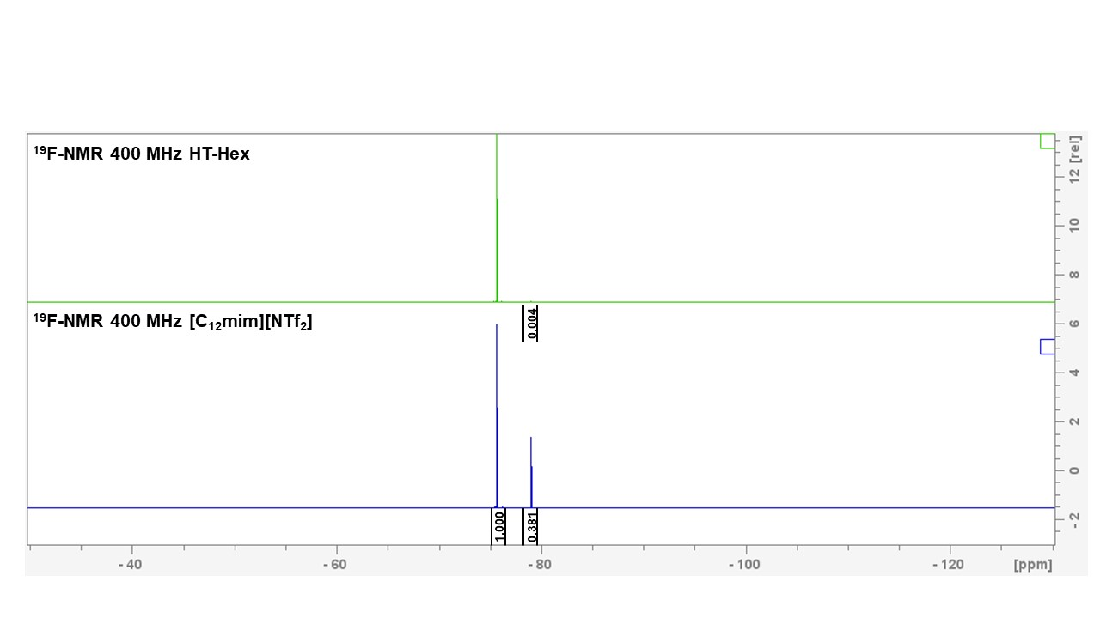

Figure S8. ¹⁹F-NMR spectra of [C₁₂mim][NTf₂] and the extracted sample of HT-Hex.
3. Sustainable analysis of the synthesis of HT esters
Different green metric parameters have been selected to perform the analysis of sustainability. Table S1 collects those parameters, their formulas ad a brief definition. Under the most sustainable condition, the parameters should reach values close to 1, with the exception of the E-Factor, where the lower value is pursued.

Table S1. Green Metric Parameters, equations, and definitions. [,]
Parameter | Calculation | Definition
Atom Economy (AE) | $$AE=\frac{Products Mw}{Σ Reactants Mw}$$ | Quantifies the atoms incorporated into the final product and the amount of waste produced in a reaction
Stoichiometric Factor (SF) | $$SF=1+\frac{Mass of Excess of Reactives (g)}{Mass of Stoichiometric Reactives (g)}$$ | Refers to the molar ratio of substrates and permits to perform calculations when using one or more reactants in excess with respect to a limiting one
Yield of Panthenol Monoesters  (ε) | $$ε=\frac{MSP}{MMP}$$ | Provides an insight into the reactivity of substrates and quantifies the selective (bio)catalytic productivity of the reaction
Material Recovery Parameter^{b}  (MRP) | $$MRP=\frac{1}{1+\frac{ε· AE· (C+S+W)}{SF·MSP}}$$ | Shows the loss of auxiliary materials not recovered along the reaction and downstream steps
Reaction Mass Efficiency (RME) | $$RME=\frac{ε ·AE ·MRP}{SF}$$ | Mass-based metric, similar to AE, but also considers yield and use of excess reagents
Product Mass Intensity (PMI) | PMI= $\frac{1}{RME}$ | Analyzes the input-output mass balance to identify the main sources of waste
E-factor | $$E=\frac{1-RME}{RME}=PMI-1$$ | Quantifies the amount of waste formed per kg product
Total Carbon Release (TCR) | TCR = (PMI organic x 2.3) + (PMI water x 0.63) | Measures CO₂ emissions in case of waste incineration from organic and aqueous sources
Mw: molecular weight; MSP: Mass of synthesized products; MMP: Maximum mass of products; C: Catalyst (g); S: Substrates (g); W: Wastes (g) The term W does not include biocatalysts and LI because both are recovered.

In addition, the EcoScale is an available free tool that permits to perform a preliminary overview of the Life Cycle Assessment of processes. Although this tool does not allow a fine discrimination between reaction conditions, it is very useful to evaluate certain parameters not contemplated in the previous metrics, such as the energy required, the price and toxicity of the reagents, or the stages and equipment necessary for the synthesis and extraction of the products. On this occasion, the tool deals with penalties that are subtracted to an initial value of 100 % sustainability and the aim is to reduce those penalties to obtain the higher value. Table S2 collects the penalties assigned to the approaches in Table 3 in the manuscript.
For entries 1-3, most of the penalties come from the cost and safety of substrates and reagents used, whereas the lower yield is mainly penalized in 3 and 4. However, it is important to note that the EcoScale only consider yield of the limiting substrate and do not account for the excess of substrate used in the entries 1 and 2. This is a limitation of this tool, together with the rough discrimination between the reaction conditions in the section of Technical setup. However, this is a very interesting metric when used in combination with other parameters that counterbalance those weaknesses.

Table S2. List of penalties assigned in each category of the EcoScale. The penalties are subtracted from an initial value of 100. F: Flammable; N: Dangerous for environment; T: Toxic.
Entry | 1 | 2 | 3 | 4
Yield | -1 | -6 | -12.5 | -12
Price availability
Hydroxytyrosol | -5 | -5 | -5 | -5
Ethyl palmitate | -5
Vinyl decanoate |  | -5
Hexanoic acid |  |  | 0 | 0
MBTE |  | -5 | -5
CH₂Cl₂ |  | -3
n-Hexane | -5 | -3 | -3
Acetonitrile | -5
Propylene glycol |  |  |  | 0
Safety*
n-Hexane (F,N) | -10 | -10 | -10
Acetonitrile (F,T)
Ethanol (T,F) |  |  | -10
Technical setup
Common setup | 0 | 0 | 0 | 0
Temperature-Time
Heating > 1h | -3 | -3 | -3 | -3
Work up and purification
Classical chromatography | -10 | -10
Simple filtration | 0 | 0
Liquid-liquid extraction |  |  | -3 | -3
Removal of solvent with bp < 150 ºC | 0 | 0 |  | 0
EcoScale value | 46 | 50 | 48.5 | 77

. Nieto, S., Bernal, J.M., Villa, R., Garcia-Verdugo, E., Donaire, A., Lozano, P. Sustainable set-ups for the biocatalytic production and scale-up of panthenyl monoacyl esters under solvent-free conditions. ACS Sustain. Chem. Eng. 2023, 11, 5737–5747, DOI: 10.1021/acssuschemeng.3c00266.
. Sheldon, R. A. Metrics of Green Chemistry and Sustainability: Past, Present, and Future. ACS Sustainable Chem. Eng. 2018, 6, 32−48, DOI: 10.1021/acssuschemeng.7b03505.

