Supplementary Materials
Bimetallic mesoporous MCM-41 nanoparticles with Ta/(Ti, V, Co, Nb) with catalytic and photocatalytic properties
Viorica Parvulescu, Gabriela Petcu, Nicoleta G. Apostol, Irina Atkinson, Simona Petrescu, Adriana Baran, Daniela C. Culita, Ramona Ene, Bogdan Trica and Elena M. Anghel
Figure S1. The high angles XRD diffractograms of TaMe/MCM-41 samples.

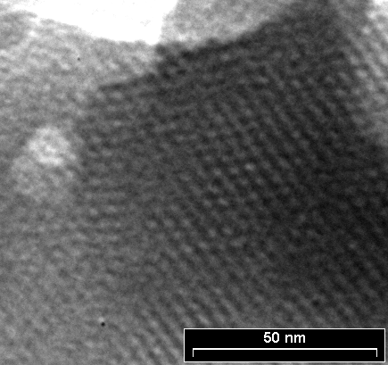  a | 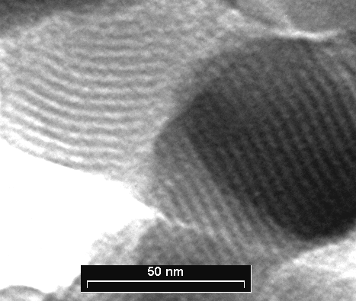  b
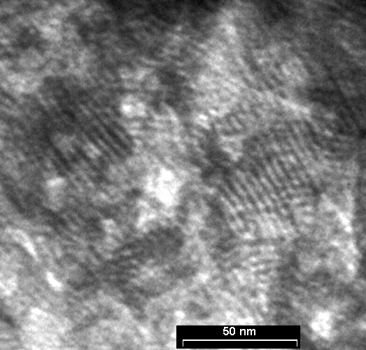  c | 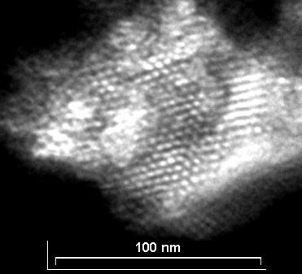  d
e

Figure S2. TEM images of Ta-MCM-41 (a); TaV-MCM-41 (b);
TaTi-MCM-41 (c); TaNb-MCM-41 (d) and TaCo-MCM-41 (e) samples.
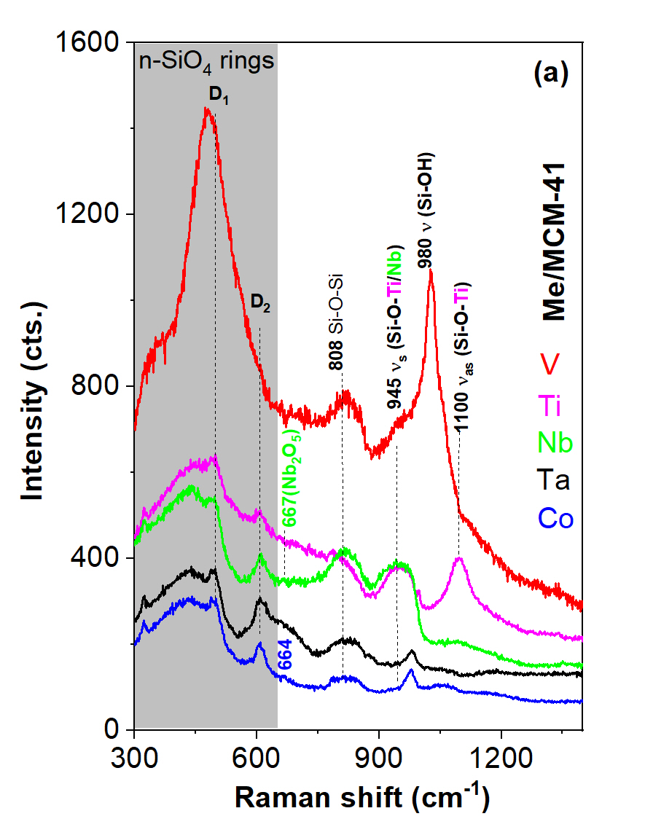 | 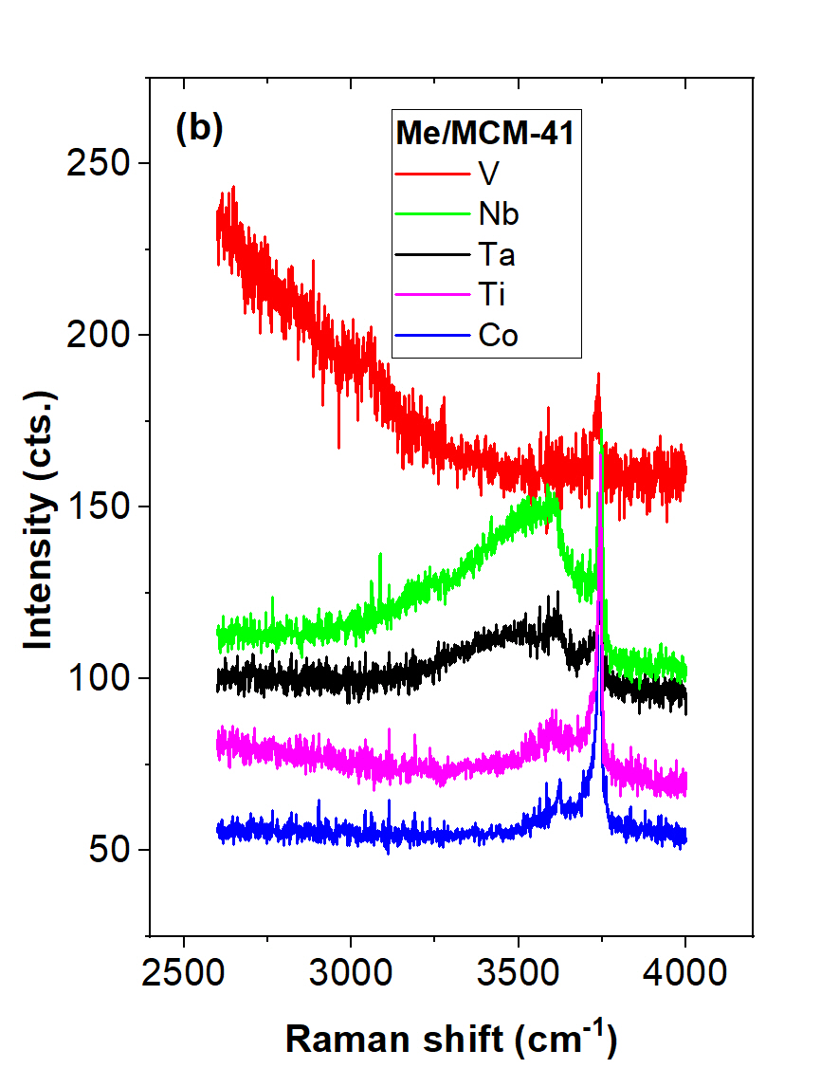
Figure S3. Raman spectra of the monometallic (Ta, V, Ti, Nb, Co)-MCM-41 samples
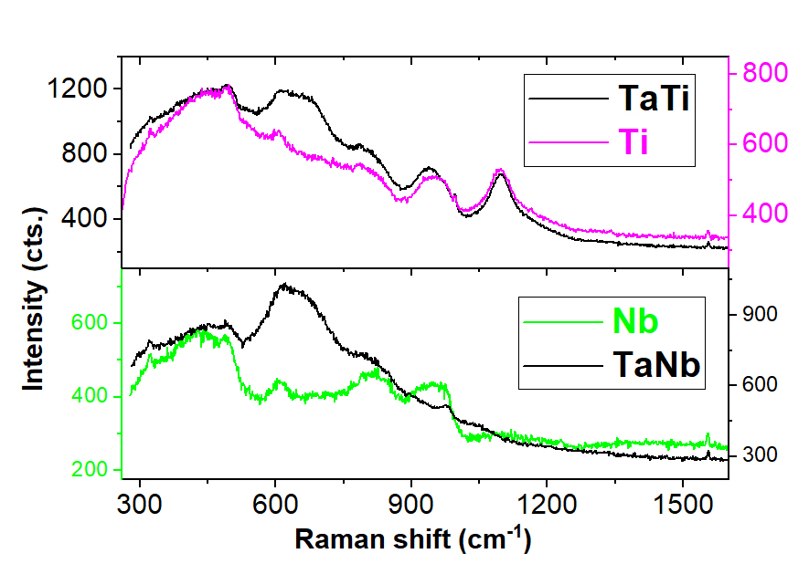 | 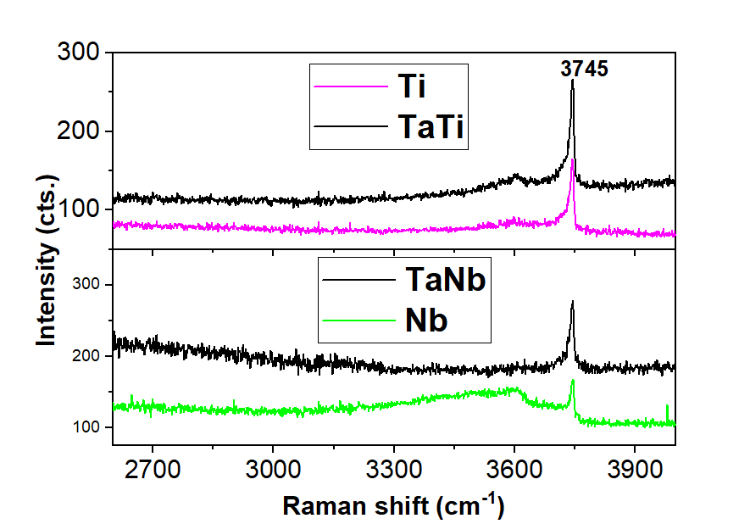
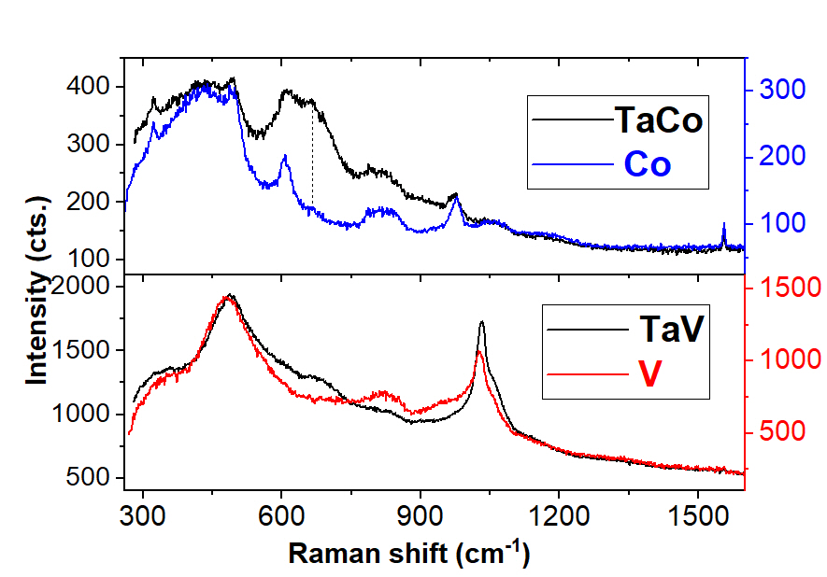 | 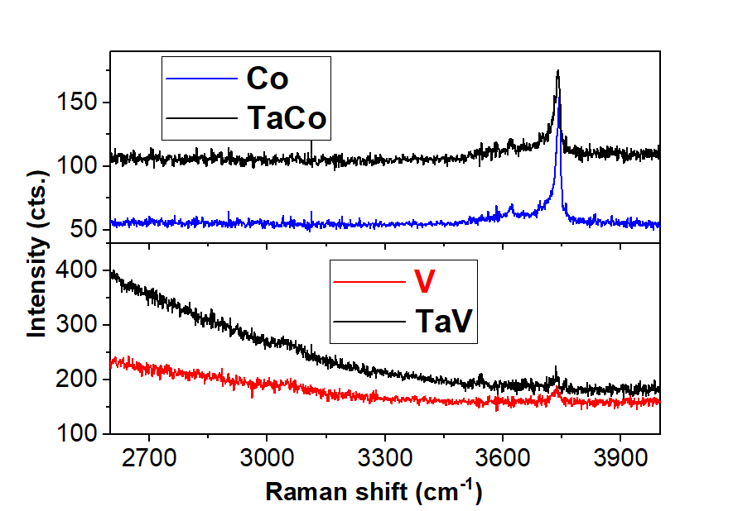

Figure S4. Comparative Raman spectra of monometallic (Ta, V, Ti, Nb, Co)-MCM-41 and bimetallic Ta(V, Ti, Nb, Co) samples

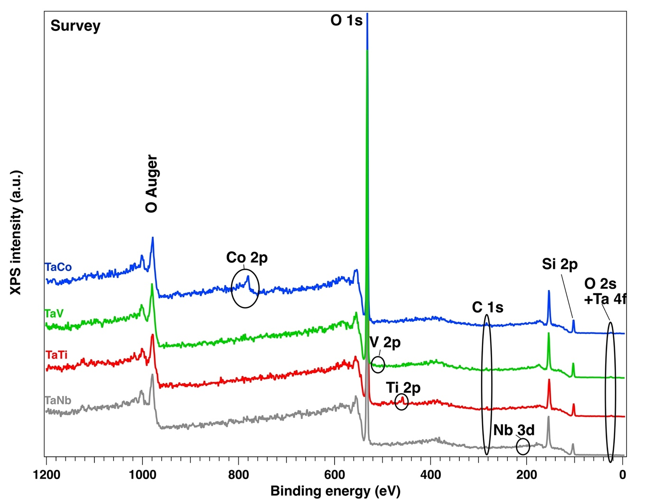

Figure S5. XPS full scan survey spectra for the bimetallic Ta/Me samples.
Figure S6. XPS spectra for Nb3d of the sample TaNb-MCM-41 sample.

Figure S7. XPS spectra for O1s of the bimetallic Ta/Me-MCM-41 samples.
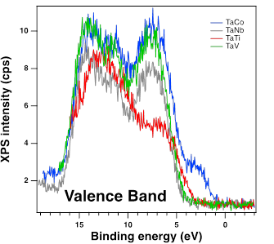
Figure S8. XPS valence band spectra of the bimetallic Ta/Me-MCM-41 samples.
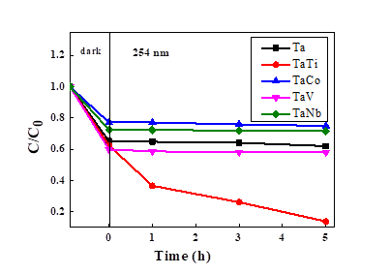
Figure S9. Photodegradation of methyl orange in aqueous solution.
Table S1. Peak position and assignments for the monometallic (Ta/Nb/Ti/Co/V)-MCM41 catalysts.
Peak position (cm⁻¹) |  |  |  |  | Assignments | Reference
Ta | Nb | Ti | Co | V | <650 cm⁻¹ n-SiO₄ rings | 34,35
 |  |  |  | 356 | δ (O-V-O) in polymeric VO_{x} | 36, 37
360 | 368 |  |  |  | 5,6,7-SiO₄ rings | 34
441 | 443 | 440 | 436 |  | 5,6,7-SiO₄ rings | 34
497 | 490 | 495 | 497 | 481 | D₁ modes (4- SiO₄ rings) | 34
 |  |  |  | 552 | Silicalite framework breathing modes | 36
608 | 610 | 607 | 608 |  | D₂ modes (3- SiO₄ rings) | 34
660 |  |  |  |  | TaO₆ | 38
 |  |  | 664 |  | CoO₆ in Co₃O₄ | 39
 | 822 | 800 | 798 | 821 | υ_{s (}Si-O-Si) and surface polymerized niobia | 34, 38
828 |  |  | 838 |  | υ_{s} of the [SiO₄] units | 34
 | 935 |  |  |  | surface polymerized niobia species (820-935 cm⁻¹) | 38
958 |  | 954 |  | 958 | υ_{s} (Si-O-Si/Ti/V) | 40,41
980 | 975 |  | 976 |  | υ (Si-OH) and TaO_{x} species (965-980 cm⁻¹) | 34,38,42
 |  |  |  | 1028 | Pyramidal structure of (SiO)₃V=O when vanadium content is less than 2wt.% (1033-1036 cm⁻¹) | 36
1050 | 1091 |  | 1052 |  | Antisymmetric stretching υ (Si-O) | 34
 |  | 1100 |  |  | υ_{as} (Si-O-Ti) with Ti⁴⁺ | 40
1185 | 1150 |  |  | 1123
 |  |  |  |  | >3000 cm⁻¹ | 42
 | 3233 |  |  |  | ν(OH) moodes of H₂O involved in a tetrahedral structure | 42
3600 | 3594 | 3595 | 3623 |  | MeO-H and free H₂O | 41,42
3700 | 3690 |  | 3695 |  | HO-H dangling | 42
3747 | 3746 | 3743 | 3745 | 3740 | SiO-H and Free SiO-H | 42

