Figure S1

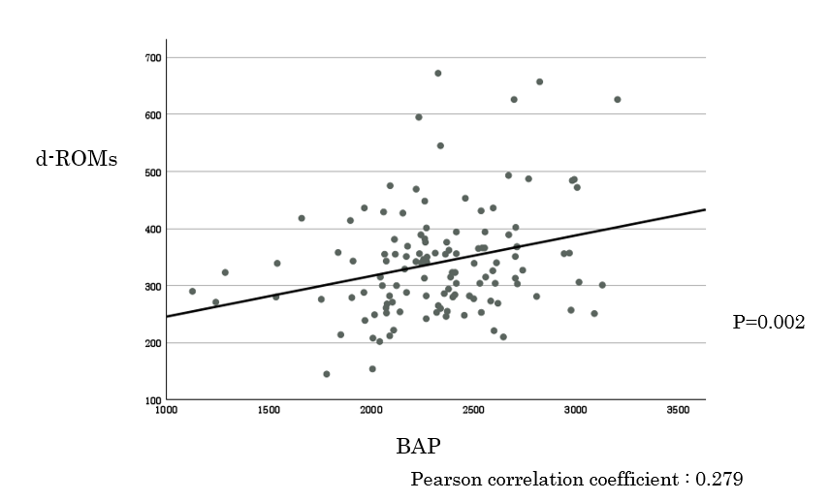

Figure S2a Figure S2b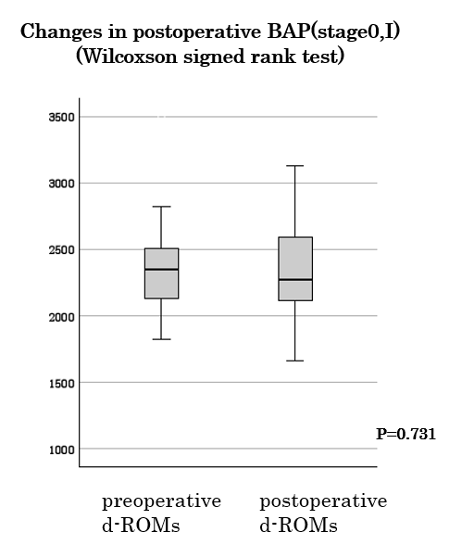

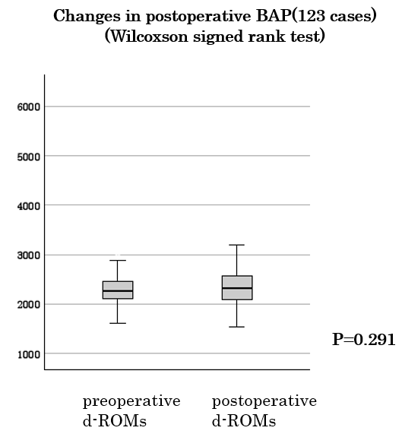

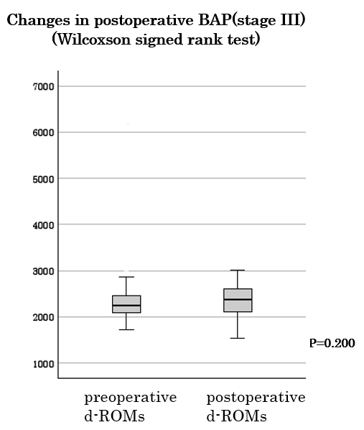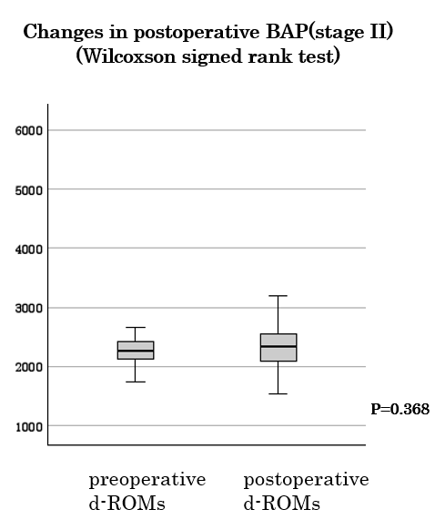Figure S2c Figure S2d

Table S1

Comparison of postoperative d-ROM and BAP values with clinicopathological factors in colorectal cancer patients using the Mann-Whitney U test.

|  |  |  |  |  |  |
| --- | --- | --- | --- | --- | --- |
| Independent variables |  | d-ROMs |  | BAP |  |
| case | Median (IQR) | p-value | Median (IQR) | p-value |
| Age (years) |  |  | 0.972 |  | 0.972 |
| <70 | 54 | 331.0 (271.5, 392.8) |  | 2327.5 (2079.3, 2615.3) |  |
| ≥70 | 69 | 327.0 (282.0, 369.0) |  | 2326.0 (2116.0, 2535.0) |  |
| Sex |  |  | ＜0.001 |  | 0.696 |
| Male | 66 | 303.5 (257.8, 54.0) |  | 2331.0 (2079.3, 2577.8) |  |
| Female | 57 | 356.0 (300.0, 402.0) |  | 2326.0 (2108.0, 2557.0) |  |
| Location |  |  | 0.992 |  | 0.554 |
| Right | 19 | 319.0 (280.0, 370.8) |  | 2373.0 (2115.0, 2545.0) |  |
| Left | 104 | 329.0 (272.0, 379.0) |  | 2271.0 (2074.0, 2587.0) |  |
| Tumor size (mm) |  |  | 0.726 |  | 0.961 |
| ＜45 | 75 | 339.0 (278.0, 385.5) |  | 2325.0 (2090.0, 2544.5) |  |
| ≥45 | 48 | 323.0 (279.0, 360.5) |  | 2346.0 (2119.5, 2602.8) |  |
| Tumor invasion depth |  |  | 0.110 |  | 0.450 |
| T1, T2 | 42 | 349.0 (285.5, 424.8) |  | 2343.5 (2155.3, 2593.5) |  |
| T3, T4 | 81 | 315.0 (273.0, 365.0) |  | 2325.0 (2076.0, 2552.0) |  |
| Lymph node metastasis |  |  | 0.161 |  | 0.814 |
| No | 81 | 341.0 (281.5, 391.5) |  | 2318.0 (290.0, 2569.5) |  |
| Yes | 42 | 314.0 (275.5, 356.3) |  | 2367.0 (2111.0, 2566.5) |  |
| Stage |  |  | 0.084 |  | 0.904 |
| 0-I | 41 | 355.0 (284.0, 418.0) |  | 2270.0 (2116.0, 2592.0) |  |
| II-III | 82 | 315.0 (273.8, 357.8) |  | 2346.0 (2088.3, 2553.5) |  |
|  |  |  |  |  |  |
| Table S2 Multivariate linear regression analysis results for postoperative d-ROM levels in patients with colorectal cancer | | | | | |

|  |  |  |  |
| --- | --- | --- | --- |
| Independent  variables | Multivariate linear regression analysis | | |
| β | eβ (95%CI) | p-value |
| Age | 1.11 e-3 | 1.001 (5.34e-3, 2.14e-3) | 0.606 |
| Sex (men vs. female) | 1.58 e-1 | 1.171 (6.00e-2, 2.57e-1) | 0.182 |
| Location (left vs. right) | 3.24 e-2 | 1.033 (-7.20e-2, 1.37e-1) | 0.540 |
| Tumor size | 1.20 e-3 | 1.001 (-1.88e-3, 4.27e-3) | 0.442 |
| Serosa invasion (no vs. yes) | -4.54 e-2 | 0.956 (-1.70e-1, 7.93e-2) | 0.472 |
| Lymph node metastasis (no vs. yes) | -4.76 e-2 | 0.954 (-1.60e-2 ~6.56e-2) | 0.407 |

β: regression coefficient CI: confidence interval

Table S3 Multivariate linear regression analysis results for postoperative d-ROM levels in patients with colorectal cancer

|  |  |  |  |
| --- | --- | --- | --- |
| Independent  variables | Multivariate linear regression analysis | | |
| β | eβ (95%CI) | p-value |
| Age | 8.53 e-4 | 1.001 (-2.03e-3, 3.74e-3) | 0.559 |
| Sex (men vs. female) | 2.30 e-2 | 1.023 (-4.38e-2, 8.99e-2) | 0.496 |
| Location (left vs. right) | -3.61 e-3 | 0.996 (-7.47e-2, 6.75e-2) | 0.920 |
| Tumor size | -1.97 e-4 | 1.000 (-2.29e-3, 1.89e-3) | 0.852 |
| Serosa invasion (no vs. yes) | -2.92 e-2 | 0.971 (-1.14e-1, 5.57e-2) | 0.497 |
| Lymph node metastasis (no vs. yes) | 2.76 e-2 | 1.028 (-4.93e-2 ~1.04e-1) | 0.400 |

β: regression coefficient CI: confidence interval

Table S4 Multivariate linear regression analysis results for BAP ratio in patients with colorectal cancer

|  |  |  |  |
| --- | --- | --- | --- |
| Independent  variables | Multivariate linear regression analysis | | |
| β | 95%CI | p-value |
| Age | 1.99 e-3 | -1.41e-3, 5.40e-3 | 0.248 |
| Sex (men vs. female) | 3.42e-2 | -4.47e-2~ 1.13e-1 | 0.392 |
| Location (left vs. right) | 2.17 | -6.23e-2, 1.06e-1 | 0.610 |
| Tumor size | -7.90e-4 | -3.26e-3, 1.68e-3 | 0.527 |
| Serosa invasion (no vs. yes) | 7.17e-3 | -9.30e-2, 1.07e-1 | 0.888 |
| Lymph node metastasis (no vs. yes) | 4.08e-2 | -1.41e-3 ~5.40e-3 | 0.376 |

β: regression coefficient CI: confidence interval