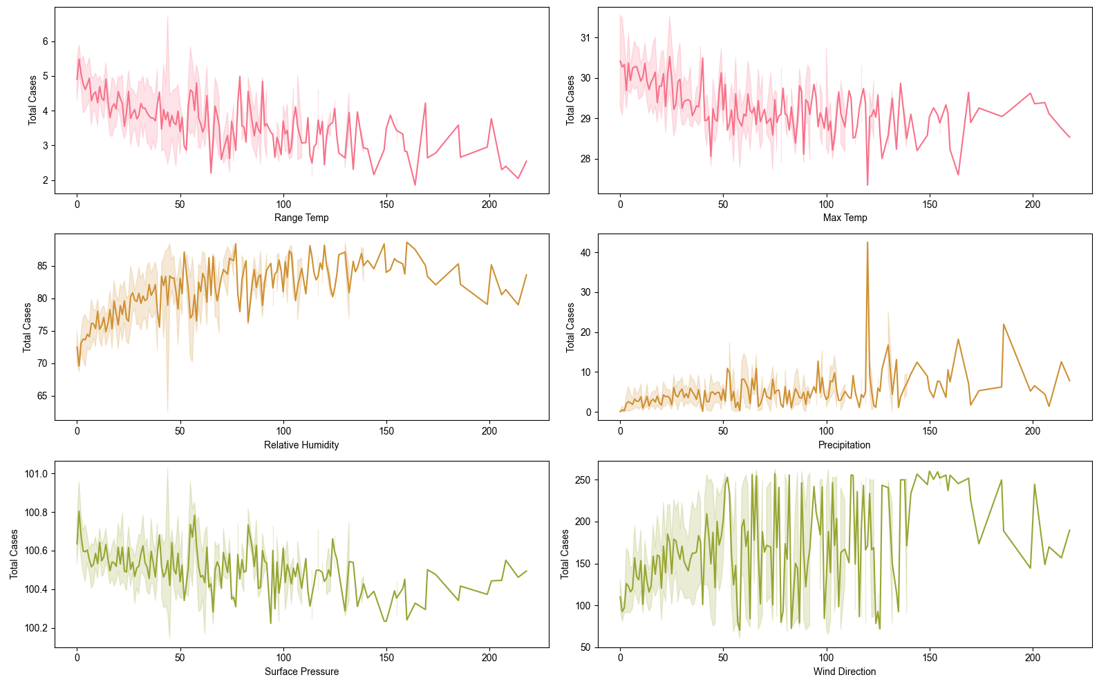

**Figure S1.** Impact of climatic factors on total cases.

|  |  |
| --- | --- |
| (A) | (B) |
| (C) | (D) |
| (E) |  |

**Figure S2.** Correlations of selected climate variables at cumulative mean values ​​of lags from 2 to 20 weeks (approximately 3 - 4 months), using a minimum period of 10 for a lag of 20 so as not to lose all data of the first 20 weeks. (A) T2M_RANGE and T2M_MAX, (B) RH2M, (C) PRECTOTCORR, (D) PS, (E) WD10M.

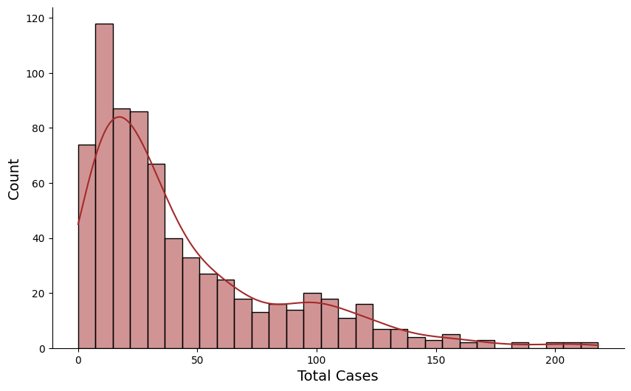

**Figure S3.** Distribution of the target variable (total cases)

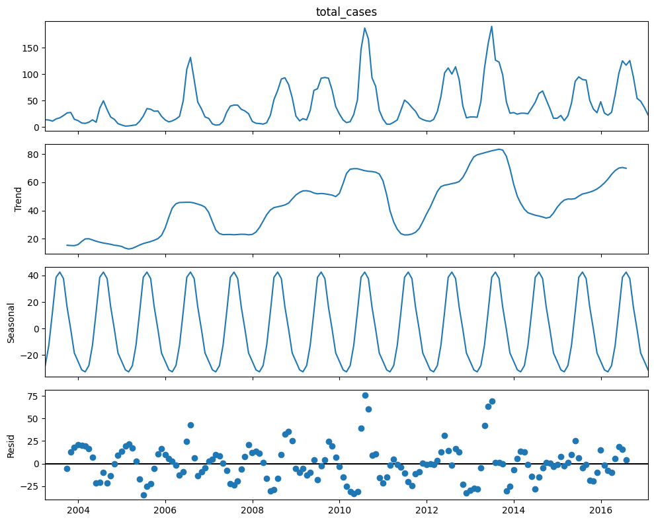

**Figure S4. Seasonal and trend decomposition of the dengue case time series.**

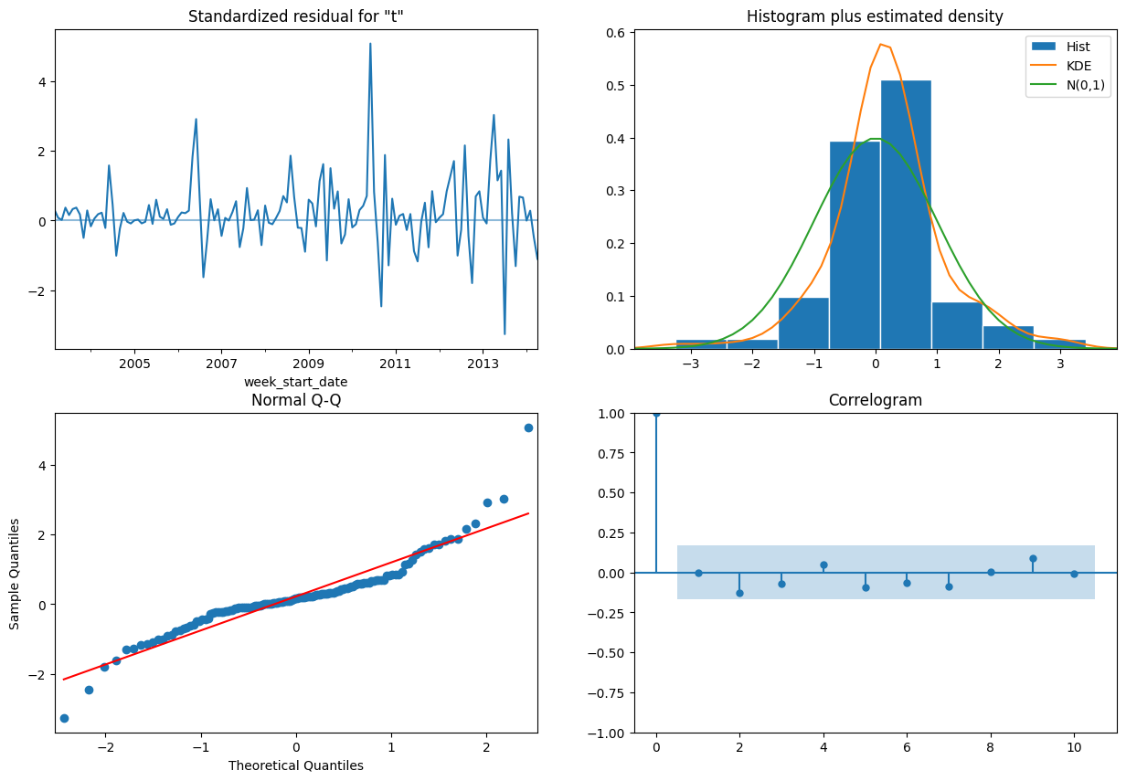

**Figure S5.** SARIMAX #1 Residual diagnostics.

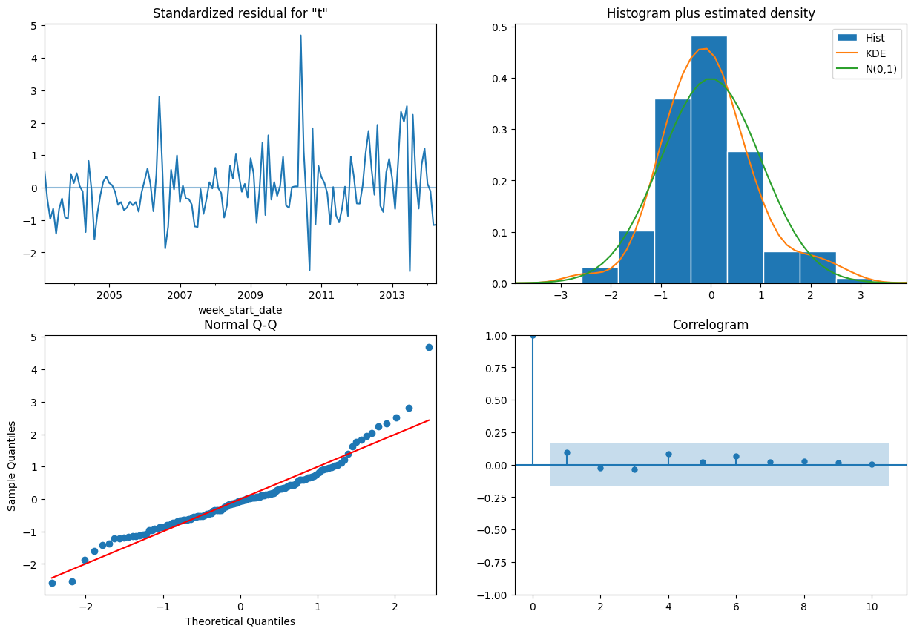

**Figure S6. SARIMAX #2 Residual diagnostics.**

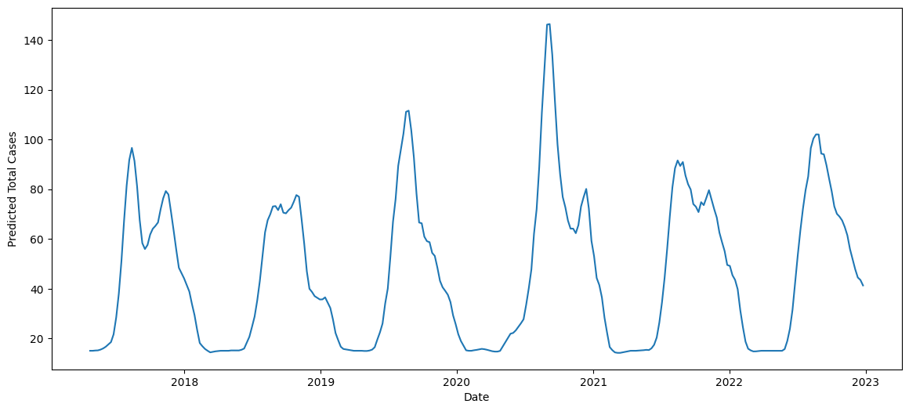

**Figure 13. Zoomed-in forecast showing additional dengue peaks for XGB Regression Model #2.**

**Table S1.** Parameter estimation and statistical diagnostics of SARIMAX #1.

|  |  |  |  |
| --- | --- | --- | --- |
| SARIMAX Results | | | |
| Dep. Variable: | total_cases | No. Observations: | 134 |
| Model: | SARIMAX(2, 0, 0)x(1, 0, [1], 12) | Log Likelihood | -564.715 |
| Date: | Mon, 26 Feb 2024 | AIC | 1139.431 |
| Time: | 16:22:13 | BIC | 1153.92 |
| Sample: | 03/31/2003 | HQIC | 1145.319 |
|  | -04/30/2014 |  |  |
| Covariance Type: | opg |  |  |

|  |  |  |  |  |  |  |
| --- | --- | --- | --- | --- | --- | --- |
|  | coef | std err | z | P>|z| | [0.025 | 0.975] |
| ar.L1 | 1.2562 | 0.075 | 16.841 | 0 | 1.11 | 1.402 |
| ar.L2 | -0.4348 | 0.06 | -7.226 | 0 | -0.553 | -0.317 |
| ar.S.L12 | 0.9153 | 0.09 | 10.156 | 0 | 0.739 | 1.092 |
| ma.S.L12 | -0.6794 | 0.135 | -5.036 | 0 | -0.944 | -0.415 |
| sigma2 | 252.8124 | 24.472 | 10.331 | 0 | 204.849 | 300.776 |
| Ljung-Box (L1) (Q): | 0 | Jarque-Bera (JB): | 173.33 |  |  |  |
| Prob(Q): | 1 | Prob(JB): | 0 |  |  |  |
| Heteroskedasticity (H): | 3.15 | Skew: | 0.82 |  |  |  |
| Prob(H) (two-sided): | 0 | Kurtosis: | 8.32 |  |  |  |

**Table S2.** Parameter estimation and statistical diagnostics of SARIMAX #2.

|  |  |  |  |  |  |  |
| --- | --- | --- | --- | --- | --- | --- |
|  | coef | std err | z | P>|z| | [0.025 | 0.975] |
| x1 | -0.1877 | 1.159 | -0.162 | 0.9 | -2.459 | 2.083 |
| x2 | -25.9949 | 10.242 | -2.538 | 0 | -46.07 | -5.92 |
| x3 | 4.4238 | 8.708 | 0.508 | 0.6 | -12.643 | 21.49 |
| x4 | -1.2387 | 1.297 | -0.955 | 0.3 | -3.78 | 1.303 |
| x5 | 1.5169 | 1.904 | 0.797 | 0.4 | -2.215 | 5.249 |
| x6 | 0.8294 | 2.983 | 0.278 | 0.8 | -5.018 | 6.677 |
| x7 | 0.1581 | 0.145 | 1.088 | 0.3 | -0.127 | 0.443 |
| ar.L1 | 1.1303 | 0.072 | 15.723 | 0 | 0.989 | 1.271 |
| ar.L2 | -0.4074 | 0.076 | -5.35 | 0 | -0.557 | -0.258 |
| ar.S.L12 | 0.1794 | 0.101 | 1.775 | 0.1 | -0.019 | 0.378 |
| sigma2 | 248.4918 | 25.431 | 9.771 | 0 | 198.648 | 298.336 |
| Ljung-Box (L1) (Q): | 1.22 | Jarque-Bera (JB): | 90.88 |  |  |  |
| Prob(Q): | 0.27 | Prob(JB): | 0 |  |  |  |
| Heteroskedasticity (H): | 2.07 | Skew: | 1.04 |  |  |  |
| Prob(H) (two-sided): | 0.02 | Kurtosis: | 6.46 |  |  |  |