Clinical and Pathologic Features Associated with Low Circulating Tumor DNA Fraction in Endometrial and Ovarian Cancers
Mark Vater¹*, Alison Garrett²*, Katharine Collier^{1,3}, Peter Rose⁴, Gabriel Tinoco^{1,3}, Ava Strahan¹, Daniel G. Stover^{1,3+}, Haider Mahdi^{2,5+}
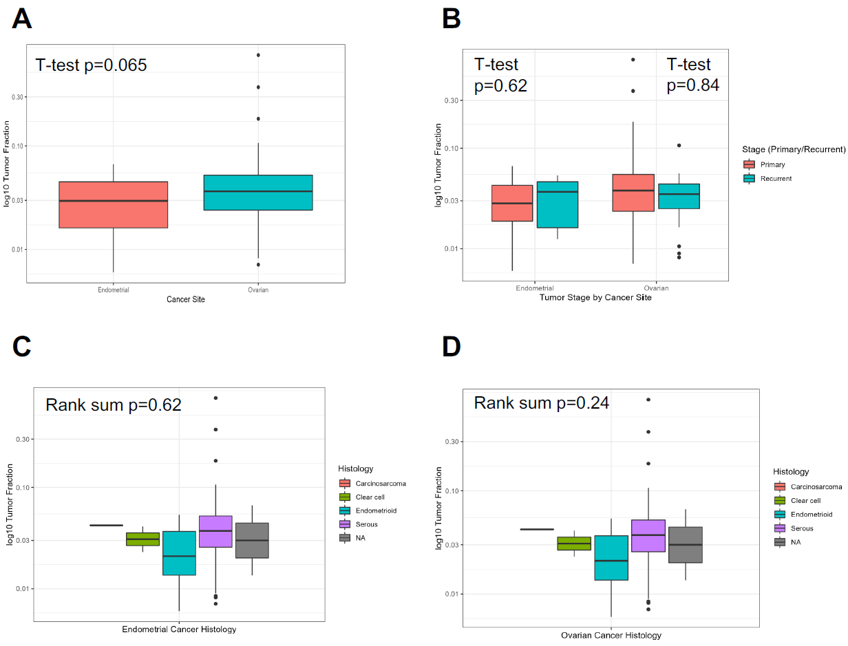
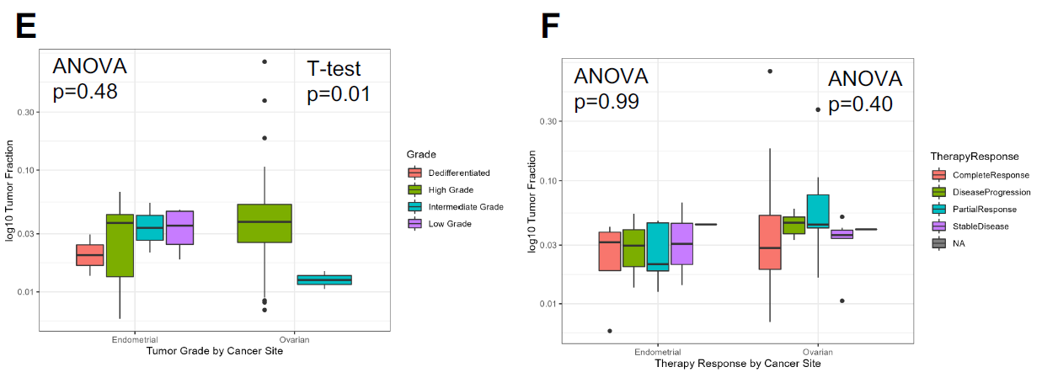
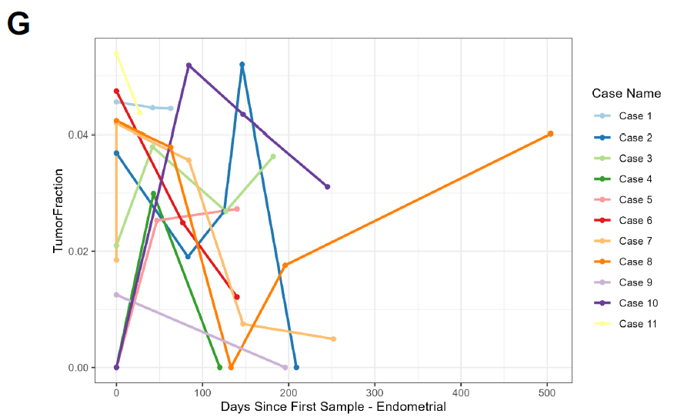
Figure S1. Association of Tumor Fraction with Clinicopathologic Characteristics in Patients with Ovarian and Endometrial Cancers. To avoid duplicate sample bias, the association of the tumor fraction (TFx) of the first ‘sentinel’ blood draw was evaluated relative to clinicopathologic characteristics, including: (A) ovarian versus endometrial cancer; (B) primary versus recurrent settings within each individual cancer type; (C-D) tumor histology within each cancer type; (E) tumor grade; (F) best overall therapy response. TFx is presented as log₁₀ transformed in each y-axis.

Table S1. Tumor fraction association with clinical and pathologic variables in endometrial and ovarian cancer.
Cancer Site | Outcome | Raw P-Value | Adjusted P-Value | Test Type
Endometrial | Histology | 0.620 | 0.861 | Rank Sum
Endometrial | MSI | 0.242 | 0.861 | T-test
Endometrial | Grade | 0.481 | 0.861 | ANOVA
Endometrial | Stage | 0.622 | 0.861 | Rank Sum
Endometrial | Therapy Response | 0.990 | 0.990 | ANOVA
Endometrial | Vital Status | 0.527 | 0.861 | ANOVA
Endometrial | Metastasis - Peritoneal | 0.646 | 0.861 | T-test
Endometrial | Metastasis - Liver | 0.579 | 0.861 | T-test
Endometrial | Metastasis - Pleural | 0.705 | 0.861 | T-test
Endometrial | Metastasis - Nodal | 0.988 | 0.990 | T-test
Endometrial | Metastasis - Other | 0.061 | 0.667 | Rank Sum
Ovarian | Histology | 0.239 | 0.614 | Rank Sum
Ovarian | BRCA | 0.273 | 0.614 | T-test
Ovarian | Grade | 0.010 | 0.094 | T-test
Ovarian | Stage | 0.841 | 0.841 | Rank Sum
Ovarian | Therapy Response | 0.398 | 0.716 | ANOVA
Ovarian | Vital Status | 0.828 | 0.841 | ANOVA
Ovarian | Metastasis - Peritoneal | 0.623 | 0.801 | T-test
Ovarian | Metastasis - Liver | 0.481 | 0.722 | T-test
Ovarian | Metastasis - Pleural | 0.180 | 0.614 | T-test

