**Supplementary Materials**

# Appendix A:Specific evaluation indicators for each ecosystem service

# （1）WC

Table A.1 Average surface runoff coefficient of different ecosystems

|  |  |  |
| --- | --- | --- |
| Ecosystem-type | | Average surface runoff （%） |
| Forest | evergreen broad-leaf forest | 2.67 |
| evergreen needleleaved forest | 3.02 |
| mixed broadleaf-conifer forest | 2.29 |
| broadleaved deciduous forest | 1.33 |
| deciduous coniferous forest | 0.88 |
| sparsewood | 19.20 |
| Shrubland | Evergreen broad-leaved scrub | 4.26 |
| Deciduous broadleaf shrub | 4.17 |
| Coniferous brush | 4.17 |
| open shrublands | 19.20 |
| Grassland | meadow | 8.20 |
| prairie | 4.78 |
| grass | 9.37 |
| Sparse grassland | 18.27 |
| Wetland | Wetland | 0.00 |
| Water | Water | 0.00 |

# （2）SC

Table A.2 Soil erosion sensitivity evaluation

|  |  |  |  |  |  |  |
| --- | --- | --- | --- | --- | --- | --- |
| Evaluation index | | classification | | | | weight |
| Insensitive | Mild sensitivity | medium sensitivity | highly sensitive |
| Raining conditions | Rainfall erosivity | Rainfall erosion is very weak | Rainfall erosion is weak | Rainfall erosion is medium | Rainfall erosion is strong | 0.2 |
| terrian condition | Slope(°) | ＜10 | 10—15 | 15-25 | ＞25 | 0.35 |
| soil conditions | soil texture | Built-up areas, reservoirs, others | Clay loam, clay soil | Medium loam, heavy loam, light loam | Sandy loam, sandy soil, loose sand, pebble beach, gravel, bare rock | 0.15 |
| Land cover condition | vegetation coverage  (%) | 67-100 | 51-67 | 34-51 | 0-34 | 0.3 |
| Rank assignment | | 1 | 3 | 5 | 7 | 1.0 |

# （3）BC

**Determination of "Source"** — Habitat Suitability Assessment. The "source" refers to the suitable habitats for each focal species, chosen based on habitat suitability assessments according to the living habits of these species.The Common Crane(*Grus grus*) inhabits open plains, grasslands, swamps, riverbanks, wastelands, lakes, and agricultural areas; it breeds in various wetlands such as marshes and meadows, especially favoring open lakes with abundant aquatic plants and reed marshes. During migration and wintering periods, they mainly reside near rivers, lakes, reservoirs, or coasts and frequently forage in open farmlands or fallow fields.The habitat suitability for the hooded crane is influenced by four factors: surface land cover, water distribution, human activities, and topography. Scores are determined based on the positive impact of each factor on the habitat, and the weights of these factors are calculated using the Analytic Hierarchy Process (AHP).（Table A.3）。

| Table A.3 Habitat Suitability Assessment for Common Crane(*Grus grus*) | | | | |
| --- | --- | --- | --- | --- |
| Evaluation factor | | Classification | Value | weight |
| Land cover | land cover types | Waters (rivers, lakes, ponds), beaches, swamps | 10 | 0.2 |
| grassland | 8 |
| Woodland, garden | 6 |
| nonirrigated farmland | 5 |
| Sandy land, Gobi, bare land, bare rock stony land | 2 |
| country | 1 |
| construction land | 0 |
| Distribution of water | Distance to water(m) | 0-50 | 10 | 0.2 |
| 50-100 | 8 |
| 100-200 | 6 |
| 200-300 | 4 |
| >300 | 0 |
| Human activity | Distance to settlements(m) | 0-500 | 0 | 0.15 |
| 500-1000 | 3 |
| 1000-2000 | 6 |
| >2000 | 10 |
| Distance to road(m) | 0-500 | 0 | 0.15 |
| 500-1000 | 6 |
| >1000 | 10 |
| Distance to farmland(m) | 0-50 | 10 | 0.2 |
| 50-100 | 8 |
| 100-200 | 6 |
| 200-300 | 4 |
| >300 | 0 |
| Terrain | slope | 0-10 | 10 | 0.1 |
| 10-30 | 6 |
| 30-60 | 2 |
| 60-90 | 0 |

The habitat of the Przewalski's Gazelle(*Procapra przewalskii*) is grasslands and sand dunes. The Przewalski's Gazelle(*Procapra przewalskii*), a typical ungulate of deserts and semi-deserts, inhabits arid environments with vegetation such as Ephedra, Stipa, moss, sand whisk, sand needle grass, Aconite, and Artemisia. Within these areas, there are also sand dunes several tens of meters high, gentle slopes, and open plains where the deep parts of the sand dunes often serve as their hiding places.The suitability of the Przewalski's Gazelle(*Procapra przewalskii*) habitat is influenced by four factors: land cover, water distribution, human activities, and topographical factors. Scores are determined based on the positive impact of each factor on the habitat, and the weights of each factor are calculated using the Analytic Hierarchy Process. Specific factors, scores, and weights related to habitat suitability can be found in Table A.4.

**Table A.4 Habitat Suitability Assessment for** **Przewalski's Gazelle*(Procapra przewalskii*)**

|  |  |  |  |  |
| --- | --- | --- | --- | --- |
| Evaluation factor | | Classification | Value | weight |
| Land cover | land cover types | Meadows, marshes, lakes, sand | 10 | 0.15 |
| Reservoir, river | 8 |
| Woodland, garden | 6 |
| Dry land, bare rock stony land | 3 |
| Rural, construction land | 0 |
| Distance to sand(m) | 0-100 | 10 | 0.2 |
| 100-200 | 6 |
| ＞200 | 4 |
| Distribution of water | Distance to water(m) | 0-50 | 10 | 0.2 |
| 50-100 | 8 |
| 100-200 | 6 |
| 200-300 | 4 |
| >300 | 0 |
| Human activity | Distance to settlements(m) | 0-1000 | 0 | 0.15 |
| 1000-2000 | 4 |
| >2000 | 10 |
| Distance to road(m) | 0-400 | 0 | 0.15 |
| 400-1200 | 3 |
| >1200 | 10 |
| Terrain | slope | 0-5 | 10 | 0.15 |
| 5-10 | 6 |
| 10-25 | 4 |
| >25 | 0 |

Red Deer(*Cervus*) prefer open forests and avoid dense, undisturbed forests. They can inhabit coniferous forests, marshes, clearings, poplar broad-leaved forests, and mixed coniferous-broadleaved forests. They exist at a wide range of altitudes, typically from sea level up to 3000 meters, and may also appear at even higher altitudes. They generally live in mountainous regions, spending summers in alpine meadows and winters in valleys. On flatter terrains, they seek densely wooded slopes in the summer and open grasslands in the winter.The suitability of the Red Deer(*Cervus*) habitat is influenced by four factors: land cover, water distribution, human activities, and topographical factors. Scores are determined based on the positive impact of each factor on the habitat, and the weights of each factor are calculated using the Analytic Hierarchy Process(Table A.5).

Table A.5 Habitat Suitability Assessment for Red Deer(*Cervus*)

|  |  |  |  |  |
| --- | --- | --- | --- | --- |
| Evaluation factor | | Classification | Value | weight |
| Land cover | land cover types | Woodlands, lakes, rivers | 10 | 0.2 |
| Meadows, marshes, reservoirs | 8 |
| Woodland, garden | 6 |
| Dry land, bare rock stony land, sandy land | 3 |
| Rural, construction land | 0 |
| Distribution of water | Distance to water(m) | 0-50 | 10 | 0.15 |
| 50-100 | 8 |
| 100-200 | 6 |
| 200-300 | 4 |
| >300 | 0 |
| Human activity | Distance to settlements(m) | 0-1000 | 0 | 0.1 |
| 1000-2000 | 4 |
| >2000 | 10 |
| Distance to road(m) | 0-400 | 0 | 0.15 |
| 400-1200 | 3 |
| >1200 | 10 |
| Terrain | slope | 0—15 | 10 | 0.2 |
| 15-36 | 8 |
| ＞36 | 3 |
| Elevation(m) | 0-1500 | 10 | 0.2 |
| 1500-2000 | 8 |
| 2000-2500 | 9 |
| ＞2500 | 2 |

**Determining the resistance surface.** Based on the spatial movement patterns of the selected indicator species, a resistance surface is established by simulating its movement through the landscape, overcoming resistance. Then, based on the characteristics of this resistance surface, landscape elements outside the core habitats are identified, providing insights into the habitat distribution of different animals.Different land cover types generate varying resistances as organisms spread outward from their habitats. Therefore, land use is chosen as the resistance factor to determine resistance coefficients. These coefficients and weights are determined based on research by scholars and opinions from experts.(Table A.6，Table A.7，Table A.8)

Table A.6 Common Crane (*Grus grus*) Horizontal Migration Resistance Surface Assignment

|  |  |  |
| --- | --- | --- |
| Resistance factor | Classification | Resistance coefficient |
| land cover types | Waters (rivers, lakes, ponds), beaches, swamps | 1 |
| woodland, shrubland | 10 |
| Woodland, other woodland, dry land, grassland | 50 |
| Permanent glacier, construction land | 300 |
| Sandy land, Gobi, bare land, bare rock stony land | 400 |

Table A.7 Przewalski's Gazelle (*Procapra przewalskii*) Horizontal Migration Resistance Surface Assignment

|  |  |  |
| --- | --- | --- |
| Resistance factor | Classification | Resistance coefficient |
| land cover types | Grassland, sandy land, Gobi, bare land, bare rock stony land, beach, swamp | 1 |
| Water area (rivers, lakes, ponds) | 50 |
| Forest land, shrub land, other forest land, dry land | 100 |
| Permanent glacier, construction land | 300 |

Table A.8 Red Deer (*Cervus*) Horizontal Migration Resistance Surface Assignment

|  |  |  |
| --- | --- | --- |
| Resistance factor | Classification | Resistance coefficient |
| land cover types | Woodland, shrubbery woodland, other woodland | 1 |
| Meadows, beaches, swamps | 10 |
| Dry land, water area (rivers, lakes, ponds) | 50 |
| Permanent glacier, construction land | 300 |
| Sandy land, Gobi, bare land, bare rock stony land | 400 |

Establish a resistance surface in the GIS model. Utilize ArcGIS's Cost Distance tool to analyze the minimum cumulative resistance surface between the source habitat and other land use types in the external environment, determining the migration tendencies of animals. Using the source of the habitat as the core, create multi-level buffer zones around it to form suitable habitat distributions for individual species. Then, overlay the grids of the three species for each year to obtain the BC for that particular year.

# （4）CS

Table A.9 Classification standard of resistance surface of forest

|  |  |  |  |  |
| --- | --- | --- | --- | --- |
| Evaluation factor | | Classification | Value | weight |
| Terrain | slope | ＜10° | 1 | 0.2 |
| 10°-20° | 10 |
| 20°-30° | 50 |
| 30°-40° | 100 |
| 40°-50° | 200 |
| ＞50° | 500 |
| aspect | flat slope | 1 | 0.2 |
| shady slope | 50 |
| Half shade slope | 100 |
| Half sunny slope | 200 |
| sunny slope | 500 |
| Human interference | land cover types | forest | 1 | 0.3 |
| grassland | 10 |
| wetland | 50 |
| Farmland, water | 100 |
| Sand, bare land | 200 |
| Construction land, glacier | 500 |
| Distance from human settlements and traffic arteries（km） | ＞5 | 1 | 0.1 |
| 4—5 | 10 |
| 3—4 | 50 |
| 2—3 | 100 |
| 1—2 | 200 |
| ＜1 | 500 |
| Distribution of water | Distance to water(km) | ＜1 | 1 | 0.2 |
| 1—2 | 10 |
| 2—3 | 50 |
| 3—4 | 100 |
| 4—5 | 200 |
| ＞5 | 500 |

Table A.10 Classification standard of resistance surface of wetland

|  |  |  |  |  |
| --- | --- | --- | --- | --- |
| Evaluation factor | | Classification | Value | weight |
| Terrain | slope | ＜10° | 1 | 0.2 |
| 10°-20° | 10 |
| 20°-30° | 50 |
| 30°-40° | 100 |
| 40°-50° | 200 |
| ＞50° | 500 |
| Distribution of water | Distance to water(km) | ＜1 | 1 | 0.3 |
| 1—2 | 10 |
| 2—3 | 50 |
| 3—4 | 100 |
| 4—5 | 200 |
| ＞5 | 500 |
| Human interference | land cover types | Wetland, water | 1 | 0.3 |
| grassland | 10 |
| forest | 50 |
| Farmland | 100 |
| Sand, bare land | 200 |
| Construction land, glacier | 500 |
| Distance from human settlements and traffic arteries（km） | ＞5 | 1 | 0.2 |
| 4—5 | 10 |
| 3—4 | 50 |
| 2—3 | 100 |
| 1—2 | 200 |
| ＜1 | 500 |

Table A.11 Classification standard of resistance surface of grassland

|  |  |  |  |  |
| --- | --- | --- | --- | --- |
| Evaluation factor | | Classification | Value | weight |
| Terrain | slope | ＜10° | 1 | 0.1 |
| 10°-20° | 10 |
| 20°-30° | 50 |
| 30°-40° | 100 |
| 40°-50° | 200 |
| ＞50° | 500 |
| Elevation(m) | 315-500 | 1 | 0.3 |
| 500-700 | 10 |
| 700-1000 | 50 |
| 1000-1400 | 100 |
| 1400-1800 | 200 |
| >1800 | 500 |
| Distribution of water | Distance to water(km) | ＜1 | 1 | 0.2 |
| 1-2 | 10 |
| 2-3 | 50 |
| 3-4 | 100 |
| 4-5 | 200 |
| ＞5 | 500 |
| Human interference | land cover types | Wetland, water | 1 | 0.3 |
| grassland | 10 |
| forest | 50 |
| Farmland | 100 |
| Sand, bare land | 200 |
| Construction land, glacier | 500 |
| Distance from human settlements and traffic arteries（km） | ＞5 | 1 | 0.1 |
| 4-5 | 10 |
| 3-4 | 50 |
| 2-3 | 100 |
| 1-2 | 200 |
| ＜1 | 500 |

# Appendix B: Driving Factors selection

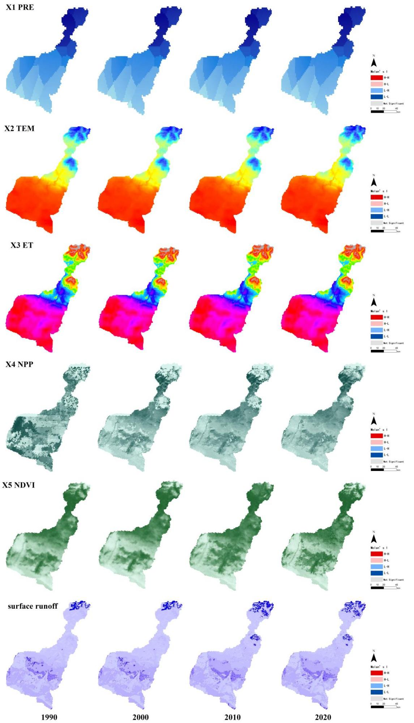

Fig. B.1. Spatial and temporal distribution of mainly ES driving factors

# Appendix C: Figures and tables of land use/cover data

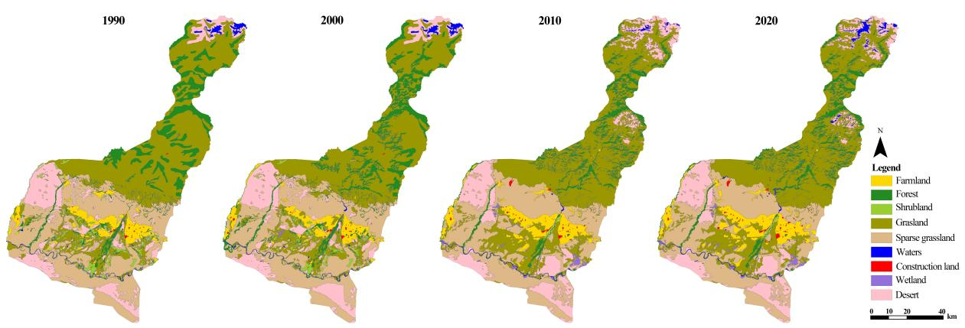

Fig. C.1. Spatial pattern of land use/cover in Haba River Basin, 1990-2020

(Reclassify as： Farmland, Forest,Shrubland, Grassland, Sparse grassland, Water, Wetland, Desert, Construction land)

|  |  |  |  |  |  |  |  |  |  |  |
| --- | --- | --- | --- | --- | --- | --- | --- | --- | --- | --- |
| Table C.1 Land use transfer matrix from 1990 to 2020  Unit: hectare | | | | | | | | | | |
| 1990-2020 | Grassland | Farmland | Shrubland | Desert | Construction land | Wetland | Water | Sparse grassland | Forest | Transfer-out area |
| Grassland | 230422.2 | 5673.3 | 896.2 | 20253.1 | 228.9 | 2879.5 | 3432 | 15417.5 | 31410.2 | 80190.7 |
| Farmland | 2789.3 | 33773.8 | 28.9 |  | 1127.5 | 54.7 | 33.7 | 3297.4 | 192 | 7523.6 |
| Shrubland | 12813.2 | 1387 | 377.7 | 448.1 |  | 1119.5 | 128.9 | 1080.6 | 459.4 | 17436.8 |
| Desert | 10266.5 | 4040.9 | 136.1 | 67865.6 | 530.7 | 126.4 | 2408.6 | 21101.9 | 475.6 | 39086.6 |
| Construction land | 167.3 | 268.3 |  |  | 661.8 |  |  | 2.9 |  | 438.5 |
| Wetland | 17.3 | 22.9 |  |  |  |  | 14.2 | 2.1 |  | 56.5 |
| Water | 1646.2 | 36.2 | 107.5 | 2519.1 |  | 202.4 | 3865.8 | 257.9 | 115.1 | 4884.5 |
| Sparse grassland | 20115.5 | 11089 | 568.2 | 25746.3 | 691 | 1621.7 | 819.7 | 172939.2 | 1536.5 | 172939.2 |
| Forest | 55685 | 1281.5 | 1995.2 | 2499.7 | 33.3 | 333.9 | 695.4 | 2474.9 | 31378.2 | 64998.8 |
| Transfer-in area | 103500.4 | 23799.2 | 3732 | 51466.4 | 2611.5 | 6338.2 | 7532.6 | 43635.1 | 34188.9 | 387555.2 |

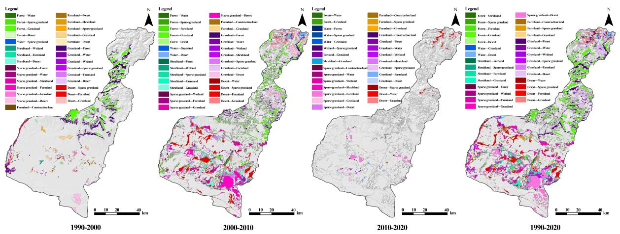

Fig. C.1. Spatial transfer of land use/cover from 1990 to 2020

# Appendix D:Spatial and temporal distribution characteristics of ES

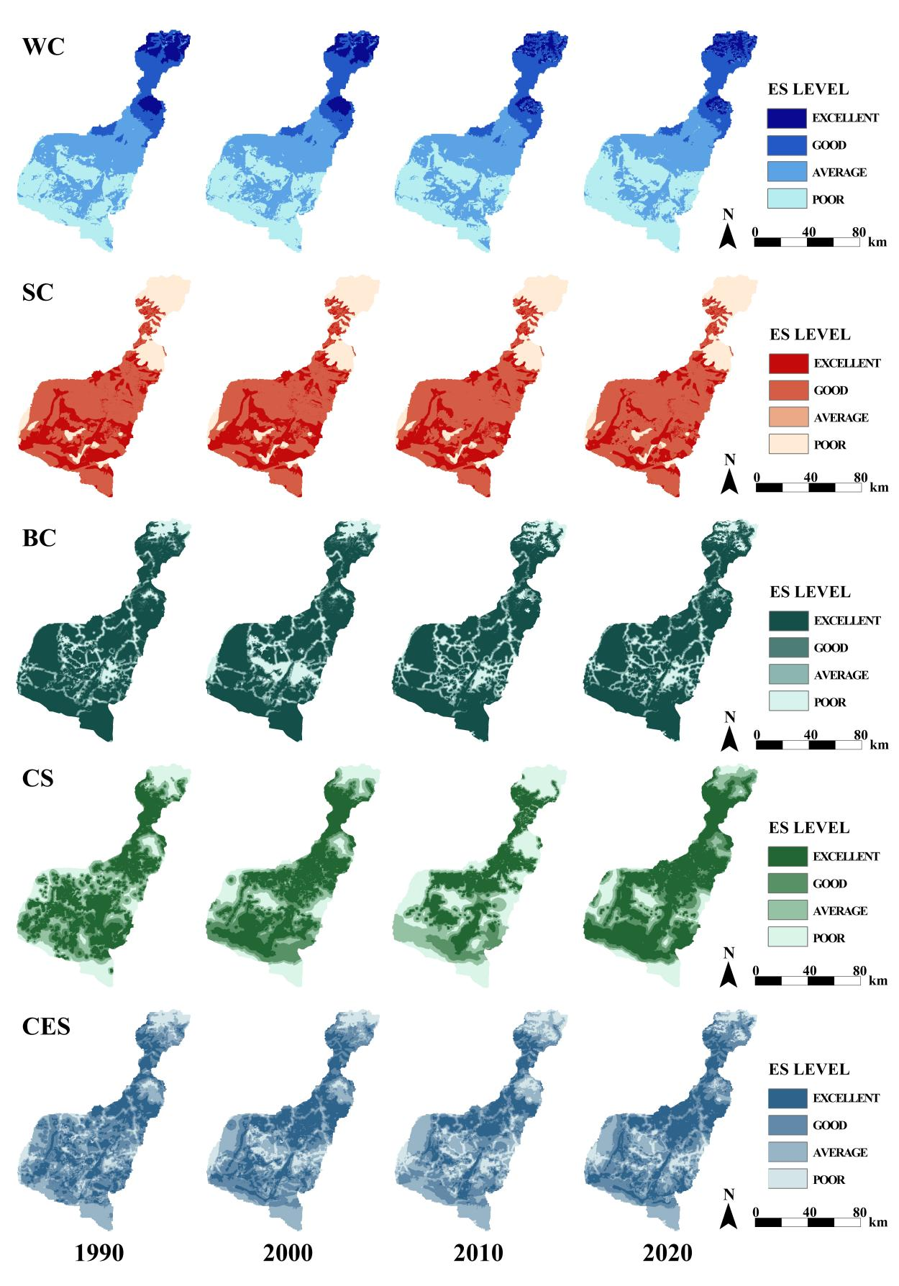

Fig. D.1 Spatial and temporal distribution of ES (WC,SC,BC,CS,CES)

# Appendix E: Spatiotemporal variation of ES cold and hot spots

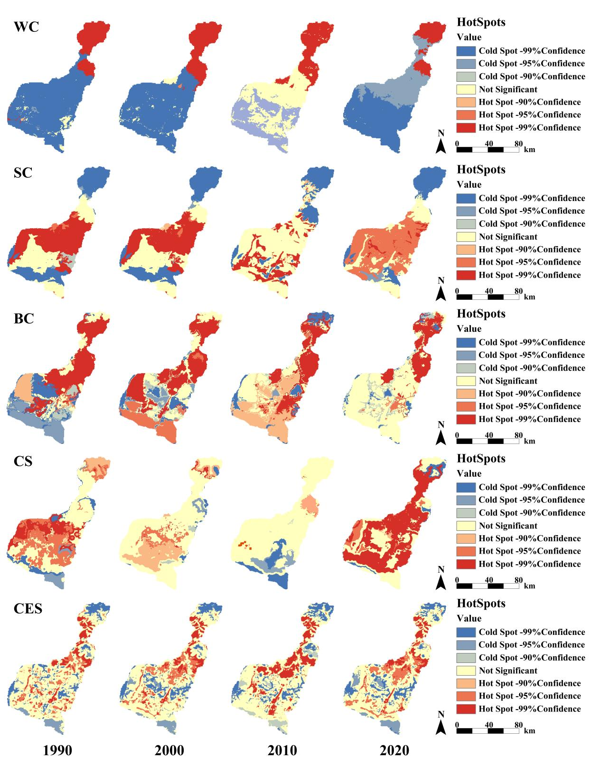

Fig. E.1 1990-2020 ES spatial changes of cold hot spots

|  |  |  |  |  |  |  |  |  |  |  |  |  |  |  |  |  |  |  |  |  |  |  |  |  |  |  |  |  |  |  |  |  |  |  |  |  |  |  |  |  |  |  |  |  |  |  |  |  |  |  |  |  |  |  |  |  |  |  |  |  |  |  |  |  |  |  |  |  |  |  |  |  |  |  |  |  |  |  |  |  |  |  |  |  |  |  |  |  |  |  |  |  |  |  |  |  |  |  |  |  |  |  |  |  |  |  |  |  |  |  |  |  |  |  |  |  |  |  |  |  |  |  |  |  |  |  |  |  |  |  |  |  |  |  |  |  |  |  |  |  |  |  |  |  |  |  |  |  |  |  |  |  |  |  |  |  |  |  |  |  |  |  |  |  |  |  |  |  |  |  |  |  |  |  |  |  |  |  |  |  |  |  |  |  |  |  |  |  |  |  |  |  |  |  |  |  |  |  |  |  |  |  |  |  |  |  |  |
| --- | --- | --- | --- | --- | --- | --- | --- | --- | --- | --- | --- | --- | --- | --- | --- | --- | --- | --- | --- | --- | --- | --- | --- | --- | --- | --- | --- | --- | --- | --- | --- | --- | --- | --- | --- | --- | --- | --- | --- | --- | --- | --- | --- | --- | --- | --- | --- | --- | --- | --- | --- | --- | --- | --- | --- | --- | --- | --- | --- | --- | --- | --- | --- | --- | --- | --- | --- | --- | --- | --- | --- | --- | --- | --- | --- | --- | --- | --- | --- | --- | --- | --- | --- | --- | --- | --- | --- | --- | --- | --- | --- | --- | --- | --- | --- | --- | --- | --- | --- | --- | --- | --- | --- | --- | --- | --- | --- | --- | --- | --- | --- | --- | --- | --- | --- | --- | --- | --- | --- | --- | --- | --- | --- | --- | --- | --- | --- | --- | --- | --- | --- | --- | --- | --- | --- | --- | --- | --- | --- | --- | --- | --- | --- | --- | --- | --- | --- | --- | --- | --- | --- | --- | --- | --- | --- | --- | --- | --- | --- | --- | --- | --- | --- | --- | --- | --- | --- | --- | --- | --- | --- | --- | --- | --- | --- | --- | --- | --- | --- | --- | --- | --- | --- | --- | --- | --- | --- | --- | --- | --- | --- | --- | --- | --- | --- | --- | --- | --- | --- | --- | --- | --- | --- | --- | --- | --- | --- |
| Appendix F: ES Trade-off/Synergy Table F.1 ES Trade-off/Synergy at grid scale   |  |  |  |  |  |  |  |  |  | | --- | --- | --- | --- | --- | --- | --- | --- | --- | |  |  | High-High | Low-Low | Not Significant | High-Low | Low-High | Trade-off | Synergy | | WC-SC | 1990 | 7% | 2% | 61% | 17% | 14% | 30% | 9% | | 2000 | 6% | 3% | 62% | 16% | 13% | 30% | 9% | | 2010 | 7% | 3% | 62% | 12% | 16% | 28% | 10% | | 2020 | 5% | 3% | 65% | 16% | 11% | 27% | 8% | | BC-WC | 1990 | 14% | 7% | 50% | 21% | 8% | 30% | 21% | | 2000 | 14% | 7% | 49% | 22% | 8% | 30% | 21% | | 2010 | 13% | 8% | 52% | 19% | 8% | 27% | 21% | | 2020 | 13% | 7% | 50% | 22% | 8% | 30% | 20% | | CS-WC | 1990 | 12% | 10% | 49% | 18% | 10% | 28% | 23% | | 2000 | 12% | 15% | 49% | 14% | 11% | 25% | 26% | | 2010 | 8% | 20% | 53% | 6% | 13% | 19% | 28% | | 2020 | 11% | 18% | 52% | 9% | 10% | 19% | 29% | | BC-SC | 1990 | 12% | 9% | 61% | 10% | 8% | 18% | 20% | | 2000 | 14% | 9% | 62% | 10% | 5% | 15% | 23% | | 2010 | 13% | 9% | 62% | 10% | 6% | 16% | 22% | | 2020 | 11% | 9% | 66% | 10% | 4% | 15% | 20% | | SC-CS | 1990 | 21% | 8% | 53% | 4% | 14% | 18% | 29% | | 2000 | 26% | 8% | 46% | 14% | 5% | 20% | 34% | | 2010 | 22% | 11% | 47% | 18% | 3% | 21% | 33% | | 2020 | 0% | 5% | 72% | 17% | 6% | 23% | 5% | | BC-CS | 1990 | 16% | 8% | 52% | 11% | 14% | 25% | 23% | | 2000 | 23% | 8% | 46% | 14% | 9% | 23% | 31% | | 2010 | 15% | 9% | 46% | 19% | 10% | 29% | 24% | | 2020 | 0% | 6% | 68% | 15% | 11% | 25% | 6% | |