**Tables**

**Table (1):** Comparison between the studied groups regarding VAS Score, Malhotra score, Activity Escidier score and regarding the effect of the treatment modalities on concentrations of Interlukin 6 at different intervals:

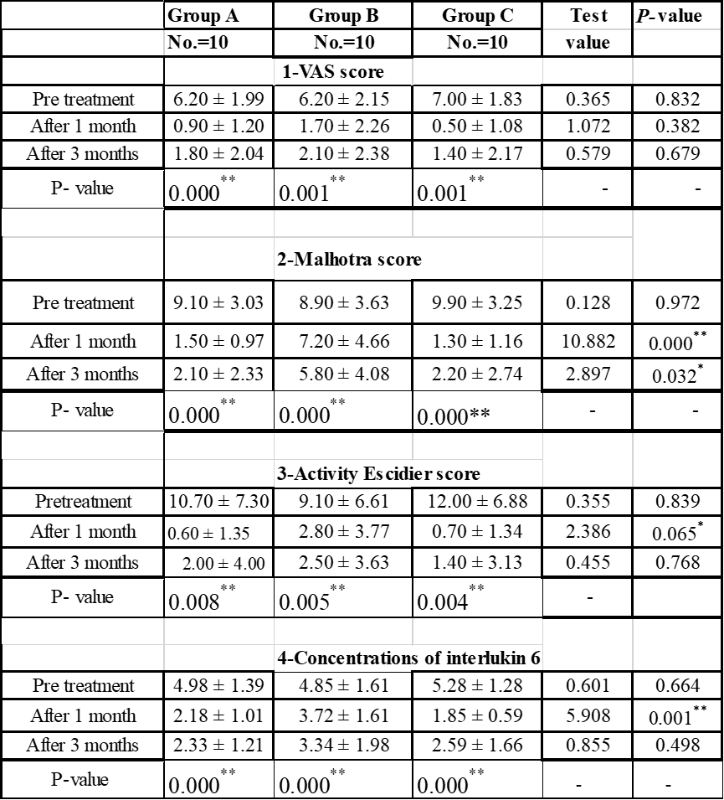

Table (2): Showing post hoc analysis between the studied groups regarding to: VAS score, Malhotra Score, Activity Escidier score and regarding the effect of the treatment modalities on concentrations of Interlukin 6 at different intervals:

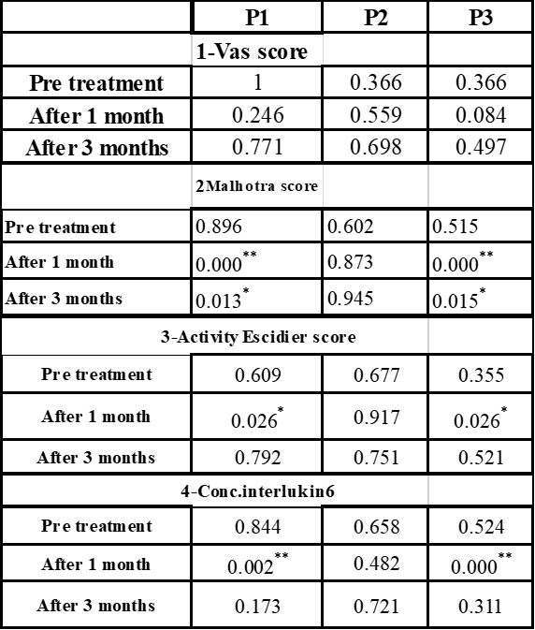

P1: A VS B P2: A VS C P3: B VS C