Supplementary Material

Table S2: Comparison of data entry modalities in the whole sample and in the subsample of first visits (sensitivity analysis)
 | Whole sample |  |  |  |  |  | Only first visit
 | P & P |  | Electronic |  |  |  | P & P |  | Electronic
 | N | Median (IQR) | N | Median (IQR) | p |  | N | Median (IQR) | N | Median (IQR) | p
Overall ward round time | 191 | 649 (189, 1186) | 160 | 637 (214, 1132) | 0.799 |  | 62 | 326 (109, 1200) | 52 | 371 (138, 1163) | 0.539
Preparatory time before visit | 187 | 0.07 (0.04, 0.20) | 147 | 0.07 (0.02, 0.22) | 0.470 |  | 59 | 0.10 (0.05, 0.28) | 48 | 0.07 (0.03, 0.28) | 0.312
Documentation time inside patient room (psysicians) | 121 | 0.14 (0.06, 0.24) | 133 | 0.19 (0.12, 0.29) | < 0.001 |  | 36 | 0.16 (0.10, 0.26) | 45 | 0.19 (0.14, 0.29) | 0.262
Documentation time inside patient room (nurses) | 132 | 0.13 (0.08, 0.18) | 105 | 0.10 (0.06, 0.13) | < 0.001 |  | 29 | 0.12 (0.08, 0.18) | 27 | 0.12 (0.07, 0.13) | 0.282
Interaction time with patients | 190 | 0.34 (0.25, 0.46) | 153 | 0.33 (0.27, 0.42) | 0.575 |  | 62 | 0.41 (0.27, 0.64) | 49 | 0.37 (0.29, 0.46) | 0.288
Time for applying bandages | 114 | 0.44 (0.35, 0.52) | 94 | 0.43 (0.34, 0.49) | 0.674 |  | 25 | 0.43 (0.35, 0.48) | 25 | 0.42 (0.38, 0.47) | 0.939

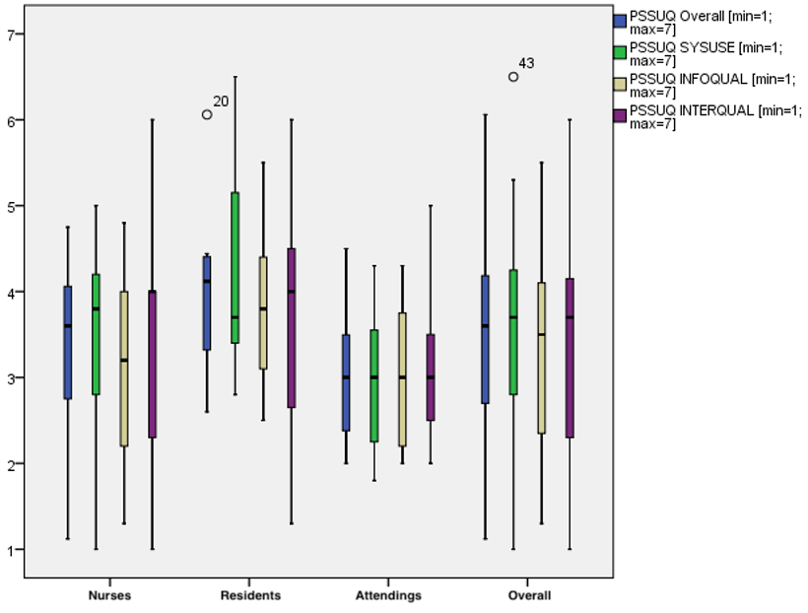
Figure S5: Detailed Chart View Across Professions for PSSUQ

Table S3: System Usability Scale (SUS)
Nr. | SUS | ++ | + | 0 | - | - -
1 | I can imagine using the system regularly.
2 | I find the system unnecessarily complex.
3 | I find the system easy to use.
4 | I think I need support from technical personnel to use the system.
5 | I find that the various functions of the system were well integrated.
6 | I find that there are too many inconsistencies in the system.
7 | I can imagine that most people would learn to use the system quickly.
8 | I find the system's operation extremely cumbersome.
9 | I felt very confident using the system.
10 | I had to learn a lot before I could use the system effectively.

Table S4: Post-Study System Usability Questionnaire (PSSUQ)
Nr. | PSSUQ | +++ | ++ | + | 0 | - | -  - | -  -  - | n/a
1 | Overall, I am satisfied with how easy it is to use this system.
2 | The system’s operation was intuitive.
3 | I was able to complete the tasks quickly using the system.
4 | I found the system’s operation pleasant.
5 | The system was easy to learn.
6 | I believe I became productive quickly using the system.
7 | The system clearly indicated error messages and how to resolve them.
8 | If I made a mistake using the system, I could recover from it easily and quickly.
9 | The information provided by the system (e.g., online help, on-screen messages, documentation) was clear.
10 | It was easy to find the information I needed in the system.
11 | The information provided by the system helped me to complete my tasks.
12 | The layout of the information on the screen was clear.
13 | The system’s interface was intuitive to use.
14 | I liked the system’s interface.
15 | The system has all the functions and capabilities I expected.
16 | I am overall satisfied with the system.

