# Supplemental Materials

**Table S1.** Station Information for stations included in 10-year dataset for analyses. Regions listed are regions assigned in analysis. Start and end dates are those used for analysis, though some stations may have longer periods of record.

|  |  |  |  |  |  |  |
| --- | --- | --- | --- | --- | --- | --- |
| Station | StationName | Region | Latitude | Longitude | Start Date | End Date |
| ANC | ANTIOCH (USBR) | Confluence | 38.01782 | -121.803 | 10/1/2009 | 9/30/2017 |
| ANH | SAN JOAQUIN RIVER AT ANTIOCH | Confluence | 38.01783 | -121.803 | 10/1/2009 | 9/30/2019 |
| BAC | BACON ISLAND AT OLD RIVER | Central | 37.96935 | -121.572 | 10/1/2009 | 9/30/2019 |
| BDL | BELDON LANDING | Suisun Marsh | 38.1869 | -121.971 | 10/1/2009 | 9/30/2019 |
| BDT | SAN JOAQUIN R AT BRANDT BRIDGE | South | 37.865 | -121.323 | 10/1/2009 | 9/30/2019 |
| BET | BETHEL ISLAND AT PIPER SLOUGH | Central | 38.04109 | -121.632 | 10/1/2009 | 9/30/2019 |
| BKS | BARKER SLOUGH PUMPING PLANT (KG000000) | North Delta | 38.2759 | -121.797 | 10/2/2009 | 9/30/2019 |
| BLL | BLACKLOCK (NE1) | Suisun Marsh | 38.1801 | -121.907 | 10/1/2009 | 9/30/2018 |
| BLP | SAN JOAQUIN RIVER AT BLIND POINT | Confluence | 38.03245 | -121.719 | 10/1/2010 | 9/30/2019 |
| CLC | CLIFTON COURT | Central | 37.8298 | -121.557 | 10/8/2009 | 9/30/2019 |
| CLL | COLLINSVILLE | Suisun Bay | 38.07398 | -121.85 | 10/1/2009 | 9/30/2019 |
| CSE | COLLINSVILLE ON SACRAMENTO RIVER | Suisun Bay | 38.074 | -121.85 | 10/1/2009 | 9/30/2019 |
| CYG | CYGNUS-CORDELIA SLOUGH | Suisun Marsh | 38.1527 | -122.091 | 10/1/2010 | 9/30/2019 |
| DGL | DOUGHTY CUT ABOVE GRANT LINE CANAL | South | 37.815 | -121.425 | 10/1/2009 | 9/30/2019 |
| DLC | DELTA CROSS CHANNEL BTW SAC R & SNODGRAS | North Delta | 38.245 | -121.505 | 10/1/2010 | 9/30/2019 |
| DSJ | DUTCH SLOUGH AT JERSEY ISLAND | Central | 38.013 | -121.671 | 10/1/2010 | 9/30/2019 |
| DWS | SACRAMENTO DEEP WATER SHIPPING CHANNEL | North Delta | 38.25611 | -121.667 | 10/1/2011 | 9/30/2019 |
| EMM | EMMATON (USBR) | Confluence | 38.08427 | -121.739 | 10/1/2009 | 9/30/2019 |
| FAL | FALSE RIVER NEAR OAKLEY | Confluence | 38.0558 | -121.667 | 10/6/2009 | 9/30/2019 |
| FRP | FARRAR PARK | Central | 38.0117 | -121.639 | 10/1/2009 | 9/30/2019 |
| GCT | GRANTLINE CANAL AT TRACY RD BRIDGE | South | 37.82014 | -121.45 | 10/1/2009 | 8/2/2018 |
| GES | SACRAMENTO RIVER BELOW GEORGIANA SLOUGH | North Delta | 38.2389 | -121.523 | 10/1/2010 | 9/30/2019 |
| GLC | GRANTLINE CANAL (USGS) | South | 37.8196 | -121.549 | 10/1/2009 | 9/30/2019 |
| GSS | GEORGIANA SLOUGH AT SACRAMENTO RIVER | North Delta | 38.237 | -121.518 | 10/1/2010 | 9/30/2019 |
| GYS | GOODYEAR SLOUGH | Suisun Marsh | 38.118 | -122.095 | 10/1/2009 | 9/30/2019 |
| HLL | HOLLAND TRACT | Central | 38.00699 | -121.581 | 10/1/2009 | 9/30/2019 |
| HLT | MIDDLE RIVER NEAR HOLT | Central | 38.0031 | -121.511 | 10/1/2009 | 9/30/2019 |
| HOL | HOLLAND CUT NEAR BETHEL ISLAND | Central | 38.0164 | -121.582 | 10/1/2009 | 9/30/2019 |
| HUN | HUNTER CUT AT MONTEZUMA SLOUGH | Suisun Marsh | 38.156 | -122.053 | 10/1/2010 | 9/30/2019 |
| HWB | MINER SLOUGH AT HWY 84 BRIDGE | North Delta | 38.2917 | -121.631 | 10/1/2010 | 9/30/2019 |
| IBS | IBIS | Suisun Marsh | 38.157 | -122.113 | 10/1/2009 | 9/30/2019 |
| JER | JERSEY POINT | Confluence | 38.05216 | -121.689 | 10/1/2009 | 9/30/2019 |
| LIS | YOLO BYPASS AT LISBON | North Delta | 38.47478 | -121.588 | 10/1/2011 | 9/30/2019 |
| LPS | LITTLE POTATO SLOUGH AT TERMINOUS | Confluence | 38.0964 | -121.496 | 10/1/2010 | 9/30/2019 |
| MAL | SACRAMENTO RIVER AT MALLARD ISLAND | Suisun Bay | 38.0428 | -121.92 | 10/1/2009 | 9/30/2019 |
| MDM | MIDDLE RIVER AT MIDDLE RIVER | Central | 37.943 | -121.534 | 10/1/2010 | 9/30/2019 |
| MHO | MIDDLE RIVER NEAR HOWARD ROAD BRIDGE | South | 37.87622 | -121.383 | 10/26/2010 | 9/30/2019 |
| MOK | MOKELUMNE R @ SAN JOAQUIN RIVER | Confluence | 38.1061 | -121.571 | 10/1/2009 | 9/30/2019 |
| MRZ | MARTINEZ | Suisun Bay | 38.02764 | -122.14 | 10/1/2009 | 9/30/2019 |
| MSD | SAN JOAQUIN RIVER AT MOSSDALE BRIDGE | South | 37.786 | -121.306 | 10/1/2009 | 9/30/2019 |
| MSL | MONTEZUMA SLOUGH AT ROARING R | Suisun Bay | 38.0934 | -121.887 | 10/1/2009 | 9/30/2019 |
| MTB | MIDDLE RIVER AT TRACY BLVD | Central | 37.881 | -121.456 | 10/1/2009 | 9/30/2019 |
| MUP | MIDDLE RIVER AT UNION POINT | Central | 37.89078 | -121.488 | 10/1/2010 | 8/14/2018 |
| NSL | NATIONAL STEEL | Suisun Marsh | 38.1221 | -121.888 | 10/1/2009 | 9/30/2019 |
| OBI | OLD RIVER AT BACON ISLAND (USGS) | Central | 37.96937 | -121.572 | 10/1/2009 | 9/30/2019 |
| ODM | OLD RIVER AT DELTA MENDOTA CANAL | South | 37.8103 | -121.542 | 10/1/2010 | 9/30/2019 |
| OH4 | OLD RIVER AT HIGHWAY 4 | Central | 37.89111 | -121.569 | 10/1/2010 | 9/30/2019 |
| OLD | OLD RIVER NEAR TRACY | South | 37.80481 | -121.45 | 10/1/2009 | 9/30/2019 |
| ORI | OLD RIVER AT CLIFTON COURT INTAKE | Central | 37.828 | -121.553 | 10/1/2011 | 9/18/2019 |
| ORQ | OLD RIVER @ QUIMBLY IS NEAR BETHEL IS | Central | 38.0272 | -121.565 | 10/1/2009 | 9/30/2019 |
| OSJ | OLD RIVER AT FRANKS TRACT NEAR TERMINOUS | Confluence | 38.0711 | -121.579 | 10/1/2009 | 9/30/2019 |
| PCT | PORT CHICAGO | Suisun Bay | 38.05679 | -122 | 10/1/2009 | 9/30/2019 |
| PPT | PRISONERS POINT | Confluence | 38.066 | -121.562 | 10/1/2009 | 9/30/2019 |
| PRI | SAN JOAQUIN R AT PRISONERS PT NR TERMINO | Confluence | 38.0594 | -121.557 | 10/1/2009 | 9/29/2019 |
| PTS | PITTSBURG | Suisun Bay | 38.04298 | -121.892 | 10/1/2009 | 9/30/2019 |
| RIV | RIO VISTA | Confluence | 38.1592 | -121.685 | 10/1/2009 | 9/30/2019 |
| RRI | ROUGH AND READY ISLAND | Central | 37.963 | -121.365 | 10/1/2009 | 9/30/2019 |
| RVB | SACRAMENTO RIVER AT RIO VISTA BRIDGE | Confluence | 38.15974 | -121.686 | 10/1/2009 | 9/30/2019 |
| SAL | SAN ANDREAS LANDING | Confluence | 38.1033 | -121.591 | 10/1/2009 | 9/30/2019 |
| SDI | SACRAMENTO RIVER AT DECKER ISLAND | Confluence | 38.0934 | -121.736 | 10/1/2010 | 9/30/2019 |
| SJG | SAN JOAQUIN RIVER AT GARWOOD BRIDGE | South | 37.935 | -121.329 | 10/1/2010 | 9/30/2019 |
| SJL | SAN JOAQUIN R BLW OLD R NEAR LATHROP | South | 37.81115 | -121.324 | 10/1/2009 | 9/30/2019 |
| SJR | SAN JOAQUIN R MCCUNE STATION NR VERNALIS | South | 37.67929 | -121.265 | 10/1/2009 | 9/30/2019 |
| SNC | SUNRISE CLUB | Suisun Marsh | 38.185 | -122.083 | 10/1/2009 | 9/30/2019 |
| SRH | SACRAMENTO RIVER AT HOOD | North Delta | 38.36798 | -121.52 | 10/1/2009 | 9/30/2019 |
| SRV | SACRAMENTO RIVER AT RIO VISTA (USGS) | Confluence | 38.16 | -121.686 | 10/1/2010 | 9/30/2019 |
| STI | STATEN ISLAND | Confluence | 38.11692 | -121.499 | 10/1/2009 | 9/30/2019 |
| TEA | TEAL CLUB AT FRANK HORAN SLOUGH | Suisun Marsh | 38.1766 | -122.087 | 10/1/2010 | 9/30/2019 |
| TMS | THREE MILE SLOUGH | Confluence | 38.106 | -121.7 | 10/1/2009 | 9/30/2019 |
| TRN | TURNER CUT NEAR HOLT | Central | 37.9928 | -121.454 | 11/1/2009 | 9/30/2019 |
| TSL | THREEMILE SLOUGH AT SAN JOAQUIN RIVER | Confluence | 38.1033 | -121.686 | 10/1/2009 | 9/30/2019 |
| UNI | UNION ISLAND | South | 37.8221 | -121.375 | 10/1/2009 | 9/30/2019 |
| VCU | VICTORIA CANAL NEAR BYRON | Central | 37.8717 | -121.528 | 10/6/2009 | 9/30/2019 |
| VIC | VICTORIA ISLAND | Central | 37.89076 | -121.488 | 10/1/2009 | 9/30/2019 |
| VOL | VOLANTI | Suisun Marsh | 38.181 | -122.046 | 10/1/2009 | 9/30/2019 |

## Region Assignments

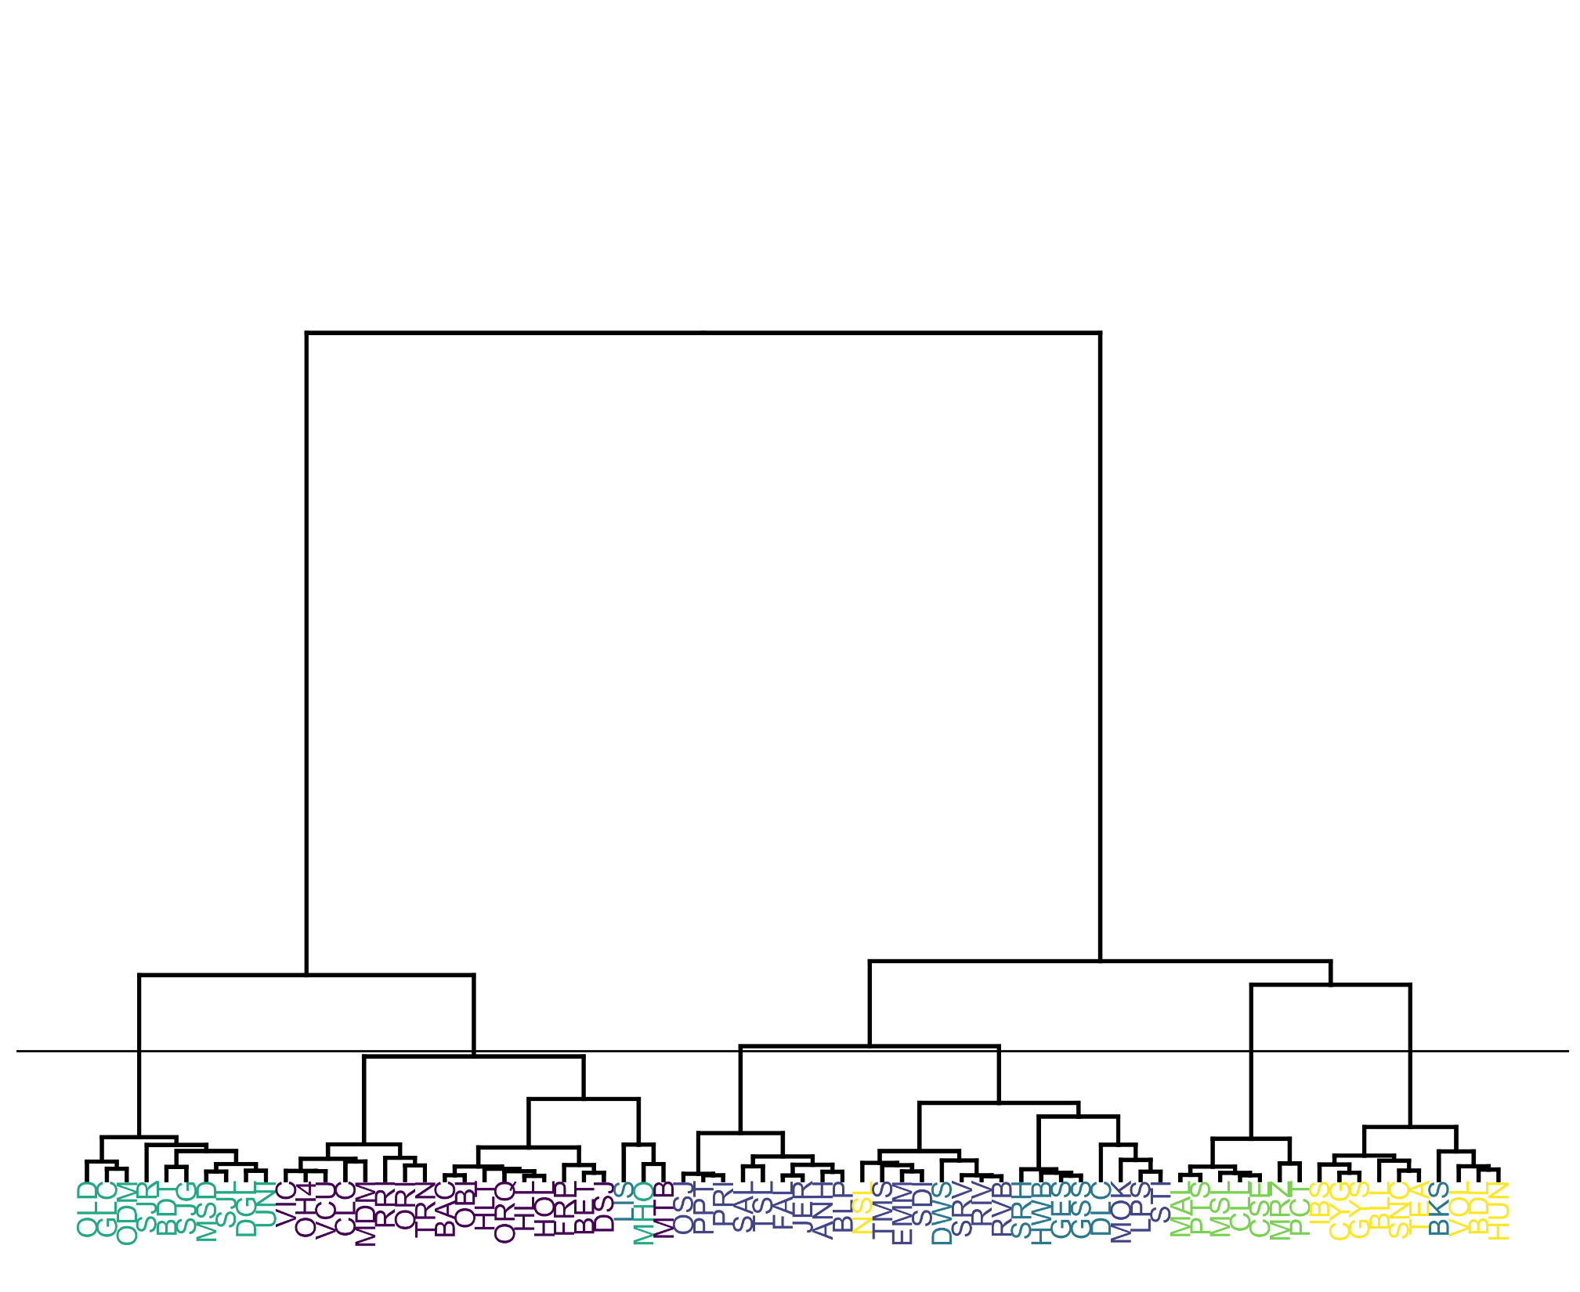

**Figure S1.** Dendrogram showing cluster analysis results based on Ward's dissimilarity on average daily temperatures. Colors indicate regions used in final analysis. The horizontal line indicates the split dividing the tree into six clusters.

**Figure S2.** Map of stations and cluster analysis based on daily mean temperatures at each station. Shapes and colors of points indicate clusters, polygons indicated final regions used for analyses. Regions were drawn so as to maximize the number of stations in a cluster within each region, but also incorporated hydrologic landmarks, so some regions contain some stations in different clusters.

## Water Temperature Patterns

**Table S2.** Model Estimates and Parameters for Mixed Effects Model for Maximum Water Temperature. Results from R summary output.

|  |  |  |  |  |  |  |
| --- | --- | --- | --- | --- | --- | --- |
| **Fixed Effects** | **Predictors** | **Estimates** | **Std. Error** | **df** | **t value** | **Pr(>|t|)** |
|  | (Intercept) | 13.535 | 1.084 | 10.1 | 12.49 | 1.76E-07 |
|  | fWY2011 | -0.338 | 0.056 | 8530.1 | -5.98 | 2.30E-09 |
|  | fWY2012 | 0.149 | 0.056 | 8531.6 | 2.66 | 7.87E-03 |
|  | fWY2013 | 0.825 | 0.056 | 8532.8 | 14.67 | 3.95E-48 |
|  | fWY2014 | 1.115 | 0.056 | 8531.4 | 19.89 | 4.12E-86 |
|  | fWY2015 | 1.941 | 0.056 | 8532.9 | 34.54 | 9.26E-245 |
|  | fWY2016 | 1.205 | 0.056 | 8531.6 | 21.49 | 7.54E-100 |
|  | fWY2017 | 0.394 | 0.056 | 8530.2 | 7.01 | 2.50E-12 |
|  | fWY2018 | 0.614 | 0.056 | 8533.2 | 10.92 | 1.36E-27 |
|  | fWY2019 | 0.355 | 0.057 | 8535.0 | 6.26 | 3.98E-10 |
|  | SeasonDry | 9.086 | 1.674 | 10.0 | 5.43 | 2.88E-04 |
|  | RegionConfluence | -0.525 | 0.110 | 78.1 | -4.77 | 8.34E-06 |
|  | RegionNorthDelta | -0.772 | 0.143 | 79.1 | -5.38 | 7.35E-07 |
|  | RegionSouth | 0.010 | 0.125 | 77.9 | 0.08 | 9.37E-01 |
|  | RegionSuisunBay | -0.300 | 0.150 | 77.2 | -2.01 | 4.81E-02 |
|  | RegionSuisunMarsh | 0.126 | 0.132 | 78.0 | 0.95 | 3.43E-01 |
|  | SeasonDry:RegionConfluence | -0.960 | 0.066 | 8507.6 | -14.50 | 4.37E-47 |
|  | SeasonDry:RegionNorthDelta | -0.695 | 0.088 | 8507.6 | -7.92 | 2.75E-15 |
|  | SeasonDry:RegionSouth | -0.272 | 0.075 | 8507.6 | -3.63 | 2.88E-04 |
|  | SeasonDry:RegionSuisunBay | -2.037 | 0.089 | 8507.6 | -22.96 | 2.76E-113 |
|  | SeasonDry:RegionSuisunMarsh | -1.327 | 0.080 | 8507.6 | -16.68 | 1.75E-61 |
| **Random Effects (N = 8608, Station = 75, Month = 12)** | **Group** | **Variance** |  |  |  |  |
|  | Station | 0.098 |  |  |  |  |
|  | Month | 8.168 |  |  |  |  |
|  | Residual | 1.162 |  |  |  |  |

**Table S3**. Mixed Effects Model Estimated Means, Standard Error, and Confidence Limits for Maximum Water Temperature Model. Results from Pairwise Comparisons in the “emmeans” package.

|  |  |  |  |  |  |
| --- | --- | --- | --- | --- | --- |
| Parameter 1 | Parameter 2 | Estimated  Mean (°C) | SE | Lower  Confidence  Limit (°C) | Upper  Confidence  Limit (°C) |
| 2011 |  | 17.06 | 0.84 | 15.41 | 18.70 |
| 2010 |  | 17.39 | 0.84 | 15.75 | 19.04 |
| 2012 |  | 17.54 | 0.84 | 15.90 | 19.19 |
| 2019 |  | 17.75 | 0.84 | 16.10 | 19.39 |
| 2017 |  | 17.79 | 0.84 | 16.14 | 19.43 |
| 2018 |  | 18.01 | 0.84 | 16.36 | 19.65 |
| 2013 |  | 18.22 | 0.84 | 16.58 | 19.87 |
| 2014 |  | 18.50 | 0.84 | 16.86 | 20.15 |
| 2016 |  | 18.60 | 0.84 | 16.95 | 20.24 |
| 2015 |  | 19.33 | 0.84 | 17.69 | 20.98 |
| Central | Wet Season | 14.16 | 1.08 | 11.75 | 16.57 |
| Confluence | Wet Season | 13.64 | 1.08 | 11.23 | 16.05 |
| NorthDelta | Wet Season | 13.39 | 1.09 | 10.98 | 15.80 |
| South | Wet Season | 14.17 | 1.08 | 11.76 | 16.58 |
| SuisunBay | Wet Season | 13.86 | 1.09 | 11.45 | 16.28 |
| SuisunMarsh | Wet Season | 14.29 | 1.09 | 11.87 | 16.70 |
| Central | Dry Season | 23.25 | 1.28 | 20.40 | 26.10 |
| Confluence | Dry Season | 21.76 | 1.28 | 18.91 | 24.61 |
| NorthDelta | Dry Season | 21.78 | 1.28 | 18.93 | 24.63 |
| South | Dry Season | 22.98 | 1.28 | 20.13 | 25.84 |
| SuisunBay | Dry Season | 20.91 | 1.28 | 18.05 | 23.76 |
| SuisunMarsh | Dry Season | 22.05 | 1.28 | 19.19 | 24.90 |

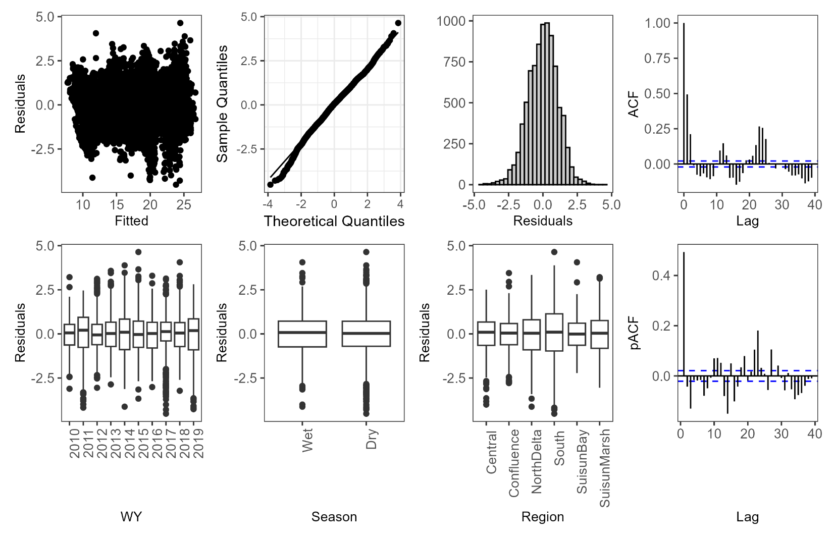

**Figure S3.** Model Validation plots for Maximum Temperature Mixed Effects Model.

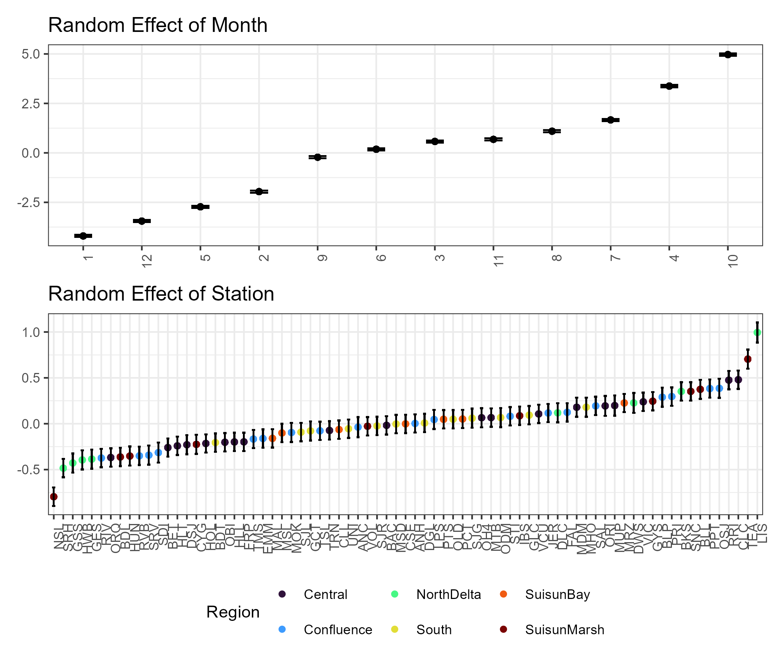

**Figure S4.** Random Effects Plots for Maximum Temperature Mixed Effects Model.

**Table S4.** Model Estimates and Parameters for Mixed Effects Model for Minimum Water Temperature. Results from R summary output.

|  |  |  |  |  |  |  |
| --- | --- | --- | --- | --- | --- | --- |
| **Fixed Effects** | **Predictors** | **Estimates** | **Std. Error** | **df** | **t value** | **Pr(>|t|)** |
|  | (Intercept) | 12.869 | 1.039 | 10.1 | 12.39 | 1.96E-07 |
|  | fWY2011 | -0.342 | 0.054 | 8537.9 | -6.29 | 3.27E-10 |
|  | fWY2012 | 0.077 | 0.054 | 8539.7 | 1.43 | 0.151615679 |
|  | fWY2013 | 0.769 | 0.054 | 8541.2 | 14.21 | 2.63E-45 |
|  | fWY2014 | 1.064 | 0.054 | 8539.5 | 19.74 | 7.56E-85 |
|  | fWY2015 | 1.897 | 0.054 | 8541.3 | 35.07 | 8.52E-252 |
|  | fWY2016 | 1.145 | 0.054 | 8539.8 | 21.24 | 1.34E-97 |
|  | fWY2017 | 0.358 | 0.054 | 8538.0 | 6.63 | 3.57E-11 |
|  | fWY2018 | 0.613 | 0.054 | 8541.7 | 11.32 | 1.67E-29 |
|  | fWY2019 | 0.381 | 0.055 | 8543.9 | 6.98 | 3.18E-12 |
|  | SeasonDry | 8.584 | 1.606 | 10.0 | 5.35 | 0.00032411 |
|  | Region2Confluence | -0.478 | 0.091 | 82.3 | -5.27 | 1.09E-06 |
|  | Region2NorthDelta | -0.750 | 0.119 | 83.9 | -6.33 | 1.18E-08 |
|  | Region2South | -0.247 | 0.103 | 82.1 | -2.39 | 0.019037724 |
|  | Region2SuisunBay | -0.371 | 0.123 | 81.2 | -3.01 | 0.003516188 |
|  | Region2SuisunMarsh | -0.565 | 0.109 | 82.2 | -5.17 | 1.61E-06 |
|  | SeasonDry:Region2Confluence | -0.834 | 0.064 | 8507.9 | -13.09 | 9.39E-39 |
|  | SeasonDry:Region2NorthDelta | -0.645 | 0.085 | 8507.9 | -7.62 | 2.76E-14 |
|  | SeasonDry:Region2South | -0.471 | 0.072 | 8507.9 | -6.53 | 7.05E-11 |
|  | SeasonDry:Region2SuisunBay | -1.979 | 0.085 | 8507.9 | -23.17 | 2.91E-115 |
|  | SeasonDry:Region2SuisunMarsh | -1.491 | 0.077 | 8507.9 | -19.47 | 1.25E-82 |
| **Random Effects (N = 8608, Station = 75, Month = 12)** | **Group** | **Variance** |  |  |  |  |
|  | Station | 0.063 |  |  |  |  |
|  | Month | 7.514 |  |  |  |  |
|  | Residual | 1.077 |  |  |  |  |

**Table S5**. Mixed Effects Model Estimated Means, Standard Error, and Confidence Limits for Minimum Water Temperature Model. Results from Pairwise Comparisons in the “emmeans” package.

|  |  |  |  |  |  |
| --- | --- | --- | --- | --- | --- |
| Parameter 1 | Parameter 2 | Estimated  Mean (°C) | SE | Lower  Confidence  Limit (°C) | Upper  Confidence  Limit (°C) |
| 2011 |  | 15.97 | 0.80 | 14.18 | 17.76 |
| 2010 |  | 16.31 | 0.80 | 14.52 | 18.10 |
| 2012 |  | 16.39 | 0.80 | 14.60 | 18.18 |
| 2017 |  | 16.67 | 0.80 | 14.88 | 18.46 |
| 2019 |  | 16.69 | 0.80 | 14.90 | 18.48 |
| 2018 |  | 16.92 | 0.80 | 15.13 | 18.71 |
| 2013 |  | 17.08 | 0.80 | 15.29 | 18.87 |
| 2014 |  | 17.37 | 0.80 | 15.58 | 19.16 |
| 2016 |  | 17.45 | 0.80 | 15.66 | 19.24 |
| 2015 |  | 18.21 | 0.80 | 16.42 | 19.99 |
| Central | Wet Season | 13.47 | 1.04 | 11.43 | 15.50 |
| Confluence | Wet Season | 12.99 | 1.04 | 10.95 | 15.02 |
| NorthDelta | Wet Season | 12.72 | 1.04 | 10.68 | 14.76 |
| South | Wet Season | 13.22 | 1.04 | 11.18 | 15.26 |
| SuisunBay | Wet Season | 13.10 | 1.04 | 11.05 | 15.14 |
| SuisunMarsh | Wet Season | 12.90 | 1.04 | 10.86 | 14.94 |
| Central | Dry Season | 22.05 | 1.23 | 19.64 | 24.46 |
| Confluence | Dry Season | 20.74 | 1.23 | 18.33 | 23.14 |
| NorthDelta | Dry Season | 20.66 | 1.23 | 18.24 | 23.07 |
| South | Dry Season | 21.33 | 1.23 | 18.92 | 23.74 |
| SuisunBay | Dry Season | 19.70 | 1.23 | 17.29 | 22.11 |
| SuisunMarsh | Dry Season | 19.99 | 1.23 | 17.58 | 22.40 |

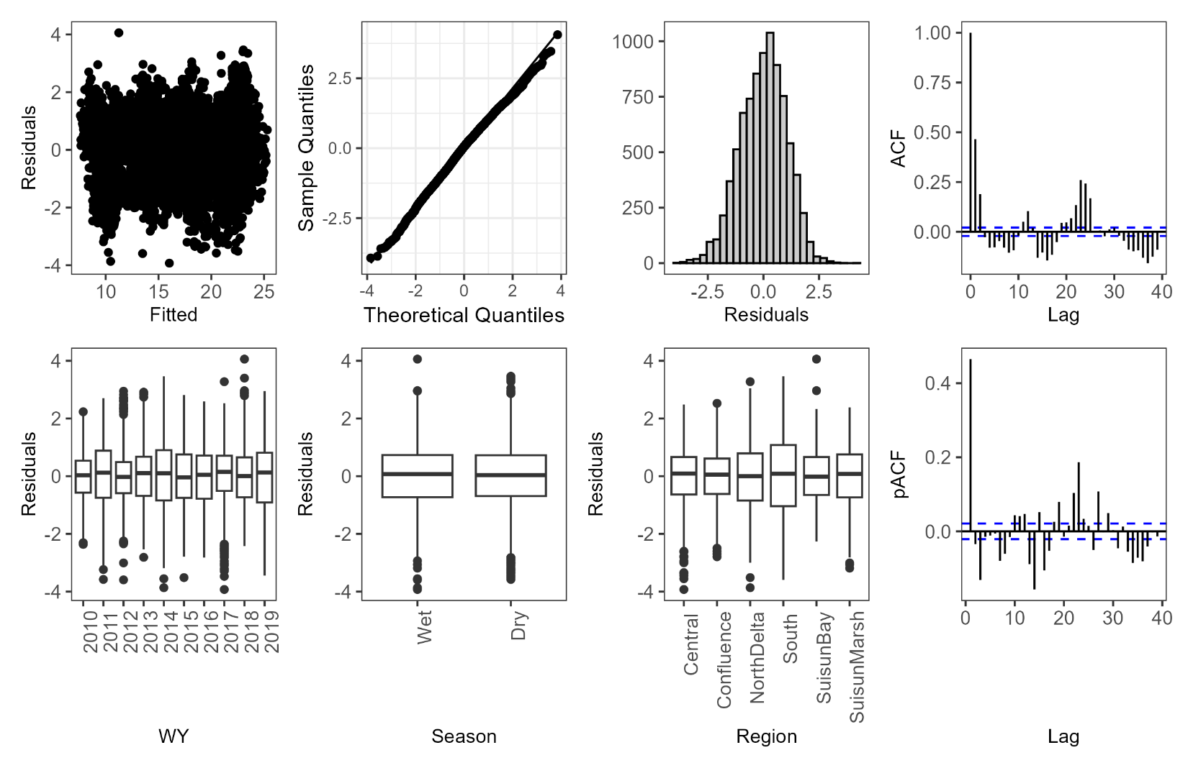

**Figure S5**. Model Validation plots for Minimum Temperature Mixed Effects Model.

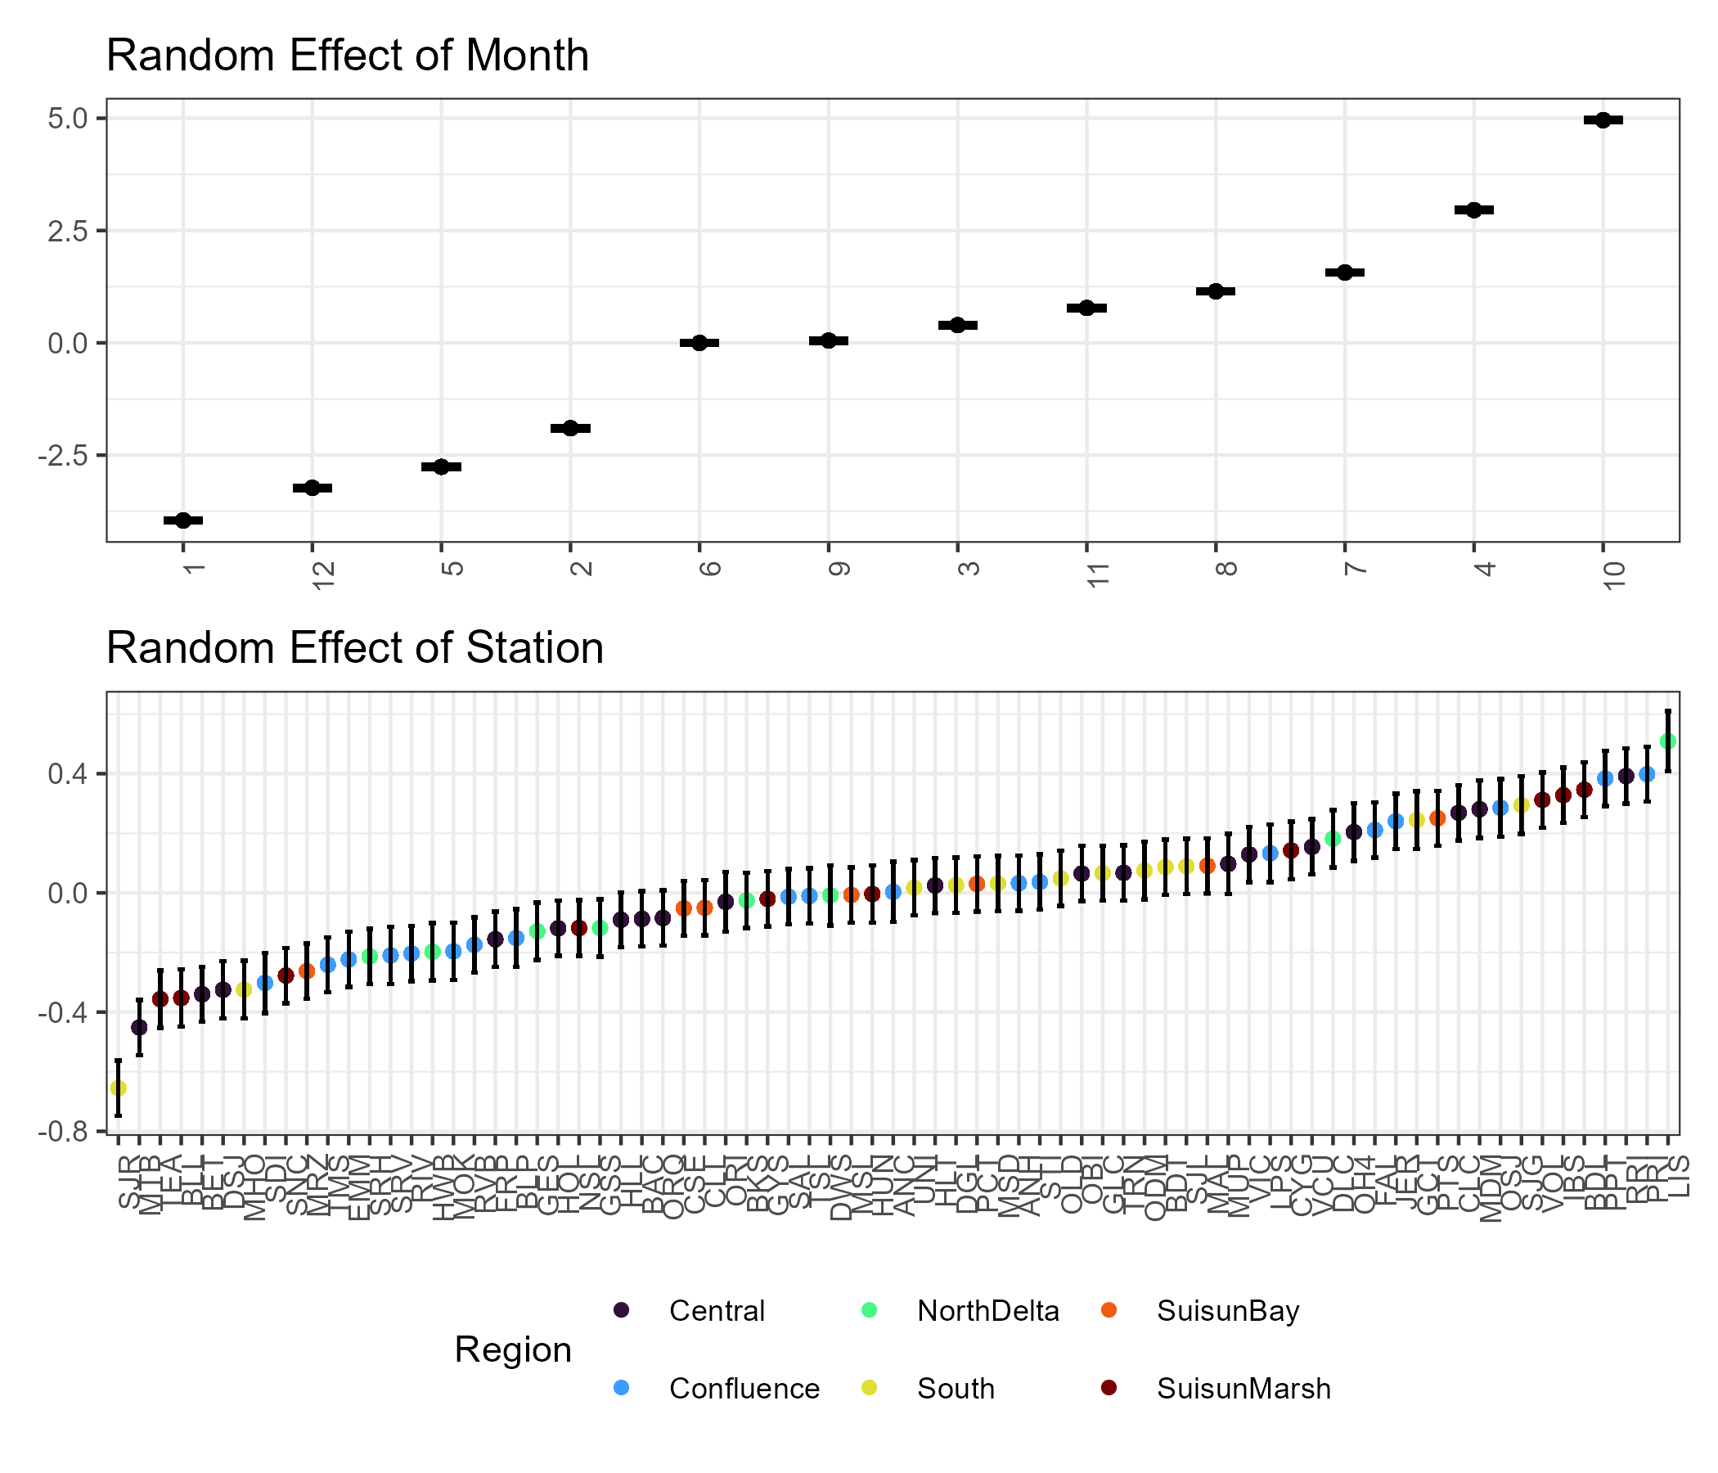

**Figure S6.** Random Effects Plots for Minimum Temperature Mixed Effects Model.

## Thermal Stress and Suitability

### Regional and Seasonal Vulnerability

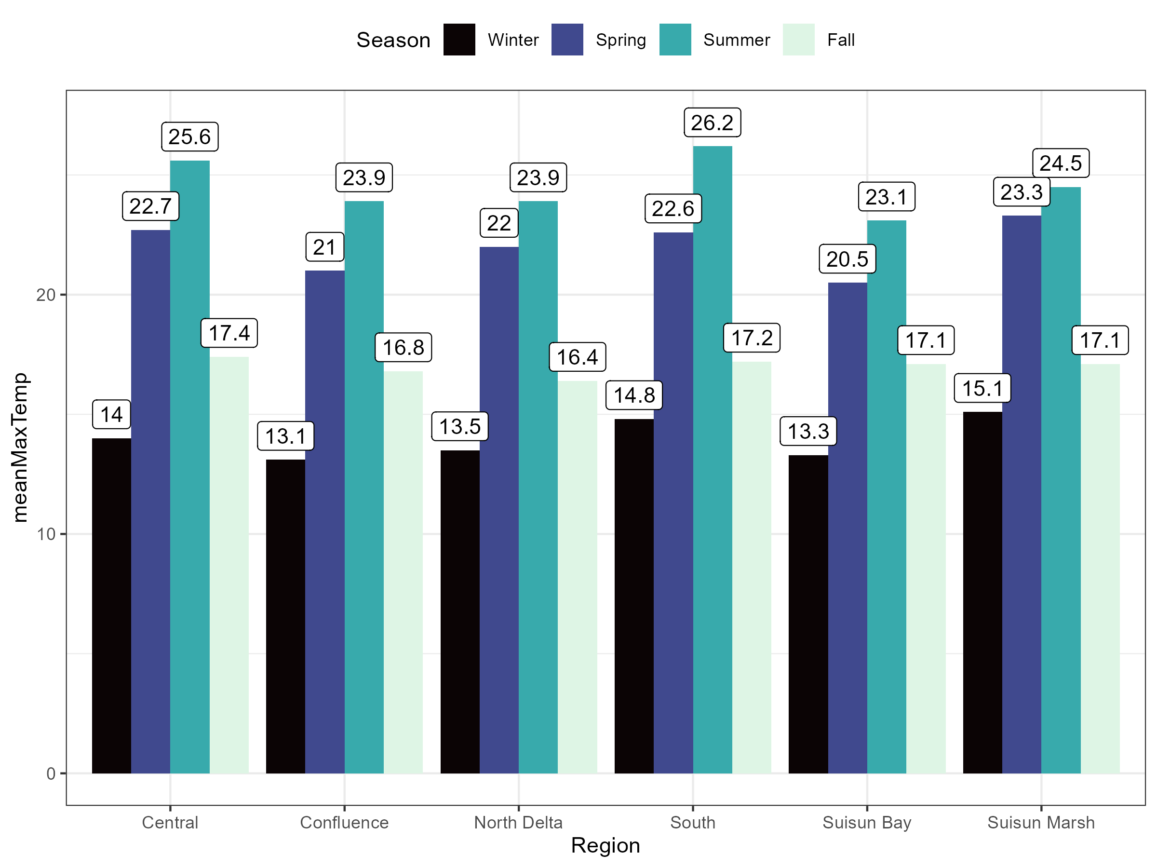

**Figure S7.** Mean Maximum Temperatures Used for Tmar calculations. Maximum temperature by station, month and water year was averaged by season and region.

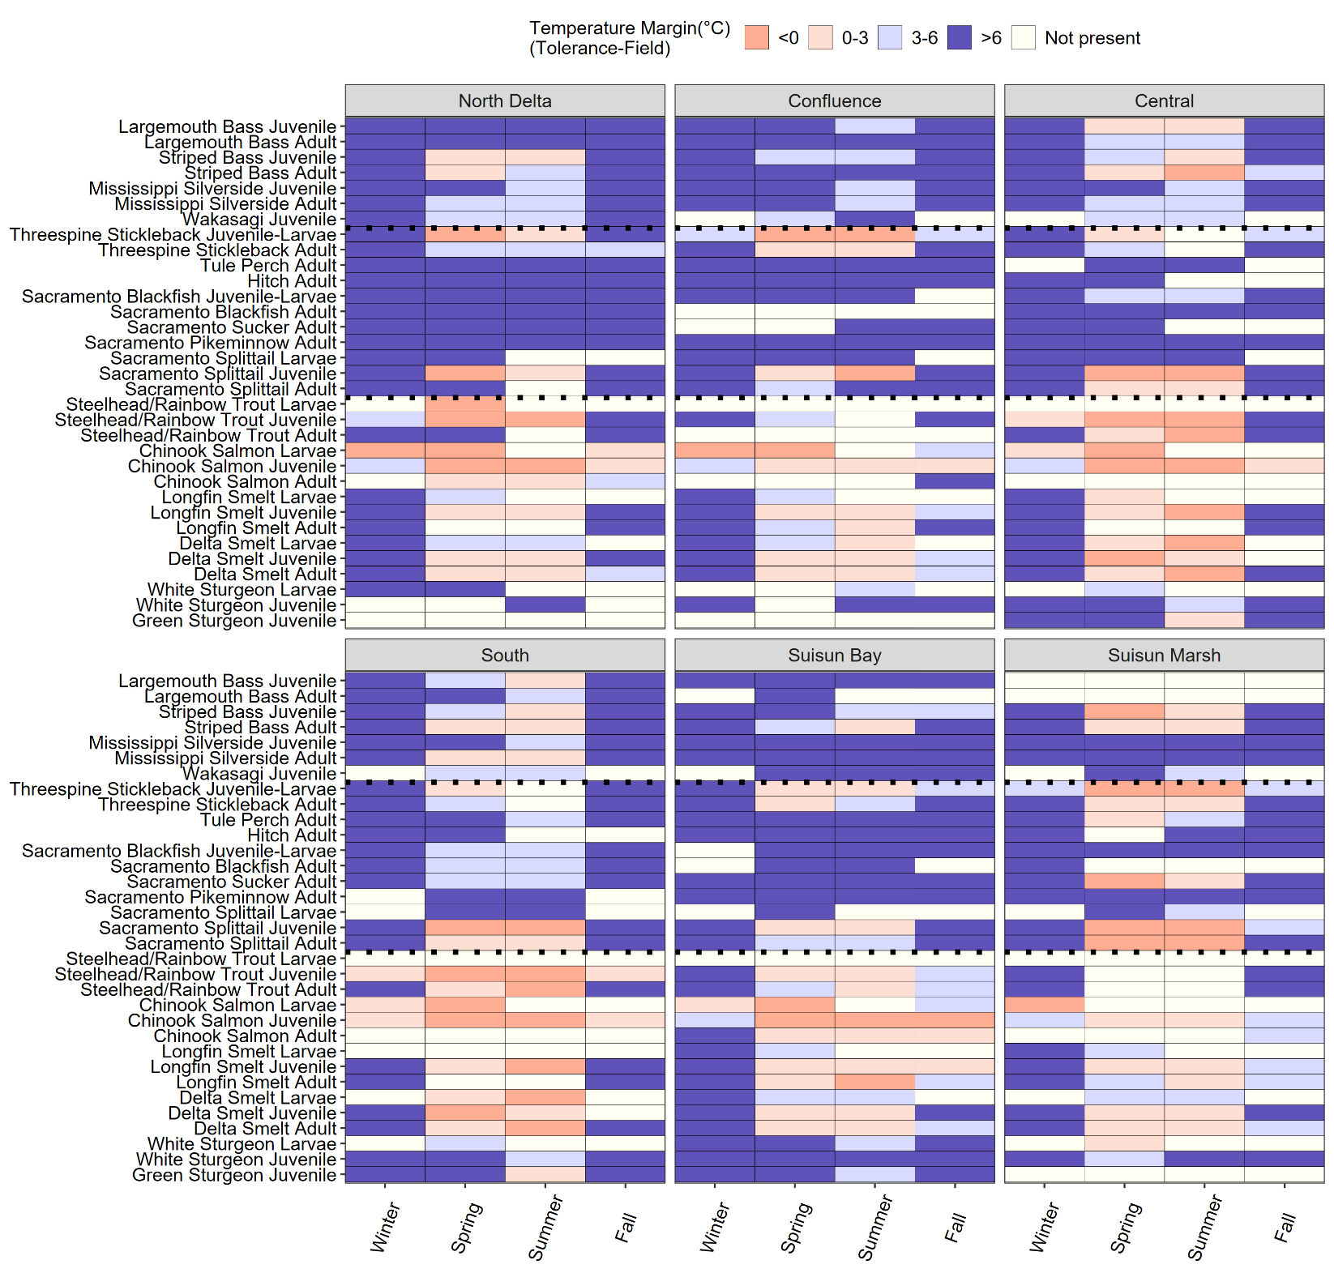

**Figure S8.** Heat map of calculated temperature margins (Tmar, °C) between 2010 and 2019 using fish monitoring and associated discrete water temperature data. White indicates the species-life stage combination is not present or not detected in the monitoring dataset at a particular region-season combination based on monitoring data and life stage-length designations from Davis et al. (2022). Species are organized from non-native fishes to native unlisted fishes to native listed fishes and their relatives. Dotted lines indicate these separations.

### Thermal Stress by Listing Status

**Table S6.** Model Estimates and Parameters for Mixed Effects Model for Days Exceeding Tolerance by ESA-Listing Status. Results from R summary output.

|  |  |  |  |  |  |  |
| --- | --- | --- | --- | --- | --- | --- |
| **Fixed Effects** | **Predictor** | **Estimates** | **SE** | **df** | **T value** | **P** |
|  | Intercept | 4.365 | 0.08 | 12 | 56.325 | 6.47e-16 |
|  | Unlisted | -0.427 | 0.092 | 12 | -4.663 | 0.0005 |
| **Random Effects (N = 140, Species = 14)** | **Groups** | **Variance** |  |  |  |  |
|  | Species | 0.012 |  |  |  |  |
|  | Residual | 0.118 |  |  |  |  |

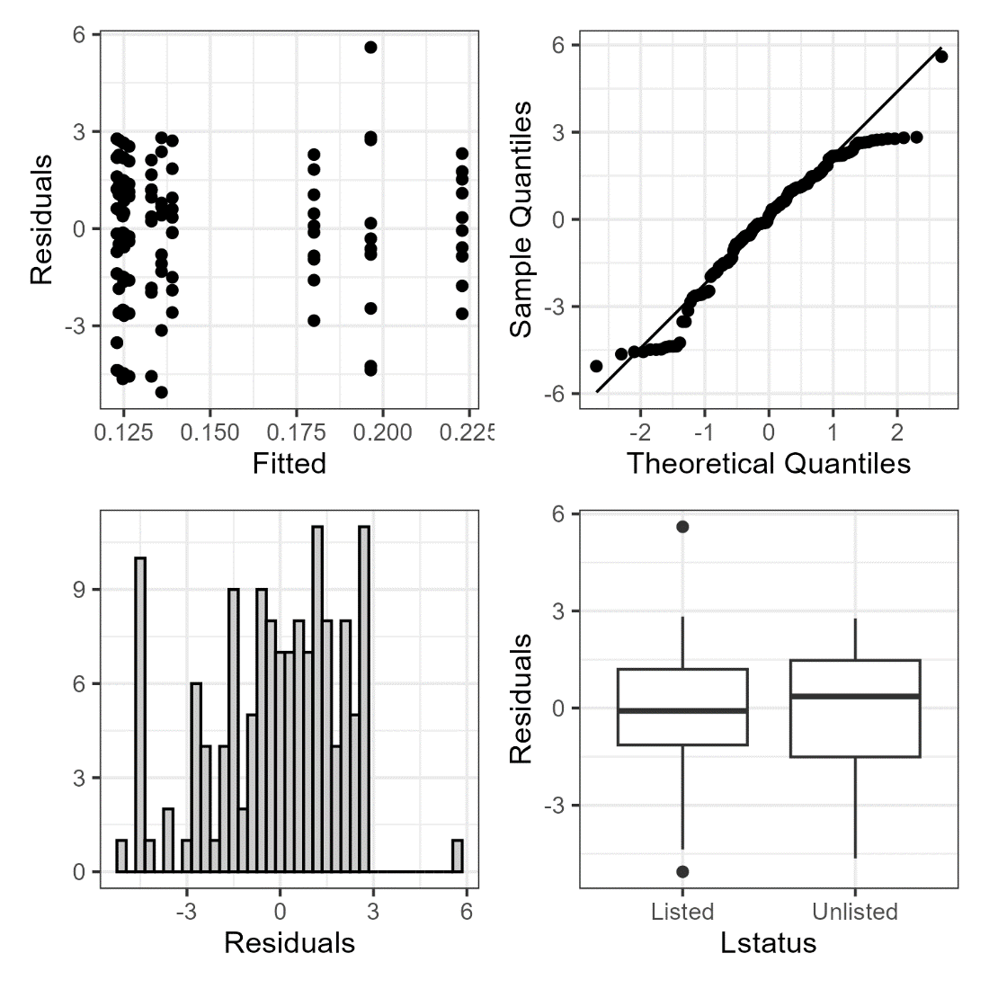

Figure 9

**Figure S10.** Model Validation Plots for ESA-listed Status Mixed Effects Model.

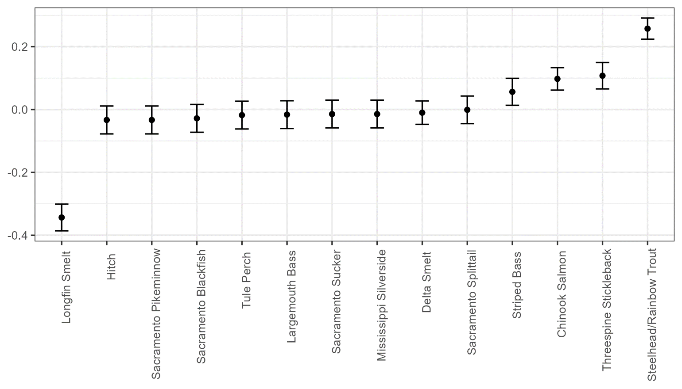

**Figure S11.** Random Effect Plot for ESA-listed Status Mixed Model.

**Table S7.** Summary Statistics of Water Temperature Across Stations. Values are based on continuous water temperature dataset.

|  |  |  |  |  |  |
| --- | --- | --- | --- | --- | --- |
| **Station** | **StationName** | **Region** | **Mean Temperature (°C)** | **Maximum Temperature (°C)** | **Minimum Temperature (°C)** |
| ANC | ANTIOCH (USBR) | Confluence | 16.7 | 25.2 | 6.7 |
| ANH | SAN JOAQUIN RIVER AT ANTIOCH | Confluence | 16.6 | 25.2 | 6.6 |
| BAC | BACON ISLAND AT OLD RIVER | Central | 17.4 | 27.7 | 5.9 |
| BDL | BELDON LANDING | Suisun Marsh | 16.7 | 26.1 | 5.3 |
| BDT | SAN JOAQUIN R AT BRANDT BRIDGE | South | 17.2 | 29.5 | 5.8 |
| BET | BETHEL ISLAND AT PIPER SLOUGH | Central | 17.2 | 26.9 | 6 |
| BKS | BARKER SLOUGH PUMPING PLANT (KG000000) | North Delta | 16.7 | 27.8 | 6.1 |
| BLL | BLACKLOCK (NE1) | Suisun Marsh | 16.6 | 30.2 | 4.1 |
| BLP | SAN JOAQUIN RIVER AT BLIND POINT | Confluence | 16.8 | 27.2 | 4.6 |
| CLC | CLIFTON COURT | Central | 17.9 | 28.6 | 6.7 |
| CLL | COLLINSVILLE | Suisun Bay | 16.2 | 24.3 | 6.6 |
| CSE | COLLINSVILLE ON SACRAMENTO RIVER | Suisun Bay | 16.3 | 24.7 | 6.5 |
| CYG | CYGNUS-CORDELIA SLOUGH | Suisun Marsh | 16.7 | 27 | 5.2 |
| DGL | DOUGHTY CUT ABOVE GRANT LINE CANAL | South | 17.2 | 30.9 | 4.4 |
| DLC | DELTA CROSS CHANNEL BTW SAC R & SNODGRAS | North Delta | 16.7 | 27.2 | 6.1 |
| DSJ | DUTCH SLOUGH AT JERSEY ISLAND | Central | 17.3 | 27 | 5.7 |
| DWS | SACRAMENTO DEEP WATER SHIPPING CHANNEL | North Delta | 16.7 | 25.9 | 6.2 |
| EMM | EMMATON (USBR) | Confluence | 16.4 | 25.1 | 6.4 |
| FAL | FALSE RIVER NEAR OAKLEY | Confluence | 16.8 | 25.6 | 6.3 |
| FRP | FARRAR PARK | Central | 17.4 | 26.9 | 5.8 |
| GCT | GRANTLINE CANAL AT TRACY RD BRIDGE | South | 17.3 | 29.6 | 6.2 |
| GES | SACRAMENTO RIVER BELOW GEORGIANA SLOUGH | North Delta | 16.3 | 26.1 | 6.2 |
| GLC | GRANTLINE CANAL (USGS) | South | 17.3 | 28.9 | 6.2 |
| GSS | GEORGIANA SLOUGH AT SACRAMENTO RIVER | North Delta | 16.3 | 26.1 | 6.1 |
| GYS | GOODYEAR SLOUGH | Suisun Marsh | 16.8 | 28.4 | 4.3 |
| HLL | HOLLAND TRACT | Central | 17.4 | 27.7 | 6 |
| HLT | MIDDLE RIVER NEAR HOLT | Central | 17.5 | 26.3 | 6.8 |
| HOL | HOLLAND CUT NEAR BETHEL ISLAND | Central | 17.4 | 27.8 | 6 |
| HUN | HUNTER CUT AT MONTEZUMA SLOUGH | Suisun Marsh | 16.6 | 25.8 | 6.3 |
| HWB | MINER SLOUGH AT HWY 84 BRIDGE | North Delta | 16.2 | 26.3 | 6.1 |
| IBS | IBIS | Suisun Marsh | 16.9 | 27.9 | 5.5 |
| JER | JERSEY POINT | Confluence | 16.9 | 25.4 | 6.6 |
| LIS | YOLO BYPASS AT LISBON | North Delta | 17.6 | 30.8 | 4.4 |
| LPS | LITTLE POTATO SLOUGH AT TERMINOUS | Confluence | 16.9 | 26.7 | 6.2 |
| MAL | SACRAMENTO RIVER AT MALLARD ISLAND | Suisun Bay | 16.3 | 24.2 | 6.9 |
| MDM | MIDDLE RIVER AT MIDDLE RIVER | Central | 17.8 | 27.3 | 6.4 |
| MHO | MIDDLE RIVER NEAR HOWARD ROAD BRIDGE | South | 17.2 | 30.3 | 4.4 |
| MOK | MOKELUMNE R @ SAN JOAQUIN RIVER | Confluence | 16.2 | 26 | 6.4 |
| MRZ | MARTINEZ | Suisun Bay | 16.1 | 25.2 | 6.8 |
| MSD | SAN JOAQUIN RIVER AT MOSSDALE BRIDGE | South | 17.3 | 31.2 | 6.2 |
| MSL | MONTEZUMA SLOUGH AT ROARING R | Suisun Bay | 16.3 | 25.1 | 6.2 |
| MTB | MIDDLE RIVER AT TRACY BLVD | Central | 17.3 | 28.6 | 4.8 |
| MUP | MIDDLE RIVER AT UNION POINT | Central | 17.7 | 27.7 | 6.3 |
| NSL | NATIONAL STEEL | Suisun Marsh | 16.1 | 25.3 | 4.7 |
| OBI | OLD RIVER AT BACON ISLAND (USGS) | Central | 17.6 | 27.1 | 6.2 |
| ODM | OLD RIVER AT DELTA MENDOTA CANAL | South | 17.4 | 27.8 | 5.6 |
| OH4 | OLD RIVER AT HIGHWAY 4 | Central | 17.7 | 27.9 | 6.3 |
| OLD | OLD RIVER NEAR TRACY | South | 17.3 | 30.2 | 5 |
| ORI | OLD RIVER AT CLIFTON COURT INTAKE | Central | 17.8 | 27.9 | 6.5 |
| ORQ | OLD RIVER @ QUIMBLY IS NEAR BETHEL IS | Central | 17.4 | 26.4 | 6.4 |
| OSJ | OLD RIVER AT FRANKS TRACT NEAR TERMINOUS | Confluence | 16.9 | 26.1 | 7.4 |
| PCT | PORT CHICAGO | Suisun Bay | 16.3 | 24.5 | 6.7 |
| PPT | PRISONERS POINT | Confluence | 17.1 | 26.1 | 6.6 |
| PRI | SAN JOAQUIN R AT PRISONERS PT NR TERMINO | Confluence | 17.1 | 25.8 | 6.7 |
| PTS | PITTSBURG | Suisun Bay | 16.5 | 26.8 | 6.8 |
| RIV | RIO VISTA | Confluence | 16.4 | 25.2 | 6.5 |
| RRI | ROUGH AND READY ISLAND | Central | 18 | 28.8 | 6.4 |
| RVB | SACRAMENTO RIVER AT RIO VISTA BRIDGE | Confluence | 16.4 | 25.3 | 6.2 |
| SAL | SAN ANDREAS LANDING | Confluence | 16.7 | 25.9 | 6.7 |
| SDI | SACRAMENTO RIVER AT DECKER ISLAND | Confluence | 16.3 | 24.9 | 6.4 |
| SJG | SAN JOAQUIN RIVER AT GARWOOD BRIDGE | South | 17.5 | 29.9 | 6.4 |
| SJL | SAN JOAQUIN R BLW OLD R NEAR LATHROP | South | 17.3 | 30.4 | 5.7 |
| SJR | SAN JOAQUIN R MCCUNE STATION NR VERNALIS | South | 16.8 | 32 | 5.6 |
| SNC | SUNRISE CLUB | Suisun Marsh | 16.7 | 28.3 | 4.1 |
| SRH | SACRAMENTO RIVER AT HOOD | North Delta | 16.2 | 26.4 | 6.1 |
| SRV | SACRAMENTO RIVER AT RIO VISTA (USGS) | Confluence | 16.4 | 25.1 | 6.4 |
| STI | STATEN ISLAND | Confluence | 16.7 | 26.5 | 6.5 |
| TEA | TEAL CLUB AT FRANK HORAN SLOUGH | Suisun Marsh | 16.9 | 29.6 | 4.1 |
| TMS | THREE MILE SLOUGH | Confluence | 16.4 | 25.2 | 5.9 |
| TRN | TURNER CUT NEAR HOLT | Central | 17.5 | 27.1 | 6.7 |
| TSL | THREEMILE SLOUGH AT SAN JOAQUIN RIVER | Confluence | 16.7 | 25.2 | 6.7 |
| UNI | UNION ISLAND | South | 17.2 | 30.6 | 3.2 |
| VCU | VICTORIA CANAL NEAR BYRON | Central | 17.6 | 28.3 | 6.4 |
| VIC | VICTORIA ISLAND | Central | 17.7 | 28.1 | 6.3 |
| VOL | VOLANTI | Suisun Marsh | 16.8 | 27.2 | 6.1 |

**Figure S12***.* Comparison of No Recovery Stations and Days Between All Years (2010-2019) and Warm Years (2014-2016). Plots include data from April-September only.