1. **Timeline of the penetrating model.**

We averaged the vector Y components at each end of the normalized displacement curves for each group. Every step curve of an animal was compared to the curves of a different control animal, sequentially with each displacement curve of all animals in the control group. Thus, we calculated differences in the displacement curves between every animal and compared experimental versus control groups. We compared this pattern comparison analysis by using a locally designed MATLAB script.

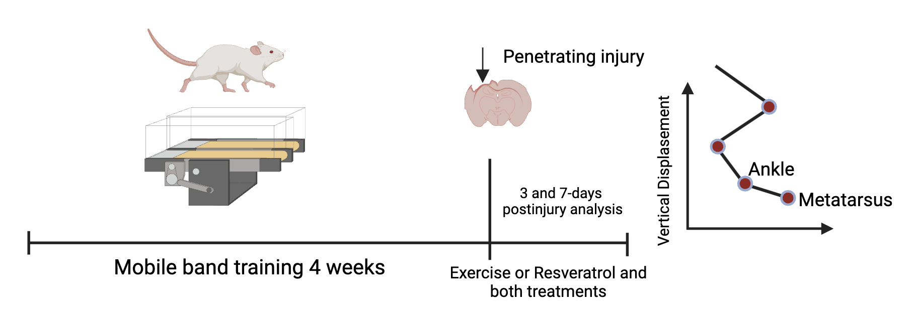

Figure 1. Timeline of the penetrating model. The rats walked for 4 weeks before and a week post-injury on the mobile band. Resveratrol treatment was administered for 7 days continuously after penetrating injury.

1. **Vertical displacement in metatarsus on the third and seventh days after the lesion in male rats.**

To determine the changes in vertical displacement of adult male rats after a penetrating injury to the hippocampus, differences in the displacement of the metatarsal and ankle joints of the hindlimb were analyzed. It illustrates the vertical displacement of the metatarsus of the control group, the 3-dpi group, and the 7 dpi group. Asterisks above zero (*) show the points where the step cycle is different with statistical significance (P ≤ 0.05). The annotation at the bottom of each graph shows the total percentage of the cycle that was statistically different.

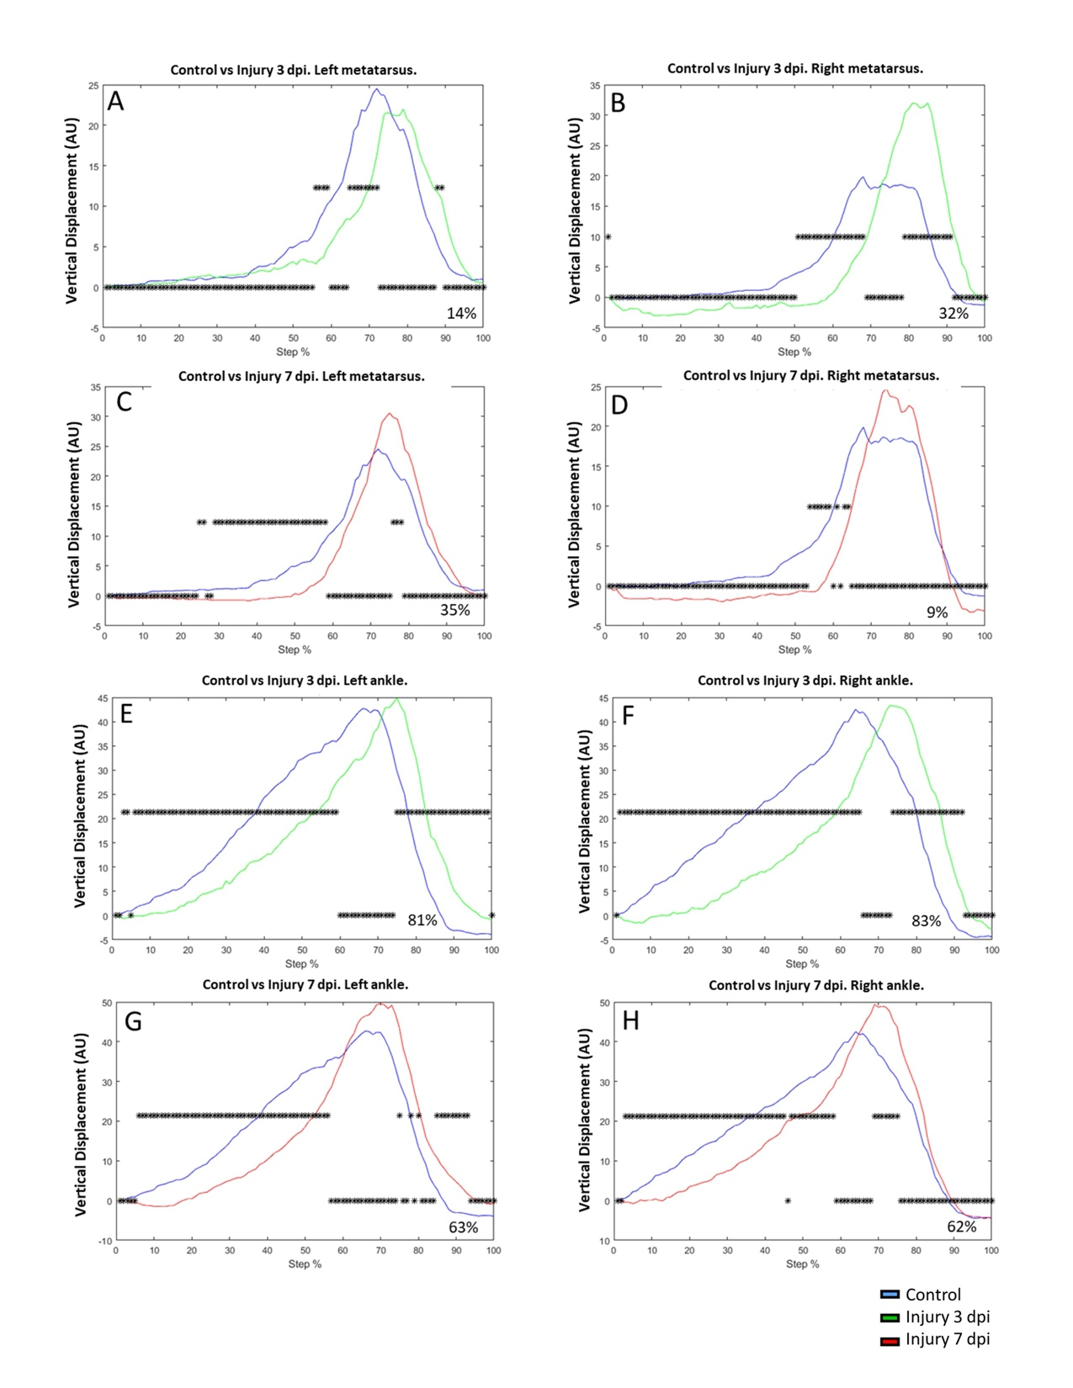

*Figure 2*. A-B, graphs illustrate the metatarsus vertical displacement (VD) of the control group (blue) versus the injury group at 3 days (3 dpi, green) in left and right metatarsus joints respectively. C – D, VD of the metatarsus control group (blue) versus the injury group at 7 days (7 dpi, red). The asterisks illustrate the bins with a statistical difference (*P ≤ 0.05). The percent of change is expressed below the graphs. E-F, graphs illustrate the ankle vertical displacement (VD) of the control group (blue) versus the injury group at 3 days after injury (3 dpi, green) in the left and right metatarsus joint respectively. G – H, VD of ankle joint control group (blue) versus a group with injury at 7 days after injury (7 dpi, red). The asterisks illustrate the bins with a statistical difference (*P ≤ 0.05). The percent of change is expressed below the graphs.

1. **General changes in locomotion kinematics after penetrating injury and treatments.**

To have a broader overview of the changes in the kinematics of gait locomotion after penetrating injury and the effects of the different treatments (Exercise and Resveratrol), a data concentrate corresponding to the changes in the Vertical displacement (VD) and Horizontal displacement that occurred between the experimental groups on both the left and right sides (Figure 3). It is important to highlight the VD that had minimal significant differences (0 or 1% of the step cycle) whether on the left or right side. These comparisons between groups either at 3 or 7 dpi, which had minimal differences between them compared to the control group, tell us that the vertical or horizontal displacement was the same as the control despite the injury model.

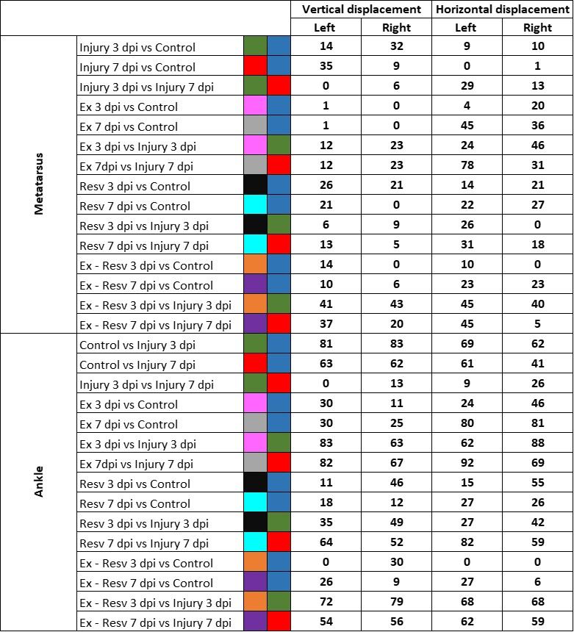

*Figure 3*. Differences in Vertical and Horizontal displacement between the left and right side by group. The total differences of differences with statistical significance in the step cycle per joint in the VD between the left side and the right side of each experimental group are shown. A data concentrate corresponding to the changes in the Vertical displacement (VD) and Horizontal displacement that occurred between the experimental groups on both the left and right sides.