**Supplementary**

**Understanding the application of emulsion system for bacterial encapsulation and temperature-modulated release**

Nur Suaidah Mohd Isa1,2*, Hani El Kadri1, Daniele Vigolo1,3,4, Nur Farra Adlina Mohamed Zakhari2, Konstantinos Gkatzionis1,5*

1 School of Chemical Engineering, University of Birmingham, Birmingham, B15 2TT, UK

2 Faculty of Fisheries and Food Science, Universiti Malaysia Terengganu, 21030 Kuala Terengganu, Terengganu, Malaysia

3 School of Biomedical Engineering, The University of Sydney, NSW 2006, Australia

4 The University of Sydney Nano Institute, The University of Sydney, Sydney, NSW 2006, Australia

5 Department of Food Science and Nutrition, School of the Environment, University of the Aegean, Metropolite Ioakeim 2, 81400, Myrina, Lemnos, Greece

*Corresponding authors: [n.suaidah@umt.edu.my](mailto:n.suaidah@umt.edu.my); [kgkatzionis@aegean.gr](mailto:kgkatzionis@aegean.gr)

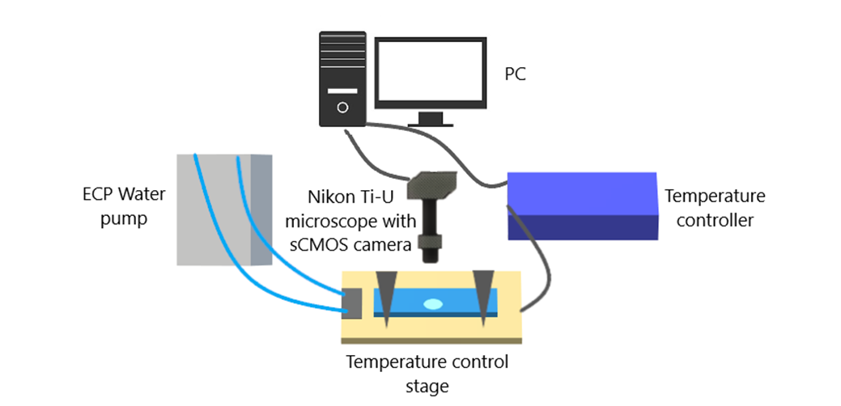

Figure S1 Microscopic observation of emulsion destabilization with the change in temperature. Sample of the emulsion was placed on a glass slide and placed on a temperature-controlled stage at 25˚C. The temperature of the stage was then reduced to -25°C that freezes the sample and was kept at that temperature for 10 minutes. The temperature of the stage was then increased to 25°C in order to thaw the sample. Photomicrographs of the sample were taken with every temperature change, from 25°C (initial) to -25°C (cooling), 5°C (heating) and back to 25°C (thawed). The temperature of the stage was maintained with ECP water pump.

Figure S2 The bacterial adherence to soybean oil assay for live and dead *E. coli*-GFP at different soybean oil volume (mL). Bars represent mean ± SEM taken from 3 independent experiments (N=3). Higher absorbance values (%) indicate lower affinity towards the oil phase (live cells) while lower absorbance values (%) indicate higher affinity towards the oil phase (dead cells).