Table 1 Advantages and disadvantages of different ligation method
LIGATION METHOD | ENZYME / SYSTEM | ADVANTAGES | DISADVANTAGES
Chemical Ligation | - | - Avoids biological components, allowing chemical control over reaction  - Potential for site-specific modifications  - Does not require ATP or cofactors  - Simple setup and fewer enzymatic constraints | - Inefficient ligation, particularly for large RNA molecules  - Formation of non-canonical 2', 5'-phosphodiester bonds  - Safety concerns with reagents  - Difficult to achieve high yields  - Formation of unintended byproducts
Enzymatic Ligation | T4 DNA Ligase | - High accuracy in joining DNA or RNA with sticky or blunt ends  - Widely used, well-studied enzyme system  - ATP-dependent reactions | - Inefficient with RNA ligation  - Reduced effectiveness in the presence of complex secondary RNA structures  - Prone to side reactions (e.g., intermolecular end joining)
Enzymatic Ligation | T4 RNA Ligase 1 | - Efficient for short RNA sequences (e.g., 6-8 nucleotides)  - Can ligate both 5’ and 3’ termini of RNA molecules | - Inefficient for large RNA molecules  - Sensitive to secondary structures in RNA  - Higher risk of intermolecular end joining and circularization
Enzymatic Ligation | T4 RNA Ligase 2 | - Optimized for single-stranded RNA ligation with secondary structures  - Greater efficiency than T4 RNA Ligase 1 for circular RNA formation | - Lower efficiency for large RNA substrates  - Susceptible to secondary structure interference  - Intermolecular side reactions are common
Enzymatic Ligation | DNA Ligase IV | - High fidelity ligation for circular RNA vaccine constructs  - In vivo and ex vivo applications possible | - Limited by secondary structure interference  - Requires ATP and specific reaction conditions for high efficiency
Ribozyme-Based Ligation | Group I Intron Self-Splicing System | - Simple conditions for ligation  - Effective for RNA cyclization both in vitro and in vivo  - Suitable for creating large circRNAs | - Impacted by significant RNA secondary structures  - Slower reactions compared to enzymatic methods  - Yield may vary based on RNA sequence complexity
Ribozyme-Based Ligation | Group II Intron Self-Splicing System | - High precision ligation  - Utilizes intrinsic RNA properties for circularization | - Formation of 2', 5'-phosphodiester bonds  - Limited applicability in vitro due to poorly understood mechanisms  - Requires specific sequence motifs
Ribozyme-Based Ligation | Hairpin Ribozyme | - High ligation efficiency for small circRNAs  - Simple reaction mechanism without ATP or additional cofactors | - Instability of circularized product  - Exogenous hairpin ribozyme sequences are required  - Limited applicability for large or complex RNAs
Autocatalytic Ligation | Permuted Intron-Exon (PIE) System | - Self-ligating RNA systems for large-scale production of circRNAs  - Allows precise control over RNA circularization | - May produce non-canonical linkages  - Requires highly specific sequence contexts for successful ligation
Click Chemistry-Based Ligation | Copper(I)-Catalyzed Azide-Alkyne Cycloaddition (CuAAC) | - Highly specific and bio-orthogonal reaction  - Generates stable circRNA vaccines via covalent bond formation | - Requires copper catalyst, which may introduce cytotoxicity  - Not suitable for in vivo systems without further optimization

Table 2 Diverse types of circRNAs, their functions, design, delivery and examples
TYPES OF CIRCRNAS | FUNCTIONS | EXAMPLES | DESIGN AND DELIVERY TECHNIQUES
Exon-derived circRNAs or exonic circRNAs | Exonic circRNAs serve as disease biomarkers for diseases such as cancer, owing to their differential expression profiles. Exonic circRNAs are commonly associated with post-transcriptional proteins. They can integrate and form RNA-protein complexes to regulate gene expression in tumor cells. | circRNA ciRS-7 is an example of an exonic circRNA that interacts with miR-7. Its dysregulation is associated with tumor growth and cancers such as hepatocellular carcinoma and gastric cancer (Chen et al., 2015; Ma et al., 2021; Ragan et al., 2019; Verduci et al., 2021) | The in vitro design and synthesis of exonic circRNAs can be derived from strategies such as permuted intron-exon (PIE) system and repetitive or non-repetitive intronic complementary sequences (ICS). The in vivo design applications of exonic circRNAs are observed with an inclined preference for a linearly transcribed exon as a back-splice acceptor. The design and synthesis of exonic circRNAs initiate their delivery within the host organism’s cells. Exonic circRNAs can be delivered efficiently through the artificial modification of nanoparticles and exosomes (Liu et al., 2017; Loan Young et al., 2023; Misir et al., 2022; Obi & Chen, 2021; Petkovic & Müller, 2015; Ragan et al., 2019; Yu & Kuo, 2019).
Intron-derived circRNAs or circular intronic RNAs | Intron-derived circRNAs interact with RNA-binding proteins (RBP). They can serve the essential function as molecular sponges for microRNAs, influencing protein expression and cellular functions in tumor tissues, specifically, originating from diseases such as cancer. | ci-Sirt7 is an example of an intronic circRNA regulating cellular differentiation and cellular proliferation by acting as effective miRNA sponges (Chen et al., 2015; Chen et al., 2019c; Li et al., 2018; Ma et al., 2021; Yu & Kuo, 2019). | In vivo design and synthesis of intron-derived circRNAs can be achieved through Muscleblind-based (an essential muscle and neuronal splicing regulator) protein binding sites identification. Additionally, techniques for in vitro transcription of intron-derived circRNAs can include chemical ligation (using cyanogen bromide) and ribozyme method. Delivery methods for intron-derived circRNAs include the transfection of circRNA constructs containing group I introns and utilizing natural circularization systems in vivo containing Alu intronic elements (Conn et al., 2015; Cui et al., 2023; Feng et al., 2023; Loan Young et al., 2023; Obi & Chen, 2021; Petkovic & Müller, 2015; Wu et al., 2019).
Intergenic circRNAs | Intergenic RNAs originate from non-coding RNA loci and intergenic regions present on the precursor RNA molecule. Intergenic RNAs serve a major purpose of transcriptional regulation and chromosome signatures that identify the expression of protein-coding genes in diseased states. | lincRNA-p21 constitutes a class derived from intergenic regions in the precursor RNA molecules. However, in the presence of miRNA, intergenic circRNAs tend to repress the target mRNA translation, serving as a crucial turning point in disease pathogenesis (Chen et al., 2015; Chen et al., 2019c; Li et al., 2018; Ma et al., 2021; Meng et al., 2017). | In-vitro synthesis of intergenic RNAs can involve incorporating RNA-binding protein motifs in the intergenic circRNA backbone. Its in vivo synthesis constitutes the expression of two intronic circRNA fragments (ICFs) flanked by GT-AG splicing signals. Delivery of intergenic circRNAs can be conducted through viral vectors such as lentiviruses and adenoviruses and lipid nanoparticles that can protect intergenic circRNAs against degradation (Chen et al., 2023; Chen & Lu, 2021; Geng et al., 2018; Long et al., 2023; Ma et al., 2021; Panzeri et al., 2015; Plewka & Raczynska, 2022).
Exons-Introns  (EIciRNAs) | ElciRNAs mitigate gene expression through scaffolds that bind to RNA polymerase II during gene transcriptional processes. They also modulate alternative splicing to identify varied protein expressions in tumorous cells. | ci-Ins2 is derived from the insulin gene and regulates cellular processes in pancreatic cells (Li et al., 2018; Ma et al., 2021; Verduci et al., 2021) | In vivo synthesis of EIciRNAs results in circRNA constructs containing introns present between alternate exons flanked by complementary gene sequences. In vitro transcription of exon-intron (EIciRNAs) involves enzymatic ligation processes (through T4 DNA ligase) and permuted introns and exons (PIE) method. Delivery of EIciRNAs can be mediated by direct transfection to facilitate adequate gene expression (Chen & Lu, 2021; J. Liu et al., 2017; Liu et al., 2019b; Yu & Kuo, 2019; Zhou et al., 2020).

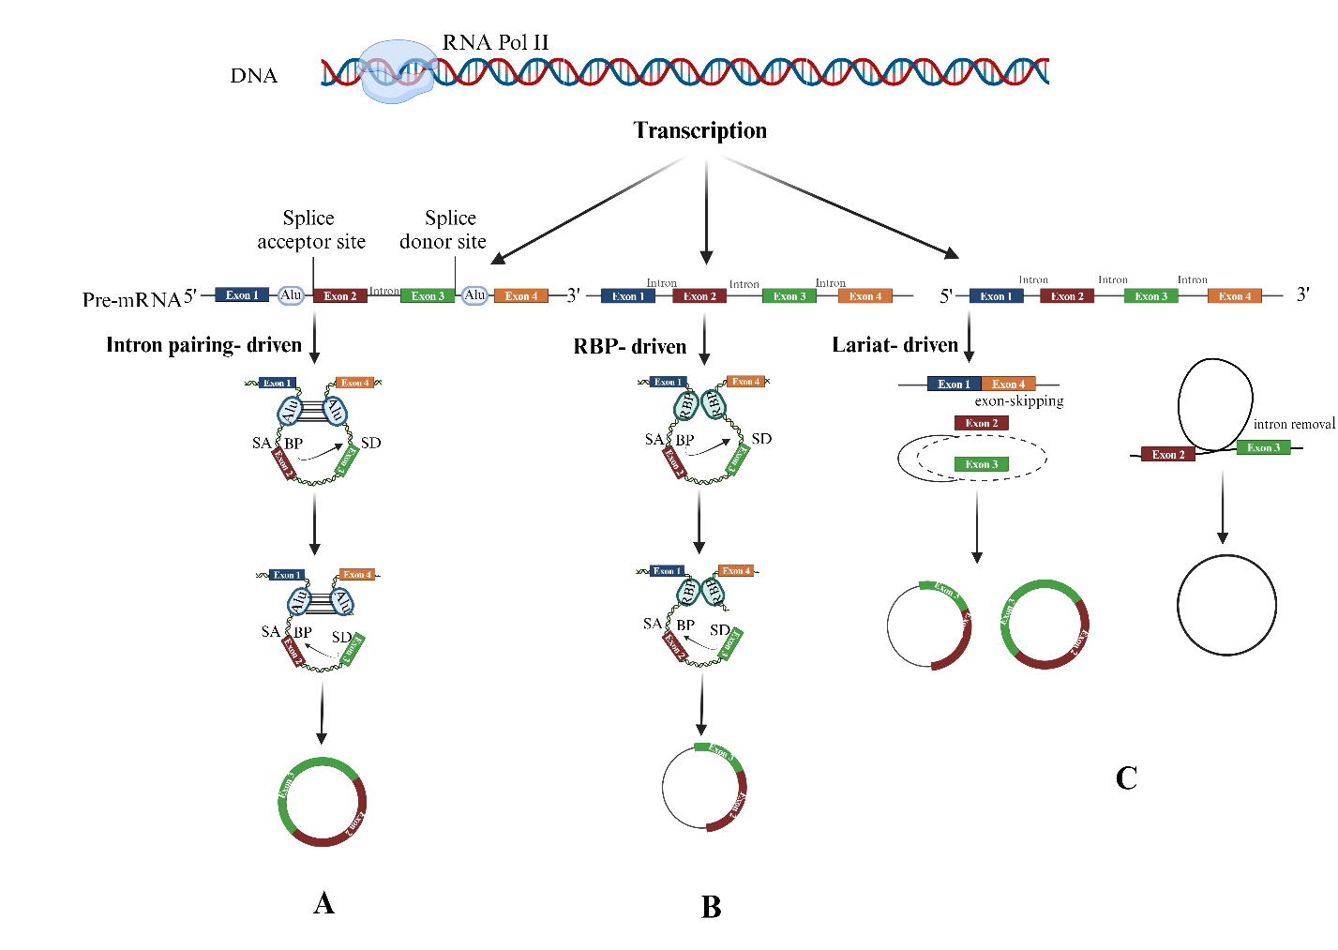
Figure 1 A: Intron pairing driven: During mRNA transcription , back-splicing may happen between the 50 region of the downstream exon as an acceptor site and the 30 region of the upstream exon donor site. B: RNA-binding proteins (RBPs) driven: dimerization of RBP and their binding to specific intron motifs of flanking bonds enhance circRNA generation. C: Lariat-driven: semi folding of RNA during transcription helps exons far from each other be adjacent, shift, and glue as a unit.

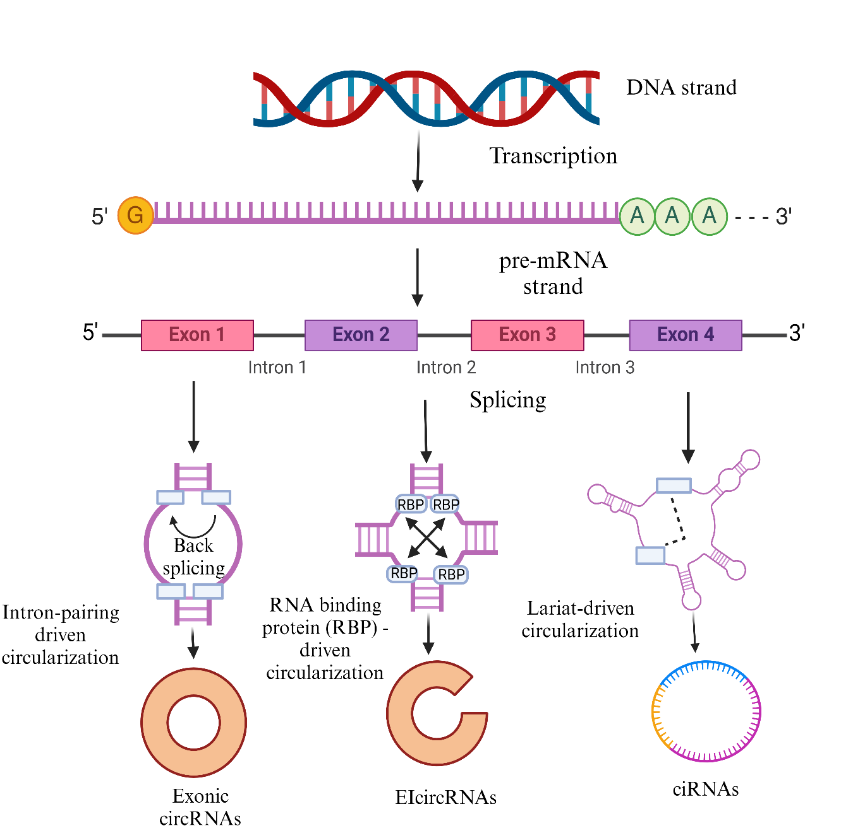
Figure 2 A diagrammatic representation of splicing events involved in the generation of diverse types of circRNAs. Intron-pairing is a process characterized by back-splicing events. RNA-binding protein (RBP)-driven circularization explores the attraction between RBPs resulting in the formation of circRNAs. Lariat-driven circularization is a process ruled by exon-skipping that facilitates the generation of circRNAs.

REFERENCES:
Chen, K.-L., Li, L., Li, C.-M., Wang, Y.-R., Yang, F.-X., Kuang, M.-Q., & Wang, G.-L. (2019c). SIRT7 Regulates Lipopolysaccharide-Induced Inflammatory Injury by Suppressing the NF-κB Signaling Pathway. Oxidative Medicine and Cellular Longevity, 2019, 3187972. https://doi.org/10.1155/2019/3187972
Chen, L.-L., & Yang, L. (2015). Regulation of circRNA biogenesis. RNA Biology, 12(4), 381–388. https://doi.org/10.1080/15476286.2015.1020271
Chen, R., Wang, S. K., Belk, J. A., Amaya, L., Li, Z., Cardenas, A., Abe, B. T., Chen, C.-K., Wender, P. A., & Chang, H. Y. (2023). Engineering circular RNA for enhanced protein production. Nature Biotechnology, 41(2), 262–272. https://doi.org/10.1038/s41587-022-01393-0
Chen, X., & Lu, Y. (2021a). Circular RNA: Biosynthesis in vitro. Frontiers in Bioengineering and Biotechnology, 9. https://doi.org/10.3389/fbioe.2021.787881
Conn, S. J., Pillman, K. A., Toubia, J., Conn, V. M., Salmanidis, M., Phillips, C. A., Roslan, S., Schreiber, A. W., Gregory, P. A., & Goodall, G. J. (2015). The RNA Binding Protein Quaking Regulates Formation of circRNAs. Cell, 160(6), 1125–1134. https://doi.org/10.1016/j.cell.2015.02.014
Cui, J., Zhang, L., Zhang, Z., Luo, X., Liu, Y., Li, C., Huang, W., Zou, L., Yu, X., & Xiao, F. (2023). A precise and efficient circular RNA synthesis system based on a ribozyme derived from Tetrahymena thermophila. Nucleic Acids Research, 51(14), e78. https://doi.org/10.1093/nar/gkad554
Feng, X.-Y., Zhu, S.-X., Pu, K.-J., Huang, H.-J., Chen, Y.-Q., & Wang, W.-T. (2023). New insight into circRNAs: Characterization, strategies, and biomedical applications. Experimental Hematology & Oncology, 12(1), 91. https://doi.org/10.1186/s40164-023-00451-w
Geng, Y., Jiang, J., & Wu, C. (2018). Function and clinical significance of circRNAs in solid tumors. Journal of Hematology & Oncology, 11(1), 98. https://doi.org/10.1186/s13045-018-0643-z
Li, X., Yang, L., & Chen, L.-L. (2018). The Biogenesis, Functions, and Challenges of Circular RNAs. Molecular Cell, 71(3), 428–442. https://doi.org/10.1016/j.molcel.2018.06.034
Liu, J., Liu, T., Wang, X., & He, A. (2017). Circles reshaping the RNA world: From waste to treasure. Molecular Cancer, 16(1), 58. https://doi.org/10.1186/s12943-017-0630-y
Liu, K.-S., Pan, F., Mao, X.-D., Liu, C., & Chen, Y.-J. (2019b). Biological functions of circular RNAs and their roles in occurrence of reproduction and gynecological diseases. American Journal of Translational Research, 11(1), 1–15
Loan Young, T., Chang Wang, K., James Varley, A., & Li, B. (2023). Clinical delivery of circular RNA: Lessons learned from RNA drug development. Advanced Drug Delivery Reviews, 197, 114826. https://doi.org/10.1016/j.addr.2023.114826
Long, F., Li, L., Xie, C., Ma, M., Wu, Z., Lu, Z., Liu, B., Yang, M., Zhang, F., Ning, Z., Zhong, C., Yu, B., Liu, S., Wan, L., Tian, B., Yang, K., Guo, Y., Chen, M., Chou, J., … Zhang, Y. (2023). Intergenic CircRNA Circ_0007379 Inhibits Colorectal Cancer Progression by Modulating miR-320a Biogenesis in a KSRP-Dependent Manner. International Journal of Biological Sciences, 19(12), 3781–3803. https://doi.org/10.7150/ijbs.85063
Ma, Y., Zheng, L., Gao, Y., Zhang, W., Zhang, Q., & Xu, Y. (2021). A Comprehensive Overview of circRNAs: Emerging Biomarkers and Potential Therapeutics in Gynecological Cancers. Frontiers in Cell and Developmental Biology, 9. https://doi.org/10.3389/fcell.2021.709512
Meng, S., Zhou, H., Feng, Z., Xu, Z., Tang, Y., Li, P., & Wu, M. (2017). CircRNA: Functions and properties of a novel potential biomarker for cancer. Molecular Cancer, 16(1), 94. https://doi.org/10.1186/s12943-017-0663-2
Misir, S., Wu, N., & Yang, B. B. (2022). Specific expression and functions of circular RNAs. Cell Death & Differentiation, 29(3), 481–491. https://doi.org/10.1038/s41418-022-00948-7
Obi, P., & Chen, Y. G. (2021). The design and synthesis of circular RNAs. Methods, 196, 85–103. https://doi.org/10.1016/j.ymeth.2021.02.020
Panzeri, I., Rossetti, G., Abrignani, S., & Pagani, M. (2015). Long Intergenic Non-Coding RNAs: Novel Drivers of Human Lymphocyte Differentiation. Frontiers in Immunology, 6. https://doi.org/10.3389/fimmu.2015.00175
Petkovic, S., & Müller, S. (2015). RNA circularization strategies in vivo and in vitro. Nucleic Acids Research, 43(4), 2454–2465. https://doi.org/10.1093/nar/gkv045
Plewka, P., & Raczynska, K. D. (2022). Long Intergenic Noncoding RNAs Affect Biological Pathways Underlying Autoimmune and Neurodegenerative Disorders. Molecular Neurobiology, 59(9), 5785–5808. https://doi.org/10.1007/s12035-022-02941-0
Ragan, C., Goodall, G. J., Shirokikh, N. E., & Preiss, T. (2019b). Insights into the biogenesis and potential functions of exonic circular RNA. Scientific Reports, 9(1), 2048. https://doi.org/10.1038/s41598-018-37037-0
Verduci, L., Tarcitano, E., Strano, S., Yarden, Y., & Blandino, G. (2021). CircRNAs: Role in human diseases and potential use as biomarkers. Cell Death & Disease, 12(5), 1–12. https://doi.org/10.1038/s41419-021-03743-3
Wu, J., Qi, X., Liu, L., Hu, X., Liu, J., Yang, J., Yang, J., Lu, L., Zhang, Z., Ma, S., Li, H., Yun, X., Sun, T., Wang, Y., Wang, Z., Liu, Z., & Zhao, W. (2019). Emerging Epigenetic Regulation of Circular RNAs in Human Cancer. Molecular Therapy. Nucleic Acids, 16, 589–596. https://doi.org/10.1016/j.omtn.2019.04.011
Yu, C.-Y., & Kuo, H.-C. (2019). The emerging roles and functions of circular RNAs and their generation. Journal of Biomedical Science, 26(1), 29. https://doi.org/10.1186/s12929-019-0523-z
Zhou, W.-Y., Cai, Z.-R., Liu, J., Wang, D.-S., Ju, H.-Q., & Xu, R.-H. (2020). Circular RNA: Metabolism, functions and interactions with proteins. Molecular Cancer, 19(1), 172. https://doi.org/10.1186/s12943-020-01286-3

