Table S1. Characteristics of included studies
Study | Study design | Study settings | Study period | Sample size | Target population | Time frame | Type of diagnostic technique | Type of detected biological markers | IgG | IgM | RNA | IgG/IgM | Serotype
Aniakwaa-Bonsu et al. 2021 | Cross-sectional | Clinical | Feb-Jul 2019 | 270 | Adult 18 and above at least presenting with fever and three malaria-like symptoms | Out of outbreak | RDT  ELISA | IgG  IgM | 34 | 6 | - | 35 | -
Amoako et al. 2018 | Cross-sectional | Clinical | Oct 2016-Jul 2017 | 166 | Children 1-15 years of age with fever and suspected of malaria | Out of outbreak | RT-PCR | RNA | - | - | 2 | - | DENV-2
Bonney et al. 2020 | Case study | Clinical | Jan 2017- Dec 2018 | 149 | Suspected viral hemorrhagic fever patients | Out of outbreak | RT-PCR | RNA | - | - | 2 | - | DENV-2
Bonney et al. 2018 | - | Clinical | 2014-2016 | 150 | Patient suspected of Ebola virus disease | Outbreak | RT-PCR  ELISA | IgG  IgM  RNA | 85 | 32 | 4 | 22 | DENV-2 DENV-3
Manu et al. 2019 | Cross-sectional | Clinical | May 2016-April 2017 | 260 | Suspected dengue and/or chikungunya febrile patients | Out of outbreak | RT-PCR  ELISA | IgG  IgM  RNA | 172 | 8 | - | 180 | -
Narkwa et al. 2016 | Cross-sectional | Clinical | Feb 2013-Dec 2015 | 188 | Healthy blood donors | Out of outbreak | RT-PCR  ELISA | IgG  IgM  RNA | 82 | - | - | - | -
Pappoe-Ashong et al. 2018 | Cross-sectional | Clinical | Jan-De 2014 | 417 | Patient with fever and jaundice | Outbreak | ELISA | IgG  IgM | 124 | - | - | - | -
Stoler et al. 2015 |  | Clinical | 2011-2014 | 218 | Children ages 2-14 years with confirmed malaria | Out of outbreak | RT-PCR  ELISA | IgG  IgM  RNA | 47 | 7 | - | - | -
Ofosu-Appiah et al. 2018 | Cross-sectional | Clinical | Jan-Dec 2013 | 360 | Patient aged 6 months to 82 years suspected of yellow fever | Out of outbreak | RT-PCR  ELISA | IgG  IgM  RN A | 13 | 7 | - | - | -

Table S2. JBI’s critical appraisal of studies
 |  | JBI’s critical appraisal questions
Author & Year | Total Sample Size | Q1 | Q2 | Q3 | Q4 | Q5 | Q6 | Q7 | Q8 | Q9 | Score | % | Study quality | Overall appraisal
Aniakwaa-Bonsu et al. 2021 | 270 | 1 | 1 | 1 | 1 | 1 | 1 | 1 | 1 | 1 | 9 | 100 | High | Included
Amoako et al. 2018 | 166 | 1 | 1 | 1 | 1 | 1 | 1 | 1 | 1 | 1 | 9 | 100 | High | Included
Bonney et al. 2020 | 149 | 1 | 1 | 1 | 1 | 1 | 1 | 1 | 1 | 1 | 9 | 100 | High | Included
Bonney et al. 2018 | 150 | 1 | 1 | 1 | 0 | 1 | 1 | 1 | 1 | 1 | 8 | 88.9 | High | Included
Manu et al. 2019 | 260 | 1 | 1 | 1 | 1 | 1 | 1 | 1 | 1 | 1 | 9 | 100 | High | Included
Narkwa et al. 2016 | 188 | 1 | 1 | 1 | 1 | 1 | 1 | 1 | 1 | 1 | 9 | 100 | High | Included
Pappoe-Ashong et al. 2018 | 417 | 1 | 1 | 1 | 1 | 1 | 1 | 1 | 0 | 1 | 8 | 88.9 | High | Included
Stoler et al. 2015 | 218 | 1 | 1 | 1 | 0 | 1 | 1 | 1 | 1 | 1 | 8 | 88.9 | High | Included
Ofosu-Appiah et al. 2018 | 360 | 1 | 1 | 1 | 1 | 1 | 1 | 1 | 1 | 1 | 9 | 100 | High | Included

Q1. Was the sample frame appropriate to address the target population?
Q2. Were study participants sampled in an appropriate way?
Q3. Was the sample size adequate?
Q4. Were the study subjects and the setting described in detail?
Q5. Was the data analysis conducted with sufficient coverage of the identified sample?
Q6. Were valid methods used for the identification of the condition?
Q7. Was the condition measured in a standard, reliable way for all participants?
Q8. Was there appropriate statistical analysis?
Q9. Was the response rate adequate, and if not, was the low response rate managed appropriately?

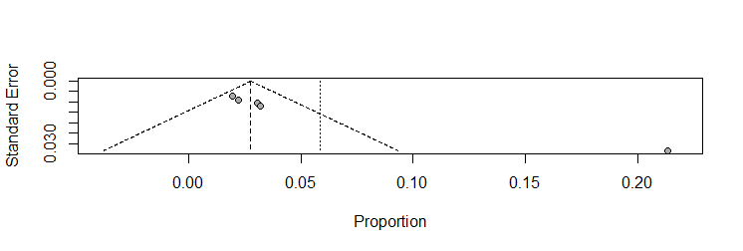

Figure S1. Funnel plot of dengue virus IgM prevalence studies

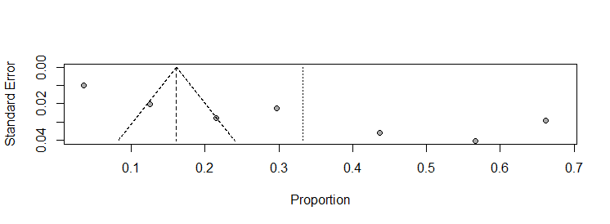

Figure S2. Funnel plot of dengue virus IgG prevalence studies

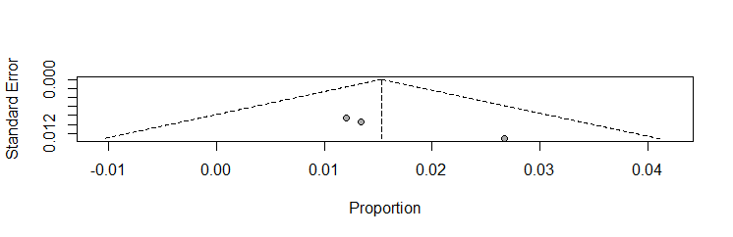

Figure S3. Funnel plot of dengue virus RNA prevalence studies

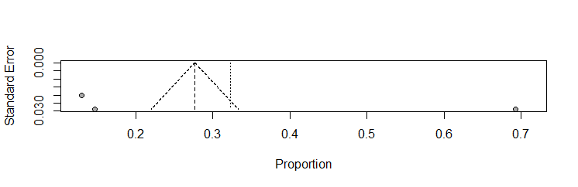

Figure S4. Funnel plot of dengue virus IgG/IgM prevalence studies

