Appendix A

Figures

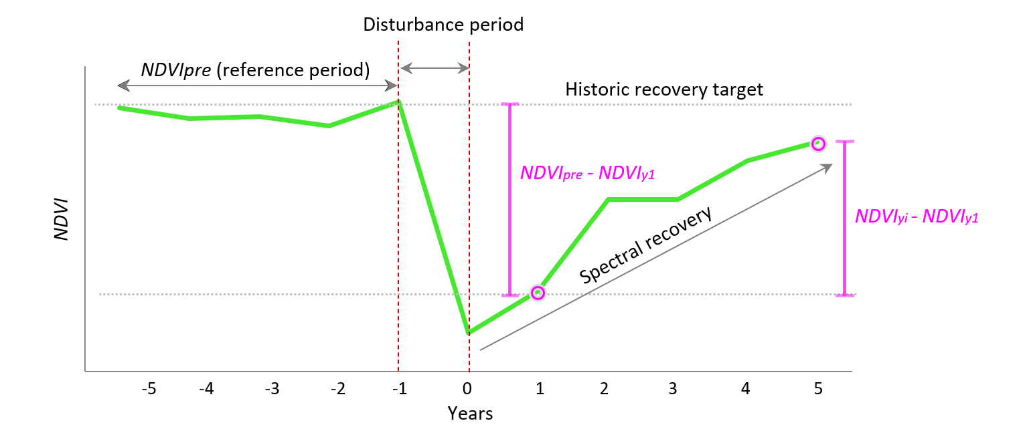
Figure A1. The spectral recovery metric scheme (NDVIrec) used in this research is described in Equation 1.

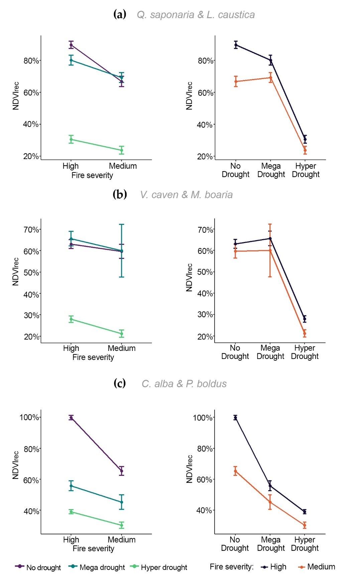

Figure A2. For each forest subtype, the interaction plots illustrate the relationship between both factors, fire severity and drought levels (x-axis). The y-axis represents the response variable NDVIrec at year five. Parallel lines in the interaction plots suggest no interaction between factors, indicating similar recovery patterns across different levels of fire severity and drought. In this case, there is a significant interaction effect as the slopes are unequal. For (a) Q. saponaria & L. caustica. (b) V. caven & M. boaria and (c) C. alba & P. boldus.
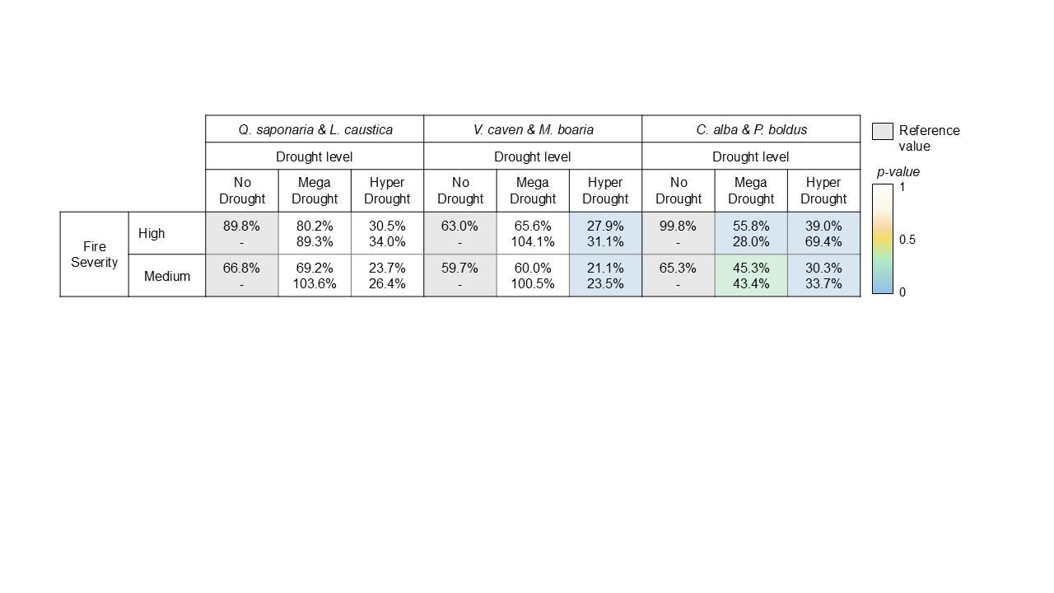
Figure A3. Summary matrices by forest subtype that indicate the percentage of the means of the NDVIrec at year 5 by fire severity and drought level. The colors indicate the p-value of the post hoc (Tukey's multiple comparison test, p < 0.01).

Tables

Table S1. Wildfires selected in the study area and their characteristics.

ID | ID CONAF | Fire Name | Fire year | Administrative Region | Forest subtype | Wildfire area (ha) | Latitude | Longitude
1 | ID189237 | Santa Maria - Los Molles | 2017 | Valparaíso | Qs & Lc, Vc & Mb, Ca & Pb | 1,190.30 | -32.24 | -71.49
2 | ID189192 | Madre del Agua | 2016 | Valparaíso | Qs & Lc | 417.2 | -32.65 | -71.32
3 | ID189119 | Lo Orozco | 2017 | Valparaíso | Qs & Lc, Vc & Mb | 169.9 | -33.24 | -71.42
4 | ID169148 | El Penon | 2014 | Metropolitana | Qs & Lc | 606,3 | -33.57 | -70.51
5 | ID189223 | El Toyo | 2017 | Metropolitana | Qs & Lc | 891,8 | -33.58 | -70.44
6 | ID169133 | El Manzano | 2013 | Metropolitana | Qs & Lc | 445.4 | -33.59 | -70.41
7 | ID169171 | El Carrizo | 2014 | Metropolitana | Vc & Mb, Ca & Pb | 14,173,5 | -33.64 | -71.37
8 | ID189257 | Rinconada de Pirque | 2017 | Metropolitana | Qs & Lc, Ca & Pb | 3,228.20 | -33.73 | -70.58
9 | ID189124 | San Rafael De Puro | 2017 | Metropolitana | Qs & Lc | 130 | -33.79 | -71.41
10 | ID39037 | Los Maitenes | 1992 | Metropolitana | Qs & Lc, Vc & Mb, Ca & Pb | 497.2 | -33.82 | -71.34
11 | ID112326 | Cruce Las Aranas | 2004 | Metropolitana | Qs & Lc, Vc & Mb, Ca & Pb | 1,911.40 | -33.87 | -71.33
12 | ID189195 | Quilamuta | 2016 | Metropolitana | Qs & Lc, Vc & Mb | 511.2 | -33.89 | -71.50
13 | ID118979 | La Manga | 2005 | Metropolitana | Qs & Lc, Vc & Mb | 2,057.20 | -33.89 | -71.61
14 | ID169040 | Corneche | 2014 | Metropolitana | Qs & Lc, Ca & Pb | 255.8 | -33.95 | -71.63
15 | ID189264 | Lo Chacon | 2017 | Metropolitana | Ca & Pb | 6,035.80 | -33.96 | -71.28
16 | ID118915 | Longovilo | 2005 | Metropolitana | Qs & Lc | 344.8 | -33.97 | -71.40
17 | ID151627 | Quelentaro | 2011 | O'Higgins | Qs & Lc | 94.2 | -33.99 | -71.56
18 | ID169139 | El Membrillo | 2014 | Metropolitana | Qs & Lc, Vc & Mb, Ca & Pb | 1252.52 | -34.00 | -71.28
19 | ID146674 | Cuesta Alhue | 2010 | Metropolitana | Qs & Lc | 1,020.00 | -34.02 | -71.20
20 | ID189263 | Talami | 2017 | Metropolitana | Qs & Lc, Va & Pb | 7,747.70 | -34.05 | -70.99
21 | ID169120 | Cruce Santa Ines | 2013 | O'Higgins | Qs & Lc | 217.1 | -34.08 | -71.37
22 | ID151674 | La Palmeria | 2011 | O'Higgins | Qs & Lc, Va & Pb | 1,490.40 | -34.18 | -71.12
23 | ID177153 | La Palmeria 4 | 2015 | O'Higgins | Qs & Lc | 576,2 | -34.19 | -71.12
24 | ID136426 | Quebrada Quillyquen | 2008 | O'Higgins | Qs & Lc | 126.4 | -34.26 | -71.61
25 | ID157096 | Rinconada de Idahue | 2012 | O'Higgins | Qs & Lc | 71.1 | -34.29 | -71.15
26 | ID157061 | Pampa Idahue | 2012 | O'Higgins | Qs & Lc | 52 | -34.31 | -71.17
27 | ID177202 | Las Nieves 4 | 2015 | O'Higgins | Ca & Pb | 688,9 | -34.47 | -70.75
28 | ID189265 | Rincon de Yaquil 4 | 2017 | O'Higgins | Qs & Lc, Vc & Mb, Ca & Pb | 40,366.70 | -34.56 | -71.28
29 | ID68831 | El Calabozo | 1997 | O'Higgins | Qs & Lc | 1,636.10 | -34.57 | -71.04
30 | ID68630 | Las Cruces | 1997 | O'Higgins | Vc & Mb | 66.4 | -34.58 | -71.98
31 | ID136494 | San Jose De Apalta | 2008 | O'Higgins | Qs & Lc | 2,221.90 | -34.62 | -71.23
32 | ID146656 | Paredones | 2010 | O'Higgins | Vc & Mb | 150.6 | -34.64 | -71.90
33 | ID189226 | Alto Nilahue | 2016 | O'Higgins | Vc & Mb | 5,463.40 | -34.67 | -71.81
34 | ID176579 | Lo Orozco | 2015 | O'Higgins | Qs & Lc | 19.1 | -34.70 | -71.07
35 | ID189275 | Las Cardillas | 2017 | Maule | Qs & Lc, Ca & Pb | 52,908.60 | -34.90 | -71.99
36 | ID73968 | Los Maquis | 1998 | Maule | Ca & Pb | 32.6 | -34.98 | -70.89
37 | ID142593 | La Aguadilla | 2009 | Maule | Qs & Lc, Vc & Mb, Ca & Pb | 174.6 | -34.98 | -70.91
38 | ID151664 | Los Quenes | 2011 | Maule | Ca & Pb | 424.5 | -35.02 | -70.81
39 | ID189254 | Tabunco- El Aguila Convenio | 2017 | Maule | Qs & Lc | 3,215.10 | -35.18 | -71.99
40 | ID169169 | Quivolgo 1 | 2014 | Maule | Ca & Pb | 2,670,9 | -35.32 | -72.39
41 | ID118965 | Loncomilla | 2005 | Maule | Qs & Lc | 742.2 | -35.66 | -71.76
42 | ID189243 | Llepo | 2017 | Maule | Qs & Lc | 1,839.90 | -35.95 | -71.48
Abreviation: Quillaja saponaria & Lithrea caustica (Qs & Lc), Vachellia caven & Maytenus boaria (Vc & Mb), Cryptocarya alba and Peumus boldus (Ca & Pb)

Table A2. Sample for two-way ANOVA.

Q. saponaria & L. caustica
Drought Level | Fire Severity | count | mean | median | sd | cv
Hyper Drought | high | 386 | 0.31 | 0.36 | 0.49 | 1.58
Hyper Drought | medium | 387 | 0.24 | 0.35 | 0.48 | 2.00
Mega Drought | high | 386 | 0.80 | 0.80 | 0.61 | 0.76
Mega Drought | medium | 386 | 0.69 | 0.79 | 0.62 | 0.90
No Drought | high | 385 | 0.90 | 0.86 | 0.46 | 0.51
No Drought | medium | 148 | 0.67 | 0.57 | 0.39 | 0.58
Total |  | 2078

V. caven & M. boaria
Drought Level | Fire Severity | count | mean | median | sd | cv
No Drought | high | 228 | 0.63 | 0.55 | 0.32 | 0.51
No Drought | medium | 85 | 0.60 | 0.46 | 0.30 | 0.50
Mega Drought | high | 109 | 0.66 | 0.64 | 0.36 | 0.55
Mega Drought | medium | 7 | 0.60 | 0.71 | 0.33 | 0.55
Hyper Drought | high | 386 | 0.28 | 0.27 | 0.30 | 1.07
Hyper Drought | medium | 341 | 0.21 | 0.20 | 0.31 | 1.48
 |  | 1156

C. alba & P. boldus
Drought Level | Fire Severity | count | mean | median | sd | cv
No Drought | high | 386 | 1.00 | 1.05 | 0.29 | 0.29
No Drought | medium | 76 | 0.65 | 0.66 | 0.25 | 0.38
Mega Drought | high | 174 | 0.56 | 0.59 | 0.41 | 0.73
Mega Drought | medium | 104 | 0.45 | 0.48 | 0.48 | 1.07
Hyper Drought | high | 360 | 0.39 | 0.42 | 0.24 | 0.62
Hyper Drought | medium | 140 | 0.30 | 0.29 | 0.24 | 0.80
 |  | 1240

Table A3. A confidence interval of ANOVA.

Q. saponaria & L. caustica
High Fire Severity
Drought Level | Mean | SE | df | Lower | Upper
No Drought | 0.898 | 0.0268 | 2072 | 0.845 | 0.950
Mega Drought | 0.802 | 0.0268 | 2072 | 0.749 | 0.855
Hyper Drought | 0.305 | 0.0268 | 2072 | 0.253 | 0.358
High Fire Severity
No Drought | 0.668 | 0.0433 | 2072 | 0.583 | 0.753
Mega Drought | 0.692 | 0.0268 | 2072 | 0.640 | 0.745
Hyper Drought | 0.237 | 0.0268 | 2072 | 0.184 | 0.289

V. caven & M. boaria
High Fire Severity
Drought Level | Mean | SE | df | Lower | Upper
No Drought | 0.630 | 0.0207 | 1150 | 0.590 | 0.671
Mega Drought | 0.656 | 0.0300 | 1150 | 0.597 | 0.715
Hyper Drought | 0.279 | 0.0159 | 1150 | 0.248 | 0.310
High Fire Severity
No Drought | 0.597 | 0.0339 | 1150 | 0.530 | 0.664
Mega Drought | 0.600 | 0.1182 | 1150 | 0.368 | 0.832
Hyper Drought | 0.211 | 0.0169 | 1150 | 0.178 | 0.245

C. alba & P. boldus
High Fire Severity
Drought Level | Mean | SE | df | Lower | Upper
No Drought | 0.998 | 0.0158 | 1234 | 0.583 | 1.29
Mega Drought | 0.558 | 0.0235 | 1234 | 0.393 | 0.604
Hyper Drought | 0.390 | 0.0163 | 1234 | 0.252 | 0.422
High Fire Severity
No Drought | 0.653 | 0.0355 | 1234 | 0.583 | 0.723
Mega Drought | 0.453 | 0.0304 | 1234 | 0.393 | 0.512
Hyper Drought | 0.303 | 0.0262 | 1234 | 0.252 | 0.355

Confidence level used: 0.95

Table A4. Post-hoc, Tukey's multiple comparison tests, confidence level 0.95, p < 0.01 (contrast).

Q. saponaria & L. caustica
High Fire Severity
Drought Level | Estimate | SE | df | t ratio | p value
No Drought -Mega Drought | 0.096 | 0.0379 | 2072 | 2.525 | 0.031
No Drought -Hyper Drought | 0.592 | 0.0379 | 2072 | 15.627 | <.0001
Hega Drought - Hyper Drought | 0.497 | 0.0379 | 2072 | 13.111 | <.0001
High Fire Severity
No Drought -Mega Drought | -0.024 | 0.0509 | 2072 | -0.471 | 0.885
No Drought -Hyper Drought | 0.4318 | 0.0509 | 2072 | 8.487 | <.0001
Hega Drought - Hyper Drought | 0.4557 | 0.0509 | 2072 | 12.036 | <.0001

V. caven & M. boaria
High Fire Severity
Drought Level | Difference | lower |  | upper
Mega drought:high-No drought:high | 0.02530 | -0.07868047 |  | 0.129287775
Hyper drought:high-No drought:high | -0.351355 | -0.42594118 |  | -0.276769678
No drought:medium-No drought:high | -0.03346069 | -0.14694297 |  | 0.080021576
Mega drought:medium-No drought:high | -0.030555039 | -0.37320465 |  | 0.312094567
Hyper drought:medium-No drought:high | -0.418985060 | -0.49537642 |  | -0.342593695
Hyper drought:high-Mega drought:high | -0.376659081 | -0.47351551 |  | -0.279802653
No drought:medium-Mega drought:high | -0.058764352 | -0.18797875 |  | 0.070450044
Mega drought:medium-Mega drought:high | -0.055858693 | -0.40403521 |  | 0.292317824
Hyper drought:medium-Mega drought:high | -0.444288713 | -0.54254233 |  | -0.346035091
No drought:medium-Hyper drought:high | 0.317894729 | 0.21090549 |  | 0.424883965
Mega drought:medium-Hyper drought:high | 0.320800388 |  | -0.01975390 |  | 0.661354676
Hyper drought:medium-Hyper drought:high | -0.067629632 |  | -0.13399311 |  | -0.001266158
Mega drought:medium-No drought:medium | 0.002905659 |  | -0.34822454 |  | 0.354035857
Hyper drought:medium-No drought:medium | -0.385524361 |  | -0.49378009 |  | -0.277268630
Hyper drought:medium-Mega drought:medium | -0.388430021 |  | -0.72938431 |  | -0.047475728

C. alba & P. boldus
High Fire Severity
Drought Level | Estimate | SE | df | t ratio | p value
No Drought -Mega Drought | 0.440 | 0.0283 | 1234 | 15.558 | <.0001
No Drought -Hyper Drought | 0.607 | 0.0227 | 1234 | 26.779 | <.0001
Hega Drought - Hyper Drought | 0.168 | 0.0286 | 1234 | 5.864 | <.0001
High Fire Severity
No Drought -Mega Drought | 0.200 | 0.0467 | 1234 | 4.290 | 0.0001
No Drought -Hyper Drought | 0.350 | 0.0441 | 1234 | 7.929 | <.0001
Hega Drought - Hyper Drought | 0.149 | 0.0441 | 1234 | 3.726 | 0.0006

Table A5. Post-hoc pairs tests, F.ratio: F statistic for drought level within each category of fire severity.

Q. saponaria & L. caustica
Drought Level | df1 | df2 | F ratio | p value
No Drought | 1 | 2072 | 20.297 | <.0001
Mega Drought | 1 | 2072 | 8.379 | 0.0038
Hyper Drought | 1 | 2072 | 3.288 | 0.0699

C. alba & P. boldus
Drought Level | df1 | df2 | F ratio | p value
No Drought | 1 | 1234 | 78.806 | <.0001
Mega Drought | 1 | 1234 | 7.561 | 0.0061
Hyper Drought | 1 | 1234 | 7.997 | 0.0048

Table A6. Report of post-fire recovery observed in previous studies using satellite indices (adapted from Bright 2019).

Location | Vegetation type | Authors | Year | Spectral index | Mean recovery time (year)
Spain | Mediterranean forest | Viedma et al. | 1997 | NDVI | 1 to 18
California, USA | Chaparral | Hope et al. | 2007 | NDVI | 10
Israel | Mediterranean forest | Wittenberg et al. | 2007 | EVI | 3
Spain | Semi-arid | Vicente-Serrano et al. | 2011 | NDVI | 24
SE Australia | Sclerophyll forest | Hislop et al. | 2018 | NBR | 8 to 10
Western, USA | Temperate forest | Meng et al. | 2015 | NDVI
Western, USA | Temperate forest | Bright et al. | 2019 | NBR | 9 to 13
Spain | Mediterranean forest | Rodríguez-Blanco et al. | 2023 | TCTB | > 5
Abbreviations: NDVI Normalize Difference Vegetation Index, EVI Enhanced Vegetation Index, NBR Normalized Burn Ratio, TCTB Tasseled Cap Transformation Brightness.

