Supplementary Materials
Supplementary Fig. S1. Dynamics of membrane potential and redox state of pyridine nucleotides (PN) in mitochondria during prolonged incubation in the presence of PTP modulator. A and B. Effect of PTP modulators on the ΔΨm dynamics. The incubation medium contained 0.5 mg/ml of mitochondrial protein, 5 mM malate plus 5 mM glutamate (M+G), 10 µM Ca²⁺, 330 nM rhodamine 123 (Rhod 123), and, where shown, 1 mM ADP, 1 mM NADH, 1 mM EGTA (EGTA), 5 µg/ml oligomycin (Oligo), and 1 µM cyclosporine A (CsA). C–E. Dynamics of PN fluorescence in a mitochondrial suspension in the presence of different respiratory substrates and PTP modulators. Where indicated, medium contained 5 mM malate plus 5 mM glutamate (M+G), 1mM EGTA, 1 mM ATP, 5 µg/ml Oligo, 2 µg/ml rotenone (R), 1 µM CsA, and 250 nM FCCP. E. Arrows show the addition of EGTA, CsA, R, substrates (Substr) (5 mM succinate (S) to R-containing samples (SR) and 5mM 3-hydroxybutyrate (3-HB)), and 25 µM Ca²⁺. The concentration of free Ca²⁺ was 10 (C and D) and ~ 3 μM (E). In panels A and B and C–E, signal acquisition was performed at different gain. Points on the curves are the means of three technical replicates (n = 3). The figure shows representative experiments of at least three similar.

Supplementary Fig. S2. Effect of respiratory substrates and PTP inhibitors on the release of SA (A, C, and E) and H₂O₂ (B, D, and F) from RLM. RLM (0.75 mg protein/ml) were placed in the standard KCl-BM without added respiratory substrates and EGTA, and the suspension was processed as described in the legend to Fig. 1. The wells contained 5 mM GM (A and B), 5 mM Pyr (C and D), 5 mM Suc plus rotenone (2 μg/ml) (SR) (E and F), and, where indicated, 1 mM EGTA, 2 µM RR, and 1 µM CsA. The intensity of MDCL expressed in AU is shown. Points on the curves are the means ± standard deviation (n = 3) of three technical replicates. The rate of H₂O₂ production is expressed in pmol·min⁻¹·mg protein⁻¹. Points on the curves are the means of three technical replicates (n = 3). The figure shows one representative experiment of at least five similar.

Supplementary Fig. S3. Dose-response effect of dicarboxylates on the release of SA and H₂O₂ from mitochondria. RLM (0.75 mg protein/ml) were placed in the standard KCl-BM without respiratory substrates but supplemented with 1 μM CsA, and the suspension was processed as described in Fig. 3. Were indicated, the wells contained Suc, fumarate (Fum), malate (Mal) at indicated concentrations, and SOD (100 U/ml). In all panels, blue and red symbols show the cumulative MDCL and H₂O₂ production in the first hour of incubation, respectively. Blue doted lines show the MDCL level in the presence of SOD and indicated substrates. Experimental points are the means ± S.D. (n = 3) of three technical replicates. The figure shows one representative experiment of at least three similar.

Supplementary Fig. S4. Effect of Suc, Rot, and CsA on the kinetics of SA release from intact RLM. Experimental conditions were as in Fig. 6. Concentrations of Suc, Rot, CsA, and SOD were 5 mM, 2 μg/ml, 1 μM, and 100 U/ml, respectively. Experimental points are the means ± S.D. (n = 3) of three technical replicates. The figure shows one representative experiment of at least three similar.

Supplementary Table S1. Suppression of spontaneous and xanthine oxidase-dependent SA generation by respiratory substrates that are alpha-keto acids.
Substrate | Structural formula | XnXnOx | Solution
3-hydroxy butyrate  (3-HB) | 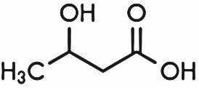 | - | -
Pyruvate  (Pyr) | 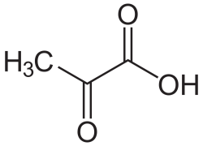 | + | +
Succinate  (Suc) | 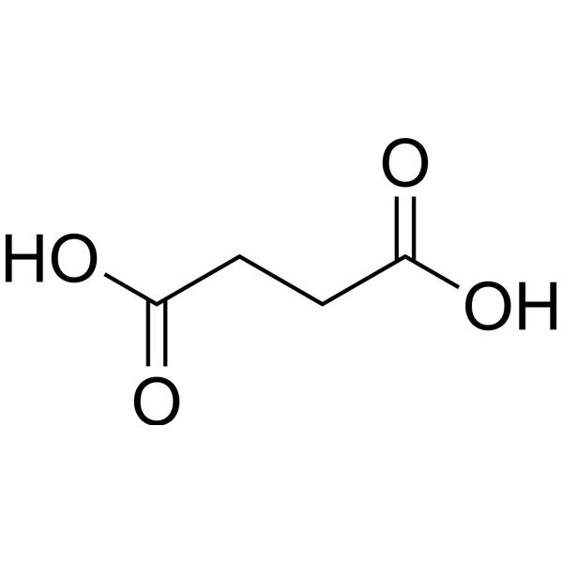 | - | -
Fumarate  (Fum) | 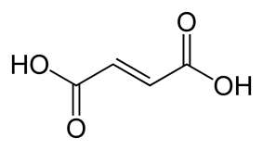 | - | -
Malate  (Mal) | 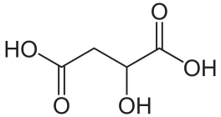 | - | -
2 oxoglutarate  (2-OG) | 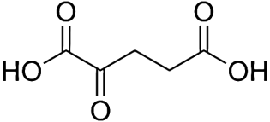 | + | +
Glutamate  (Glu) | 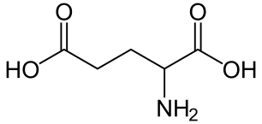 | - | -

Note: Original representative traces demonstrating the MDCL suppression are shown in Fig. 7.

