Soluble PD-L1 and PD-1 significantly improve the accuracy of a diagnostic model of mRNA transcripts in the diagnosis of prostate cancer
Margarita Žvirblė^{1,2}, Ieva Vaicekauskaitė^{1,2}, Žilvinas Survila², Paulius Bosas¹, Neringa Dobrovolskiene¹, Agata Mlynska^{1,3}, Rasa Sabaliauskaitė^{1,2}, Vita Pašukonienė¹

Supplementary materials
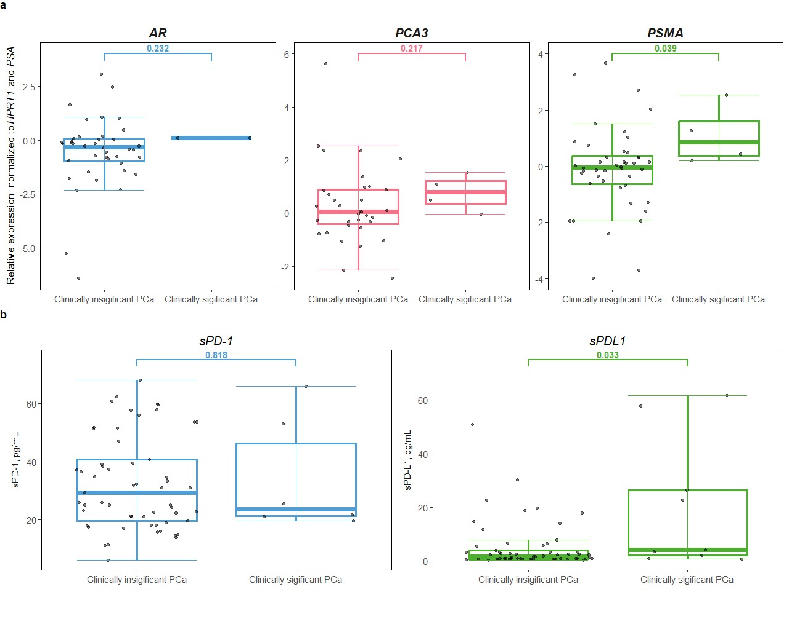
Figure S1 Relative expression values of AR, PCA3, and PSMA mRNAs as well as sPD-L1 and sPD-1 in clinicly significant and insignificant PCa cases.
A Relative expression values of AR, PCA3, and PSMA mRNAs in clinicly significant (ISUP ≥3) and insignificant (ISUP ≤2) PCa cases (PSMA p = 0.039). B sPD-L1 and sPD-1 levels in clinicly significant and insignificant PCa cases (sPDL1 p = 0.033).

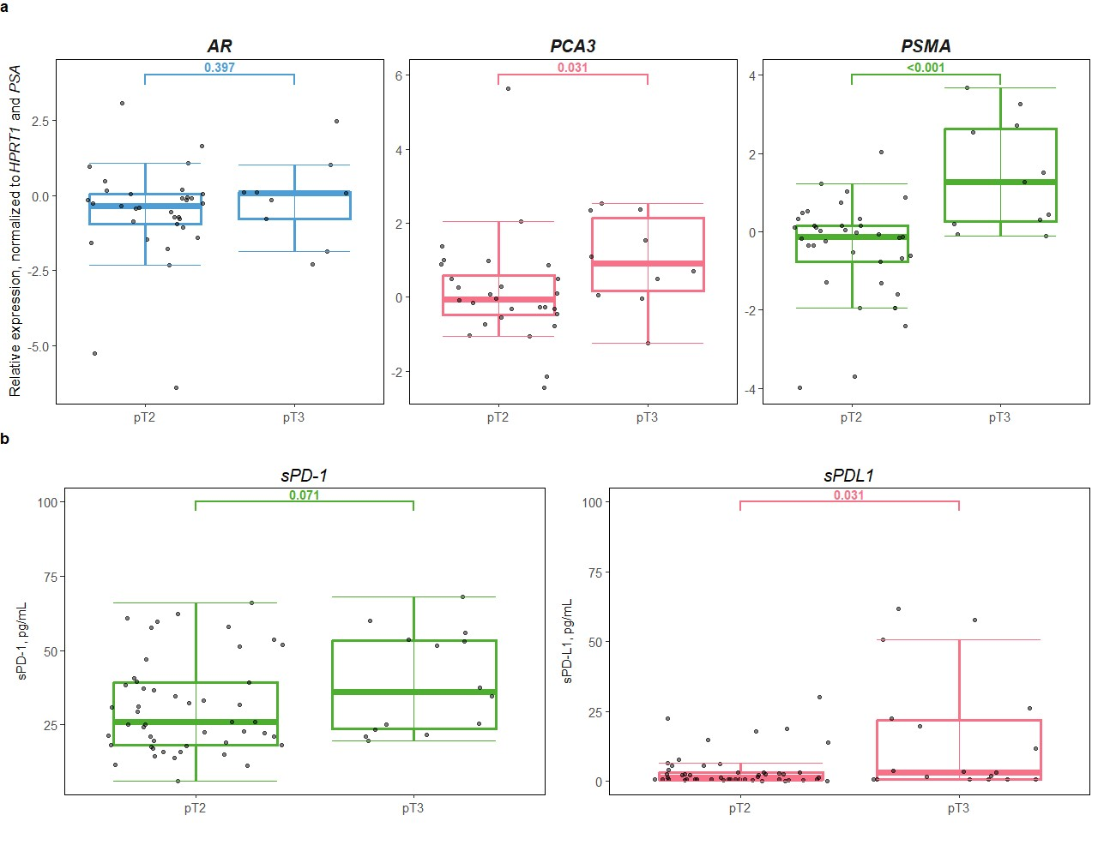
Figure S2 Relative expression values of AR, PCA3, and PSMA mRNAs as well as sPD-L1 and sPD-1 in association with tumor stage.
A Relative expression values of AR, PCA3, and PSMA mRNAs in association with tumor stage. PCA3 and PSMA p < 0.05. B sPD-L1 and sPD-1 levels in association with tumor stage. sPDL1 p = 0.031.

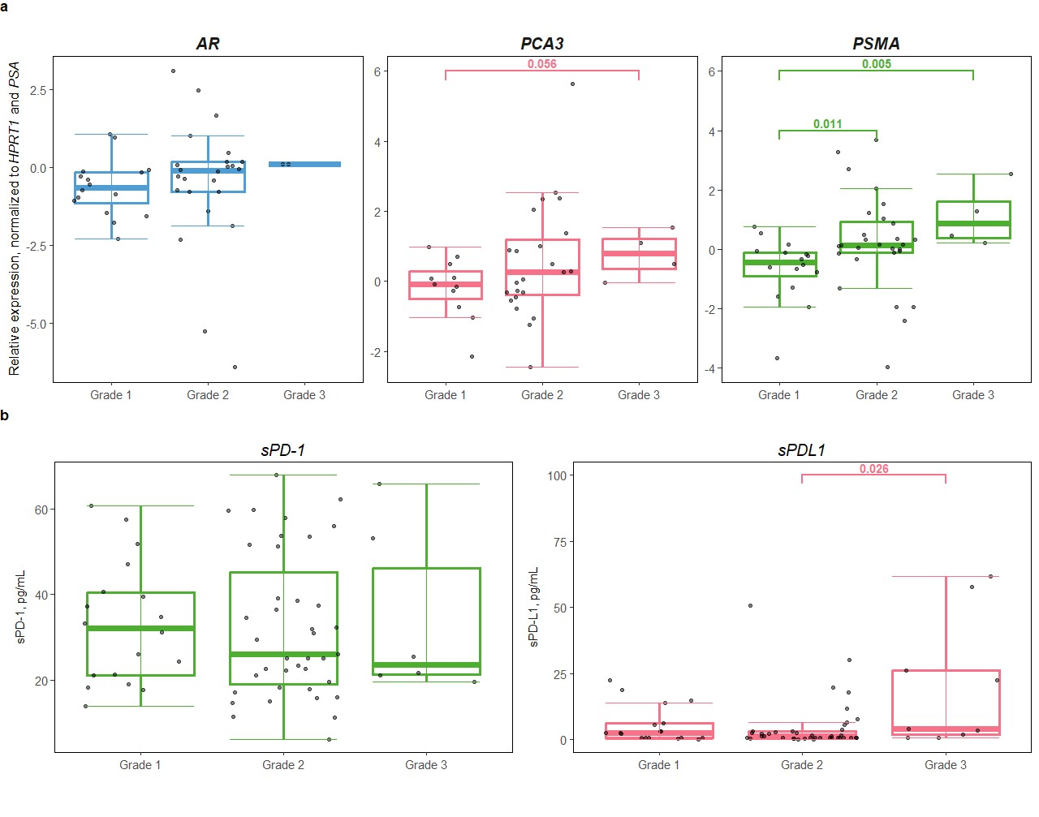
Figure S3 Relative expression values of AR, PCA3, and PSMA mRNAs as well as sPD-L1 and sPD-1 in association with ISUP grading.
A Relative expression values of AR, PCA3, and PSMA mRNAs in association with ISUP grading. Grade 1 vs grade 3 PSMA p = 0.005, grade 1 vs grade 2 PSMA p = 0.011. B sPD-L1 and sPD-1 levels in association with ISUP grading. Grade 2 vs grade 3 sPDL1 = 0.026.

