**Supplementary materials**

**Jessica Marchesan and Jurek Kolasa**

1. **Author contributions**

Conceptualization: Both JM and JK developed the question, approach, and methodology for the test. JM modified the software, original Metacommunity Model 13, for the simulation of the patch size and connectivity effects. JM ran the model, designed the data collection, and both JM and JK prepared the data for the analyses. JK and JM analyzed the data, with the more complex analyses performed in Statistica by JK. JK wrote the first draft of the manuscript, and both authors contributed significantly to the edits.

## **Appendix 1**: **Model settings for the data used in this paper**

* 1. **Landscape**

Small-patch landscapes consist of 121 squares, medium-patch landscape comprised 64 patches and large-patch landscape contained 25 patches.

The squares were randomly assigned and uniformly spaced with random habitat suitability values in 0.2 steps (five classes). For example, a square patch may have a suitability defined by 0.2-0.4. This means that an instance belonging to this class can have a value from 0.2 to 0.39.

Connectivity and heterogeneity. 121 patches of five different suitability categories (actual values are random) create a heterogeneous habitat (Fig. S1). Note that some patches of the same color are connected to one or more other patches of the same color when they are adjacent to them. Vertex contact does not imply connection because individuals move across the patch boundary at the right angle only. For example, 22 dark green patches are connected. The software identifies all the patches connected and reports it separately by habitat suitability class for each landscape and each replicate. A total relative number of connected patches provides a rough approximate of connectivity. Also, note that clusters of connected patches become an obstacle to species dispersal using other habitat suitability values. The same color dots indicate individuals of one species, with each species possessing a unique color (see Figure S2).

Figure S1. A snapshot of one of the initial 30 random setups for a simulation before it started (small patches). The small numbers in the lower right patch corners provide information on habitat suitability assigned to a patch in a particular run.

* 1. **Species specialization**

Species specialization followed a similar approach to that used in defining landscape patches. Each species had a randomly assigned specialization value. When this value matched a habitat suitability value, an individual arriving at a patch would gain the energy necessary for survival, reproduction, and movement. Other patches would not provide this energy, and an individual would risk running out of energy, with death being an eventual consequence.

* 1. **Species interactions**

The interactions occurring in this model are between individuals belonging to different species (e.g., species 1 and species 2) as well as categories of species (e.g., specialists and generalists). We used the command ‘in-radius’ to designate the largest distance allowing individuals to ‘interact’ with others. Species interactions were set to High. Under this setting, ten predefined species had positive interactions with ten other species and negative interactions with another set of ten species. All other inter-specific encounters had either no or negative effects on both species depending on the amount of patch energy and the energetic status of individuals of each species on a given patch. Individuals of the same species use the same resources and thus can be limited by intraspecific competition.

* 1. **Dispersal**

The simulations used the setting of High. This setting involved a movement of 50% of all individuals per simulation step, random direction for two steps (in practice, two steps may result in a distance of two patches, one patch, or a return trip), with fixed energetic costs and benefits from visiting patches of different resources and species composition. During the dispersal, the species with randomly assigned specialization values less than 0.5 expend one energy unit, and the remaining species lose two units. The discount was necessary to stabilize the default performance of the model and avoid a quick loss of specialist species due to a smaller supply and greater relative distances among the patches they must reach to survive.

* 1. **Model runs**

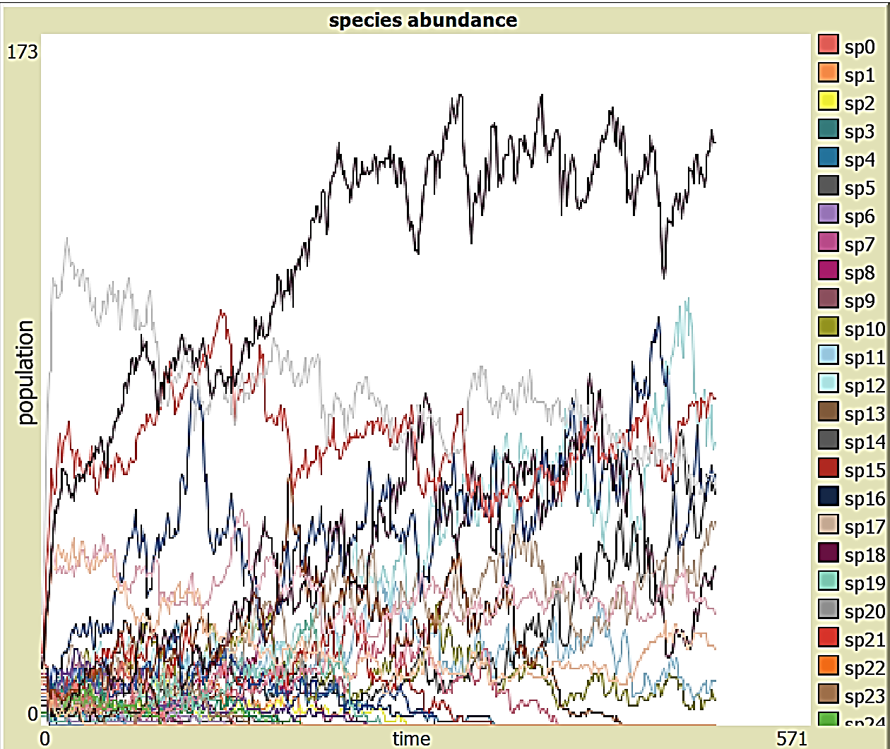An example of a simulation. The initial combined population of all species was 500, with a carrying capacity set at 700. The final population after the simulation shown in Figure S2 was 635, and the number of steps was 500. A typical pattern involved the early loss of a portion of species, an increase in the abundance of others, and a general stabilization of the populations. The final numbers were used in the analyses. Species and assigned colors appear on the right.

**Additional model information files are available in the accompanying metadata section of the project deposited in the McMaster University Dataverse (with a link provided in the manuscript).**