Supporting Materials
Powering the Future: Leveraging Carbon Nanotubes, Silicon Nanowires, and MoS₂ for Breakthroughs in Hydrogen Production and Li-ion Batteries
Abniel Machín¹, María C. Cotto², Francisco Márquez*², Jesús Díaz³, Celia Polop^{3,4}, Carmen Morant*⁵
¹ Division of Natural Sciences and Technology, Universidad Ana G. Méndez-Cupey Campus, San Juan, 00926 San Juan, PR, United States
² Nanomaterials Research Group, School of Natural Sciences and Technology, Universidad Ana G. Méndez-Gurabo Campus, 00778 Gurabo, PR, United States
³ Department of Condensed Matter Physics, Autonomous University of Madrid, and Instituto de Ciencia de Materiales Nicolás Cabrera, Madrid, 28049, Spain
⁴ IFIMAC: Condensed Matter Physics Center (IFIMAC), Universidad Autónoma de Madrid, Madrid, 28049, Spain
⁵ Department of Applied Physics, Autonomous University of Madrid, and Instituto de Ciencia de Materiales Nicolás Cabrera, Madrid, 28049, Spain
* Correspondence: fmarquez@uagm.edu (F.M.); c.morant@uam.es (C.M.); +1-787-743-7979, ext. 4250 (F.M.); +34-914974924 (C.M.)
Table S1. BET surface area of the different composites.
Catalyst | BET surface area (m²g⁻¹)
ZnONPs | 62
ZnONPs-SiNWs-CNTs | 297
5%(MoS₂-SiNWs)@ZnONPs-CNTs | 231
6.7%(MoS₂-SiNWs)@ZnONPs-CNTs | 246
Table S2. Elemental composition of MoS₂@SiNWs@CNT and MoS₂@CNT electrodes after 100 charge/discharge cycles, measured by Nuclear Reaction Analysis (NRA).
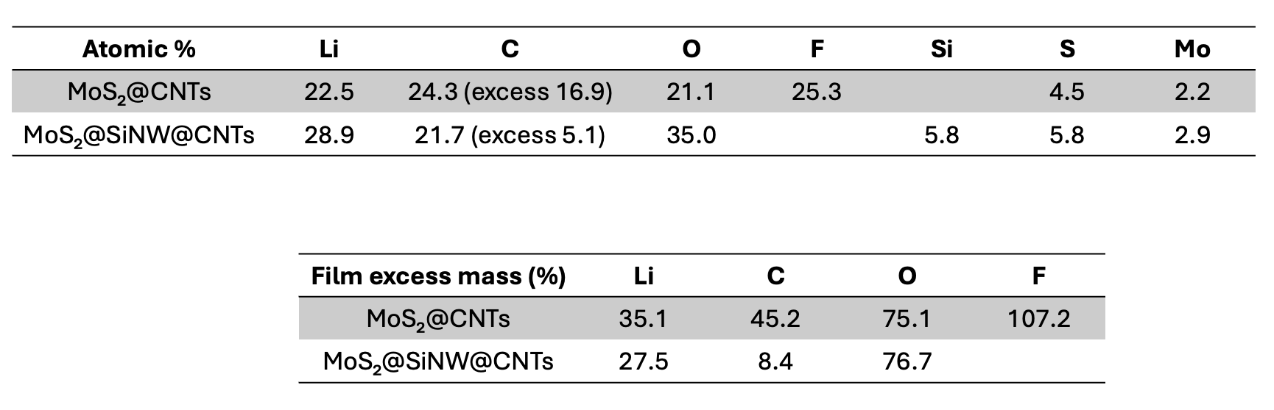

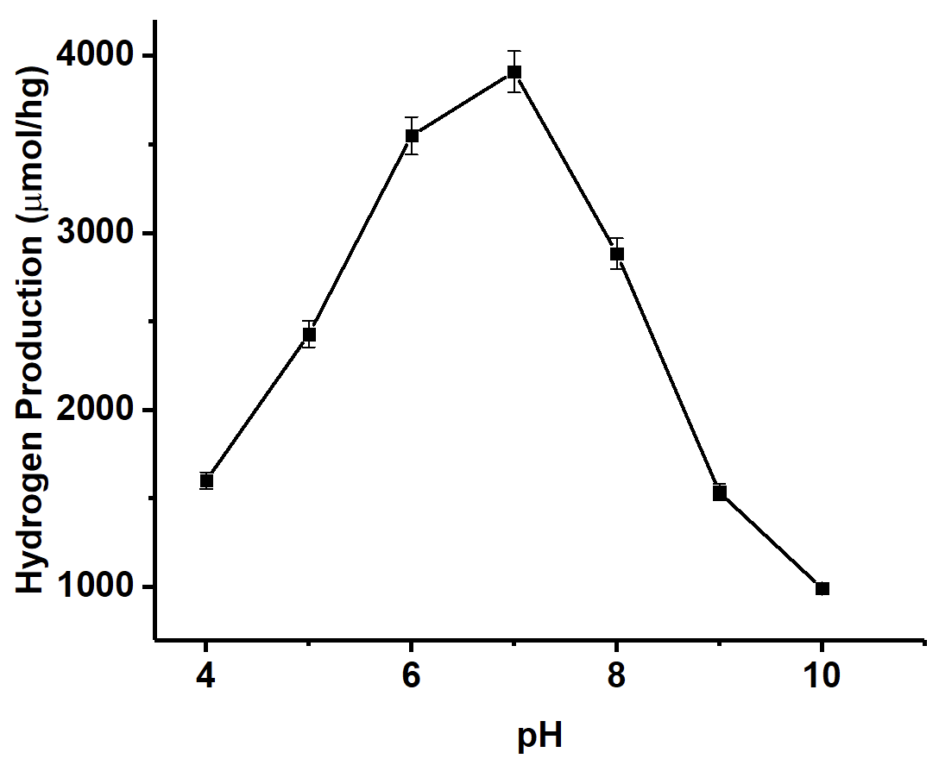
Figure S1. Effect of pH on the photocatalytic activity of the 6.7%(MoS₂-SiNWs)@ZnONPs-CNTs catalyst for hydrogen production.
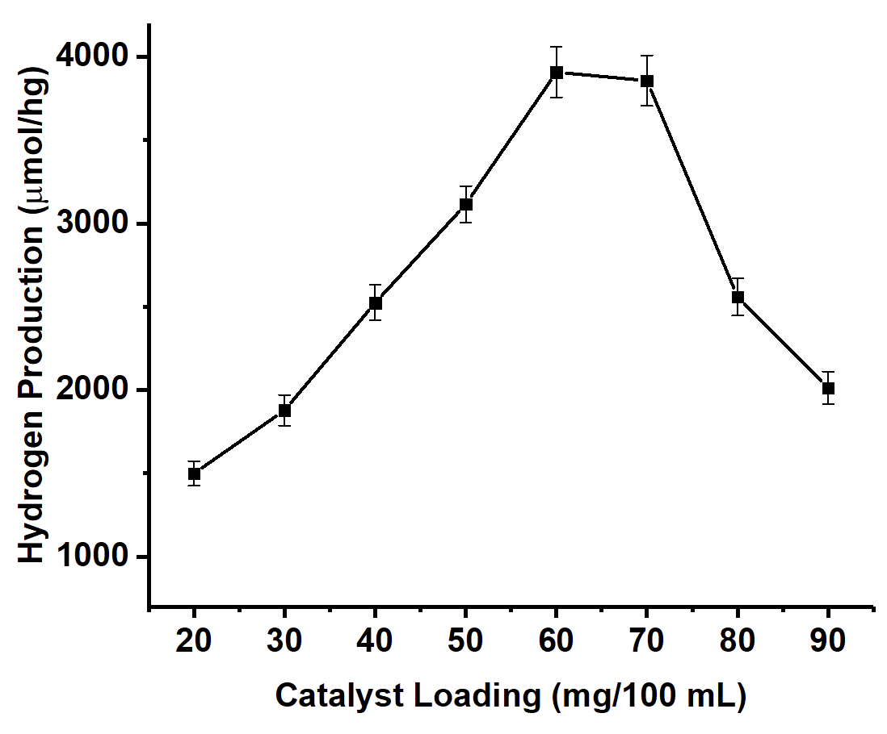
Figure S2. Evaluation of the initial concentration of the 6.7%(MoS₂-SiNWs)@ZnONPs-CNTs catalyst on the efficiency of hydrogen production.
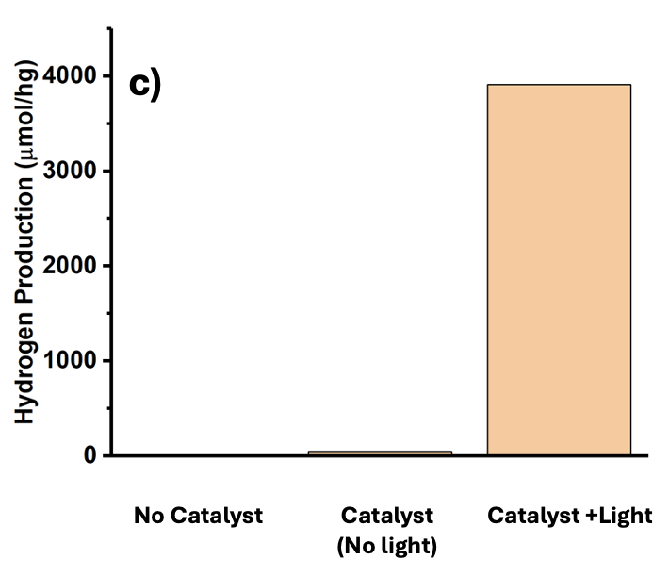
Figure S3. Control experiments for 6.7%(MoS₂-SiNWs)@ZnONPs-CNTs on the efficiency of hydrogen production.
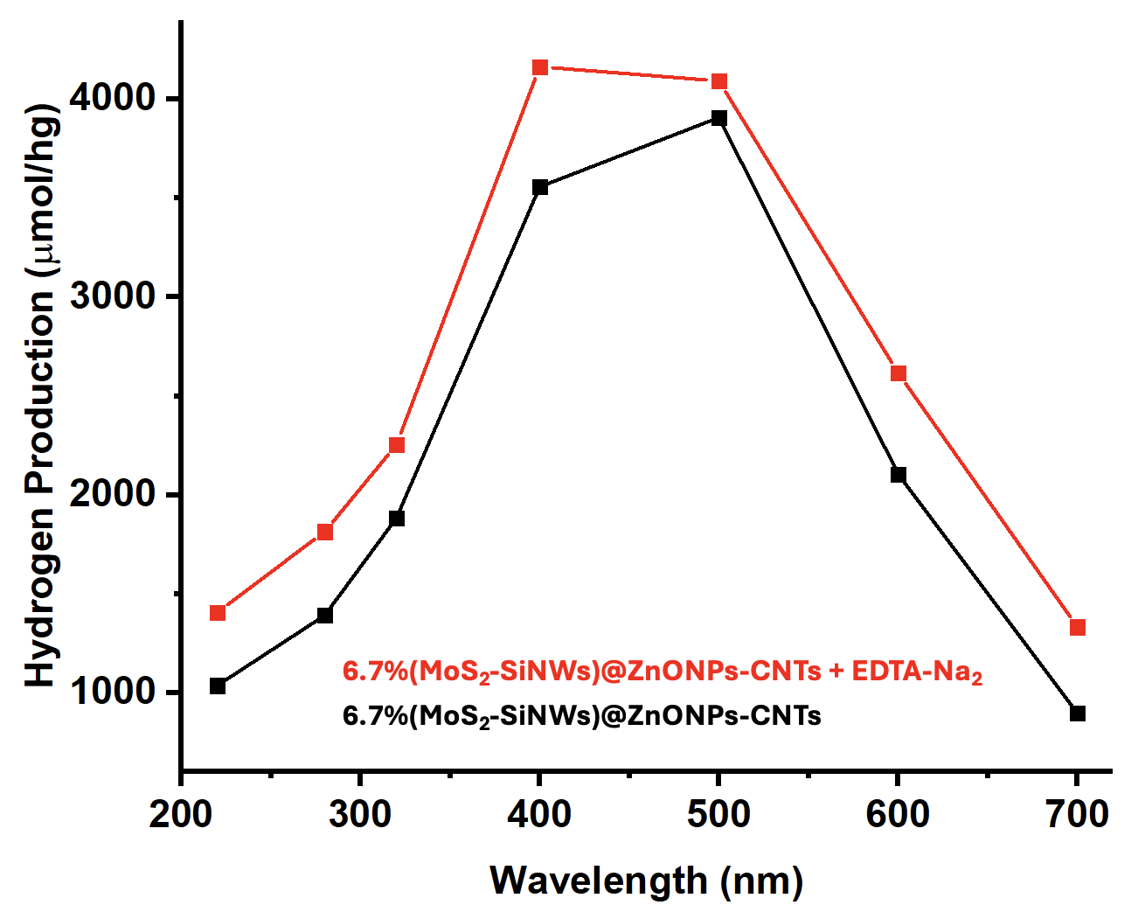
Figure S4. Hydrogen production via water splitting using 6.7%(MoS₂-SiNWs)@ZnONPs-CNTs under irradiation, and also in the presence of a hole scavenger, namely EDTA-Na₂.
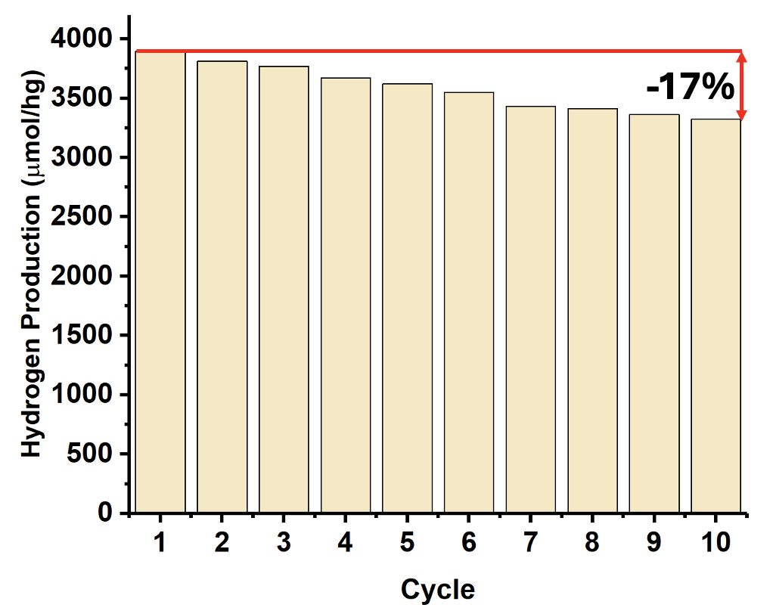
Figure S5. Recyclability of 6.7%(MoS₂-SiNWs)@ZnONPs-CNTs after 10 consecutive catalytic cycles of hydrogen production, under irradiation at 500 nm.
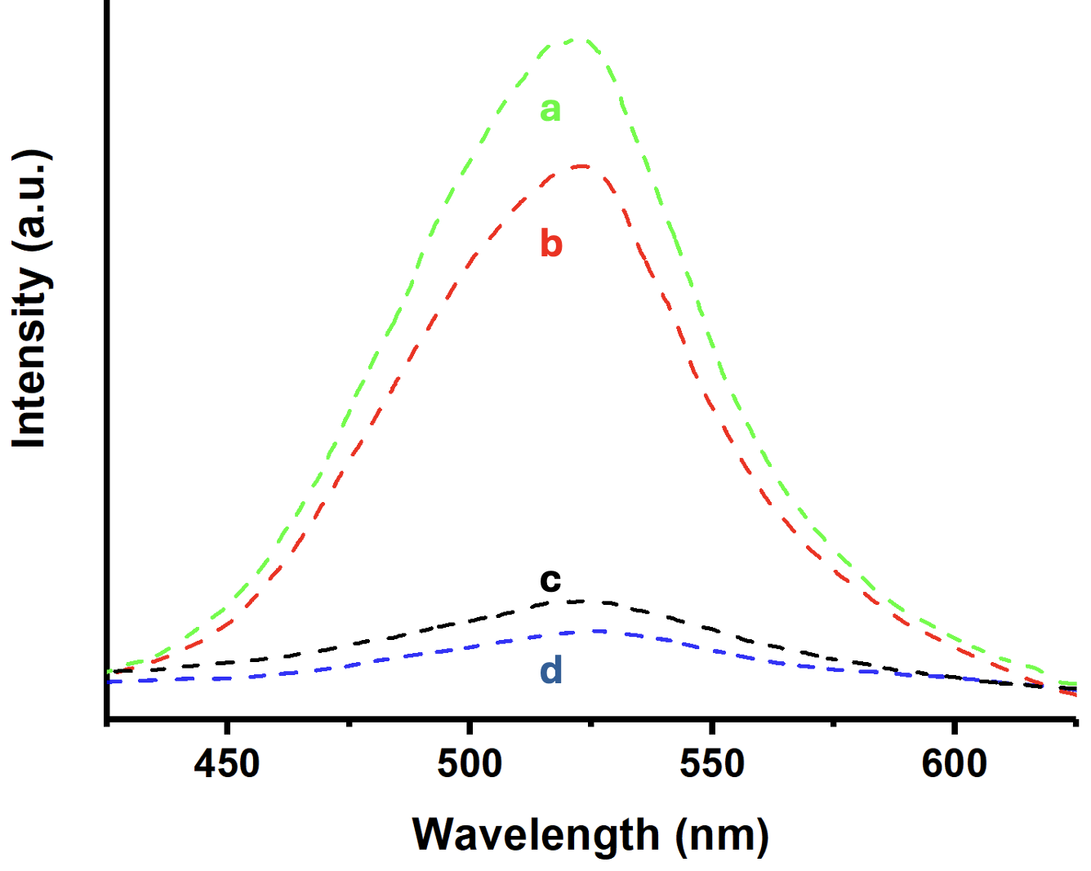
Figure S6. Photoluminescence of ZnONPs (a); ZnONPs-CNTs (b); 5%(MoS₂-SiNWs)@ZnONPs-CNTs (c); and 6.7%(MoS₂-SiNWs)@ZnONPs-CNTs (d), by a 350 nm excitation at room temperature.
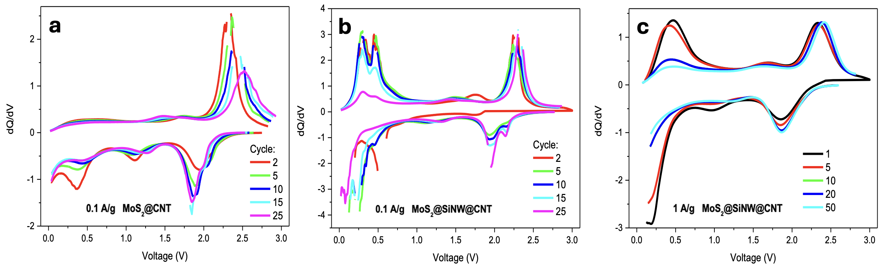
Figure S7. Differential capacity (dQ/dV) curves for (a) MoS₂@CNT at 0.1 A/g, (b) MoS₂@SiNW@CNT at 0.1 A/g, and (c) MoS₂@SiNW@CNT at 1 A/g.
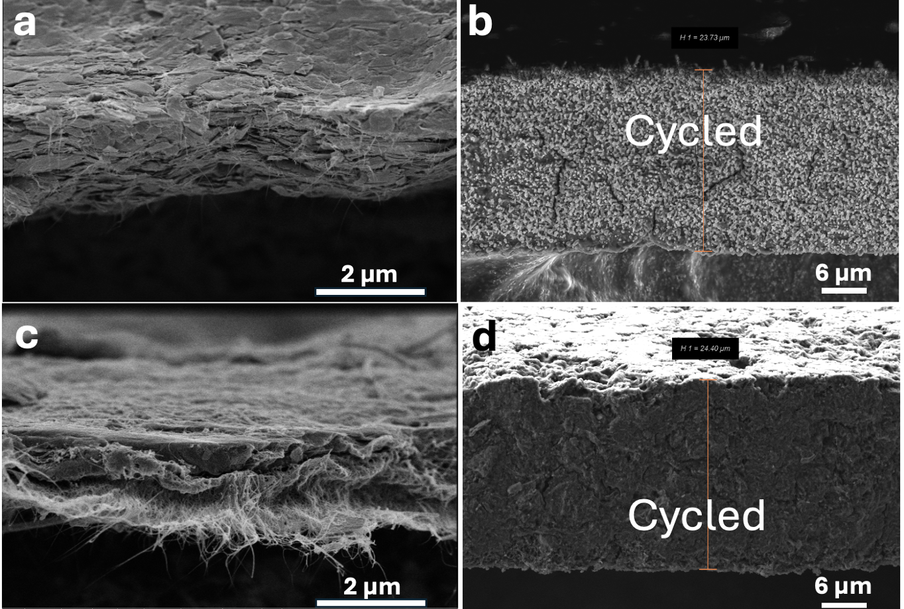
Figure S8. Cross-sectional SEM images of pristine and cycled electrodes: (a) MoS₂@CNT (80:20 wt.%) before cycling, (b) MoS₂@CNT after 100 cycles at 1 A/g, (c) MoS₂@SiNW@CNT (56:24:20 wt.%) before cycling, and (d) MoS₂@SiNW@CNT after 100 cycles at 1 A/g. .

